Shakti · Sales Automation
Sales CRM
One assistant replies instantly. Only real buyers reach your team.
The problem
A new enquiry can land on WhatsApp, Instagram, Facebook or a web form at any hour, and no sales team can answer every one of them the moment it arrives — especially the early, low-value messages that make up most of the volume. By the time someone gets around to replying, a genuinely interested buyer has often gone quiet, while a good chunk of the team's day goes into manually triaging messages that were never going to turn into a sale. A CRM that only starts working once a person types a lead in misses exactly the moment that matters most: the first reply.
The idea
An AI assistant named Aria sits at the front of every channel and replies instantly, in the lead's own language. She moves each conversation through six states — greeting, qualifying, qualified, support, nurture, closed — asking one smart question at a time rather than working through a script, and answering business questions only from an approved knowledge base, never a guess. Behind that conversation, a fixed points formula and a five-gate rule — not the model's judgement — decide how serious a lead really is; the same signals always produce the same verdict, and every score comes with a plain-language reason attached. Leads that clear the bar reach the sales team with a WhatsApp alert explaining why; the team can then run the whole CRM — updating, assigning, replying, approving — from short WhatsApp commands, without opening another app. Everyone else isn't dropped: a scheduled follow-up sequence checks in over the next two weeks, and a daily digest keeps the admin briefed on the pipeline each morning.
Message arrives → Aria chats → scored against fixed rules → hot leads to sales, rest nurtured
What it does
- A real conversation, not a form, Aria asks at most three questions across a whole conversation, replies in under 150 words, and matches the lead's language — English, Hindi or Hinglish.
- A fixed, explainable score, not a guess — a points formula rates intent, urgency and contact details, and every score comes with a plain-language reason attached.
- Five checks before a lead reaches sales, a lead is only promoted once it clears fixed rules — not spam, genuinely engaged, a real buying signal, reachable — so the same signals always produce the same verdict.
- Every channel, one engine, WhatsApp, Instagram, Facebook, web forms and Meta Lead Ads all funnel into the same system.
- The team runs it from WhatsApp, short commands like UPDATE, NOTE, ASSIGN and REPLY let the sales team manage leads without opening another app.
- Automatic nurture and a daily digest, leads that aren't ready yet get a day 1 / 3 / 7 / 14 follow-up sequence, and a WhatsApp summary of the pipeline lands with the admin every morning.
Who it's for Any business getting more inbound messages than its sales team can personally triage — right now, a sports club's membership enquiries, with the same engine built to serve other clients next.
Prerequisites
- Your own WhatsApp Business number, connected to the Cloud API — this is the channel Aria actually replies from, under your business's own identity.
- A verified Meta Business Manager, only needed if Instagram, Facebook Messenger or Meta Lead Ads are in the mix — WhatsApp works on its own, but those three channels need your business approved with Meta first.
- Your product, pricing and FAQ answers, written down, this is what Aria's knowledge base draws from — she's built to never guess, so anything not on file simply doesn't get answered.
- A team roster, each salesperson's WhatsApp number and role — sales, support or admin — decides who an alert reaches and who can run which WhatsApp command.
- The hours you want Aria answering in, she only engages inside a configured window (Shakti's own is 10:00–19:00, Monday to Saturday) — outside it, a message simply waits.
The system design
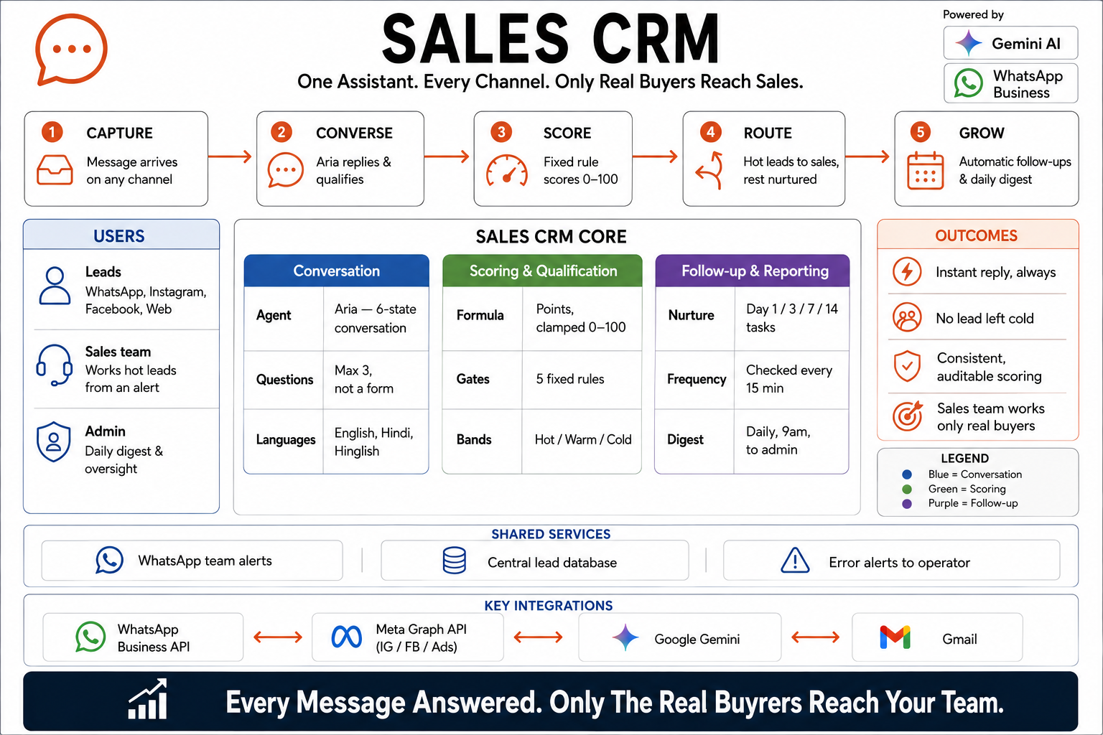
Read left to right: a message lands on any channel, Aria replies and qualifies it, a fixed rule scores it 0–100, hot leads route to sales while the rest get nurtured, and the pipeline keeps growing through follow-ups and a daily digest. The centre panel breaks Aria's engine into three layers — the conversation itself (a 6-state agent, capped at 3 questions, three languages), the scoring and qualification rules (a points formula and 5 fixed gates sorting leads into Hot, Warm or Cold), and follow-up and reporting (day 1/3/7/14 nurture tasks checked every 15 minutes, plus a 9am digest to the admin) — while the strip underneath names the four outside services it depends on: the WhatsApp Business API, Meta's Graph API for Instagram, Facebook and Lead Ads, Google Gemini, and Gmail.
See Aria in conversation
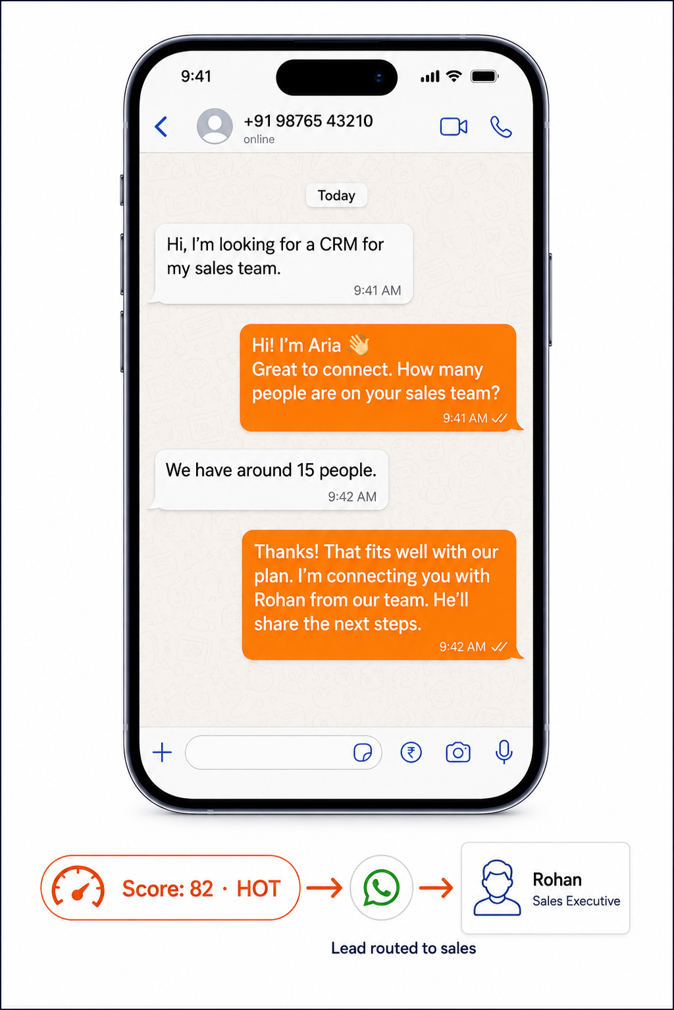
The actual hand-off, message by message. A lead opens with “Hi, I'm looking for a CRM for my sales team”; Aria replies in one line — “Hi! I'm Aria 👋 Great to connect. How many people are on your sales team?” — asking exactly the kind of qualifying question the scoring rules need. The lead answers “We have around 15 people,” and Aria closes the loop herself: “Thanks! That fits well with our plan. I'm connecting you with Rohan from our team.” Underneath, the score the conversation just earned — Score: 82 · HOT — flows through a WhatsApp icon straight to Rohan's own alert card, labelled “Lead routed to sales”: the exact moment a chat becomes a handled lead, with no form and no manual triage in between.
Tell the story — before and after

“From chaos to clarity — Aria filters, scores and delivers only what matters.” On the left, one overwhelmed inbox: WhatsApp, Instagram and Facebook bubbles stacked on top of each other, each carrying its own unread count — 23, 31, 12, 8, 19 on WhatsApp and Facebook, 17 and 27 on Instagram, and more besides — next to a person holding their head, with three costs spelled out underneath: too many notifications, wasted time and context, important leads get missed. On the right, the same person calm at a laptop with exactly one notification on screen — “New HOT lead — ready to buy, via WhatsApp” — with the payoff named below it: smarter filtering and scoring, only real buyers, more focus and more sales.

