Database Management Systems Lab [CSF 2124]
Second Year B.Tech. (Computer Science & Financial Technology)
Academic Year 2026-2027
UNIVERSITY COURSE REGISTRATION
AND MANAGEMENT SYSTEM
Submitted by
Name | Reg. No. | Roll No.
Shakti Raj | 251090580202 | 58
Dhruv Chaturvedi | 251090580204 | 59

1. Title & Team Members
Field | Details
Project Title | University Course Registration and Management System
Course | Database Systems Lab [CSF 2124]
Team Members | 1. Shakti Raj (Reg. No.: 251090580202, Roll No.: 58)  2. Dhruv Chaturvedi (Reg. No.: 251090580204, Roll No.: 59)
Technology | React 18 / Tailwind CSS & HTML5/JS → Python 3.11 + Django 5.2 (alt.: Java Servlets 6.0 + JDBC) → PostgreSQL / MySQL / SQLite3
Live Demo | Web application “CourseHub”: https://university-course-system-92pk.onrender.com/

Contents
1. Title & Team Members 2
2. Abstract 2
3. Problem Statement 3
4. ER Diagram & Relational Tables with Sample Data 4
5. DDL Commands 7
6. List of SQL Queries 9
7. UI Design 11
8. PL/SQL Procedures, Functions & Triggers 16
9. Java Code for Functional Design 19
10. References 21

2. Abstract
The University Course Registration and Management System is a three-tier database application that manages course scheduling, student enrollment, classroom allocation and grading for a university. The presentation tier (React 18 + Tailwind CSS SPA alongside HTML5/CSS3 and JavaScript fetch) calls JSON REST APIs in the application tier (Python 3.11 + Django 5.2, with an alternate Java Servlets 6.0/JDBC implementation), which enforces business rules and talks to a data tier of 11 relational tables in Third Normal Form (PostgreSQL / MySQL / SQLite3).
Three roles use the system: Administrators provision accounts and master data, Students self-register for sections, and Instructors view rosters and grade their own sections. Every registration runs as one ACID transaction that locks the section row (SELECT ... FOR UPDATE) and verifies prerequisites, time-slot clashes, the 18-credit cap, seat capacity and duplicates, so overbooking cannot occur under concurrent use.
Keywords: RDBMS, 3NF, ACID transactions, row-level locking, PL/SQL, JDBC, Django.
Project Scale | Value | Project Scale | Value
Relational tables | 11 | Departments | 5
Courses | 18 | Instructors | 10
Students | 32 | Fall 2026 sections | 18
Roles | 3 | Automated tests | 9 / 9 pass

3. Problem Statement
Manual or poorly synchronized registration systems suffer from seat overbooking (two students read "29/30" at the same instant), missing prerequisites, time-slot clashes, room/instructor double-booking, credit overload and redundant data that causes update anomalies. The project builds a database-backed system that prevents all of these.

3.1 Data Requirements
Entity | Data Stored
Department | Name, building, budget
Course / Prerequisite | Course id, title, credits, owning department; which courses must be passed first
Classroom / Time slot | Building, room, capacity; weekday, start and end time
Section (offering) | Course, section id, semester, year, room, time slot, seat capacity
Instructor / Student | Id, name, department, salary (instructor) or earned credits (student), login link
Teaches / Takes | Which instructor teaches which section; which student registered in which section, with grade and registration time
User account | Username, password hash, email, role

3.2 Functional Requirements
ID | Role | Requirement
FR1 | Admin | Create departments, classrooms, time slots, courses, prerequisites, sections; assign instructors; onboard student/instructor accounts
FR2 | Student | Browse catalog with live search and department filter; see live seat counts (Available (28/30) / Full)
FR3 | Student | Self-register for a section, drop a section, view weekly timetable and grades
FR4 | Instructor | View assigned sections and rosters; enter and revise letter grades (assigned sections only)
FR5 | System | Reject registration if a prerequisite is unmet, a time slot clashes, credits would exceed 18, the section is full, or the student is already registered
FR6 | System | Prevent classroom or instructor double-booking when sections are scheduled
FR7 | System | Authenticate users, enforce role-based access (HTTP 403 for forbidden actions) and protect against SQL injection

Note: Who registers whom? The administrator creates the student's record and credentials; the student then registers themselves for courses. The admin never picks a student's electives.

4. ER Diagram & Relational Tables with Sample Data

4.1 ER Diagram
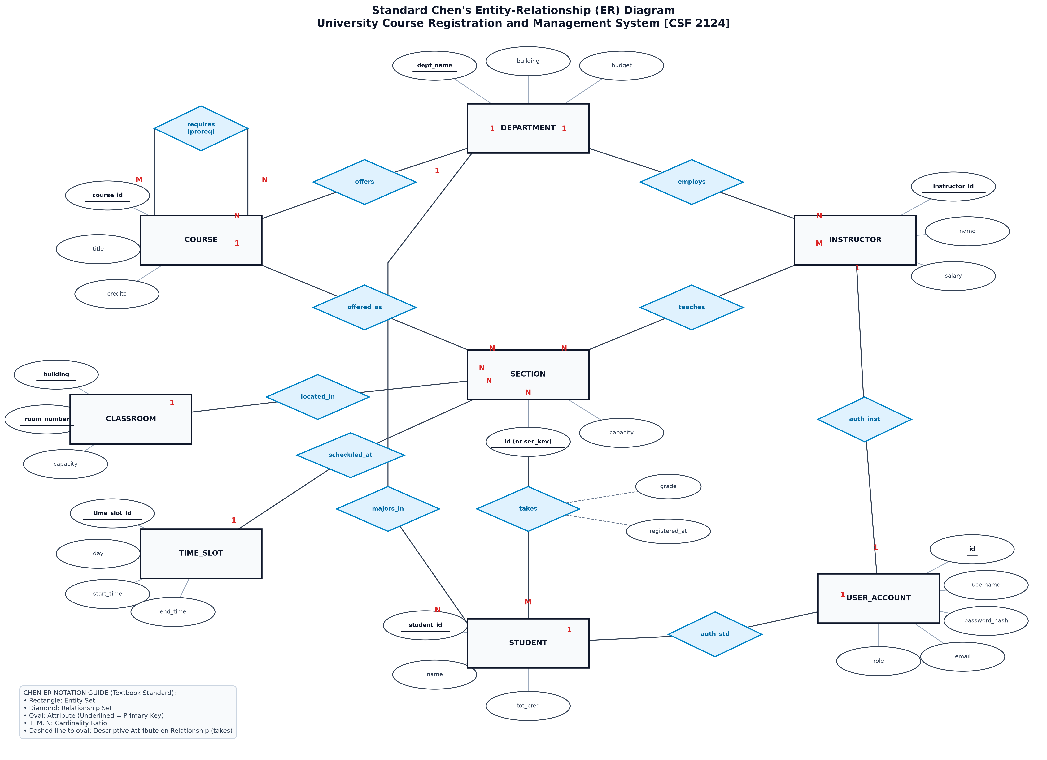
Figure 1: Entity-Relationship diagram of the University Course Registration and Management System
Notation: Chen's ER model (Rectangles = Entity Sets, Diamonds = Relationship Sets, Ovals = Attributes with primary keys underlined). Cardinalities are indicated as 1:1 (one-to-one), 1:N (one-to-many), and M:N (many-to-many). The three M:N relationships resolve into associative tables: student–section (takes), instructor–section (teaches), and course–course (prereq).

4.2 Relational Schema (underlined = primary key, * = foreign key)
department(dept_name, building, budget)
classroom(building, room_number, capacity)
time_slot(time_slot_id, day, start_time, end_time)
course(course_id, title, dept_name*, credits)
prereq(course_id*, prereq_id*)
section(id, course_id*, section_id, semester, year, building*, room_number*, time_slot_id*, capacity)
instructor(instructor_id, name, dept_name*, salary, user_id*)
teaches(instructor_id*, course_id*, section_id*, semester*, year*)
student(student_id, name, dept_name*, tot_cred, user_id*)
takes(student_id*, course_id*, section_id*, semester*, year*, grade, registered_at)
user_account(id, username, password_hash, email, role)

In teaches and takes, (course_id, section_id, semester, year) is one composite foreign key referencing section.

4.3 Normalisation (3NF)
Form | Evidence in this schema
1NF | Every column is atomic; no repeating groups; every table has a primary key (a multi-course cell such as "CS101, CS201" becomes one takes row per enrollment).
2NF | In composite-key tables (takes, teaches, classroom) each non-key attribute depends on the whole key: grade needs all five takes key columns. Course title and credits live in course, not in takes.
3NF | No transitive dependency: course stores only the FK dept_name; the department's building and budget live in department. Every determinant in all 11 tables is a candidate key.

Why course and section are separate: a course is a lasting subject; a section is a term-specific offering with room, slot and capacity. Merging them would repeat title and credits per offering (update anomaly).

4.4 Sample Data
Representative rows from the Fall 2026 seed data (the full data set is loaded by the seed script).
department
dept_name | building | budget
Computer Science | Turing Hall | 500000.00
Electrical Engineering | Tesla Complex | 400000.00

classroom
building | room_number | capacity
Turing Hall | 101 | 40
Turing Hall | 201 | 40
Turing Hall | 301 | 40
Tesla Complex | 105 | 30
Tesla Complex | 205 | 30

time_slot
time_slot_id | day | start_time | end_time
T1 | Monday | 09:00 | 10:30
T2 | Monday | 11:00 | 12:30
T3 | Monday | 14:00 | 15:30
T4 | Tuesday | 09:00 | 10:30
T5 | Tuesday | 11:00 | 12:30
T6 | Wednesday | 09:00 | 10:30
T7 | Thursday | 09:00 | 10:30
T8 | Friday | 10:00 | 11:30

course · prereq
course_id | title | dept_name | credits
CS101 | Intro to Computer Science | Computer Science | 4
CS201 | Data Structures & Algorithms | Computer Science | 4
CS202 | Database Management Systems | Computer Science | 4
CS301 | Design & Analysis of Algorithms | Computer Science | 4
CS401 | Distributed Systems & Cloud | Computer Science | 3
EE101 | Circuit Theory & Analysis | Electrical Engineering | 4
EE201 | Signals and Systems | Electrical Engineering | 4

course_id | prereq_id
CS201 | CS101
CS401 | CS301
EE201 | EE101

user_account
id | username | password_hash | email | role
1 | admin | pbkdf2_sha256$… | admin@university.edu | admin
2 | stud_cs01 | pbkdf2_sha256$… | alice@university.edu | student
3 | inst_cs01 | pbkdf2_sha256$… | turing@university.edu | instructor

instructor · student
instructor_id | name | dept_name | salary | user_id
I101 | Dr. Alan Turing | Computer Science | 98000.00 | 3
I102 | Dr. Grace Hopper | Computer Science | 92000.00 | NULL
I103 | Dr. Nikola Tesla | Electrical Engineering | 95000.00 | NULL
I104 | Dr. Claude Shannon | Electrical Engineering | 88000.00 | NULL

student_id | name | dept_name | tot_cred | user_id
S1001 | Alice Johnson | Computer Science | 48 | 2

section (Fall 2026)
id | course_id | section_id | semester | year | building | room_number | time_slot_id | capacity
1 | CS101 | SEC01 | Fall | 2026 | Turing Hall | 101 | T1 | 40
2 | CS101 | SEC02 | Fall | 2026 | Turing Hall | 201 | T4 | 35
3 | CS201 | SEC01 | Fall | 2026 | Turing Hall | 301 | T2 | 40
4 | CS202 | SEC01 | Fall | 2026 | Turing Hall | 101 | T6 | 35
5 | CS301 | SEC01 | Fall | 2026 | Turing Hall | 201 | T7 | 30
6 | CS302 | SEC01 | Fall | 2026 | Turing Hall | 301 | T8 | 35
7 | CS401 | SEC01 | Fall | 2026 | Turing Hall | 201 | T3 | 25
8 | EE101 | SEC01 | Fall | 2026 | Tesla Complex | 105 | T1 | 30
9 | EE201 | SEC01 | Fall | 2026 | Tesla Complex | 205 | T5 | 30

teaches
instructor_id | course_id | section_id | semester | year
I101 | CS101 | SEC01 | Fall | 2026
I102 | CS101 | SEC02 | Fall | 2026
I101 | CS201 | SEC01 | Fall | 2026
I102 | CS202 | SEC01 | Fall | 2026
I101 | CS301 | SEC01 | Fall | 2026
I102 | CS302 | SEC01 | Fall | 2026
I101 | CS401 | SEC01 | Fall | 2026
I103 | EE101 | SEC01 | Fall | 2026
I104 | EE201 | SEC01 | Fall | 2026

takes (Alice Johnson's Fall 2026 registrations: 16 credits)
student_id | course_id | section_id | semester | year | grade | registered_at
S1001 | EE101 | SEC01 | Fall | 2026 | IP | 2026-07-20 09:15:40
S1001 | CS101 | SEC02 | Fall | 2026 | IP | 2026-07-20 09:16:12
S1001 | CS202 | SEC01 | Fall | 2026 | IP | 2026-07-20 09:17:03
S1001 | CS201 | SEC01 | Fall | 2026 | IP | 2026-07-20 09:18:47

5. DDL Commands
Tables are created in dependency order. All integrity constraints (PK, FK with ON DELETE rules, CHECK, UNIQUE, NOT NULL, DEFAULT) are declared in the schema. Oracle porting: VARCHAR→VARCHAR2, INT→NUMBER, SERIAL→GENERATED ALWAYS AS IDENTITY, TIME→VARCHAR2(5).
CREATE TABLE user_account (
id SERIAL PRIMARY KEY,
username VARCHAR(50) NOT NULL UNIQUE,
password_hash VARCHAR(255) NOT NULL,
email VARCHAR(100) NOT NULL UNIQUE,
role VARCHAR(20) NOT NULL CHECK (role IN ('student','instructor','admin'))
);
CREATE TABLE department (
dept_name VARCHAR(50) PRIMARY KEY,
building VARCHAR(50),
budget NUMERIC(12,2) CHECK (budget >= 0)
);
CREATE TABLE classroom (
building VARCHAR(50) NOT NULL,
room_number VARCHAR(20) NOT NULL,
capacity INT NOT NULL CHECK (capacity > 0),
PRIMARY KEY (building, room_number)
);
CREATE TABLE time_slot (
time_slot_id VARCHAR(10) PRIMARY KEY,
day VARCHAR(10) NOT NULL,
start_time TIME NOT NULL,
end_time TIME NOT NULL,
CHECK (end_time > start_time)
);
CREATE TABLE course (
course_id VARCHAR(10) PRIMARY KEY,
title VARCHAR(100) NOT NULL,
dept_name VARCHAR(50) NOT NULL REFERENCES department(dept_name) ON DELETE RESTRICT,
credits INT NOT NULL CHECK (credits > 0 AND credits <= 10)
);
CREATE TABLE prereq (
course_id VARCHAR(10) NOT NULL REFERENCES course(course_id) ON DELETE CASCADE,
prereq_id VARCHAR(10) NOT NULL REFERENCES course(course_id) ON DELETE CASCADE,
PRIMARY KEY (course_id, prereq_id),
CHECK (course_id <> prereq_id)
);
CREATE TABLE section (
id SERIAL PRIMARY KEY,
course_id VARCHAR(10) NOT NULL REFERENCES course(course_id) ON DELETE RESTRICT,
section_id VARCHAR(10) NOT NULL,
semester VARCHAR(10) NOT NULL,
year INT NOT NULL,
building VARCHAR(50),
room_number VARCHAR(20),
time_slot_id VARCHAR(10) REFERENCES time_slot(time_slot_id) ON DELETE RESTRICT,
capacity INT NOT NULL CHECK (capacity > 0),
CONSTRAINT uq_section_offering UNIQUE (course_id, section_id, semester, year),
FOREIGN KEY (building, room_number) REFERENCES classroom(building, room_number) ON DELETE RESTRICT
);
CREATE TABLE instructor (
instructor_id VARCHAR(10) PRIMARY KEY,
name VARCHAR(100) NOT NULL,
dept_name VARCHAR(50) NOT NULL REFERENCES department(dept_name) ON DELETE RESTRICT,
salary NUMERIC(10,2) CHECK (salary >= 0),
user_id INT UNIQUE REFERENCES user_account(id) ON DELETE SET NULL
);
CREATE TABLE teaches (
instructor_id VARCHAR(10) NOT NULL REFERENCES instructor(instructor_id) ON DELETE RESTRICT,
course_id VARCHAR(10) NOT NULL,
section_id VARCHAR(10) NOT NULL,
semester VARCHAR(10) NOT NULL,
year INT NOT NULL,
PRIMARY KEY (instructor_id, course_id, section_id, semester, year),
FOREIGN KEY (course_id, section_id, semester, year)
REFERENCES section(course_id, section_id, semester, year) ON DELETE CASCADE
);
CREATE TABLE student (
student_id VARCHAR(10) PRIMARY KEY,
name VARCHAR(100) NOT NULL,
dept_name VARCHAR(50) NOT NULL REFERENCES department(dept_name) ON DELETE RESTRICT,
tot_cred INT DEFAULT 0 CHECK (tot_cred >= 0),
user_id INT UNIQUE REFERENCES user_account(id) ON DELETE SET NULL
);
CREATE TABLE takes (
student_id VARCHAR(10) NOT NULL REFERENCES student(student_id) ON DELETE RESTRICT,
course_id VARCHAR(10) NOT NULL,
section_id VARCHAR(10) NOT NULL,
semester VARCHAR(10) NOT NULL,
year INT NOT NULL,
grade VARCHAR(2) DEFAULT 'IP'
CHECK (grade IN ('A+','A','A-','B+','B','B-','C+','C','C-','D','F','P','IP')),
registered_at TIMESTAMP NOT NULL DEFAULT CURRENT_TIMESTAMP,
PRIMARY KEY (student_id, course_id, section_id, semester, year),
FOREIGN KEY (course_id, section_id, semester, year)
REFERENCES section(course_id, section_id, semester, year) ON DELETE RESTRICT
);

-- Performance indexes
CREATE INDEX idx_section_lookup ON section (course_id, semester, year);
CREATE INDEX idx_takes_section ON takes (course_id, section_id, semester, year);
CREATE INDEX idx_takes_student_term ON takes (student_id, semester, year);

-- Views
CREATE VIEW student_timetable_view AS
SELECT t.student_id, c.course_id, c.title, sec.section_id, sec.semester, sec.year,
ts.day, ts.start_time, ts.end_time, sec.building, sec.room_number, i.name AS instructor_name
FROM takes t
JOIN course c ON c.course_id = t.course_id
JOIN section sec ON sec.course_id = t.course_id AND sec.section_id = t.section_id
AND sec.semester = t.semester AND sec.year = t.year
JOIN time_slot ts ON ts.time_slot_id = sec.time_slot_id
LEFT JOIN teaches th ON th.course_id = sec.course_id AND th.section_id = sec.section_id
AND th.semester = sec.semester AND th.year = sec.year
LEFT JOIN instructor i ON i.instructor_id = th.instructor_id;

CREATE VIEW section_enrollment_summary_view AS
SELECT sec.id, sec.course_id, sec.section_id, sec.semester, sec.year, sec.capacity,
COUNT(t.student_id) AS enrolled,
sec.capacity - COUNT(t.student_id) AS seats_remaining,
ROUND(COUNT(t.student_id) * 100.0 / sec.capacity, 1) AS occupancy_pct
FROM section sec
LEFT JOIN takes t ON t.course_id = sec.course_id AND t.section_id = sec.section_id
AND t.semester = sec.semester AND t.year = sec.year
GROUP BY sec.id, sec.course_id, sec.section_id, sec.semester, sec.year, sec.capacity;

ON DELETE rationale: RESTRICT protects records that still have dependants (department, course, student, section); CASCADE removes rows meaningless without their parent (prereq edges, teaches assignments); SET NULL lets a login be removed without deleting the person's record.

6. List of SQL Queries

6.1 Basic Queries
-- B1: courses with 3 credits in a department (selection)
SELECT course_id, title FROM course WHERE dept_name = 'Computer Science' AND credits = 3;
-- B2: instructors in a salary range (BETWEEN)
SELECT name, salary FROM instructor WHERE salary BETWEEN 40000 AND 95000;
-- B3: students whose name starts with 'A' (LIKE)
SELECT student_id, name FROM student WHERE name LIKE 'A%';
-- B4: instructor enters a grade (UPDATE)
UPDATE takes SET grade = 'A'
WHERE student_id = 'S1001' AND course_id = 'CS201' AND section_id = 'SEC01'
AND semester = 'Fall' AND year = 2026;
-- B5: student drops a course (DELETE) and B6: query a view
DELETE FROM takes WHERE student_id = 'S1001' AND course_id = 'CS202' AND section_id = 'SEC01'
AND semester = 'Fall' AND year = 2026;
SELECT * FROM student_timetable_view WHERE student_id = 'S1001';

6.2 Complex Queries
# | Concept | Purpose
Q1 | Multi-table JOIN + LEFT JOIN | Weekly schedule of a student
Q2 | GROUP BY / HAVING | Departments with average salary ≥ 90,000
Q3 | LEFT OUTER JOIN | Course offering audit including courses with zero sections
Q4 | Subquery NOT IN | Students who have not passed CS101
Q5 | Correlated subquery, EXISTS | Instructors with two or more Fall 2026 sections
Q6 | Derived table in FROM | Seat occupancy percentage per section
Q7 | Set operations | Fall 2026 courses that have prerequisites
Q8 | CASE conditional aggregation | Class-standing distribution per department
Q9 | Self-join | Classroom double-booking audit
Q10 | Window function | Credit ranking within each department
Q11 | WITH clause | Departments whose total salary exceeds the average department total

-- Q1: weekly schedule of S1001 (weekday-ordered with CASE)
SELECT s.student_id, s.name AS student_name, c.course_id, c.title, sec.section_id,
ts.day, ts.start_time, ts.end_time, sec.building, sec.room_number, i.name AS instructor_name
FROM takes t
JOIN student s ON t.student_id = s.student_id
JOIN course c ON t.course_id = c.course_id
JOIN section sec ON t.course_id = sec.course_id AND t.section_id = sec.section_id
AND t.semester = sec.semester AND t.year = sec.year
JOIN time_slot ts ON sec.time_slot_id = ts.time_slot_id
LEFT JOIN teaches tch ON sec.course_id = tch.course_id AND sec.section_id = tch.section_id
AND sec.semester = tch.semester AND sec.year = tch.year
LEFT JOIN instructor i ON tch.instructor_id = i.instructor_id
WHERE t.student_id = 'S1001' AND t.semester = 'Fall' AND t.year = 2026
ORDER BY CASE ts.day WHEN 'Monday' THEN 1 WHEN 'Tuesday' THEN 2 WHEN 'Wednesday' THEN 3
WHEN 'Thursday' THEN 4 ELSE 5 END, ts.start_time;

-- Q2: GROUP BY / HAVING
SELECT dept_name, COUNT(instructor_id) AS faculty_count,
ROUND(AVG(salary), 2) AS avg_salary, MAX(salary) AS max_salary
FROM instructor GROUP BY dept_name
HAVING AVG(salary) >= 90000 ORDER BY avg_salary DESC;

-- Q3: LEFT OUTER JOIN (zero-offering courses stay in the result)
SELECT c.course_id, c.title, c.dept_name, c.credits, COUNT(s.section_id) AS sections_offered
FROM course c
LEFT JOIN section s ON c.course_id = s.course_id AND s.semester = 'Fall' AND s.year = 2026
GROUP BY c.course_id, c.title, c.dept_name, c.credits
ORDER BY sections_offered DESC, c.course_id;

-- Q4: NOT IN subquery
SELECT student_id, name, dept_name, tot_cred FROM student
WHERE student_id NOT IN (SELECT student_id FROM takes WHERE course_id = 'CS101'
AND grade IN ('A+','A','A-','B+','B','B-','C+','C','C-','D','P'))
ORDER BY student_id;

-- Q5: correlated subquery (count) and EXISTS
SELECT i.instructor_id, i.name, i.dept_name FROM instructor i
WHERE (SELECT COUNT(*) FROM teaches t WHERE t.instructor_id = i.instructor_id
AND t.semester = 'Fall' AND t.year = 2026) >= 2;
SELECT s.student_id, s.name FROM student s -- students with no registration this term
WHERE NOT EXISTS (SELECT 1 FROM takes t WHERE t.student_id = s.student_id
AND t.semester = 'Fall' AND t.year = 2026);

-- Q6: derived table
SELECT util.course_id, util.section_id, util.capacity, util.enrolled,
ROUND(util.enrolled * 100.0 / util.capacity, 1) AS occupancy_pct
FROM (SELECT sec.course_id, sec.section_id, sec.capacity, COUNT(t.student_id) AS enrolled
FROM section sec
LEFT JOIN takes t ON sec.course_id = t.course_id AND sec.section_id = t.section_id
AND sec.semester = t.semester AND sec.year = t.year
WHERE sec.semester = 'Fall' AND sec.year = 2026
GROUP BY sec.course_id, sec.section_id, sec.capacity) util
ORDER BY occupancy_pct DESC;

-- Q7: set operations (Oracle: MINUS instead of EXCEPT)
SELECT course_id FROM section WHERE semester = 'Fall' AND year = 2026
INTERSECT
SELECT course_id FROM prereq; -- UNION would list courses that are offered OR have a prerequisite

-- Q8: CASE conditional aggregation
SELECT dept_name, COUNT(*) AS total_students,
SUM(CASE WHEN tot_cred < 20 THEN 1 ELSE 0 END) AS freshman,
SUM(CASE WHEN tot_cred >= 20 AND tot_cred < 40 THEN 1 ELSE 0 END) AS sophomore,
SUM(CASE WHEN tot_cred >= 40 AND tot_cred < 60 THEN 1 ELSE 0 END) AS junior,
SUM(CASE WHEN tot_cred >= 60 THEN 1 ELSE 0 END) AS senior
FROM student GROUP BY dept_name ORDER BY total_students DESC;

-- Q9: self-join collision audit (s1.id < s2.id reports each pair once; 0 rows = no conflicts)
SELECT s1.building, s1.room_number, s1.course_id AS c1, s2.course_id AS c2, ts1.day
FROM section s1
JOIN section s2 ON s1.building = s2.building AND s1.room_number = s2.room_number
AND s1.semester = s2.semester AND s1.year = s2.year AND s1.id < s2.id
JOIN time_slot ts1 ON s1.time_slot_id = ts1.time_slot_id
JOIN time_slot ts2 ON s2.time_slot_id = ts2.time_slot_id
WHERE s1.semester = 'Fall' AND s1.year = 2026 AND ts1.day = ts2.day
AND ts1.start_time < ts2.end_time AND ts1.end_time > ts2.start_time;

-- Q10: window function
SELECT student_id, name, dept_name, tot_cred,
DENSE_RANK() OVER (PARTITION BY dept_name ORDER BY tot_cred DESC) AS dept_rank
FROM student ORDER BY dept_name, dept_rank;

-- Q11: WITH clause
WITH dept_total AS (SELECT dept_name, SUM(salary) AS total_salary FROM instructor GROUP BY dept_name)
SELECT dept_name, total_salary FROM dept_total
WHERE total_salary > (SELECT AVG(total_salary) FROM dept_total);

7. UI Design
The application is deployed as CourseHub at https://university-course-system-92pk.onrender.com/. It uses React 18 + Tailwind CSS alongside responsive HTML5 templates in a sleek dark theme, and asynchronous JavaScript fetch() calls that update seat counts, timetables and rosters in real time without page reloads. Every page shows the signed-in user's name, role badge and department in the header, and the menus and dashboards differ by role. The UI only hints at rules (for example, it disables Register when a prerequisite is missing); the server and database remain authoritative.
# | Screen | Role | Key Elements | Figure
1 | Login | All | Username/password form, Sign In to Dashboard, one-click demo logins for each role | 2
2 | Student dashboard and course catalog | Student | Welcome banner, semester credit-load meter (e.g. 8 / 18 max), tabs (Course Catalog, Visual Timetable, My Enrolled Classes, Grades & Transcript), search by code/title/instructor, department filter, Hide Full toggle, course cards | 3
3 | Seat capacity and registration status | Student | Per-section seat bar (e.g. 1 / 30 (29 open)), Enrolled in this Section state, Prereq needed: CS301 warning, disabled Missing Prerequisite button | 4
4 | Weekly timetable | Student | Visual grid (Monday to Friday by hour) with colour-coded section blocks showing course, section, room and time; List Agenda toggle | 5
5 | Grades & Transcript | Student | Cumulative CGPA (10.0 scale), earned credits, major department, transcript table | 6
6 | Faculty academic portal | Instructor | Assigned classes and total students, section cards with enrolment (e.g. 2 / 40), View Roster & Grade Students | 7
7 | Institutional Master Console | Admin | New Dept, New Course, Schedule Section; counters (departments, courses, sections, students, instructors); Fall 2026 sections table with classroom, schedule, instructor, capacity and enrolled | 8

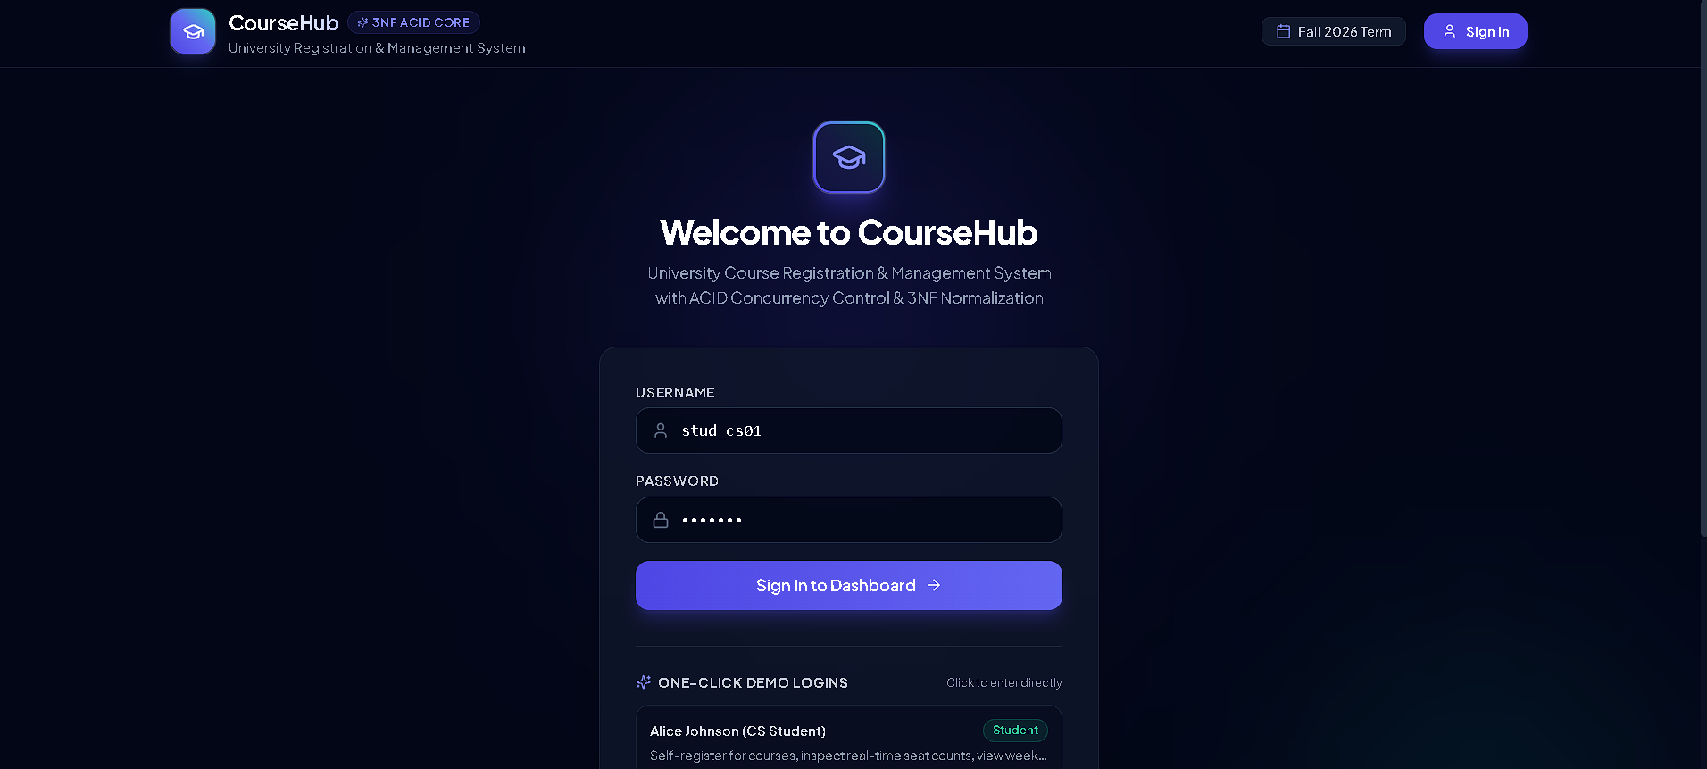
Figure 2: Login page with username/password form and one-click demo logins for each role
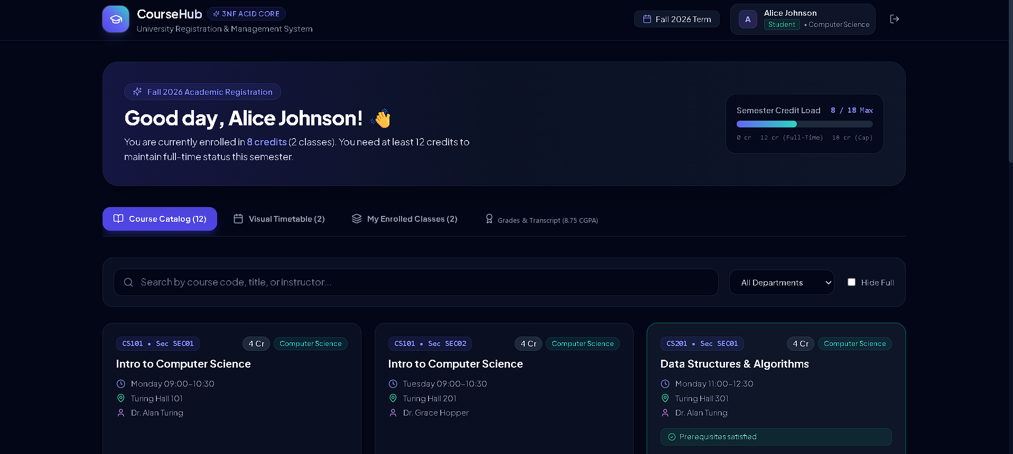
Figure 3: Student dashboard: credit-load meter, tabs, search, department filter and course catalog
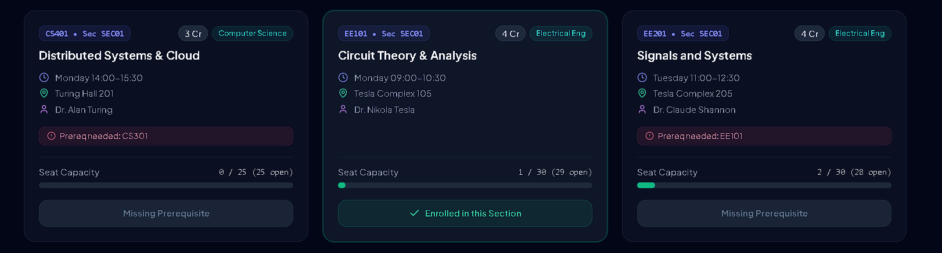
Figure 4: Course cards showing seat capacity, enrolled state and missing-prerequisite warnings
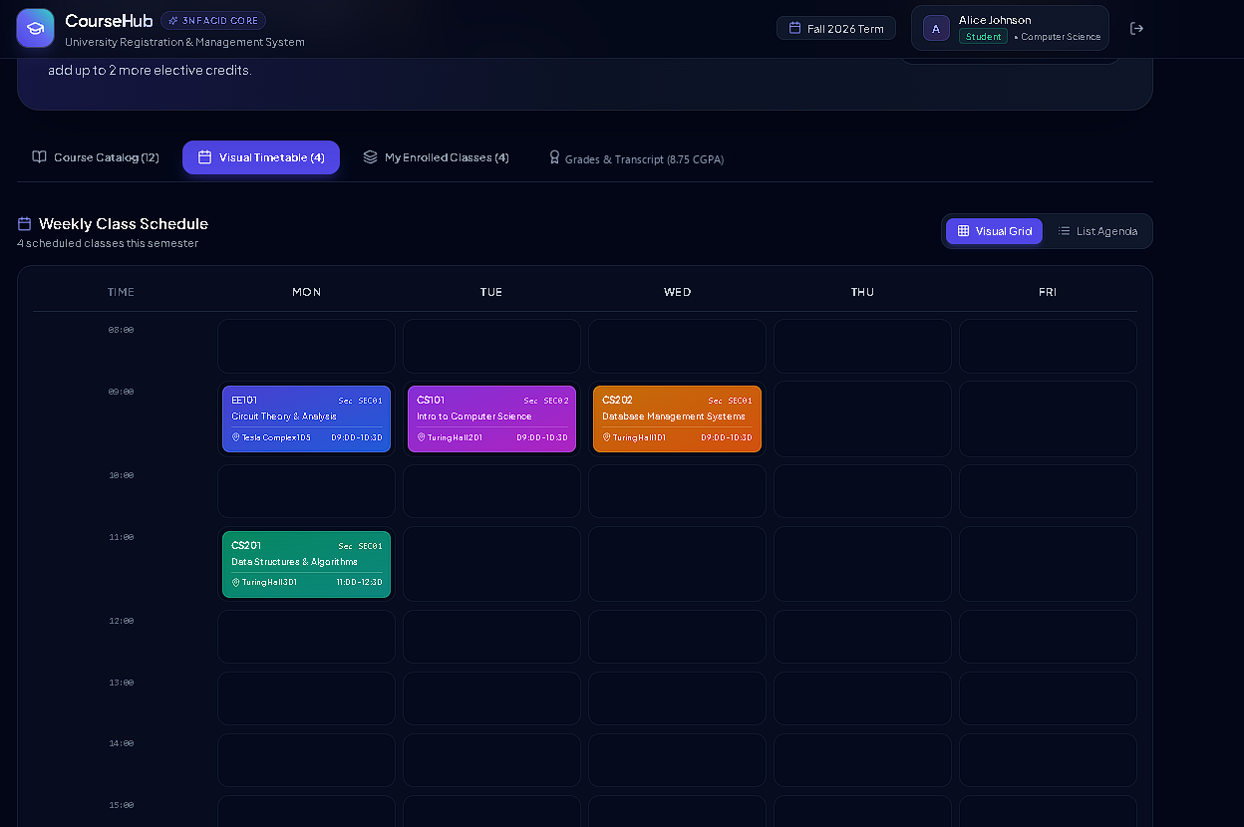
Figure 5: Student weekly timetable (visual grid view)
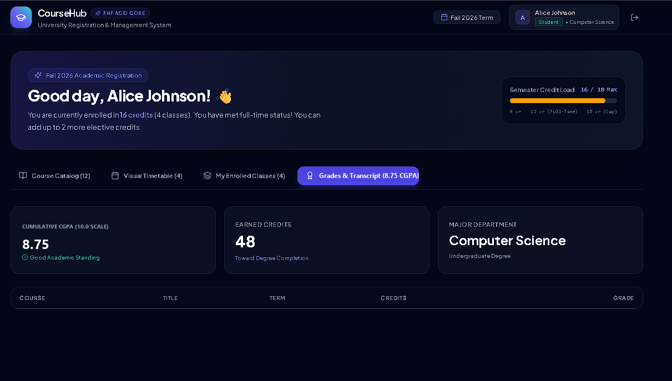
Figure 6: Student Grades & Transcript page with cumulative CGPA (10.0 scale) and earned credits
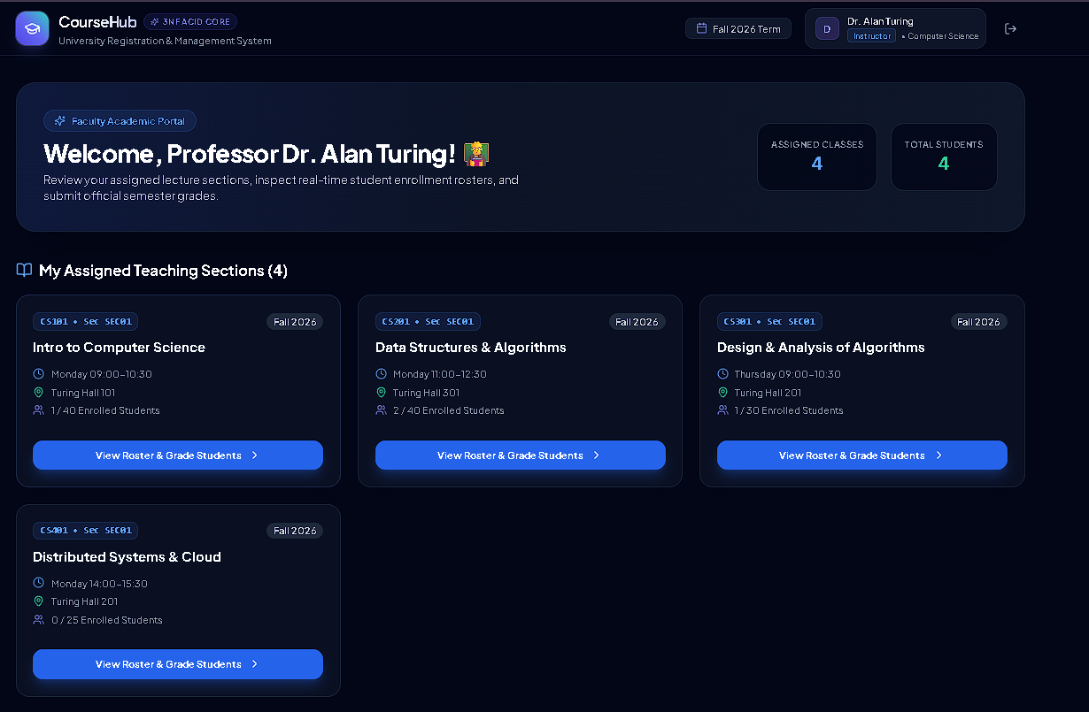
Figure 7: Instructor portal: assigned sections with enrolment and roster/grading access
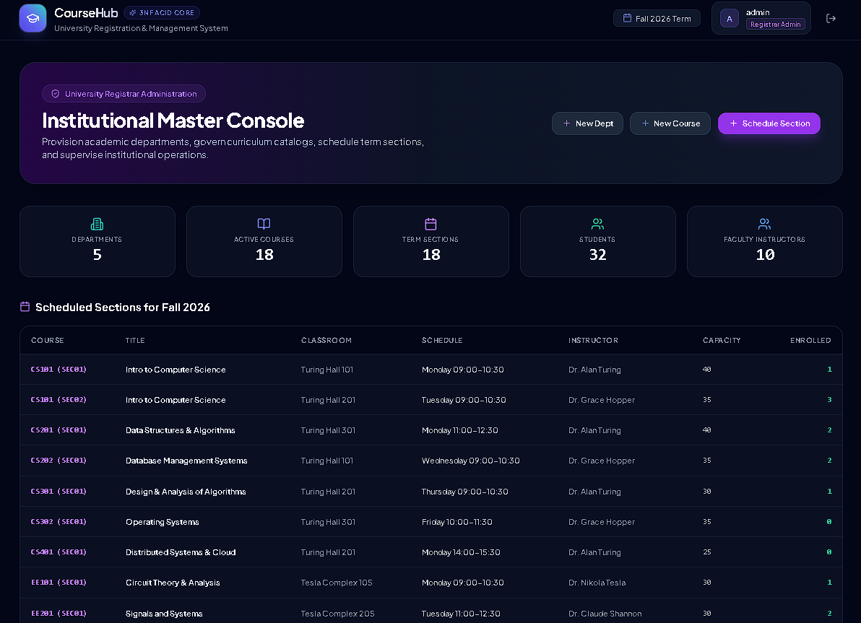
Figure 8: Admin Institutional Master Console with master-data actions and Fall 2026 section schedule

8. PL/SQL Procedures, Functions & Triggers
Oracle PL/SQL, matching the lab manual (a PL/pgSQL port is straightforward). These routines move the registration rules into the database so any client (Django, Java, SQL*Plus) gets identical behaviour.

8.1 Functions
-- Seats still free in a section
CREATE OR REPLACE FUNCTION fn_seats_available(p_section_pk IN NUMBER) RETURN NUMBER IS
v_cap NUMBER; v_enr NUMBER;
BEGIN
SELECT s.capacity,
(SELECT COUNT(*) FROM takes t WHERE t.course_id = s.course_id AND t.section_id = s.section_id
AND t.semester = s.semester AND t.year = s.year)
INTO v_cap, v_enr
FROM section s WHERE s.id = p_section_pk;
RETURN v_cap - v_enr;
EXCEPTION
WHEN NO_DATA_FOUND THEN RETURN NULL;
END fn_seats_available;
/

-- Credits a student already holds in a semester
CREATE OR REPLACE FUNCTION fn_semester_credits(p_student_id IN VARCHAR2, p_sem IN VARCHAR2, p_year IN NUMBER)
RETURN NUMBER IS
v_total NUMBER;
BEGIN
SELECT NVL(SUM(c.credits), 0) INTO v_total
FROM takes t JOIN course c ON c.course_id = t.course_id
WHERE t.student_id = p_student_id AND t.semester = p_sem AND t.year = p_year;
RETURN v_total;
END fn_semester_credits;
/

8.2 Procedure: transactional registration (row lock + five checks)
CREATE OR REPLACE PROCEDURE sp_register_course(
p_student_id IN VARCHAR2,
p_section_pk IN NUMBER,
p_status OUT VARCHAR2) AS
v_sec section%ROWTYPE;
v_credits course.credits%TYPE;
v_day time_slot.day%TYPE;
v_start time_slot.start_time%TYPE;
v_end time_slot.end_time%TYPE;
v_cnt NUMBER;
BEGIN
-- 1. Exclusive row lock: concurrent registrations for this section queue here
SELECT * INTO v_sec FROM section WHERE id = p_section_pk FOR UPDATE;
SELECT credits INTO v_credits FROM course WHERE course_id = v_sec.course_id;

-- 2. Capacity (counted after the lock, so the number is fresh)
SELECT COUNT(*) INTO v_cnt FROM takes
WHERE course_id = v_sec.course_id AND section_id = v_sec.section_id
AND semester = v_sec.semester AND year = v_sec.year;
IF v_cnt >= v_sec.capacity THEN
ROLLBACK; p_status := 'REJECTED: Section is full'; RETURN;
END IF;

-- 3. Duplicate registration
SELECT COUNT(*) INTO v_cnt FROM takes
WHERE student_id = p_student_id AND course_id = v_sec.course_id
AND semester = v_sec.semester AND year = v_sec.year;
IF v_cnt > 0 THEN
ROLLBACK; p_status := 'REJECTED: Already registered'; RETURN;
END IF;

-- 4. Prerequisites: any prerequisite without a passing grade blocks the registration
SELECT COUNT(*) INTO v_cnt FROM prereq p
WHERE p.course_id = v_sec.course_id
AND NOT EXISTS (SELECT 1 FROM takes t
WHERE t.student_id = p_student_id AND t.course_id = p.prereq_id
AND t.grade IN ('A+','A','A-','B+','B','B-','C+','C','C-','D','P'));
IF v_cnt > 0 THEN
ROLLBACK; p_status := 'REJECTED: Missing prerequisite'; RETURN;
END IF;

-- 5. Time-slot clash (same weekday, overlapping interval)
SELECT day, start_time, end_time INTO v_day, v_start, v_end
FROM time_slot WHERE time_slot_id = v_sec.time_slot_id;
SELECT COUNT(*) INTO v_cnt
FROM takes t
JOIN section s ON s.course_id = t.course_id AND s.section_id = t.section_id
AND s.semester = t.semester AND s.year = t.year
JOIN time_slot x ON x.time_slot_id = s.time_slot_id
WHERE t.student_id = p_student_id AND t.semester = v_sec.semester AND t.year = v_sec.year
AND x.day = v_day AND x.start_time < v_end AND x.end_time > v_start;
IF v_cnt > 0 THEN
ROLLBACK; p_status := 'REJECTED: Time-slot clash'; RETURN;
END IF;

-- 6. Credit cap (18 per semester)
IF fn_semester_credits(p_student_id, v_sec.semester, v_sec.year) + v_credits > 18 THEN
ROLLBACK; p_status := 'REJECTED: Credit limit exceeded'; RETURN;
END IF;

-- 7. All checks passed: register and release the lock
INSERT INTO takes (student_id, course_id, section_id, semester, year, grade)
VALUES (p_student_id, v_sec.course_id, v_sec.section_id, v_sec.semester, v_sec.year, 'IP');
COMMIT;
p_status := 'OK: Registered';
EXCEPTION
WHEN OTHERS THEN
ROLLBACK;
p_status := 'ERROR: ' || SQLERRM;
END sp_register_course;
/

8.3 Procedure: grade submission (instructor must teach the section)
CREATE OR REPLACE PROCEDURE sp_submit_grade(
p_instructor_id IN VARCHAR2, p_student_id IN VARCHAR2,
p_section_pk IN NUMBER, p_grade IN VARCHAR2) AS
v_sec section%ROWTYPE;
v_cnt NUMBER;
BEGIN
SELECT * INTO v_sec FROM section WHERE id = p_section_pk;
SELECT COUNT(*) INTO v_cnt FROM teaches
WHERE instructor_id = p_instructor_id AND course_id = v_sec.course_id
AND section_id = v_sec.section_id AND semester = v_sec.semester AND year = v_sec.year;
IF v_cnt = 0 THEN
RAISE_APPLICATION_ERROR(-20403, 'Instructor is not assigned to this section');
END IF;
UPDATE takes SET grade = p_grade
WHERE student_id = p_student_id AND course_id = v_sec.course_id
AND section_id = v_sec.section_id AND semester = v_sec.semester AND year = v_sec.year;
IF SQL%ROWCOUNT = 0 THEN
RAISE_APPLICATION_ERROR(-20404, 'Student is not registered in this section');
END IF;
COMMIT;
END sp_submit_grade;
/

8.4 Triggers
-- T1: administrative section capacity may not exceed the physical room capacity
CREATE OR REPLACE TRIGGER trg_section_room_capacity
BEFORE INSERT OR UPDATE ON section FOR EACH ROW
DECLARE v_room_cap classroom.capacity%TYPE;
BEGIN
SELECT capacity INTO v_room_cap FROM classroom
WHERE building = :NEW.building AND room_number = :NEW.room_number;
IF :NEW.capacity > v_room_cap THEN
RAISE_APPLICATION_ERROR(-20001, 'Section capacity exceeds room capacity');
END IF;
EXCEPTION
WHEN NO_DATA_FOUND THEN NULL;
END;
/

-- T2: when a grade moves from IP to a passing grade, add the course credits to the student's total
CREATE OR REPLACE TRIGGER trg_grade_updates_credits
AFTER UPDATE OF grade ON takes FOR EACH ROW
WHEN (OLD.grade = 'IP' AND NEW.grade IN ('A+','A','A-','B+','B','B-','C+','C','C-','D','P'))
BEGIN
UPDATE student
SET tot_cred = tot_cred + (SELECT credits FROM course WHERE course_id = :NEW.course_id)
WHERE student_id = :NEW.student_id;
END;
/

Note: The seat-capacity check lives inside sp_register_course, under the row lock, rather than in a trigger: an Oracle row-level trigger cannot query the table it fires on (error ORA-04091, "mutating table"). PostgreSQL has no such restriction and can enforce it with a BEFORE INSERT trigger on takes.

8.5 Demonstration block
SET SERVEROUTPUT ON
DECLARE v_status VARCHAR2(100);
BEGIN
DBMS_OUTPUT.PUT_LINE('Seats free in CS401 SEC01: ' || fn_seats_available(7));
sp_register_course('S1001', 7, v_status); -- CS401 needs CS301: expect a prerequisite rejection
DBMS_OUTPUT.PUT_LINE(v_status);
sp_submit_grade('I101', 'S1001', 3, 'A'); -- Dr. Turing grades Alice in CS201 SEC01
END;
/

9. Java Code for Functional Design
The alternate backend (Jakarta Servlets 6.0, JDBC, HikariCP) shares the same schema. The three classes below show DB connectivity, data access with PreparedStatement, and the PL/SQL procedure call through CallableStatement, including the "No Database Connectivity" handling the lab requires.

9.1 Database connectivity (connection pool)
import com.zaxxer.hikari.HikariConfig;
import com.zaxxer.hikari.HikariDataSource;
import java.sql.Connection;
import java.sql.SQLException;

public final class DBConnection {
private static HikariDataSource ds;

private DBConnection() {}

public static synchronized Connection get() throws SQLException {
if (ds == null) {
HikariConfig cfg = new HikariConfig();
cfg.setJdbcUrl(System.getenv("DB_URL")); // e.g. jdbc:postgresql://localhost:5432/university
cfg.setUsername(System.getenv("DB_USER"));
cfg.setPassword(System.getenv("DB_PASS"));
cfg.setMaximumPoolSize(10);
cfg.setConnectionTimeout(5000); // fail fast when the DB is down
ds = new HikariDataSource(cfg);
}
return ds.getConnection();
}
}

9.2 Data access: queries, transaction, procedure call
import java.sql.*;
import java.util.*;

public class RegistrationDao {

/** Live seat badge: "Available (28/30)" or "Full". */
public String seatBadge(int sectionPk) throws SQLException {
String sql = "SELECT s.capacity, COUNT(t.student_id) AS enrolled FROM section s "
+ "LEFT JOIN takes t ON t.course_id = s.course_id AND t.section_id = s.section_id "
+ "AND t.semester = s.semester AND t.year = s.year "
+ "WHERE s.id = ? GROUP BY s.capacity";
try (Connection con = DBConnection.get();
PreparedStatement ps = con.prepareStatement(sql)) {
ps.setInt(1, sectionPk); // bound parameter: no SQL injection
try (ResultSet rs = ps.executeQuery()) {
if (!rs.next()) return "Unknown section";
int cap = rs.getInt("capacity"), enr = rs.getInt("enrolled");
return enr >= cap ? "Full" : "Available (" + (cap - enr) + "/" + cap + ")";
}
}
}

/** Registration through the PL/SQL procedure (row lock + all rule checks inside the DB). */
public String register(String studentId, int sectionPk) throws SQLException {
try (Connection con = DBConnection.get();
CallableStatement cs = con.prepareCall("{call sp_register_course(?, ?, ?)}")) {
cs.setString(1, studentId);
cs.setInt(2, sectionPk);
cs.registerOutParameter(3, Types.VARCHAR);
cs.execute();
return cs.getString(3); // "OK: Registered" or "REJECTED: ..."
}
}

/** Drop a course: explicit transaction with commit/rollback. */
public boolean drop(String studentId, String courseId, String sectionId,
String semester, int year) throws SQLException {
String sql = "DELETE FROM takes WHERE student_id = ? AND course_id = ? "
+ "AND section_id = ? AND semester = ? AND year = ?";
try (Connection con = DBConnection.get()) {
con.setAutoCommit(false);
try (PreparedStatement ps = con.prepareStatement(sql)) {
ps.setString(1, studentId); ps.setString(2, courseId);
ps.setString(3, sectionId); ps.setString(4, semester); ps.setInt(5, year);
int rows = ps.executeUpdate();
con.commit();
return rows == 1;
} catch (SQLException e) {
con.rollback();
throw e;
}
}
}
}

9.3 Servlet: role guard, procedure call, error handling
import jakarta.servlet.annotation.WebServlet;
import jakarta.servlet.http.*;
import java.io.IOException;
import java.sql.SQLException;

@WebServlet("/api/register")
public class RegisterServlet extends HttpServlet {
private final RegistrationDao dao = new RegistrationDao();

@Override
protected void doPost(HttpServletRequest req, HttpServletResponse resp) throws IOException {
resp.setContentType("application/json");
HttpSession session = req.getSession(false);
String role = session == null ? null : (String) session.getAttribute("role");
if (!"student".equals(role)) { // RBAC guard
resp.setStatus(HttpServletResponse.SC_FORBIDDEN);
resp.getWriter().write("{\"message\":\"Students only\"}");
return;
}
try {
String studentId = (String) session.getAttribute("studentId");
int sectionPk = Integer.parseInt(req.getParameter("section_id"));
String status = dao.register(studentId, sectionPk);
resp.setStatus(status.startsWith("OK") ? 200 : 400);
resp.getWriter().write("{\"message\":\"" + status.replace("\"", "'") + "\"}");
} catch (NumberFormatException e) {
resp.setStatus(400);
resp.getWriter().write("{\"message\":\"Invalid section id\"}");
} catch (SQLException e) { // "No Database Connectivity"
resp.setStatus(503);
resp.getWriter().write("{\"message\":\"Database unavailable, try again later\"}");
}
}
}

9.4 Verification
The Django implementation of the same rules is covered by 9 automated unit tests in apps/tests/test_business_rules.py, all passing (about 0.30 s): prerequisite satisfied, prerequisite missing, capacity limit, time-slot clash, credit limit, duplicate registration, student drop, instructor grade update, and non-assigned instructor denied (HTTP 403). A multi-role end-to-end run (admin creates → student registers → instructor grades → student views grade) was also verified.

10. References
- A. Silberschatz, H. F. Korth, S. Sudarshan, Database System Concepts, 6th Edition, McGraw-Hill.
- Ivan Bayross, SQL, PL/SQL, 2nd/3rd Edition, BPB Publications.
- Oracle Corp., PL/SQL Language Reference, docs.oracle.com.
- G. Reese, Database Programming with JDBC and Java, 2nd Edition, O'Reilly, 2000.
- learndb.com, Databases, http://www.learndb.com/databases
- Django Software Foundation, Django 5.2 Documentation: Database transactions and select_for_update(), docs.djangoproject.com.
- PostgreSQL Global Development Group, PostgreSQL Documentation: Explicit Locking, postgresql.org/docs.

