**The change in electrical resistance under mechanical strain** is called the piezoresistive effect.

Lithography, which is also called optical lithography or UV lithography, is a process used in microfabrication to pattern parts of a thin film or the bulk of a substrate

**Key Features**

* Miniaturization
* Mass fabricationMicro
* Electronic Integration
* Multi-physics
* Low power consumption
* Highly efficient
* Light weight
* Enhanced performance and reliability

Compatibility

**Advantages of MEMS**

* Minimize vitality.
* Cost of device is less.
* Performance is better.
* Improved reproducible.
* Improved reliability.

Good selectivity and as well as good sensitivity

* **Micro-electromechanical systems** (MEMS) is a process technology used to create tiny integrated devices that combine mechanical and electrical components. can range in size from a few micrometers to millimetres
* More than one component is combined, such as the pairing of microsensors, microactuators and microelectronic structures onto one silicon substrate with integrated circuits.
* These devices (or systems) have the ability to sense, control and actuate on the micro scale and generate effects on the macro scale
* The small size, low power consumption and long-term stability of MEMS devices also makes them well suited to markets such as aerospace where long life and reliability are important.
* 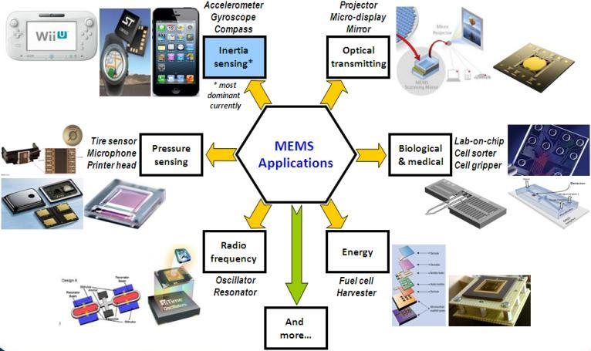MEMS devices take advantage of lithographic techniques, so there is not a practical limit to the size improvements. It is a batch fabrication techniques
* MEMS sensors have the advantage of very small size. This means they can respond rapidly to small changes in pressure.



* A pressure sensor is an electronic device that detects, regulates and monitors pressure
* The main advantages of piezoresistive sensors are high linearity and stability

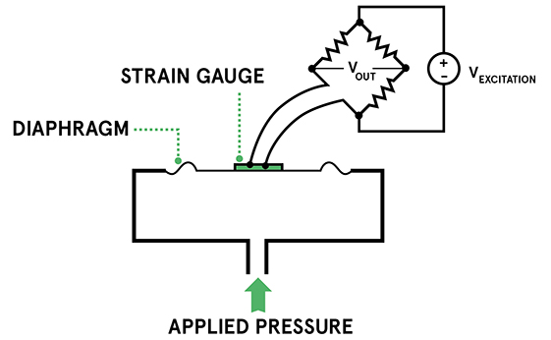

s

The objectives of the proposed research are listed below.

1. To investigate existing design mechanisms, performance parameters and optimization techniques for micro piezoresistive pressure sensor.

2. To employ structural optimization to optimize the dimensions of micro piezoresistive pressure sensor to enhance sensitivity.

3. To generate neural network algorithm to obtain the appropriate dimension of micro piezoresistive pressure sensor for a specified sensitivity of levels.

Methodology

1.Carry out literature review to comprehend existing design mechanisms , performance parameters and optimization techniques used in micro piezoresistive pressure sensor

2. Use an structural optimization to develop optimized micro piezoresistive pressure sensor with enhanced sensitivity.

3. To developing neural network algorithm to obtain dimension of micro piezoresistive pressure sensor when sensitivity levels are specified.

D: Work Carried Out So Far

* Simulation of existing models and studied their performance analysis of micro pressure sensor. Models of different shapes of diaphragms.
* And wrote paper on the literature survey .

E: Results And Discussions

* Deformation obtained for a square membrane
* 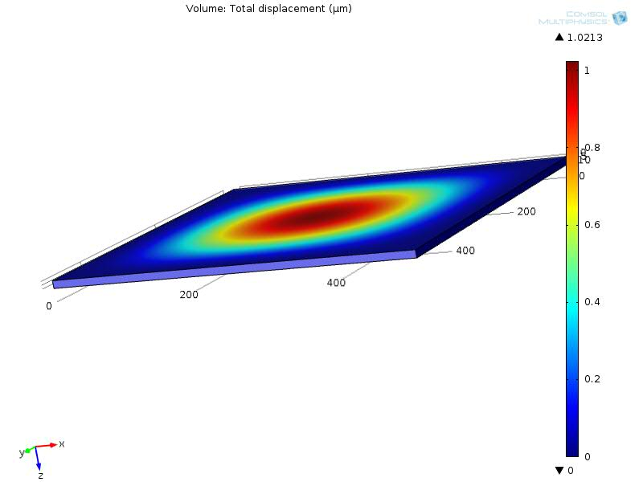
* Formula to find maximum deflection for square diaphragm

W (max)= (0.0151*(1-γ^2)*P*a^4)/(E*h^3)

* γ- Poisson’s ratio (0.28) h=Thickness
* P- Applied pressure
* For constant pressure of 1MPa and vary the thickness of 5um-50um  
  Size: *500um*500um*, Shape: *Square  
  (thick V/s deformation*a- Side length (500um) E- Young’s modulus (170e^9)
* Graph of diaphragm deformation v/s thickness
* Analysis
* As can be seen from graph the central deflection is increased when the applied pressure increased. .
* Both analytical and simulation results are arbitrarily equal
* comparison for circle, square and rectangle diaphragm  
   Deformation v/s Thickness.
* For constant area of circle, rectangle and square diaphragm, the deformation obtained is high for circular diaphragm.
* comparison for circle, square and rectangle diaphragm  
   Deformation v/s Pressure
* 
* For constant area of circle, rectangle and square diaphragm, the deformation obtained is high for circular diaphragm
* Sensitivity calculation (Simulated Values)

|  |  |  |  |
| --- | --- | --- | --- |
| * **Diaphragm** | * **Square** | * **Rectangle** | * **Circle** |
| Sensitivity(10^-12) | 5.10 | 2.34 | 6.39 |

Sensitivity calculation (theoretical values)

|  |  |  |  |
| --- | --- | --- | --- |
| **Diaphragm** | **Square** | **Rectangle** | **Circle** |
| Sensitivity(10^-12) | 5.116 | 2.307 | 6.430 |

Piezoresistive material

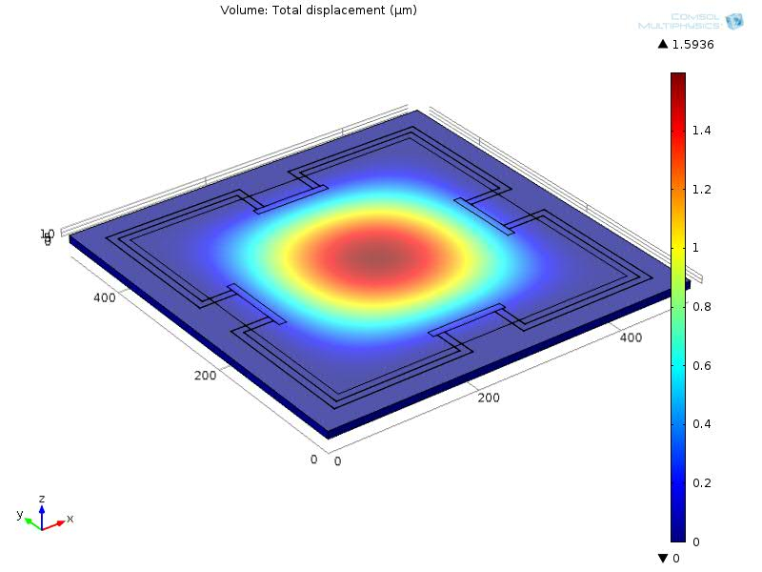

SENSITIVITY CALCULATION

|  |  |  |
| --- | --- | --- |
| **Diaphragm** | **zero turn** | **two turn** |
| Sensitivity(10^-9) | 0.0225 | 0.0026 |

Further Work To Bo Carried Out

* Research to be carried on finding definite dimensions of the sensors
* To generate neural network algorithm to obtain the appropriate dimension of micro piezoresistive pressure sensor for a specified sensitivity of levels.
* ANN approach is used to decide the dimensions of the piezoresistors for the targeted application.
* The ANN approach design and analysis is done using MATLAB. The results obtained by ANN method are validated using the FEM tool simulation, which show that the developed models have good accuracy over the range of switch dimension values for the intended application.

CONCLUSION

* Simulation results show that resistors should be placed at high stress regions, high occurs at the centre of the four edges.
* Appropriate length of resistors is found to be 100*µ*m and width 5*µ*m.
* Meander shape for the resistors has been simulated with different turns. Simulation results show that one-turn and two-turn shapes provide good sensitivity with very minimum offset.
* Therefore design with 100*µ*m Piezoresistors, width of 5*µ*m and two-turn meander configuration would provide good sensitivity and better performance over a pressure range of 0 to 1MPa.
* ANN approach is used to decide the dimensions of the sensor for the targeted application.
* The ANN approach design and analysis is done using MATLAB. The results obtained by ANN method are validated using the FEM tool simulation, which show that the developed models have good accuracy over the range of switch dimension values for the intended application.

Scupus gives ratings to springer and web of science