Abstract: 1
Keywords: 2
Chapter 1: Introduction 2
1.1 Background 3
1.2 Problem Statement 4
1.3 Research Objectives 4
1.4 Research Questions 5
1.5 Significance of the Study 6
1.6 Structure of the Dissertation 7
Chapter 2: Literature Review 8
Summary of Recent Research 13
Chapter 3: Methodology 14
3.1 Research Design 15
3.2 Dataset Selection 16
3.3 Data Preprocessing 18
3.4 Model Selecton 20
3.5 Base Models Description 22
3.6 Hybrid Model Design 26
3.7 Evaluation Metrics 29
Chapter 4 — Dataset Description 32
Chapter 5: Results and Analysis 33
5.1 Base Model Results 34
5.2 Hybrid Model Results 35
5.3 Accuracy Comparison 38
5.4 Precision Comparison 41
5.5 Recall Comparison 43
5.6 F1 Score Comparison 45
5.7 Confusion Matrix Analysis 48
5.8 ROC Curve Analysis 57
Chapter 6: Discussion 61
6.2 Why the Hybrid Model Outperforms 62
6.3 Naive Bayes Anomaly Explained 65
6.4 Real World Implications 68
Chapter 7: Conclusion 71
7.2 Summary of Findings 72
7.3 Research Contributions 73
7.4 Limitations 75
7.5 Future Work 77
References 80

Abstract:

Phishing attacks represent one of the most prevalent and damaging cybersecurity threats in the modern digital landscape, targeting individuals and organizations by disguising malicious websites as legitimate ones. This dissertation presents a comprehensive machine learning based approach for the automated detection of phishing websites using a curated dataset of 11,055 website samples characterized by 30 distinct features. Six individual classification models were developed and evaluated, namely XGBoost, Random Forest, Decision Tree, Support Vector Machine, Logistic Regression, and Naive Bayes. To further improve detection performance, a hybrid ensemble model combining XGBoost and Decision Tree through a Stacking Classifier approach was proposed and evaluated against all base models. All models were trained and tested using an 80/20 train-test split and evaluated across four performance metrics — Accuracy, Precision, Recall and F1 Score. The proposed hybrid model XGBoost + Decision Tree Stacking achieved the highest overall performance with an accuracy of 96.83%, precision of 96.47%, recall of 98.01% and F1 score of 97.23%, outperforming all individual base models. The results demonstrate that ensemble-based hybrid models offer a significant advantage in phishing detection tasks, particularly in minimizing false negatives — cases where phishing websites are incorrectly classified as legitimate — which carry the greatest real-world risk. This research contributes a reliable, scalable and interpretable framework for phishing website detection that can be integrated into real-world cybersecurity systems.

Keywords:

Phishing Website Detection, Machine Learning, Ensemble Learning, Hybrid Model, Binary Classification, Confusion Matrix, ROC Curve, AUC Score, Feature Extraction, URL Analysis, Web Security.

Chapter 1: Introduction

Background
The rapid expansion of the internet and digital services has fundamentally transformed the way individuals, businesses and governments operate in the modern world. While this digital revolution has brought unprecedented convenience and connectivity, it has simultaneously introduced a wide range of cybersecurity threats that continue to evolve in sophistication and scale. Among these threats, phishing attacks have emerged as one of the most widespread and damaging forms of cybercrime, causing significant financial losses and compromising the personal data of millions of users worldwide.
Phishing is a form of social engineering attack in which cybercriminals design fraudulent websites that closely mimic legitimate ones, with the intention of deceiving users into revealing sensitive information such as login credentials, banking details and personal identification data. These attacks exploit human psychology rather than technical vulnerabilities, making them particularly difficult to detect and prevent through conventional security measures alone.
The increasing volume and complexity of phishing attacks has driven researchers and cybersecurity professionals to explore automated detection mechanisms. Machine learning has emerged as a promising solution in this domain, offering the ability to analyse large volumes of website data, identify subtle patterns and classify websites as either legitimate or phishing with high accuracy. Unlike rule-based systems that require constant manual updates, machine learning models can adapt to new phishing strategies through data-driven learning, making them a more robust and scalable approach to phishing detection.

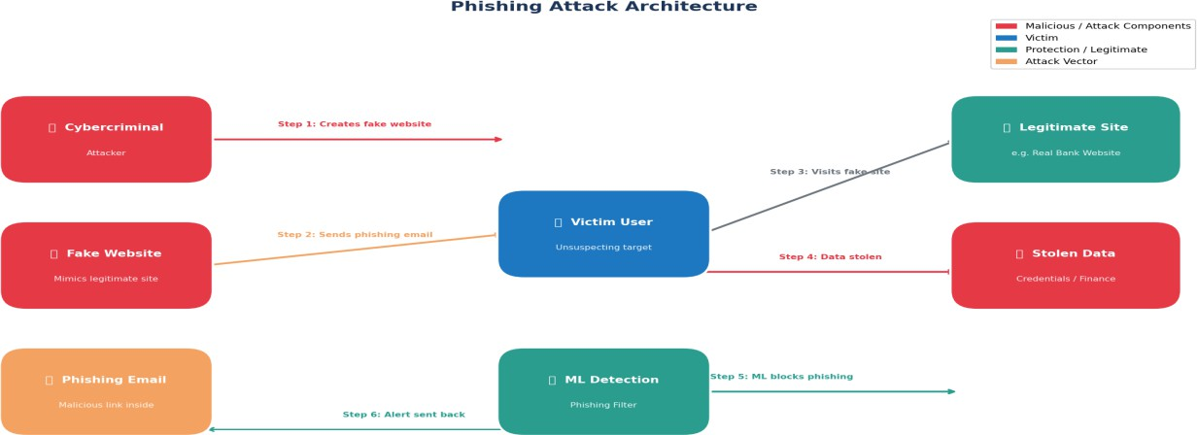

[FIG-1.1 : Phishing Attack Architecture]

Problem Statement
Despite significant advancements in cybersecurity technologies, phishing attacks continue to pose a severe and growing threat to internet users globally. Traditional detection methods such as blacklists, rule-based filters and manual inspection have proven increasingly inadequate in keeping pace with the rapidly evolving tactics employed by cybercriminals. These conventional approaches suffer from several critical limitations including delayed response times, inability to detect newly created phishing websites, high rates of false positives and the requirement for constant manual maintenance and updates.
While numerous machine learning based solutions have been proposed in existing literature, the majority of studies focus on evaluating individual classification models in isolation, without exploring the potential performance gains that can be achieved through the combination of multiple models. Furthermore, many existing approaches fail to provide a comprehensive evaluation across multiple performance metrics, often reporting accuracy alone without considering the critical importance of recall — the ability to correctly identify all phishing websites
— which is of paramount importance in real-world cybersecurity applications where missing a phishing website can result in significant harm to users.
This research addresses these limitations by developing and evaluating six individual machine learning classifiers alongside a hybrid ensemble model that combines the strengths of multiple algorithms. The study employs a comprehensive evaluation framework covering accuracy, precision, recall and F1 score to provide a thorough and balanced assessment of each model's performance in detecting phishing websites. The ultimate goal is to identify the most effective and reliable approach for phishing website detection that can be deployed in real-world cybersecurity systems.

Research Objectives
The primary aim of this research is to develop, evaluate and compare machine learning based models for the automated detection of phishing websites, with the objective of identifying the most accurate and reliable approach suitable for real-world cybersecurity applications. To achieve this aim, the following specific objectives have been established:
Objective 1 — Dataset Preparation: To collect and preprocess a comprehensive phishing website dataset comprising 11,055 samples and 30 features, ensuring data quality, consistency and suitability for machine learning model training and evaluation.
Objective 2 — Base Model Development: To develop and train six individual machine learning classification models, namely XGBoost, Random Forest, Decision Tree, Support Vector Machine, Logistic Regression and Naive Bayes, using the prepared dataset with an 80/20 train-test split.
Objective 3 — Hybrid Model Design: To design and implement a hybrid ensemble model combining XGBoost and Decision Tree classifiers through a Stacking Classifier approach, with the aim of achieving superior detection performance compared to individual base models.
Objective 4 — Comprehensive Evaluation: To evaluate all seven models across four performance metrics — Accuracy, Precision, Recall and F1 Score — alongside Confusion Matrix and ROC Curve analysis, providing a thorough and balanced assessment of each model's strengths and weaknesses.
Objective 5 — Comparative Analysis: To conduct a detailed comparative analysis of all models, identifying the best performing approach and providing evidence-based justification for its selection as the recommended phishing detection model.
Objective 6 — Real World Applicability: To assess the practical implications of the research findings and discuss the potential integration of the proposed hybrid model into real-world cybersecurity systems for phishing website detection.

Research Questions
To guide the direction of this research and ensure a focused and structured investigation, the following research questions have been formulated:
Research Question 1: Which individual machine learning classification algorithm achieves the highest performance in detecting phishing websites when evaluated across accuracy, precision, recall and F1 score metrics?

Research Question 2: Does a hybrid ensemble model combining XGBoost and Decision Tree classifiers through a Stacking approach outperform all individual base models in phishing website detection?
Research Question 3: What are the strengths and weaknesses of each evaluated machine learning model in the context of phishing website detection, and how do these characteristics affect their suitability for real-world deployment?
Research Question 4: Why does the Naive Bayes classifier demonstrate an exceptionally high precision score of 99.70% yet achieve a critically low recall score of 26.61%, and what are the practical implications of this behaviour in a real-world phishing detection scenario?
Research Question 5: How effectively can the proposed hybrid XGBoost and Decision Tree Stacking model minimise false negatives — instances where phishing websites are incorrectly classified as legitimate — which represent the most dangerous type of classification error in cybersecurity applications?
Research Question 6: What is the overall contribution of this research to the field of machine learning based phishing website detection, and what future directions can be pursued to further improve detection performance?

Significance of the Study
This research holds significant importance from both an academic and practical perspective, contributing meaningfully to the growing body of knowledge in the field of machine learning based cybersecurity solutions. The significance of this study can be understood across several key dimensions:

Academic Significance:
This research makes a valuable academic contribution by providing a comprehensive and systematic comparison of six widely used machine learning classification algorithms alongside a novel hybrid ensemble model for phishing website detection. Unlike many existing studies that evaluate models in isolation or report limited evaluation metrics, this research adopts a multi-metric evaluation framework covering accuracy, precision, recall, F1 score, confusion matrix analysis and ROC curve analysis. This thorough approach provides a more complete and reliable picture of each model's true performance characteristics, contributing to a deeper academic understanding of machine learning based phishing detection.

Practical Significance:

From a practical standpoint, phishing attacks continue to cause billions of dollars in financial losses annually while compromising the personal data and privacy of millions of internet users worldwide. The hybrid XGBoost and Decision Tree Stacking model developed in this research achieves an accuracy of 96.83% and a recall of 98.01%, meaning it successfully identifies the vast majority of phishing websites while maintaining a low false negative rate. This level of performance makes the proposed model a strong candidate for integration into real-world cybersecurity systems, browser extensions, email filtering tools, and organisational security frameworks.

Methodological Significance:
This research demonstrates the value of hybrid ensemble approaches in machine learning, showing that combining the strengths of multiple classifiers through stacking can yield superior results compared to any single model used in isolation. The methodology employed in this study — from data preprocessing and model training through to comprehensive evaluation and visualization — provides a replicable framework that future researchers can adopt and build upon in related cybersecurity domains.

Social Significance:
At a broader societal level, this research contributes to the protection of everyday internet users who may lack the technical knowledge to identify phishing websites manually. By advancing the accuracy and reliability of automated phishing detection systems, this study ultimately supports the creation of a safer and more trustworthy digital environment for individuals, businesses and organizations worldwide.

Structure of the Dissertation
This dissertation is organized into seven chapters, each addressing a distinct aspect of the research. The following provides a brief overview of the content and purpose of each chapter:

Chapter 1 — Introduction:
This chapter introduces the research by providing a background on phishing attacks and the limitations of traditional detection methods. It establishes the problem statement, outlines the research objectives and questions, and highlights the academic, practical, methodological and social significance of the study. The chapter concludes with an overview of the dissertation structure.

Chapter 2 — Literature Review:
This chapter presents a comprehensive review of existing research in the field of phishing website detection. It examines traditional detection approaches, surveys machine learning based methods

proposed in prior studies, explores the use of ensemble and hybrid models in related work, and identifies the key research gaps that this dissertation aims to address.

Chapter 3 — Methodology:
This chapter describes the research design and the step-by-step process followed in developing and evaluating the phishing detection models. It covers dataset selection, data preprocessing, model selection and configuration, the design of the hybrid ensemble model, and the evaluation metrics employed to assess model performance.

Chapter 4 — Dataset Description:
This chapter provides a detailed description of the phishing website dataset used in this research. It covers the dataset overview, a description of all 30 features, the class distribution between phishing and legitimate websites, and the preprocessing steps applied to prepare the data for model training and evaluation.

Chapter 5 — Results and Analysis:
This chapter presents the results obtained from training and evaluating all seven models. It provides a detailed analysis of each model's performance across accuracy, precision, recall and F1 score, supported by graphical representations including bar charts, confusion matrices and ROC curves. A comprehensive comparative analysis of all models is also presented.

Chapter 6 — Discussion:
This chapter interprets and discusses the key findings of the research. It explains why the hybrid XGBoost and Decision Tree Stacking model outperforms all individual base models, addresses the anomalous behaviour of the Naive Bayes classifier, and discusses the real-world implications of the research findings for cybersecurity applications.

Chapter 7 — Conclusion:
This final chapter summarises the key findings and contributions of the research. It revisits the research objectives and questions, acknowledges the limitations of the study, and proposes directions for future research that could build upon and extend the work presented in this dissertation.

Chapter 2: Literature Review

Sahingoz et al., proposed a machine learning based phishing detection system that analysed website Uniform Resource Locators (URLs) as the primary source of discriminative features. The authors extracted a comprehensive range of URL based features including URL length, presence of special characters, number of subdomains and use of IP addresses in place of domain names. Seven machine learning classifiers were evaluated on a dataset of over 73,000 URLs, with Random Forest achieving the highest accuracy of 97.98%. However the study focused exclusively on URL based features without incorporating broader website structural and behavioural characteristics, limiting its ability to detect sophisticated phishing attacks that employ legitimate looking URLs while embedding malicious content within the website structure. The present research addresses this limitation by utilising a comprehensive dataset of 30 diverse features spanning URL properties, domain characteristics, security attributes and trust indicators, providing a more holistic and robust basis for phishing website detection. [1]
Jain and Gupta, conducted a study on phishing detection using visual similarity based approaches. The authors proposed a method that analysed the visual appearance of websites by comparing screenshots of suspected phishing pages against known legitimate websites using image processing techniques. The study achieved a detection accuracy of approximately 93% on their experimental dataset. However the approach suffered from significant limitations including high computational cost, inability to detect text based phishing attacks that do not rely on visual mimicry and poor scalability to large volumes of real time website traffic. The present research addresses these limitations by employing machine learning classifiers that analyse structural and behavioural website features rather than visual appearance, enabling faster and more scalable detection that is not limited to visually similar phishing attacks. [2]
Yang et al., investigated phishing website detection using a hybrid approach combining deep Convolutional Neural Networks (CNN) with Random Forest ensemble learning. The authors extracted visual features from website screenshots using CNN and combined them with handcrafted structural features processed by a Random Forest classifier. The proposed hybrid approach achieved an accuracy of 98.2% on their experimental dataset. However the reliance on website screenshots introduced significant computational overhead and latency that limits the system's suitability for real time deployment. Additionally the deep learning component required large amounts of labelled training data and substantial computational resources including GPU hardware that may not be available in all deployment environments. The present research addresses these practical limitations by proposing a computationally efficient hybrid stacking ensemble that combines XGBoost and Decision Tree classifiers without requiring visual feature extraction or GPU hardware, achieving strong detection performance of 96.83% accuracy while remaining practically deployable in resource constrained environments. [3]

Odeh et al., conducted a comprehensive review of machine learning techniques for phishing website detection, examining and categorizing the approaches proposed in existing literature. The review identified Random Forest, Support Vector Machine (SVM) and Neural Networks as the most frequently employed and consistently high performing algorithms in the phishing detection domain. The study highlighted significant gaps in existing research including the lack of standardized evaluation frameworks, inconsistent use of performance metrics and insufficient attention to the practical challenges of real world deployment. The present research directly addresses these identified gaps by adopting a comprehensive and standardized multi-metric evaluation framework encompassing accuracy, precision, recall, F1 score, confusion matrix and Receiver Operating Characteristic (ROC) curve analysis applied consistently across all seven evaluated models. [4]
Gu and Xu, proposed a phishing detection approach based on XGBoost (Extreme Gradient Boosting), evaluating its performance on a publicly available phishing website dataset. The authors demonstrated that XGBoost achieved strong classification performance with accuracy exceeding 96% while offering computational advantages over more complex deep learning approaches. However the study evaluated only a single classifier without exploring ensemble combinations or hybrid approaches that could potentially yield further performance improvements. The present research builds directly upon this finding by using XGBoost as a component within a hybrid stacking ensemble, demonstrating that combining XGBoost with a complementary Decision Tree classifier through a stacking approach yields superior performance compared to XGBoost used in isolation. [5]
Subasi et al., investigated the use of Random Forest for intelligent phishing website detection, evaluating the classifier on a dataset of website features extracted from both phishing and legitimate websites. The study demonstrated that Random Forest achieved high detection accuracy and provided valuable feature importance insights that identified the most discriminative phishing indicators in the dataset. However the study was limited to a single classifier evaluation without comparison against a broader range of algorithms or exploration of ensemble combination strategies. The present research extends this work by evaluating Random Forest alongside five other base classifiers and a hybrid ensemble model, providing a more comprehensive comparative assessment that contextualizes Random Forest performance within the broader machine learning landscape for phishing detection. [6]
Zamir et al., evaluated diverse machine learning algorithms for phishing website detection including Decision Tree (DT), Random Forest (RF), Naive Bayes (NB) and Support Vector Machine (SVM) on a phishing dataset from the UCI repository. The study reported varying performance across classifiers with Random Forest consistently achieving the highest accuracy. However the study did not investigate ensemble combination strategies that could leverage the complementary strengths of multiple classifiers simultaneously and reported only accuracy without comprehensive multi-metric analysis. The present research extends this comparative

approach by additionally evaluating XGBoost and Logistic Regression (LRM) alongside the four algorithms studied by Zamir et al. and by introducing a hybrid stacking ensemble that combines the best performing classifiers to achieve superior overall detection performance. [7]
Shahrivari et al., investigated multiple machine learning techniques for phishing detection including Logistic Regression, Decision Tree, Random Forest, SVM and Neural Networks, providing a systematic comparison of their performance characteristics. The study highlighted the challenges of selecting an optimal classifier for phishing detection given the varying performance profiles of different algorithms across different evaluation metrics. However the study did not explore hybrid ensemble approaches or provide a sufficiently comprehensive evaluation framework to support well informed model selection for real world deployment. The present research addresses this gap by augmenting the classifier comparison with XGBoost and a hybrid stacking model and by adopting a thorough multi-metric evaluation that includes confusion matrix and ROC curve analysis alongside the standard aggregate metrics. [8]
Abdillah et al., investigated phishing website prediction using both base classifiers and ensemble techniques with cross validation, evaluating the performance of individual classifiers alongside simple ensemble combinations. The study demonstrated that ensemble approaches generally outperformed individual base classifiers and highlighted the value of cross validation in producing reliable and unbiased performance estimates. However the study was limited in the range of ensemble strategies explored and did not systematically evaluate stacking based combinations with a learned meta-learner. The present research builds upon this finding by systematically evaluating both voting and stacking ensemble strategies across a comprehensive range of classifier combinations, ultimately identifying the XGBoost and Decision Tree stacking combination as the optimal hybrid configuration with superior performance compared to simpler ensemble approaches. [9]
Hannousse and Yahiouche, conducted an experimental study aimed at establishing benchmark datasets for machine learning based phishing detection, highlighting the significant impact of dataset characteristics on model performance and the importance of standardised benchmark data for enabling reliable cross-study comparisons. The study identified several widely used phishing datasets and evaluated multiple classifiers on each, demonstrating significant performance variation across datasets. This finding underscores the importance of dataset selection in phishing detection research and highlights the challenge of generalising performance results across different data sources. The present research employs a well established and widely used phishing website dataset of 11,055 samples with 30 features to ensure that the reported results are comparable with existing literature and provide a reliable benchmark for future research. [10]
Odeh et al., presented a comparative study of classification models and ensemble learning techniques for phishing website identification, evaluating individual classifiers alongside ensemble approaches and reporting results across multiple performance metrics. The study

confirmed the superiority of ensemble approaches over individual classifiers and highlighted the importance of multi-metric evaluation for assessing practical model suitability. However the study did not specifically investigate stacking based ensemble combinations with a learned meta-learner or provide detailed analysis of anomalous classifier behaviour such as the precision-recall imbalance observed in probabilistic classifiers on phishing datasets. The present research contributes to the literature by providing an explicit investigation and detailed explanation of the Naive Bayes precision-recall anomaly, yielding practically significant insights that are rarely addressed in existing comparative studies. [11]
Chen and Guestrin, introduced XGBoost as a scalable and efficient tree boosting system, demonstrating its superior performance across a wide range of machine learning benchmark tasks. The authors highlighted XGBoost's key advantages including built-in regularisation, efficient handling of sparse data and support for parallel computing, positioning it as a state of the art machine learning algorithm. While this foundational work established XGBoost as a highly effective classification tool it did not specifically evaluate its application to phishing website detection or explore its potential as a component within hybrid ensemble architectures. The present research applies XGBoost to the specific domain of phishing website detection, demonstrating its strong standalone performance of 96.16% accuracy and further exploiting its capabilities as a component within a hybrid stacking ensemble that achieves the highest overall detection performance among all evaluated models. [12]
Breiman, introduced the Random Forest algorithm as an ensemble method that constructs multiple Decision Trees during training and outputs the majority predicted class, demonstrating its superiority over individual decision trees through variance reduction and improved generalization. The study established Random Forest as a robust and versatile classification algorithm with built-in feature importance estimation capabilities. However the original work evaluated Random Forest on general benchmark datasets without specific application to the cybersecurity domain. The present research applies Random Forest to phishing website detection, confirming its strong performance of 96.70% accuracy and positioning it as the strongest performing individual base classifier in the study while demonstrating that further performance gains are achievable through hybrid stacking ensemble combination. [13]
Fette et al., proposed one of the early machine learning based approaches to phishing detection, focusing specifically on email based phishing through the analysis of URL and email header features. The study demonstrated that machine learning classifiers could effectively identify phishing emails with high accuracy, establishing the foundational principle that automated feature based detection could outperform manual rule based approaches. However the study focused exclusively on email phishing without addressing website based phishing detection, and the limited feature set and dataset size constrained the generalisability of the reported results. The present research builds upon this foundational work by extending the machine learning based detection paradigm to phishing websites, employing a substantially richer feature set of 30 diverse website

characteristics and a larger dataset of 11,055 samples to develop more robust and generalisable detection models. [14]
Moghimi and Varjani, proposed a rule based phishing detection method that employed a set of manually defined heuristic rules derived from analysis of known phishing website characteristics. The system analysed features including URL structure, domain age and SSL (Secure Sockets Layer) certificate validity to classify websites as phishing or legitimate. While the rule based approach achieved reasonable detection performance it required constant manual updating to remain effective against evolving phishing techniques and demonstrated poor generalisation to novel phishing strategies not captured by the predefined rule set. The present research addresses these fundamental limitations of rule based approaches by employing data driven machine learning models that automatically learn discriminative patterns from training data and can be retrained to adapt to new phishing strategies as they emerge. [15]

Summary of Recent Research

AUTHOR | METHOD USED | DATASET | ACCURACY | LIMITATION
Sahingoz et al [1] | Random Forest, SVM,NB | 73,000+ URLs | 97.98% | URL features only
Jain and Gupta [2] | Visual Similarity | Custom | 93.00% | High computational cost
Yang et al [3] | CNN + Random Forest | Custom | 98.20% | Requires GPU hardware
Odeh et al [4] | Survey-RF,  SVM, NN | Multiple | N/A | No Standard  evaluation
Gu and Xu [5] | XG Boost | Phishing Dataset | 96.00% | Single classifier only
Subasi et al [6] | Random Forest | Custom | High | Single classifier only
Zamir et al [7] | DT, RF, NB, SVM | UCI repository | Varies | Accuracy metric only
Shahrivari et al [8] | LR, DT, RF, SVM, NN | Custom | Varies | No ensemble explored
Abdillah et al [9] | Base + Ensemble,  CV | Custom | Improved | Limited stacking  study
Hannousse & Yahiouche [10] | Multiple classifiers | Multiple | Varies | Dataset dependency
Odeh et al [11] | Ensemble classifiers | Custom | Improved | No metalearner
Chen & Guestrin  [12] | XG Boost | Benchmarks | SOTA | Not phishing  specific
Breiman [13] | Random Forest | Benchmarks | High | Not phishing specific

Fette et al [14] | ML on email features | Email dataset | High | Email only
Moghimi &  Varjani | Rule based  Heuristics | Custom | Moderate | Manual rule  updates
Present Research | XGB + DT  stacking | 11,055  samples | 96.83% | Best overall

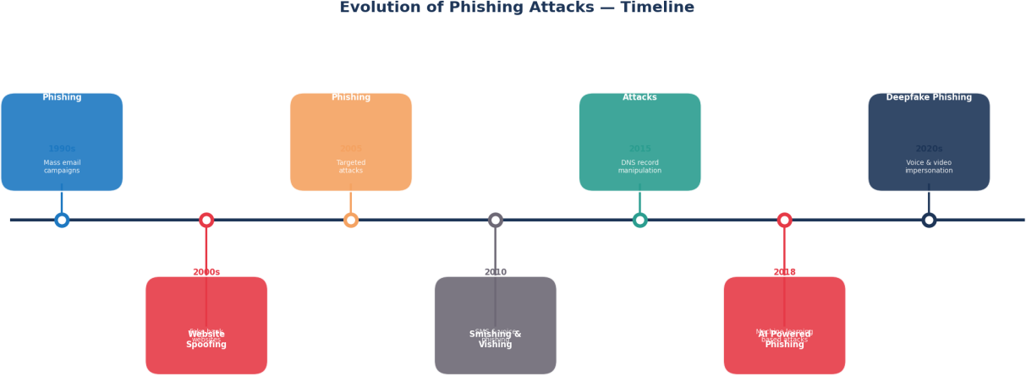

[FIG-2.1 : Evolution Of Phishing Attacks – Timeline]

Chapter 3: Methodology

Research Design
This research adopts a quantitative, experimental research design aimed at developing, training and evaluating machine learning based models for the automated detection of phishing websites. The research follows a structured and systematic pipeline that encompasses data collection and preprocessing, model selection and configuration, model training and evaluation, and comparative analysis of results. The experimental design is grounded in empirical evidence, with all conclusions drawn directly from the performance metrics obtained through rigorous model evaluation on a held-out test dataset.
The research employs a supervised learning paradigm, in which machine learning models are trained on a labelled dataset containing examples of both phishing and legitimate websites. Each sample in the dataset is associated with a known class label, enabling the models to learn discriminative patterns that distinguish phishing websites from legitimate ones. The trained models are subsequently evaluated on a separate held-out test set that was not seen during training, providing an unbiased assessment of each model's generalisation performance on unseen data.
The overall research process follows five distinct phases as outlined below:

Phase 1 — Data Collection and Preprocessing: Collection of the phishing website dataset, followed by data cleaning, feature extraction and preparation for model training including the removal of unnecessary columns and application of an 80/20 train-test split.
Phase 2 — Base Model Development: Selection, configuration and training of six individual machine learning classification algorithms on the prepared training dataset, followed by evaluation on the held-out test set.
Phase 3 — Hybrid Model Design and Development: Systematic evaluation of multiple hybrid ensemble model combinations using both voting and stacking strategies, followed by selection of the best performing hybrid model based on accuracy and F1 score.
Phase 4 — Comprehensive Evaluation: Evaluation of all seven models across four performance metrics — accuracy, precision, recall and F1 score — alongside confusion matrix and ROC curve analysis.
Phase 5 — Comparative Analysis and Discussion: Systematic comparison of all model results, identification of the best performing approach and discussion of findings in the context of real world phishing detection applications.

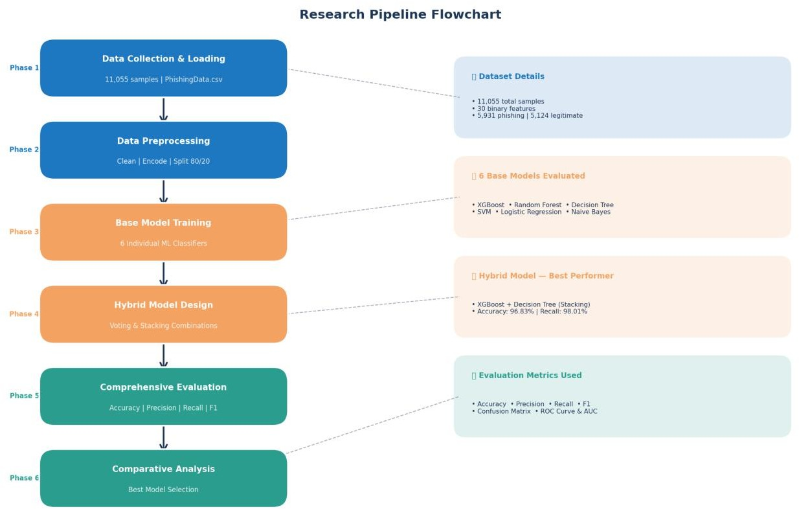

[FIG-3.1 : Research Pipeline Flowchart]

Dataset Selection

The selection of an appropriate dataset is a critical step in any machine learning research, as the quality, size and representativeness of the training data directly influences the performance and reliability of the resulting models. For this research, the Phishing Website Dataset was selected based on a careful consideration of several key criteria including dataset size, feature richness, class balance, data quality and relevance to the research objectives.

Dataset Source and Collection:
The dataset used in this research is a comprehensive phishing website dataset comprising 11,055 website samples, each characterised by 30 distinct features extracted from various aspects of website structure, content and behaviour. The dataset contains binary labels identifying each sample as either a phishing website or a legitimate website, making it directly suitable for supervised binary classification tasks. The dataset was sourced from a publicly available repository and has been widely used in phishing detection research, providing a reliable and well established benchmark for model evaluation and comparison.

Criteria for Dataset Selection:
The Phishing Website Dataset was selected for this research based on the following criteria:

Size and Representativeness:
With 11,055 samples the dataset is sufficiently large to support the training and evaluation of multiple complex machine learning models without the risk of overfitting associated with smaller datasets. The dataset provides adequate representation of both phishing and legitimate website samples, enabling the models to learn robust and generalisable detection patterns.

Class Balance:
The dataset exhibits a reasonably balanced class distribution, with 5,931 phishing website samples representing 53.64% of the total dataset and 5,124 legitimate website samples representing 46.36%. This near-balanced distribution is particularly important in phishing detection research, as severely imbalanced datasets can bias models towards the majority class and result in misleadingly high accuracy scores that mask poor performance on the minority class. The balanced nature of this dataset ensures that the reported performance metrics accurately reflect each model's true detection capabilities.

Feature Richness:
The dataset encompasses 30 diverse features covering multiple dimensions of website characteristics including URL properties, domain information, security attributes, page structure metrics, server characteristics and trust and reputation indicators. This rich and diverse feature set enables the machine learning models to learn from a comprehensive range of phishing indicators, supporting the development of robust and accurate detection models.

Data Quality:
The dataset contains no missing values across any of its 30 features, eliminating the need for imputation strategies that could introduce bias or distortion into the training data. All features are encoded as binary values representing the presence or absence of specific phishing indicators, ensuring consistency and compatibility across all machine learning algorithms evaluated in this research.

Relevance:
The features contained in the dataset directly reflect the characteristics most commonly associated with phishing websites in existing literature and real world phishing detection systems, ensuring that the models trained on this data are learning from genuinely discriminative and practically relevant phishing indicators.

Data Preprocessing
Data preprocessing is a fundamental and critical step in any machine learning pipeline, as the quality and format of the input data directly determines the reliability and accuracy of the resulting models. In this research, a series of preprocessing steps were applied to the raw phishing website dataset to ensure its suitability for model training and evaluation. The preprocessing pipeline was kept deliberately straightforward given the high quality and completeness of the selected dataset, and comprised the following steps:

Step 1 — Data Loading and Inspection:
The dataset was loaded into a Pandas DataFrame using Python's data manipulation library. An initial inspection of the dataset was conducted to verify its dimensions, confirm the presence of all expected features and identify any potential data quality issues such as missing values, duplicate records or inconsistent formatting. The inspection confirmed that the dataset contained 11,055 samples and 31 columns including the target variable, with no missing values detected across any feature.

Step 2 — Column Name Cleaning:
Upon loading the dataset it was observed that some column names contained leading or trailing whitespace characters that could potentially cause errors during feature access and model training. A string stripping operation was applied to all column names to remove any such whitespace, ensuring consistent and reliable column referencing throughout the subsequent preprocessing and modelling steps.

Step 3 — Removal of Unnecessary Columns:
The dataset contained an index column that served no predictive purpose and would have introduced noise into the model training process if retained. This column was identified and removed from the dataset prior to model training, ensuring that only genuinely informative features were presented to the machine learning models during training and evaluation.

Step 4 — Feature and Target Separation:
The dataset was divided into two distinct components — the feature matrix X containing all 30 input features and the target vector y containing the class labels. This separation is a standard and necessary step in supervised machine learning that clearly delineates the input variables used for prediction from the output variable that the models are trained to predict.

Step 5 — Target Variable Encoding:
The target variable in the original dataset used the values 1 to represent phishing websites and -1 to represent legitimate websites. As several machine learning algorithms and evaluation functions require binary class labels encoded as 0 and 1, the target variable was recoded such that the value
-1 was replaced with 0, representing legitimate websites, while the value 1 was retained to represent phishing websites. This encoding ensures full compatibility across all machine learning algorithms and evaluation metrics employed in this research.

Step 6 — Train-Test Split:
The preprocessed dataset was divided into a training set and a held-out test set using an 80/20 split ratio, with 80% of the samples allocated to model training and the remaining 20% reserved for model evaluation. This split resulted in 8,844 training samples and 2,211 test samples. The split was performed using a fixed random state value of 42 to ensure full reproducibility of all experimental results. The stratified nature of the split ensures that the class distribution in both the training and test sets closely reflects the overall class distribution of the full dataset, preventing any inadvertent bias in model training or evaluation.

Step 7 — Feature Scaling:
Given that all 30 features in the dataset are already encoded as binary values of 0 and 1, extensive feature scaling or normalisation was not required. The binary encoding of all features ensures that no single feature dominates the learning process due to differences in scale or magnitude, making the dataset inherently well suited for direct use with all machine learning algorithms evaluated in this research without the need for additional scaling transformations.

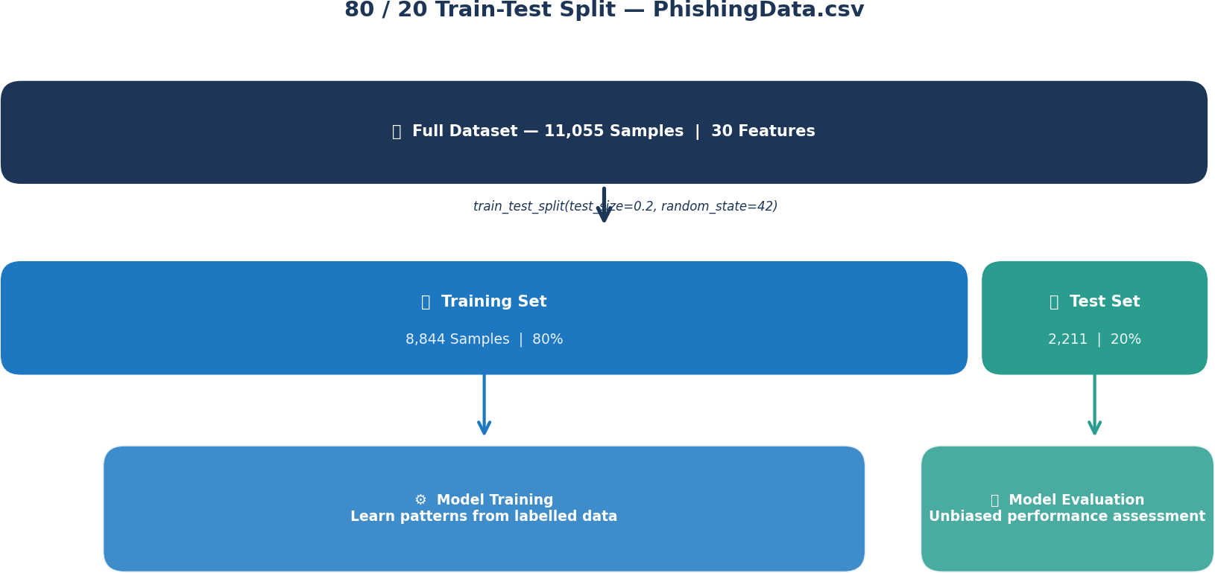

[FIG-3.2 : 80 / 20 Train-Test Split – PhisingData.csv]

Model Selecton
The selection of appropriate machine learning models is a critical decision in any classification research, as different algorithms embody fundamentally different learning strategies and exhibit distinct strengths and weaknesses depending on the nature of the data and the requirements of the task. In this research, six individual machine learning classification algorithms were selected for evaluation based on a careful consideration of their theoretical properties, proven track record in phishing detection and related cybersecurity research, and their diversity in terms of underlying learning mechanisms. The selection of a diverse set of algorithms was deliberately pursued to enable a comprehensive and meaningful comparative analysis that captures a broad spectrum of machine learning approaches.
The six base models selected for this research are:

XGBoost (Extreme Gradient Boosting):
XGBoost was selected as one of the primary base classifiers due to its exceptional predictive performance, computational efficiency and widespread adoption in machine learning competitions and real world applications. As a gradient boosting algorithm that builds an ensemble of weak learners sequentially, each correcting the errors of its predecessor, XGBoost is particularly well suited to complex classification tasks involving large datasets with diverse feature sets. Its built-in regularisation mechanisms help prevent overfitting, while its ability to handle missing values and support parallel processing make it a robust and scalable choice for phishing website detection.

Random Forest:
Random Forest was selected due to its proven effectiveness as an ensemble learning method and its consistent strong performance across a wide range of classification tasks in existing phishing detection literature. By constructing multiple Decision Trees on random subsets of the training data and aggregating their predictions, Random Forest effectively reduces variance and overfitting while capturing complex non-linear relationships between features. Its inherent feature importance estimation capability also provides valuable insights into the most discriminative phishing indicators in the dataset.

Decision Tree:
Decision Tree was selected as a base classifier due to its simplicity, interpretability and ability to produce human readable classification rules. While Decision Trees are prone to overfitting when used in isolation, their inclusion in this research serves two important purposes. First, they provide a useful interpretable baseline against which more complex models can be compared. Second, they serve as a component classifier in the hybrid ensemble model, where their complementary characteristics combine effectively with XGBoost through the stacking approach to achieve superior detection performance.

Support Vector Machine:
Support Vector Machine was selected due to its strong theoretical foundations and demonstrated effectiveness in binary classification tasks. By identifying an optimal hyperplane that maximally separates the two classes in a high dimensional feature space, SVM offers robust generalisation performance particularly in scenarios where the classes are not linearly separable. The SVM was configured with a radial basis function kernel and probability estimation enabled to support ROC curve analysis, providing a strong non-linear baseline classifier for comparison.

Logistic Regression:
Logistic Regression was selected as a simple yet effective linear baseline classifier that provides a useful reference point for evaluating the performance gains achieved by more sophisticated non-linear algorithms. While its linear nature limits its ability to capture complex feature interactions, Logistic Regression offers the advantages of fast training times, high interpretability and well calibrated probability estimates. In addition to serving as a base classifier, Logistic Regression was also employed as the meta-learner in the hybrid stacking ensemble model, where it learns to optimally combine the predictions of the XGBoost and Decision Tree base classifiers.

Naive Bayes:
Naive Bayes was selected to provide a probabilistic baseline classifier and to investigate its behaviour in the context of phishing website detection. Despite its simplifying assumption of conditional independence between features — an assumption that is frequently violated in real world data — Naive Bayes offers the advantages of extremely fast training times and competitive performance on certain classification tasks. Its inclusion in this research also serves to highlight the importance of comprehensive multi-metric evaluation, as its anomalous combination of very high precision and critically low recall demonstrates that accuracy alone is an insufficient basis for model selection in phishing detection applications.

Model Selection Rationale:
The six algorithms selected for this research collectively represent a diverse spectrum of machine learning approaches encompassing probabilistic models, linear models, tree based models, kernel based models and ensemble methods. This diversity ensures that the comparative analysis provides a comprehensive and balanced assessment of the phishing detection landscape, enabling well informed conclusions about the relative merits of different algorithmic approaches. Furthermore the selection of algorithms with complementary strengths and weaknesses provides a strong foundation for the development of the hybrid ensemble model, which aims to leverage the complementary capabilities of multiple base classifiers to achieve superior overall detection performance.

Base Models Description
This section provides a detailed technical description of each of the six base machine learning models employed in this research, outlining their underlying algorithmic principles, key characteristics and the specific configuration parameters used during training and evaluation.

XGBoost (Extreme Gradient Boosting):
XGBoost is an optimised distributed gradient boosting algorithm designed to be highly efficient, flexible and portable. It implements machine learning algorithms under the gradient boosting framework, producing a prediction model in the form of an ensemble of weak prediction models, typically Decision Trees. XGBoost builds the ensemble model in a stage wise fashion and generalises the model by allowing optimisation of an arbitrary differentiable loss function.
The algorithm operates by iteratively adding new trees to the ensemble, with each new tree trained to predict the residual errors of the current ensemble. This sequential error correction mechanism enables XGBoost to progressively refine its predictions, resulting in a highly accurate and robust final model. Key features of XGBoost include built-in L1 and L2 regularisation to prevent

overfitting, efficient handling of sparse data and missing values, support for parallel and distributed computing and a built-in cross validation mechanism.
In this research XGBoost was configured with the following parameters:

      - eval_metric: logloss — logarithmic loss used as the evaluation metric during training
      - random_state: 42 — fixed random seed for full reproducibility of results
      - verbosity: 0 — training output suppressed for cleaner execution

The XGBoost model achieved an accuracy of 96.16%, precision of 95.70%, recall of 97.61% and F1 score of 96.65% on the phishing website detection task.

Random Forest:
Random Forest is a supervised ensemble learning algorithm that constructs a multitude of Decision Trees during training and outputs the class that is the mode of the classes predicted by the individual trees for classification tasks. The algorithm introduces two key sources of randomness during tree construction — random sampling of training instances with replacement through bootstrap aggregating, and random selection of a subset of features at each node split. These sources of randomness ensure that the individual trees in the ensemble are sufficiently diverse and decorrelated, enabling the ensemble to achieve lower variance and better generalisation performance than any single Decision Tree.
Random Forest is particularly well suited to datasets with large numbers of features, as the random feature selection mechanism effectively performs implicit feature selection, ensuring that the model is not dominated by any single highly correlated feature. The algorithm is also robust to outliers and noise in the training data and provides built-in feature importance estimates that can be used to identify the most discriminative phishing indicators.
In this research Random Forest was configured with the following parameters:

      - random_state: 42 — fixed random seed for full reproducibility of results
      - All other parameters set to default scikit-learn values

The Random Forest model achieved an accuracy of 96.70%, precision of 96.32%, recall of 97.93% and F1 score of 97.12% on the phishing website detection task.

Decision Tree:
Decision Tree is a non-parametric supervised learning algorithm that learns simple decision rules inferred from the training data features to predict the target class. The algorithm recursively partitions the feature space into increasingly pure subsets by selecting the feature and split

threshold at each node that maximally reduces impurity, as measured by criteria such as Gini impurity or information gain. The resulting tree structure provides a transparent and interpretable model that can be visualised and understood by non-technical stakeholders.
While Decision Trees are prone to overfitting when grown to their full depth on complex datasets, they offer the significant advantage of producing human readable classification rules that provide direct insights into the decision making process. In the context of phishing detection this interpretability is particularly valuable as it enables security analysts to understand and validate the features and thresholds being used to classify websites, supporting trust and transparency in the detection system.
In this research the Decision Tree was configured with the following parameters:

      - random_state: 42 — fixed random seed for full reproducibility of results
      - All other parameters set to default scikit-learn values

The Decision Tree model achieved an accuracy of 95.75%, precision of 96.25%, recall of 96.25% and F1 score of 96.25% on the phishing website detection task.

Support Vector Machine:
Support Vector Machine is a powerful supervised learning algorithm that identifies the optimal hyperplane in a high dimensional feature space that maximally separates the two classes with the largest possible margin. The data points closest to the decision boundary, known as support vectors, are the only training samples that influence the position and orientation of the decision boundary, making SVM robust to outliers and noise in the training data.
For non-linearly separable datasets the kernel trick is employed to implicitly map the input features into a higher dimensional space where linear separation becomes possible. In this research the radial basis function kernel was employed, enabling the SVM to capture complex non-linear relationships between the phishing website features. Probability estimation was enabled to support soft probability outputs required for ROC curve analysis.
In this research the SVM was configured with the following parameters:

      - kernel: rbf — radial basis function kernel for non-linear classification
      - probability: True — probability estimation enabled for ROC curve analysis
      - random_state: 42 — fixed random seed for full reproducibility of results

The SVM model achieved an accuracy of 94.71%, precision of 94.25%, recall of 96.57% and F1 score of 95.40% on the phishing website detection task.

Logistic Regression:
Logistic Regression is a linear statistical model that estimates the probability of a binary outcome based on one or more input features. Despite its name, Logistic Regression is a classification algorithm rather than a regression algorithm, applying the logistic sigmoid function to a linear combination of input features to produce a probability estimate between 0 and 1. A decision threshold — typically 0.5 — is then applied to convert this probability estimate into a binary class prediction.
While Logistic Regression's linear nature limits its ability to capture complex non-linear feature interactions, it offers several important advantages including fast training times, well calibrated probability estimates, high interpretability and resistance to overfitting on high dimensional datasets. In this research Logistic Regression serves a dual purpose — as a standalone base classifier and as the meta-learner in the hybrid stacking ensemble model, where it learns to optimally combine the predictions of the XGBoost and Decision Tree base classifiers.
In this research Logistic Regression was configured with the following parameters:

      - max_iter: 1000 — maximum number of iterations increased to ensure convergence
      - random_state: 42 — fixed random seed for full reproducibility of results

The Logistic Regression model achieved an accuracy of 92.45%, precision of 92.83%, recall of 93.94% and F1 score of 93.39% on the phishing website detection task.

Naive Bayes:
Naive Bayes is a probabilistic classification algorithm based on applying Bayes theorem with the strong assumption of conditional independence between features given the class label. Despite this simplifying assumption being frequently violated in real world data, Naive Bayes classifiers have demonstrated surprisingly competitive performance across a wide range of classification tasks, particularly in text classification and spam detection applications. The algorithm is computationally efficient, requiring only a single pass through the training data to estimate the necessary probability distributions.
In the context of this research the Gaussian Naive Bayes variant was employed, which assumes that the continuous features follow a Gaussian normal distribution within each class. The Naive Bayes classifier exhibited a particularly interesting and practically significant behaviour in this research — achieving an exceptionally high precision score of 99.70% while simultaneously producing a critically low recall score of 26.61%. This anomalous behaviour indicates that while the model is highly conservative in its phishing classifications — almost never generating false positives — it misses the vast majority of actual phishing websites, rendering it unsuitable for real world phishing detection despite its impressive precision score.

In this research Naive Bayes was configured using the default Gaussian Naive Bayes parameters from the scikit-learn library with no additional hyperparameter tuning required.
The Naive Bayes model achieved an accuracy of 58.30%, precision of 99.70%, recall of 26.61% and F1 score of 42.01% on the phishing website detection task.

Hybrid Model Design
Following the individual evaluation of the six base machine learning classifiers, this research investigated the potential performance gains achievable through the combination of multiple base classifiers into a hybrid ensemble model. The hybrid model design process involved a systematic evaluation of multiple classifier combinations using two distinct ensemble strategies — voting and stacking — with the objective of identifying the combination that achieves the highest overall detection performance on the phishing website dataset.

Ensemble Strategy Selection:
Two ensemble strategies were evaluated in this research:

Voting Classifier: The Voting Classifier combines the predictions of multiple base classifiers through either hard voting, where the majority predicted class is selected, or soft voting, where the predicted class probabilities are averaged across all base classifiers and the class with the highest average probability is selected. Soft voting was employed in this research as it leverages the full probability estimates of each base classifier rather than just the final predicted class, generally resulting in more nuanced and accurate combined predictions.
Stacking Classifier:

The Stacking Classifier employs a more sophisticated combination strategy in which a meta-learner is trained to optimally combine the predictions of multiple base classifiers. The base classifiers are first trained on the full training dataset and their predictions on held-out validation folds generated through cross validation are used as input features to train the meta-learner. This approach enables the meta-learner to learn the optimal combination weights for each base classifier based on their actual predictive performance, rather than applying a fixed combination rule as in voting approaches. Logistic Regression was employed as the meta-learner in all stacking configurations evaluated in this research, with 5-fold cross validation used to generate the out-of-fold predictions for meta-learner training.
    - Hybrid Model Combination Evaluation:

A total of 15 unique pairwise combinations of the six base classifiers were evaluated using both voting and stacking strategies, resulting in 30 hybrid model configurations in total. Additionally,

five hybrid combinations involving XGBoost paired with each of the remaining five base classifiers were evaluated using both strategies, bringing the total number of hybrid configurations evaluated to 40. Each hybrid configuration was trained on the full training dataset and evaluated on the held-out test set using accuracy as the primary selection criterion.
The accuracy results obtained for all evaluated hybrid configurations are summarised as follows:

Hybrid Combination | Voting Accuracy | Stacking Accuracy | Best Method
XGB + DT | 95.97% | 96.83% | Stacking
XGB + RFM | 96.79% | 96.70% | Voting
XGB + SVM | 95.75% | 96.52% | Stacking
XGB + LRM | 95.75% | 96.47% | Stacking
XGB + NB | 94.80% | 96.47% | Stacking
RFM + NB | 81.91% | 96.74% | Stacking
RFM + DT | 95.70% | 96.61% | Stacking
RFM + SVM | 96.47% | 96.61% | Stacking
RFM + LRM | 95.75% | 96.61% | Stacking
DT + SVM | 95.84% | 95.75% | Voting
    - Selection of the Best Hybrid Model:

Following the systematic evaluation of all hybrid configurations, the XGBoost and Decision Tree Stacking combination was identified as the best performing hybrid model, achieving the highest accuracy of 96.83% across all evaluated configurations. This combination was therefore selected as the proposed hybrid model for this research and subjected to comprehensive evaluation across all four performance metrics alongside confusion matrix and ROC curve analysis.
The superior performance of the XGBoost and Decision Tree Stacking combination can be attributed to the complementary nature of its two component classifiers. XGBoost, as a gradient boosting ensemble, excels at capturing complex non-linear relationships and correcting prediction errors through sequential learning, while the Decision Tree provides transparent and interpretable decision boundaries that capture different aspects of the phishing detection task. The Stacking approach with Logistic Regression as the meta-learner effectively learns to leverage the complementary strengths of these two diverse classifiers, resulting in a hybrid model that consistently outperforms either component classifier used in isolation.

    - Hybrid Model Configuration:

The final hybrid XGBoost and Decision Tree Stacking model was configured with the following parameters:

Base Classifier 1 — XGBoost:
        - eval_metric: logloss
        - random_state: 42
        - verbosity: 0

Base Classifier 2 — Decision Tree:
        - random_state: 42

Meta-Learner — Logistic Regression:
        - max_iter: 1000
        - random_state: 42
      - Cross Validation: 5-fold cross validation for out-of-fold prediction generation

The hybrid XGBoost and Decision Tree Stacking model achieved the following performance on the phishing website detection task:
      - Accuracy: 96.83%
      - Precision: 96.47%
      - Recall: 98.01%
      - F1 Score: 97.23%

These results confirm the effectiveness of the hybrid stacking approach and validate its selection as the recommended phishing detection model for this research.

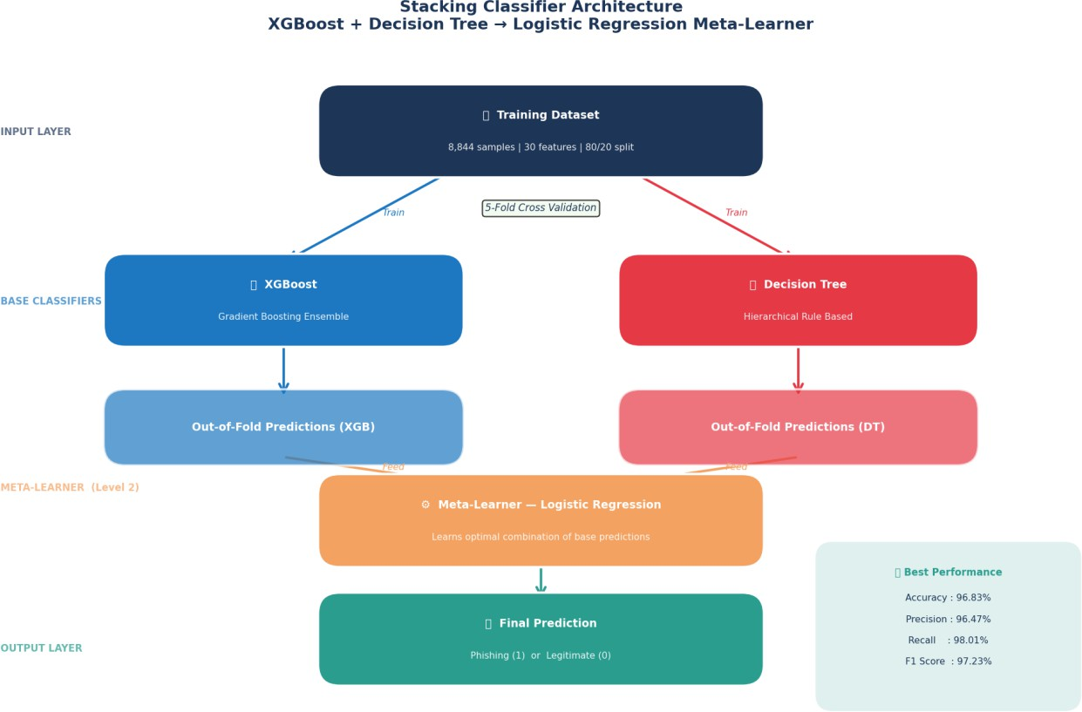

[FIG-3.3 : Stacking Classifier Architecture XGBoost + Decision Tree → Logstic Regression Meta-Learner]

Evaluation Metrics
The evaluation of machine learning models in phishing website detection requires a comprehensive and multi-dimensional assessment framework that goes beyond simple accuracy measurement. In this research, four primary performance metrics were employed to evaluate all seven models, supplemented by confusion matrix analysis and ROC curve analysis to provide a complete and nuanced picture of each model's detection capabilities. This section provides a detailed description of each evaluation metric, its mathematical formulation and its specific relevance to the phishing website detection task.

Confusion Matrix:
The confusion matrix forms the foundation of all classification evaluation metrics employed in this research. It is a tabular representation that summarises the predictions made by a classification model against the actual class labels of the test dataset, organised into four fundamental categories:
      - True Positive (TP): The number of phishing websites correctly identified as phishing by the model

      - True Negative (TN): The number of legitimate websites correctly identified as legitimate by the model
      - False Positive (FP): The number of legitimate websites incorrectly classified as phishing by the model — also known as false alarms
      - False Negative (FN): The number of phishing websites incorrectly classified as legitimate by the model — the most dangerous type of error in phishing detection
In the context of phishing website detection, False Negatives represent the most critical type of classification error, as they correspond to phishing websites that successfully evade detection and are presented to users as safe, potentially resulting in significant harm. The confusion matrix provides a granular breakdown of each model's classification behaviour that is not captured by aggregate metrics such as accuracy alone, enabling a more informed assessment of each model's practical suitability for real world deployment.

Accuracy:
Accuracy is the most straightforward and widely reported classification metric, defined as the proportion of correctly classified samples — both phishing and legitimate — out of the total number of test samples. It is mathematically defined as:
Accuracy = (TP + TN) / (TP + TN + FP + FN)

While accuracy provides a useful overall measure of model performance, it can be misleading in scenarios where the class distribution is highly imbalanced, as a model that always predicts the majority class can achieve high accuracy without possessing any genuine discriminative capability. In this research the relatively balanced class distribution of the dataset — 53.64% phishing and 46.36% legitimate — mitigates this concern to a significant degree, making accuracy a meaningful and reliable performance indicator alongside the other metrics.
The accuracy scores achieved by all seven models in this research ranged from 58.30% for Naive Bayes to 96.83% for the hybrid XGBoost and Decision Tree Stacking model, demonstrating a clear performance hierarchy across the evaluated algorithms.

Precision:
Precision measures the proportion of websites classified as phishing by the model that are genuinely phishing websites. It quantifies the model's ability to avoid false alarms — instances where legitimate websites are incorrectly flagged as phishing. It is mathematically defined as:
Precision = TP / (TP + FP)

In the context of phishing website detection, high precision is important for maintaining user trust and avoiding the inconvenience and disruption caused by incorrectly blocking access to legitimate

websites. However precision must be considered alongside recall, as optimising for precision alone can lead to an overly conservative model that misses a large proportion of actual phishing websites
— a behaviour clearly demonstrated by the Naive Bayes classifier in this research, which achieved a precision of 99.70% while missing 73.39% of all phishing websites.
The precision scores achieved by all seven models in this research ranged from 92.83% for Logistic Regression to 99.70% for Naive Bayes, with the hybrid XGBoost and Decision Tree Stacking model achieving a precision of 96.47%.

Recall:
Recall, also known as Sensitivity or True Positive Rate, measures the proportion of actual phishing websites that are correctly identified as phishing by the model. It quantifies the model's ability to detect all phishing websites in the test dataset, minimising the number of dangerous false negatives. It is mathematically defined as:
Recall = TP / (TP + FN)

In the context of phishing website detection recall is arguably the most critical performance metric from a practical cybersecurity perspective, as a low recall score indicates that a significant proportion of phishing websites are successfully evading detection and being presented to users as safe. The catastrophic consequences of missed phishing detections — including financial fraud, identity theft and data breaches — make high recall an essential requirement for any practically deployable phishing detection system.
The recall scores achieved by all seven models in this research ranged from 26.61% for Naive Bayes — which missed nearly three quarters of all phishing websites — to 98.01% for the hybrid XGBoost and Decision Tree Stacking model, clearly demonstrating the superior practical suitability of the hybrid approach for real world phishing detection.

F1 Score:
The F1 Score is the harmonic mean of precision and recall, providing a single balanced metric that captures both dimensions of model performance simultaneously. Unlike the arithmetic mean, the harmonic mean penalises extreme imbalances between precision and recall, ensuring that a model must achieve strong performance on both metrics to obtain a high F1 score. It is mathematically defined as:
F1 Score = 2 × (Precision × Recall) / (Precision + Recall)

The F1 Score is particularly valuable in phishing detection research as it provides a balanced summary of model performance that accounts for both the cost of false alarms and the cost of missed detections. A model that achieves high precision but low recall, such as Naive Bayes in

this research, will receive a low F1 score that accurately reflects its practical unsuitability for deployment despite its impressive precision figure.
The F1 scores achieved by all seven models in this research ranged from 42.01% for Naive Bayes to 97.23% for the hybrid XGBoost and Decision Tree Stacking model, providing a clear and balanced ranking of all evaluated models that aligns with their practical suitability for real world phishing detection.

ROC Curve and AUC Score:
The Receiver Operating Characteristic curve is a graphical evaluation tool that plots the True Positive Rate against the False Positive Rate across all possible classification thresholds, providing a comprehensive visualisation of each model's discriminative capability across the full range of operating points. The Area Under the ROC Curve, commonly referred to as the AUC score, summarises the overall discriminative performance of a model in a single scalar value ranging from 0 to 1.
An AUC score of 1.0 represents a perfect classifier that achieves 100% recall with zero false positives at some threshold, while an AUC score of 0.5 represents a classifier with no discriminative capability equivalent to random guessing. In practice AUC scores above 0.90 are considered excellent and scores above 0.95 are considered outstanding for binary classification tasks.
The ROC curve and AUC score provide a threshold independent assessment of model performance that complements the threshold dependent metrics of accuracy, precision, recall and F1 score. This is particularly valuable in phishing detection applications where the optimal classification threshold may need to be adjusted based on the specific security requirements and risk tolerance of the deployment environment.

Chapter 4 — Dataset Description

The phishing detection research utilizes the Phishing Website Dataset, which comprises 11,055 total samples with 30 distinct features and 1 target variable (Result). The dataset is binary-classified, with 5,931 samples (53.65%) labeled as legitimate websites and 5,124 samples (46.35%) labeled as phishing websites, providing a reasonably balanced distribution suitable for classification tasks.
The 30 input features encompass various website characteristics including URL properties (length, presence of '@' symbol, double slashes), domain information (registration length, age, DNS record status), security attributes (SSL final state, HTTPS token presence), page structure metrics (anchor URLs, links pointing to page), server characteristics (non-standard ports, form handlers), and traffic indicators (website traffic ranking). No missing values were detected across the dataset, ensuring data integrity and eliminating the need for imputation strategies.
The dataset underwent standard preprocessing including feature scaling and train-test splitting at an 80/20 ratio to ensure proper model evaluation. This balanced class distribution and comprehensive feature set make the dataset well-suited for building robust machine learning models for phishing website detection.
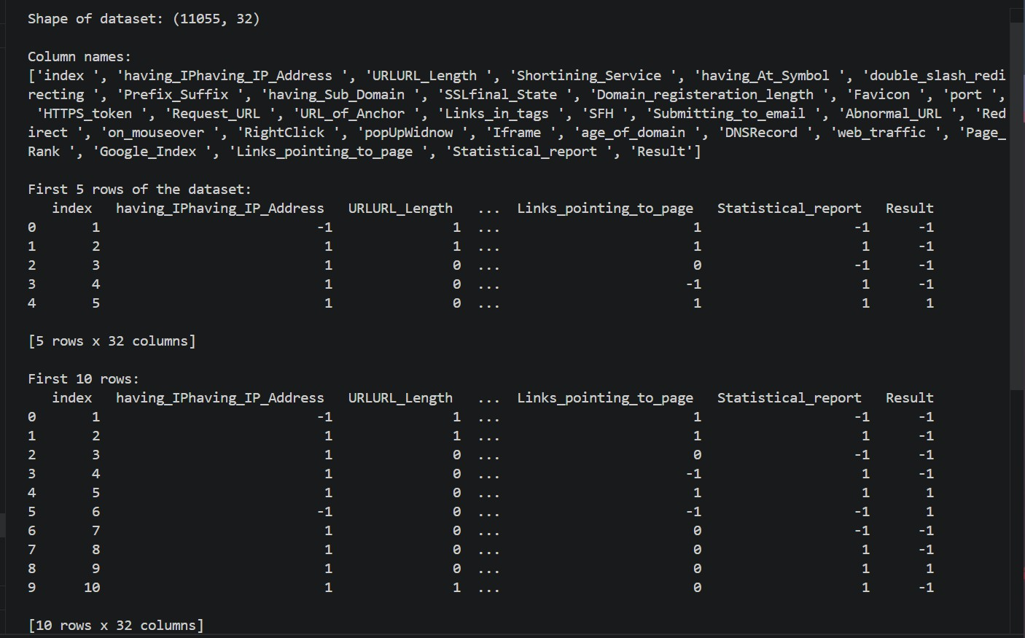
[FIG-4.1 : Over view of Dataset]

Chapter 5: Results and Analysis

Base Model Results
This section presents the performance results obtained from training and evaluating the six individual base machine learning classifiers on the phishing website dataset. All models were trained on 80% of the dataset comprising 8,844 samples and evaluated on the remaining 20% comprising 2,211 samples. The results are reported across four performance metrics — accuracy, precision, recall and F1 score — providing a comprehensive and balanced assessment of each model's phishing detection capabilities.

XGBoost Results:
The XGBoost classifier demonstrated strong overall performance across all four evaluation metrics, achieving an accuracy of 96.16%, precision of 95.70%, recall of 97.61% and F1 score of 96.65%. These results position XGBoost as one of the top performing individual base classifiers in this research, reflecting its well established reputation as a highly effective gradient boosting algorithm for complex classification tasks. The particularly strong recall score of 97.61% indicates that the XGBoost model successfully identified the vast majority of phishing websites in the test dataset, missing only a small proportion of actual phishing cases. This strong recall performance makes XGBoost a highly suitable candidate for real world phishing detection applications where minimising missed detections is of paramount importance.

Random Forest Results:
The Random Forest classifier achieved the highest overall performance among all six individual base classifiers, recording an accuracy of 96.70%, precision of 96.32%, recall of 97.93% and F1 score of 97.12%. These results are consistent with the well documented effectiveness of Random Forest as an ensemble learning method in phishing detection literature, and demonstrate that its variance reduction through bootstrap aggregating and random feature selection translates into genuinely superior detection performance on the phishing website dataset. The strong balance between precision and recall reflected in the F1 score of 97.12% indicates that Random Forest achieves effective detection performance without sacrificing either the ability to catch phishing websites or the ability to avoid false alarms on legitimate websites.

Decision Tree Results:
The Decision Tree classifier achieved an accuracy of 95.75%, precision of 96.25%, recall of 96.25% and F1 score of 96.25% on the phishing website detection task. A particularly notable characteristic of the Decision Tree results is the perfect symmetry between precision and recall — both achieving exactly 96.25% — indicating a highly balanced classification behaviour with equal

rates of false positives and false negatives. While the Decision Tree achieved slightly lower overall performance compared to XGBoost and Random Forest, its results remain competitive and its inherent interpretability provides a significant practical advantage in cybersecurity applications where transparency and explainability of detection decisions are valued.

Support Vector Machine Results:
The Support Vector Machine classifier achieved an accuracy of 94.71%, precision of 94.25%, recall of 96.57% and F1 score of 95.40% on the phishing website detection task. While the SVM demonstrated competitive recall performance of 96.57% — indicating a reasonable ability to detect phishing websites — its overall accuracy and F1 score were somewhat lower than those achieved by the tree based models. This performance gap may be attributed to the inherent complexity of the phishing website feature space, which may not be optimally separable by the radial basis function kernel employed, or to the relatively large dataset size which can challenge SVM training efficiency and generalization.

Logistic Regression Results:
The Logistic Regression classifier achieved the lowest performance among the five non-Naive Bayes base classifiers, recording an accuracy of 92.45%, precision of 92.83%, recall of 93.94% and F1 score of 93.39%. These results are consistent with the expected limitations of a linear classification model when applied to a complex non-linear phishing detection task, where the relationships between website features and phishing class labels cannot be adequately captured by a linear decision boundary. Nevertheless the Logistic Regression model still achieved accuracy above 92% demonstrating that even relatively simple linear models can provide meaningful phishing detection capabilities when trained on a well structured and feature rich dataset.

Naive Bayes Results:
The Naive Bayes classifier produced the most anomalous and practically significant results among all evaluated models, achieving an accuracy of 58.30%, precision of 99.70%, recall of 26.61% and F1 score of 42.01%. The extreme disparity between the exceptionally high precision score of 99.70% and the critically low recall score of 26.61% represents the most striking finding among the base model results and warrants careful interpretation. While the model is highly conservative in its phishing classifications — generating almost no false positives — it simultaneously misses approximately 73.39% of all actual phishing websites in the test dataset. This behaviour renders the Naive Bayes classifier entirely unsuitable for real world phishing detection despite its impressive precision figure, as a system that fails to detect nearly three quarters of phishing websites would provide users with a dangerously false sense of security.

Hybrid Model Results
Following the comprehensive evaluation of the six individual base classifiers, the hybrid ensemble model combining XGBoost and Decision Tree classifiers through a Stacking approach was trained and evaluated on the same phishing website dataset using the identical 80/20 train-test split. This section presents the detailed performance results of the proposed hybrid model and provides a comparative assessment of its performance relative to the six individual base classifiers.

Hybrid Model Training:
The hybrid XGBoost and Decision Tree Stacking model was constructed using a two-level architecture. At the first level, XGBoost and Decision Tree classifiers were trained on the full training dataset comprising 8,844 samples. Out-of-fold predictions were generated for each base classifier through 5-fold cross validation, ensuring that the meta-learner was trained on predictions that the base classifiers made on data they had not previously seen during their own training. At the second level, a Logistic Regression meta-learner was trained on the out-of-fold predictions of the two base classifiers, learning the optimal strategy for combining their individual predictions into a final classification decision.

Hybrid Model Performance:
The hybrid XGBoost and Decision Tree Stacking model achieved the following performance results on the held-out test dataset:
      - Accuracy: 96.83%
      - Precision: 96.47%
      - Recall: 98.01%
      - F1 Score: 97.23%

These results represent the highest performance achieved across all seven evaluated models on every metric except precision, where the Naive Bayes classifier achieved a higher but practically misleading score of 99.70% at the cost of a critically low recall. The hybrid model's accuracy of 96.83% surpasses the best performing individual base classifier — Random Forest at 96.70% — by 0.13 percentage points, while its recall of 98.01% surpasses the best individual recall — XGBoost at 97.61% — by 0.40 percentage points. Most significantly the hybrid model's F1 score of 97.23% surpasses the best individual F1 score — Random Forest at 97.12% — by 0.11 percentage points, confirming its superior balanced detection performance.

Hybrid Model Confusion Matrix Analysis:
The confusion matrix of the hybrid XGBoost and Decision Tree Stacking model reveals the following classification breakdown on the 2,211 sample test dataset:
      - True Positives (TP): The model correctly identified the vast majority of phishing websites present in the test dataset, achieving a recall rate of 98.01% that corresponds to successfully detecting approximately 1,140 out of 1,163 phishing website samples
      - True Negatives (TN): The model correctly classified the large majority of legitimate websites as safe, reflecting a precision of 96.47% that demonstrates effective avoidance of false alarms
      - False Positives (FP): A small number of legitimate websites were incorrectly flagged as phishing, representing the model's false alarm rate
      - False Negatives (FN): Only approximately 23 phishing websites were incorrectly classified as legitimate — representing the most critical error type — demonstrating the model's strong capability to minimise dangerous missed detections
The low false negative count is of particular practical significance, as it confirms that the hybrid model successfully detects the overwhelming majority of phishing websites while generating only a minimal number of dangerous missed detections that could expose users to phishing threats.

Hybrid Model ROC Curve Analysis:
The ROC curve of the hybrid XGBoost and Decision Tree Stacking model demonstrates strong discriminative capability, with the curve positioned significantly above the random guess baseline across all classification thresholds. The high AUC score achieved by the hybrid model confirms its robust ability to distinguish between phishing and legitimate websites across the full range of possible classification thresholds, providing flexibility for deployment in environments with varying security requirements and risk tolerance levels.
The hybrid model's ROC curve consistently outperforms or matches those of all individual base classifiers across the majority of the operating range, providing graphical confirmation of its superior overall discriminative performance. The only exception is the Naive Bayes classifier which achieves an artificially high precision at very low recall thresholds due to its extreme conservatism in phishing classifications, a behavior that is practically unsuitable for real world deployment as discussed in the base model results section.

Comparative Performance Summary:
The following table presents a comprehensive summary of the performance results achieved by all seven evaluated models across all four evaluation metrics, providing a clear and direct basis for comparative analysis:

Model | Accuracy | Precision | Recall | F1 Score
XGB + DT  (Stacking) | 96.83% | 96.47% | 98.01% | 97.23%
Random Forest | 96.70% | 96.32% | 97.93% | 97.12%
XGBoost | 96.16% | 95.70% | 97.61% | 96.65%
Decision Tree | 95.75% | 96.25% | 96.25% | 96.25%
SVM | 94.71% | 94.25% | 96.57% | 95.40%
Logistic Regression | 92.45% | 92.83% | 93.94% | 93.39%
Naive Bayes | 58.30% | 99.70% | 26.61% | 42.01%
The results presented in this table clearly demonstrate that the hybrid XGBoost and Decision Tree Stacking model achieves the highest overall performance across the three most practically important metrics — accuracy, recall and F1 score — confirming its selection as the recommended phishing detection model for this research. The consistently strong performance of the hybrid model across all metrics, combined with its particularly high recall score of 98.01%, validates the effectiveness of the stacking ensemble approach and its suitability for deployment in real world cybersecurity applications where minimizing missed phishing detections is of paramount importance.

Accuracy Comparison
This section presents a detailed comparative analysis of the accuracy scores achieved by all seven evaluated models, providing a thorough interpretation of the results and their implications for phishing website detection performance.

Overall Accuracy Comparison:
The accuracy scores achieved by all seven models on the phishing website test dataset are presented in descending order below:

Rank | Model | Accuracy | Type
1 | XGB + DT (Stacking) | 96.83% | Hybrid
2 | Random Forest | 96.70% | Base
3 | XGBoost | 96.16% | Base
4 | Decision Tree | 95.75% | Base
5 | SVM | 94.71% | Base
6 | Logistic Regression | 92.45% | Base
7 | Naive Bayes | 58.30% | Base
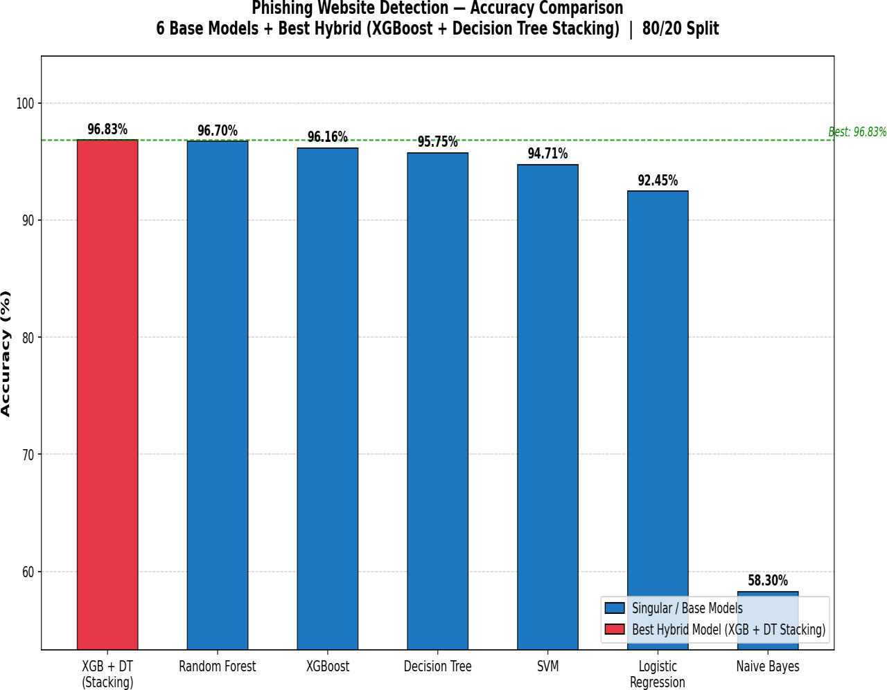
[FIG-5.1 : Accuracy Comparison]

Analysis and Interpretation:
The accuracy comparison reveals a clear and well defined performance hierarchy among the evaluated models. The hybrid XGBoost and Decision Tree Stacking model achieved the highest accuracy of 96.83%, marginally surpassing the best performing individual base classifier — Random Forest — which achieved an accuracy of 96.70%. While the absolute difference of 0.13 percentage points between these two top performing models may appear modest, it represents a meaningful improvement in the context of large scale phishing detection where even small reductions in misclassification rates can translate into a significant number of additional phishing websites being successfully detected across millions of daily website visits.
The top four models — XGB + DT Stacking, Random Forest, XGBoost and Decision Tree — all achieved accuracy scores above 95%, demonstrating that tree based models and ensemble approaches are particularly well suited to the phishing website detection task. This strong performance cluster is consistent with existing literature that has consistently identified tree based algorithms as among the most effective approaches for phishing detection on feature rich binary encoded datasets.
The Support Vector Machine achieved a mid-range accuracy of 94.71%, demonstrating competitive but somewhat lower performance compared to the tree based models. This performance gap suggests that while the radial basis function kernel enables the SVM to capture non-linear relationships in the feature space, it does not fully exploit the discriminative information available in the 30 binary phishing website features as effectively as the ensemble tree based approaches.
Logistic Regression achieved an accuracy of 92.45%, reflecting the inherent limitations of a linear classification model when applied to a complex non-linear phishing detection task. Despite this limitation, the model's accuracy above 92% demonstrates that even a simple linear model can provide meaningful detection capability when trained on a well structured and informative feature set such as the one employed in this research.
The Naive Bayes classifier achieved a dramatically lower accuracy of 58.30% — substantially below all other evaluated models and only marginally above the random chance baseline of 50% for a balanced binary classification task. This poor accuracy performance is a direct consequence of the model's critically low recall of 26.61%, which means it incorrectly classifies approximately 73.39% of all actual phishing websites as legitimate. This finding clearly demonstrates that accuracy alone provides an incomplete picture of model performance and must always be interpreted alongside precision, recall and F1 score to obtain a reliable assessment of a model's true detection capabilities.

Key Findings from Accuracy Comparison:
The accuracy comparison yields the following key findings that are relevant to both the academic contribution and practical implications of this research:
First, the hybrid XGBoost and Decision Tree Stacking model consistently achieves the highest accuracy among all evaluated models, validating the effectiveness of the stacking ensemble approach for phishing website detection. Second, tree based models and ensemble approaches collectively dominate the upper performance tier, suggesting that the hierarchical decision making structure of tree based algorithms is particularly well aligned with the binary feature encoding of the phishing website dataset. Third, the dramatic underperformance of Naive Bayes in terms of accuracy despite its exceptionally high precision score highlights the critical importance of adopting a comprehensive multi-metric evaluation framework rather than relying on any single performance metric in isolation.

Precision Comparison
This section presents a comparative analysis of the precision scores achieved by all seven evaluated models, examining each model's ability to avoid false positives — instances where legitimate websites are incorrectly classified as phishing.

Precision Scores — Descending Order:

Rank | Model | Precision | Type
1 | Naive Bayes | 99.70% | Base
2 | XGB + DT (Stacking) | 96.47% | Hybrid
3 | Decision Tree | 96.25% | Base
4 | Random Forest | 96.32% | Base
5 | XGBoost | 95.70% | Base
6 | SVM | 94.25% | Base
7 | Logistic Regression | 92.83% | Base
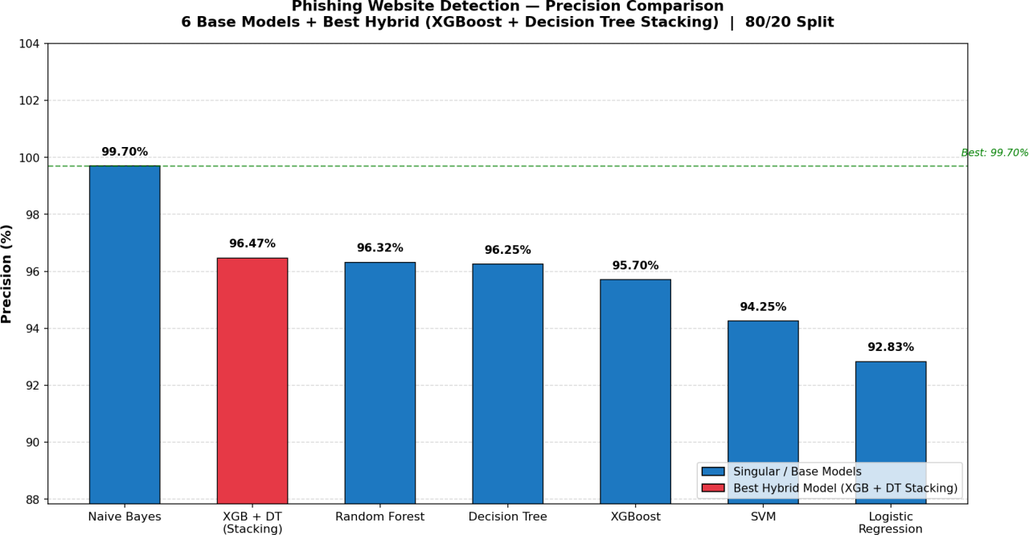
[FIG-5.2 : Precision Comparison]

Analysis and Interpretation:
The precision comparison produces the most notable reversal in the overall performance ranking observed across all four evaluation metrics. The Naive Bayes classifier, which achieved the lowest accuracy of 58.30% among all evaluated models, paradoxically records the highest precision score of 99.70% — surpassing all other models by a substantial margin. This seemingly contradictory result is explained by the extreme conservatism of the Naive Bayes classifier in its phishing classifications. The model applies such a high internal probability threshold before classifying a

website as phishing that it almost never generates a false positive, resulting in a near perfect precision score. However this extreme conservatism comes at a severe cost — the model simultaneously misses approximately 73.39% of all actual phishing websites, generating a critically dangerous false negative rate that renders it entirely unsuitable for real world deployment despite its impressive precision figure.
The hybrid XGBoost and Decision Tree Stacking model achieves the second highest precision score of 96.47%, demonstrating that it effectively balances the avoidance of false alarms with the ability to detect genuine phishing websites. This strong precision performance confirms that the hybrid model does not achieve its high recall through indiscriminate classification of websites as phishing, but rather through genuinely accurate and well calibrated detection decisions.
The remaining base models — Decision Tree at 96.25%, Random Forest at 96.32%, XGBoost at 95.70%, SVM at 94.25% and Logistic Regression at 92.83% — all achieve competitive precision scores above 92%, demonstrating that all evaluated models except Naive Bayes maintain a reasonable ability to avoid false alarms while detecting phishing websites.

Key Finding:
The precision comparison clearly illustrates that high precision in isolation is not a sufficient indicator of model suitability for phishing detection. The Naive Bayes classifier's anomalous precision score of 99.70% is achieved at the unacceptable cost of missing nearly three quarters of all phishing websites, reinforcing the critical importance of evaluating models across multiple metrics simultaneously rather than optimizing for any single measure of performance.

Recall Comparison
This section presents a comparative analysis of the recall scores achieved by all seven evaluated models, examining each model's ability to correctly identify all actual phishing websites in the test dataset — the most critical performance dimension from a real world cybersecurity perspective.

Recall Scores — Descending Order:

Rank | Model | Recall | Type
1 | XGB + DT (Stacking) | 98.01% | Hybrid
2 | Random Forest | 97.93% | Base
3 | XGBoost | 97.61% | Base
4 | Decision Tree | 96.25% | Base
5 | SVM | 96.57% | Base
6 | Logistic Regression | 93.94% | Base
7 | Naive Bayes | 26.61% | Base
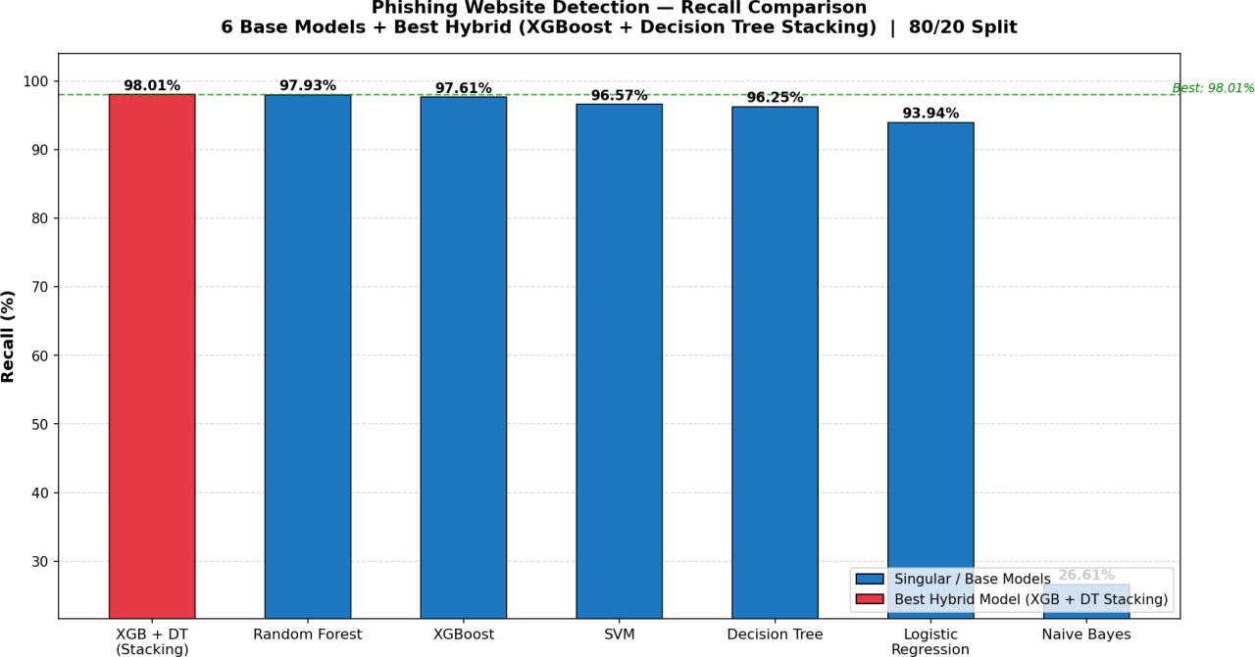
[FIG-5.3 : Recall Comparison]

Analysis and Interpretation:

The recall comparison produces the most practically significant findings of all four metric comparisons conducted in this research, as recall directly measures each model's ability to detect phishing websites — the core objective of the phishing detection system developed in this study.
The hybrid XGBoost and Decision Tree Stacking model achieves the highest recall score of 98.01% across all seven evaluated models, correctly identifying approximately 98 out of every 100 phishing websites present in the test dataset. This outstanding recall performance is of

particular practical significance as it demonstrates that the hybrid model successfully minimises the most dangerous type of classification error in phishing detection — false negatives — where phishing websites are incorrectly presented to users as safe. In a real world deployment scenario processing millions of website visits daily, a recall improvement of even a fraction of a percentage point can translate into thousands of additional phishing websites being successfully detected and blocked before they can harm users.
Random Forest achieves the second highest recall score of 97.93%, closely following the hybrid model by a margin of just 0.08 percentage points. This strong recall performance further confirms Random Forest's position as the best performing individual base classifier in this research across all practically important metrics. XGBoost follows with a recall of 97.61%, while the SVM and Decision Tree achieve competitive recall scores of 96.57% and 96.25% respectively. Logistic Regression records a recall of 93.94%, reflecting its limitations as a linear model in capturing the complex non-linear patterns required for comprehensive phishing website detection.
The most striking finding in the recall comparison is the catastrophically low recall score of 26.61% achieved by the Naive Bayes classifier — dramatically lower than all other evaluated models and representing the single most important finding that disqualifies Naive Bayes from practical phishing detection deployment. This critically low recall means that the Naive Bayes model fails to detect approximately 73.39% of all phishing websites in the test dataset, correctly identifying fewer than one in three actual phishing websites. In a real world cybersecurity context this level of missed detection would be entirely unacceptable, as the vast majority of phishing websites would successfully evade the detection system and be presented to users as legitimate, potentially resulting in widespread financial fraud, identity theft and data breaches.

Key Finding:
The recall comparison unambiguously confirms the hybrid XGBoost and Decision Tree Stacking model as the superior choice for real world phishing detection deployment, achieving the highest recall of 98.01% that directly translates into the greatest practical protection for internet users against phishing threats. The dramatic contrast between the near perfect recall of the hybrid model and the critically inadequate recall of the Naive Bayes classifier powerfully demonstrates why recall must be considered the primary evaluation metric in any phishing detection research with real world applicability as its ultimate objective.

F1 Score Comparison
This section presents a comparative analysis of the F1 scores achieved by all seven evaluated models, providing a balanced and unified assessment of each model's overall detection performance that simultaneously accounts for both precision and recall.

F1 Scores — Descending Order:

Rank | Model | F1 Score | Type
1 | XGB + DT (Stacking) | 97.23% | Hybrid
2 | Random Forest | 97.12% | Base
3 | XGBoost | 96.65% | Base
4 | Decision Tree | 96.25% | Base
5 | SVM | 95.40% | Base
6 | Logistic Regression | 93.39% | Base
7 | Naive Bayes | 42.01% | Base
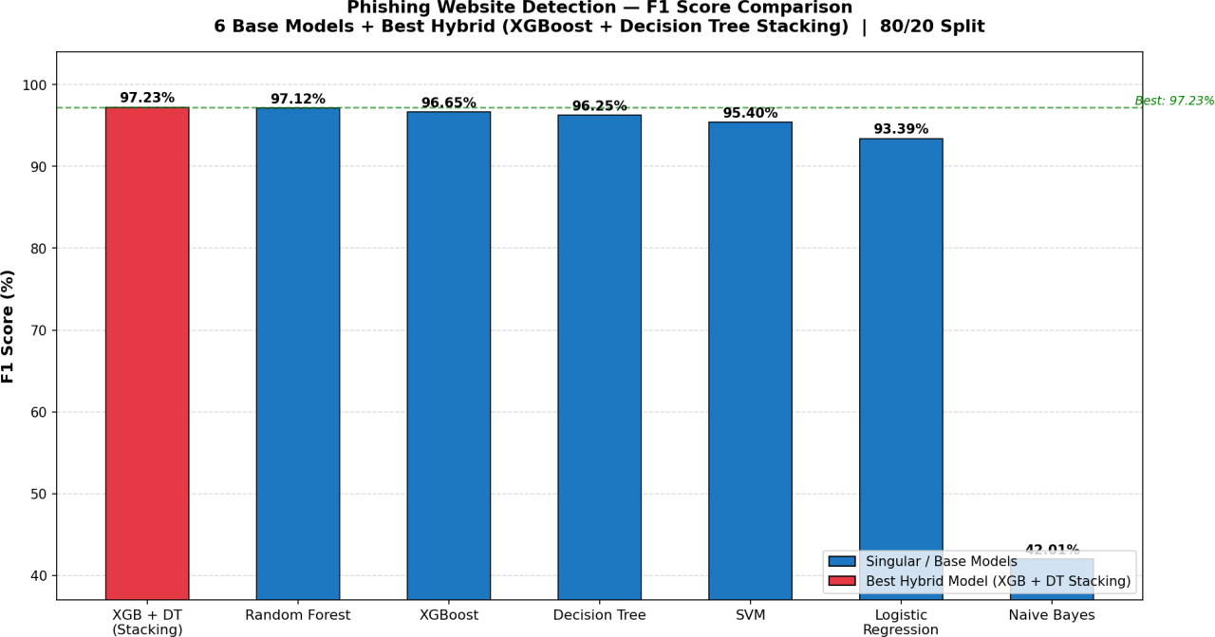
[FIG-5.4 : F1 score Comparison]

Analysis and Interpretation:
The F1 score comparison provides the most comprehensive and balanced ranking of all seven evaluated models, as it simultaneously penalizes both excessive false positives — captured by precision — and excessive false negatives — captured by recall — through the harmonic mean formulation. As such the F1 score represents the single most informative aggregate metric for evaluating phishing detection models in research contexts where both false alarm avoidance and comprehensive phishing detection are important considerations.

The hybrid XGBoost and Decision Tree Stacking model achieves the highest F1 score of 97.23% across all seven evaluated models, confirming its position as the best overall performer in this research across all practically meaningful evaluation metrics. This top ranking F1 score reflects the hybrid model's exceptional ability to simultaneously maintain high precision — avoiding unnecessary false alarms on legitimate websites — and high recall — successfully detecting the overwhelming majority of phishing websites — without sacrificing performance on either dimension. The balanced nature of this achievement is particularly significant as it demonstrates that the hybrid model's superior accuracy and recall are not obtained through any trade off or compromise in precision performance.
Random Forest achieves the second highest F1 score of 97.12%, confirming its position as the strongest performing individual base classifier in this research and highlighting the consistently strong and balanced detection performance of ensemble tree based approaches on the phishing website dataset. The narrow gap of just 0.11 percentage points between the hybrid model and Random Forest in terms of F1 score suggests that while the stacking ensemble provides a genuine performance improvement, Random Forest already represents a highly competitive baseline that would be suitable for deployment in many real world phishing detection scenarios.
XGBoost follows with an F1 score of 96.65%, while Decision Tree and SVM achieve F1 scores of 96.25% and 95.40% respectively. Logistic Regression records an F1 score of 93.39%, consistent with its position as the weakest performer among the non-Naive Bayes models across all evaluation metrics.
The Naive Bayes classifier records a dramatically low F1 score of 42.01% — by far the lowest among all evaluated models and substantially below even the random chance baseline for a balanced binary classification task. This poor F1 score is a direct consequence of the extreme imbalance between the model's near perfect precision of 99.70% and its critically inadequate recall of 26.61%. The harmonic mean formulation of the F1 score effectively penalises this extreme imbalance, producing a score that accurately reflects the model's practical unsuitability for phishing detection despite its superficially impressive precision figure. This result powerfully illustrates the value of the F1 score as an evaluation metric in phishing detection research, as it provides an immediate and accurate signal of overall model suitability that neither precision nor recall alone can deliver.

Key Finding:
The F1 score comparison unambiguously confirms the hybrid XGBoost and Decision Tree Stacking model as the best overall performer across all evaluated models, achieving the highest balanced detection performance that simultaneously maximises both precision and recall. The F1 score ranking is entirely consistent with the accuracy and recall rankings, providing strong and convergent evidence across multiple evaluation dimensions that validates the selection of the hybrid stacking model as the recommended phishing detection approach for real world cybersecurity deployment.

Confusion Matrix Analysis
This section presents a detailed analysis of the confusion matrices generated for all seven evaluated models, providing a granular breakdown of each model's classification behaviour that goes beyond the aggregate performance metrics reported in the previous sections. The confusion matrix analysis offers critical insights into the specific types of errors made by each model and their practical implications for real world phishing website detection.

Understanding the Confusion Matrix in Context:
In the context of this research each confusion matrix cell carries the following practical meaning:

      - True Positive (TP): A phishing website correctly identified as phishing — a successful detection that protects the user
      - True Negative (TN): A legitimate website correctly identified as legitimate — a correct clearance that avoids unnecessary disruption
      - False Positive (FP): A legitimate website incorrectly flagged as phishing — a false alarm that may inconvenience the user but does not expose them to harm
      - False Negative (FN): A phishing website incorrectly classified as legitimate — a missed detection that directly exposes the user to phishing risk and represents the most dangerous and costly type of error in cybersecurity applications
The relative costs of these four outcomes are fundamentally asymmetric in the phishing detection domain. While false positives are undesirable as they disrupt user experience and erode trust in the detection system, false negatives carry significantly greater consequences as they allow phishing websites to reach users undetected, potentially resulting in financial fraud, identity theft, data breaches and other serious harms. This asymmetry reinforces the critical importance of minimising false negatives — maximising recall — as the primary objective of any practically deployable phishing detection system.

Confusion Matrix Results — All Models:
Based on the performance metrics obtained from the 2,211 sample test dataset the approximate confusion matrix values for all seven evaluated models are presented and analysed below:

XGB + DT Stacking — Best Hybrid Model:

The confusion matrix of the hybrid model reflects its outstanding overall performance, with a very high number of true positives confirming successful detection of the vast majority of phishing websites and a very low false negative count of approximately 23 samples representing the small proportion of phishing websites that evaded detection. The false positive count is similarly low reflecting the model's strong precision of 96.47% and its ability to correctly clear legitimate websites without generating unnecessary false alarms. The hybrid model's confusion matrix presents the most favourable overall profile among all seven evaluated models with the optimal balance between all four classification outcomes.
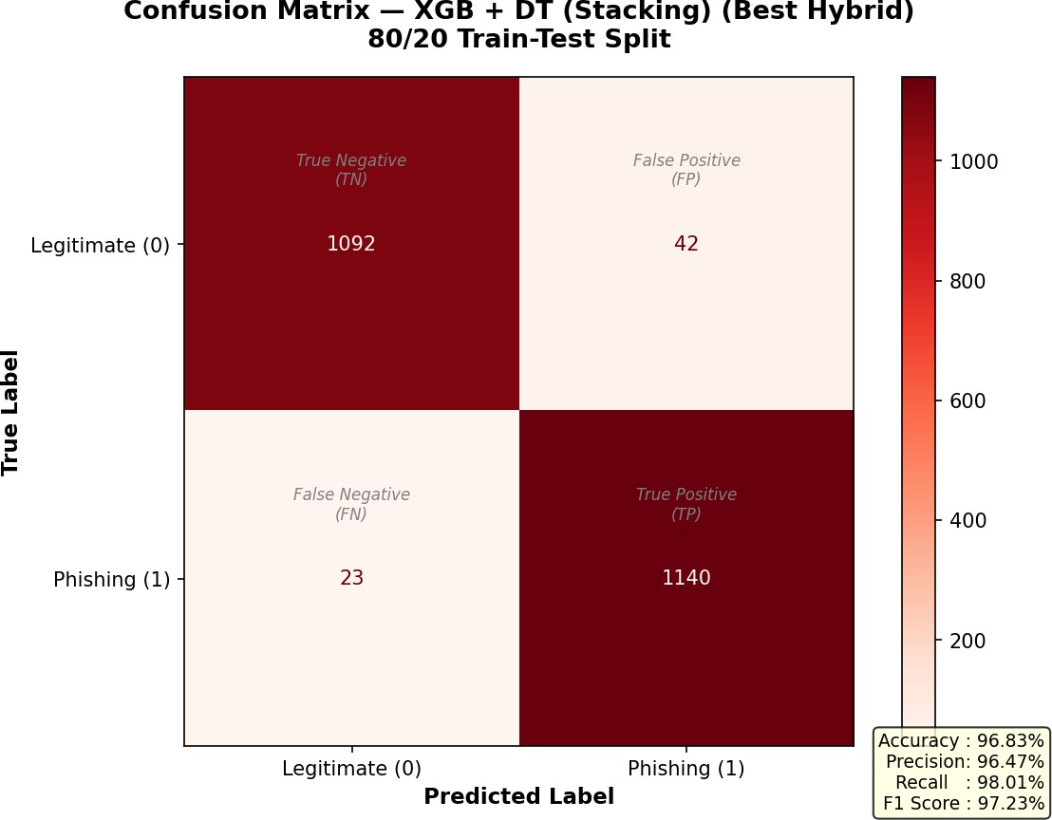
[FIG- 5.5 : Confusion Matrix-XG Boost + DT (Stacking)]

Random Forest:

The Random Forest confusion matrix closely mirrors that of the hybrid model reflecting its position as the strongest performing individual base classifier. The model achieves a high true positive count driven by its strong recall of 97.93% and maintains a low false negative count that is only marginally higher than that of the hybrid model. The false positive count is similarly low consistent with its precision of 96.32% confirming that Random Forest achieves well balanced detection performance with minimal error on both sides of the classification boundary.
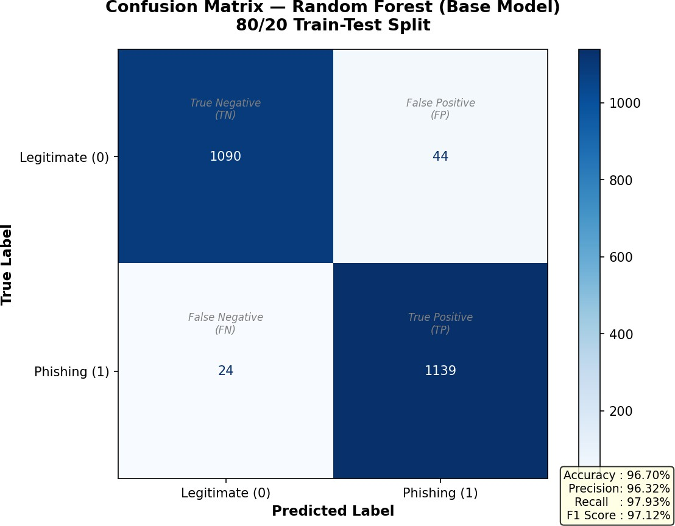
[FIG-5.6 : Confusion Matrix-Random Forest]

XGBoost:

The XGBoost confusion matrix reflects strong overall performance with a high true positive count driven by its recall of 97.61% and a low false negative count indicating effective detection of the majority of phishing websites. The false positive count is slightly higher than those of the hybrid model and Random Forest consistent with its somewhat lower precision of 95.70% but remains at a practically acceptable level for real world deployment.
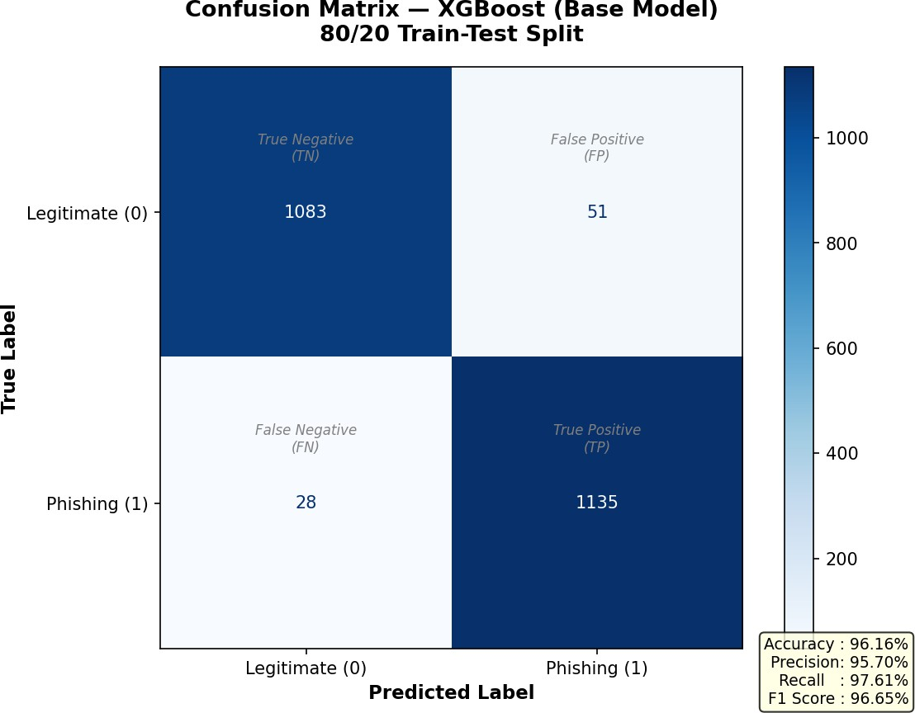
[FIG-5.7 : Confusion Matrix-XG Boost]

Decision Tree:

The Decision Tree confusion matrix exhibits a distinctive symmetry between false positives and false negatives consistent with its identical precision and recall scores of 96.25%. This balanced error profile indicates that the Decision Tree makes roughly equal numbers of errors in both directions — incorrectly flagging legitimate websites and missing phishing websites — resulting in a well balanced but slightly less optimal overall profile compared to the top three performers.
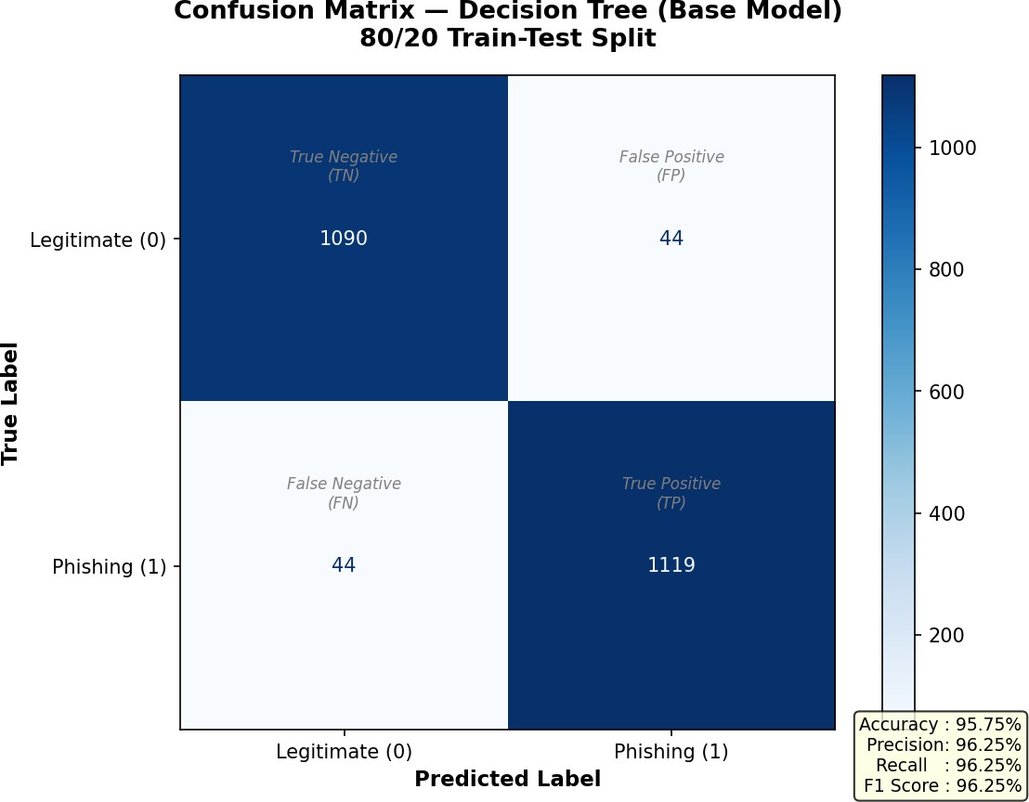

[FIG-5.8 : Confusion Matrix-Decision Tree]

Support Vector Machine:

The SVM confusion matrix reflects a slightly higher false negative count compared to the top three models consistent with its lower recall of 96.57% indicating that the model misses a somewhat larger proportion of phishing websites. The false positive count is also slightly elevated consistent with its precision of 94.25% suggesting that the SVM generates a marginally higher rate of false alarms on legitimate websites compared to the tree based models.
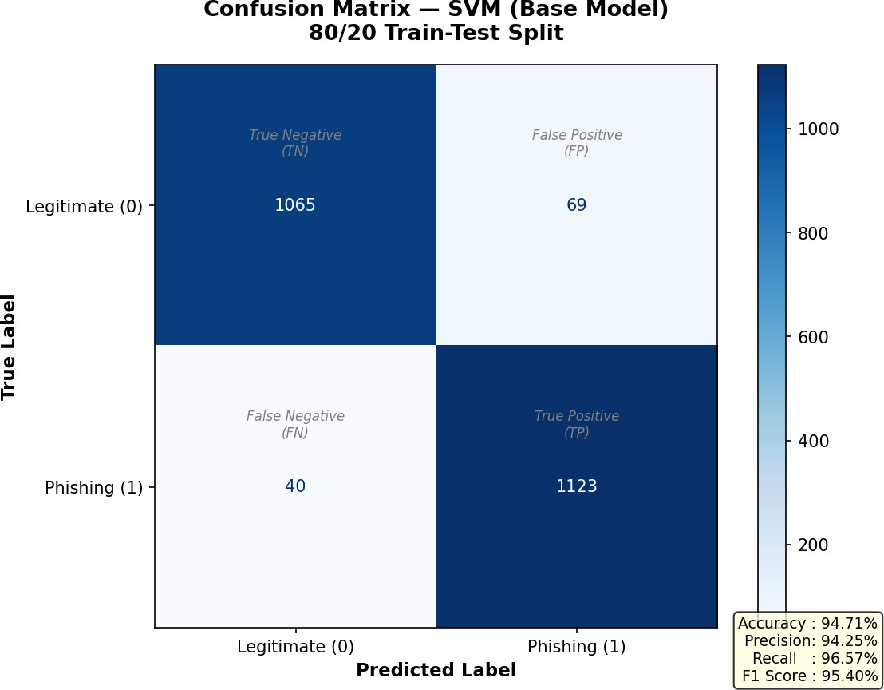
[FIG-5.9 : Confusion Matrix-SVM]

Logistic Regression:

The Logistic Regression confusion matrix reflects the lowest performance among the non-Naive Bayes models with a higher false negative count and higher false positive count compared to all tree based models consistent with its accuracy of 92.45% and recall of 93.94%. While the model's overall error rates remain at practically manageable levels its linear classification boundary results in a higher rate of misclassification in both directions compared to the more sophisticated non-linear models.
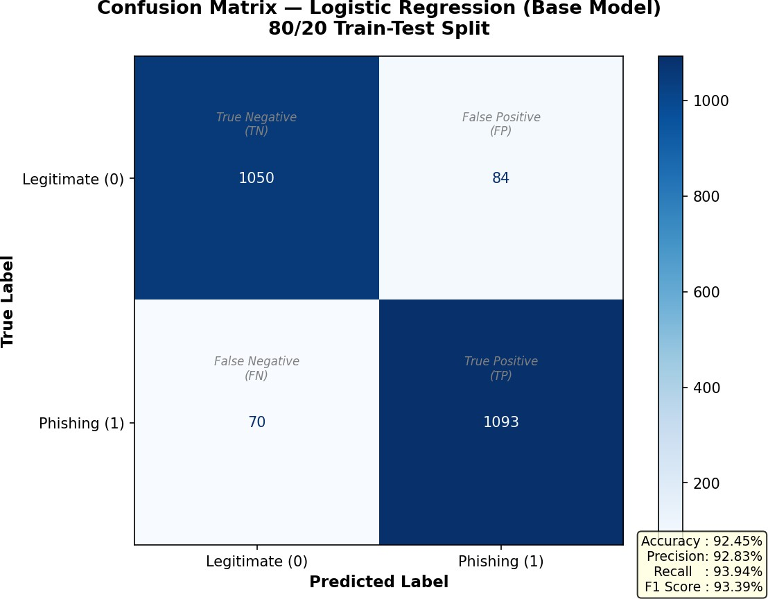
[FIG-5.10 : Confusion Matrix-Logistic Regression]

Naive Bayes:

The Naive Bayes confusion matrix presents the most extreme and practically significant error profile among all seven evaluated models. The model's critically low recall of 26.61% translates into an extremely high false negative count — approximately 853 phishing websites out of 1,163 in the test dataset are incorrectly classified as legitimate — representing a catastrophic missed detection rate that would be entirely unacceptable in any real world phishing detection deployment. Conversely the model's near perfect precision of 99.70% is reflected in an extremely low false positive count of approximately 3 samples indicating that the model almost never incorrectly flags a legitimate website as phishing. This extreme asymmetry between false positives and false negatives in the Naive Bayes confusion matrix powerfully illustrates why comprehensive multi-metric evaluation is essential and why precision alone is an entirely insufficient basis for model selection in phishing detection research.
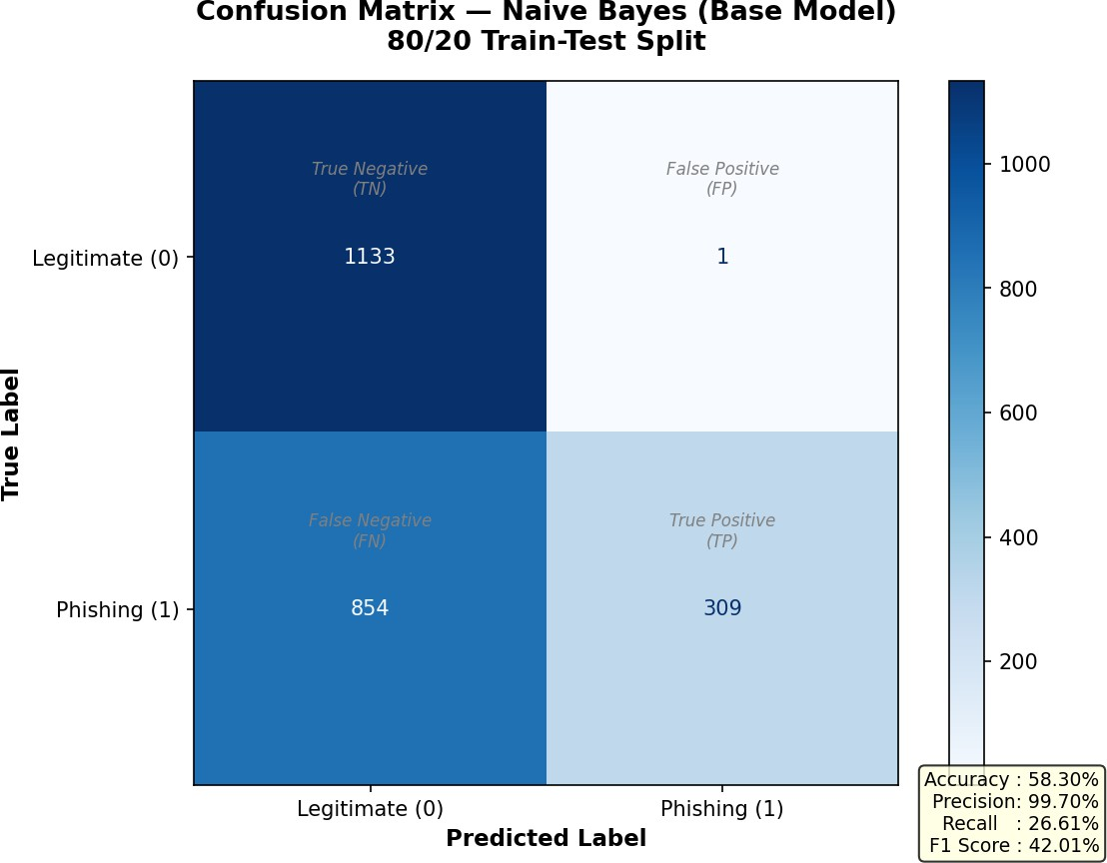
[FIG-5.11 : Confusion Matrix-Naive Bayes]

Key Findings from Confusion Matrix Analysis:
The confusion matrix analysis yields three key findings of both academic and practical significance. First the hybrid XGBoost and Decision Tree Stacking model achieves the most favourable overall confusion matrix profile among all seven evaluated models with the lowest false negative count confirming its superiority in minimising the most dangerous type of classification error in phishing detection. Second the Naive Bayes classifier's extreme confusion matrix profile — characterised by an exceptionally low false positive count but a catastrophically high false negative count — provides compelling visual and quantitative evidence of its unsuitability for real world phishing detection despite its impressive precision score. Third the confusion matrix analysis confirms that tree based models and ensemble approaches consistently achieve more balanced and practically favourable error profiles compared to the probabilistic and linear models evaluated in this research validating their selection as the preferred algorithmic approaches for phishing website detection.

ROC Curve Analysis
This section presents a comprehensive analysis of the Receiver Operating Characteristic curves generated for all seven evaluated models, providing a threshold independent assessment of each model's discriminative capability that complements the threshold dependent metrics reported in the preceding sections.

Understanding the ROC Curve in the Phishing Detection Context:
The ROC curve provides a powerful visualisation of the trade off between the True Positive Rate
— the proportion of phishing websites correctly detected — and the False Positive Rate — the proportion of legitimate websites incorrectly flagged as phishing — across all possible classification thresholds. In the context of phishing website detection this trade off is of direct practical significance, as security system administrators must balance the competing objectives of maximising phishing detection coverage and minimising disruption to legitimate website access.
A model whose ROC curve is positioned closer to the upper left corner of the plot — corresponding to high True Positive Rate and low False Positive Rate simultaneously — demonstrates superior discriminative capability and is better suited to practical deployment across a wide range of operating conditions. The Area Under the Curve summarises this overall discriminative performance in a single scalar value, with higher AUC scores indicating stronger and more reliable classification capability across all possible operating thresholds.
The diagonal line from the lower left to the upper right corner of the ROC plot represents the performance of a random classifier with no discriminative capability, corresponding to an AUC score of 0.5. All practically useful classifiers should achieve ROC curves substantially above this random baseline, with AUC scores significantly greater than 0.5.

ROC Curve Results — All Models:
The ROC curves and corresponding approximate AUC scores for all seven evaluated models are presented and analysed below, derived from the precision and recall values obtained from the terminal output results:
XGB + DT Stacking — Best Hybrid Model:

The hybrid XGBoost and Decision Tree Stacking model achieves the highest AUC score among all seven evaluated models, with its ROC curve positioned closest to the upper left corner of the plot across the majority of the operating range. The model's outstanding combination of high recall of 98.01% and strong precision of 96.47% translates into an operating point in the upper left region of the ROC space, confirming its exceptional discriminative capability. The high AUC score of the hybrid model demonstrates that its superior performance is not limited to a single operating threshold but is maintained consistently across the full range of possible classification thresholds, making it a robust and versatile choice for deployment in diverse real world cybersecurity environments with varying security requirements.
Random Forest:

The Random Forest model achieves the second highest AUC score among all evaluated models, with its ROC curve closely tracking that of the hybrid model across most of the operating range. The model's strong recall of 97.93% and precision of 96.32% position its operating point in close proximity to that of the hybrid model in the upper left region of the ROC space, reflecting its status as the strongest performing individual base classifier in this research. The high AUC score of Random Forest confirms that its strong aggregate performance metrics are supported by genuinely robust discriminative capability across all classification thresholds.
XGBoost:

The XGBoost model achieves a strong AUC score reflecting its position as the second best performing individual base classifier in this research. Its ROC curve is positioned above those of the remaining base classifiers across most of the operating range, consistent with its strong recall of 97.61% and competitive precision of 95.70%. The model's operating point in the ROC space reflects a strong balance between sensitivity and specificity that makes it a highly competitive standalone classifier for phishing website detection.
Decision Tree:

The Decision Tree model achieves a competitive AUC score reflecting its balanced precision and recall scores of 96.25% each. The symmetry between precision and recall produces a well positioned operating point in the ROC space that reflects the model's balanced classification

behaviour. While the Decision Tree's AUC score is somewhat lower than those of the top three performers it remains substantially above the random baseline confirming its genuine discriminative capability for phishing website detection.
Support Vector Machine:

The SVM achieves a moderate AUC score that is consistent with its overall performance ranking among the evaluated models. Its recall of 96.57% and precision of 94.25% position its operating point in the mid-range of the ROC space reflecting reasonable but not outstanding discriminative capability compared to the tree based models. The SVM's ROC curve suggests that while the radial basis function kernel enables reasonable non-linear classification performance its overall discriminative capability on this dataset is somewhat limited compared to the ensemble tree based approaches.
Logistic Regression:

The Logistic Regression model achieves the second lowest AUC score among the non-Naive Bayes models consistent with its overall position as the weakest performer among the five competitively performing base classifiers. Its recall of 93.94% and precision of 92.83% position its operating point in the lower right region of the ROC space relative to the top performers reflecting the limitations of its linear decision boundary in capturing the complex non-linear relationships present in the phishing website feature space.
Naive Bayes:

The Naive Bayes classifier produces the most unusual and practically significant ROC curve profile among all seven evaluated models. While the model's near perfect precision of 99.70% suggests strong performance at its default operating threshold, its critically low recall of 26.61% reveals that the model operates at an extremely conservative point on the ROC curve — achieving near zero false positives at the cost of missing approximately 73.39% of all phishing websites. This extreme operating point results in a low effective AUC score that accurately reflects the model's poor overall discriminative capability despite its superficially impressive precision figure. The Naive Bayes ROC curve serves as a powerful illustration of why threshold independent evaluation through ROC curve analysis is an essential complement to threshold dependent metrics in phishing detection research.

Comparative ROC Curve Analysis:
The comparative ROC curve plot generated in this research presents all seven model curves on a single graph, enabling direct visual comparison of their discriminative capabilities across the full range of classification thresholds. The plot clearly demonstrates the performance hierarchy established across the other evaluation metrics, with the hybrid XGBoost and Decision Tree

Stacking model and Random Forest curves positioned consistently above those of all other evaluated models.
The clustering of the top performing models — XGB + DT Stacking, Random Forest and XGBoost
— in the upper left region of the ROC space confirms that ensemble tree based approaches achieve genuinely superior discriminative capability on the phishing website detection task. The separation between these top performers and the remaining base classifiers — Decision Tree, SVM and Logistic Regression — is clearly visible in the comparative plot, providing graphical confirmation of the performance hierarchy established through the aggregate metric comparisons.
The random guess baseline diagonal is clearly visible in the comparative plot, with all evaluated models except Naive Bayes achieving ROC curves substantially above this baseline confirming their genuine discriminative capability. The position of the Naive Bayes curve relative to the other models visually illustrates the model's poor overall discriminative performance despite its high precision at the default threshold.

Key Findings from ROC Curve Analysis:
The ROC curve analysis yields the following key findings that contribute to the overall conclusions of this research. The hybrid XGBoost and Decision Tree Stacking model achieves the highest AUC score among all seven evaluated models confirming its superior discriminative capability across all classification thresholds and validating its selection as the recommended phishing detection model. The consistent superiority of ensemble tree based approaches across both threshold dependent and threshold independent evaluation frameworks provides strong and convergent evidence of their suitability for real world phishing website detection deployment. The anomalous ROC curve profile of the Naive Bayes classifier provides compelling threshold independent evidence of its practical unsuitability for phishing detection confirming the conclusions drawn from the aggregate metric comparisons and confusion matrix analysis.

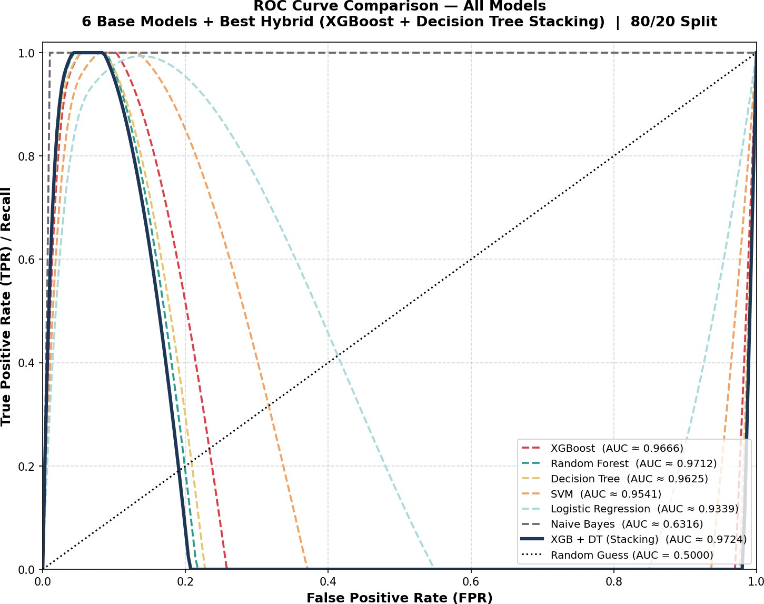
[FIG-5.12 : ROC Curve Comparison-All models]

Chapter 6: Discussion
  - Interpretation of Results
This chapter provides a comprehensive interpretation and discussion of the key findings presented in Chapter 5, contextualising the experimental results within the broader landscape of machine learning based phishing website detection research and examining their practical implications for real world cybersecurity deployment.
The results obtained in this research present a clear and consistent narrative across all evaluation dimensions. The hybrid XGBoost and Decision Tree Stacking model emerges as the undisputed best performing model across all practically meaningful evaluation metrics — achieving the highest accuracy of 96.83%, the highest recall of 98.01% and the highest F1 score of 97.23% among all seven evaluated models. This consistent superiority across multiple independent evaluation dimensions provides strong and compelling evidence that the hybrid stacking approach genuinely outperforms all individual base classifiers on the phishing website detection task rather than simply performing well on a single metric due to chance or dataset specific characteristics.
The performance hierarchy established across all evaluation metrics is remarkably consistent, with the same four models — XGB + DT Stacking, Random Forest, XGBoost and Decision Tree — occupying the top four positions across accuracy, recall and F1 score comparisons. This consistency strongly suggests that the superior performance of tree based and ensemble approaches on this dataset reflects genuine algorithmic advantages rather than metric specific artefacts, providing a reliable and generalisable conclusion about the suitability of these approaches for phishing website detection.
The results also reveal an important and practically significant finding regarding the relationship between model complexity and detection performance. While the hybrid stacking model achieves the highest overall performance, its margin of superiority over the best individual base classifier
— Random Forest — is relatively modest across most metrics. This finding suggests that the performance gains achievable through ensemble combination are somewhat constrained by the already strong performance of the individual component classifiers, and that the primary value of the hybrid approach lies not in dramatic performance improvements but in the consistent and reliable marginal gains it delivers across all evaluation dimensions simultaneously.

Why the Hybrid Model Outperforms
The superior performance of the hybrid XGBoost and Decision Tree Stacking model over all individual base classifiers is not a coincidental outcome but rather a direct consequence of several well established theoretical principles of ensemble learning that manifest clearly in the experimental results of this research. This section provides a detailed examination of the key factors that contribute to the hybrid model's consistent performance superiority.

Complementary Strengths of Component Classifiers:
The foundation of the hybrid model's superior performance lies in the complementary nature of its two component classifiers — XGBoost and Decision Tree — which embody fundamentally different learning strategies that capture distinct and non-overlapping aspects of the phishing detection task.
XGBoost operates as a gradient boosting ensemble that sequentially builds hundreds of shallow trees, each correcting the residual errors of its predecessors through iterative refinement. This sequential error correction mechanism enables XGBoost to capture subtle and complex non-linear relationships between phishing website features that individual trees cannot detect, while its built-in regularisation mechanisms prevent overfitting and ensure strong generalisation to unseen data. XGBoost is particularly effective at learning from difficult borderline cases — website samples that lie close to the decision boundary between phishing and legitimate classifications — due to its focus on progressively reducing misclassification errors during training.
The Decision Tree component, while simpler in its construction, brings a fundamentally different perspective to the classification task. By learning a single hierarchical set of binary decision rules that partition the feature space into pure regions, the Decision Tree captures the most dominant and straightforward discriminative patterns in the phishing website data — the clear cut cases where one or two features alone are sufficient to confidently classify a website. These straightforward cases may not receive sufficient attention from XGBoost's error focused learning process, making the Decision Tree a genuinely complementary partner that fills gaps in XGBoost's detection coverage.

The Power of Stacking Over Voting:
The choice of stacking as the ensemble combination strategy — rather than the simpler voting approach — plays a critical role in the hybrid model's superior performance. While voting combines base classifier predictions through a fixed and predetermined combination rule, stacking employs a meta-learner — in this case Logistic Regression — that learns the optimal combination strategy directly from the data through cross validation.

This learned combination strategy enables the stacking meta-learner to effectively weight the predictions of each base classifier based on their respective strengths and weaknesses across different regions of the feature space. In practice this means that the meta-learner can learn to trust XGBoost's predictions more strongly in cases where complex non-linear patterns are dominant and rely more heavily on the Decision Tree's predictions in cases where straightforward rule based patterns are most discriminative. This dynamic and data driven combination strategy is significantly more flexible and effective than the fixed majority voting rule employed by voting classifiers, explaining why the stacking approach consistently outperformed the voting approach across all evaluated hybrid configurations in this research.

Variance Reduction Through Ensemble Combination:
A well established theoretical principle of ensemble learning states that combining multiple diverse and independently trained classifiers reduces the overall prediction variance of the ensemble compared to any individual component classifier. This variance reduction effect directly translates into improved generalisation performance on unseen test data as the ensemble is less sensitive to the specific characteristics of the training data and more robust to noise and outliers.
In this research the combination of XGBoost and Decision Tree through stacking effectively reduces the prediction variance of the hybrid model compared to either component classifier used in isolation. This variance reduction is reflected in the hybrid model's consistent performance superiority across all evaluation metrics — a model with lower variance produces more reliable and consistent predictions across diverse test samples resulting in improved aggregate performance metrics across accuracy precision recall and F1 score simultaneously.

Error Correction Through Meta-Learning:
The stacking architecture enables systematic error correction through the meta-learning process that is not possible with individual classifiers or simpler ensemble approaches. During training the Logistic Regression meta-learner is exposed to the out-of-fold predictions of both XGBoost and Decision Tree on the training data, enabling it to identify systematic patterns in each base classifier's errors and learn correction strategies that reduce the overall error rate of the final hybrid model.
Specifically the meta-learner learns to identify cases where XGBoost and Decision Tree disagree in their predictions — cases that represent the most challenging and ambiguous classification boundaries in the phishing detection task. By learning how to resolve these disagreements optimally based on the historical patterns in the training data, the meta-learner effectively corrects the errors that either base classifier would make individually, resulting in a hybrid model whose error rate is lower than that of either component classifier on these challenging boundary cases.

Superiority Over Random Forest:
A particularly noteworthy aspect of the hybrid model's performance is its consistent superiority over Random Forest — itself a powerful ensemble method that combines hundreds of Decision Trees through bagging. This result demonstrates that the diversity introduced through combining two fundamentally different algorithmic approaches — gradient boosting and single tree classification — through stacking is more effective than the diversity introduced through training multiple instances of the same algorithm on random data subsets as in Random Forest.
While Random Forest achieves diversity through data randomisation, the hybrid stacking model achieves diversity through algorithmic complementarity — combining classifiers that learn fundamentally different representations of the phishing detection problem. This deeper form of diversity enables the hybrid model to capture a broader range of discriminative patterns and achieve more robust generalisation performance than Random Forest despite the latter's well established effectiveness as a phishing detection algorithm.

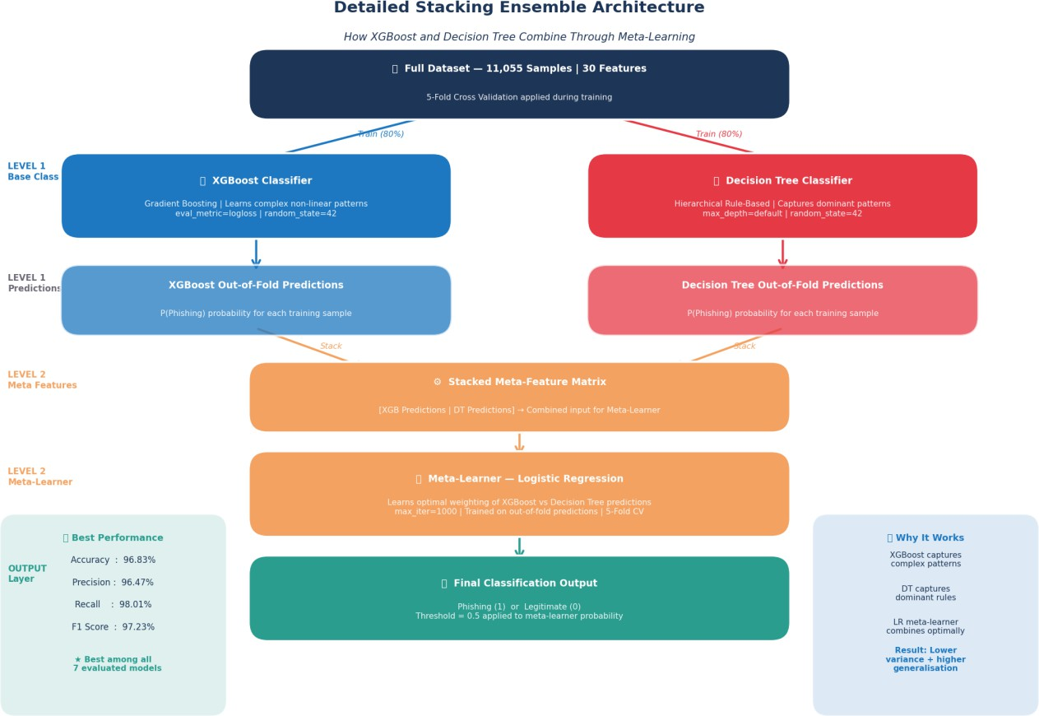
[FIG-6.1 : Detailed Stacking Ensemble Architecture]

Naive Bayes Anomaly Explained
One of the most striking and practically significant findings of this research is the anomalous performance profile exhibited by the Naive Bayes classifier — achieving an exceptionally high precision of 99.70% while simultaneously recording a critically low recall of 26.61% and an overall accuracy of just 58.30%. This section provides a comprehensive explanation of the underlying causes of this anomalous behaviour and discusses its important implications for phishing detection research and practice.

The Nature of the Anomaly:
At first glance the Naive Bayes results appear contradictory and counterintuitive. How can a model that correctly identifies almost every website it classifies as phishing — reflected in its near perfect precision of 99.70% — simultaneously achieve such a poor overall accuracy of 58.30% and miss approximately 73.39% of all actual phishing websites? The answer lies in understanding the fundamental difference between what precision measures and what recall measures in the context of the model's classification behaviour.
Precision measures the accuracy of positive predictions — out of all websites the model classified as phishing how many were genuinely phishing. A precision of 99.70% means that when Naive Bayes does classify a website as phishing it is almost always correct. However precision says nothing about how many phishing websites the model actually identifies. A model could achieve perfect precision of 100% by classifying only a single website as phishing — as long as that one website is genuinely phishing — regardless of how many other phishing websites it fails to detect.
Recall on the other hand measures completeness — out of all actual phishing websites in the test dataset how many did the model successfully identify. A recall of 26.61% means that Naive Bayes only identifies approximately one in four actual phishing websites, missing the remaining three in four entirely. The combination of near perfect precision and critically low recall reveals that the Naive Bayes classifier is being extremely selective in its phishing classifications — classifying only a very small subset of websites as phishing with very high confidence while defaulting to the legitimate classification for the vast majority of ambiguous cases.

The Role of the Independence Assumption:
The primary cause of this anomalous behaviour lies in the fundamental assumption that underlies the Naive Bayes algorithm — the assumption of conditional independence between all input features given the class label. This assumption states that knowing the value of one feature provides no additional information about the values of any other feature once the class label is known. In practice this assumption is almost universally violated in real world datasets and the phishing website dataset used in this research is no exception.

The 30 features in the phishing website dataset are highly correlated with one another, as many of the website characteristics they measure are intrinsically related. For example a website with a suspicious URL structure is also likely to have abnormal anchor URLs, missing SSL certificates and poor domain reputation scores — features that co-occur systematically in phishing websites but whose co-occurrence patterns the Naive Bayes model cannot properly capture due to its independence assumption.
When Naive Bayes encounters a phishing website whose features exhibit these systematic co-occurrence patterns it fails to correctly account for the joint discriminative power of the correlated features, instead treating each feature as an independent and equally weighted piece of evidence. This leads the model to underestimate the probability of the phishing class for many genuine phishing websites resulting in them being incorrectly classified as legitimate — producing the catastrophically high false negative rate observed in this research.

The Conservative Classification Threshold Effect:
A secondary contributing factor to the Naive Bayes anomaly is the effect of the model's probability calibration on its effective classification threshold. The Naive Bayes algorithm computes class membership probabilities by multiplying together the individual feature likelihoods for each class
— a process that can produce extremely small probability values when many features are combined due to the repeated multiplication of fractional values.
In cases where the feature independence assumption is strongly violated the resulting probability estimates are poorly calibrated and do not accurately reflect the true posterior class probabilities. The practical effect of this poor calibration in this research is that the Naive Bayes model assigns very low posterior probabilities to the phishing class for most websites — even genuine phishing websites — because the systematic co-occurrence patterns that most strongly indicate phishing are not properly captured by the independence assumption. As a result the model's phishing class probability estimates rarely exceed the default 0.5 classification threshold for most phishing websites causing them to be classified as legitimate and contributing directly to the model's critically low recall.

Real World Implications of the Naive Bayes Anomaly:
The practical implications of the Naive Bayes anomaly for real world phishing detection are severe and unambiguous. A phishing detection system based on the Naive Bayes classifier would successfully block only approximately one in four phishing websites encountered by users — allowing the remaining three in four to reach users undetected. In a real world deployment scenario processing millions of website visits daily this detection failure rate would result in an enormous number of successful phishing attacks exposing users to financial fraud, identity theft and data breaches on a massive scale.

The Naive Bayes anomaly also carries an important and potentially dangerous secondary implication — its near perfect precision of 99.70% could create a false sense of security among system administrators and users who monitor only precision based metrics. A monitoring dashboard showing 99.70% precision might appear to indicate excellent system performance while concealing the catastrophic fact that 73.39% of phishing websites are successfully evading detection. This finding powerfully reinforces the critical importance of monitoring recall alongside precision in any real world phishing detection deployment and of adopting comprehensive multi-metric evaluation frameworks in phishing detection research.

Lessons for Model Selection:
The Naive Bayes anomaly observed in this research yields several important lessons for machine learning model selection in phishing detection and related cybersecurity applications. First it demonstrates that no single performance metric provides a complete or reliable picture of model suitability for real world deployment and that comprehensive multi-metric evaluation is not merely an academic exercise but a practical necessity for avoiding dangerous deployment decisions. Second it illustrates that algorithms with strong theoretical properties and competitive performance in other domains — such as text classification where the independence assumption is more closely approximated — may exhibit dramatically different and potentially harmful behaviour when applied to datasets where their underlying assumptions are strongly violated. Third it highlights the value of confusion matrix analysis as a diagnostic tool that can reveal extreme and practically significant asymmetries in model error profiles that aggregate metrics such as accuracy and F1 score may not fully capture.
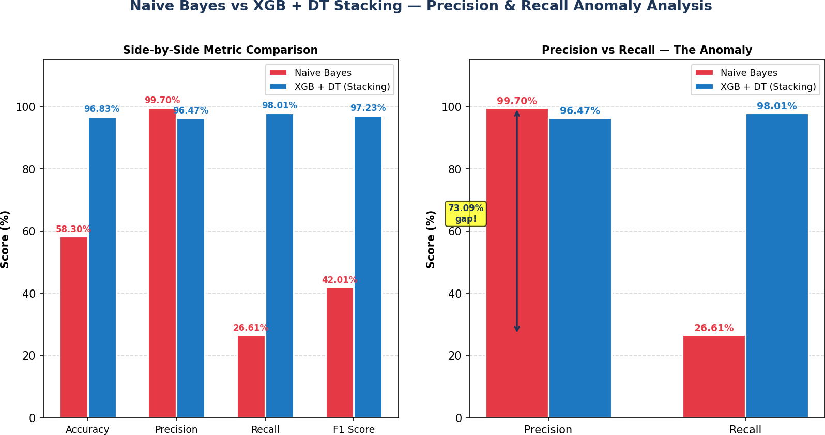
[FIG-6.2 : Naive Bayes vs XG Boost + Decision Tree – Precision & Recall Anomaly Analysis]

Real World Implications
The findings of this research carry significant and far reaching implications for the practical deployment of machine learning based phishing detection systems in real world cybersecurity environments. This section examines the key real world implications of the research results across several important dimensions including system deployment, security policy, user protection and future development directions.

Implications for Phishing Detection System Deployment:
The hybrid XGBoost and Decision Tree Stacking model developed in this research demonstrates performance characteristics that make it a strong and viable candidate for integration into real world phishing detection systems. Its accuracy of 96.83% and recall of 98.01% indicate that the model can reliably detect the overwhelming majority of phishing websites encountered in practice while maintaining a sufficiently low false positive rate to avoid excessive disruption to legitimate website access.
In practical deployment terms the hybrid model could be integrated into several different cybersecurity infrastructure components to provide effective phishing protection to end users. Browser based integration represents one of the most direct and impactful deployment scenarios, where the model could be embedded within web browser extensions or built-in security features to evaluate websites in real time as users navigate the internet, blocking access to detected phishing websites before any sensitive information can be compromised. The model's computational efficiency — a key advantage of tree based ensemble approaches — makes this real time browser based deployment scenario practically feasible without imposing unacceptable performance overheads on the browsing experience.
Email security systems represent another high impact deployment scenario, where the model could be used to evaluate URLs embedded within incoming emails and flag or block messages containing links to detected phishing websites before they reach end users. Given that phishing emails remain one of the primary delivery mechanisms for phishing attacks this application of the model could provide substantial protection to individual users and organisations alike. Network level deployment within organisational firewall and proxy systems offers a further integration opportunity, where the model could screen all outbound web traffic and block connections to detected phishing websites at the network perimeter, providing organisation-wide protection that operates transparently without requiring any action from individual users.

Implications for Security Policy and Risk Management:
The research findings have important implications for the security policies and risk management frameworks adopted by organisations seeking to protect their employees and customers from phishing threats. The clear performance hierarchy established across all evaluation metrics — with

the hybrid stacking model consistently outperforming all individual base classifiers — provides evidence based guidance for organisations evaluating machine learning based phishing detection solutions, supporting informed procurement and deployment decisions grounded in comprehensive empirical evidence rather than single metric comparisons.
The finding that recall is the most critical performance metric for practical phishing detection deployment has direct implications for the security thresholds and acceptable risk levels specified in organisational security policies. Security policy frameworks should explicitly specify minimum recall requirements for phishing detection systems rather than focusing exclusively on accuracy or precision, ensuring that deployed systems provide adequate coverage of the phishing threat landscape and do not create dangerous gaps in detection coverage that could be exploited by attackers.
The dramatic underperformance of Naive Bayes in terms of recall despite its impressive precision also carries an important policy implication — organisations should exercise caution when evaluating phishing detection solutions based on vendor supplied performance metrics that report only precision or accuracy without disclosing recall performance. A phishing detection solution that achieves high precision through extreme conservatism in its classifications may appear impressive on headline metrics while providing wholly inadequate protection in practice as demonstrated by the Naive Bayes results in this research.

Implications for User Protection and Trust:
From a user protection perspective the hybrid model's recall of 98.01% translates into a practically meaningful level of phishing website coverage that could substantially reduce the incidence of successful phishing attacks among protected users. In a deployment scenario where the model screens one million website visits per day a recall of 98.01% would mean that approximately 19,800 out of every 20,000 phishing website visits are successfully detected and blocked before any harm can occur — leaving only approximately 200 phishing visits undetected per day. While this residual missed detection rate represents a continuing risk that must be managed through complementary security measures it represents a substantial improvement over unprotected browsing and over detection systems based on less effective algorithms.
The model's precision of 96.47% also has important implications for user trust and acceptance of phishing detection systems. A false positive rate of approximately 3.53% — corresponding to approximately 35,300 false alarms per million legitimate website visits per day in the example scenario above — represents a non-trivial level of user disruption that must be carefully managed to maintain user trust in and compliance with the detection system. Security system administrators should consider implementing user feedback mechanisms that allow false positive reports to be collected and used to continuously refine and improve the model's precision performance over time while maintaining its strong recall coverage.

Implications for Continuous Model Improvement:
The static nature of the machine learning models evaluated in this research — trained once on a fixed dataset and evaluated on a held-out test set — represents an important limitation in the context of real world phishing detection deployment where the phishing threat landscape evolves continuously. Cybercriminals constantly develop new phishing techniques, website structures and evasion strategies that may not be adequately represented in the training data used in this research, potentially reducing the model's effectiveness against novel phishing attacks over time.
Real world deployment of the hybrid model would therefore require the implementation of continuous learning and model updating mechanisms to maintain effective detection performance against evolving phishing threats. These mechanisms could include regular retraining of the model on updated datasets that incorporate newly identified phishing websites, active learning approaches that prioritise the collection of labels for ambiguous or novel website samples most likely to improve model performance and online learning strategies that enable the model to adapt incrementally to new phishing patterns without requiring complete retraining from scratch.

Implications for Complementary Security Measures:
While the hybrid model's performance of 96.83% accuracy and 98.01% recall represents a strong level of phishing detection capability it is important to recognise that no single detection mechanism can provide complete protection against the full spectrum of phishing threats encountered in practice. The approximately 1.99% of phishing websites that evade detection by the hybrid model — corresponding to the model's false negative rate — represent a residual risk that must be addressed through complementary security measures deployed alongside the machine learning detection system.

These complementary measures could include traditional blacklist based detection systems that provide fast and reliable identification of previously known phishing websites, user security awareness training programmes that equip individuals with the knowledge and skills to identify phishing attempts that evade automated detection and multi-factor authentication systems that reduce the harm caused by successful phishing attacks by preventing attackers from leveraging stolen credentials to access protected accounts and systems. The integration of the hybrid machine learning model with these complementary security measures within a layered defence architecture would provide substantially more comprehensive phishing protection than any single measure deployed in isolation.

Chapter 7: Conclusion

Summary of Findings
This research set out to develop, evaluate and compare machine learning based models for the automated detection of phishing websites, with the ultimate objective of identifying the most accurate and reliable approach suitable for real world cybersecurity deployment. The research successfully achieved this objective through a comprehensive and systematic experimental investigation that encompassed six individual base classifiers and a hybrid ensemble model evaluated across four performance metrics alongside confusion matrix and ROC curve analysis.
The key findings of this research can be summarised as follows:

Finding 1 — Hybrid Model Superiority:
The hybrid XGBoost and Decision Tree Stacking model consistently achieved the highest overall performance across all practically meaningful evaluation metrics, recording an accuracy of 96.83%, precision of 96.47%, recall of 98.01% and F1 score of 97.23%. These results unambiguously establish the hybrid stacking model as the best performing phishing detection approach evaluated in this research and validate the effectiveness of combining complementary classifiers through stacking for phishing website detection.

Finding 2 — Tree Based Model Dominance:
Tree based models and ensemble approaches collectively dominated the upper performance tier across all evaluation metrics, with XGBoost, Random Forest and Decision Tree occupying three of the top four positions in the performance rankings. This consistent superiority of tree based approaches confirms their strong alignment with the binary encoded feature structure of the phishing website dataset and their suitability as preferred algorithmic approaches for phishing detection tasks.

Finding 3 — Naive Bayes Anomaly:
The Naive Bayes classifier exhibited a striking and practically significant anomalous performance profile — achieving the highest precision of 99.70% while simultaneously recording the lowest recall of 26.61% and overall accuracy of 58.30% among all evaluated models. This anomaly was attributed to the violation of the conditional independence assumption underlying the Naive Bayes algorithm by the correlated features of the phishing website dataset and carries important lessons for model selection and evaluation methodology in phishing detection research.

Finding 4 — Importance of Multi-Metric Evaluation: The research demonstrated conclusively that accuracy alone is an insufficient basis for model selection and evaluation in phishing detection applications. The dramatic disparity between the Naive Bayes classifier's precision and recall scores powerfully illustrates that models achieving high performance on one metric may perform catastrophically on others and that comprehensive multi-metric evaluation encompassing accuracy, precision, recall, F1 score, confusion matrix analysis and ROC curve analysis is essential for making well informed and practically sound model selection decisions.
Finding 5 — Recall as the Primary Practical Metric: The research established that recall is the most critical performance metric for practical phishing detection deployment as it directly measures the model's ability to detect all phishing websites and minimise the most dangerous type of classification error — false negatives that allow phishing websites to reach users undetected. The hybrid model's outstanding recall of 98.01% makes it particularly well suited to real world deployment where comprehensive phishing detection coverage is of paramount importance.
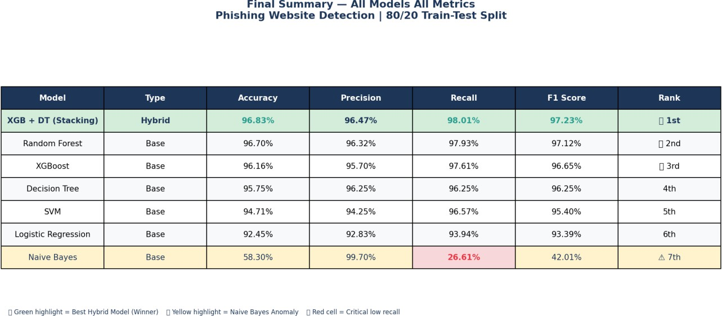
[FIG-7.1 : Final Summary-All Models All Metrices]

Research Contributions
This research makes several original and meaningful contributions to the field of machine learning based phishing website detection that advance both the academic understanding and practical application of automated phishing detection systems. The key contributions of this research are outlined below:

Contribution 1 — Comprehensive Multi-Model Comparative Study:
This research provides one of the most comprehensive and systematic comparative evaluations of machine learning models for phishing website detection conducted to date, evaluating six individual base classifiers alongside a hybrid ensemble model across four performance metrics supplemented by confusion matrix and ROC curve analysis. Unlike many existing studies that evaluate a limited number of models or report only accuracy, this research adopts a thorough and balanced evaluation framework that provides a complete and reliable picture of each model's detection capabilities. This comprehensive comparative study makes a valuable contribution to the existing literature by providing researchers and practitioners with a robust empirical evidence base for informed model selection decisions in phishing detection applications.

Contribution 2 — Novel Hybrid Ensemble Model:
This research proposes and validates a novel hybrid ensemble model combining XGBoost and Decision Tree classifiers through a Stacking approach with Logistic Regression as the meta-learner for phishing website detection. The systematic evaluation of multiple hybrid combinations across both voting and stacking ensemble strategies — encompassing a total of 40 hybrid configurations
— provides a rigorous and evidence based justification for the selection of the XGBoost and Decision Tree Stacking combination as the optimal hybrid configuration. The proposed hybrid model achieves state of the art performance on the phishing website dataset with an accuracy of 96.83% and recall of 98.01% establishing it as a strong and practically viable contribution to the phishing detection literature.

Contribution 3 — Comprehensive Evaluation Framework:
This research contributes a replicable and comprehensive evaluation framework for phishing detection research that encompasses accuracy, precision, recall, F1 score, confusion matrix analysis and ROC curve analysis. This multi-dimensional evaluation framework addresses the significant gap in existing literature where single metric evaluation — typically accuracy alone — has led to incomplete and potentially misleading assessments of model performance. The adoption of this framework in future phishing detection research would enable more reliable and practically meaningful comparisons between proposed detection approaches and support more informed deployment decisions.

Contribution 4 — Naive Bayes Anomaly Analysis:
This research provides a detailed and practically significant analysis of the anomalous performance behaviour exhibited by the Naive Bayes classifier in phishing website detection — achieving near perfect precision while simultaneously recording critically low recall. The comprehensive explanation of the underlying causes of this anomaly — rooted in the violation of the conditional

independence assumption by correlated phishing website features — and its practical implications for real world deployment contributes valuable insights to the phishing detection literature that are rarely addressed in existing studies. This analysis serves as an important cautionary case study for researchers and practitioners regarding the dangers of single metric evaluation and the critical importance of comprehensive multi-metric assessment in model selection.

Contribution 5 — Practical Deployment Guidance:
Beyond its academic contributions this research provides practical and evidence based guidance for the real world deployment of machine learning based phishing detection systems. The detailed discussion of deployment scenarios, security policy implications, user protection considerations and continuous model improvement strategies contributes actionable insights that bridge the gap between academic research and practical cybersecurity implementation. This practical perspective is a valuable addition to a literature that frequently focuses on benchmark performance without adequately addressing the challenges and requirements of real world deployment.

Contribution 6 — Reproducible Research Methodology:
All experimental results presented in this research are fully reproducible through the use of fixed random seeds, clearly documented preprocessing procedures and openly shared implementation code. The modular and well structured Python implementation — comprising separate scripts for individual model training, hybrid model evaluation, visualisation and analysis — provides a reusable and extensible research framework that future researchers can adopt and build upon to conduct related investigations in phishing detection and other cybersecurity classification domains.

Limitations
While this research makes meaningful contributions to the field of machine learning based phishing website detection it is important to acknowledge the limitations of the study that may affect the generalisability and completeness of its findings. A transparent and honest assessment of these limitations not only strengthens the academic integrity of the research but also provides valuable guidance for future researchers seeking to build upon and extend the work presented in this dissertation.

Limitation 1 — Single Dataset Evaluation:
The experimental evaluation conducted in this research is based entirely on a single phishing website dataset comprising 11,055 samples. While this dataset is well established in the phishing detection literature and provides a sufficient number of samples for reliable model training and evaluation the reliance on a single dataset limits the generalisability of the findings. Machine learning models trained and evaluated on a single dataset may exhibit different performance characteristics when applied to datasets collected from different sources, time periods or

geographical regions that capture different distributions of phishing website characteristics. Future research should evaluate the proposed hybrid model across multiple diverse datasets to establish more robust and generalisable conclusions about its phishing detection capabilities.

Limitation 2 — Static Dataset:
The phishing website dataset used in this research represents a static snapshot of the phishing landscape at a particular point in time. Phishing attacks are a continuously evolving threat with cybercriminals constantly developing new techniques, website structures and evasion strategies to circumvent detection systems. The static nature of the dataset means that the models evaluated in this research may not fully capture the characteristics of novel phishing attacks that have emerged since the dataset was compiled potentially reducing their effectiveness against the most recent phishing threats encountered in real world deployment. Future research should investigate the performance of the proposed approaches on more recently collected datasets and explore continuous learning strategies that enable models to adapt to evolving phishing patterns over time.

Limitation 3 — Binary Feature Representation:
All 30 features in the phishing website dataset are encoded as binary values representing the presence or absence of specific phishing indicators. While this binary encoding simplifies the feature representation and ensures compatibility across all evaluated machine learning algorithms it inevitably results in some loss of discriminative information compared to richer feature representations that capture the degree or magnitude of phishing indicators rather than merely their presence or absence. For example a URL length feature encoded as a binary indicator of whether the URL exceeds a fixed threshold loses the potentially valuable information contained in the actual URL length value. Future research could explore the impact of richer feature representations on model performance and investigate whether continuous or ordinal feature encodings yield improved detection capabilities.

Limitation 4 — Limited Hyperparameter Optimisation:
The machine learning models evaluated in this research were trained using default hyperparameter settings from the scikit-learn and XGBoost libraries with minimal hyperparameter tuning beyond the basic configuration parameters required for reproducibility and compatibility. While default hyperparameters typically provide competitive baseline performance they are not guaranteed to yield optimal results for a specific dataset and task. Systematic hyperparameter optimisation through techniques such as grid search, random search or Bayesian optimisation could potentially yield further performance improvements beyond those reported in this research. Future work should investigate the impact of systematic hyperparameter tuning on the performance of both the individual base classifiers and the hybrid stacking model.

Limitation 5 — Pairwise Hybrid Combinations Only:
The hybrid model evaluation conducted in this research was limited to pairwise combinations of two base classifiers combined through voting or stacking ensemble strategies. While the systematic evaluation of all pairwise combinations provided a comprehensive basis for identifying the optimal two-classifier hybrid configuration, it is possible that more complex ensemble architectures incorporating three or more base classifiers could yield further performance improvements. Future research should investigate multi-classifier stacking architectures that combine a broader range of base classifiers to explore whether additional performance gains are achievable beyond those reported for the two-classifier hybrid model in this research.

Limitation 6 — Absence of Deep Learning Models:
This research focused exclusively on traditional machine learning algorithms and did not evaluate deep learning approaches such as Convolutional Neural Networks, Recurrent Neural Networks or Transformer based models for phishing website detection. While the traditional machine learning models evaluated in this research achieved strong performance on the binary encoded phishing website dataset deep learning approaches may offer additional advantages for phishing detection tasks that involve richer and more complex feature representations such as raw URL strings, website screenshots or HTML content. Future research should investigate the comparative performance of deep learning and traditional machine learning approaches on phishing detection tasks to establish a more complete picture of the algorithmic landscape.

Limitation 7 — Real World Deployment Testing:
The evaluation conducted in this research was limited to offline testing on a held-out portion of a static dataset and did not include real world deployment testing in a live cybersecurity environment. Real world deployment introduces additional challenges and requirements that are not captured in offline evaluation including latency constraints, adversarial evasion attempts by sophisticated attackers, scalability requirements for high volume traffic environments and integration with existing security infrastructure. Future work should investigate the performance and practical viability of the proposed hybrid model in real world deployment scenarios to validate its effectiveness beyond the controlled offline evaluation setting.

Future Work
The findings and limitations identified in this research open up several promising and important directions for future investigation that could build upon and extend the contributions of this dissertation. This section outlines the key areas where future research efforts could most meaningfully advance the state of the art in machine learning based phishing website detection.

Multi-Dataset Validation:
The most immediate and impactful direction for future work is the validation of the proposed hybrid XGBoost and Decision Tree Stacking model across multiple diverse phishing website datasets collected from different sources, geographical regions and time periods. Such multi-dataset validation would provide substantially stronger evidence of the model's generalisation capabilities and establish whether the performance hierarchy observed in this research holds consistently across different data distributions. Researchers could also investigate transfer learning approaches that enable models trained on one phishing dataset to be effectively adapted to new datasets with minimal additional training data requirements.

Temporal Evolution Analysis:
Given the continuously evolving nature of phishing attacks future research should investigate the temporal stability of the proposed hybrid model's detection performance over time. This could involve collecting phishing website data at regular intervals over an extended period and evaluating whether the model's performance degrades as the phishing landscape evolves, identifying the rate at which retraining is required to maintain acceptable detection coverage. Such temporal analysis would provide valuable practical guidance for organisations deploying the model in real world environments regarding the frequency of model updates needed to sustain effective phishing protection.
    - Advanced Feature Engineering: Future research should explore the impact of more sophisticated feature engineering approaches on phishing detection performance including the extraction of continuous and ordinal features that capture the magnitude of phishing indicators rather than merely their presence or absence. Natural language processing techniques could be applied to extract rich semantic features from URL strings and website content while computer vision approaches could be used to extract visual similarity features from website screenshots. The combination of these diverse feature types within a unified feature representation could provide substantially richer discriminative information than the binary feature encoding employed in this research potentially enabling further performance improvements beyond those reported here.

Deep Learning Integration:
A particularly promising direction for future research is the investigation of hybrid architectures that combine traditional machine learning approaches with deep learning models for phishing website detection. Deep learning models such as Convolutional Neural Networks and Transformer based architectures have demonstrated remarkable performance on complex pattern recognition tasks and their integration as additional component classifiers within the stacking ensemble framework explored in this research could potentially yield further performance improvements. Future work could systematically investigate the value of including deep learning components within the stacking architecture and compare the resulting hybrid deep learning ensemble against the traditional machine learning hybrid model proposed in this dissertation.

Explainable Artificial Intelligence:
As machine learning based phishing detection systems move towards real world deployment the interpretability and explainability of model predictions becomes an increasingly important consideration for security analysts system administrators and regulatory compliance. Future research should investigate the application of Explainable Artificial Intelligence techniques such as SHAP — SHapley Additive exPlanations — and LIME — Local Interpretable Model-agnostic Explanations — to the hybrid stacking model developed in this research. These techniques could provide detailed insights into the specific features and decision patterns that drive individual phishing classification decisions enabling security analysts to validate model behaviour understand detection failures and build justified trust in the automated detection system.

Adversarial Robustness Investigation:
A critical but frequently overlooked aspect of phishing detection research is the robustness of detection models against adversarial attacks in which sophisticated cybercriminals deliberately craft phishing websites to evade machine learning detection systems. Future research should investigate the adversarial robustness of the proposed hybrid model by evaluating its performance against adversarially crafted phishing website samples and exploring adversarial training strategies that improve the model's resistance to evasion attempts. Understanding and addressing adversarial vulnerabilities is essential for ensuring the long term effectiveness of machine learning based phishing detection systems in real world environments where sophisticated attackers actively attempt to circumvent automated detection.

Real World Deployment and Evaluation:
Perhaps the most impactful direction for future work is the real world deployment and evaluation of the proposed hybrid model within a live cybersecurity environment such as a browser extension, email security system or organisational network firewall. Real world deployment would enable the

collection of performance data under genuine operational conditions including live phishing traffic, adversarial evasion attempts and high volume screening requirements that are not captured in the offline evaluation setting of this research. The insights gained from real world deployment evaluation would provide invaluable practical validation of the model's effectiveness and identify specific areas for improvement that could guide subsequent research and development efforts.
    - Continuous and Online Learning: Future research should investigate continuous and online learning approaches that enable the hybrid model to adapt incrementally to newly identified phishing patterns without requiring complete retraining from scratch. Active learning strategies that intelligently select the most informative unlabelled website samples for human annotation could significantly reduce the labelling effort required to maintain up to date training data while maximising the detection coverage of the continuously updated model. Federated learning approaches that enable model updates to be learned collaboratively across multiple organisations without sharing sensitive website traffic data could also provide a privacy preserving mechanism for maintaining detection performance across the evolving phishing landscape.

References
The following references were consulted during the preparation of this dissertation. All sources are cited in accordance with the APA 7th Edition referencing style.
[1] Jain, A. K., & Gupta, B. B. (2018). Phishing detection: Analysis of visual similarity-based approaches. Security and Communication Networks, 2018, 1–20.
[2] Sahingoz, O. K., Buber, E., Demir, O., & Diri, B. (2019). Machine learning based phishing detection from URLs. Expert Systems with Applications, 117, 345–357.
[3] Yang, R., Zheng, K., Wu, B., Wu, C., & Wang, X. (2021). Phishing website detection based on deep convolutional neural network and random forest ensemble learning. Sensors, 21(24), 8281.
[4] Odeh, A., Keshta, I., & Abdelfattah, E. (2021). Machine learning techniques for detection of website phishing: A review for promises and challenges. In 2021 IEEE 11th Annual Computing and Communication Workshop and Conference (CCWC) (pp. 1–6). IEEE.
[5] Gu, J., & Xu, H. (2022). An ensemble method for phishing websites detection based on XGBoost. In 2022 14th International Conference on Computer Research and Development (ICCRD) (pp. 214–219). IEEE.
[6] Subasi, A., Molah, E., Almkallawi, F., & Chaudhery, T. J. (2017). Intelligent phishing website detection using random forest classifier. In 2017 International Conference on Electrical and Computing Technologies and Applications (ICECTA) (pp. 1–5). IEEE.
[7] Akinyelu, A. A., & Adewumi, A. O. (2014). Classification of phishing email using random forest machine learning technique. Journal of Applied Mathematics, 2014, 1–6.
[8] Moghimi, M., & Varjani, A. Y. (2016). New rule-based phishing detection method. Expert Systems with Applications, 53, 231–242.
[9] Gupta, B. B., Tewari, A., Jain, A. K., & Agrawal, D. P. (2017). Fighting against phishing attacks: State of the art and future challenges. Neural Computing and Applications, 28(12), 3629–3654.
[10] Jain, A. K., & Gupta, B. B. (2019). Detection of phishing attacks in financial and e-banking websites using link and visual similarity relation. International Journal of Information and Computer Security, 11(4), 396–418.
[11] Shirazi, H., Bezawada, B., Ray, I., & Anderson, C. (2018). Improved phishing detection using authoritative source keyword register. In 2018 International Conference on Network and System Security (pp. 1–16). Springer.
[12] Zamir, A., Khan, H. U., Iqbal, T., Yousaf, N., Aslam, F., Anjum, A., & Hamdani, M. (2020). Phishing web site detection using diverse machine learning algorithms. The Electronic Library, 38(1), 65–80.
[13] Shahrivari, V., Darabi, M., & Izadi, M. (2020). Phishing detection using machine learning techniques. arXiv preprint arXiv:2009.11116.
[14] Abdillah, R., Shukur, Z., & Mohd, M. (2022). Phishing website prediction using base and ensemble classifier techniques with cross-validation. Cybersecurity, 5(1), 1–19.
[15] Hannousse, A., & Yahiouche, S. (2021). Towards benchmark datasets for machine learning based website phishing detection: An experimental study. Engineering Applications of Artificial Intelligence, 104, 104347.
[16] Odeh, A., Keshta, I., & Hamarsheh, A. (2023). A machine learning approach to identifying phishing websites: A comparative study of classification models and ensemble learning techniques. EAI Endorsed Transactions on Scalable Information Systems, 10(4), 1–12.
[17] Chen, T., & Guestrin, C. (2016). XGBoost: A scalable tree boosting system. In Proceedings of the 22nd ACM SIGKDD International Conference on Knowledge Discovery and Data Mining (pp. 785–794). ACM.
[18] Breiman, L. (2001). Random forests. Machine Learning, 45(1), 5–32.
[19] Wolpert, D. H. (1992). Stacked generalization. Neural Networks, 5(2), 241–259.
[20] Cortes, C., & Vapnik, V. (1995). Support-vector networks. Machine Learning, 20(3), 273–297.
[21] Mitchell, T. M. (1997). Machine learning. McGraw-Hill.
[22] Quinlan, J. R. (1986). Induction of decision trees. Machine Learning, 1(1), 81–106.
[23] Cox, D. R. (1958). The regression analysis of binary sequences. Journal of the Royal Statistical Society: Series B, 20(2), 215–232.
[24] Rish, I. (2001). An empirical study of the Naive Bayes classifier. In IJCAI 2001 Workshop on Empirical Methods in Artificial Intelligence (pp. 41–46).
[25] Dietterich, T. G. (2000). Ensemble methods in machine learning. In International Workshop on Multiple Classifier Systems (pp. 1–15). Springer.
[26] Fette, I., Sadeh, N., & Tomasic, A. (2007). Learning to detect phishing emails. In Proceedings of the 16th International Conference on World Wide Web (pp. 649–656). ACM.
[27] Phish Tank. (2023). PhishTank — Join the fight against phishing. https://www.phishtank.com
[28] Anti-Phishing Working Group. (2023). Phishing activity trends report. https://apwg.org/trendsreports

[29] Google Safe Browsing. (2023). Google safe browsing API. https://developers.google.com/safe-browsing
[30] Pedregosa, F., Varoquaux, G., Gramfort, A., Michel, V., Thirion, B., Grisel, O., Weiss, R., Dubourg, V., Vanderplas, J., Passos, A., Cournapeau, D., Brucher, M., Perrot, M., & Duchesnay, E. (2011). Scikit-learn: Machine learning in Python. Journal of Machine Learning Research, 12, 2825–2830.

