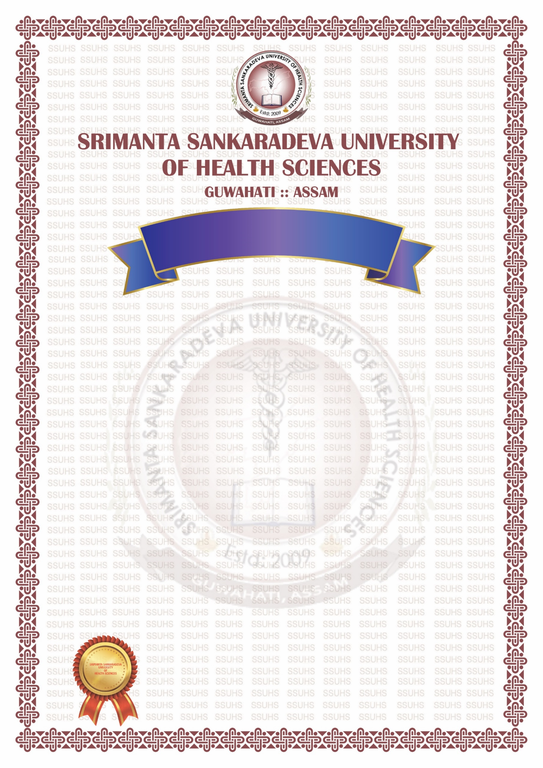
This is to certify that
{{Table.StudentName }}
(Registration No.{{ Table.RegistrationNo }} of {{ Table.RegistrationYear }}) of
{{ Table.CollegeName }}
Roll No. {{ RollNo }} having passed the Final
{{ Table.CourseName}}Examination held in {{Table. ExamDate }} and having
successfully completed the compulsory Rotating Internship on
{{}} as required under the regulations has qualified for the
Degree of Bachelor of Medicine and Surgery and is hereby
declared competent and authorised to practise Medicine Surgery
and Obstetrics & Gynaecology.

Guwahati Assam (India)
The {{Table.ApprovalDate}}
{{Table.CourseName2}}
Prof (Dr) Dhruba Jyoti Borah
Vice Chancellor

ORIGINAL PASS CERTIFICATE

