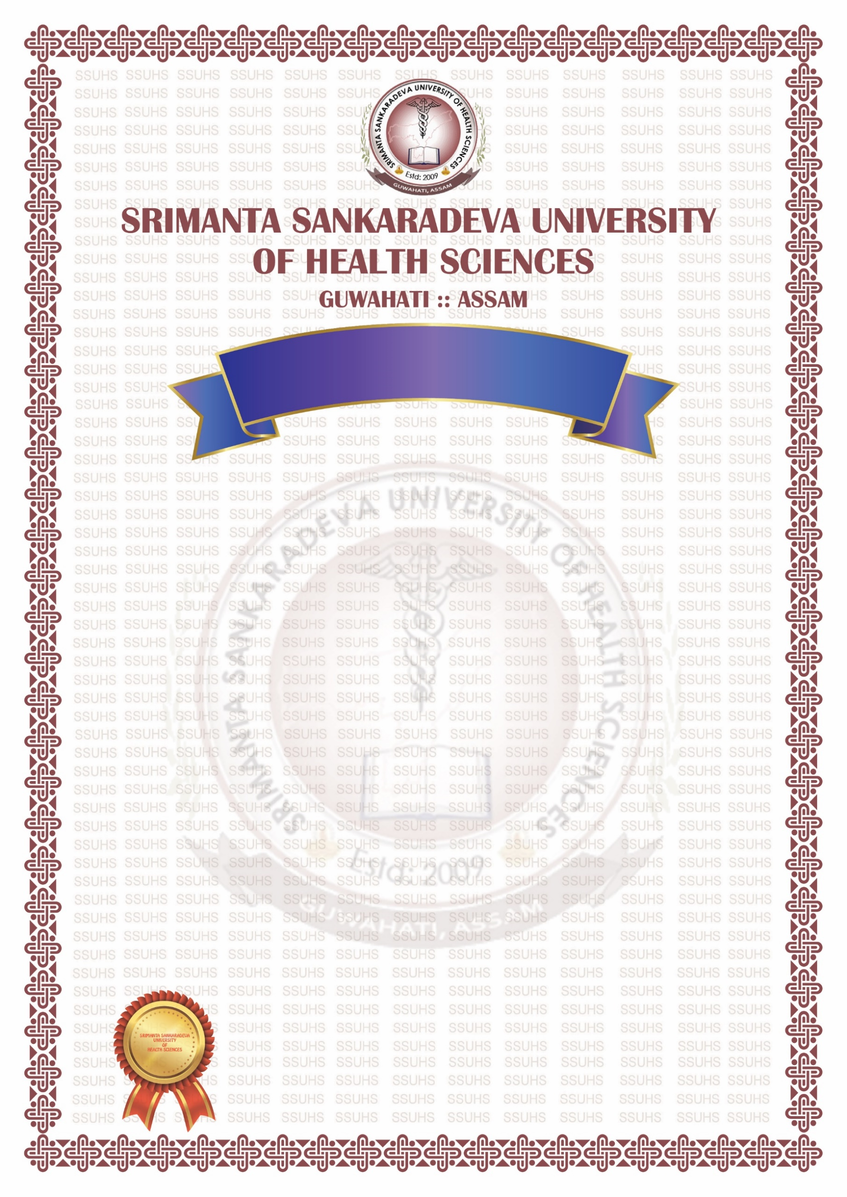
This is to certify that
{ }
(Registration No. { } of { }) of
{ }
Roll No. { } having passed the Final
M.B.B.S. Examination held in { } and having
successfully completed the compulsory Rotating Internship on
{ } as required under the regulations has qualified for the
Degree of Bachelor of Medicine and Surgery and is hereby
declared competent and authorised to practise Medicine Surgery
and Obstetrics & Gynaecology.

Guwahati Assam (India)
The { }
Prof (Dr) Dhruba Jyoti Borah
Vice Chancellor
OPC No – { }
{ }
ORIGINAL PASS CERTIFICATE

