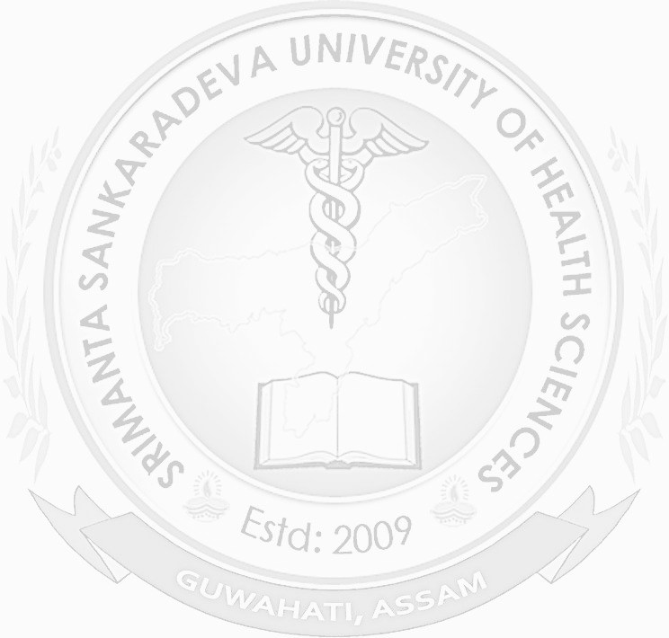.
PROVISIONAL PASS CERTIFICATE
{{Table.CourseName}}
ID: SSU/{{Table.ApprovalYear}}/PPC/{{Table.SrNo}}
This is to certify that
{{ Table.StudentName}}
(Registration No. {{Table.RegistrationNo}} of {{Table.RegistrationYear}}) of
{{ Table.CollegeName}}
Roll No. {{Table.RollNo}} has been examined and found qualified
for the Degree of {{Table.CourseName}} of this University in the
Examination held in {{Table.ExamDate}}. He/ She completed the
Compulsory Rotating Internship on
{{Table.InternshipDate}}.
Guwahati Assam (India)
The {{Table.ApprovalDate}}
Digitally signed by
Dr. Sujit Bordhan
Registrar
{{Table.SignDate}}
Note: This is computer generated certificate and does not need any signature

