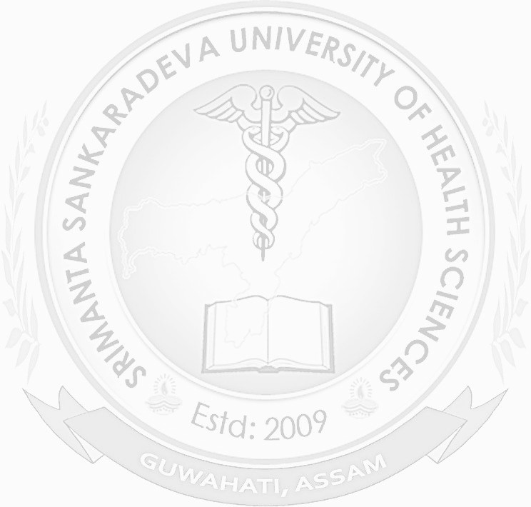
.
SRIMANTA SANKARADEVA UNIVERSITY
OF HEALTH SCIENCES
(A State University of Govt. of Assam)
NARAKASUR HILLTOP, BHANGAGARH, GUWAHATI, ASSAM (INDIA)
SL No: {{Table.SlNo}}
REGISTRATION CERTIFICATE

Certified that {{Table.FullName}}
Son/Daughter of {{Table.FatherName}} (Father)
and {{Table.MotherName}} (Mother)
a student of {{Table.CgName}}
is registered as a student of this University.
His/Her Registration Number is {{Table.RgNo}} of {{Table.RgYear}}.
Date of Birth: {{Table.Dob}}.

Note: This is computer generated certificate and does not need any signature

Date:{{Table.ApproveDate}}
Digitally signed by
Dr. Sujit Bhordhan
Registrar
Srimanta Sankaradeva University
of Health Sciences

