Wizard OS: Project Report
Team: Shakya Sopory (24BCE0371), Syed Saad Ali (24BCE0576)
Course: Operating Systems Lab (BCSE303P) | Faculty: Jagalingam P
Wizard OS is a local, retrieval-augmented tutor for Operating Systems built on Qwen3 and a course knowledge base. A QLoRA fine-tune was tried and compared against retrieval alone.

1. Dataset
The knowledge base is 10 course PDFs (398 pages): six lecture/theory files and four question banks of 120 questions each. The question banks came without answers, so 480 answers were drafted, reviewed and, for the lab questions, compiled and run-tested.
Source | Files | Role
Theory notes | Deadlocks, Disk scheduling, Memory-management, Process Synchronization, Process-Scheduling, Shell Script | Facts and terminology for retrieval
MCQ bank | 120 questions + answers | Style for MCQ generation
Viva bank | 120 questions + answers | Style for viva generation
Descriptive bank | 120 questions + answers | Style for long-answer questions
Lab bank | 120 exercises + tested C/C++/shell/Python solutions | Style and reference code for labs

The textbook, lecture slides and past papers listed in the project plan were not part of this prototype. The prototype uses the lecture PDFs and question banks only.

2. Dataset preprocessing
The 398 pages became 532 searchable chunks, and the same material was reshaped into 696 training and 72 test examples for the fine-tuning experiment.
Step | What was done | Result
Parse | pypdf reads each page; each file is tagged theory, mcq, viva, descriptive or lab from its name | 398 pages
Chunk | 1,000 characters with 150 overlap, keeping source file and page | 532 chunks (theory 415, MCQ 37, descriptive 33, lab 29, viva 18)
Embed | BAAI/bge-large-en-v1.5, normalised vectors, query prefix for search | 1,024-dimension vectors
Store | ChromaDB, cosine distance, metadata: source, page, category | collection wizard_os
Retrieve | Mode decides the filter: theory only for Explain, theory + lab for Debug, plus the matching question bank for Faculty modes | top 5 to 8 chunks
Training set | Each answered question became a prompt (with retrieved context) and a response; every 10th item per type held out | 696 train, 72 test
Token filter | Examples longer than 1,536 tokens dropped for the 6 GB GPU | 501 of 696 kept

3. Code implementation
Three programs make up the system: a Colab notebook that builds the knowledge base, a QLoRA training script, and a local Streamlit app. The full code is kept in the files below.
File | Purpose
Wizard_OS_Colab.ipynb | Parse, chunk, embed, store, retrieve, prompt, data builder
train_local.py | QLoRA fine-tuning of Qwen3-1.7B on the RTX 3060
eval_local.py | Base + RAG vs adapter comparison on held-out examples
app.py | Local Streamlit tutor with Qwen3-4B (4-bit), retrieval and added sources

Retrieval filters by category, so each mode sees the right kind of context:
def retrieve_for_mode(emb, col, question, mode, k=5):
if mode == "Debug my code":
hits = retrieve(emb, col, question, k, cats=["theory", "lab"])
elif mode in STYLE_CAT: # faculty modes: question-bank style + theory
hits = retrieve(emb, col, question, 3, cats=[STYLE_CAT[mode]]) \
+ retrieve(emb, col, question, k, cats=["theory"])
else:
hits = retrieve(emb, col, question, k, cats=["theory"])
return hits or retrieve(emb, col, question, k)

The fine-tune trains only the LoRA adapter on a 4-bit model, with the loss on the response tokens:
bnb = BitsAndBytesConfig(load_in_4bit=True, bnb_4bit_quant_type="nf4",
bnb_4bit_compute_dtype=torch.bfloat16)
lora = LoraConfig(r=16, lora_alpha=32, lora_dropout=0.05, task_type="CAUSAL_LM",
target_modules=["q_proj","k_proj","v_proj","o_proj","gate_proj","up_proj","down_proj"])
labels = [-100] * len(prompt_ids) + response_ids # train on the answer only

The app adds a Sources list from the retrieved chunks after every answer, so citations do not depend on the model.
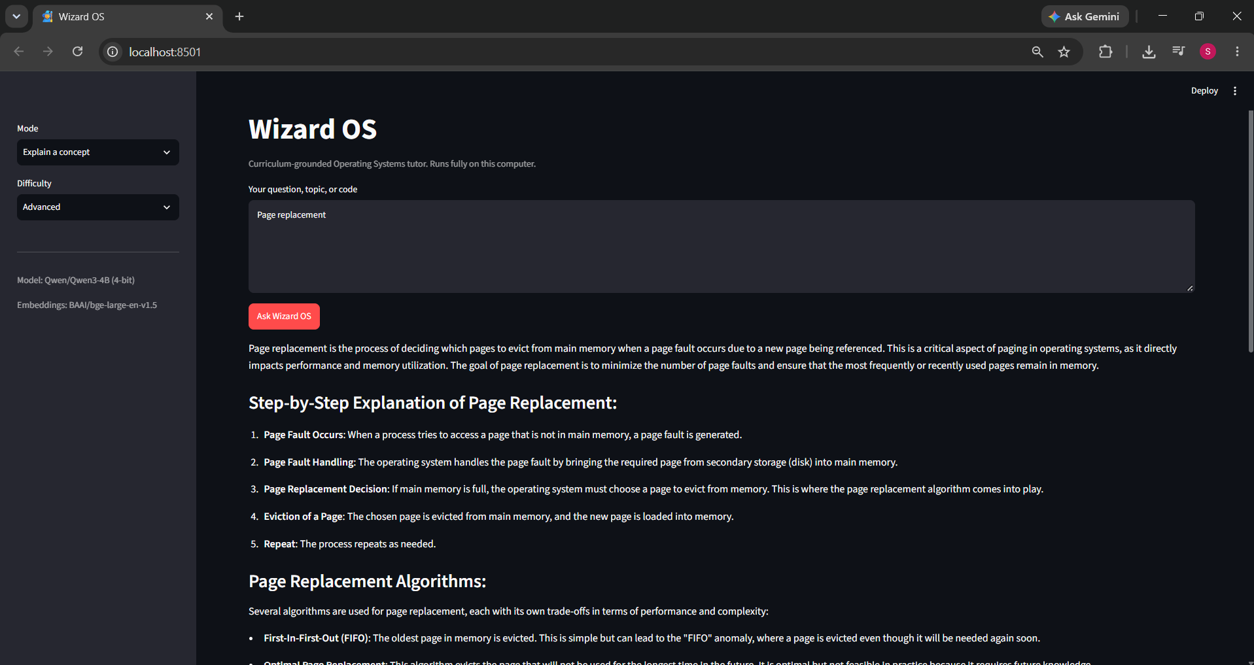
Figure 1: Explain a concept, "Page replacement", Advanced level.
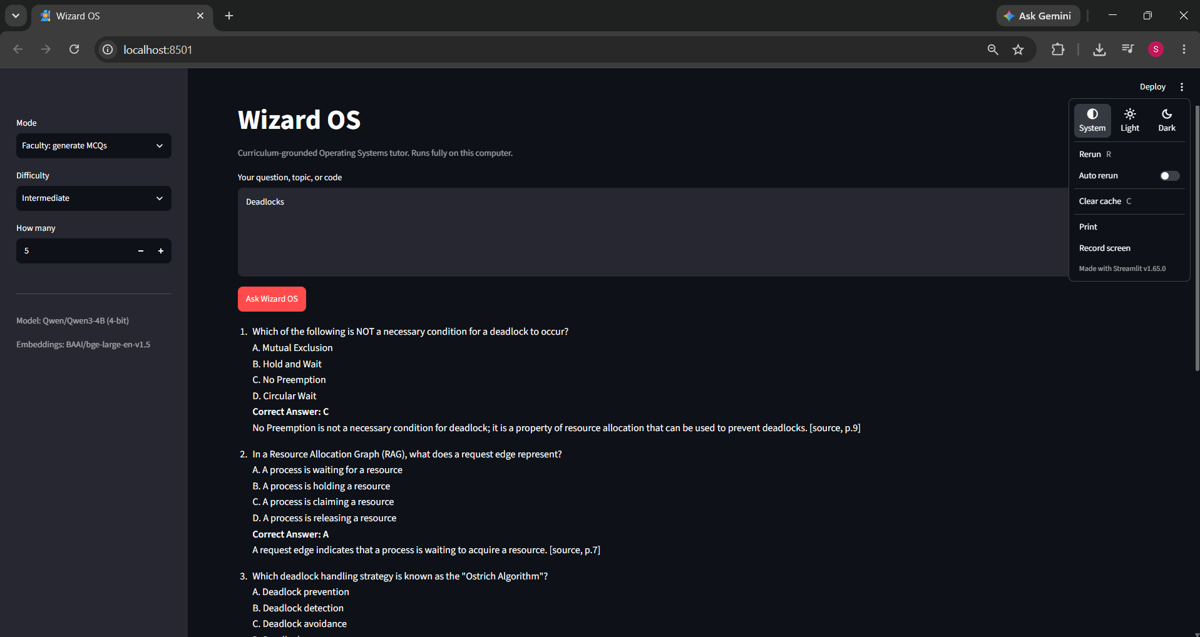
Figure 2: Faculty mode, 5 MCQs on Deadlocks. Question 1 has a wrong answer key (see section 4).

4. Metrics, results and discussion
The fine-tune taught the model the question-bank layouts but made its answers less accurate and less grounded, so the final system uses retrieval alone.
Training. QLoRA on Qwen3-1.7B, 1 epoch, 501 examples, 63 steps at about 11 s per step. Training loss fell from about 2.9 to about 1.4 to 1.6.
Assessment. Three held-out examples per mode (15 in total) were answered by the base model with RAG and by the adapter, using the same retrieved context. Two automatic checks were used (share of answers, 0 to 1), then the answers were read against the reference answers.
Mode | Format OK, base | Format OK, adapter | Cites sources, base | Cites sources, adapter
Explain a concept | not checked | not checked | 0.33 | 0.00
MCQs | 1.00 | 1.00 | 0.00 | 0.00
Viva questions | 0.00 | 1.00 | 0.67 | 0.00
Descriptive questions | 0.00 | 1.00 | 0.33 | 0.00
Lab exercises | 0.00 | 0.00 | 0.33 | 0.00

Speed. On the RTX 3060 laptop (6 GB), one Explain answer (Page replacement) took about 90 seconds with Qwen3-4B in 4-bit.
Discussion.
- Format: the adapter fixed the layout for viva and descriptive questions (0 to 1.00). MCQs were already correct, and lab layout did not improve.
- Citations: the adapter stopped citing sources, because its training answers contained none.
- Correctness: Explain answers were worse. On the PCB question it said the PCB is added to the ready queue, and it described copy-on-write as a page replacement strategy. Both are wrong. The final app shows the same risk: a generated Deadlocks MCQ (Figure 2) asked which option is NOT a necessary condition and keyed "No Preemption", but all four options are necessary conditions, so the question and key are wrong. Generated questions need faculty review.
- Labs: the adapter invented a GitHub link and wrote a shell that passes the whole input line to execvp, which would not run. Few lab examples fit the length limit, so it saw little of them.
- Limits of this test: 3 examples per mode is too few for firm numbers, and the checks measure layout and citation presence, not correctness.
These results match the project plan's choice of retrieval over weight changes: grounding in course material kept answers closer to the notes than fine-tuning a small model did.

5. What went wrong
Hardware limits caused most of the problems, and the fine-tune itself did not improve answer quality.
Problem | Cause | What was done
Out-of-memory in Colab (8B) | Preparing the 8B model for training upcast large layers to 32-bit on a 15 GB T4 | Removed the upcast, shortened examples, set gradient checkpointing
Training cut off at 38 of 170 steps | Free Colab runtime limit, no checkpoint saved | Saved checkpoints every few steps, then moved to the laptop GPU
Colab GPU quota ran out | Free-tier usage limit | Ran training and evaluation locally
Laptop used the CPU | A CPU-only PyTorch build was installed | Reinstalled PyTorch 2.6.0 with CUDA 12.4
4B training stalled at 8 of 48 steps | 6 GB VRAM overflowed into shared memory, about 3 minutes per step | Switched to Qwen3-1.7B and shorter sequences
Weak adapter | 1.7B model, 1 epoch, 195 of 696 examples dropped as too long (mostly lab and descriptive) | Reported honestly, used retrieval only
Answers not checked by faculty | The 480 answers were drafted with Claude and reviewed by the authors | Marked as drafts, lab code compiled and run
Small evaluation | Only 3 examples per mode, layout checks only | Added a manual read of the answers

6. Alternative flow and improvements
Keep retrieval as the core and use fine-tuning only for layout, on a larger model with better data.
- Larger model: run Qwen3-8B or 14B on the 12 GB card in the project plan. Qwen3-4B is the largest that fits the current 6 GB laptop.
- Retrieval first, tuning second: keep the RAG answers as they are and train an adapter only for the question-bank layouts, with the retrieved context in every training prompt.
- Better training data: train on answers that cite the context and say "Outside course notes" when it is missing, so the adapter keeps both habits. Have faculty check the 480 drafted answers.
- Separate lab handling: train lab examples on their own with a longer length limit, and run the generated code automatically before showing it.
- Retrieval improvements: add the textbook, lecture slides and past papers, rerank the retrieved chunks, and combine keyword and vector search.
- Stronger evaluation: use 30 or more held-out questions per mode, score correctness against references (by faculty or a judge model), and measure unsupported statements.
- Cloud training: train on a paid GPU with 24 GB or more so sequences do not need cutting.

