signal 1

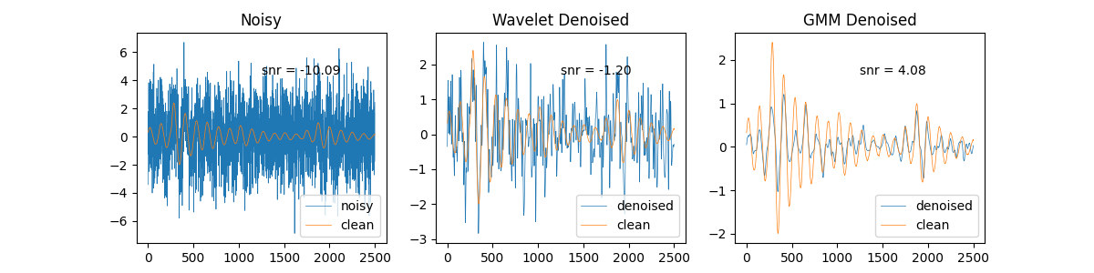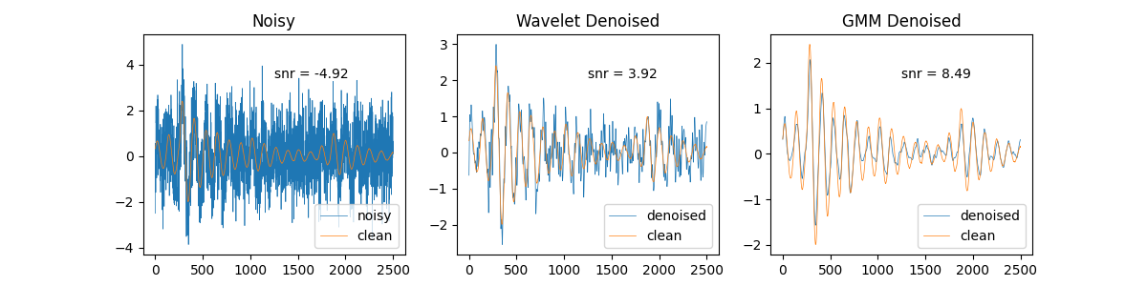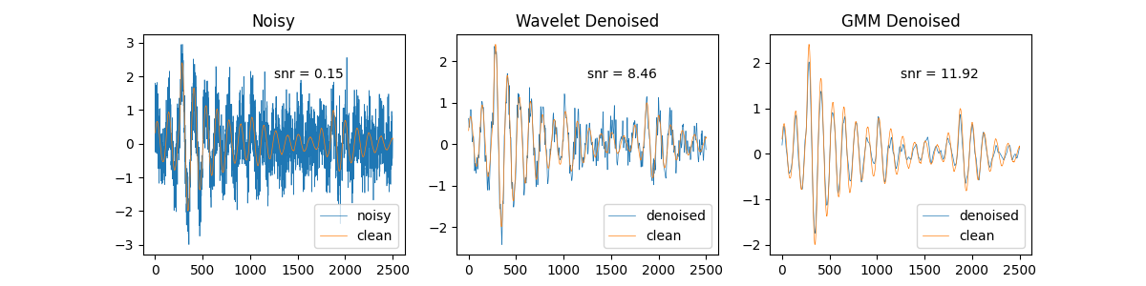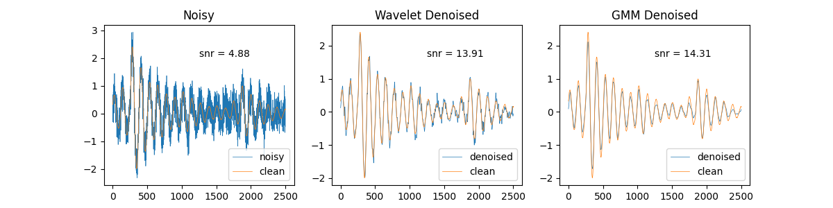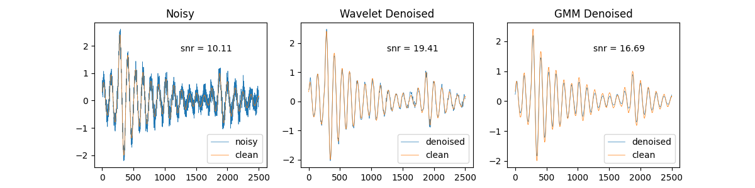

signal 2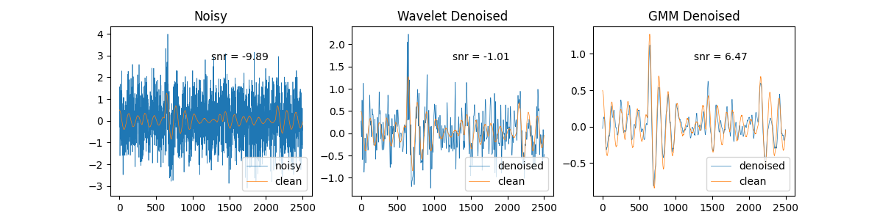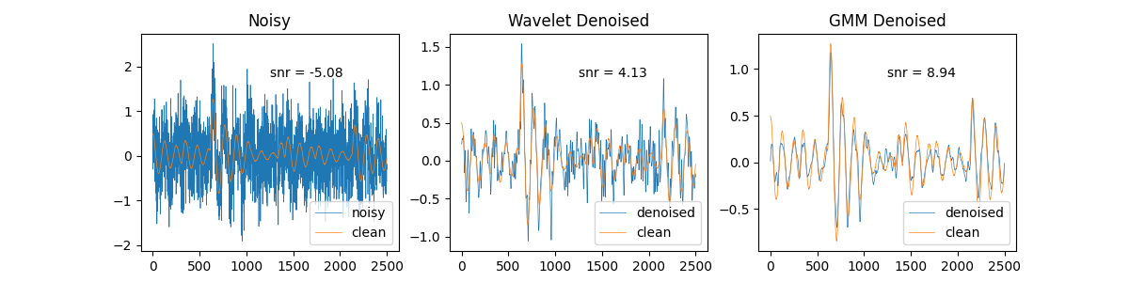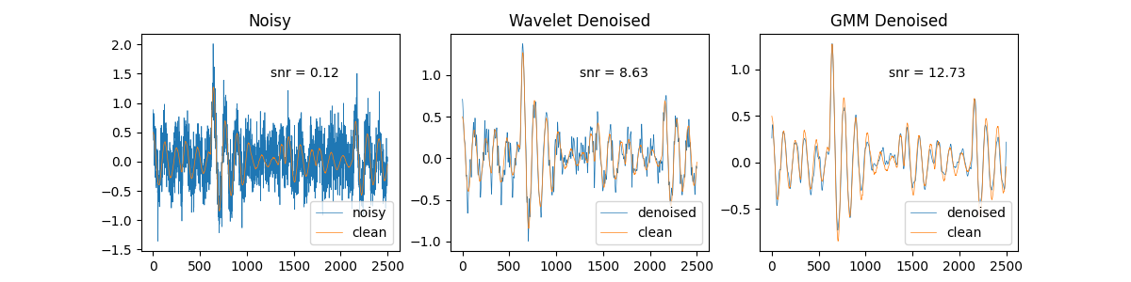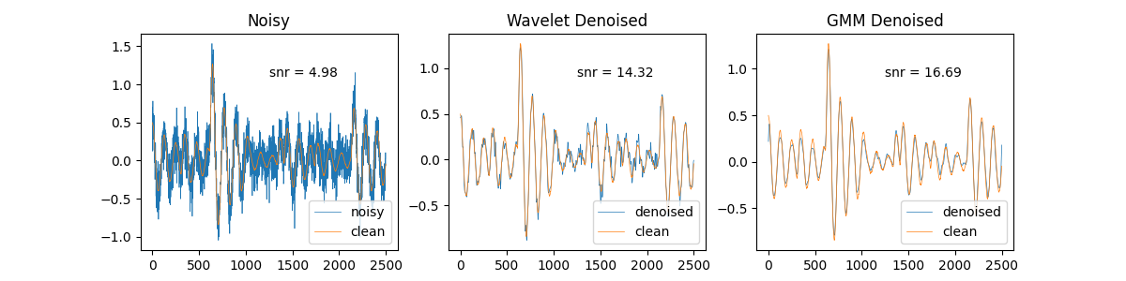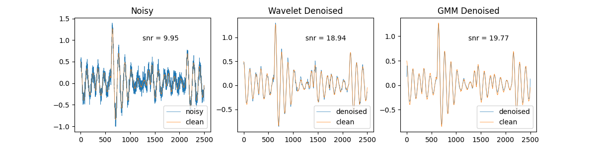

signal 3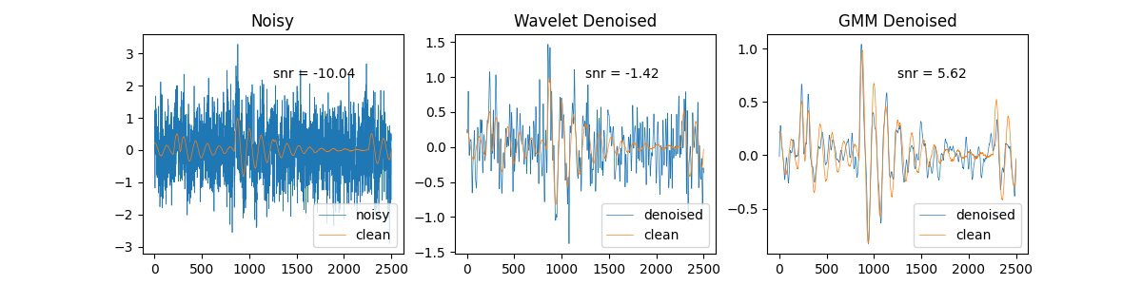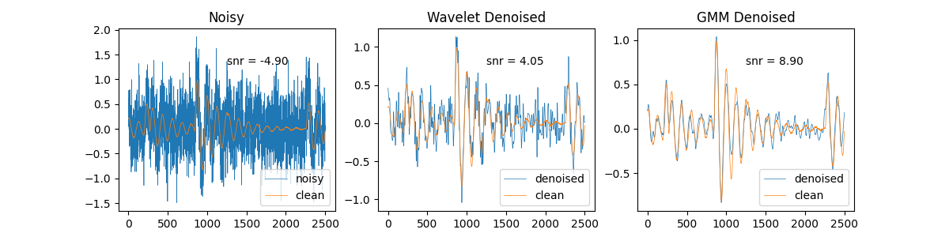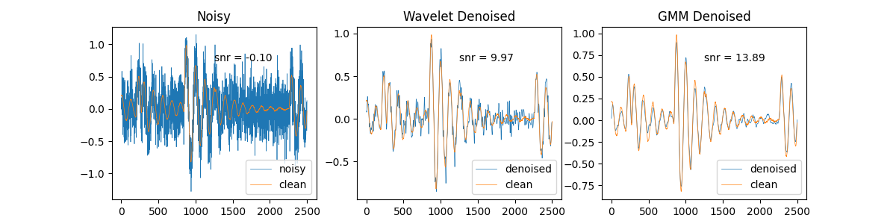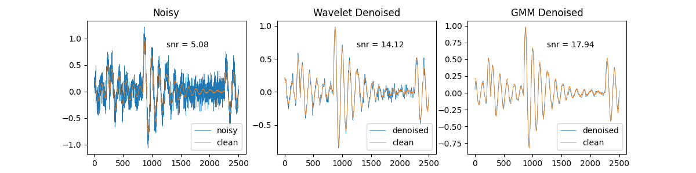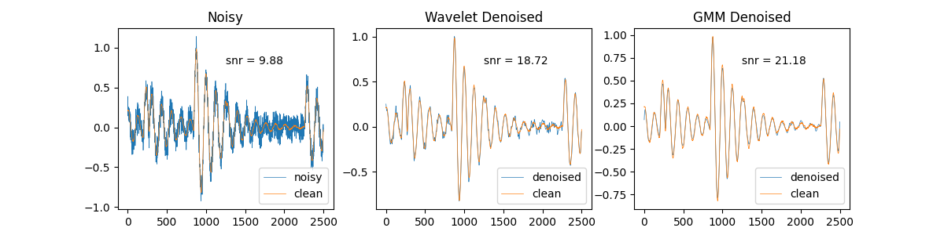

signal 4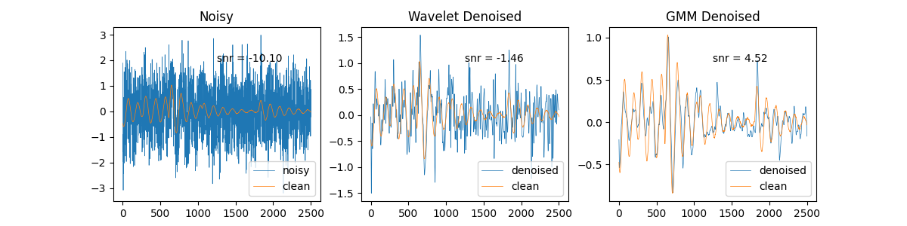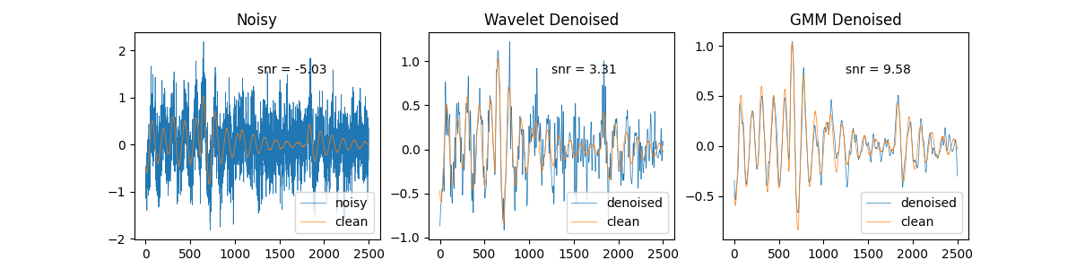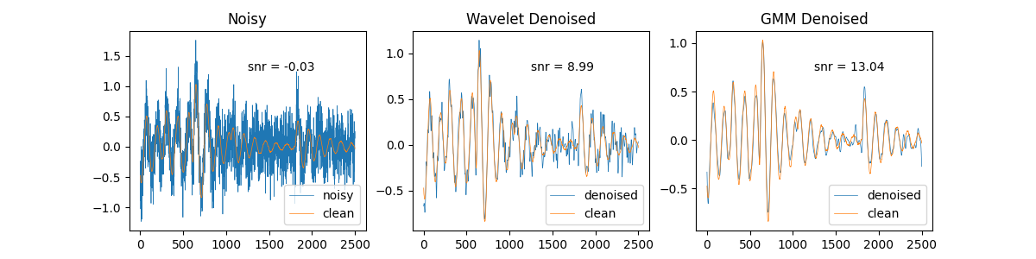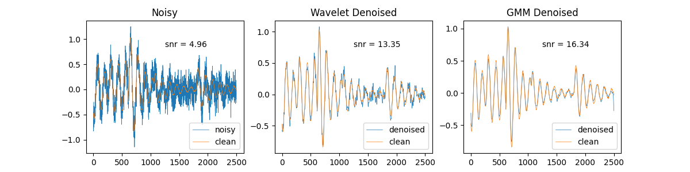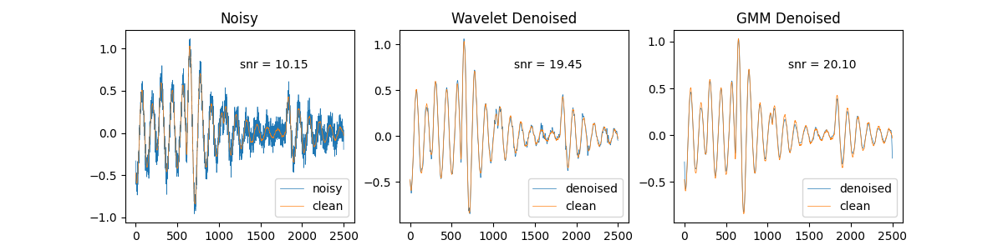

signal 5