**Docker**link 🡪 https://www.tutorialspoint.com/docker/docker_hub.htm  
 🡪 docker is used to build , test and deploy applications quickly  
 **OR**  
 simply it is used to deploy the applications  
   
**Images and Container**  
**Images**:- are templates of project.  
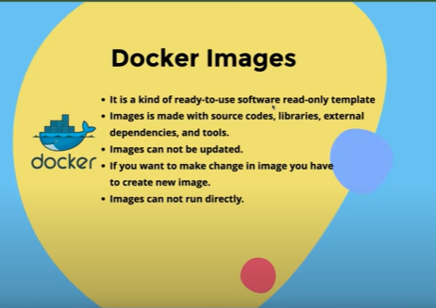  
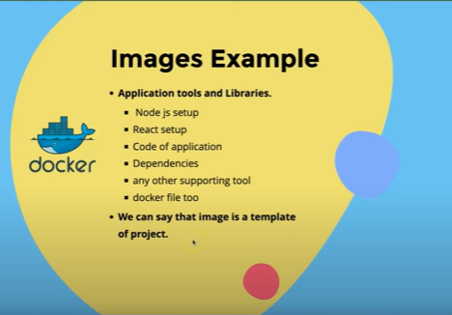  
  
  
  
  
  
  
  
  
  
  
  
 **Container**:- Running Instance of Image  
  
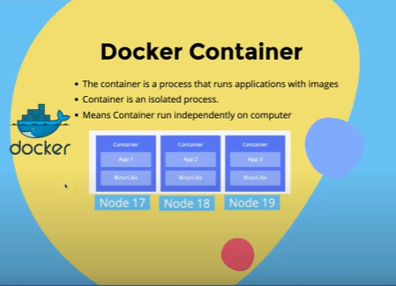  
  
 **docker hub and docker desktop**both are used to use the image but docker desktop gives more functionality as compared to docker hub. **parent Image and the image of our project**  
parent image or those image we have to use in our project like nodejs, mongodb  
and the images that we have created like our project image

**Base Image or Parent Image  
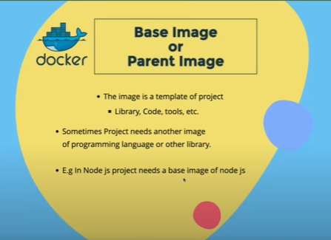  
  
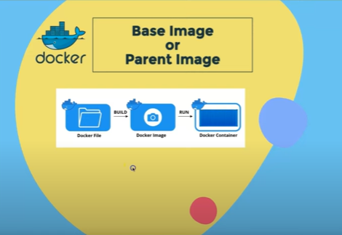  
  
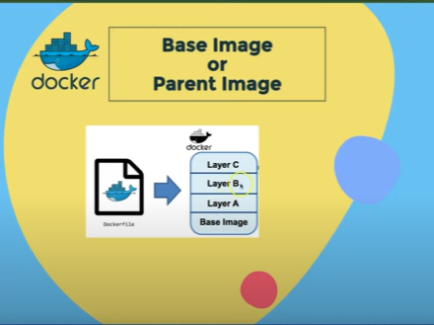**Pull Image and Run Container  
  
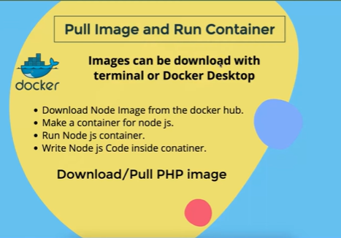  
 **to download and run the nodejs image for example**1. pull the nodejs   
2. and then run the command in images section in terminal 🡪 docker run -it /bin/bash  
 **maker docker file and make image**  
step:-  
1.make the nodejs app   
2. Now use this code to make the image  
  
FROM node:latest – base image

COPY . . copy from which directory(root) and in which directory should remain (root ) in image

RUN npm install – to run the installation in image

EXPOSE 5000 – that port on which our application run

CMD [ "node","index.js" ] --to run the node

