User Name:ADMIN; Password:DEFRAN

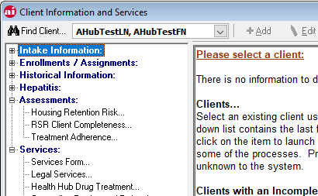

Selecting the Health Hub Drug Treatment option will launch a new form (Hub Drug Treatment)

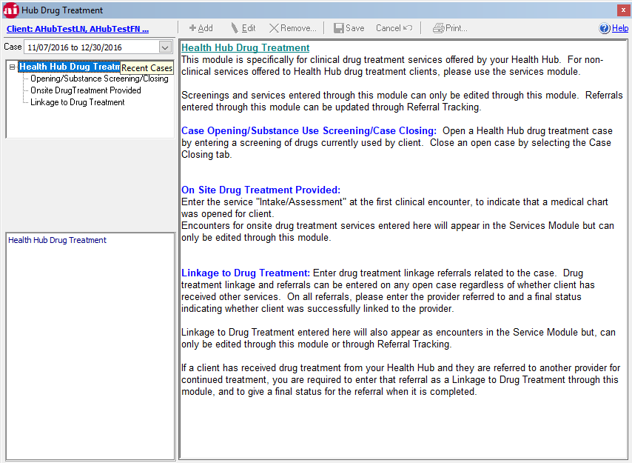

Each menu selection accesses different tables. But, unlike the ‘normal’ grid-based forms, these forms interact somewhat with each other.

Starting point: Opening a new case and entering a drug use assessment.

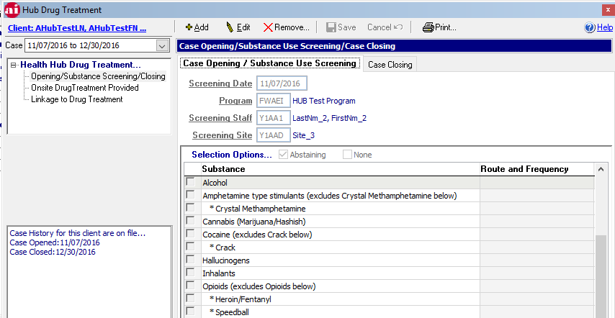

Opening/saving a Case…

Tables:

* ai_drug_tx_header
* Program
* Site
* Userprof
* ai_substance_use_header (HUB_ID FK)
* substance_use_details
* ai_enc (HUB_ID FK)
* ai_serv

Upon saving…

If this is a New case, the stored procedure dbcDetermineEncounter determines if an encounter and service can be created, but only if one does not exist that is linked to this case. The ai_drug_tx_header.drug_tx_id is the FK for the related tables (HUB_ID). If there is no linked encounter and service, the app creates encounter 319 and service 1386.

Next is to provide/track a drug regimen for the client

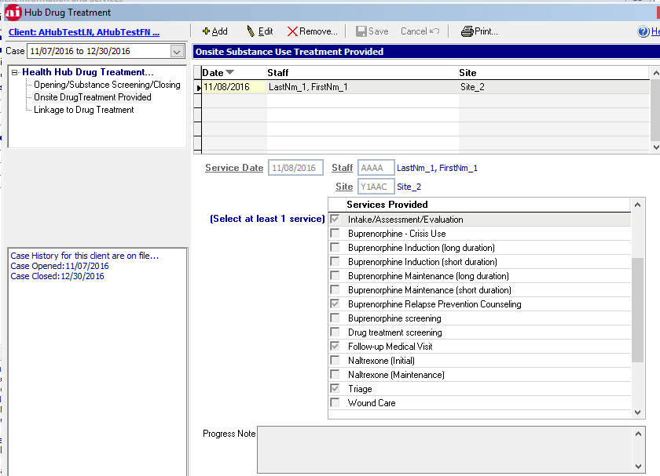

This form uses tables:

* ai_drug_tx_provided
* userprof
* site
* ai_enc (HUB_ID & hub_treatid)
* ai_serv

After data in the top grid (ai_drug_tx_provided) is saved, the PK tx_provided_id and the HUB_ID are linked to ai_enc (hub_treatid). Encounter 319 and service 440 are created if ones do not exist.

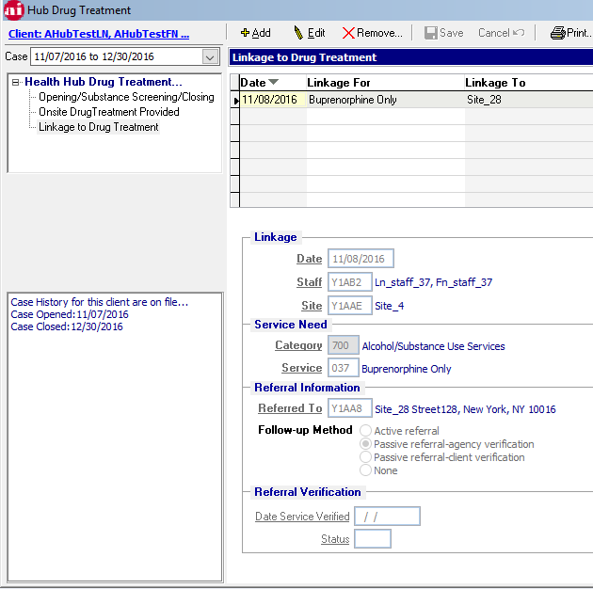

This form accesses only AI_REF. the column HUB_ID is the FK that links the referral to the Hub case.

The user can add or remove any record – there are no business requirements on this form.