**Calculator Assignment Project**

This is the initial release of the instructions file calculator project. The calculator assumes that:

1. the calculator runs with instructions file name as an argument.
2. an instruction is formed of a keyword (add, subtract, divide, or multiply), and number ranges from -int to +int.
3. every line containing an instruction only (keyword space number line terminator). i.e. add 5
4. any spaces or tabs are considered malformed instructions
5. keywords are small case letters.
6. last instruction must be the apply instruction.
7. a file contains one list of instructions, which must end with the apply instruction.
8. if the file contains more than one apply instructions, it will consider the first one as the end of instructions.

Running the application

1. Navigate to the executable jar folder, you may place a test file to use
2. Open command line and type this script

**>**java **-**jar calculator-0.0.1-SNAPSHOT-jar-with-dependencies.jar test.txt

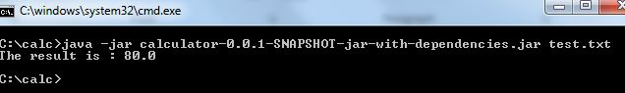

Project structure

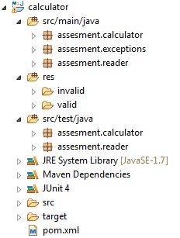

Used Technologies

|  |  |
| --- | --- |
| Technology | Usage |
| JUnit | Testing |
| Maven | Project and dependency management |
| TDD | Development practice |
| Java SE | Core |