DTL Assignment – File access

MIS: 111903095

Name: Shalaka Pawar

Div: 2 ( S1 Batch )

Program:

#DTL Assignment - File access

#MIS : 111903095

#Name : Shalaka Pawar

#Div : 2

#!/bin/bash

file="C:\Users\Shalaka\Desktop\Study\SY\DTL\employee.txt"

if [ -r $file ]

then

echo "File has read access"

else

echo "File does not have read access"

fi

if [ -w $file ]

then

echo "File has write permission"

else

echo "File does not have write permission"

fi

if [ -x $file ]

then

echo "File has execute permission"

else

echo "File does not have execute permisiion"

fi

if [ -f $file ]

then

echo "File is an ordinary file"

else

echo "It is a special file"

fi

if [ -d $file ]

then

echo "File is a directory"

else

echo "It is not a directory"

fi

if [ -s $file ]

then

echo "File size is not zero"

else

echo "File size is zero"

fi

if [ -e $file ]

then

echo "File exists"

else

echo "File does not exist"

fi

OUTPUT:

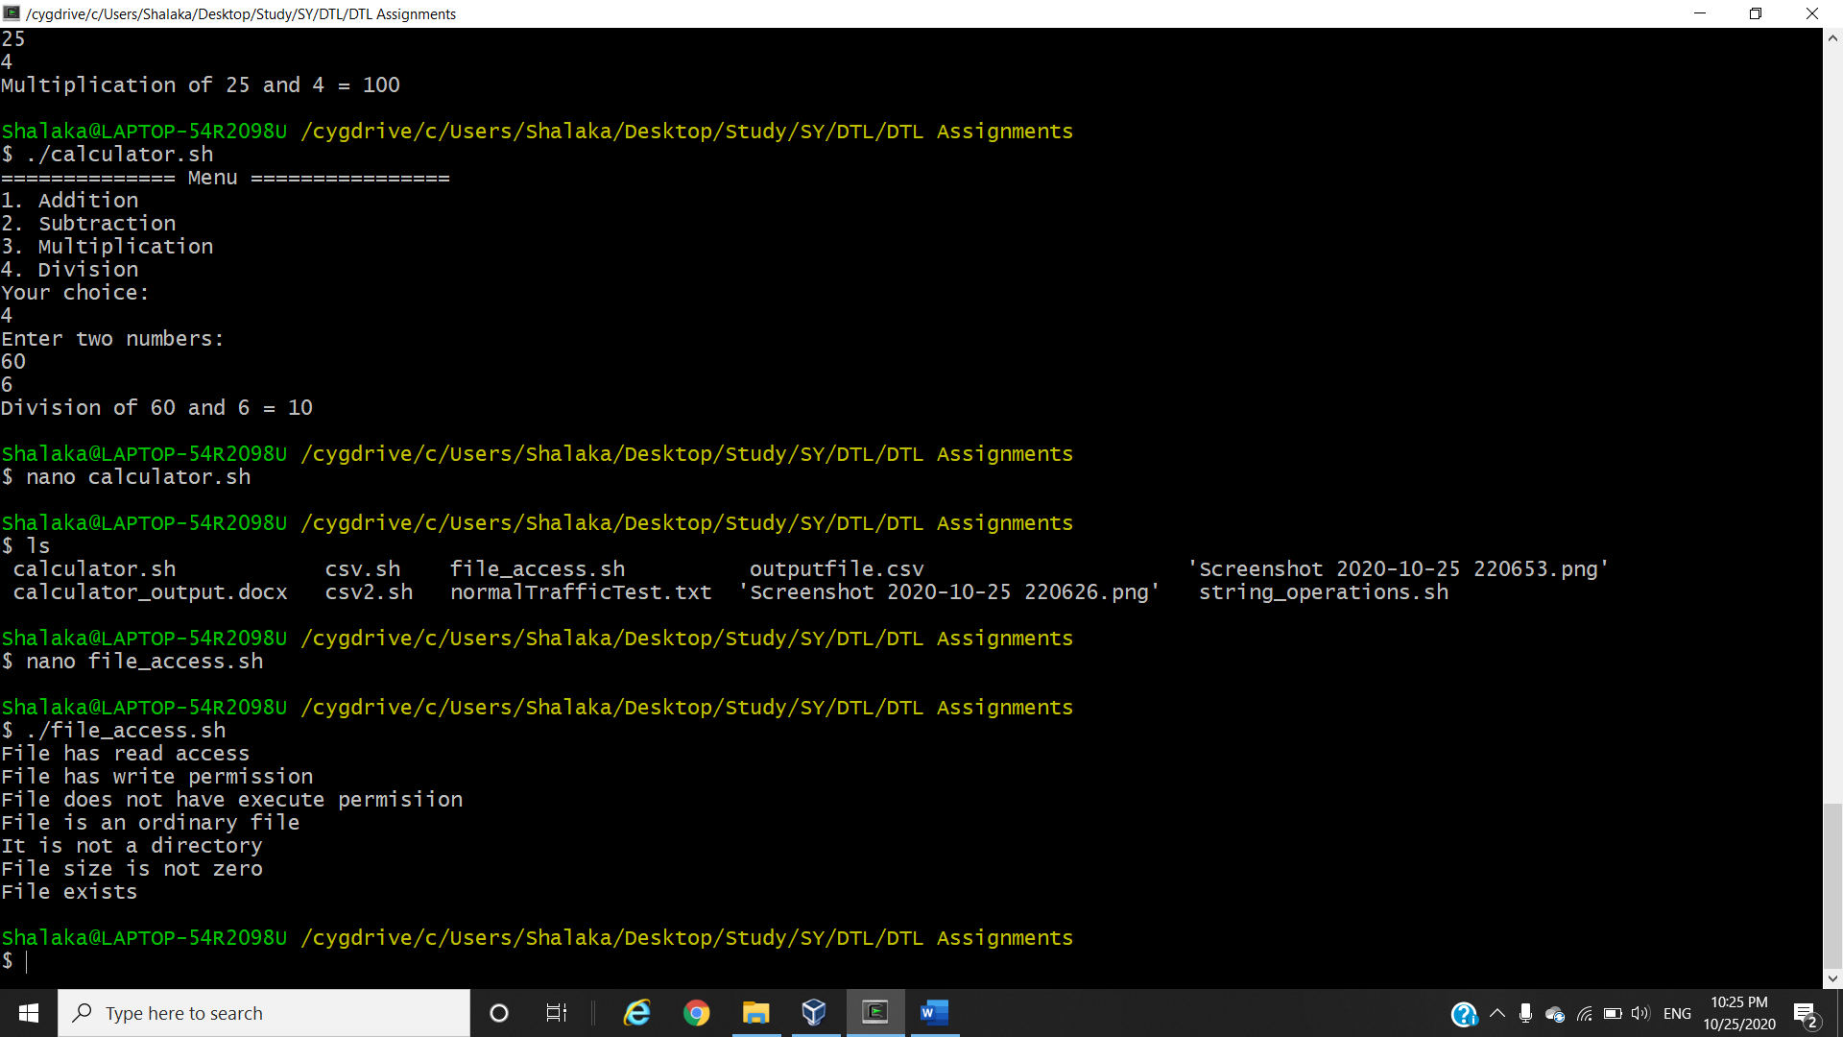for .txt file

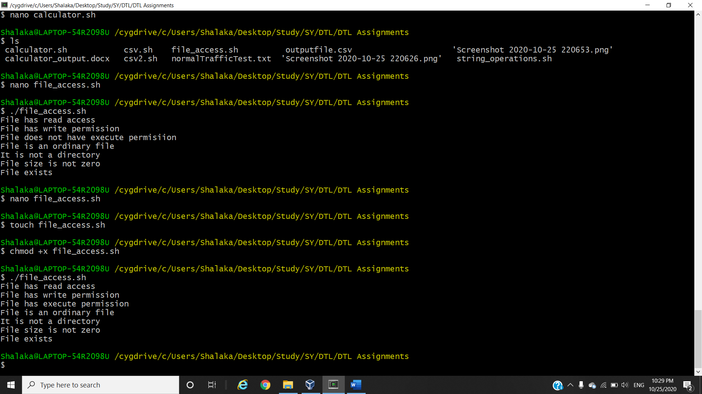for .sh file