**Kids Calculator.**

The kids are made to learn using a simple mobile application without the use of internet. They are taught single digit addition and subtraction by the means of apples. We use visual tools like images to teach the students the concept. The images of apples are used to illustrate this concept. The application is divided into 2 stages namely, learning phase and testing phase. In the learning phase single digit numbers appear randomly which are represented by the number of apples then fundamental operations like addition and subtraction is performed. The addition is represented by the increase in the number of apples and the subtraction is represented by the eaten apple. This help kids to understand basic mathematical concepts.

**Existing Applications and their features.**

There are a few applications in the market who cater to young children amongst them are

1. **Kid Calculator.**

This is an application on the Apple market which depicts rudimentary calculator comprised of the existing 10 digits as buttons and the basic operations.

**Features-** Make learning math fun with this beautiful talking calculator for kids.  
Your children will have a blast with numbers, aliens, a rocket, and hidden surprise with this calculator.

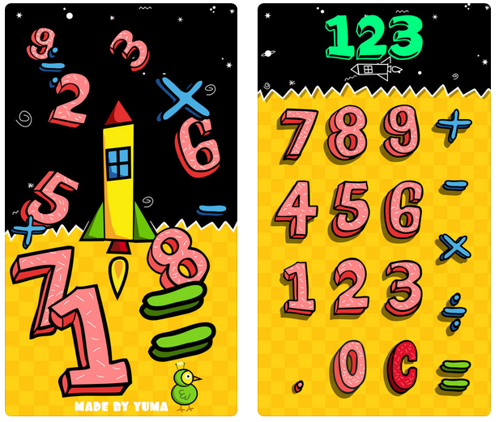

1. **Kid Fun Calculator.**

This is an application on the google play store which also depicts basic functionality of the calculator.

**Features-** Kids Fun Calculator is a free app especially made for children to enjoy. Kids Fun Calculator has an engaging, kids-friendly interface that can perform basic arithmetic functions. Kids can choose from a variety of fun themes by simply clicking the tab at the top right-hand side of their screens. Kids Fun Calculator has five fun themes: Classroom, Car Racing, Doll House, Play Area, Home Kids can easily use the Kids Fun Calculator wherever they are as it is very easy to operate. The large and easy to press buttons are specifically designed for kids and we have tested it to ensure that it won't crash regardless of how many buttons they press! The app is not only a tool which can help kids do their homework but it can also help them develop their mathematical skills without even realizing it. Kids Fun Calculator will make kids love mathematics and numbers and find it less intimidating.

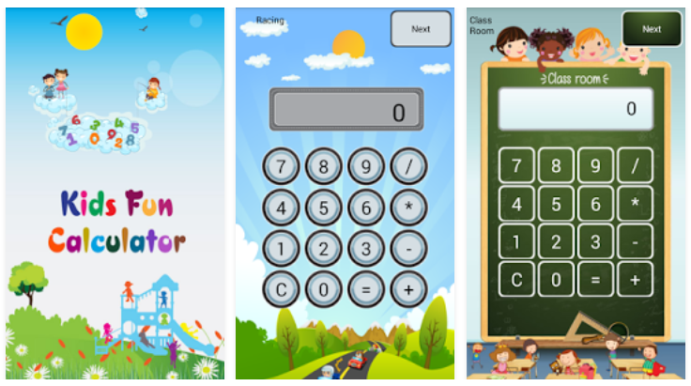

**Our Model-**

Our model tries to integrate the good features of both the applications and again overcome certain flaws. The flaws like increase in complexity and too many buttons. Our app is easy on the eye and with minimal clutter.

**Screenshots-**

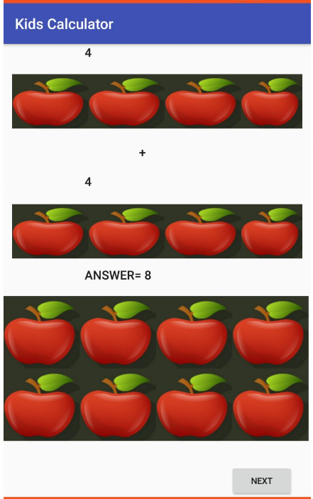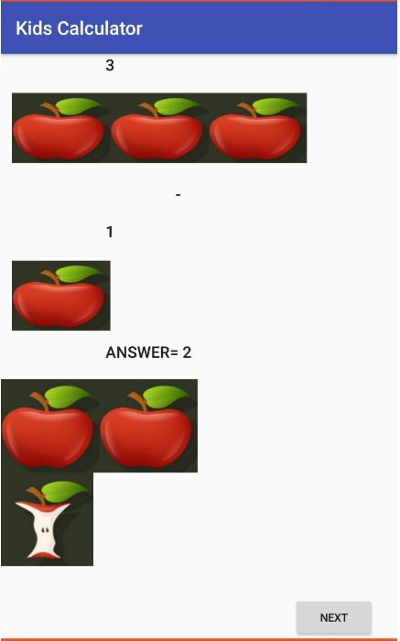

**Conclusion-**

We build an android application that helps us understand the various design principles that are necessary for us to design any interface. We constructed a kids calculator which helped us to cater to a different generation of customers and also incorporate the design principles of Human Machine Interaction.