**Mini Project #1**

**Group 14.**

**Group Members:**

Manav Gupta [MXG220027]

Shalin Ronakkumar Kaji [SXK220263]

Shivani Talatam [SXT220047]

**Contribution:**

Manav : Calculated the probability of lifetime exceeding 15yrs using fT(t) , implemented the Monte-Carlo approach in Q1, found relation between pi(π) and the Probability of random point in Q2.

Shalin : Solved integrations involved in Q1, developed R code for both the problems (Q1&Q2) , and typed the final assignment documentation.

Shivani : Solved the parts involving the Histogram plot and density curve after data is generated by the replicate-rexp functions. In Q2, applied the distance formula to find the probability of set of points falling inside the inscribed circle.

**A1)**

For solving this question, we assume the following variables:

**XA** = Lifetime of Block A

**XB** = Lifetime of Block B

**T** = Lifetime of the satellite

It is given that XA and XB follow independent exponential distributions with mean 10.

⸫ E(T) = 1/λ = 10 and hence **λ = 0.1 years**

We know that lifetime of the satellite will be till one of them is operational.

Hence, *Lifetime of Satellite T = max(XA, XB)*

Since it is given that the lifetime of both the blocks follow independent

exponential distributions, we can conclude that:

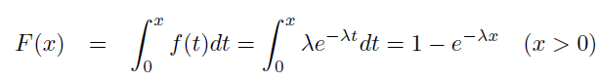

**FT(t) = FXA(t) * FXB(t) = (1 – exp(-0.1t) )2**

**= 1 – 2exp(-0.1t) + exp(-0.2t)**

Now to find the probability density function (pdf), we will have to

differentiate the cumulative distribution function **(cdf: FT(t))**.

Therefore, fT(t) = (d/dt) * (FT(t))

|  |
| --- |
| ⸫ 𝐟**T** (𝐭)= {𝟎.𝟐 𝐞𝐱𝐩(−𝟎.𝟏𝐭) – 𝟎.𝟐 𝐞𝐱𝐩(𝟎.𝟐𝐭) ,𝟎 ≤ 𝐭 < ∞,  𝟎 ,𝐨𝐭𝐡𝐞𝐫𝐰𝐢𝐬𝐞 |

Now the expected lifetime of the satellite is:

E(T) = ∫𝐭𝐟**T** (𝐭) = ∫ (𝟎.𝟐 𝐭∗𝐞𝐱𝐩(−𝟎.𝟏𝐭) – 𝟎.𝟐 𝐭∗𝐞𝐱𝐩(𝟎.𝟐𝐭))𝒅𝒕

E(T) = 0.2 * [ (e-0.1t/-0.1) - (e-0.2t/-0.2) ] where t ranges from 0 to ∞.

**E(T) = 0.2(100 – 25)**

**E(T) = 15 years.**

1. Now using the probability density function we can find the probability that the lifetime of the satellite exceeds 15 years.

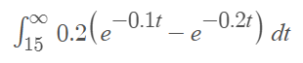

**P( T>15 ) :**

**P(T>15):** 0.2 * [ (e-0.1t/-0.1) - (e-0.2t/-0.2) ] where t ranges from 15 to ∞.

**P( T>15 ) : 0.3946.**

1. Now we use Monte Carlo approach to compute E(T) and P (T > 15).

**(I & II)**

To simulate exponential distribution, we use the function rexp (n, rate) in R. As per the question, the rate is 0.1 and T is the max of the lifetimes of the two satellites. We need to repeat the above step 10,000 times.

> T = replicate (10000, max (rexp (1,0.1) rexp(1,0.1)))

**(III)** Now to get the histogram of the draw T, we use the hist(T) method to get the histogram shown below.

> hist( T, breaks = 50)

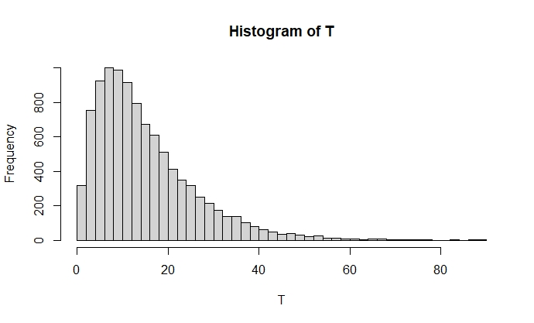

To superimpose the probability density function, we use the curve function given in R.

> curve((0.2*exp(-0.1*x)-0.2*exp(-0.2*x)) *20000, from =0, to=100, add = TRUE, col="orange")

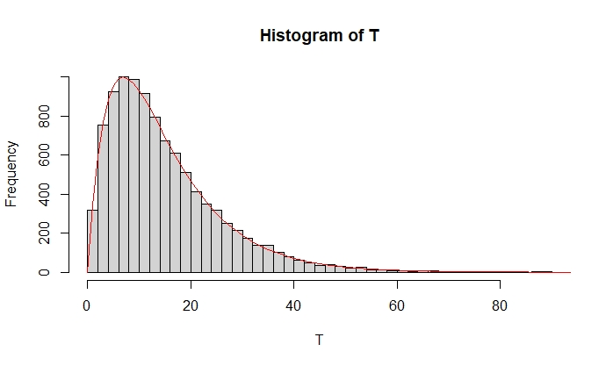The density function superimposed on the histogram will then look like:

**(IV)** Now to calculate the estimated value of T i.e **E(T)**, we will use the mean () function on the T variable. This will give the estimated lifetime of the satellite.

> mean(T)

[1] 14.94985

**(V)** To calculate this, we will get a sum of all the exponential random variables having the value greater than 15 and then we will divide this by the sample size which is the length of the observations.

> sum (T > 15)/ length(T)

[1] 0.3972

**(VI)**

|  |  |  |
| --- | --- | --- |
| **Observation No.** | **E(T)** | **P(T>15)** |
| 1 | 15.13872 | 0.4343 |
| 2 | 15.03095 | 0.3958 |
| 3 | 14.89279 | 0.3979 |
| 4 | 15.02758 | 0.4095 |

1. Using 1000 Monte Carlo replications, 5 observations for E(T) and P(T>15) are as follows:

|  |  |  |
| --- | --- | --- |
| **Observation No.** | **E(T)** | **P(T>15)** |
| 1 | 15.08499 | 0.398 |
| 2 | 14.99945 | 0.412 |
| 3 | 14.93744 | 0.381 |
| 4 | 14.88778 | 0.409 |
| 5 | 15.23751 | 0.404 |

1. Using 100000 Monte Carlo replications, 5 observations for E(T) and P(T>15) are as follows:

|  |  |  |
| --- | --- | --- |
| **Observation No.** | **E(T)** | **P(T>15)** |
| 1 | 15.00677 | 0.39524 |
| 2 | 14.98538 | 0.39639 |
| 3 | 14.97744 | 0.3957 |
| 4 | 15.02278 | 0.39714 |
| 5 | 15.0727 | 0.39903 |

**R Code:**

T = replicate (10000, max (rexp (1,0.1), rexp (1,0.1)))

hist(T)

curve((0.2*exp(-0.1*x)-0.2*exp(-0.2*x)) *20000, from =0, to=100, add = TRUE, col="orange")

mean(T)

sum (T > 15)/ length(T)

for (i in 1:5) {

T = replicate (10000, max(rexp(1000,.1),rexp(1000,.1)))

print(mean(T))

print(sum(T>15)/length(T))

}

For (i in 1:5) {

T = replicate (10000, max(rexp(100000,.1),rexp(100000,.1)))

print(mean(T))

print(sum(T>15)/length(T))

}

**A2)**

We find the relation between π and the probability of the randomly selected point by dividing the area of circle by the area of square (because the circle inscribed in the square gives us the favorable outcome area).

Let E = event of random point falling in the inscribed circle.

**P(E) = Area of Circle / Area of Square.**

P(E) = πr2 / (2r)2

**π = 4 * P(E). ---------(i)**

Now we use the runif() function in R to generate 10,000 different values of x and y coordinates:-

> x = runif(10000,0,1)

> y = runif(10000,0,1)

Now using the equation(i) we will calculate the value of π by implementing the Monte Carlo approach.

> dis= sqrt((0.5-x)^2+(0.5-y)^2)

> pi[i]=4*sum(dis<0.5)/length(dis)

> mean(pi)

**Output : 3.137564.**

**R Code:**

pi= c (0,1)

for (i in 1:100) {

x = runif(10000,0,1)

y = runif(10000,0,1)

dis= sqrt((0.5-x)^2+(0.5-y)^2)

pi[i]=4*sum(dis<.5)/length(dis)

}

mean(pi)