**Mini Project #2**

**Group 14.**

**Group Members:**

Manav Gupta [MXG220027]

Shalin Ronakkumar Kaji [SXK220263]

Shivani Talatam [SXT220047]

**Contribution:**

Manav : Solved Question 2.

Shalin : Solved Question 1 – a, b, d and prepared the final draft of the documentation.

Shivani : Solved Question 1 – c.

**Question 1:**

1. Creating a Bar Plot for Runners on basis of the categorical variable of Maine attribute: Maine/Away.

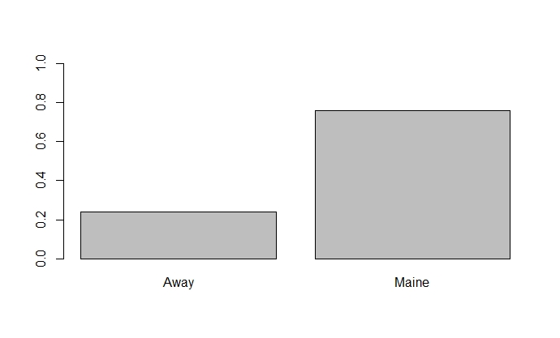> barplot(table(rdrace$Maine)/length(rdrace$Maine), ylim = c(0,1))

We can conclude after analysing the Bar Plot:

> To conclude: No. of runners from Maine is thrice the no. of runners from other cities.

The following summary statistics support our conclusion:

> print('Probabilities of runners from Maine/Away: ')

table(rdrace$Maine)/length(rdrace$Maine)

|  |  |
| --- | --- |
| Away | Maine |
| 0.2411915 | 0.7588085 |

1. On creating Histogram plots for both the ‘Maine’ and ‘Away’ group of runners we get:

> p1 <- hist(fr_Maine$Time..minutes., breaks=20)

> p2 <- hist(fr_Away$Time..minutes., breaks=20)

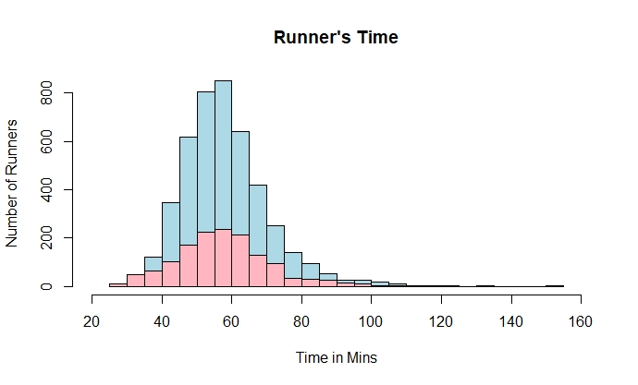

> desc_Maine <- summary(fr_Maine$Time..minutes.)

> desc_Maine

> print(paste("Range: ",desc_Maine["Max."]-desc_Maine["Min."]))

> print(paste("Standard Deviation: ", sd(fr_Maine$Time..minutes.)))

> print(paste("IQR: ",(desc_Maine["3rd Qu."]-desc_Maine["1st Qu."])))

|  |  |  |  |  |  |
| --- | --- | --- | --- | --- | --- |
| Minimum | 1st Quartile | Mean | Median | 3rd Quartile | Maximum |
| 30.57 | 50.00 | 58.20 | 57.03 | 64.24 | 152.17 |

[1] "Range: 121.6"

[1] "Standard Deviation: 12.1851105531497"

[1] "IQR: 14.24775"

Statistics for ‘Away’ runners:

> desc_Away <- summary(fr_Away$Time..minutes.)

> desc_Away

> print(paste("Range: ",desc_Away["Max."]-desc_Away["Min."]))

> print(paste("Standard Deviation: ", sd(fr_Away$Time..minutes.)))

> print(paste("IQR: ",(desc_Away["3rd Qu."]-desc_Away["1st Qu."])))

> print("In conclusion: The running times of Runners from Maine & Away follow Symmetric distribution. ")

|  |  |  |  |  |  |
| --- | --- | --- | --- | --- | --- |
| Minimum | 1st Quartile | Mean | Median | 3rd Quartile | Maximum |
| 27.78 | 49.15 | 57.82 | 56.92 | 64.83 | 133.71 |

[1] "Range: 105.928"

[1] "Standard Deviation: 13.8353842414778"

[1] "IQR: 15.674"

[1] "In conclusion: The running times of Runners from Maine & Away follow Symmetric distribution. "

1. > # Creating Box plots for both Runner categories.

> bplt_runners <- cbind("Maine"=(fr_Maine$Time..minutes.),"Away"=(fr_Away$Time..minutes.))

> boxplot(bplt_runners, beside=T, horizontal = TRUE)

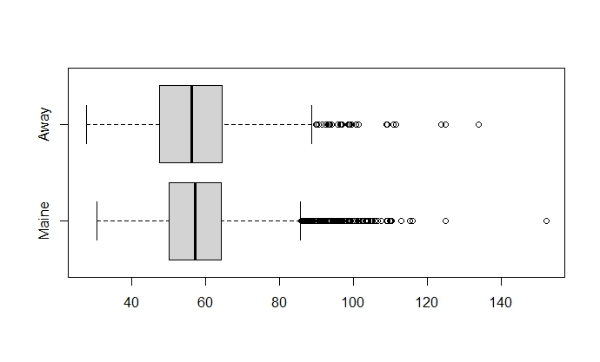

1. **>** # Question 1-d

> Run_M <- rdrace[rdrace$Sex=='M',]

> Run_F <- rdrace[rdrace$Sex=='F',]

> mfrunner <- cbind("Male"=(type.convert(Run_M$Age)),"Female"=(type.convert(Run_F$Age)))

> boxplot(mfrunner, beside=T, horizontal = TRUE)

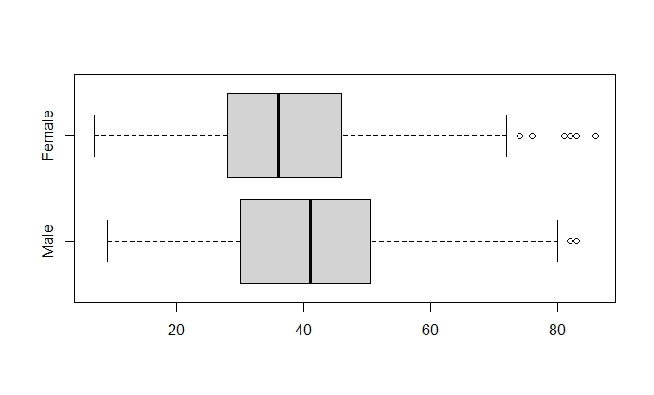

> summary(mfrunner)

> sd_run1 <- sd(mfrunner[,"Male"],na.rm = T)

> sd_run1

> sd_run1 <- sd(mfrunner[,"Female"],na.rm = T)

> sd_run1

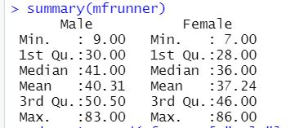

[1] 14.00449 # male sd

[1] 12.26925 # female sd

**R Code for MP-2-Question-1:**

**# STATS-Mini-Project-2**

**# Setting working directory to Proj-2 folder.**

**setwd("C:/Users/Shalin Kaji/Desktop/UT-Dallas-Spr23/STATS-DS-Min.Chen/Mini-Proj-2")**

**getwd()**

**# Observing our .csv file**

**rdrace <- read.csv("roadrace.csv")**

**head(rdrace,10)**

**# Question 1-a**

**# Create a barplot of Maine, what does it conclude?**

**barplot(table(rdrace$Maine)/length(rdrace$Maine), ylim = c(0,1))**

**print('Probabilities of runners from Maine/Away: ')**

**table(rdrace$Maine)/length(rdrace$Maine)**

**print('To conclude: No. of runners from Maine is thrice the no. of runners from other cities.')**

**# Question 1-b**

**# Creating histograms of running times for Runners from Maine/Away.**

**fr_Maine <- rdrace[rdrace$Maine=='Maine',]**

**fr_Away <- rdrace[rdrace$Maine=="Away",]**

**p1 <- hist(fr_Maine$Time..minutes., breaks=20)**

**p2 <- hist(fr_Away$Time..minutes., breaks=20)**

**plot(p1,col="light blue",xlim = c(20,160), main="Runner's Time" , xlab = "Time in Mins" , ylab = "Number of Runners")**

**plot(p2,col="light pink",add=T)**

**legend("topright", c("Maine","Away"), col=c("light blue","light pink"),lwd = 5)**

**# Statistics for Maine Runners**

**desc_Maine <- summary(fr_Maine$Time..minutes.)**

**desc_Maine**

**print(paste("Range: ",desc_Maine["Max."]-desc_Maine["Min."]))**

**print(paste("Standard Deviation: ", sd(fr_Maine$Time..minutes.)))**

**print(paste("IQR: ",(desc_Maine["3rd Qu."]-desc_Maine["1st Qu."])))**

**#Statistics for Away Runners**

**desc_Away <- summary(fr_Away$Time..minutes.)**

**desc_Away**

**print(paste("Range: ",desc_Away["Max."]-desc_Away["Min."]))**

**print(paste("Standard Deviation: ", sd(fr_Away$Time..minutes.)))**

**print(paste("IQR: ",(desc_Away["3rd Qu."]-desc_Away["1st Qu."])))**

**print("In conclusion: The running times of Runners from Maine & Away follow Symmetric distribution. ")**

**# Question 1-C**

**# Creating Box plots for both Runner categories.**

**bplt_runners <- cbind("Maine"=(fr_Maine$Time..minutes.),"Away"=(fr_Away$Time..minutes.))**

**boxplot(bplt_runners, beside=T, horizontal = TRUE)**

**# Question 1-d**

**Run_M <- rdrace[rdrace$Sex=='M',]**

**Run_F <- rdrace[rdrace$Sex=='F',]**

**mfrunner <- cbind("Male"=(type.convert(Run_M$Age)),"Female"=(type.convert(Run_F$Age)))**

**boxplot(mfrunner, beside=T, horizontal = TRUE)**

**summary(mfrunner)**

**sd_run1 <- sd(mfrunner[,"Male"],na.rm = T)**

**sd_run1**

**sd_run1 <- sd(mfrunner[,"Female"],na.rm = T)**

**sd_run1**

**Question 2:**

Plotting Box Plot for number of fatal motorcycle accidents along with jittered data points to avoid over-plotting the outliers.

> ctyacc <- motor$Fatal.Motorcycle.Accidents

> boxplot(ctyacc, horizontal = TRUE)

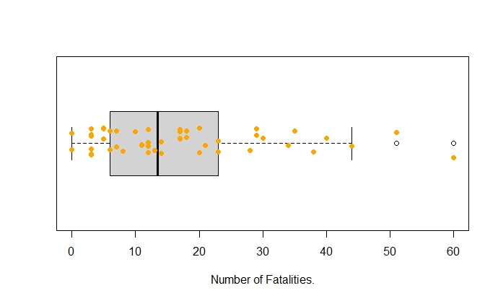> stripchart(ctyacc, method = "jitter", pch = 19, add = TRUE, col = "orange")

Analysing the motorcycle dataset, we obtain the following statistics:

> dstats <- summary(ctyacc)

> dstats

> print(paste("Standard Deviation: ", sd(ctyacc)))

> print(paste("IQR: ", dstats[5]-dstats[2]))

|  |  |  |  |  |  |
| --- | --- | --- | --- | --- | --- |
| Minimum | 1st Quartile | Mean | Median | 3rd Quartile | Maximum |
| 0.00 | 6.00 | 17.02 | 13.50 | 23.00 | 60.00 |

[1] "Standard Deviation: 13.8125591683852"

[1] "IQR: 17"

Identifying the outliers in the given dataset, using Boxplot:

> motor[motor$Fatal.Motorcycle.Accidents>((dstats[5]-dstats[2])*1.5+dstats[5]),]

|  |  |  |
| --- | --- | --- |
|  | County | Fatal.Motorcycle.Accidents |
| 23 | GREENVILLE | 51 |
| 26 | HORRY | 60 |

These counties might have the highest number of motorcycle fatalities in South Carolina:

*> Due to many underage riders.*

**R Code:**

getwd()

# Observing our .csv file

motor <- read.csv("motorcycle.csv")

ctyacc <- motor$Fatal.Motorcycle.Accidents

boxplot(ctyacc, horizontal = TRUE, xlab = 'Number of Fatalities.')

stripchart(ctyacc, method = "jitter", pch = 19, add = TRUE, col = "orange")

dstats <- summary(ctyacc)

dstats

print(paste("Standard Deviation: ", sd(ctyacc)))

print(paste("IQR: ", dstats[5]-dstats[2]))

motor[motor$Fatal.Motorcycle.Accidents>((dstats[5]-dstats[2])*1.5+dstats[5]),]