3203 Assignment 2

Shalin Lathigra,

101036399

1.

a)

k = 4, n = 7. 3*3 combos

a b c 4 e f g

k = 4, n = 8. 3*4 combos

a b c 4 e f g h

(k-1)*(n-k) pairs.

b)

1. n is odd, k=(n+1)/2.

2. n is even, k=n/2, or n/2+1

2.

a)

n-d pairs with hop distance d.

b)

Average dist = Weight of all paths / # paths

net weight = $\sum_{i=1}^{n-1}{\left(path weight\right)*\left(\#paths of length n-i\right)}$

= $\sum_{i=1}^{n-1}{\left(n-i\right)i}$

# paths = $\sum_{i=1}^{n-1}{\left(\#paths of length n-i\right)}$

= $\sum_{i=1}^{n-1}{i}$

Average Dist = $\frac{\sum_{i=1}^{n-1}{\left(n-i\right)i}}{\sum_{i=1}^{n-1}{i}}$

c)

Average Dist = net weight / # paths

net weight = $\sum_{i=1}^{n-1}{\left(n-i\right)i}$

= $\sum_{i=1}^{n-1}{ni+ }\sum_{i=1}^{n-1}{i^{2}}$

= n(n(n-1)/2) - n(n-1)(2n-1)/6

= n(n^2-n)/2 - (n^2-n)(2n-1)/6

= (n^3-n^2)/2 - (2n^3-2n^2-n^2+n)/6

= (n^3-n^2)/2 - (2n^3-3n^2+n)/6

= (3n^3-3n^2)/6 - (2n^3-3n^2+n)/6

= (n^3-n)/6

= n(n-1)(n+1)/6

# paths = $\sum_{i=1}^{n-1}{i}$

= 1 + 2 + 3 + ... + n-3 + n-2 + n-1

= (1+n-1) + (2+n-2) + (3+n-3) + ... + ((n-1)/2 + n - (n-1)/2)

= n + n + n + ...

= n(n-1)/2

Average Dist = (n(n-1)(n+1)/6) / (n(n-1)/2)

= 2n(n-1)(n+1)/(6n(n-1))

= (n+1)/3

Therefore, == (n+1)/3

3.

Sending at most L bits in one packet, each packet lasts 2 minutes, sequence number is S bits long.

Maximum Sequence number = 2^S

Data Rate R = (L*(2^S)*8)/120s

Max in 2 minutes = R * 120s = L*(2^S)*8

Max in 60 minutes = 30 * Max in 2 minutes = 30 * L * (2^S) * 8

4.

a)

PR(Exactly One Lost) = (4 choose 1)PR(One Lost)*PR(4 Not Lost)

= 4*.1*(1-.1)*(1-.1)*(1-.1)*(1-.1)

= 4*.1*.9*.9*.9*.9

= 4*.06561

= .26244

b)

PR(1 of 4 lost && Last Arrived) = PR(1<x<=4 fragments lost) * (PR(Last Arrived))

= (1-PR(4 Fragments Arrived)) * (1-PR(Last Lost))

= (1-.9*.9*.9*.9) * (1-.1)

= .3439*.9

= .30951

5.

|  |  |  |  |  |  |  |  |
| --- | --- | --- | --- | --- | --- | --- | --- |
| Slot 1 | 2 | 4 | 10 | 12 | 13 | 16 | COLLISION |
| Slot 2 | 2 | 4 | COLLISION |
| Slot 3 | 2 | 4 | COLLISION |
| Slot 4 | 2 | SUCCESS |
| Slot 5 | 4 | SUCCESS |
| Slot 6 | 10 | 12 | 13 | 16 | COLLISION |
| Slot 7 | 10 | 12 | COLLISION |
| Slot 8 | 10 | SUCCESS |
| Slot 9 | 12 | SUCCESS |
| Slot 10 | 13 | 16 | COLLISION |
| Slot 11 | 13 | SUCCESS |
| Slot 12 | 16 | SUCCESS |

6.

a)

case 1: i < j # hops = j-i. Will be clamped between 1 and 6 hops

b)

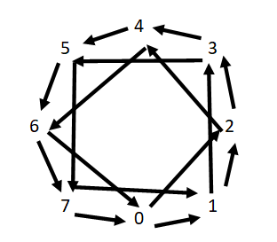

c)

2 to 5 takes 2 hops. One from 2 to 4, then 4 to 5.

6 to 0 takes 3. 6 to 0, 0 to 2, 2 to 3.

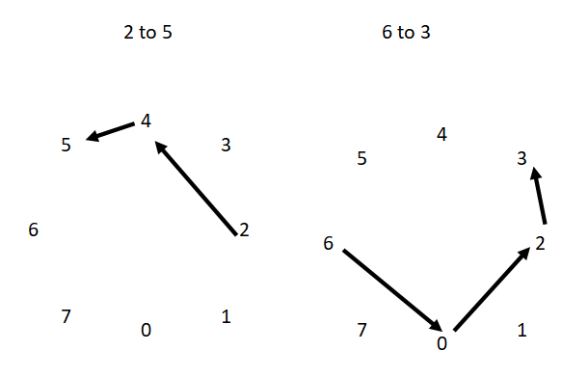

7.

a = 01110101 = -1+1+1+1-1+1-1+1

b = 10101001 = +1-1+1-1+1-1-1+1

c = 11100101 = +1+1+1-1-1+1-1+1

{a,b} = (-1*1)+(1*-1)+(1*1)+(1*-1)+(-1*1)+(1*-1)+(-1-1)+(1*1)

= -1-1+1-1-1-1+1+1=-5+2=-2

{a,c} = (-1*1)+(1*1)+(1*1)+(1*-1)+(-1*-1)+(1*1)+(-1-1)+(1*1)

=-1+1+1-1+1+1+1+1=-2+6=4

{b,c} = (1*1)+(-1*1)+(1*1)+(-1*-1)+(1*-1)+(-1*1)+(-1-1)+(1*1)

=1-1+1+1-1-1+1+1=-3+5=2

None are orthogonal because their dot products are not zero.

8.

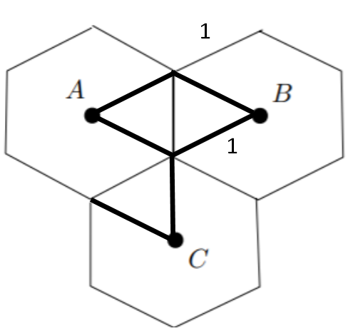

a)

Equilateral Triangles. Height of one triangle = sqrt(3) / 2.

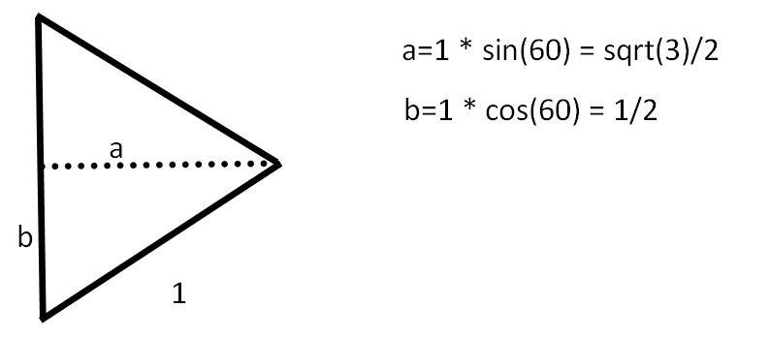

Therefore dist from A to B = 2*a = sqrt(3) = 1.73

b)

As per diagram of hexes above, dist from C = side length + ½ side length = 1 + .5 = 1.5

9.

a)

min sensor range for every pair to communicate: r = sqrt(2)

b)

Orient each such that it is looking at it's left neighbor. Networks can communicate cyclically

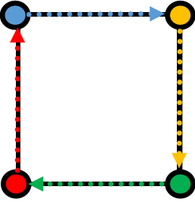

c)

Angle such that each sensor is pointing directly at the opposite corner, with pi/4 range to the left and right.

This requires r to be sqrt(2) as in part 1 of this question

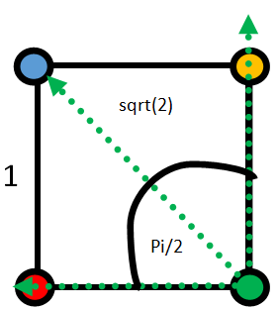

d)

No orientation with angle less than pi/2 will allow a complete network.

Each node must be able to communicate with ALL OTHER nodes, as in the previous section.

With angle less than pi/2, this cannot be attained.

10.

a)

The edge of each antenna's range must be perfectly along exactly one edge of the square

and be facing towards the antenna's left neighbor. This results in a bit of overlap between

every antenna and it's left and right neighbors, but will ensure complete coverage.

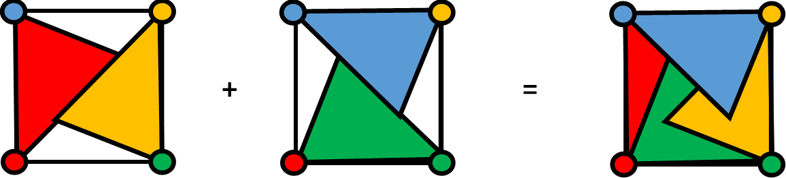

b)

See image. Assuming that even the slightest overlap counts as multiple antennae

reaching a location

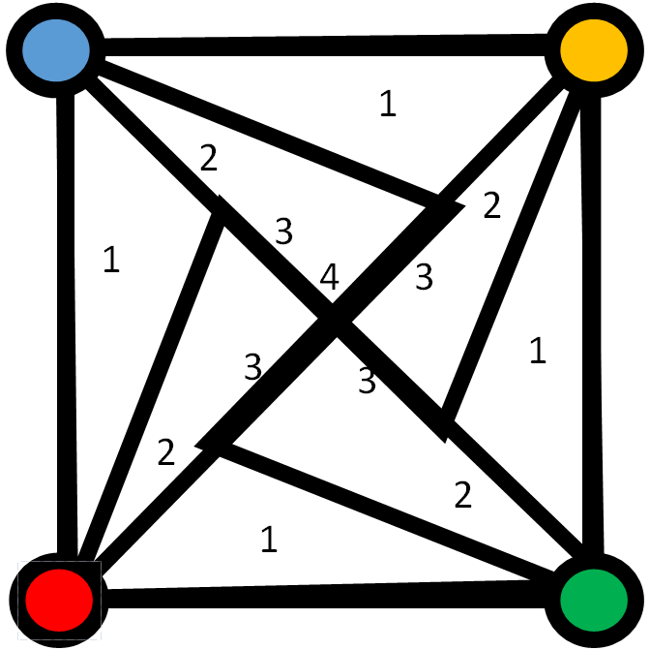

11.

a)

E = c*pi*r^2

Solve for r.

b)

E = c*pi*r^2(phi/360)

Solve for r