Shalin Lathigra -101036399

Part 1

Could not find sufficient information in slides or online to make progress on Question 3.

Ran out of time to complete Question 8 due to constraints on other assignments.

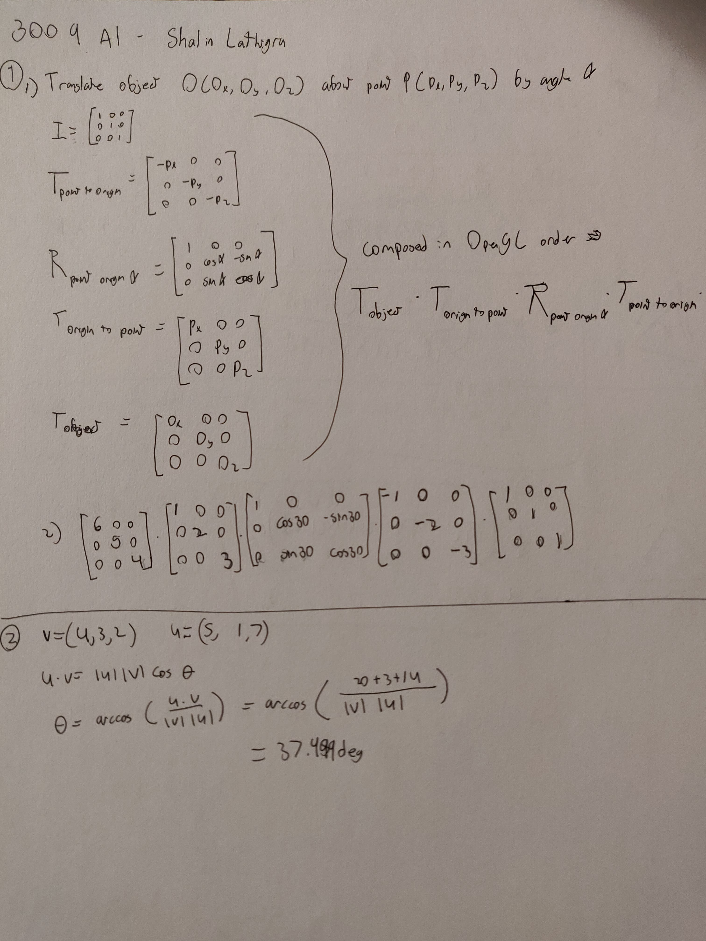

Figure 1: Questions 1 and 2

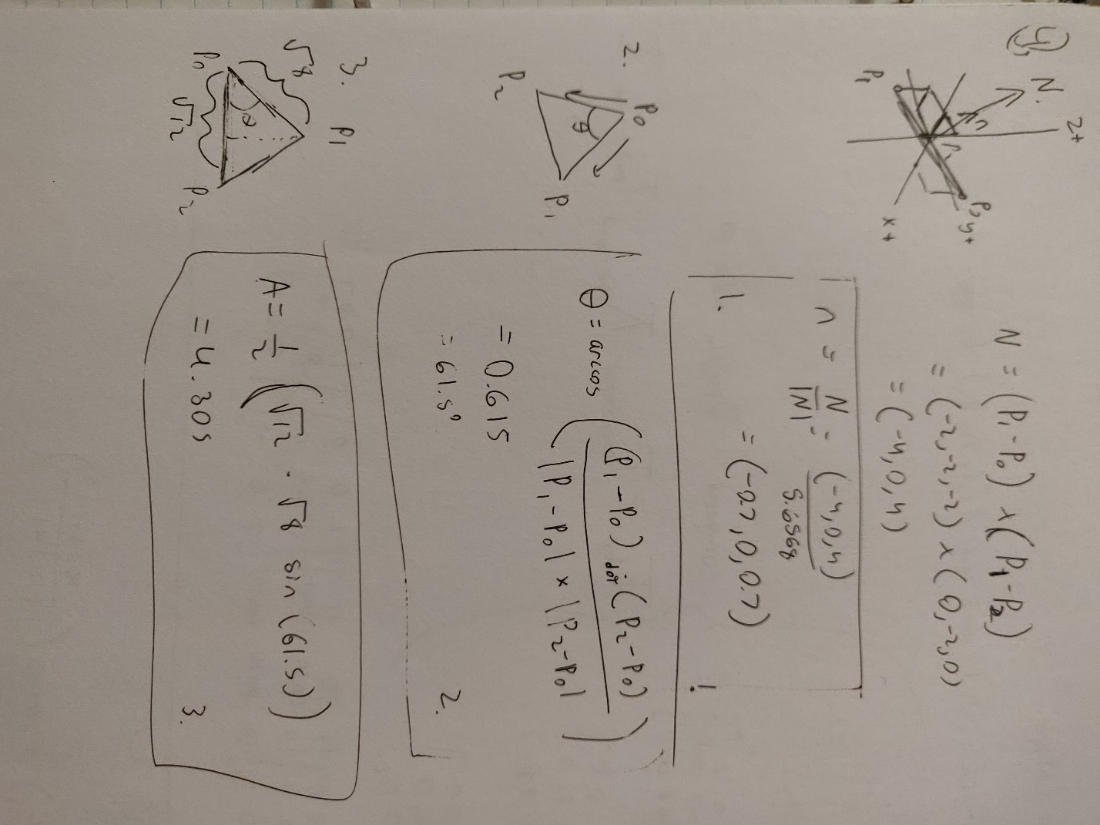

Figure 2: Question 4

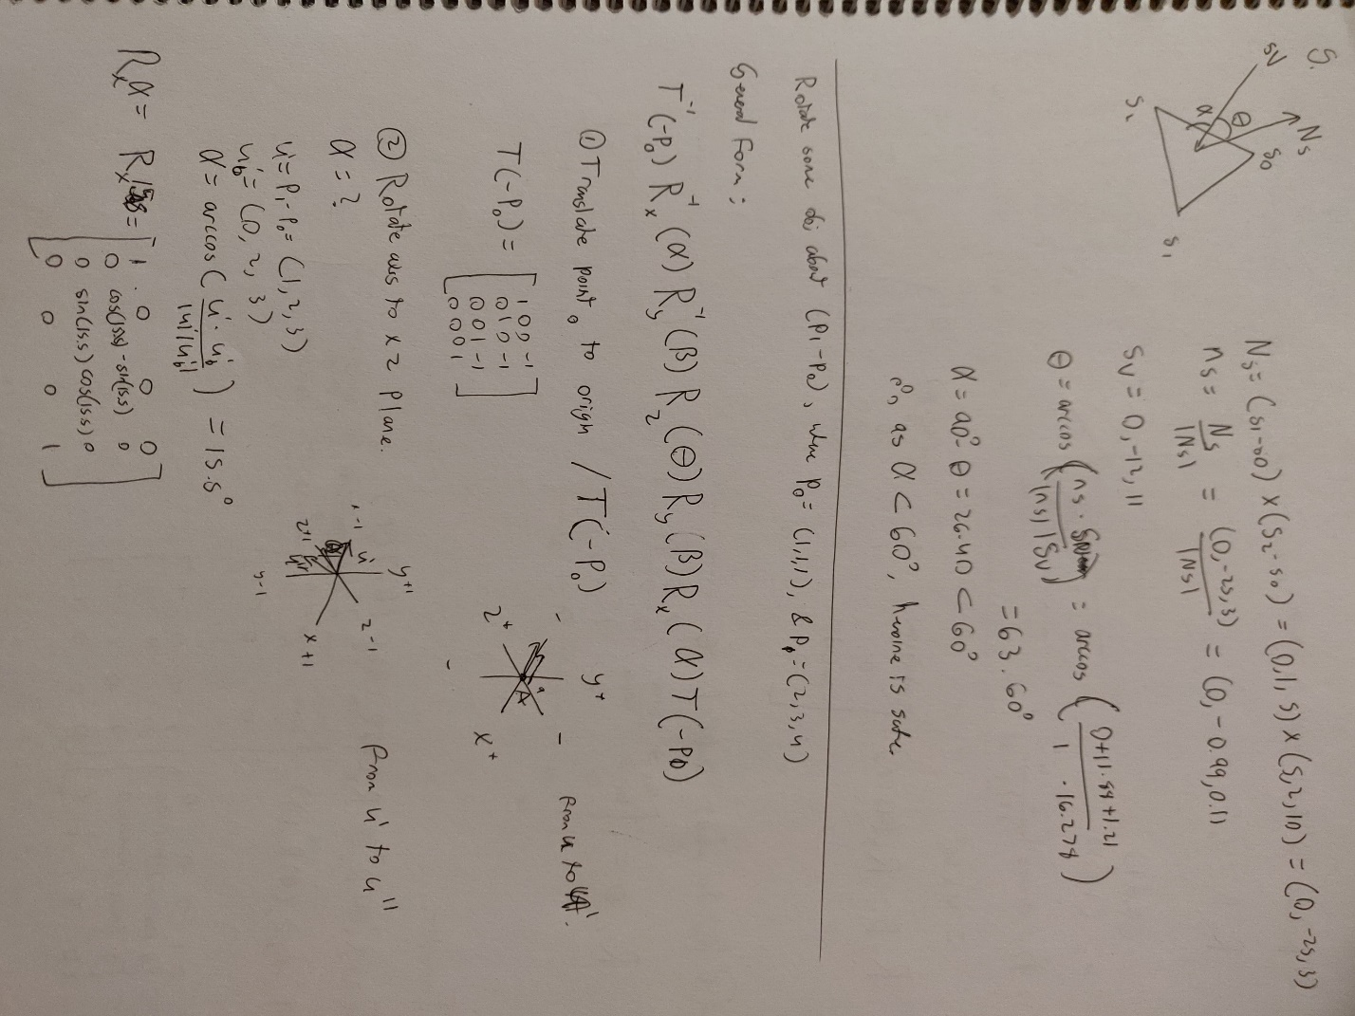

Figure 3: Question 5, Beginning of Question 6.

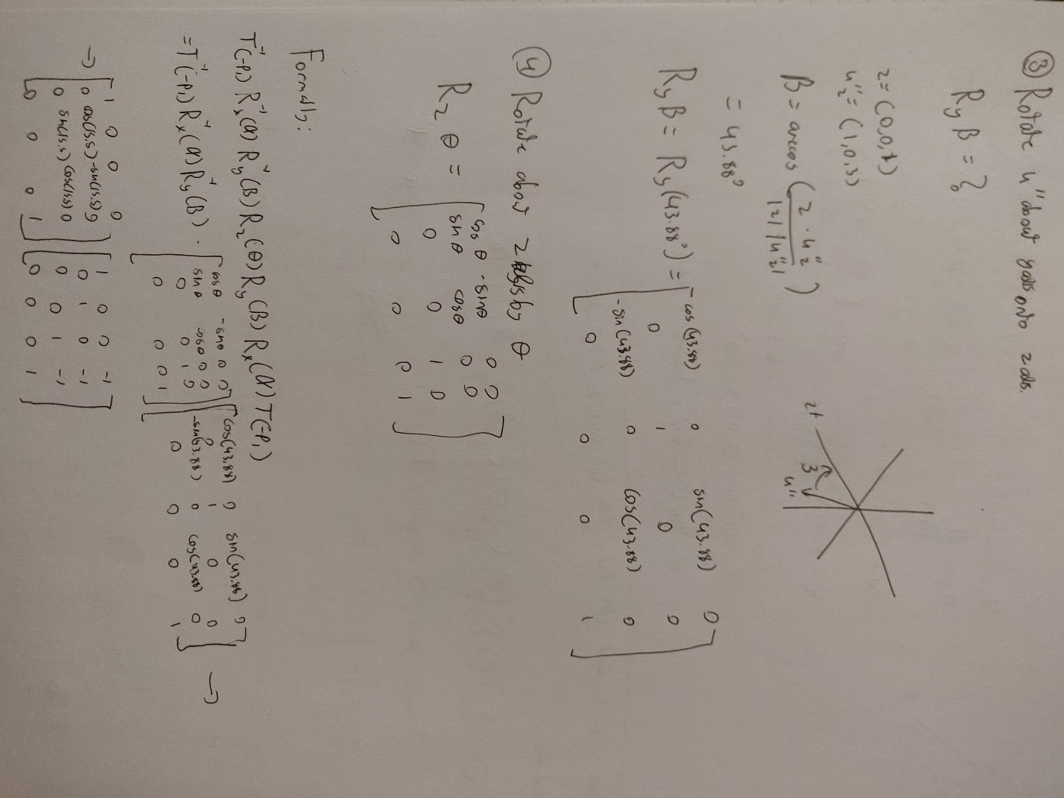

Figure 4: Question 6 conclusion

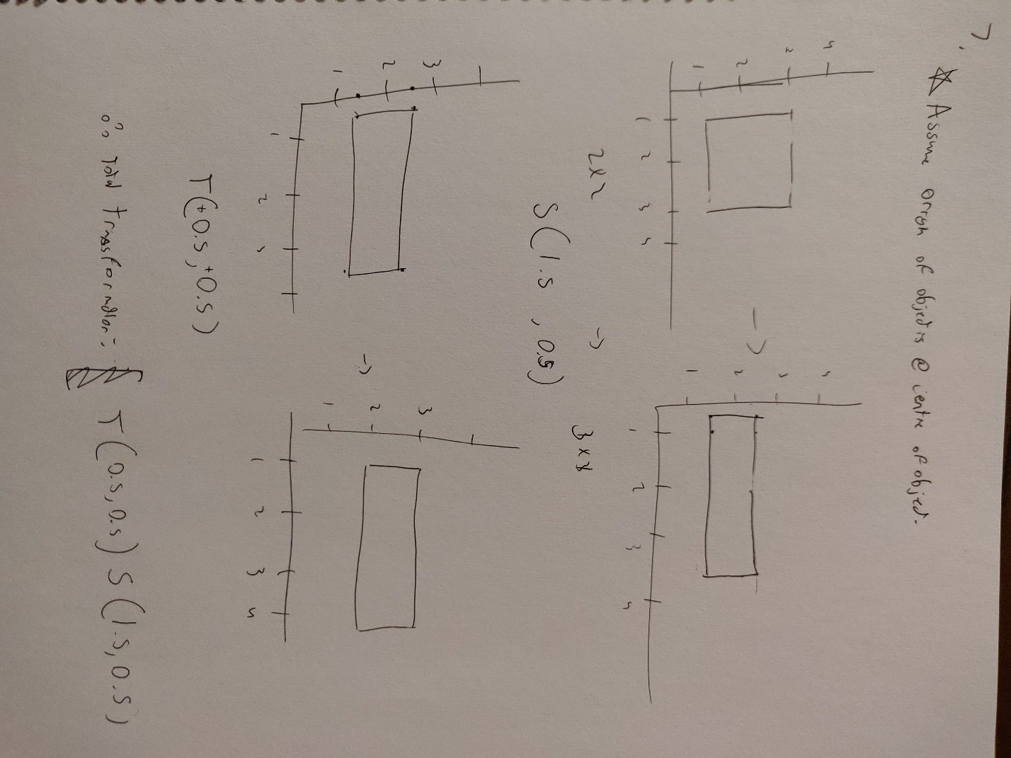

Figure 5: Question 7