Shalin Lathigra – 101036399. Part 2

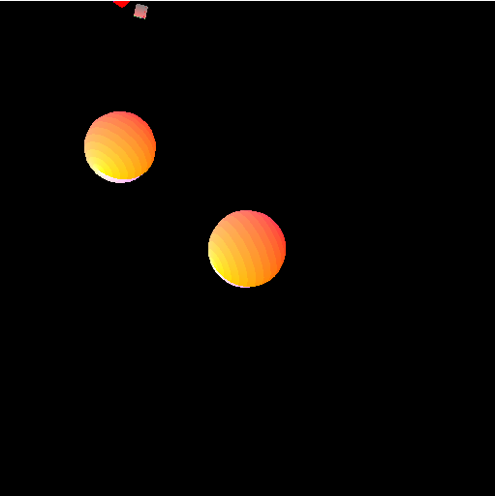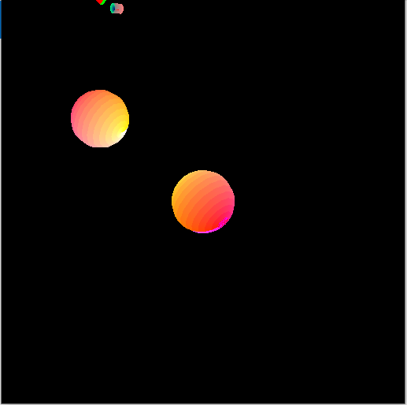

Figure 1 is right after running, Figure 2 is a few seconds later.

Each figure contains the sphere rotating at the 66.5-degree axis depicted in the center, as well as another sphere rotating around the y axis depicted above and to the left of the tilted sphere.

As you can see, the tilted sphere is obviously tilting about a different axis, specifically about the vector:  
  
(cos(23.5), sin(23.5), 0.0). which is the result of rotating the y axis 23.5 degrees (or 90-66.5 degrees) about the x axis. I chose to use this method to arrive at the axis to have the above illustration better reflect the desired results.