Shalin Lathigra – 101036399

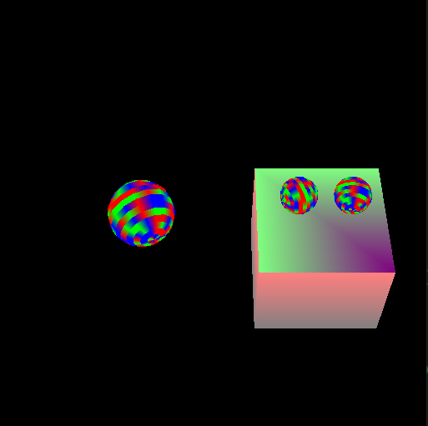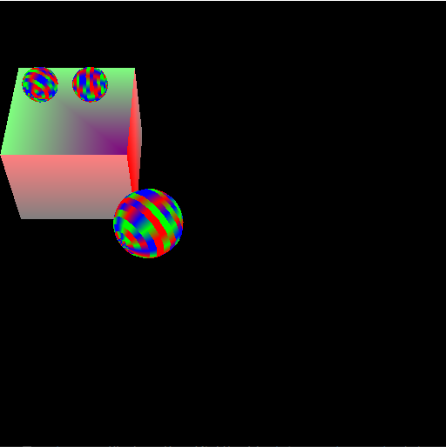Part 3

The screenshot on the left was taken moments after pressing play, the screenshot on the right was taken several seconds later after navigating the shape to the correct location.  
  
NOTE:

The wording of the assignment led me to believe the camera was to remain at it’s previously stated location. This means that movement on the xz plane does not feel correct as our view is offset, look at the input code to see that it is indeed working as requested.