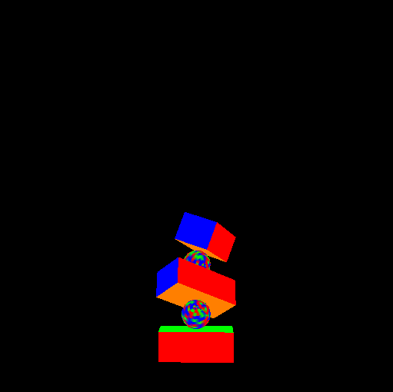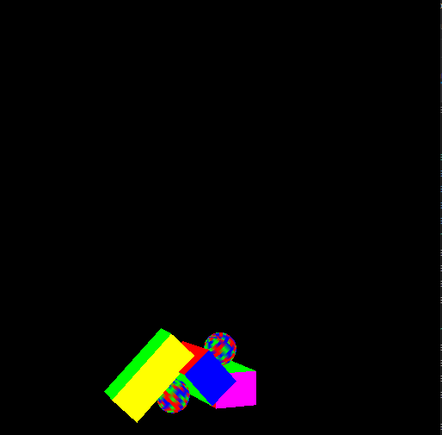Shalin Lathigra – 101036399

Part 4

As you can see, hierarchical transformations are working. I accomplished this by having each SceneNode contain a vector of pointers to children and iterating over these children when rendering/searching for a node.

When rendering, child nodes account for the position and rotation of their parent. This means that grandchildren of a node will also inherit the grandparent node’s transformation matrix (excluding scale) through their direct parent’s transformation matrix.