Docker

The Dockerfile Concept in Simple English: This is a dictionary of the main "ingredients" in your container recipe.
  - FROM: The starting base for your container (like an OS).
  - LABEL: Metadata about the container.
  - ENV: Sets special options (variables) for the system inside.
  - COPY: Moves files from your computer into the container.
  - RUN: Installs libraries and other software the container needs.
  - EXPOSE: Opens a communication port for your app.
  - HEALTHCHECK: A test to make sure the app is running correctly.
  - CMD: The final command that runs your app.
- Recommended Structure: This section shows you the standard order of these ingredients to help you build the best, fastest containers.
- Common Scenario Examples: I have included two examples showing how a real Dockerfile would look:
  - Inference (Serving): For running your machine learning model to make predictions.
  - Training (Building): For training your machine learning model.
- Key Differences Summary: A quick table comparing how the variables, file locations, starting commands, and ports differ between inference and training.
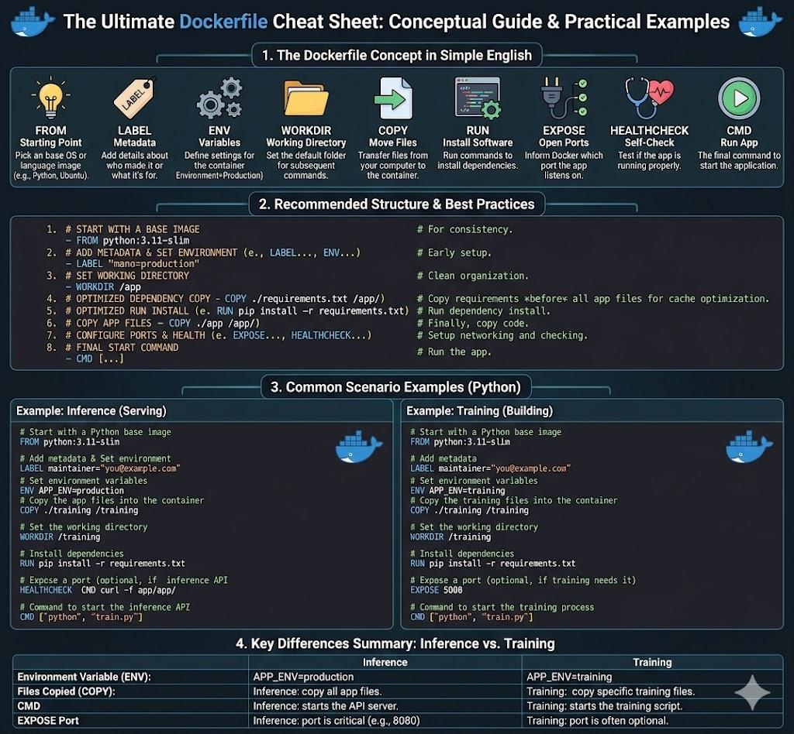
How to Use This Detailed Conceptual Guide:
This image is organized into eight clear, modular panels, matching the pseudo-code from the previous lesson:
- Base Image (FROM): Explains why a container needs a foundation, where the core files come from, and how specify this at image hubs like Docker Hub to get a consistent environment.
- Metadata (LABEL): Shows how labels add organizational details and context, essential for auditing, search, and managing large numbers of images, without affecting the file structure.
- Environment Variables (ENV): Highlights how they provide runtime configuration control, allowing you to change app behavior without code changes, and how they can be overridden at container start for different environments.
- Copy Files (COPY): Describes how your specific application code, requirements, and data files move from your host machine into the image layers, making the app present.
- Install Dependencies (RUN): Details how to pre-install all required software libraries and system tools during the build phase, creating persistent changes in the image so the container is ready for production.
- Expose Port (EXPOSE): Illustrates how to document the port your application will listen on, facilitating network communication and guiding external tools for proper port mapping.
- Health Check (HEALTHCHECK): Demonstrates how to configure a test that periodically runs to monitor the actual health of your running application, informing orchestrators and load balancers if the container is healthy.
- Command to start the App (CMD): Identifies the final primary process and execution point for the container, defining what the container actually runs when it starts and how to specify this optimally.

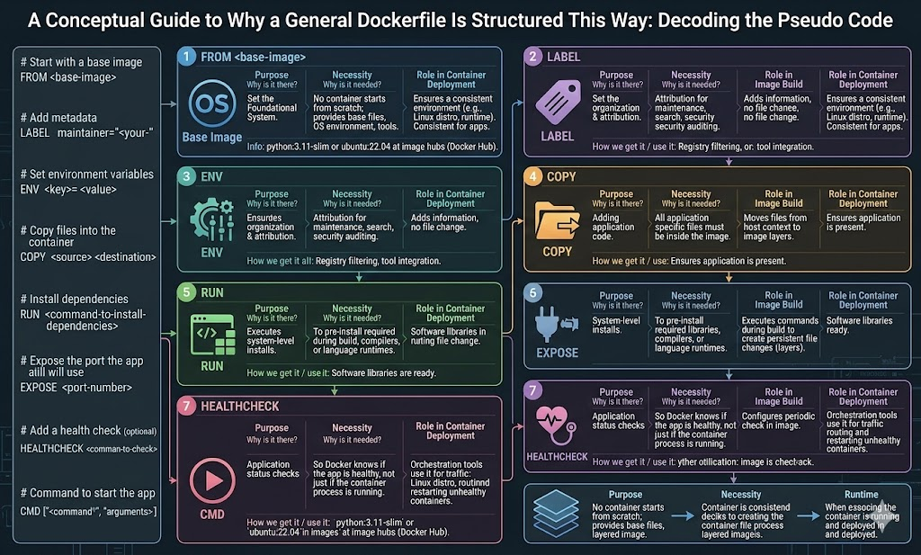
1: The Core Concept and Architecture
This image would visualize the core definitions and the relationship between the host system and Docker components. It would clarify:
- Containers: Visualized as loosely isolated environments for packaging and running applications.
- The Host: Showing how isolation allows many containers to run simultaneously on a single host.
- Images: Visualized as the lightweight blueprint (code, runtime, tools, libraries, settings) used to create the container.
Visualize the Core Concepts:
Based on the provided text, this diagram will clarify:
- DOCKER IMAGE: The visualization of a "package" icon. A standalone executable, it includes the required "Code," "Runtime," "System Tools," "System Libraries," and "Settings".
- Blueprint Connection: An arrow demonstrating that a container is a "runtime instance of a docker image".
- HOST SYSTEM: A broad outer boundary representing the physical or virtual host.
- CONTAINERS : Multiple, distinct, enclosed boxes contained within the Host System boundary, illustrating the ability to run "many containers simultaneously on a given host". Each container box will show a visualization of the "Application" and state it contains "Everything Needed". Each box will have a slight glowing/dashed border labeled "Isolation/Security".
it clarifies that:
- A DOCKER IMAGE is a sealed "package" containing Code, Runtime, System Tools, System Libraries, and Settings.
- It serves as the template for a CONTAINER (the "Application").
- The HOST SYSTEM boundary contains multiple, enclosed container boxes, demonstrating how isolation allows "many containers simultaneously" on a host.
- Each container is "loosely isolated" and includes "Everything Needed".

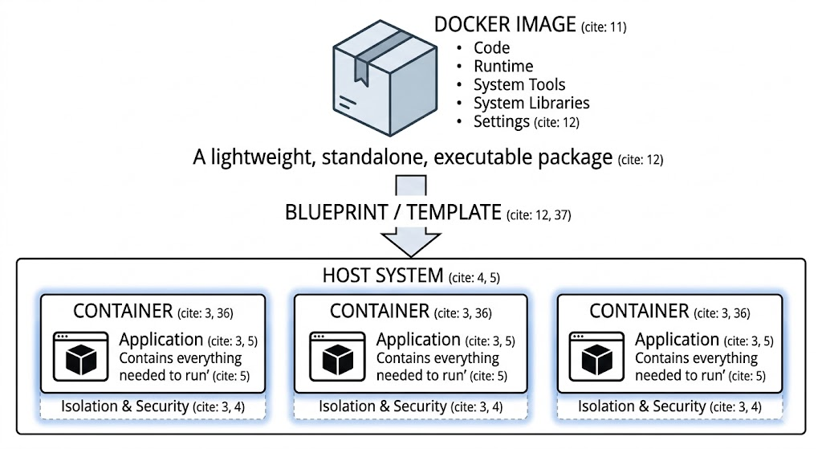

2: The Development Life Cycle (Flowchart)
This image would visualize the flow of creating, running, and managing Docker assets using specific CLI commands. It would show the progression from code to runtime:
- Dockerfile to Image: Visualizing the docker build command.
- Image to Container: Visualizing the docker run command to create a runtime instance.
- Image Sharing: Showing the relationship with Docker Hub, including docker push , docker pull , and docker search.
This image visualizes the flow of creating, running, and sharing Docker assets using specific CLI commands found in the text. It clarifies the progression from a definition file to a running application.
Visualize the Lifecycle Flow:
Based on the provided text, this diagram clarifies:
- THE BUILD PHASE : An arrow from a "Dockerfile" icon to a "Docker Image" package, using the command docker build -t <image_name>. This creates the executable package.
- THE RUN PHASE : An arrow from the "Docker Image" to a "Container" runtime instance, using the command docker run <image_name>.
- DOCKER HUB INTERACTIONS : Visualizing the sharing service.
  - Publish (Push): An arrow from the local "Docker Image" up to "Docker Hub," using docker push <username>/<image_name>.
  - Pull (Download): An arrow from "Docker Hub" down to the local "Docker Image" repository, using docker pull <image_name>.
  - Search: An icon indicating finding images on the service.

image visualizes the flow of creating, running, and sharing Docker assets using specific CLI commands found in the text. It clarifies the progression from a definition file to a running application.
It highlights:
- BUILDING : An arrow demonstrating docker build converting a "Dockerfile" into a "Docker Image" package.
- RUNNING : An arrow showing docker run creating a "Container" (a runtime instance) from that Image.
- SHARING : Visualizing "Docker Hub" as a service for 'publishing' (docker push) , 'pulling' (docker pull) , and 'searching' (docker search).
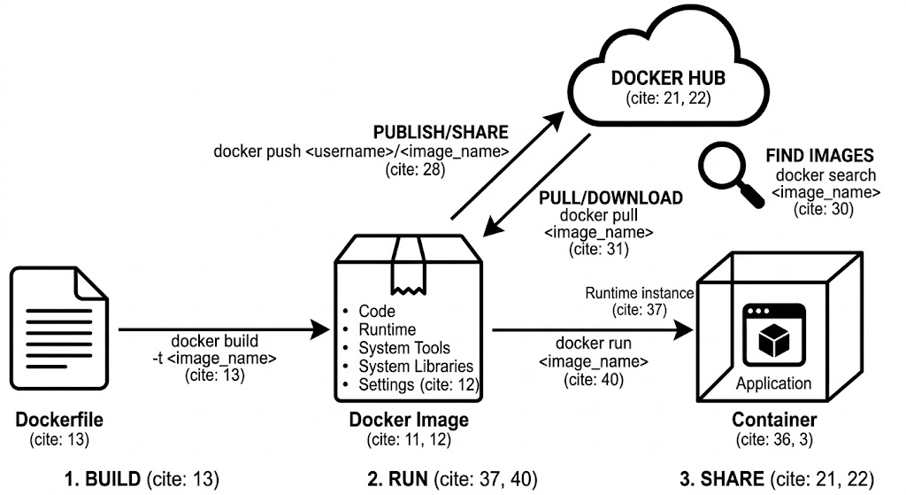
3: Container Management & Operations
This image would focus on visualizing the various states of a container and the commands that manage them:
- States: Differentiating between running, background (detached) , and stopped containers.
- Operations: Visualizing commands like starting/stopping , removing , opening a shell inside (docker exec) , following logs , and inspecting.
- Networking: A simple visual of publishing ports from the container to the host (docker run -p).
This image visualizes the states of a container and the various CLI commands used to manage them throughout their lifecycle. It clarifies the distinction between running and stopped containers and shows how to interact with them and manage networking.
Visualize Management Operations:
Based on the provided text, this diagram clarifies:
- CONTAINER STATES & COMMANDS: A visualization of distinct states and the transitions between them.
  - Running: Visualized with commands like docker run -name <name> <image> , docker run -d <image> (for background/detached mode) , and docker start <name>. Interacting with the running container includes opening a shell (docker exec -it <name> sh) , following logs (docker logs -f <name>) , inspecting details (docker inspect <name>) , and viewing resource stats (docker container stats). Running containers are listed by docker ps.
  - Stopped: Containers enter this state with docker stop <name>. From here, they can be restarted to the running state (docker start <name>) or removed completely (docker rm <name>). All containers, running and stopped, are listed by docker ps --all.
- PORT PUBLISHING : A specific section visualizing how a container's port is published to the host using docker run -p <host_port>:<container_port> <image>.

This image visualizes the states of a container and the various CLI commands used to manage them throughout their lifecycle.
It highlights:
- CONTAINER STATES & COMMANDS : Distinguishes between the Running state and the Stopped state.
  - Running: Visualized with commands like docker run , docker run -d , and docker start. Interact with running containers using docker exec , docker logs , docker inspect , and docker container stats. Running containers are listed by docker ps.
  - Stopped: Containers enter this state with docker stop <name> and can be restarted (docker start <name>) or removed completely (docker rm <name>). All containers, running and stopped, are listed by docker ps --all.
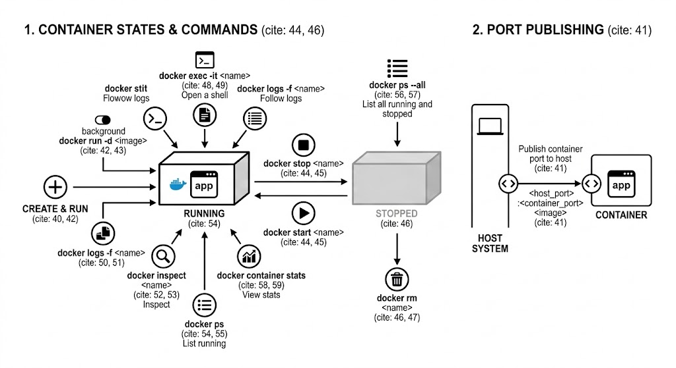
- PORT PUBLISHING : A specific section showing the specific command docker run -p <host_port>:<container_port> <image> to visualize publishing ports from a container to the host.

1. How Many Containers Can One Image Produce?
A single Docker image can produce many containers. An image is a "standalone, executable package of software" , and a container is a "runtime instance" of that image. You can "run many containers simultaneously on a given host" based on the image you have created.
2. Under What Conditions Are Containers Produced?
Containers are produced when you need to package and run an application in a loosely isolated environment called a container. They are created and run from an image using the docker run command. Common conditions for running a container include ensuring that software works uniformly across different infrastructures, such as development and staging environments. Containers are "lightweight and contain everything needed to run the application".
3. What To Do Next and Missing Fundamentals
You correctly identified that after building an image from a Dockerfile (docker build) , you can run a container and push that image to Docker Hub to share it with your team.
Based on the documentation provided, you have covered the high-level concepts of images, basic container operations, and Docker Hub interactions. Other foundational areas outlined in the text that you may want to review include:
- Image Management: Listing local images (docker images) , deleting images (docker rmi) , or removing all unused images (docker image prune).
- Container Maintenance: Stopping (docker stop) and removing stopped containers (docker rm).
- System Commands: Starting the docker daemon (docker-d) , getting help (docker --help) , and displaying system-wide information (docker info).
- Inspection: Fetching and following logs of a container (docker logs -f) , inspecting a running container (docker inspect) , or viewing resource usage stats (docker container stats).
4. How to Manage Services, Volumes, and Ports
Managing a suite of services (like ML training, Prometheus, Grafana, and Alertmanager) typically involves running them as background processes and ensuring they can communicate with the outside world.
Please note: The provided text does not contain information regarding volume management or specific configuration details for ML training, Prometheus, Grafana, or Alertmanager.
However, based on the commands available in the text, you manage background services, ports, and monitoring in the following ways:
- Run Services in the Background: Start services as "detached" (background) containers using docker run -d <image_name>.
- Manage Ports: Publish a container's port to the host so services like Grafana can be accessed using docker run -p <host_port>:<container_port> <image_name>.
- Interact with Services: You can open a shell inside a running container (like a training environment) with docker exec -it <container_name> sh.
- Control Service State: Start or stop existing service containers using docker start <container_name> or docker stop <container_name>.
- Monitor Resources: View resource usage stats (like CPU or memory) for your running service containers using docker container stats.
- List running services: View a list of currently running containers using docker ps.

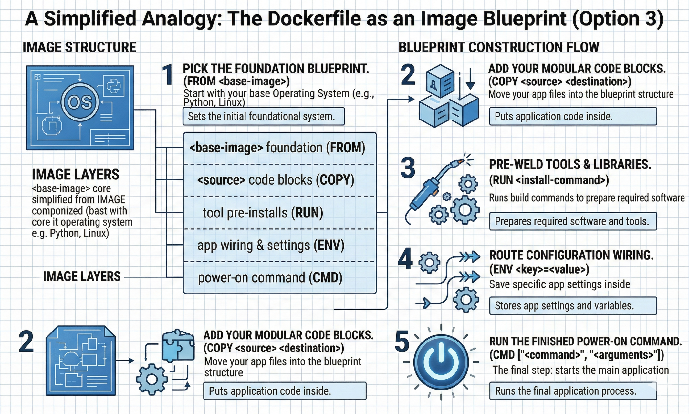
.
Lifecycle image: Docker lifecycle infographic

Docker Essentials — 1-Page Cheat Sheet
1) Core mental model
- Dockerfile = recipe (how to build)
- Image = packaged app (code + libs + OS layers) — read-only
- Container = running instance of an image — read/write layer
- Registry (Docker Hub/ECR/GHCR) = store & share images
- Volume = persistent data (survives container deletion)

2) Full lifecycle (Build → Run → Operate → Share → Cleanup)
A) BUILD (Dockerfile → Image)
docker build -t myapp:1.0 .
docker images
B) RUN (Image → Container)
docker run --name myapp -p 8000:8000 myapp:1.0
# background:
docker run -d --name myapp -p 8000:8000 myapp:1.0
C) OPERATE (day-to-day)
docker ps # running
docker ps -a # all (incl. stopped)
docker logs -f myapp # logs
docker exec -it myapp sh # shell inside container
docker stop myapp
docker start myapp
docker rm myapp
D) SHARE (push/pull)
docker tag myapp:1.0 yourname/myapp:1.0
docker push yourname/myapp:1.0
docker pull yourname/myapp:1.0
E) CLEANUP (save disk)
docker system df
docker container prune
docker image prune
docker image prune -a # aggressive (unused images)
docker builder prune # build cache

3) The 10 Docker “must know” flags
- -p 8000:8000 → publish port (host:container)
- -d → detached (background)
- --rm → auto-delete container on stop
- -it → interactive terminal
- --name X → friendly container name
- -e KEY=VAL → env var
- --env-file .env → load env file
- -v vol:/path → named volume mount
- -v ./host:/app → bind mount (dev)
- --restart unless-stopped → auto-restart policy

4) Dockerfile essentials (what matters in practice)
Golden build pattern (fast rebuilds)
FROM python:3.11-slim
WORKDIR /app
COPY requirements.txt .
RUN pip install -r requirements.txt
COPY . .
EXPOSE 8000
CMD ["uvicorn","main:app","--host","0.0.0.0","--port","8000"]
Key keywords
- FROM base image
- WORKDIR default folder
- COPY bring files into image
- RUN execute during build (install deps)
- ENV set env variables
- EXPOSE documents port (does not publish)
- CMD default start command
- HEALTHCHECK optional “is it healthy?”
Must-have: .dockerignore
Stop copying junk into images (huge speed/size win):
- .git/, __pycache__/, data/, mlruns/, .dvc/, .pytest_cache/, etc.

5) Compose in 60 seconds (multi-container apps)
docker compose up -d
docker compose ps
docker compose logs -f
docker compose down
Use Compose when you have API + DB + MLflow + Prometheus/Grafana etc.

6) The #1 common mistake
- EXPOSE 8000 ≠ reachable from browser
✅ You need: docker run -p 8000:8000 ...

