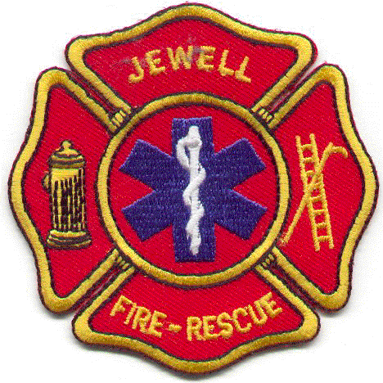

JEWELL FIRE AND RESCUE
P.O. Box 399
JEWELL, IOWA 50130-0399

Duane Hendrickson, Chief Ron Imlay, Asst. Chief
Shelly Smith, Secretary Konni VanLangen, Treasurer

August 7, 2017

To Whom It May Concern:

Jewell Fire and Rescue is making an official request for access to the Iowa Statewide Interoperable Communications System (ISICS). Based on this "Letter of Intent", we request that the Iowa Statewide Interoperable Communications System Board (ISICSB) forward an application and information package to identify the information that must be provided in our application.

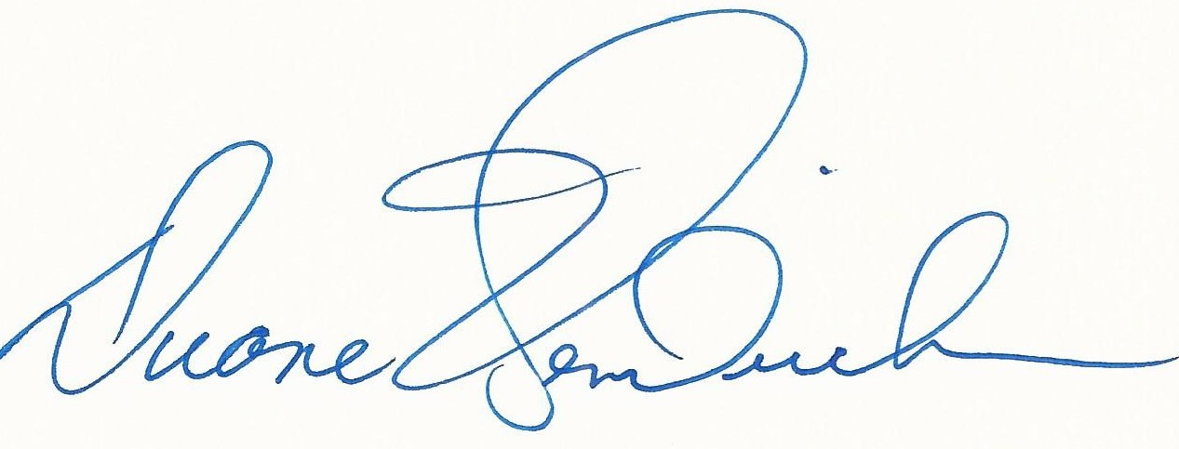
Duane Hendrickson, Chief
Jewell Fire and Rescue

