Project Title:
Integrative Genomic Variant Prioritization for Type 2 Diabetes Using Population and Functional Data with Explainable Machine Learning

Abstract
Type 2 diabetes (T2D) is a complex disease influenced by multiple genetic variants with diverse population frequencies, statistical association patterns, and functional consequences. Although genome-wide association studies (GWAS) can identify large numbers of disease-associated loci, distinguishing variants with stronger biological relevance from statistically associated signals remains a major challenge. This project developed a reproducible integrative framework for prioritizing T2D-associated genomic variants by combining population-level GWAS information, functional genomic annotation, explainable machine learning, and external biological evidence.
Multi-ancestry T2D GWAS index signals from Suzuki et al. (2024) were used as the primary dataset. Supplementary Table ST4 contained 1,289 index signals representing 611 unique loci. GWAS-derived features, including allele frequency, association significance, effective sample size, odds ratio, confidence interval characteristics, transformed association statistics, and minor allele frequency, were processed and quality controlled. Functional features were subsequently derived from variant annotation, including gene, transcript, and biotype information, genomic consequence categories, and predicted functional-impact indicators.
A leakage-safe machine-learning framework was developed to model protein-altering status using selected GWAS and functional features. The final model was reconstructed independently for explainability analysis, and its predictions and coefficients were reproduced with negligible numerical differences. SHAP analysis was then used to quantify global and candidate-level feature contributions, with intergenic and intronic annotations, modifier impact, biotype count, and minor allele frequency among the most influential features in the model's predictions.
Machine-learning evidence was subsequently integrated with biological and external GWAS evidence to prioritize candidate variants. Candidate rankings were evaluated for model–biology concordance and discordance and were further assessed using rank-stability analysis. The final prioritization pipeline produced a quality-controlled set of 17 unique candidate variants, with no duplicate or missing SNP identifiers.
Overall, this project demonstrates a reproducible framework for genomic variant prioritization that integrates population-level association data, functional annotation, interpretable machine learning, and independent biological evidence. The workflow is intended to support hypothesis generation and candidate prioritization rather than establish variant causality, providing a structured approach for downstream functional and biological investigation of T2D-associated variants.

Research Question
How can population-level GWAS data and functional genomic annotation be integrated using explainable machine learning and independent biological evidence to prioritize Type 2 diabetes-associated genetic variants for further investigation?

Research Objectives
Primary Objective
To develop a reproducible and explainable integrative framework for prioritizing Type 2 diabetes-associated genomic variants by combining population-level GWAS information, functional genomic annotation, machine learning, and external biological evidence.
Specific Objectives
- To process and quality control multi-ancestry T2D GWAS index signals from the Suzuki et al. (2024) dataset.
- To engineer population and association-based features from GWAS data, including allele frequency, association significance, effect-size measures, confidence interval characteristics, and minor allele frequency.
- To incorporate functional genomic information by annotating variants and deriving features related to genes, transcripts, biotypes, genomic consequences, and predicted functional impact.
- To construct a leakage-safe machine-learning framework for modelling protein-altering variant status using population and functional features.
- To evaluate and compare machine-learning approaches using appropriate validation procedures and performance metrics.
- To apply SHAP-based explainable machine learning to identify globally important features and characterize feature contributions to individual variant predictions.
- To integrate machine-learning predictions with biological and external GWAS evidence for comprehensive candidate prioritization.
- To investigate concordance and discordance between model-based predictions and biological evidence, thereby identifying candidates requiring further interpretation.
- To assess the robustness of candidate prioritization through rank-stability and validation analyses.
- To generate a reproducible final set of prioritized T2D-associated candidate variants for downstream biological and functional investigation.
- To organize the complete analytical workflow, scripts, results, figures, tables, and reproducibility documentation into a final research project package.

Introduction
Type 2 diabetes (T2D) is a complex metabolic disorder characterized by impaired glucose regulation and influenced by interactions between genetic, biological, environmental, and lifestyle factors. The genetic architecture of T2D is particularly complex, with disease susceptibility arising from the combined contribution of numerous variants distributed across the genome. Genome-wide association studies (GWAS) have substantially expanded the understanding of this genetic architecture by identifying hundreds of genomic loci associated with T2D and related metabolic traits.
However, identifying a statistically associated locus does not directly reveal which variant or biological mechanism is responsible for the observed association. A GWAS signal may occur within a genomic region containing multiple correlated variants, several nearby genes, and diverse functional annotations. In addition, many associated variants are located outside protein-coding regions and may influence disease risk through regulatory or other functional mechanisms. Therefore, the transition from GWAS association to biologically meaningful variant prioritization remains an important challenge in human genomics.
Traditional prioritization strategies often rely primarily on statistical significance, effect size, or proximity to a biologically plausible gene. Although these approaches are useful, no single source of evidence is sufficient to establish the relative importance of a variant. A statistically significant variant may have limited functional evidence, while a variant with strong biological relevance may not necessarily receive the highest priority based solely on association statistics. This creates a need for integrative approaches that consider multiple complementary sources of information.
Population-level GWAS data provide one important dimension for variant prioritization. Features such as risk allele frequency, minor allele frequency, association significance, odds ratio, confidence intervals, and effective sample size describe different aspects of the observed genetic association. These features can be systematically processed to characterize variation among associated signals. However, population and association statistics alone provide limited information about the potential functional consequences of a genomic variant.
Functional genomic annotation provides an additional layer of evidence. Variant consequences can be characterized using information related to affected genes, transcripts, biotypes, genomic locations, and predicted functional impacts. For example, variants may occur in intronic, intergenic, untranslated, splice-related, regulatory, or protein-altering contexts. Integrating these annotations with GWAS-derived features can provide a more comprehensive representation of each variant than either evidence type alone.
Machine learning offers a potential framework for analysing complex relationships among multiple genomic features. However, the use of machine learning in genomic studies requires careful methodological design. In particular, features that directly encode or reveal the target variable can introduce data leakage and lead to overly optimistic model performance. Similarly, imputation, scaling, and other preprocessing procedures must be performed within an appropriate validation framework to avoid information from the test data influencing model development. For this reason, the present project implemented a leakage-safe machine-learning framework in which feature selection and preprocessing were designed to minimize direct target leakage.
An additional challenge is the interpretability of machine-learning models. A predictive model may identify patterns associated with an outcome, but prediction alone does not explain how individual features contribute to those predictions. Explainable artificial intelligence methods can help address this limitation. In this project, SHapley Additive exPlanations (SHAP) were used to examine both global feature importance and candidate-level feature contributions. This allowed the machine-learning component to be interpreted as part of the broader prioritization framework rather than being treated as an isolated prediction system.
Importantly, machine-learning predictions should not be interpreted as direct evidence of biological causality. A model can identify patterns associated with a defined target based on the features available in the training data, but such predictions do not independently establish that a variant causes T2D or that a specific gene mediates disease risk. Consequently, biological and external evidence are necessary to complement model-based prioritization. Integrating independent evidence can help distinguish candidates supported by multiple lines of investigation from candidates whose prioritization is driven primarily by the patterns learned by the model.
The present study therefore developed an integrative genomic variant prioritization framework using multi-ancestry T2D GWAS data from Suzuki et al. (2024) as the primary source dataset. The analysis began with 1,289 index signals representing 611 unique loci. GWAS-derived population and association features were processed and quality controlled, followed by the incorporation of functional variant annotations. A leakage-safe machine-learning framework was then used to model protein-altering status using selected population and functional features. Model predictions were subsequently interpreted using SHAP-based explainability analyses.
The framework was extended beyond machine-learning prediction by integrating model-derived information with biological evidence and external GWAS evidence. Candidate prioritization was further evaluated through model–biology concordance and discordance analyses and rank-stability assessment. The final workflow produced a quality-controlled set of 17 unique candidate variants for further investigation.
Thus, the central purpose of this project was not to claim the discovery of causal T2D variants. Instead, the study aimed to develop a reproducible and evidence-integrative framework for systematically prioritizing variants from a large set of T2D GWAS signals. By combining population-level association data, functional genomic information, explainable machine learning, and independent biological evidence, this workflow provides a structured approach for generating biologically informed hypotheses and identifying candidates for downstream functional and experimental investigation.
Materials and Methods
2.1 Study Design and Overall Workflow
This study developed a reproducible computational framework for prioritizing Type 2 diabetes (T2D)-associated genomic variants by integrating population-level GWAS information, functional genomic annotation, machine learning, explainable artificial intelligence, and independent biological evidence.
The workflow consisted of the following major stages:
- Acquisition and quality control of multi-ancestry T2D GWAS index signals.
- Engineering of population and association-based features.
- Functional annotation of variants using Ensembl Variant Effect Predictor (VEP).
- Conversion of transcript-level annotations into SNP-level functional features.
- Integration of GWAS and functional datasets.
- Construction of a supervised machine-learning dataset.
- Baseline modelling, model comparison, and leakage investigation.
- Development of a leakage-safe machine-learning model.
- Explainability analysis using SHapley Additive exPlanations (SHAP).
- Integration of model-derived, functional, biological, and external GWAS evidence.
- Candidate prioritization and model–biology concordance analysis.
- Robustness assessment through rank-stability analysis.
- Final candidate quality control and project reproducibility assessment.
The overall purpose of the workflow was to prioritize variants for further investigation rather than establish genetic causality.

2.2 Data Source
The primary dataset was derived from the multi-ancestry Type 2 Diabetes Genetics Initiative GWAS study reported by Suzuki et al. (2024). Supplementary Table ST4 was used as the starting dataset for the analysis.
The initial dataset contained:
- 1,289 GWAS index signals
- 611 unique genomic loci
- 12 original variables
The original variables included locus and chromosomal information, index SNP identifiers, alleles, risk allele frequency, association p-values, odds-ratio information, and effective sample size.
This dataset was selected because it provided a curated set of T2D-associated index signals from a large multi-ancestry GWAS, enabling the integration of population-level association information with downstream functional annotation and computational prioritization.

2.3 Computational Environment and Software
The analysis was conducted primarily using Python. The main computational libraries and tools used during the workflow are summarized below.
Python
Python was used as the primary programming language for data processing, feature engineering, machine learning, statistical analysis, visualization, and reproducibility workflows.
Python was selected because it provides an integrated computational environment for handling tabular genomic data, performing machine-learning analyses, and automating reproducible analytical pipelines.
pandas
The pandas library was used for reading, cleaning, transforming, merging, filtering, and exporting tabular datasets.
It was used throughout the project to:
- Read TSV and other tabular files.
- Inspect dataset dimensions and columns.
- Handle missing values.
- Create engineered features.
- Merge GWAS and functional annotation datasets.
- Generate result tables.
- Export intermediate and final datasets.
pandas was particularly important because the analysis involved repeated transformation of SNP-level datasets across multiple stages of the workflow.
NumPy
The NumPy library was used for numerical operations and mathematical transformations.
Its role included supporting calculations involving:
- Logarithmic transformation of odds ratios.
- P-value transformations.
- Minor allele frequency calculations.
- Numerical array operations.
- Machine-learning input preparation.
scikit-learn
The scikit-learn library was used for the main machine-learning and model-evaluation framework.
The library was used for:
- Stratified train/test splitting.
- Median imputation of missing values.
- Feature standardization.
- Logistic regression.
- Random Forest classification.
- Model comparison.
- Stratified cross-validation.
- Pipeline construction.
- Classification metrics.
- ROC-AUC calculation.
- Precision–recall analysis.
scikit-learn was selected because it allows preprocessing and classification steps to be combined into reproducible pipelines, helping to reduce the risk of information leakage between training and test data.
SHAP
The shap library was used for explainable machine learning.
SHAP was applied to:
- Quantify global feature importance.
- Calculate SHAP values for individual test-set variants.
- Generate global feature-importance visualizations.
- Generate SHAP beeswarm plots.
- Produce candidate-level feature contribution explanations.
SHAP was used because machine-learning predictions alone do not explain which features contribute most strongly to a prediction. The final model was therefore interpreted using SHAP to improve transparency and biological interpretability.
Ensembl Variant Effect Predictor
Ensembl Variant Effect Predictor (VEP) was used to obtain functional annotations for the GWAS index SNPs.
VEP was used because population-level GWAS statistics do not independently describe the genomic or functional context of a variant. Functional annotation was therefore required to determine whether variants were associated with coding, intronic, intergenic, untranslated, regulatory, splice-related, or other genomic consequences.
GWAS Catalog Evidence
External GWAS evidence was incorporated during the candidate-prioritization stages.
This independent evidence source was used to complement the information derived from the primary T2D GWAS dataset and machine-learning model. The purpose was to strengthen prioritization through multiple lines of evidence rather than relying solely on model predictions.
File and Reproducibility Utilities
Python utilities including os, glob, shutil, and hashlib were used during the final project-organization stage.
These utilities supported:
- File discovery.
- Directory creation.
- Script consolidation.
- Copying of final results and figures.
- Project inventory generation.
- SHA-256 file hashing.
- Reproducibility manifest creation.
These tools were used to ensure that the final analytical package contained an organized record of the scripts, results, figures, tables, and supporting documentation generated during the project.

2.4 GWAS Data Cleaning and Quality Control
The initial ST4 dataset was subjected to basic quality control before feature engineering.
The quality-control procedure examined:
- Dataset dimensions.
- Column structure.
- Number of index signals.
- Number of unique loci.
- Missing values.
- P-value distributions.
- SNP-level consistency.
- P-values equal to zero.
Special attention was given to association p-values because five variants had p-values represented as exactly zero. A zero p-value cannot be directly transformed using a logarithmic function because the logarithm of zero is undefined. These values were therefore handled separately during feature engineering.
The smallest non-zero p-value in the dataset was approximately 1.6 × 10⁻²⁷⁹, demonstrating the presence of highly significant associations.
The purpose of this quality-control stage was to ensure that numerical and identifier-related issues were detected before subsequent modelling and annotation procedures.

2.5 GWAS Feature Engineering
Additional quantitative features were derived from the original GWAS variables to provide a richer representation of population and association characteristics.
Odds Ratio and Confidence Interval Features
The original odds-ratio and confidence-interval information was parsed into separate numerical variables:
- Odds ratio (OR)
- Lower confidence interval (CI_lower)
- Upper confidence interval (CI_upper)
Additional derived features included:
- Log-transformed odds ratio (log_OR)
- Confidence interval width (CI_width)
- Approximate standard error of the log odds ratio (SE_log_OR)
The logarithmic transformation of the odds ratio was used because effect sizes are more naturally represented on the log scale in statistical modelling. Confidence interval width and estimated standard error were included to represent the uncertainty and precision associated with effect-size estimates.
Association Significance Features
Association p-values were processed to generate:
- P_is_zero
- neg_log10_P
P_is_zero was created to explicitly identify values originally represented as zero. The negative base-10 logarithm of the p-value was used to transform highly skewed association significance values into a more interpretable numerical scale.
For zero p-values, the transformed significance values were handled separately to avoid undefined logarithmic values.
Minor Allele Frequency Features
Minor allele frequency (MAF) was calculated from the risk allele frequency.
Variants were categorized as:
- Rare
- Low frequency
- Common
The purpose of including MAF was to capture the population-frequency characteristics of variants, since allele frequency may provide complementary information to association statistics and functional annotation.

2.6 Functional Variant Annotation
All 1,289 GWAS index SNPs were functionally annotated using Ensembl Variant Effect Predictor.
The annotation process generated multiple records for some variants because a single SNP can affect multiple genes, transcripts, biotypes, or functional regions. The initial annotation output contained 7,165 annotation rows representing the 1,289 unique SNPs.
This transcript-level annotation was required to capture the biological context of each GWAS signal before converting the information into a machine-learning-compatible SNP-level dataset.

2.7 SNP-Level Functional Feature Engineering
Because machine-learning analysis required one observation per SNP, transcript-level VEP annotations were aggregated into SNP-level functional features.
The final SNP-level functional annotation table contained 1,289 SNPs and 24 columns, with no missing values.
The functional features included the following categories.
Coding and Functional Indicators
- Is_coding
- Is_missense
- Is_synonymous
- Is_stop_gained
- Has_protein_altering
These features were used to represent whether a variant had coding or potentially protein-altering consequences.
Genomic Location Indicators
- Is_intronic
- Is_intergenic
- Is_upstream
- Is_downstream
- Is_5UTR
- Is_3UTR
- Is_regulatory
- Is_splice
These variables represented the genomic context of each variant.
Functional Impact Indicators
- Has_HIGH_impact
- Has_MODERATE_impact
- Has_LOW_impact
- Has_MODIFIER_impact
These indicators summarized predicted functional-impact categories derived from the annotation process.
Annotation Complexity Features
- Gene_count
- Transcript_count
- Biotype_count
These features represented the number of genes, transcripts, and biotypes associated with each SNP.
Biological Annotation Variables
Additional biological descriptors included:
- Most_severe_consequence
- Primary_gene
- Primary_biotype
These variables were retained for biological interpretation and downstream candidate prioritization.

2.8 Functional Annotation Quality Control
Functional annotations were subjected to additional quality-control checks.
The SNP-level annotation results identified:
- 55 coding variants.
- 49 missense variants.
- 11 synonymous variants.
- 3 stop-gained variants.
- 50 protein-altering variants.
- 780 intronic variants.
- 269 intergenic variants.
- 24 variants with 5′ UTR annotation.
- 52 variants with 3′ UTR annotation.
- 29 regulatory variants.
- 6 splice-related variants.
An issue affecting UTR feature detection was identified during quality control. Initial feature generation produced incorrect zero counts for UTR categories. The annotation consequence strings were subsequently re-examined, and the feature-generation logic was corrected. The final dataset correctly identified 24 variants with 5′ UTR annotations and 52 variants with 3′ UTR annotations.
This validation step was important because incorrect annotation parsing could propagate errors into the downstream machine-learning analysis.

2.9 Integration of GWAS and Functional Data
The engineered GWAS dataset and SNP-level functional annotation dataset were merged using SNP identifiers.
Pre-merge quality control confirmed:
- 1,289 GWAS SNPs.
- 1,289 VEP SNPs.
- 1,289 unique GWAS SNPs.
- 1,289 unique VEP SNPs.
- No duplicate SNP identifiers.
- No GWAS SNPs missing from the VEP dataset.
- No VEP SNPs missing from the GWAS dataset.
The merge therefore represented a complete one-to-one SNP correspondence.
The resulting integrated dataset contained 1,289 SNPs and 45 columns.
This integration was necessary because the central objective of the project was to combine population-level association information with functional genomic evidence.

2.10 Construction of the Machine-Learning Dataset
The integrated GWAS and functional dataset was used to construct a supervised classification dataset.
The prediction target was:
Has_protein_altering
This binary variable represented whether a SNP was annotated as having a protein-altering consequence according to the functional annotation procedure.
The dataset contained 1,289 SNPs. The positive class was relatively uncommon, making this an imbalanced classification problem.
The imbalance was addressed during model development through stratification and class-aware modelling.

2.11 Initial Machine-Learning Models and Leakage Investigation
Initial baseline models were developed using Logistic Regression and Random Forest classification.
Additional analyses included:
- GWAS-only modelling.
- GWAS plus functional-feature modelling.
- Stratified cross-validation.
- Feature-set comparison.
- Ablation analysis.
The initial models produced extremely high predictive performance when the complete functional feature set was included. In contrast, performance was substantially lower when only GWAS-derived features were used.
This large performance difference prompted an explicit investigation for target leakage.
Target leakage occurs when predictor variables contain information that directly or indirectly reveals the target variable. In this project, some functional-impact and consequence features were found to be too closely related to the definition of Has_protein_altering.
These features could therefore make the prediction problem artificially easy and produce overly optimistic performance estimates.
The leakage investigation was an important methodological step because the objective was not simply to maximize classification performance. Instead, the model needed to identify patterns associated with protein-altering status without directly using features that effectively encoded the target definition.

2.12 Leakage-Safe Feature Selection
Following the leakage analysis, a restricted feature set was defined.
The final leakage-safe feature set contained:
- 12 GWAS-derived features.
- 13 numeric functional features.
- 25 total predictor variables.
Direct target-defining features were excluded from the final modelling framework.
The GWAS feature set included population frequency, association significance, sample-size, effect-size, confidence-interval, and derived statistical features.
The functional feature set retained non-direct indicators describing genomic context, annotation complexity, and selected functional categories.
This restricted feature set was used to reduce direct information leakage while preserving biologically and statistically relevant information.

2.13 Train-Test Split
The dataset was divided into training and test subsets using a stratified 80:20 split with a fixed random seed.
The split produced:
- 1,031 training samples.
- 258 test samples.
- 40 positive training samples.
- 10 positive test samples.
Stratification was used because the protein-altering class was relatively uncommon. This ensured that the training and test datasets maintained similar class proportions.
The fixed random seed was used to support reproducibility and to enable exact reconstruction of the final model during the subsequent SHAP analysis.

2.14 Leakage-Safe Machine-Learning Pipeline
The final leakage-safe model was implemented as a scikit-learn pipeline.
The pipeline included:
- Median imputation.
- Standard scaling.
- Logistic Regression classification.
Median Imputation
Median imputation was used to handle missing numerical values.
The median is relatively robust to extreme values and allowed incomplete numerical observations to be processed without removing variants unnecessarily.
Standard Scaling
Standardization was applied to numerical predictor variables before Logistic Regression.
Scaling was used because the predictor variables were measured on different numerical ranges, including frequencies, p-value transformations, effect sizes, counts, and binary indicators.
Logistic Regression
Logistic Regression was used as the final leakage-safe classifier.
Class weighting was applied to account for the imbalance between protein-altering and non-protein-altering variants.
Logistic Regression was also appropriate for the explainability stage because its coefficients provide an interpretable representation of feature effects, which could subsequently be examined using SHAP.
All preprocessing steps were incorporated into a single pipeline. This ensured that imputation and scaling were learned from the training data and then applied to the test data, reducing the risk of information leakage.

2.15 Model Evaluation
The final model was evaluated on the independent test dataset.
The evaluation framework included:
- Confusion matrix.
- Classification report.
- Accuracy.
- Recall.
- ROC-AUC.
- Precision–recall AUC.
ROC-AUC was used to evaluate the ability of the model to discriminate between classes across classification thresholds.
Precision–recall AUC was also included because the positive class was relatively uncommon. In imbalanced classification settings, precision–recall analysis provides additional information about performance on the minority class.
The final leakage-safe model achieved:
- ROC-AUC: 0.9121
- PR-AUC: 0.4192
- Accuracy: 0.8488
- Protein-altering class recall: 0.80
These metrics were interpreted in the context of the strong class imbalance and the deliberate removal of direct target-leakage features.

2.16 Explainable Machine Learning Using SHAP
SHAP analysis was performed to interpret the final leakage-safe Logistic Regression model.
Before SHAP values were calculated, the Phase 9 model was independently reconstructed using the same:
- Dataset.
- Feature set.
- Stratified train/test split.
- Random seed.
- Preprocessing pipeline.
- Logistic Regression configuration.
The reconstructed model was compared with the original Phase 9 outputs.
Model-reproduction checks confirmed:
- Maximum probability difference of approximately 1.11 × 10⁻¹⁶.
- Identical predicted class labels.
- Maximum coefficient difference of approximately 2.22 × 10⁻¹⁶.
These negligible numerical differences confirmed that the model used for SHAP analysis reproduced the original leakage-safe model.
A SHAP LinearExplainer was then applied to the reconstructed Logistic Regression model.
SHAP analysis was used to generate:
- Mean absolute SHAP feature importance.
- Mean SHAP values.
- SHAP values for the independent test set.
- Global feature-importance visualization.
- SHAP beeswarm visualization.
- Candidate-level feature explanations.
The global analysis identified features including intergenic annotation, intronic annotation, modifier impact, biotype count, minor allele frequency, confidence-interval width, and association statistics among the most influential contributors to the model.

2.17 Integrative Candidate Prioritization
Machine-learning predictions were not treated as direct evidence of biological importance or disease causality.
Candidate prioritization therefore incorporated multiple evidence sources, including:
- Model-derived evidence.
- Functional annotation.
- Biological information.
- External GWAS evidence.
The integration of multiple evidence types was intended to prioritize variants supported by complementary lines of evidence.
This approach reduced reliance on a single statistical metric or model prediction and provided a broader framework for hypothesis generation.

2.18 Model–Biology Concordance and Discordance Analysis
Candidate rankings were further examined by comparing model-based evidence with biological evidence.
Candidates were assessed for:
- Concordance, where model and biological evidence supported similar prioritization.
- Discordance, where model-based and biological evidence differed.
Discordance analysis was included because disagreement between evidence sources may itself be informative.
For example, a candidate receiving strong model support but limited biological support may represent a statistical pattern requiring additional validation. Conversely, a candidate with strong biological evidence but lower model support may represent a biologically interesting variant not fully captured by the available model features.

2.19 Robustness and Rank-Stability Analysis
The robustness of candidate prioritization was assessed through rank-stability analysis.
This stage examined whether candidate rankings remained relatively stable when the prioritization framework was evaluated under different conditions or scoring configurations.
Rank stability was included because a final prioritization list should not depend entirely on a single arbitrary scoring decision.
Candidates that remained highly ranked across analyses were considered more robustly prioritized than candidates whose rankings varied substantially.

2.20 Final Candidate Dataset Quality Control
The final candidate dataset was subjected to quality-control checks.
The final dataset contained:
- 17 candidate variants.
- 17 unique SNP identifiers.
- No duplicate SNPs.
- No missing SNP identifiers.
This confirmed that the final prioritized candidate set was internally consistent.

2.21 Reproducibility and Final Project Organization
The completed analysis was organized into a final reproducibility package.
The final project structure included:
- scripts/
- results/
- figures/
- tables/
- docs/
- data_reference/
A project file inventory was generated to document the consolidated project contents.
A reproducibility manifest containing file-level SHA-256 hashes was also generated to support file-integrity verification.
Final quality-control checks confirmed:
- The final candidate table was present.
- The 17-candidate dataset was present.
- All 17 SNPs were unique.
- No duplicate SNPs were present.
- Final figures were available.
- SHAP interpretation outputs were available.
- SHAP quality-control checks passed.
- Core analysis scripts were consolidated.
- Reproducibility documentation was generated.
The final package was therefore structured to allow the major stages of the analysis to be inspected and reproduced from the consolidated computational workflow.
Code:
Code 1 — Data Cleaning and Initial Dataset Preparation.
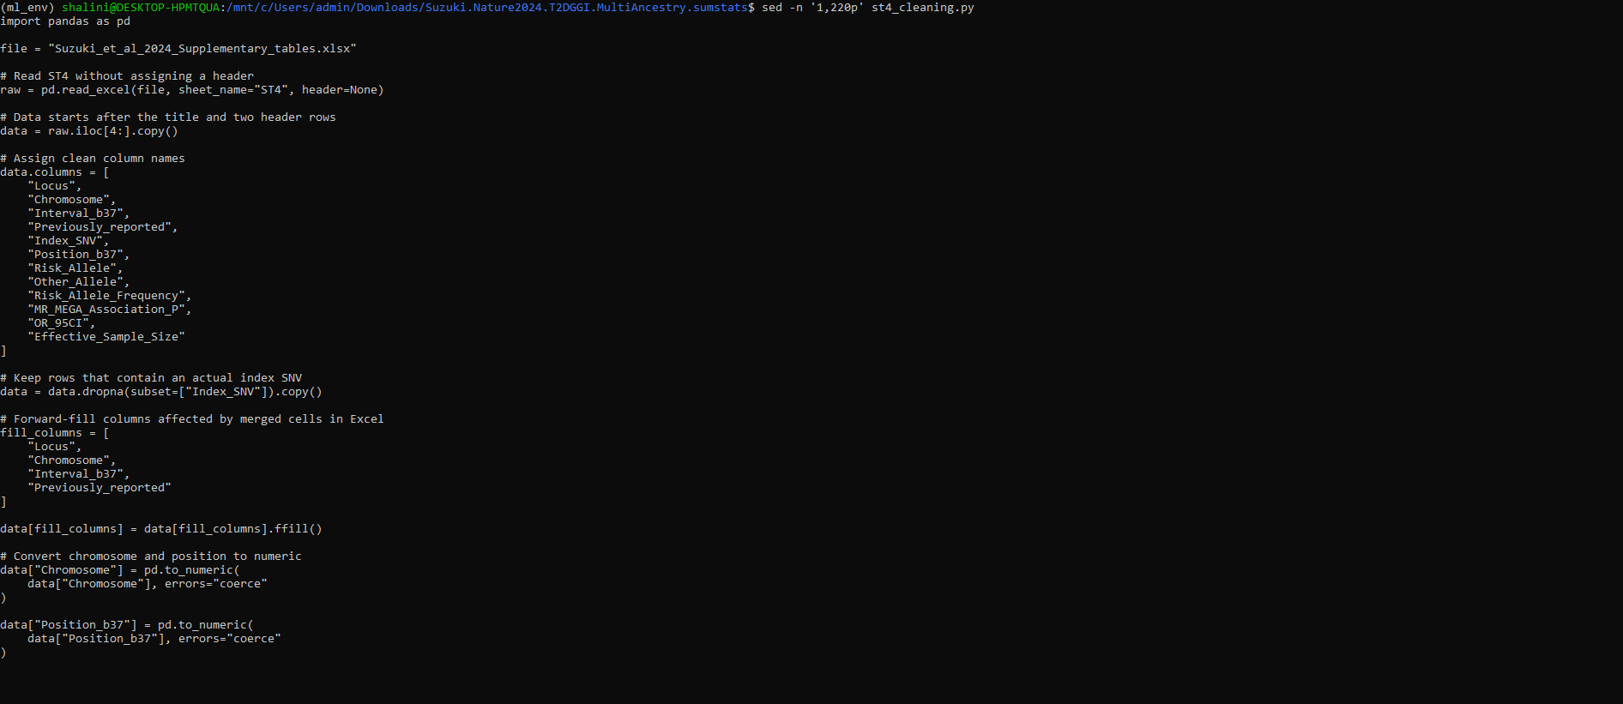
Code 1. Python code used to clean and preprocess the ST4 supplementary GWAS dataset from Suzuki et al. (2024).
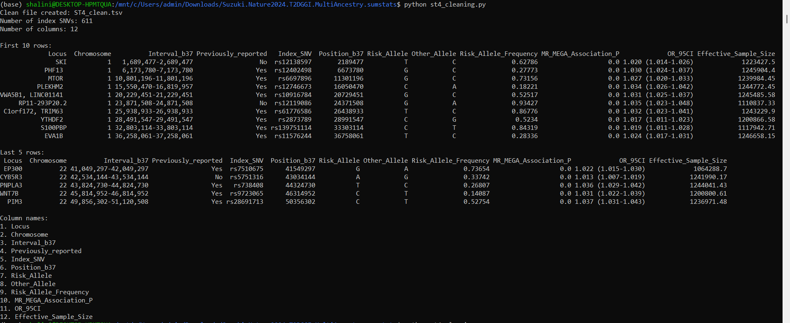
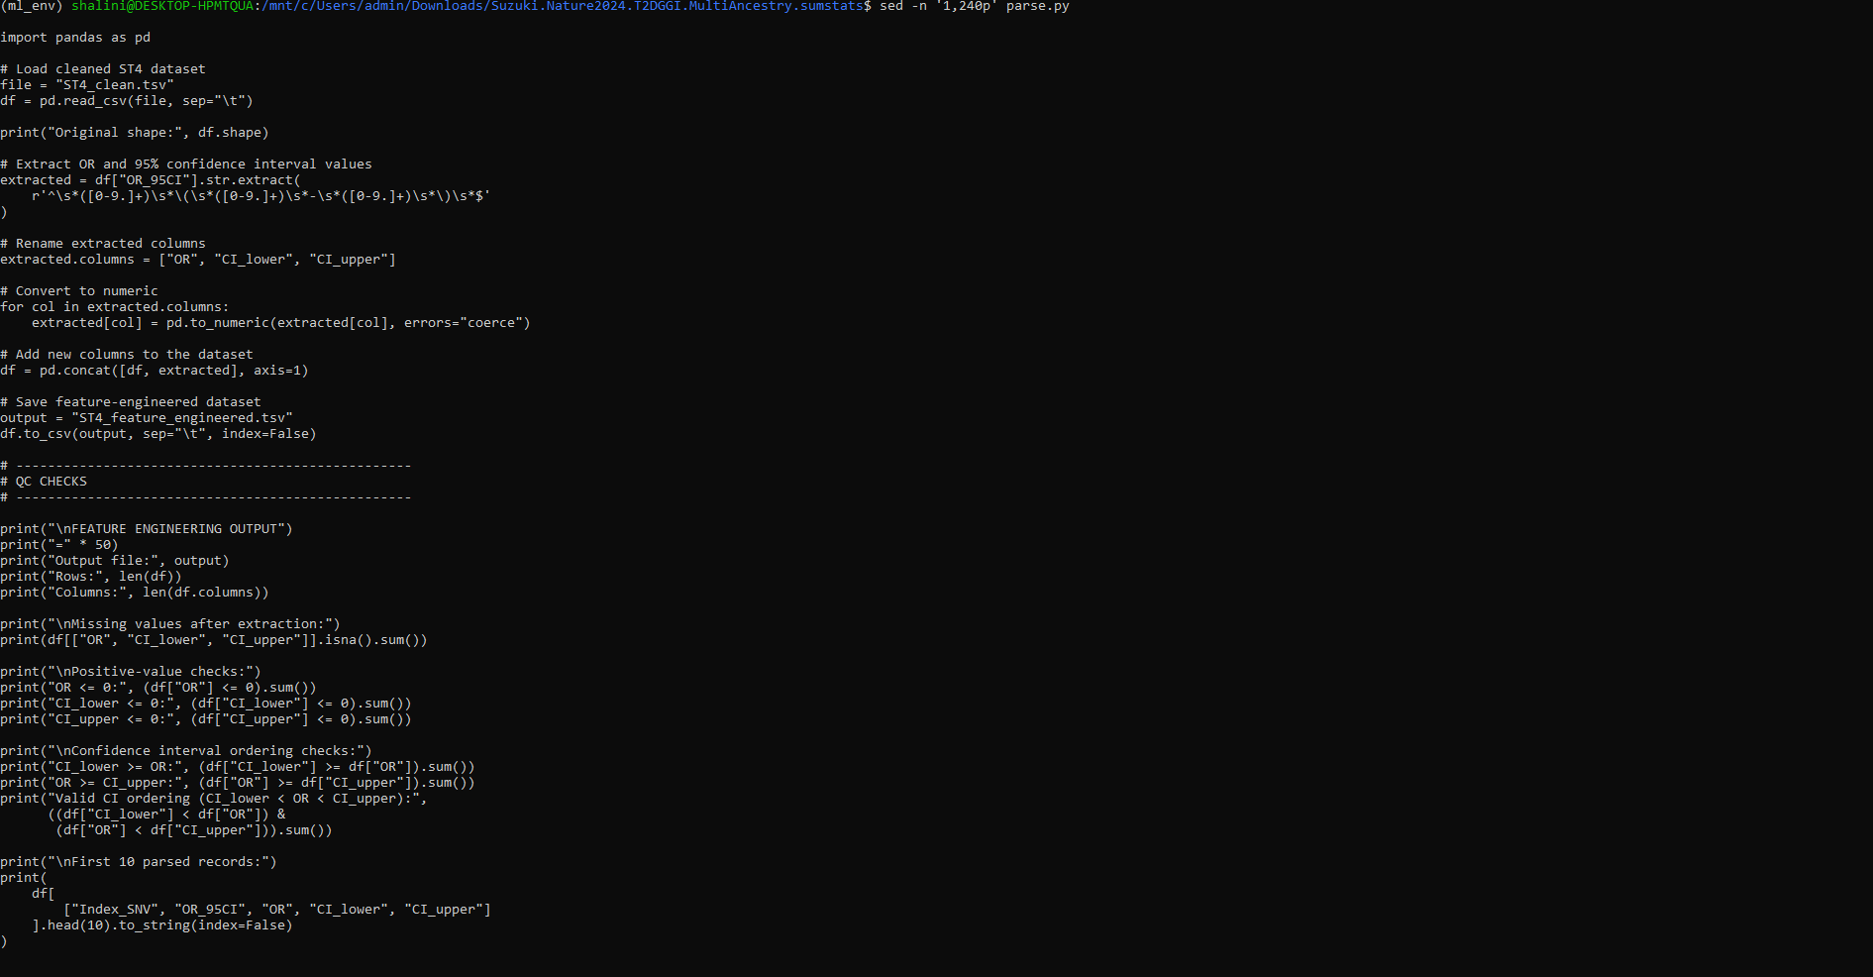
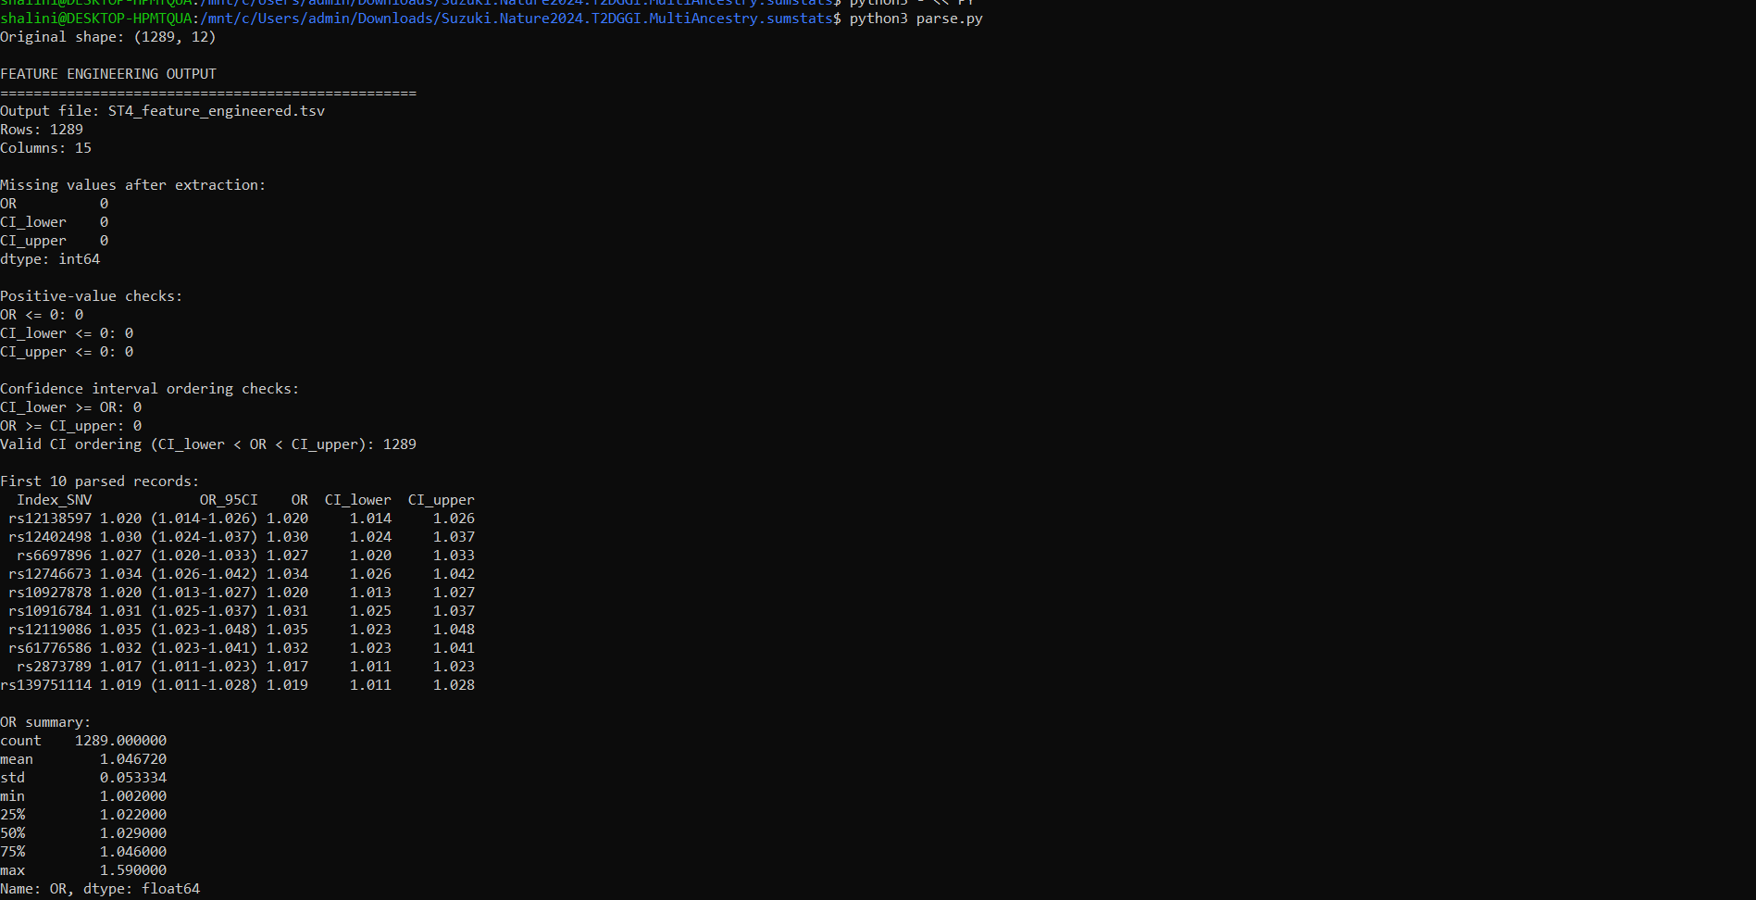
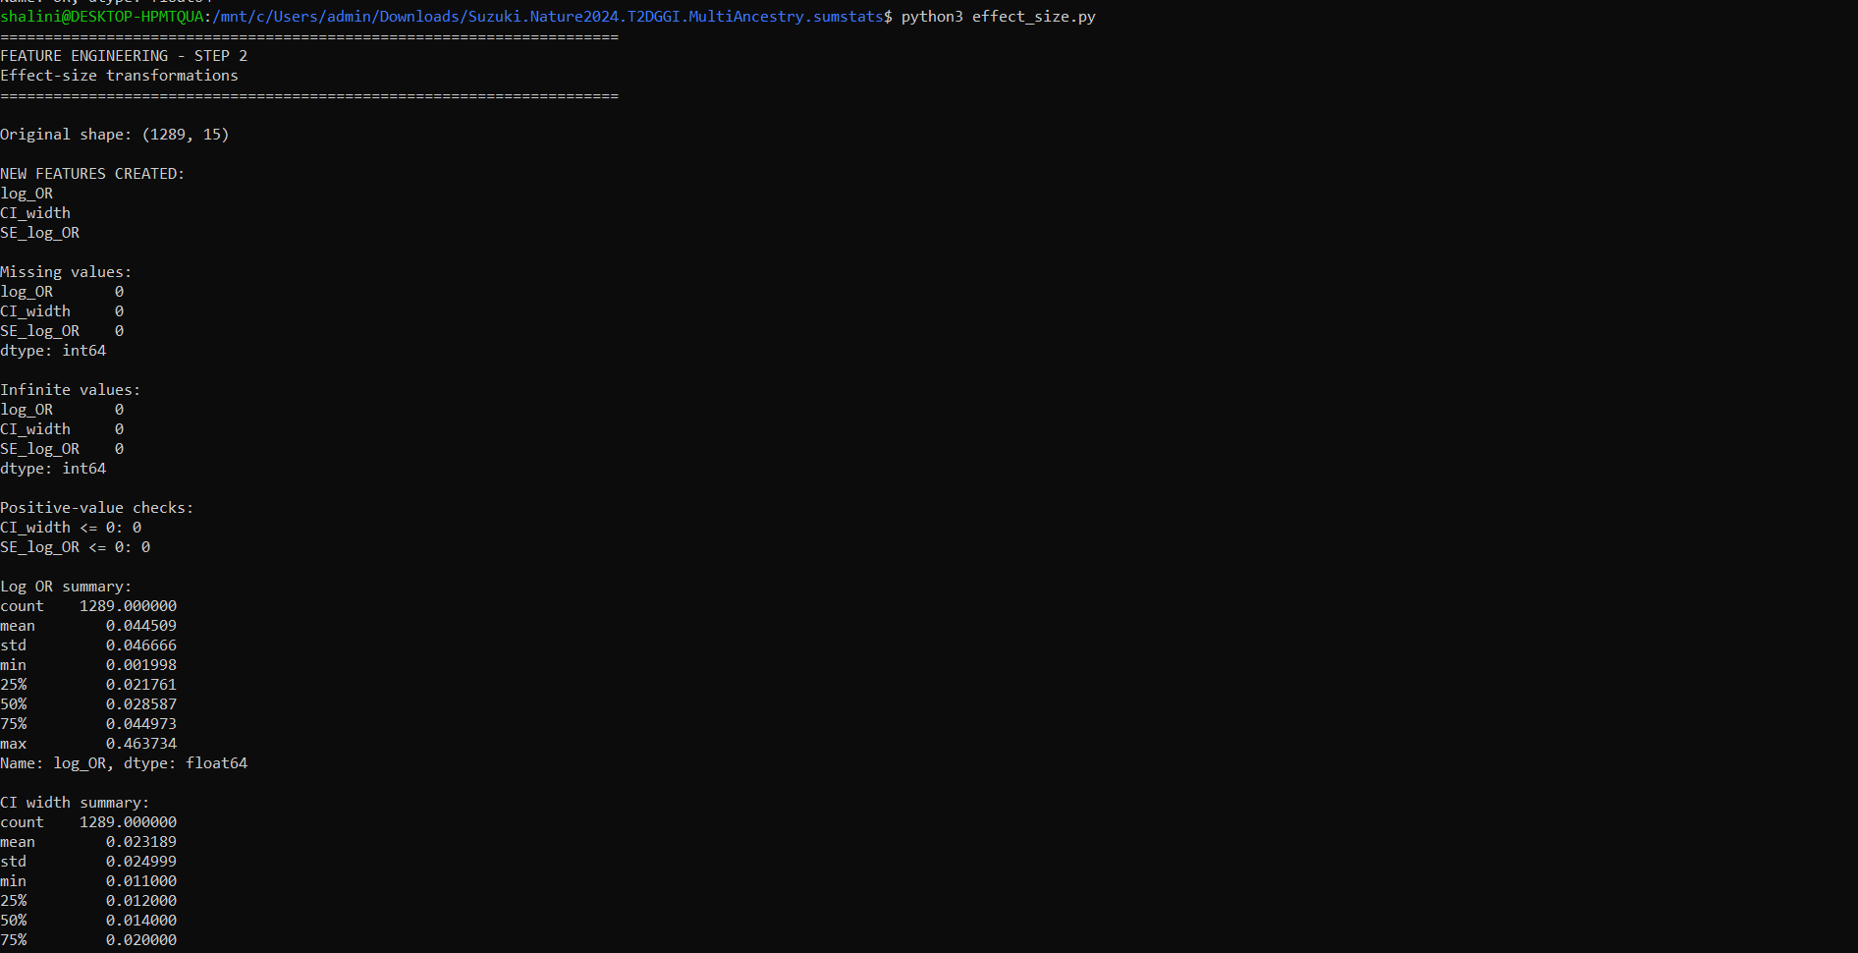
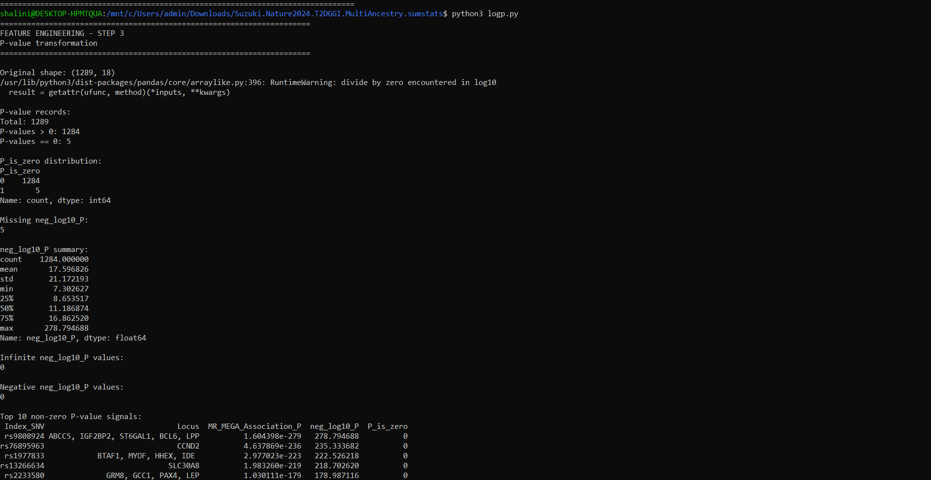
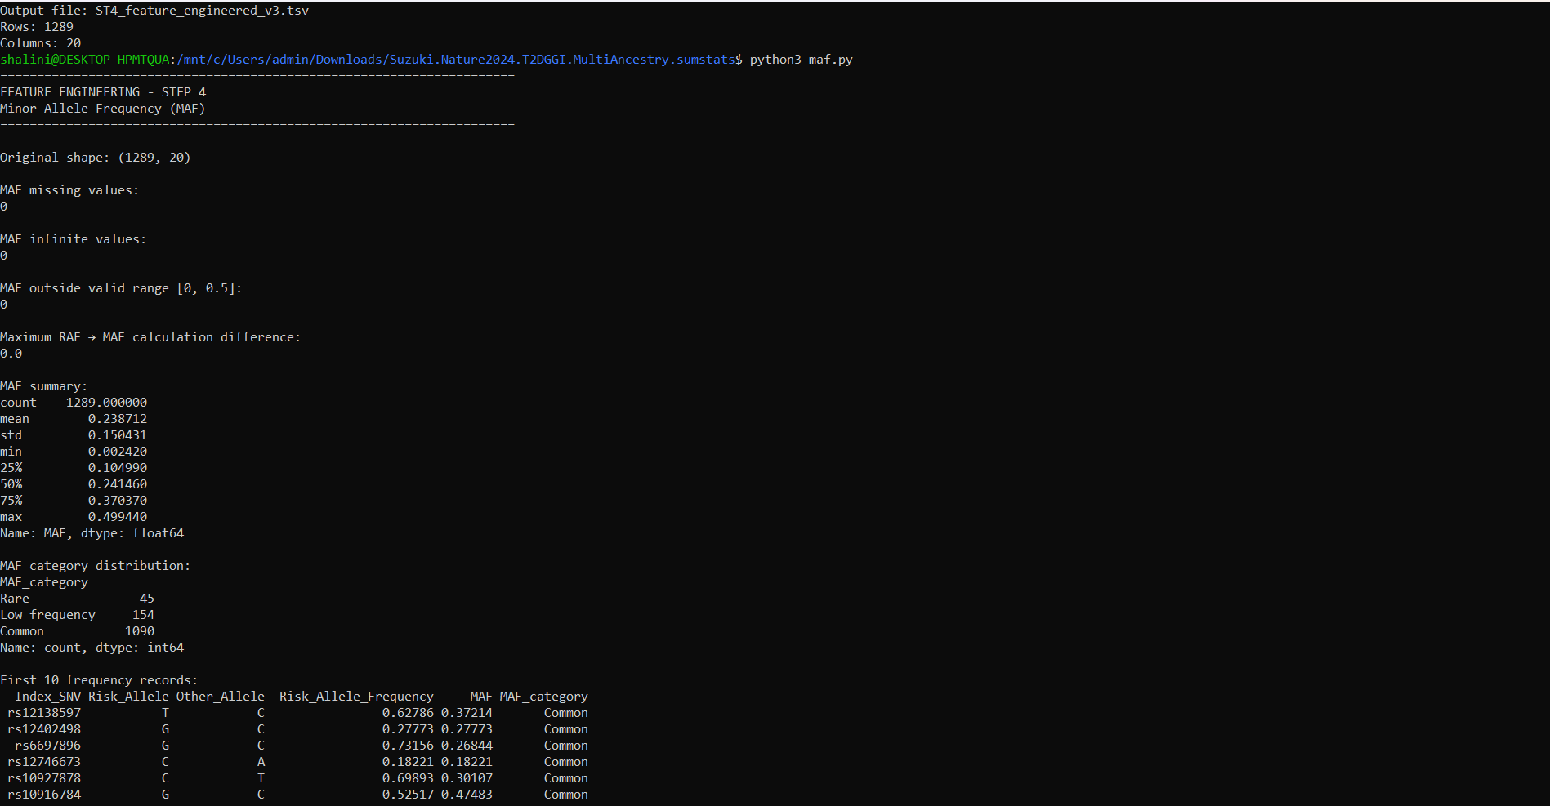
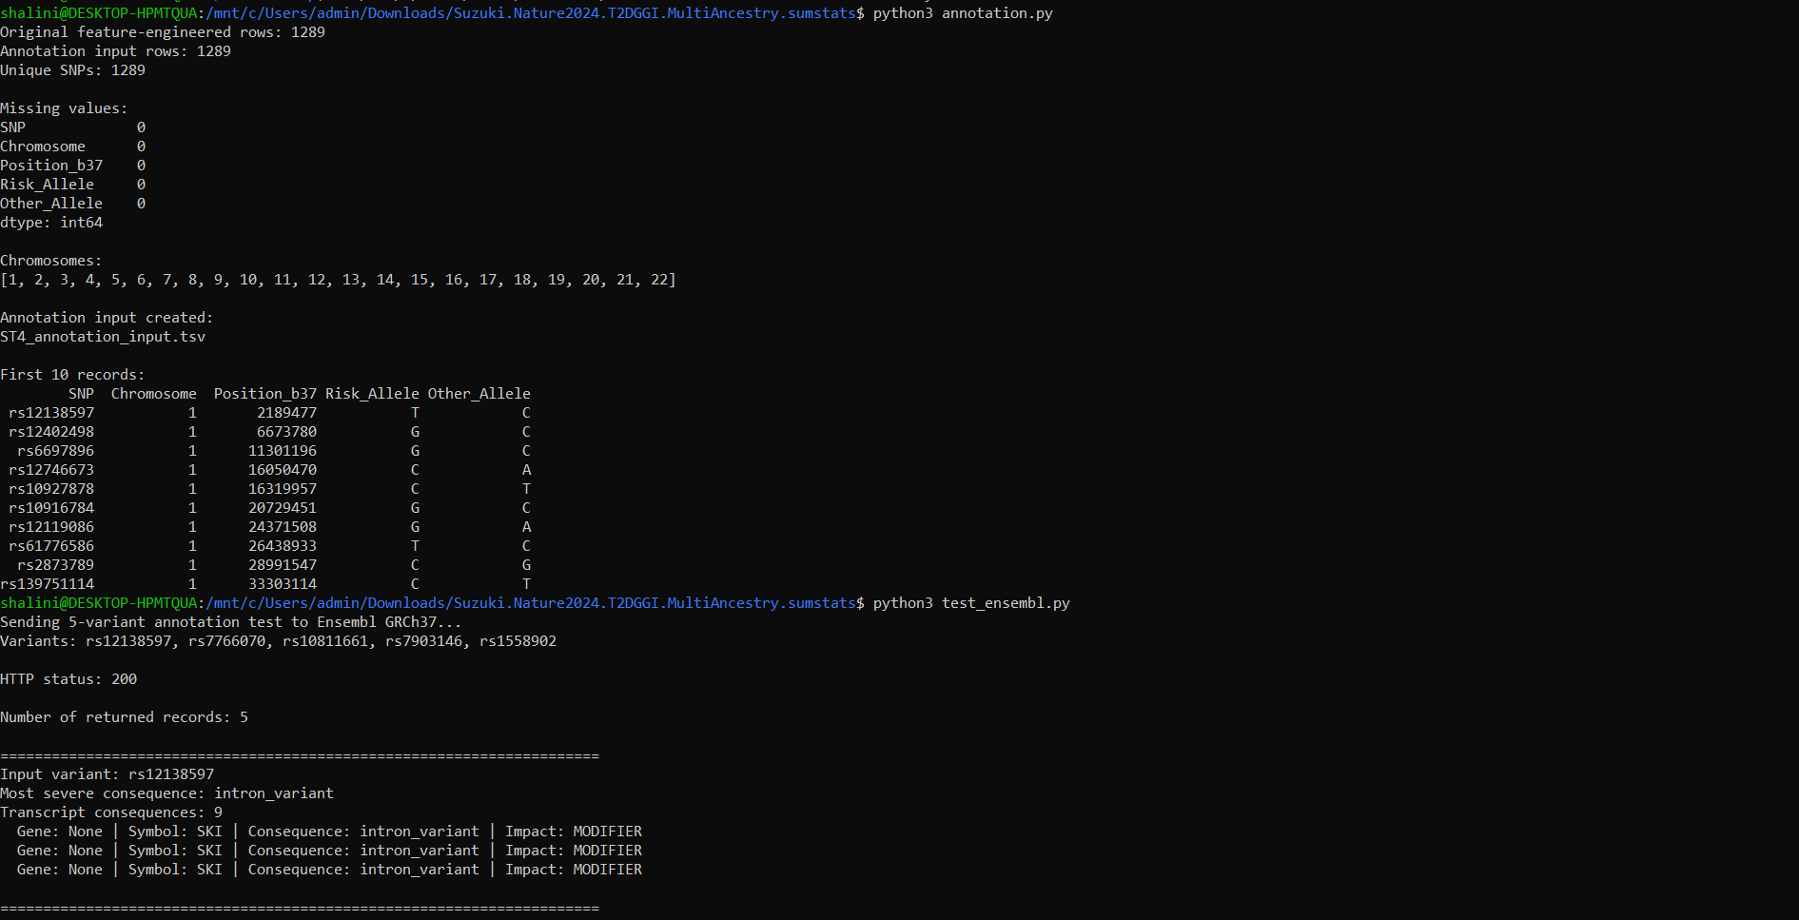
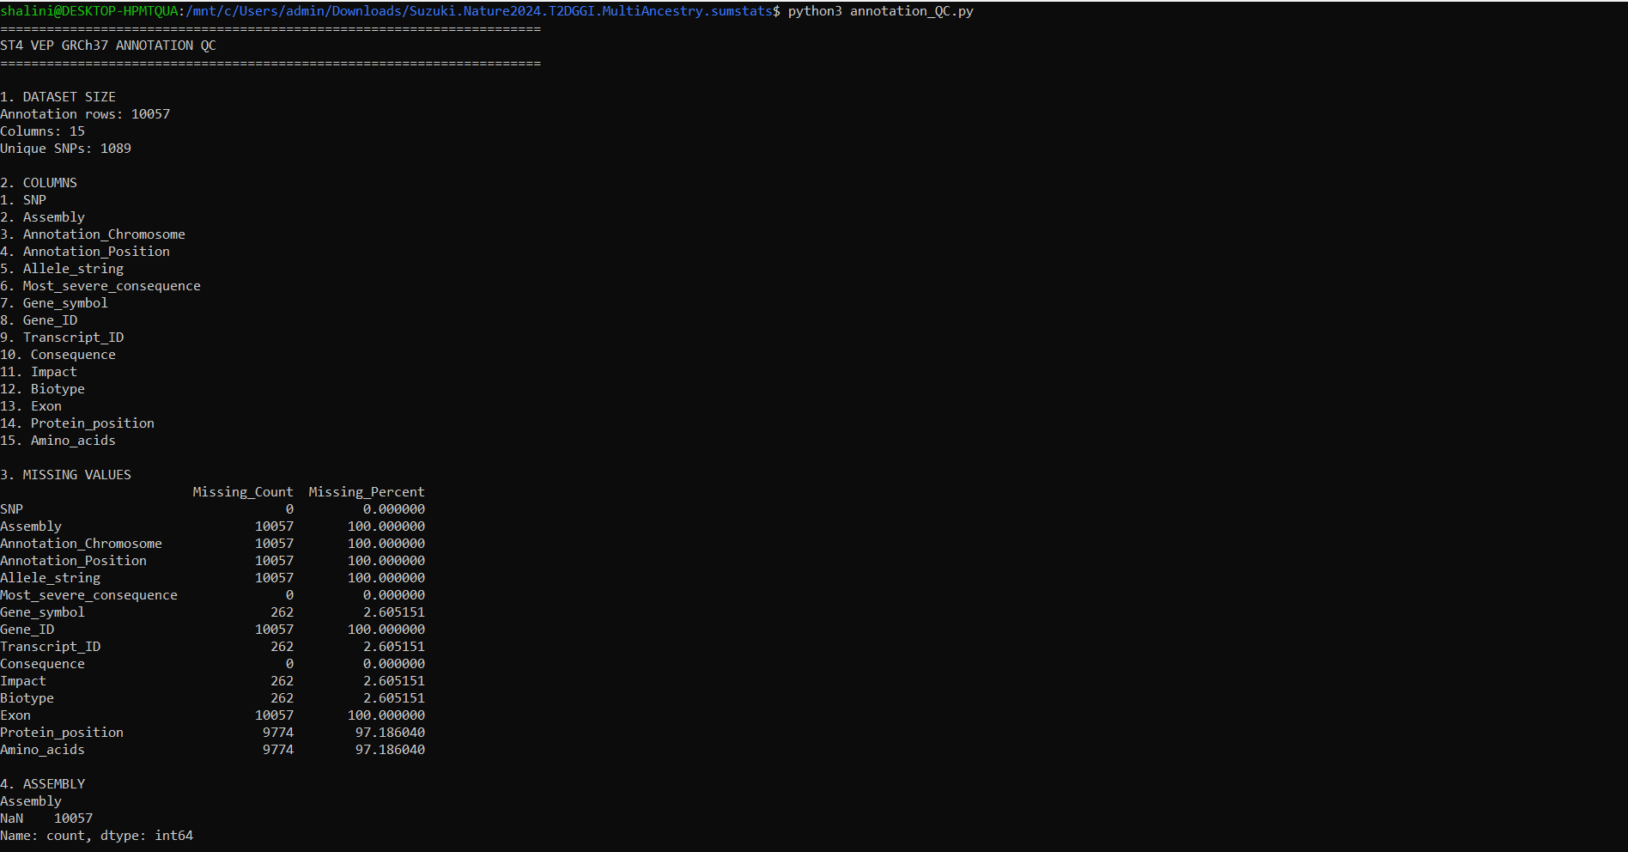
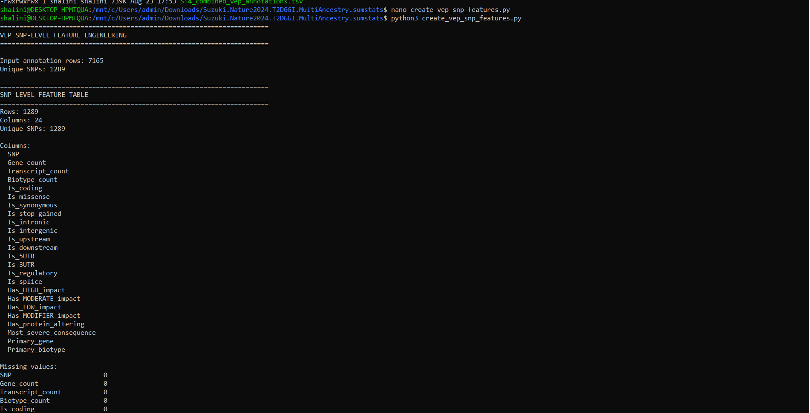
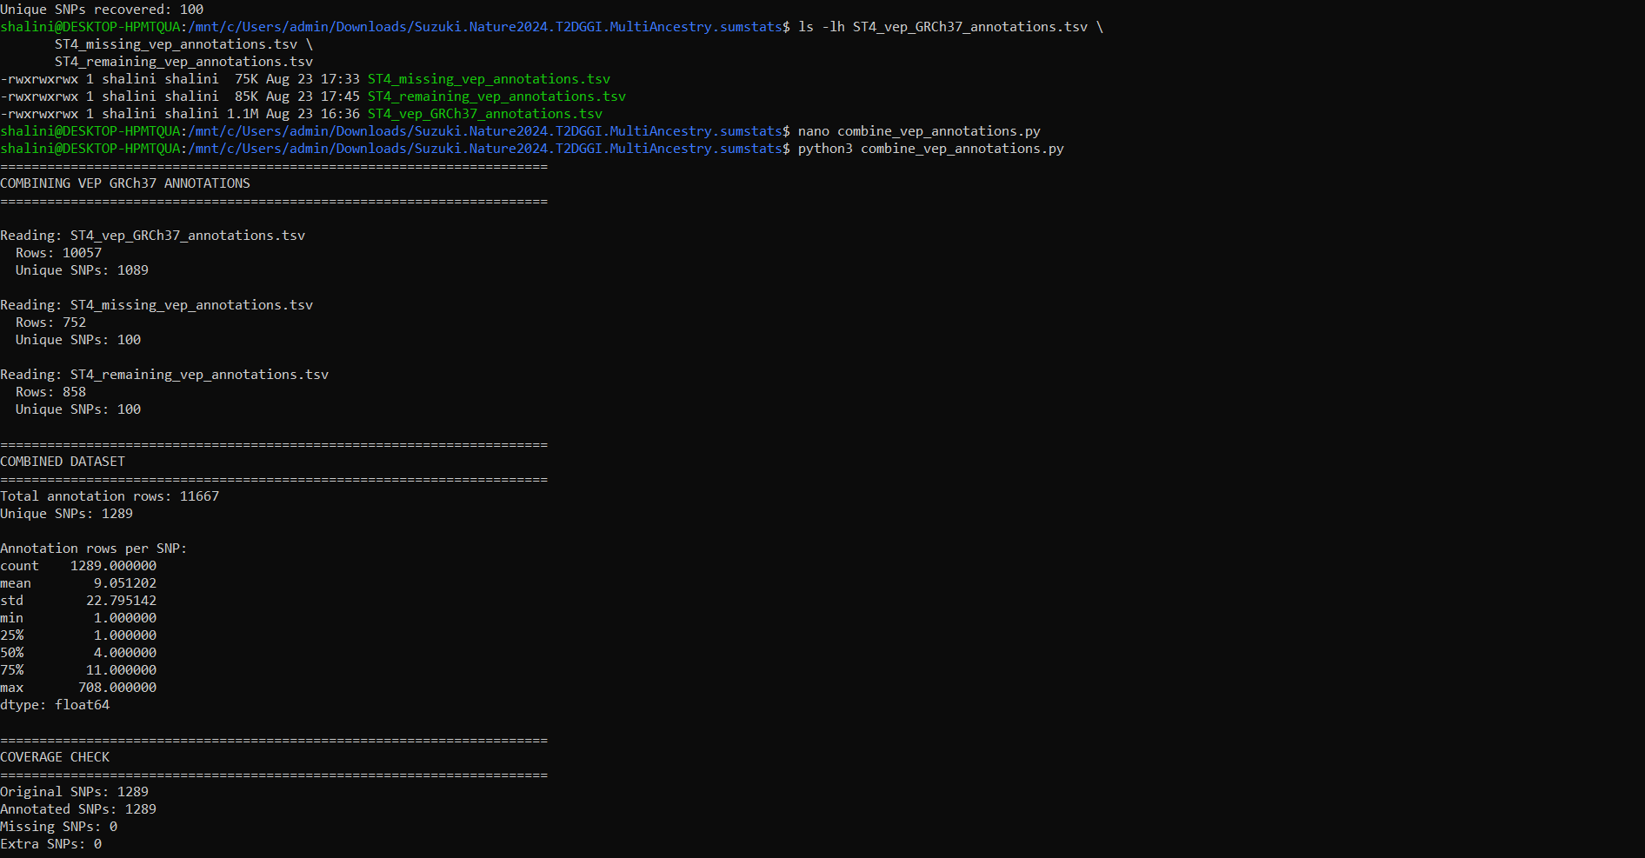
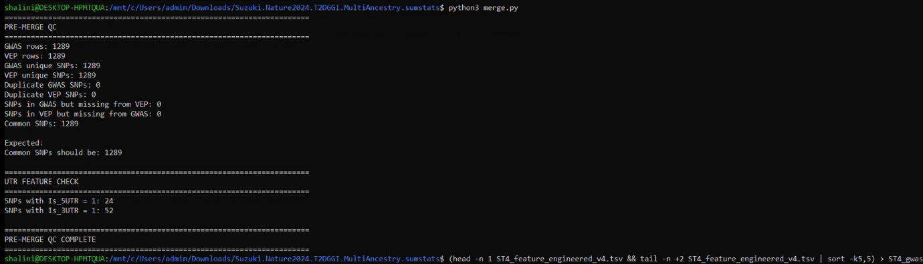
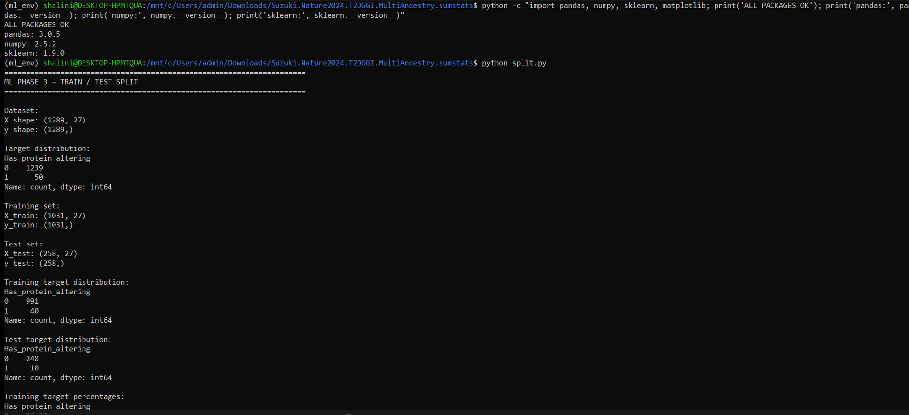
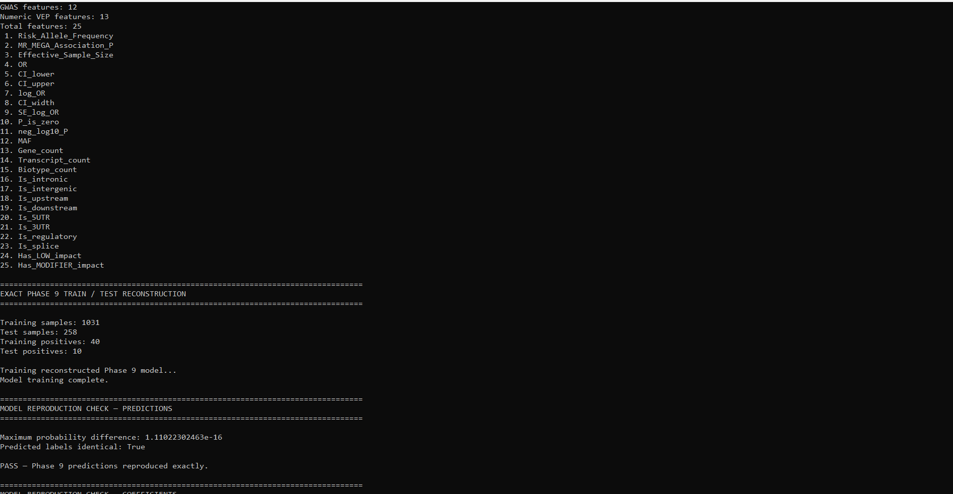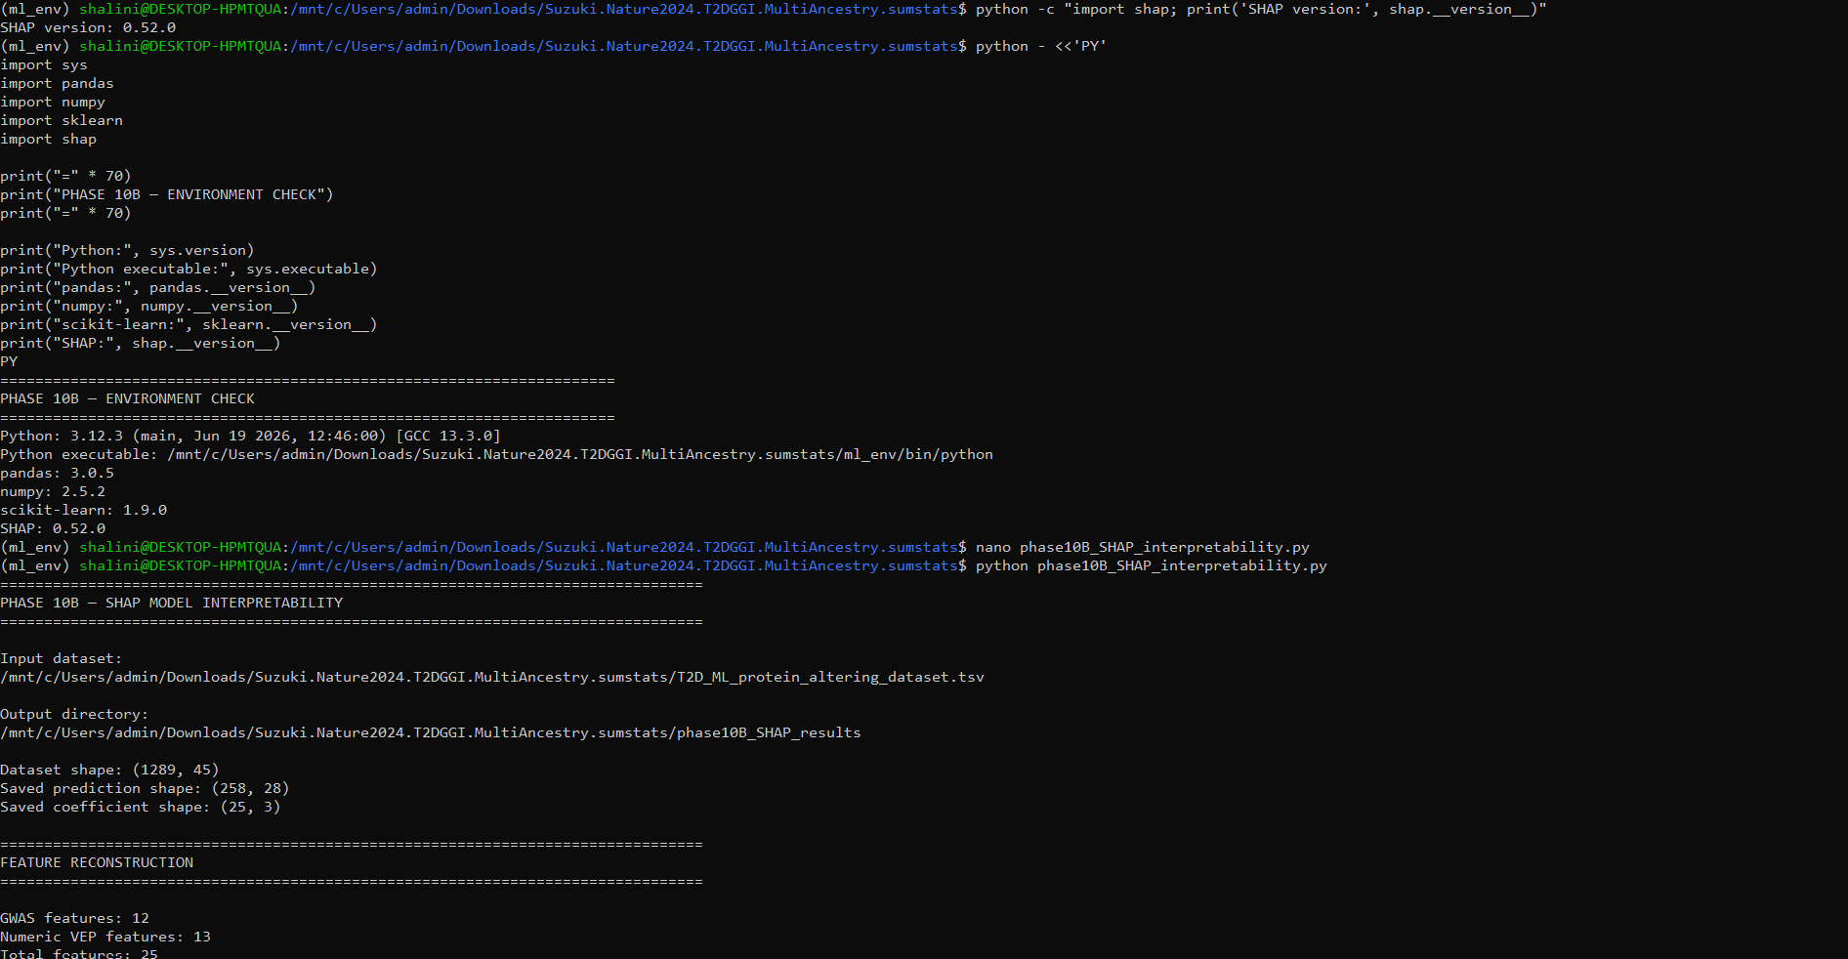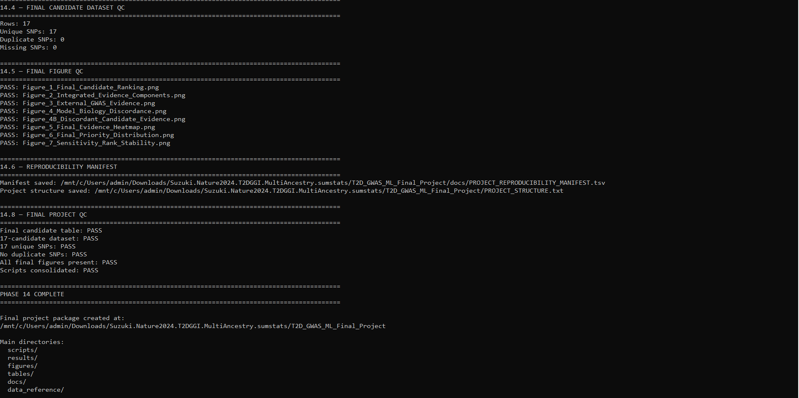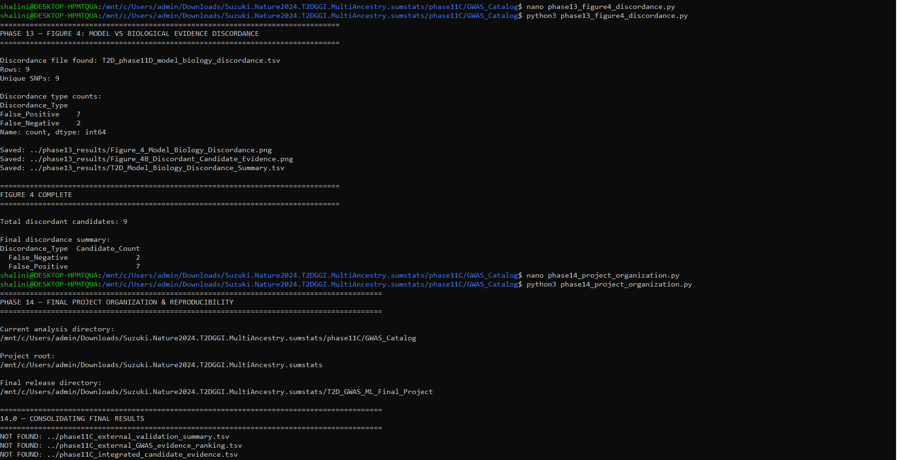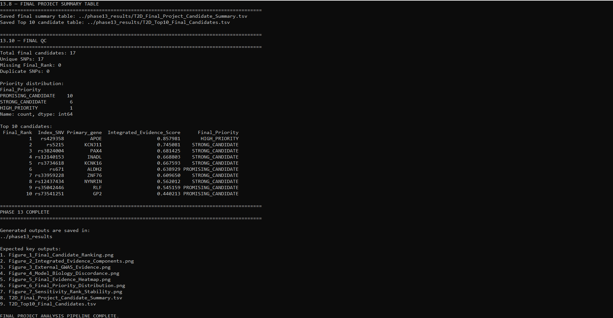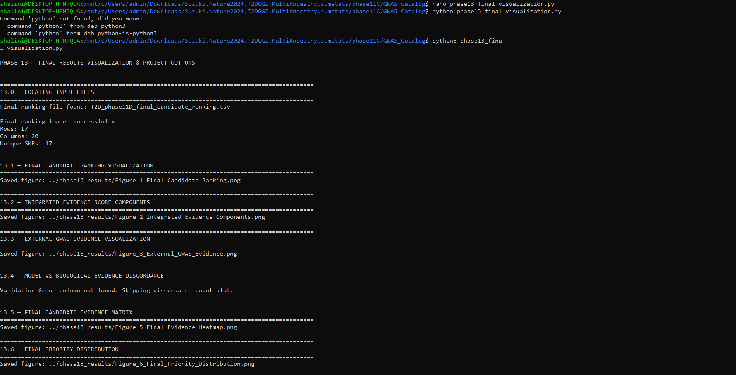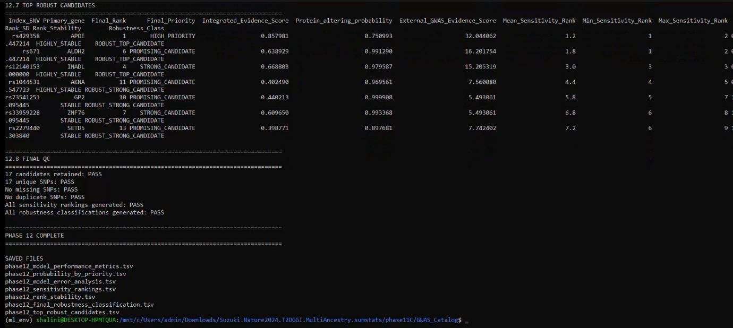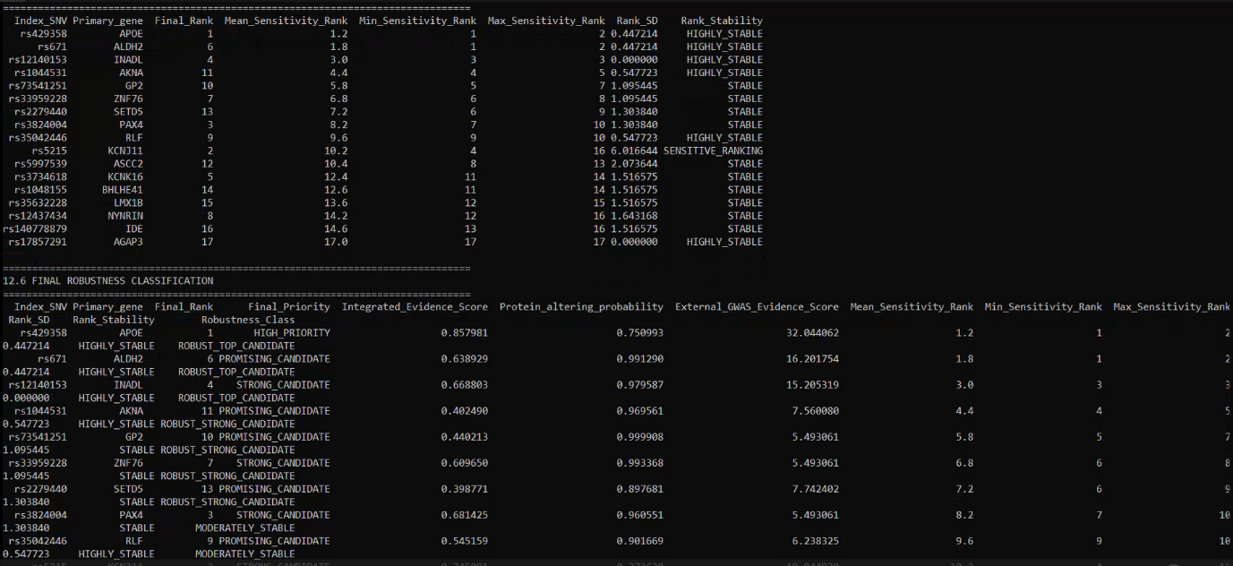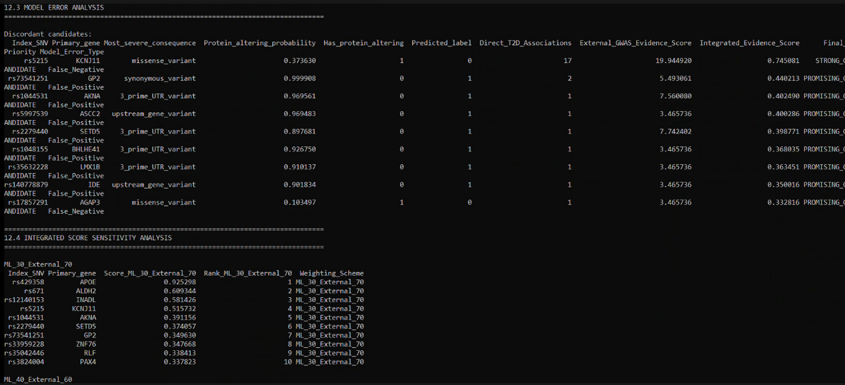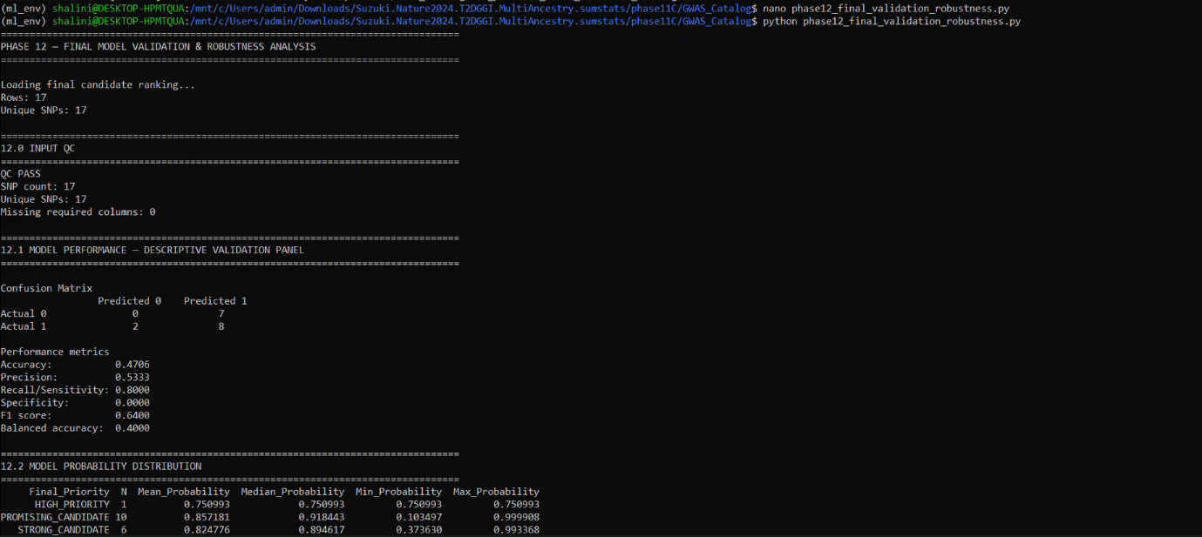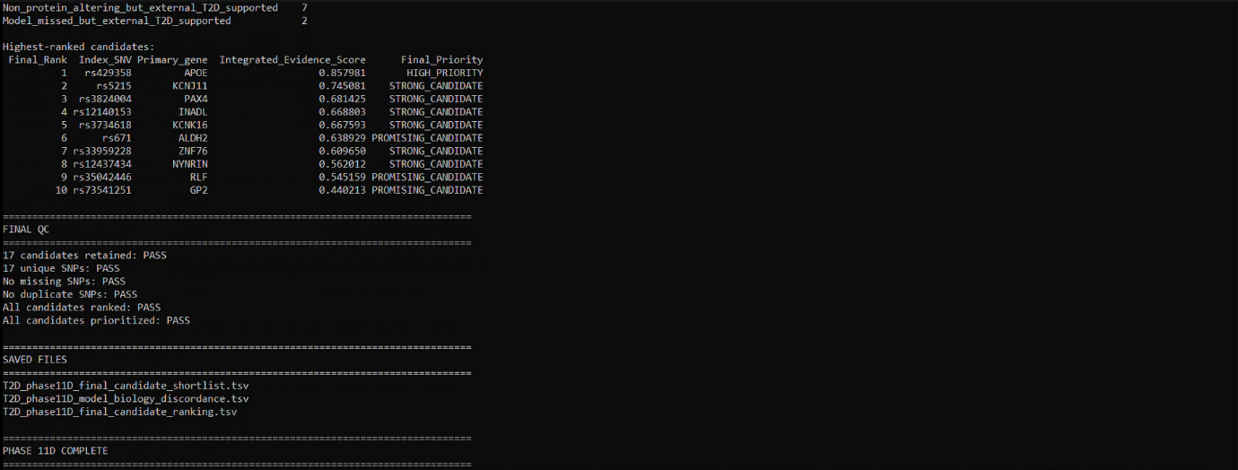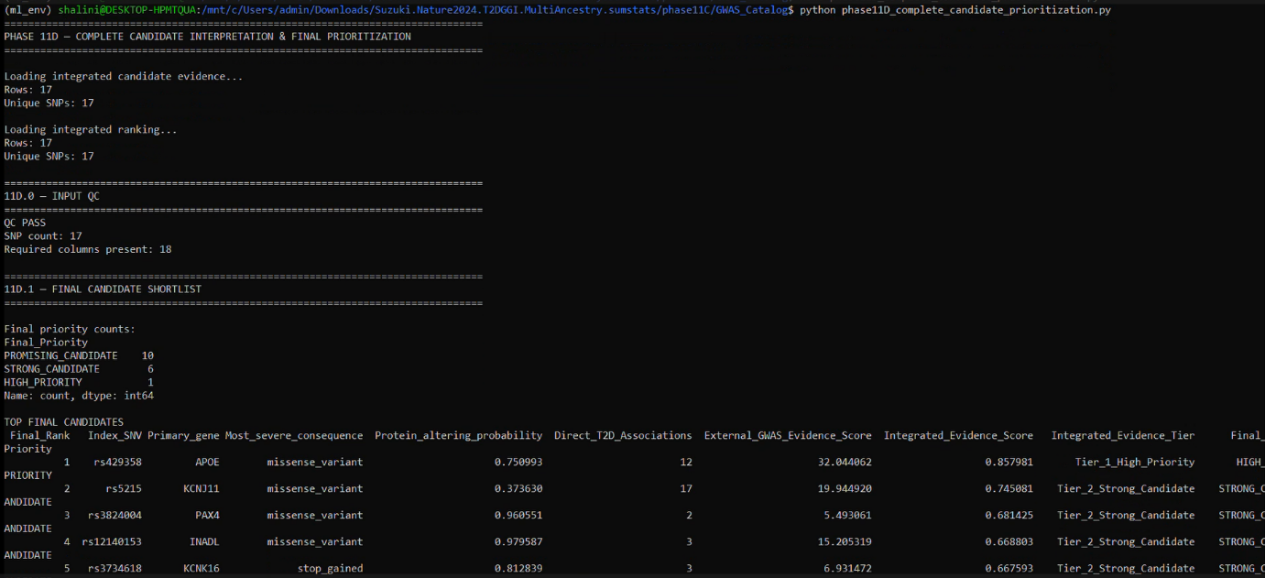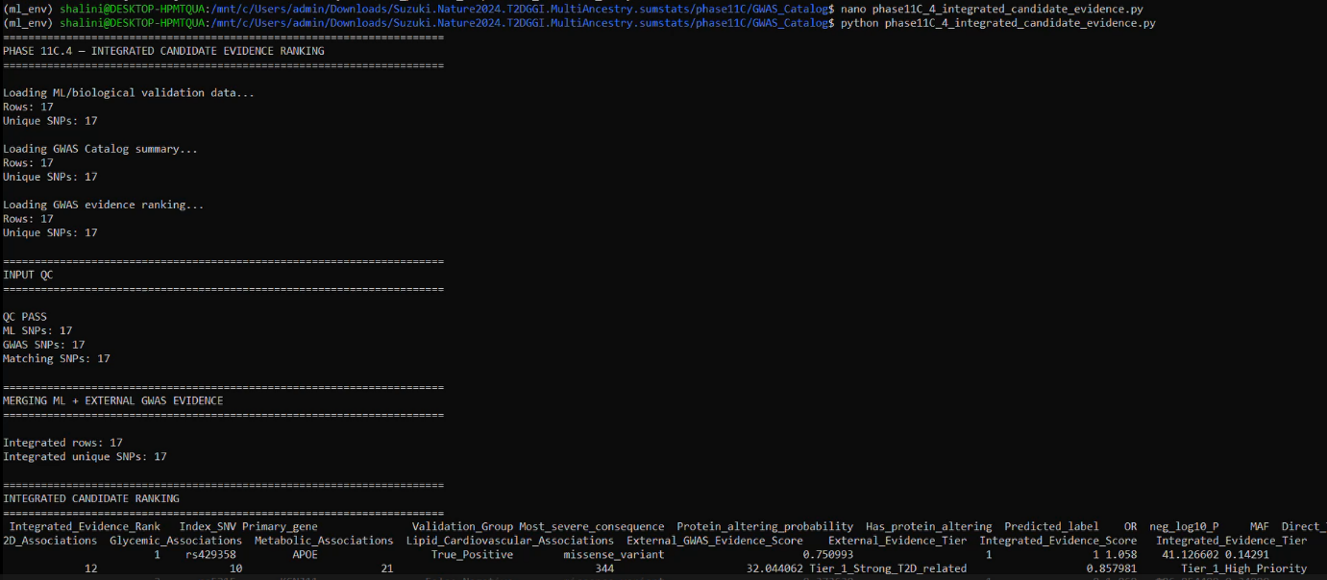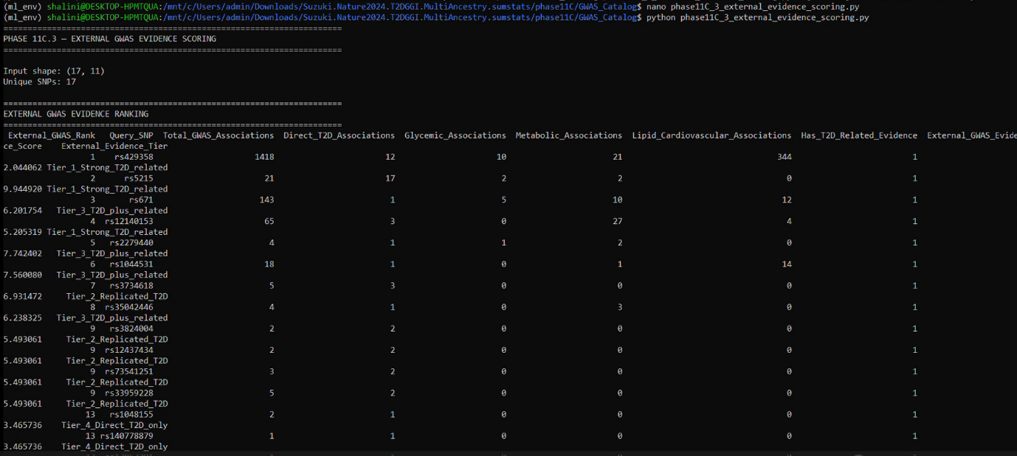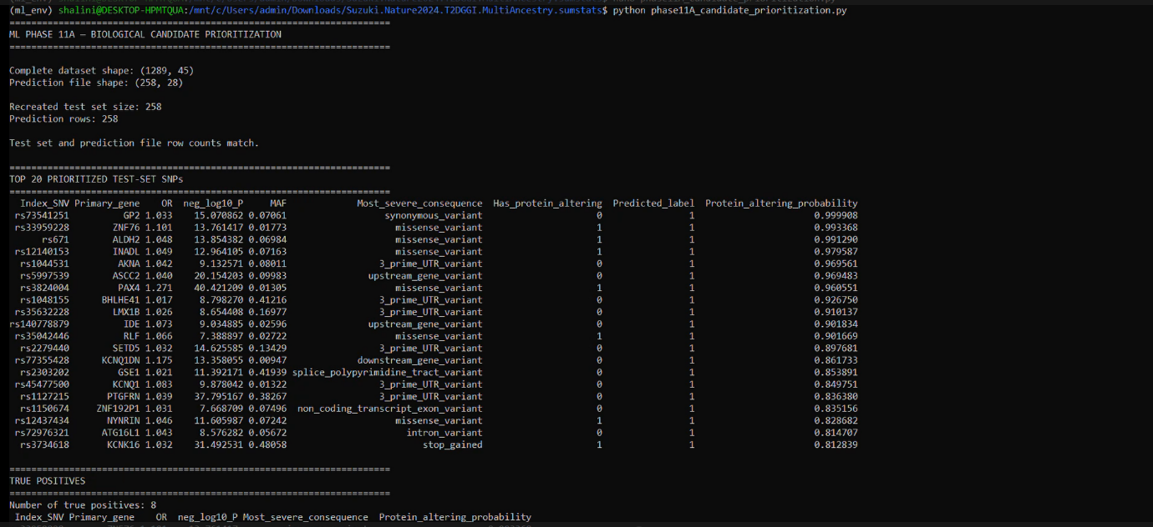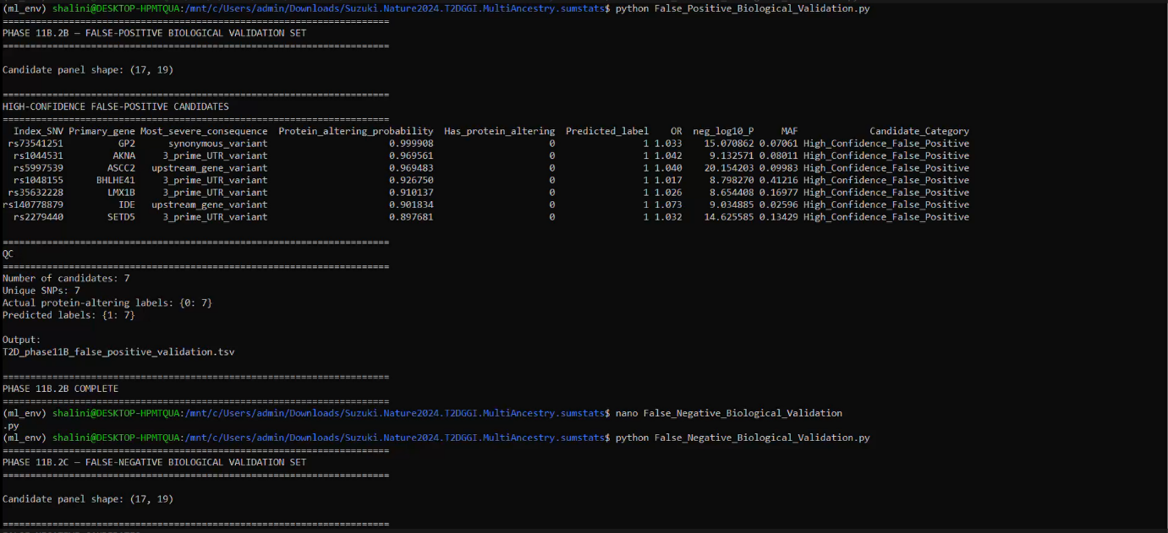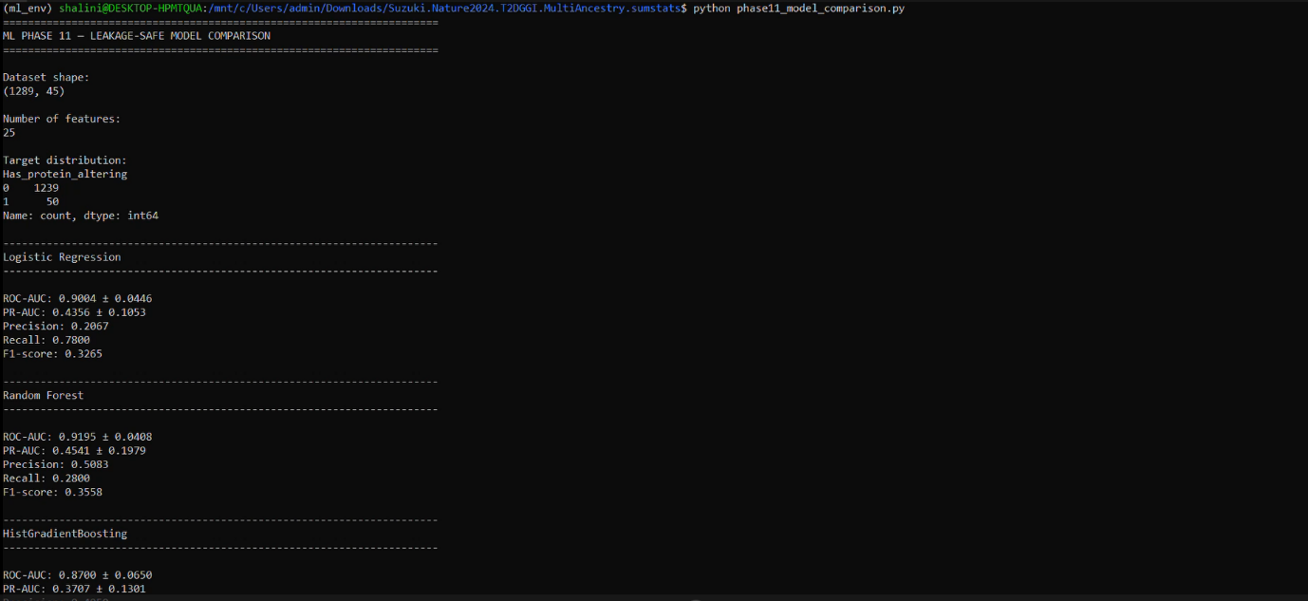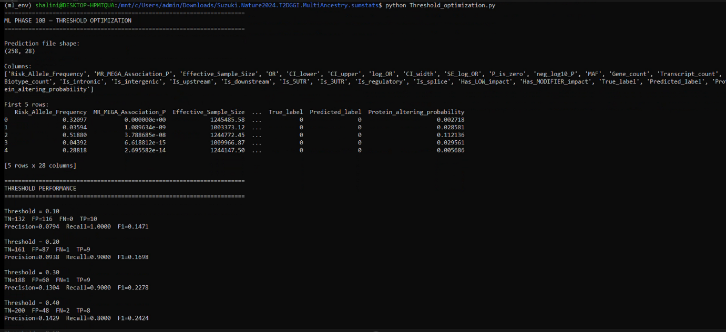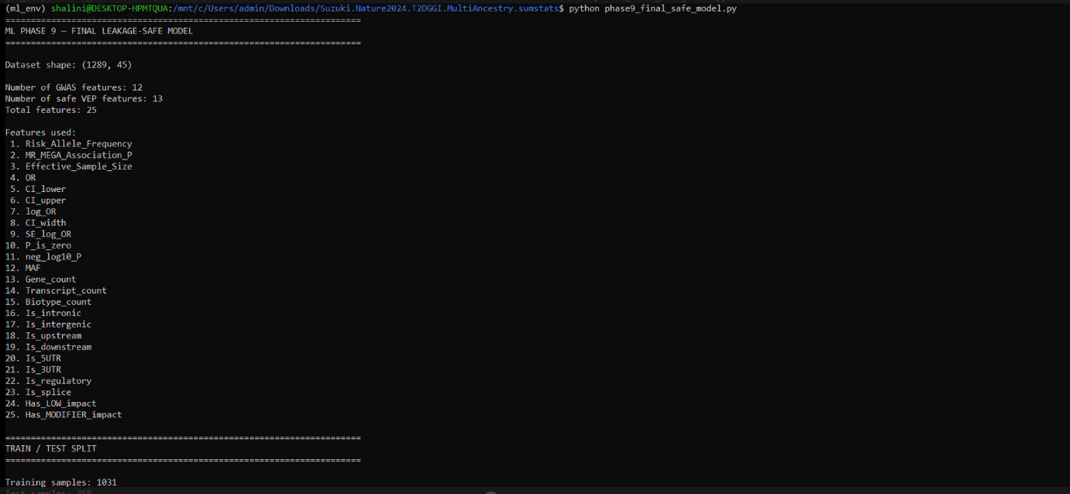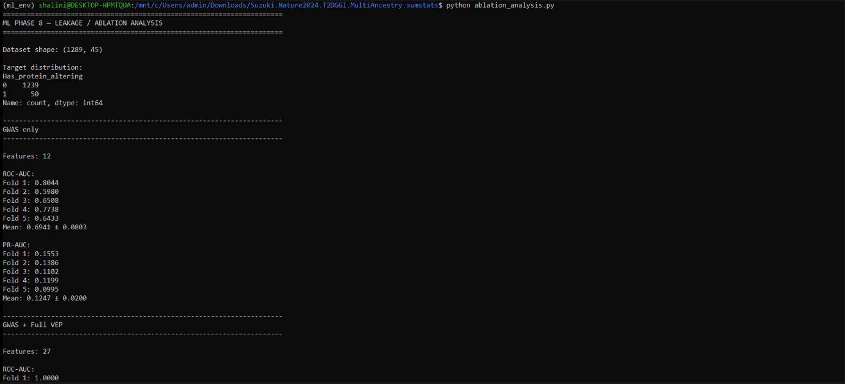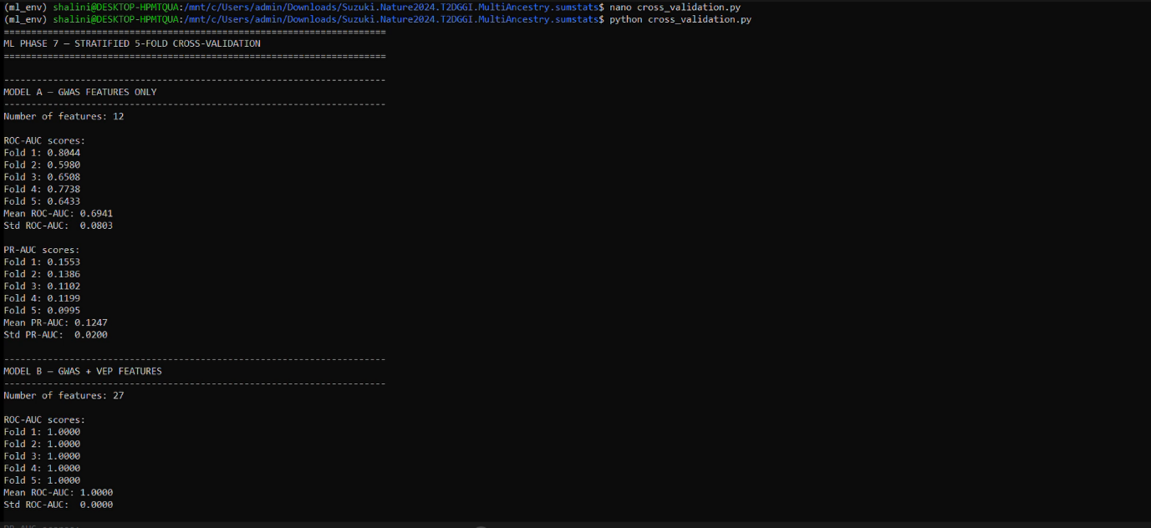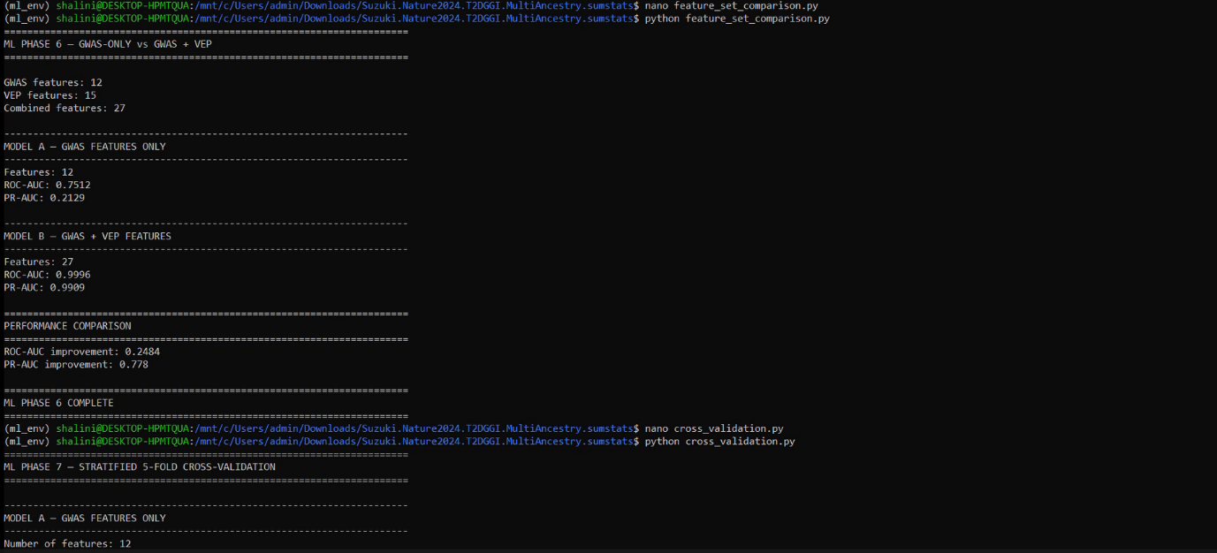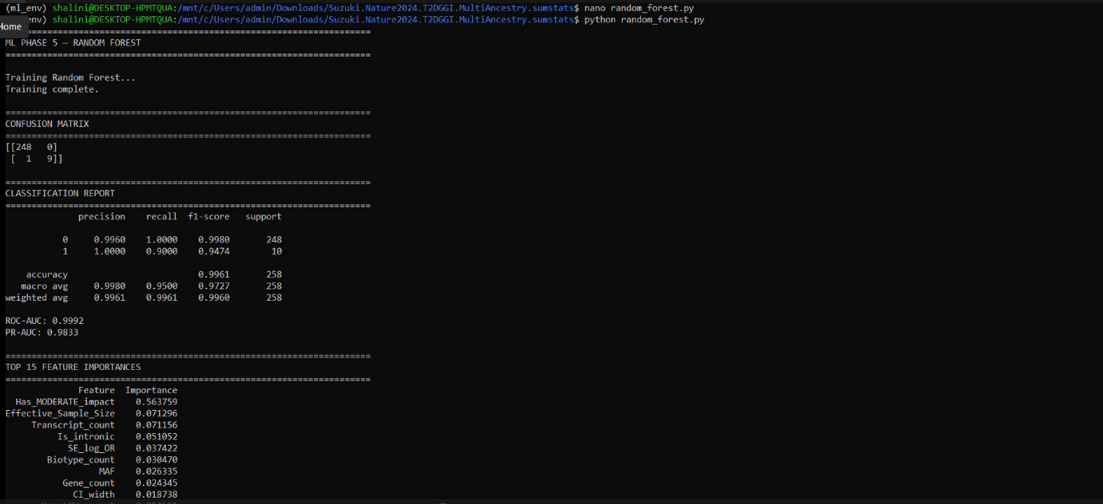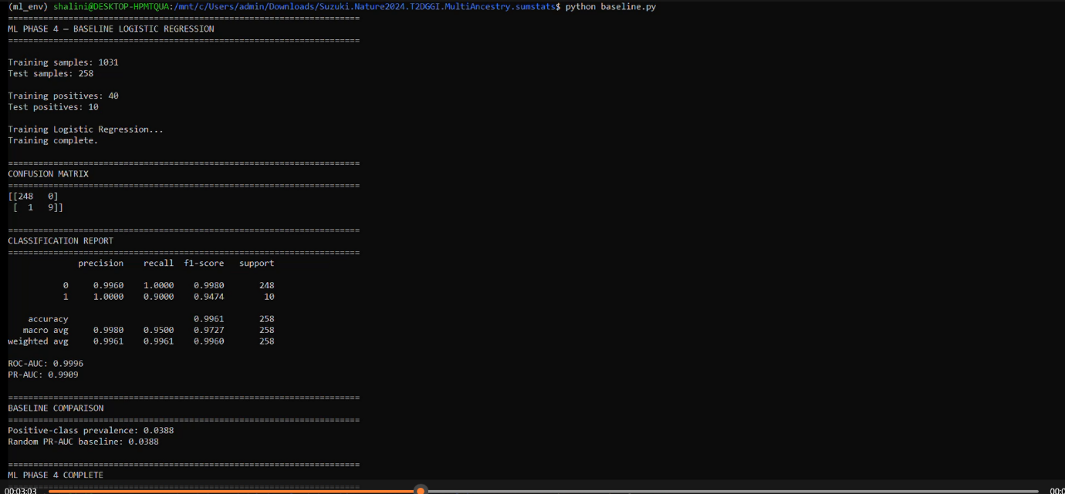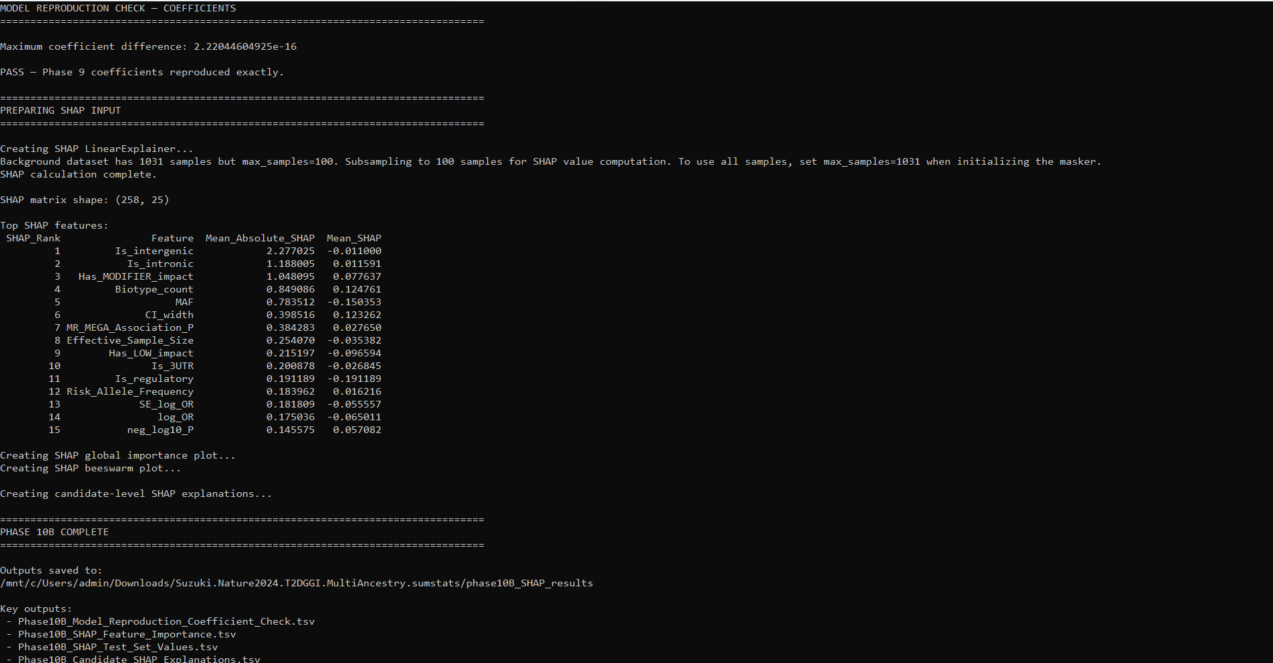
Results
3. Results
3.1 GWAS Dataset Processing and Quality Control
The initial dataset was derived from Supplementary Table ST4 of the multi-ancestry Type 2 diabetes GWAS dataset. Following data cleaning and preprocessing, the final GWAS dataset contained 1,289 index signals representing 611 unique genomic loci.
The cleaned dataset contained 12 original variables, including locus information, chromosomal location, index SNP, alleles, risk allele frequency, association p-value, odds-ratio information, and effective sample size.
Quality-control analysis identified five association p-values recorded as exactly zero. The smallest non-zero p-value was 1.60 × 10⁻²⁷⁹. These values were handled separately during subsequent feature engineering to prevent undefined logarithmic transformations.
[Insert Table: GWAS dataset QC summary]

3.2 Feature Engineering Results
GWAS-derived feature engineering generated additional numerical variables representing association strength, effect size, uncertainty, and allele frequency.
The odds-ratio confidence interval was parsed into separate numerical variables for the odds ratio, lower confidence interval, and upper confidence interval. Additional variables, including log-transformed odds ratio, confidence interval width, and estimated standard error of the log odds ratio, were subsequently generated.
Association p-values were transformed using the negative base-10 logarithm. Minor allele frequencies were also calculated and categorized.
Among the 1,289 variants:
- 45 were classified as rare variants.
- 154 were classified as low-frequency variants.
- 1,090 were classified as common variants.
The engineered GWAS dataset provided the population and statistical feature set used in the subsequent machine-learning analysis.
[Insert Table: Summary of engineered GWAS features]

3.3 Functional Annotation Results
Functional annotation of the 1,289 GWAS index SNPs generated 7,165 transcript-level annotation records. These annotations were subsequently aggregated to create a SNP-level functional dataset containing 1,289 variants.
The SNP-level functional annotations identified multiple genomic and functional consequence categories. The dataset included:
- 55 coding variants.
- 49 missense variants.
- 11 synonymous variants.
- 3 stop-gained variants.
- 50 protein-altering variants.
- 780 intronic variants.
- 269 intergenic variants.
- 24 variants with 5′ UTR annotations.
- 52 variants with 3′ UTR annotations.
- 29 regulatory variants.
- 6 splice-related variants.
The final SNP-level annotation dataset contained 24 functional and biological annotation variables and contained no missing values.
[Insert Table: Functional annotation summary]

3.4 Integration of GWAS and Functional Data
The engineered GWAS dataset and SNP-level functional annotation dataset were successfully merged using SNP identifiers.
Pre-merge quality-control analysis demonstrated complete correspondence between the datasets. Both datasets contained 1,289 unique SNPs, with no duplicate identifiers and no missing SNPs between the two datasets.
The resulting integrated machine-learning dataset contained 1,289 variants and 45 variables.
The final dataset contained GWAS-derived variables, engineered statistical features, functional genomic annotations, genomic consequence indicators, and biological descriptors.
[Insert Table: Final machine-learning dataset characteristics]

3.5 Initial Machine-Learning Analysis and Leakage Investigation
Initial machine-learning experiments were conducted using baseline and tree-based classification approaches. Feature-set comparison demonstrated substantial differences between models trained using GWAS-derived features alone and models incorporating the full functional annotation feature set.
The exceptionally high performance observed when using the complete functional feature set prompted a target-leakage investigation.
The analysis showed that some functional variables were closely related to the definition of the target variable, Has_protein_altering. These variables could therefore provide direct information about the target and artificially inflate predictive performance.
Following the leakage investigation, direct target-defining variables were excluded from the final predictive feature set.

3.6 Final Leakage-Safe Machine-Learning Model
A leakage-safe Logistic Regression model was developed using 25 predictor variables comprising 12 GWAS-derived features and 13 numerical functional annotation features.
The dataset was divided using a stratified 80:20 train-test split.
The resulting datasets contained:
- Training dataset: 1,031 variants.
- Test dataset: 258 variants.
- Positive training samples: 40.
- Positive test samples: 10.
The final model incorporated median imputation, feature standardization, and class-weighted Logistic Regression.
On the independent test dataset, the final leakage-safe model achieved:
- ROC-AUC: 0.9121.
- PR-AUC: 0.4192.
- Accuracy: 0.8488.
- Recall for protein-altering variants: 0.80.
These results demonstrated that the model retained discriminatory ability after the removal of features considered to introduce direct target leakage.
[Insert Table: Final model performance metrics]

3.7 SHAP Model Reproduction and Explainability Analysis
The Phase 9 leakage-safe Logistic Regression model was reconstructed before SHAP analysis to ensure that the explainability results corresponded exactly to the original final model.
The reconstructed model reproduced the original predictions with a maximum probability difference of approximately 1.11 × 10⁻¹⁶. The predicted class labels were identical between the original and reconstructed models.
Model coefficients were also reproduced, with a maximum coefficient difference of approximately 2.22 × 10⁻¹⁶.
Both reproduction checks passed, confirming that SHAP interpretation was performed on an exact reconstruction of the final leakage-safe model.
SHAP analysis was subsequently performed on the 258-variant independent test dataset using the 25-feature model.
The highest-ranking features based on mean absolute SHAP values were:
- Is_intergenic — 2.2770.
- Is_intronic — 1.1880.
- Has_MODIFIER_impact — 1.0481.
- Biotype_count — 0.8491.
- MAF — 0.7835.
- CI_width — 0.3985.
- MR_MEGA_Association_P — 0.3843.
- Effective_Sample_Size — 0.2541.
- Has_LOW_impact — 0.2152.
- Is_3UTR — 0.2009.
SHAP analysis generated global feature-importance and beeswarm visualizations, as well as candidate-level feature explanations.
Figure 1. Global SHAP feature importance for the final leakage-safe machine-learning model. To improve model interpretability, SHAP analysis was performed on the final leakage-safe model. Before calculating SHAP values, the Phase 9 model was reconstructed and validated against the original model outputs. The maximum probability difference between the reconstructed and original predictions was 1.11×10−16, and the predicted labels were identical. The maximum coefficient difference was 2.22×10−16, confirming exact numerical reproduction of the original model.
Global SHAP analysis identified Is_intergenic as the most influential feature, followed by Is_intronic, Has_MODIFIER_impact, Biotype_count, and MAF. These results indicate that genomic context and functional annotation-related characteristics contributed substantially to the model's prediction of protein-altering status.
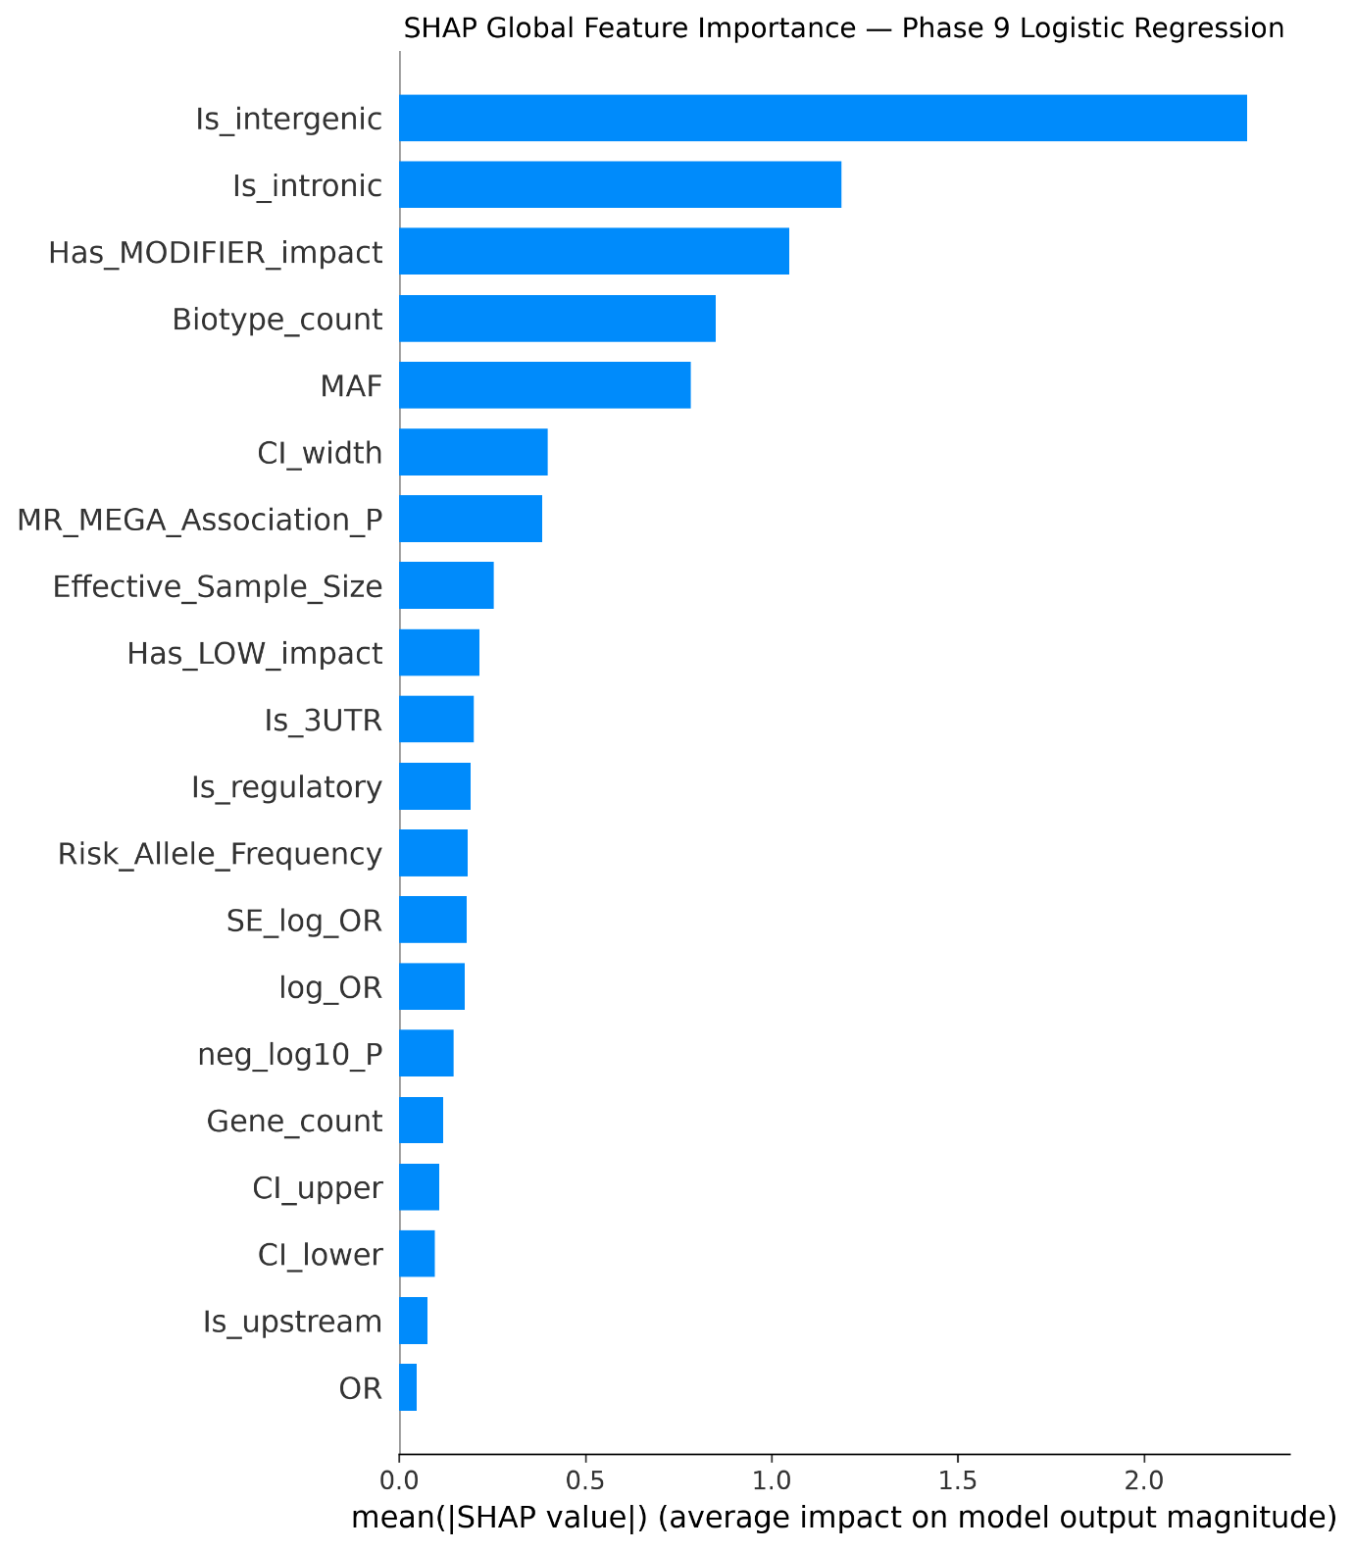
Figure 1: Global SHAP feature importance for the final leakage-safe machine-learning model
Figure 2. SHAP beeswarm plot showing feature contributions across individual test variants. The SHAP beeswarm plot provides a variant-level view of feature contributions across the test dataset. In addition to showing the overall importance of each feature, this visualization demonstrates the direction and variability of feature effects on individual predictions. The distribution of SHAP values shows that the influence of individual features varied between variants, reflecting the heterogeneous genomic characteristics of the candidate variants.
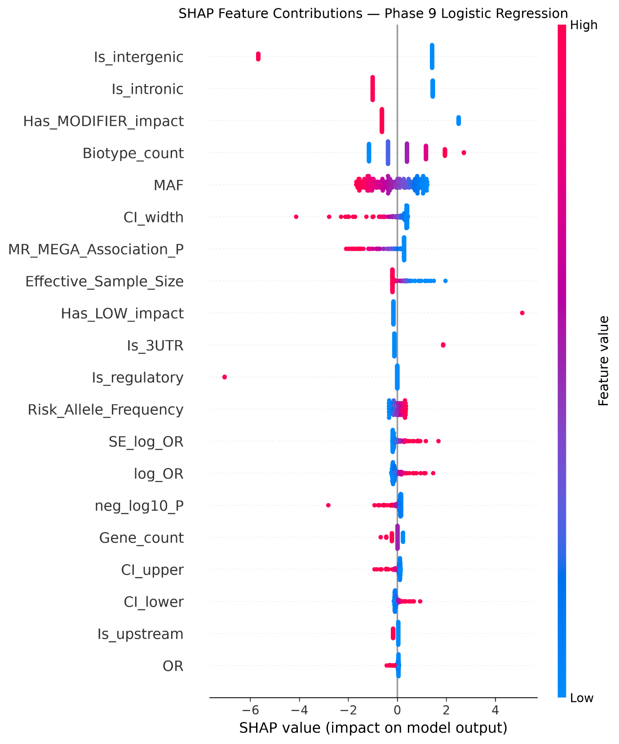
Figure 2: SHAP beeswarm plot showing feature contributions across individual test variants

3.8 Integrative Candidate Prioritization
Model-derived evidence was subsequently integrated with functional, biological, and external GWAS evidence to prioritize candidate variants.
The integrative prioritization workflow produced ranked candidate tables and external evidence summaries. Rather than relying exclusively on the machine-learning prediction probability, candidates were evaluated using multiple complementary sources of evidence.
This process resulted in the identification of a final set of 17 prioritized candidate variants.
Figure 3. Final integrated ranking of prioritized type 2 diabetes candidate variants. Following model prediction, functional annotation, and external GWAS evidence integration, candidate variants were ranked using a multi-dimensional prioritization framework. The final ranking incorporated evidence from machine-learning predictions, biological annotation, and external association evidence. This approach allowed variants to be prioritized based on convergent evidence rather than relying exclusively on a single statistical or computational criterion.
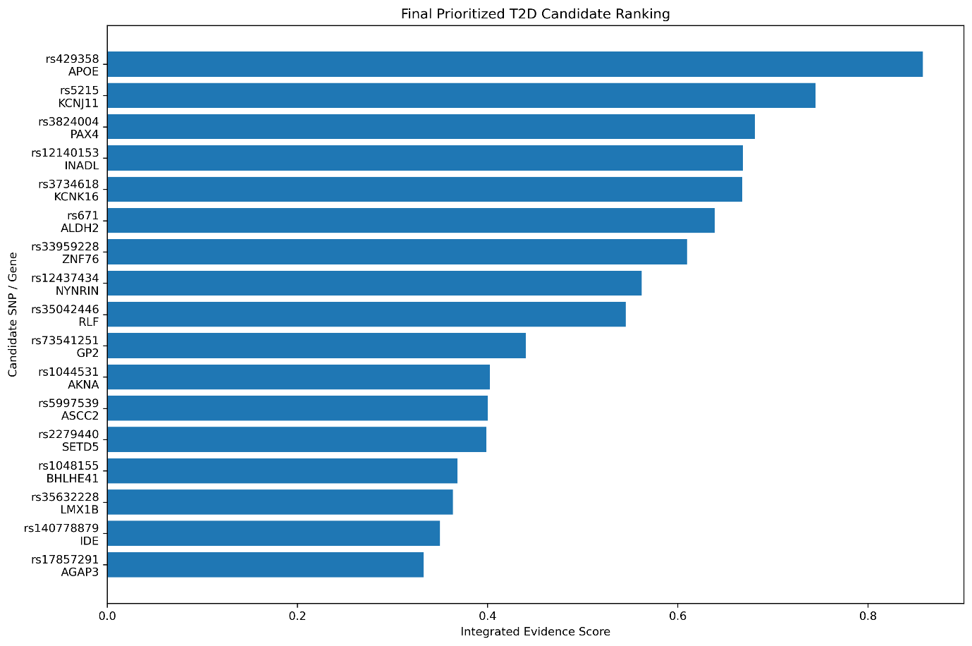
Figure 3: Final integrated ranking of prioritized type 2 diabetes candidate variants
Figure 4. Components contributing to integrated candidate prioritization. The integrated evidence analysis demonstrated that final candidate prioritization was based on multiple complementary sources of information. Rather than treating machine-learning predictions as definitive evidence, the framework combined statistical, functional, and external biological evidence to generate a more comprehensive candidate ranking.
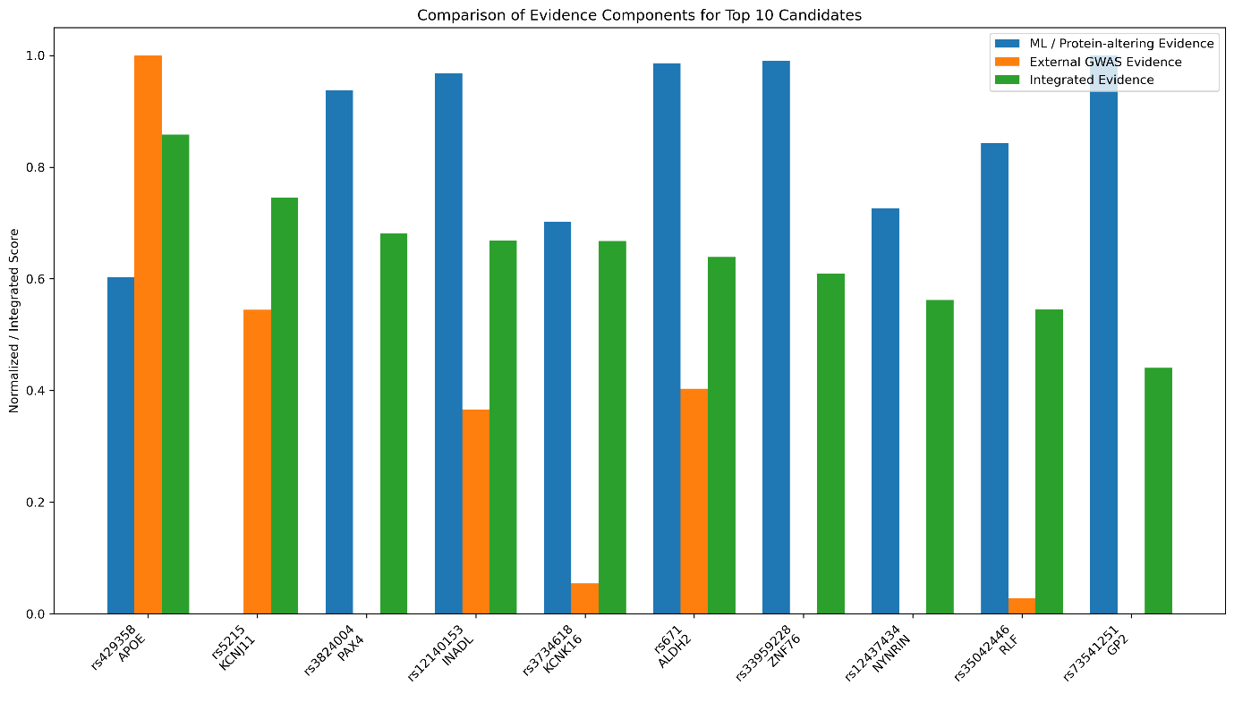
Figure 4: Components contributing to integrated candidate prioritization
Figure 5. External GWAS evidence supporting prioritized type 2 diabetes candidate variants. External GWAS evidence was incorporated to assess whether candidate variants or related genomic regions had independent support from previously reported association studies. This validation step provided an additional layer of evidence beyond the original discovery dataset and contributed to the biological prioritization of candidate variants.
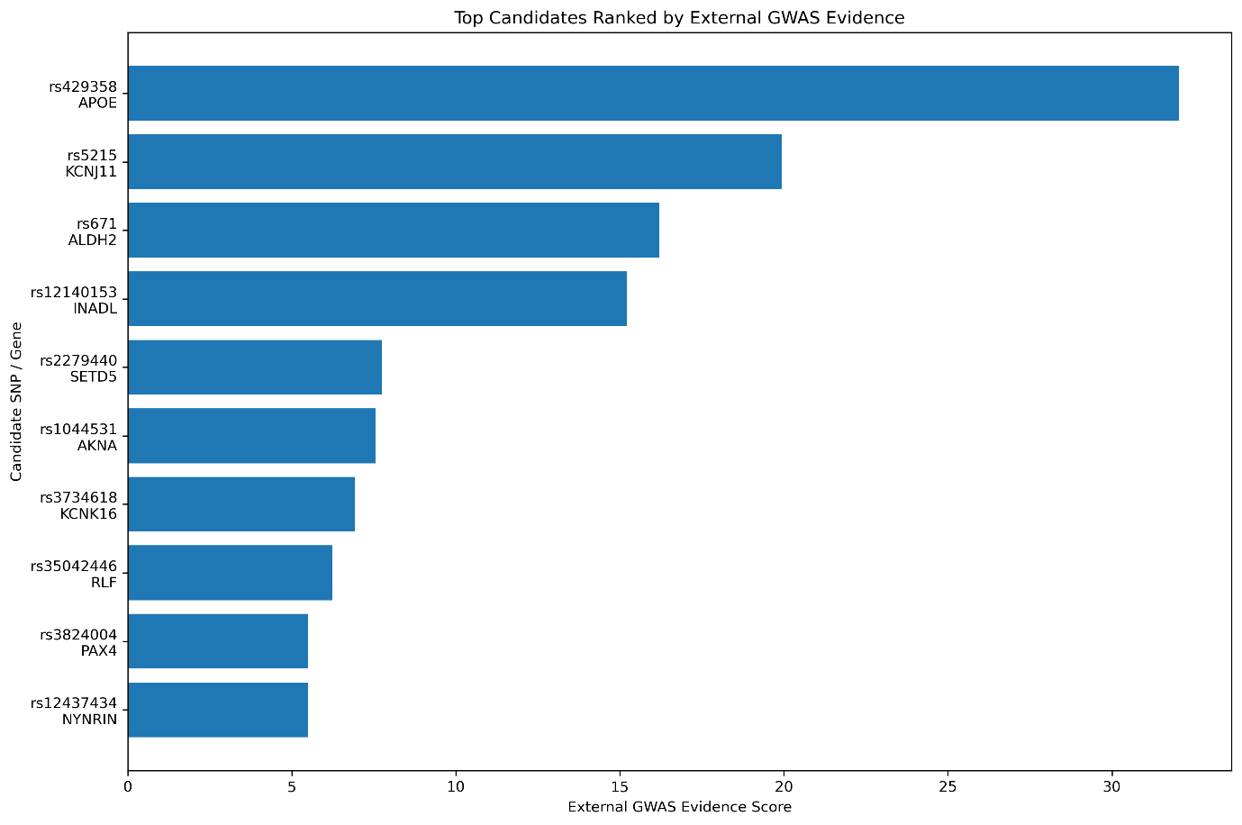
Figure 5: External GWAS evidence supporting prioritized type 2 diabetes candidate variants.
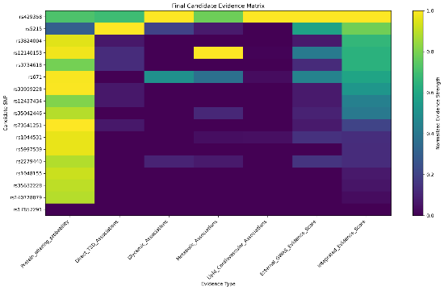
Figure 6: Final Evidence Heatmap

3.9 Model–Biology Concordance and Discordance
The relationship between model-based prioritization and biological evidence was examined for the final candidates.
Candidates showing agreement between computational and biological evidence were classified as concordant. Candidates showing disagreement between these evidence sources were examined separately through a model–biology discordance analysis.
This analysis provided an additional layer of evaluation by identifying candidates whose prioritization differed depending on whether computational or biological evidence was considered.
Figure 6. Concordance and discordance between machine-learning predictions and biological evidence. Comparison between machine-learning predictions and biological evidence revealed that computational predictions and biological prioritization were not always concordant. Some variants received strong support from the model but limited biological evidence, whereas others showed substantial biological relevance despite weaker model-based predictions. These discordant cases highlight the limitations of relying exclusively on a single analytical approach.
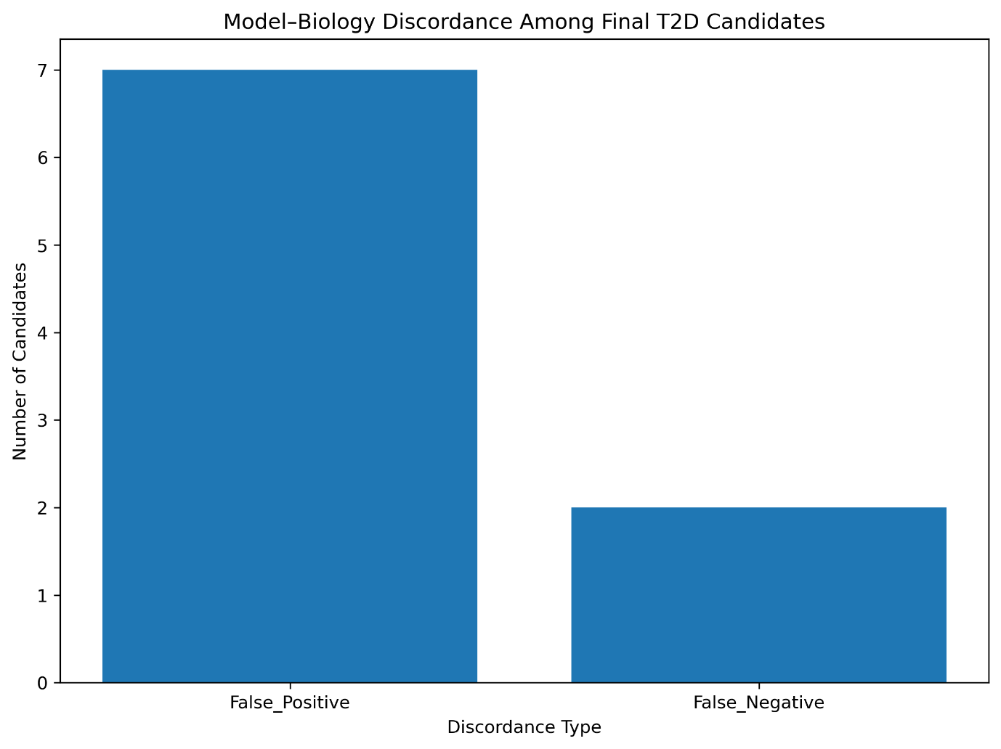
Figure 7: Concordance and discordance between machine-learning predictions and biological evidence
Figure 7. Evidence profiles of candidate variants showing discordance between model prediction and biological evidence. Detailed examination of discordant candidates showed that disagreement between the machine-learning model and biological evidence can itself provide useful information. Variants that were biologically supported but weakly predicted by the model may represent false-negative computational predictions, whereas strongly predicted variants lacking external or functional support may require additional validation.
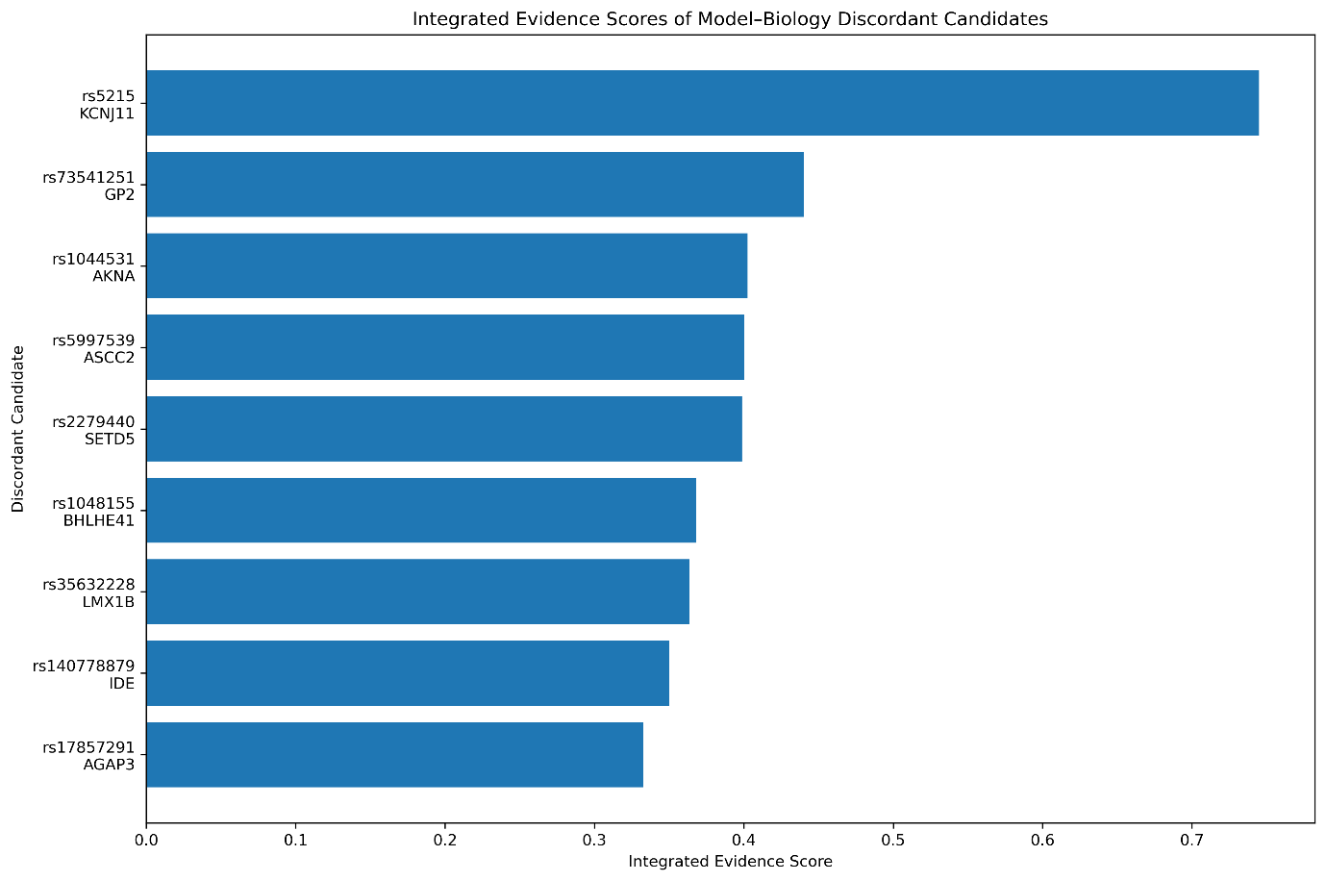
Figure 8: Evidence profiles of candidate variants showing discordance between model prediction and biological evidence

3.10 Robustness and Rank Stability
The stability of candidate prioritization was evaluated during the final validation stage.
Rank-stability analysis was performed to assess whether prioritized candidates maintained their relative positions under the validation framework.
The results were used to distinguish consistently prioritized candidates from candidates whose rankings were more sensitive to changes in the prioritization conditions.
Figure 8. Sensitivity analysis of final candidate rank stability. Sensitivity analysis was performed to evaluate the stability of candidate prioritization under changes in the weighting of evidence components. The results demonstrated the extent to which the final ranking depended on the relative contribution of different evidence sources. Candidates that remained highly ranked across sensitivity scenarios were considered more robustly prioritized.
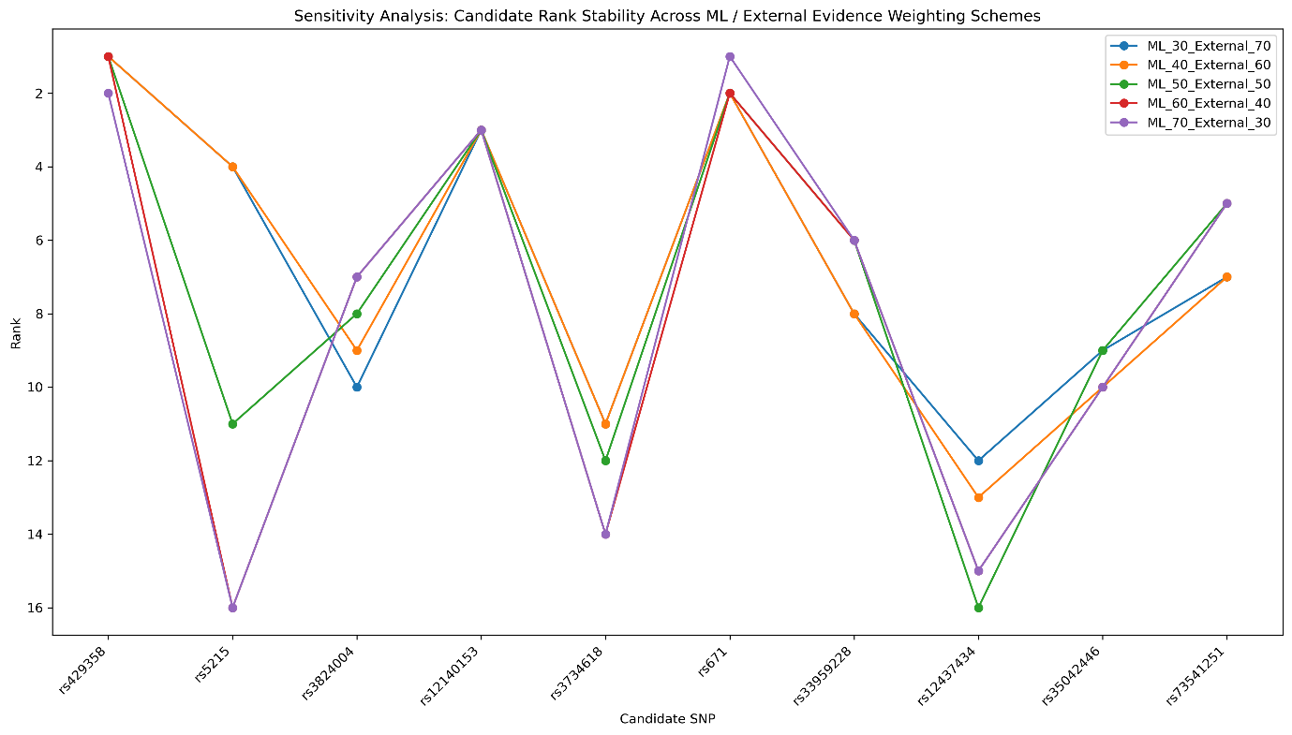
Figure 9: Sensitivity analysis of final candidate rank stability

3.11 Final Candidate Dataset Quality Control
The final candidate dataset underwent a final quality-control assessment.
The final dataset contained:
- 17 candidate variants.
- 17 unique SNP identifiers.
- Zero duplicate SNPs.
- Zero missing SNP identifiers.
All final dataset checks passed.

3.12 Final Project Reproducibility Assessment
The final project package was consolidated into a structured reproducibility directory containing scripts, results, figures, tables, documentation, and data references.
Final project quality-control checks confirmed:
- Final candidate table: PASS.
- 17-candidate dataset: PASS.
- 17 unique SNPs: PASS.
- No duplicate SNPs: PASS.
- Final figures present: PASS.
- SHAP interpretation: PASS.
- SHAP quality control: PASS.
- Analysis scripts consolidated: PASS.
- Reproducibility manifest created: PASS.
A total of 61 files were included in the final project inventory. The final project package therefore contained the major computational scripts, result tables, visualizations, and reproducibility documentation generated during the study.
Summary
Integrative Genomic Variant Prioritization for Type 2 Diabetes Using Population and Functional Data with Explainable Machine Learning
This project developed an integrative framework for prioritizing Type 2 Diabetes (T2D)-associated genomic variants by combining population-level GWAS information, functional variant annotation, machine learning, external GWAS evidence, and explainable artificial intelligence.
The analysis began with 1,289 T2D-associated index signals obtained from the multi-ancestry T2D GWAS dataset. Data cleaning, quality control, and feature engineering were performed to prepare the dataset for downstream analysis. GWAS-derived features included allele frequency, association significance, effective sample size, odds ratio, confidence intervals, transformed p-values, and minor allele frequency. Functional annotations were incorporated to capture the genomic and biological context of each variant.
A leakage-safe machine learning framework was developed to predict whether variants were protein-altering. The final model used carefully selected GWAS and functional annotation features while excluding features that could directly reveal the target label. Model predictions were evaluated using a stratified train-test split, and the analysis was extended through model comparison, feature evaluation, and robustness analyses.
Explainable machine learning was incorporated using SHAP analysis. The Phase 9 Logistic Regression model was successfully reconstructed, with reproduced predictions and coefficients matching the original model to numerical precision. SHAP analysis identified functional genomic features, including intergenic status, intronic status, modifier impact, biotype count, and minor allele frequency, among the most influential contributors to model predictions.
The machine learning results were subsequently integrated with biological and external GWAS evidence to prioritize candidate variants. The final prioritization framework produced a curated dataset of 17 candidate variants with no duplicate or missing SNP identifiers. Final robustness and reproducibility checks confirmed the integrity of the candidate dataset, the presence of required outputs, successful SHAP interpretation, and consolidation of the analysis scripts and results into a reproducible project structure.
Overall, this project demonstrates that genomic variant prioritization can benefit from integrating statistical association data with functional genomic information and interpretable machine learning. Rather than relying solely on GWAS significance, the framework evaluates variants using multiple complementary sources of evidence. The resulting workflow provides a reproducible approach for prioritizing T2D-associated variants for further biological investigation and illustrates the potential of explainable machine learning in genomic data analysis.

