**SQL Assignment: All concepts I**

**Download the following database file from the link:**

**AirlineDB**: https://drive.google.com/file/d/15ehp3FtyuYqExne3FaFcWHB4TFI_vtSR/view?usp=sharing

**Table structure**

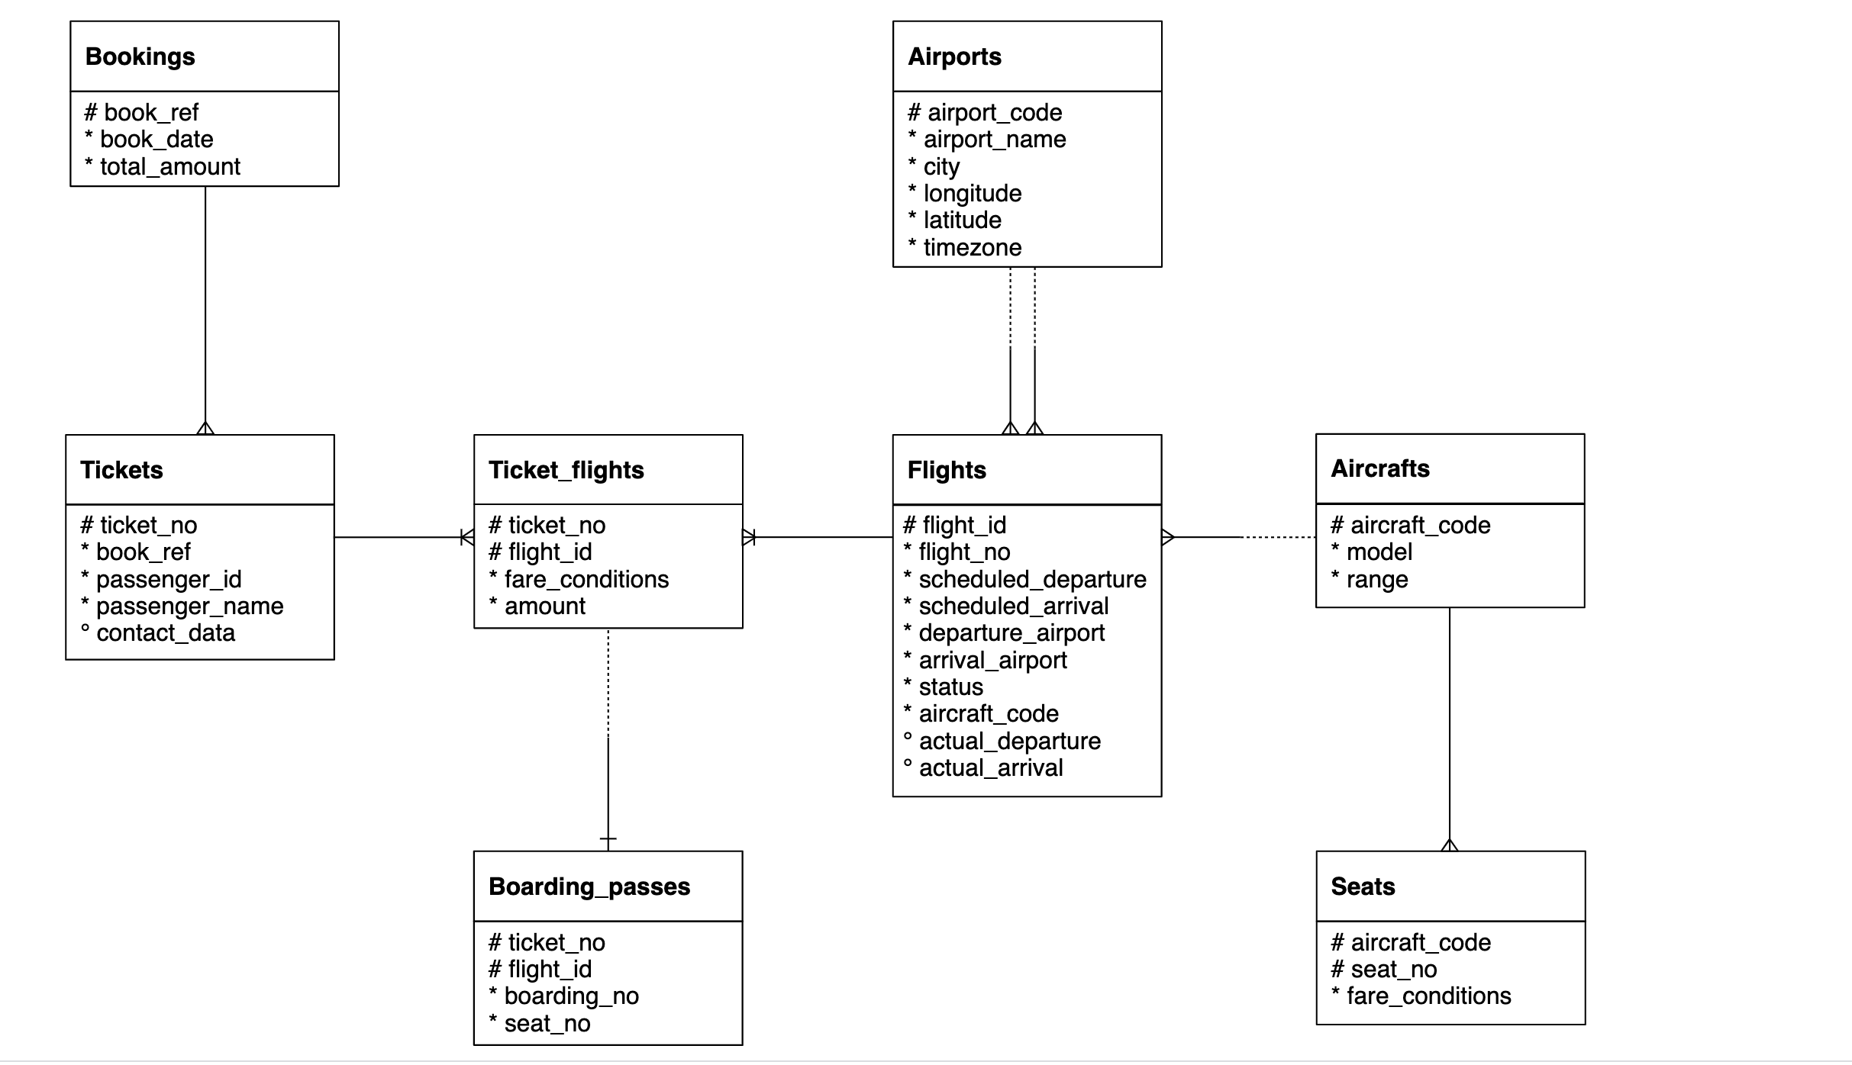

Important Instructions:

* Download the database link and restore in postgres. For restoration, you can refer to the instructions in the first chapter of SQL
* The AirlineDB is quite big in size, hence restoration might take time. Once the restoration starts, wait for 15 to 20 mins and don’t shut down the computer
* Table names in database has “**booking.”** as prefix. For example, bookings.tickets, bookings.boarding_passes. Hence use the prefix in the query as well
  + Correct way of accessing tables: SELECT * FROM **bookings.tickets**
  + Wrong way of accessing tables: SELECT * FROM tickets
* Queries need to be submitted in a **word/text file**. CSV output of the queries will **NOT** be accepted
* Expected output written is written in some of the following question to make sure that you are getting the columns in the same sequence. It doesn’t mean that you will get same values in the output. The exact values in your queries might be different depending on the values sorted in your copy of database.

1. Represent the “book_date” column in “yyyy-mmm-dd”. User Bookings table

*Expected output*

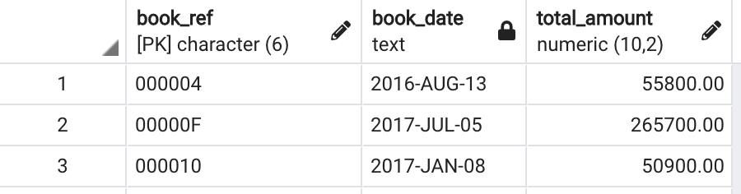

Solution:- SELECT

book_ref,

to_char(book_date,'yyyy Mon dd') as book_date,

total_amount

FROM bookings.bookings

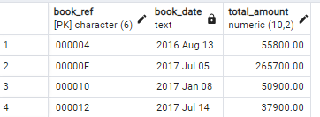

1. Create a table having ticket_no, boarding_no, seat_number, passenger_id, passenger_name.

*Expected output*

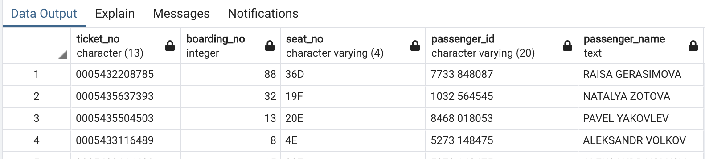

Solution:-

CREATE TABLE IF NOT EXISTS bookings.Details (

ticket_no character(13),

boarding_no integer NOT NULL,

seat_number character varying(4),

passenger_id character varying(20),

passenger_name text

); 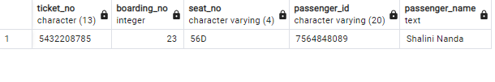

1. Which seat number is least allocated among all the seats?

Solutions:-

SELECT

seat_no,

COUNT(seat_no) AS frequency

FROM

bookings.boarding_passes

GROUP BY

seat_no

ORDER BY

Frequency

LIMIT 1;

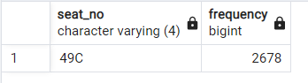

1. In the database, identify the month wise highest paying passenger name and passenger id

*Expected output*

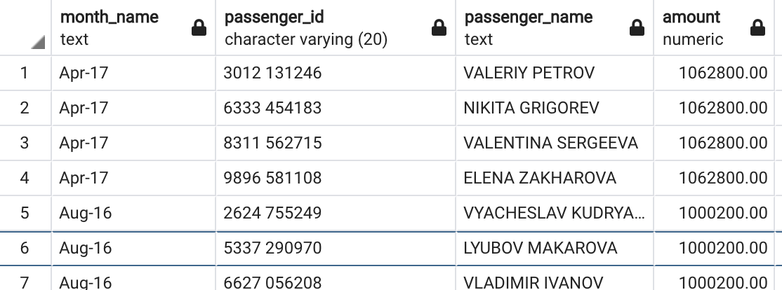

Solution:-

SELECT

to_char(B.book_date,'Mon-dd') month_name,

T.passenger_id,

T.passenger_name,

MAX(B.total_amount) Amount

FROM bookings.bookings B

FULL OUTER JOIN bookings.tickets T

on B.book_ref = T.book_ref

GROUP BY 1,2,3

ORDER BY 4 DESC

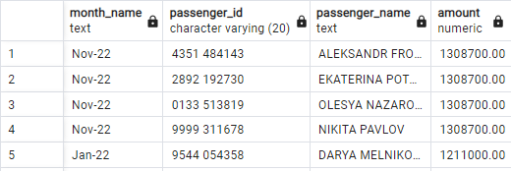

1. In the database, identify the month wise least paying passenger name and passenger id?

*Expected output*

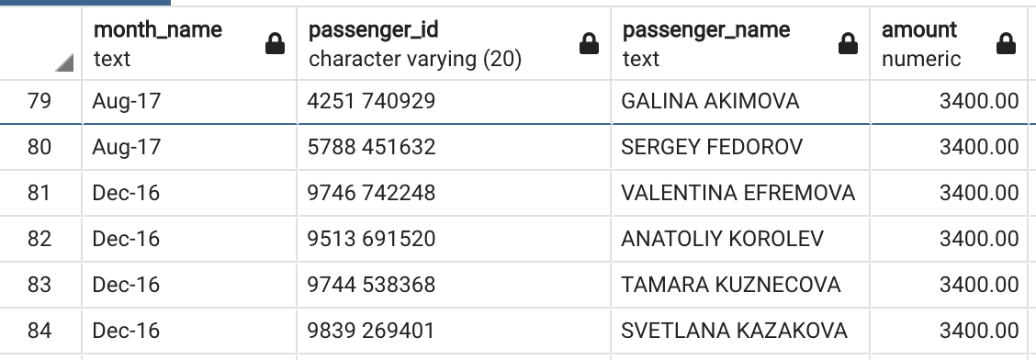

Solution:-

SELECT

to_char(B.book_date,'Mon-dd') month_name,

T.passenger_id,

T.passenger_name,

MIN(B.total_amount) Amount

FROM bookings.bookings B

FULL OUTER JOIN bookings.tickets T

on B.book_ref = T.book_ref

GROUP BY 1,2,3

ORDER BY 4

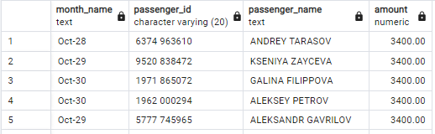

1. Identify the travel details of non no stop journeys or return journeys (having more than 1 flight).

*Expected output*

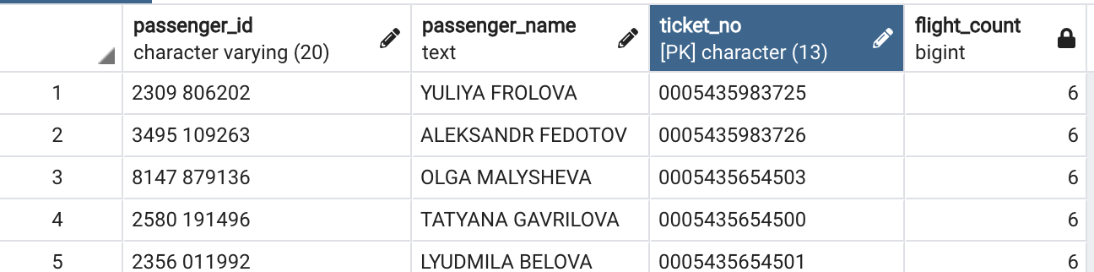

Solution:-

SELECT

T.passenger_id,

T.passenger_name,

T.ticket_no,

COUNT(F.flight_no) Flight_count

FROM bookings.tickets T

INNER JOIN bookings.ticket_flights TF

ON T.ticket_no = TF.ticket_no

INNER JOIN bookings.flights F

ON TF.flight_id = F.flight_id

GROUP BY 1,2,3

HAVING COUNT(F.flight_no) > 1

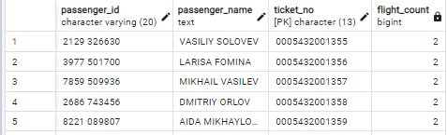

1. How many tickets are there without boarding passes?

Solution :-

SELECT

COUNT(T.ticket_no)

FROM bookings.tickets T

LEFT JOIN bookings.boarding_passes B

ON T.ticket_no = B.ticket_no

WHERE B.boarding_no IS NULL

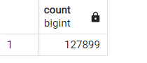

1. Identify details of the longest flight (using flights table) ?

Solution:-

SELECT

flight_id,

flight_no,

departure_airport,

arrival_airport,

status,

aircraft_code,

EXTRACT(hour FROM (scheduled_arrival - scheduled_departure)) AS duration

FROM

bookings.flights

ORDER BY

duration DESC

LIMIT 1;

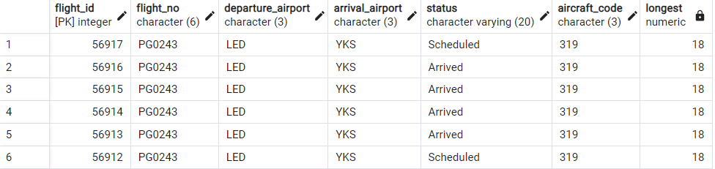

1. Categorize flights using following logic (using flights table) :
   1. Early morning flights: 2 AM to 6AM
   2. Morning flights: 6 AM to 11 AM
   3. Noon flights: 11 AM to 4 PM
   4. Evening flights: 4 PM to 7 PM
   5. Night flights: 7 PM to 11 PM
   6. Late Night flights: 11 PM to 2 AM

*Expected output*

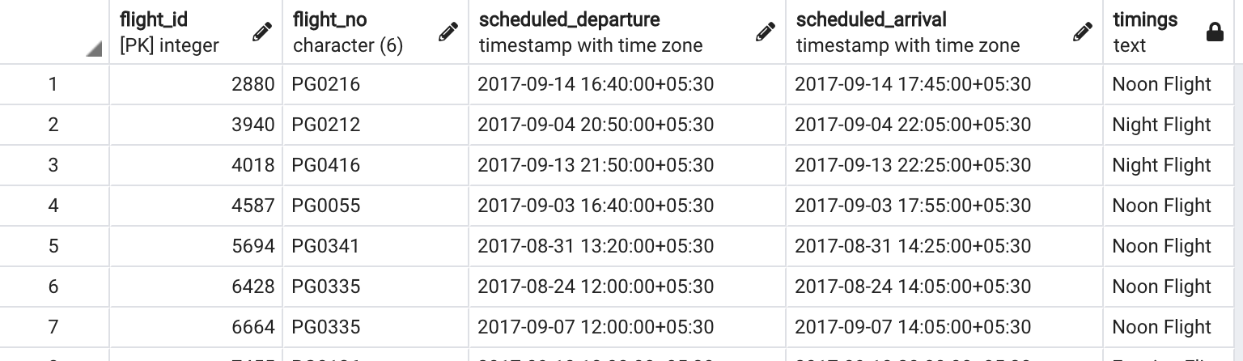

Solution:-

SELECT

flight_id,flight_no,scheduled_departure,scheduled_arrival,

CASE

WHEN TO_CHAR(scheduled_departure,'HH24')

BETWEEN '02' AND '06' THEN 'Early morning flights'

WHEN TO_CHAR(scheduled_departure,'HH24')

BETWEEN '06' AND '11' THEN 'Morning flights'

WHEN TO_CHAR(scheduled_departure,'HH24')

BETWEEN '11' AND '16' THEN 'Noon flights'

WHEN TO_CHAR(scheduled_departure,'HH24')

BETWEEN '16' AND '19' THEN 'Evening flights'

WHEN TO_CHAR(scheduled_departure,'HH24')

BETWEEN '19' AND '23' THEN 'Night flights'

ELSE 'Late Night flights'

END AS Timings

FROM bookings.flights

LIMIT 15

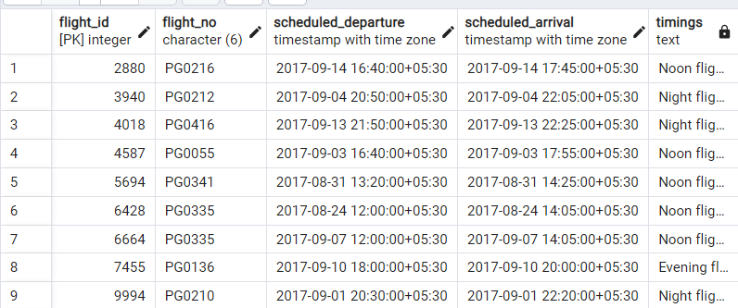

1. Identify details of all the morning flights (morning means between 6AM to 11 AM, using flights table) ?

Solutions:-

WITH Morning_Time AS

(SELECT

flight_id,flight_no,scheduled_departure,scheduled_arrival,

CASE

WHEN TO_CHAR(scheduled_departure,'HH24')

BETWEEN '02' AND '06' THEN 'Early morning flights'

WHEN TO_CHAR(scheduled_departure,'HH24')

BETWEEN '06' AND '11' THEN 'Morning flights'

WHEN TO_CHAR(scheduled_departure,'HH24')

BETWEEN '11' AND '16' THEN 'Noon flights'

WHEN TO_CHAR(scheduled_departure,'HH24')

BETWEEN '16' AND '19' THEN 'Evening flights'

WHEN TO_CHAR(scheduled_departure,'HH24')

BETWEEN '19' AND '23' THEN 'Night flights'

ELSE 'Late Night flights'

END AS Timings

FROM bookings.flights

)

SELECT * FROM Morning_Time

WHERE Timings = 'Morning flights'

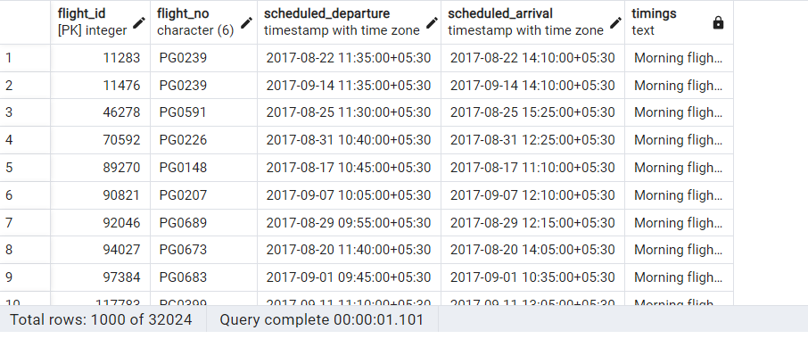

Solution :-

WITH Morning_Time AS (

SELECT

flight_id,

flight_no,

scheduled_departure,

scheduled_arrival,

departure_airport,

CASE

WHEN TO_CHAR(scheduled_departure, 'HH24') BETWEEN '02' AND '06' THEN 'Early morning flights'

WHEN TO_CHAR(scheduled_departure, 'HH24') BETWEEN '06' AND '11' THEN 'Morning flights'

WHEN TO_CHAR(scheduled_departure, 'HH24') BETWEEN '11' AND '16' THEN 'Noon flights'

WHEN TO_CHAR(scheduled_departure, 'HH24') BETWEEN '16' AND '19' THEN 'Evening flights'

WHEN TO_CHAR(scheduled_departure, 'HH24') BETWEEN '19' AND '23' THEN 'Night flights'

ELSE 'Late Night flights'

END AS Timings

FROM

bookings.flights

)

SELECT

departure_airport,

MIN(scheduled_departure) AS earliest_departure,

flight_id,

flight_no

FROM

Morning_Time

WHERE

Timings = 'Morning flights'

GROUP BY

departure_airport, flight_id, flight_no;