**SQL Assignment: All concepts II**

*\*\*Same database file from previous assignment will be used in this assignment. If you haven’t download the first assignment yet follow the instructions:*

**Download the following database file from the link:**

**AirlineDB**: https://drive.google.com/file/d/15ehp3FtyuYqExne3FaFcWHB4TFI_vtSR/view?usp=sharing

**Table structure**

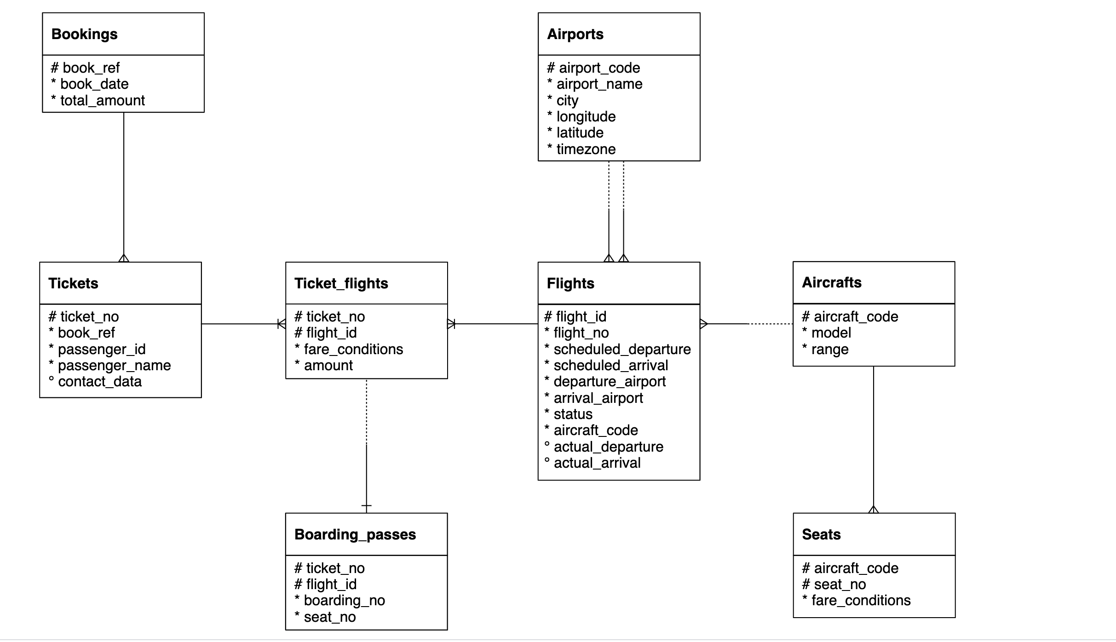

Important Instructions:

* Download the database link and restore in postgres. For restoration, you can refer to the instructions in the first chapter of SQL
* The AirlineDB is quite big in size, hence restoration might take time. Once the restoration starts, wait for 15 to 20 mins and don’t shut down the computer
* Table names in database has “**booking.”** as prefix. For example, bookings.tickets, bookings.boarding_passes. Hence use the prefix in the query as well
  + Correct way of accessing tables: SELECT * FROM **bookings.tickets**
  + Wrong way of accessing tables: SELECT * FROM tickets
* Queries need to be submitted in a **word/text file**. CSV output of the queries will **NOT** be accepted
* Expected output written is written in some of the following question to make sure that you are getting the columns in the same sequence. It doesn’t mean that you will get same values in the output. The exact values in your queries might be different depending on the values sorted in your copy of database.

1. Find list of airport codes in Europe/Moscow timezone

Solution:-

SELECT

airport_code ,

timezone

FROM bookings.airports

WHERE timezone = 'Europe/Moscow'

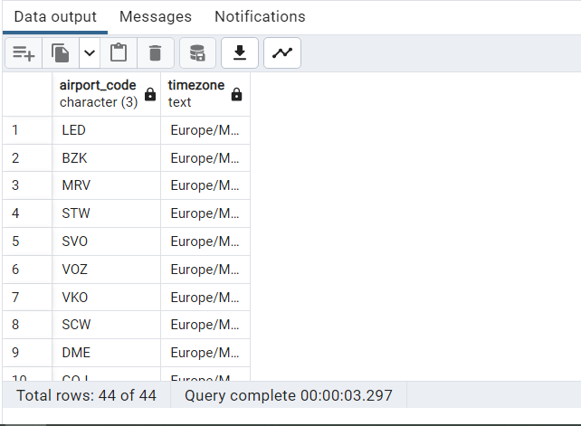

1. Write a query to get the count of seats in various fare condition for every aircraft code?

Solutions:-

SELECT

aircraft_code,

fare_conditions,

COUNT(seat_no)

FROM bookings.seats

GROUP BY 1,2

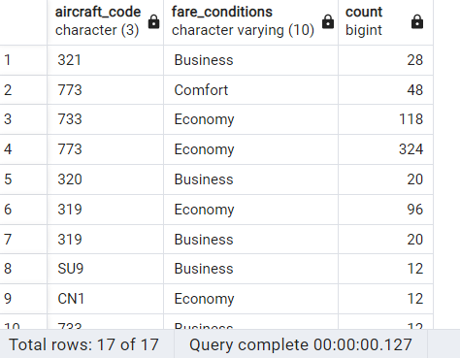

1. How many aircrafts codes have at least one Business class seats?

Solutions:-

SELECT

COUNT(aircraft_code),

fare_conditions

FROM bookings.seats

WHERE fare_conditions = 'Business'

GROUP BY 2

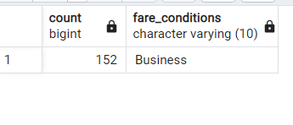

1. Find out the name of the airport having maximum number of departure flight

Solution:-

WITH counter as

(

SELECT

COUNT(scheduled_departure) AS counting

FROM bookings.flights

)

SELECT

MAX(C.counting) AS Max_depart,

A.airport_name->>'en'

FROM counter C

CROSS JOIN bookings.airports_data A

GROUP BY 2

ORDER BY 1 DESC

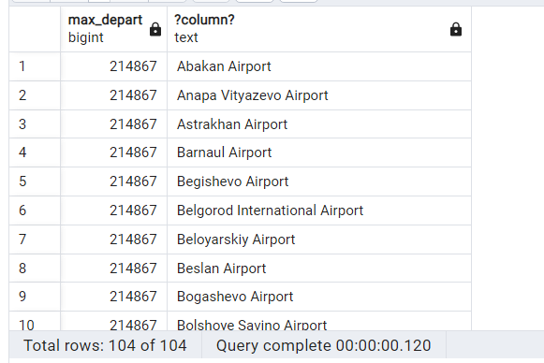

1. Find out the name of the airport having least number of scheduled departure flights

Solution:-

WITH Least_departure as(

SELECT departure_airport,

COUNT(scheduled_departure)AS Depart

FROM bookings.flights

where status = 'Scheduled'

GROUP BY 1

)

SELECT airport_name->>'en' as Name_of_Airport,depart from bookings.airports_data a

left join Least_departure l ON l.departure_airport=a.airport_code

GROUP BY 1,2

ORDER BY 2

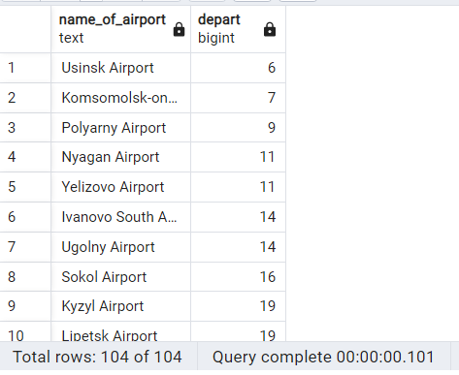

1. How many flights from ‘DME’ airport don’t have actual departure?

Solutions:-

SELECT

departure_airport,

COUNT(flight_no) AS no_of_flights

FROM

bookings.flights

WHERE

departure_airport = 'DME' AND actual_departure IS NULL

GROUP BY

departure_airport;

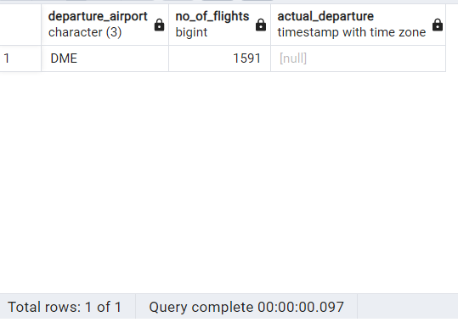

1. Identify flight ids having range between 3000 to 6000

Solution:-

SELECT

flight_id,

flight_no,

aircraft_code

FROM bookings.flights

WHERE flight_id between 3000 and 6000

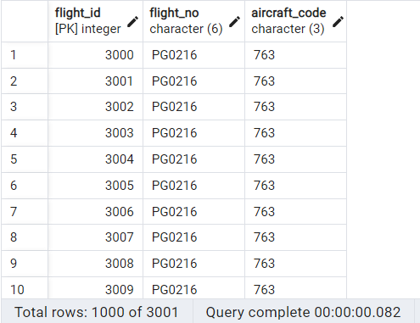

1. Write a query to get the count of flights flying between URS and KUF?

Solution:-

SELECT

COUNT(flight_id) AS Total_flight_count,

departure_airport,

arrival_airport

FROM bookings.flights

WHERE departure_airport = 'URS'

AND arrival_airport = 'KUF'

GROUP BY 2,3

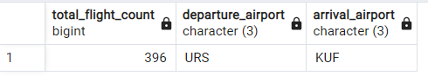

1. Write a query to get the count of flights flying from either from NOZ or KRR?

Solutions:-

SELECT

COUNT(flight_id) AS Total_flight_count,

departure_airport

FROM bookings.flights

WHERE departure_airport = 'NOZ'

OR departure_airport = 'KRR'

GROUP BY 2

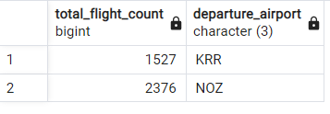

1. Write a query to get the count of flights flying from KZN, DME, NBC,NJC,GDX,SGC,VKO,ROV

Solutions:-

SELECT

COUNT(flight_id) AS Count_of_Flights,

departure_airport

FROM bookings.flights

WHERE departure_airport IN ('KZN','DME','NBC','NJC','GDX','SGC','VKO','ROV')

GROUP BY 2

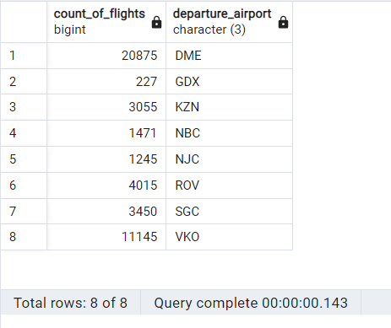

1. Write a query to extract flight details having range between 3000 and 6000 and flying from DME

Solutions:-

SELECT

*

FROM bookings.flights

WHERE flight_id BETWEEN 3000 AND 6000

AND departure_airport = 'DME'

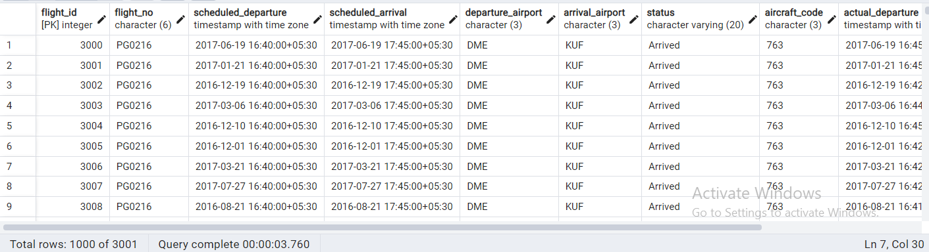

1. Find the list of flight ids which are using aircrafts from “Airbus” company and got cancelled or delayed

SELECT

F.flight_id

FROM

bookings.flights F

LEFT JOIN

bookings.aircrafts_data D ON F.aircraft_code = D.aircraft_code

WHERE

D.model->>'en' LIKE '%Airbus%'

AND F.status IN ('Cancelled', 'Delayed');

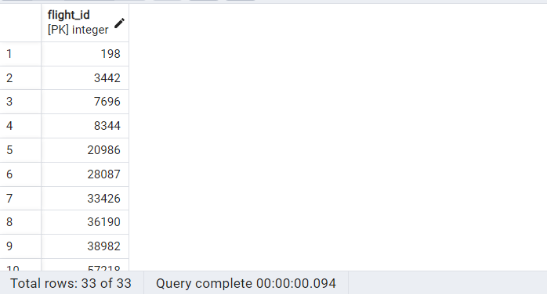

1. Find the list of flight ids which are using aircrafts from “Boeing” company and got cancelled or delayed

Solutions:-

SELECT

F.flight_id

FROM

bookings.flights F

LEFT JOIN

bookings.aircrafts_data D ON F.aircraft_code = D.aircraft_code

WHERE

D.model->>'en' LIKE '%Boeing%'

AND F.status IN ('Cancelled', 'Delayed');

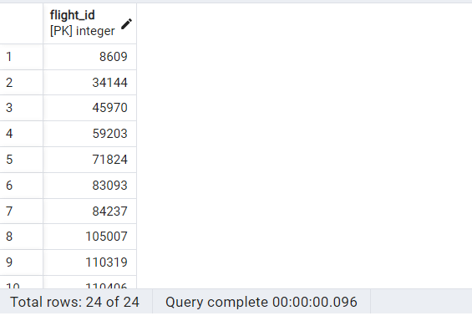

1. Which airport(name) has most cancelled flights (arriving)?

Solutions:-

SELECT

D.airport_name,

F.arrival_airport,

COUNT(F.flight_id) AS Max_cancelled

FROM

bookings.flights F

CROSS JOIN

bookings.airports_data D

WHERE

F.status = 'Cancelled'

GROUP BY

1, 2

ORDER BY

3 DESC

LIMIT 1;

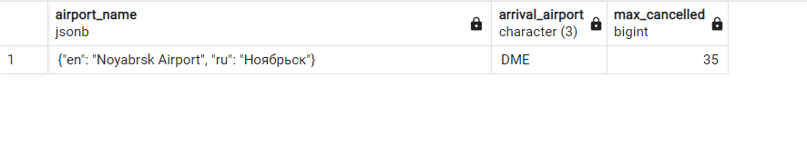

1. Identify flight ids which are using “Airbus aircrafts”

Solutions:-

SELECT

F.flight_id

FROM

bookings.flights F

LEFT JOIN

bookings.aircrafts_data D ON F.aircraft_code = D.aircraft_code

WHERE

D.model->>'en' LIKE '%Airbus%';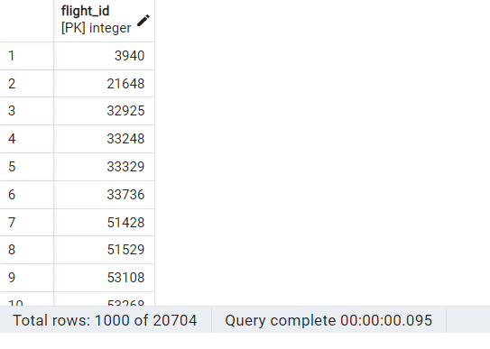

1. Identify date-wise last flight id flying from every airport?

Solutions:-

SELECT

flight_id,

scheduled_departure::date AS flight_date,

departure_airport

FROM

(

SELECT

*,

ROW_NUMBER() OVER (PARTITION BY scheduled_departure::date, departure_airport ORDER BY scheduled_departure DESC) AS rn

FROM

bookings.flights

WHERE

status != 'Cancelled'

) AS Flight_Table

WHERE

rn = 1;

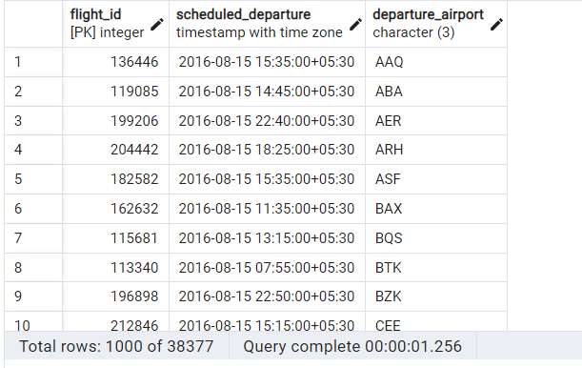

1. Identify list of customers who will get the refund due to cancellation of the flights? And how much amount they will get?

Solutions:-

SELECT

T.passenger_name,

SUM(TF.refund_amount) AS refund_amount

FROM

bookings.tickets T

LEFT JOIN (

SELECT

TF.ticket_no,

B.total_amount * 0.8 AS refund_amount

FROM

bookings.ticket_flights TF

INNER JOIN bookings.flights F ON TF.flight_id = F.flight_id

INNER JOIN bookings.bookings B ON B.book_ref = TF.book_ref

WHERE

F.status = 'Cancelled'

) TF ON T.ticket_no = TF.ticket_no

GROUP BY

T.passenger_name;

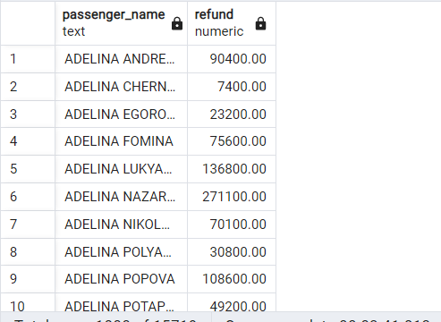

1. Identify date wise first cancelled flight id flying for every airport?

Solutions:-

SELECT

flight_id,

scheduled_departure,

departure_airport

FROM (

SELECT

*,

ROW_NUMBER() OVER (PARTITION BY cast(scheduled_departure AS date), departure_airport ORDER BY scheduled_departure) AS rn

FROM

bookings.flights

WHERE

status = 'Cancelled'

) AS Flight_Table

WHERE

rn = 1;

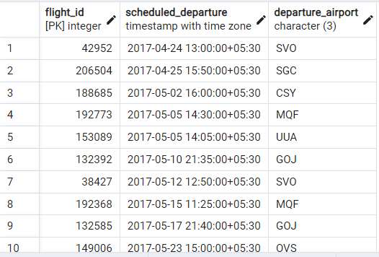

1. Identify list of Airbus flight ids which got cancelled.

Solutions:-

SELECT

F.flight_id,

F.status,

AD.model->>'en'

FROM bookings.Flights F

LEFT JOIN bookings.aircrafts_data AD

ON F.aircraft_code = AD.aircraft_code

WHERE AD.model->>'en' like '%Airbus%'

AND F.status='Cancelled'

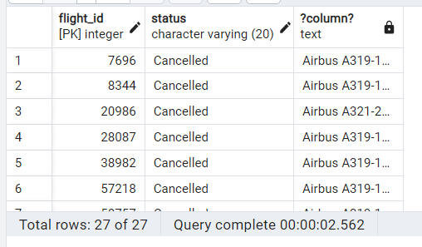

1. Identify list of flight ids having highest range.

Solutions:-

SELECT

F.flight_id,

AC.range

FROM bookings.flights F

LEFT JOIN bookings.aircrafts AC ON F.aircraft_code = AC.aircraft_code

WHERE AC.range = (SELECT MAX(range) FROM bookings.aircrafts)

