SYSTEM REQUIREMENTS SPECIFICATION
Full Stack Java (AI-Integrated) Training Programme
Project Title | VisionPath – AI-Powered Personalized Career Guidance and Learning Platform
SIH Problem Statement ID | SIH25094
Ministry / Organisation | Government of Jammu and Kashmir
Domain Category | Education
Team Name | Data Pulse
Team Members | 1. Shalini S 2. Sri Muthu Nivethitha S
Institution | Karpagam College of Engineering
Project Type | Software only
Version | v1.0
Date | 10-06-2026
Faculty Mentor | Dr. Jothi Prakash V / Mr. Jegathesh P / Mr. Navaneetha Krishnan M

DOCUMENT REVISION HISTORY
Version | Date | Author | Description of Changes
v1.0 | 10-06-2026 | Team Data Pulse | Initial Software Requirements Specification document created.
v1.1 | 19.06.2026 | Team Data Pulse | Updated project scope, objectives, and system overview.
V1.2 | 21.06.2026 | Team Data Pulse | Updated stakeholder and user information
V1.3 | 26.06.2026 | Shalini S | Updated system requirements and functional requirements
V2.1 | 30.06.2026 | Sri muthu nivethitha | Updated system architecture and microservice structure
V2.2 | 07.07.2026 | Team Data Pulse | Updated authentication, student and admin service requirements
V3.1 | 12.07.2026 | Shalini S | Added and updated assessment service requirements
V4.1 | 16.07.2026 | Shalini S | Added AI Mentor and AI-based personalization requirements
V5.1 | 21.07.2026 | Shalini S | Updated career recommendation and career service requirements
V6.1 | 17.07.2026 | Sri muthu nivethitha | Added study plan and personalized learning roadmap requirements
V7.1 | 21.07.2026 | Shalini S | Added resume analysis and ATS analysis requirements
V8.1 | 25.07.2026 | Shalini S | Updated AI integration and external AI/API requirements
V9.1 | 31.07.2026 | Sri muthu nivethitha | Updated resume processing and recommendation workflow
V10.1 | 03.08.2026 | Sri muthu nivethitha | Updated database and data management requirements
V11.1 | 05.08.2026 | Shalini S | Updated API Gateway and microservice communication requirements
V12.1 | 08.08.2026 | Sri muthu nivethitha | Updated frontend-backend integration and user interface requirements
v13.1 | 13.08.2026 | Team Data Pulse | Final review and consolidation of SRS requirements

GITHUB URL:

https://github.com/Shalini-S21/Vision-Path-V1

https://github.com/Nivethitha-07/visionpath

1. INTRODUCTION

1.1 Purpose
This document is the Software Requirements Specification (SRS) for VisionPath, an AI-powered personalized career guidance and learning platform. It describes the functional and non-functional requirements, system architecture, data design, and interfaces of the platform for the project team, faculty mentors, and industry reviewers involved in the Full Stack Java (AI-Integrated) Training Programme.
VisionPath helps students understand their skills, interests, personality, and educational background, and uses that information to recommend suitable career paths. Students complete an initial assessment followed by an AI-personalized assessment, receive AI-generated career recommendations, chat with an AI mentor for guidance, generate a personalized study/career roadmap toward a chosen goal, track their progress, receive personalized notifications, and upload a resume to receive an ATS score and improvement recommendations. The platform also provides counsellors with tools to support students and gives administrators oversight of the platform.

1.2 Scope
System Name: VisionPath
What the system does:
VisionPath is an AI-powered career guidance, assessment, education and career-development platform for students, counsellors, and administrators. It personalizes career assessments, career recommendations, AI mentoring, study/career roadmaps, learning plans, resume/ATS analysis, progress tracking, and notifications. The system's goal is to provide students with a single platform where they can assess themselves, receive personalized career recommendations, understand which skills they need, generate a roadmap toward a selected career, track their progress, and receive AI-based guidance throughout the journey.

1.3 Definitions, Acronyms & Abbreviations
Term / Acronym | Definition
SRS | System Requirements Specification — this document
API | Application Programming Interface
REST | Representational State Transfer — architectural style for HTTP APIs
JWT | JSON Web Token — used for authentication and authorization
ML / AI | Machine Learning / Artificial Intelligence
LLM | Large Language Model — powers the AI Mentor, personalized assessment generation, and roadmap generation
ATS | Applicant Tracking System — automated resume-screening software; the Resume Analyzer estimates an ATS-compatibility score
CRUD | Create, Read, Update, Delete — basic data operations
CI/CD | Continuous Integration / Continuous Deployment — automated build and release pipeline
FR | Functional Requirement
NFR | Non-Functional Requirement
UC | Use Case
ER | Entity-Relationship (database design)
Roadmap | A structured, ordered set of learning stages, topics, and tasks generated toward a student's chosen career/academic goal

1.4 References
- Spring Boot Documentation — used for backend microservice development and REST API implementation.
- React Documentation — used for frontend development and user interface design.
- FastAPI Documentation — used for AI/ML integration and REST API services that call the external AI provider.
- PostgreSQL Documentation — used for database design, schema management, and data storage.
- Spring Security / JWT Documentation — used for authentication and role-based access control.
- AI Provider API Documentation — used for AI Mentor responses, personalized assessment generation, career recommendation, and roadmap generation.

1.5 Document Overview
Section 2 provides an overall description of the product. Section 3 describes the system architecture. Sections 4 and 5 specify external interfaces and functional requirements. Section 6 details the AI/ML module specifications. Sections 7 through 10 cover non-functional requirements, database design, API design overview, and the DevOps/deployment plan. Section 11 presents the project timeline. Section 12 defines team roles. Section 13 registers risks. Section 14 contains the appendix.

2. OVERALL DESCRIPTION

2.1 Product Perspective
VisionPath is a new, self-contained AI-powered career guidance platform built as a set of cooperating microservices behind a single API Gateway. It is not a replacement for an existing institutional system; it is a standalone product aimed at students, counsellors, and administrators who currently lack a single place to combine self-assessment, AI-driven career recommendation, mentoring, roadmap planning, progress tracking, and resume/ATS feedback.
VisionPath addresses the lack of personalized, end-to-end career guidance available to students during important academic and career decision-making stages. Rather than a one-time test, the platform builds a profile of the student's skills, interests, personality, and education, and uses that profile — together with an AI-personalized second-stage assessment — to recommend relevant careers. Students can then turn a chosen career into an AI-generated study roadmap, track their progress against it, receive contextual notifications, chat with an AI mentor at any stage, and analyze their resume for ATS compatibility. Counsellors support students through the platform, and administrators manage users and platform-level data.

2.2 Product Functions — Feature Summary
# | Feature Name | Description
1 | Authentication & Role Access | Secure registration/login and role-based access for Students, Counsellors, and Administrators.
2 | Student Profile | Maintains skills, interests, educational background, career interests, saved careers, goals, and progress used for personalization.
3 | Personalized Assessment | Two-stage assessment: a predefined initial assessment across technical, non-technical, personality, interest, skills, and education areas, followed by an AI-generated personalized assessment based on the student's initial results.
4 | AI Career Recommendation | Analyzes assessment results, skills, interests, personality, and education to recommend relevant career options.
5 | AI Mentor Chatbot | Conversational AI assistant that gives career, education, and study-related guidance based on the student's context.
6 | Study/Career Roadmap | Lets students search, save, and follow a roadmap, or generate a personalized AI roadmap toward a chosen goal, with stages, topics, and tasks.
7 | Notifications | Personalized, event-driven notifications such as assessment completion, new recommendations, task due dates, and progress milestones.
8 | Resume / ATS Analyzer | Analyzes an uploaded resume, produces an ATS-compatibility score, flags issues, and recommends improvements.
9 | skill Information | Supplies education/learning information that supports students in working toward their selected career goal.
10 | Counsellor Support | Gives counsellors tools to support and guide students through career-guidance and counselling activities.
11 | Admin Management | Gives administrators user/system management, monitoring, and administrative operations over platform data.

2.3 User Classes and Characteristics
User Role | Description | Technical Expertise | Primary Actions | Access Level
Student (Primary User) | Students who use the platform for career guidance, assessment, and learning planning. | Low | Register/login, complete profile, take initial and personalized assessments, view/save career recommendations, chat with AI Mentor, generate/track a study roadmap, upload resume for ATS analysis, view progress and notifications. | Read + Submit (own data)
Counsellor | Career counsellors who support students with guidance and counselling-related activities. | Medium | View assigned student information, provide counselling support, assist with career-guidance decisions. | Read + Write (assigned students)
Administrator | Person responsible for managing the platform, users, and system-level information. | High | Manage users, monitor system activity, maintain platform-level data. | Full Access
AI Provider (System Actor) | External AI service accessed by backend services through an API key to power personalization. | System | Generate personalized assessment questions, interpret assessment results, generate career recommendations, generate roadmaps, respond as the AI Mentor, and assist resume analysis. | System / API Access Only

2.4 Operating Environment
Server / Cloud | Local development server; deployable to cloud platforms such as AWS/Azure/GCP
Operating System | Windows 10/11 for development; Linux (Ubuntu) recommended for production
Backend Runtime | Java 17+ with Spring Boot; Spring Cloud for microservices
Frontend Runtime | Node.js 18+ / 20+ with React.js
Database | PostgreSQL 15+ (relational, service-owned schemas)
AI/ML Runtime | External AI provider API accessed through the AI Mentor/AI-enabled backend services
Client Browser | Google Chrome, Microsoft Edge, Mozilla Firefox, or other modern HTML5-compatible browsers
Network | HTTP/HTTPS over TCP/IP; REST APIs for frontend–backend and microservice communication

2.5 Design and Implementation Constraints
All backend microservices shall be implemented using Java with Spring Boot 3.x.
● The frontend shall be developed using React 18+ with responsive design support for desktop, tablet, and mobile devices.
● Authentication and authorization shall use JWT-based security with role-based access control for Student, Counsellor, and Administrator roles, enforced through the Auth Service and API Gateway.
● The system shall follow a microservice architecture, with separate services for authentication, administration, AI mentoring, assessments, careers, counselling, education, notifications, progress, study planning, students, and resume analysis.
● AI functionality, including AI Mentor conversations, personalized assessment generation, assessment-result analysis, career recommendations, personalized study-roadmap generation, and resume-analysis assistance, shall be processed through backend services.
● The AI provider API key shall never be exposed to the React frontend. AI requests shall be routed through the backend/AI integration layer.
● Student, assessment, career, study-plan, progress, notification, and resume-related data shall be persisted using PostgreSQL with appropriate access control and data-protection mechanisms.
● The Resume Analyzer Service shall operate as a separate microservice and shall be integrated without unnecessarily modifying the existing microservice structure.
● Career and job-related functionality shall be consolidated within the Career Service. A separate Jobs Service shall not be maintained.
● The Assessment Service shall support an initial set of common assessment questions and shall use AI to generate personalized assessment questions based on the student's responses, interests, skills, education, and assessment scores.
● Career recommendations shall be generated using the student's assessment results and relevant profile information rather than relying solely on generic recommendations.
● The Study Plan Service shall support personalized roadmaps, allowing students to search available roadmaps, save a roadmap as an active study roadmap, track tasks, and monitor completion progress.
● The Progress Service shall aggregate relevant student activity, including completed assessments, saved careers, active study roadmaps, and related progress information.
● The Notification Service shall generate and deliver notifications based on relevant student activities and progress.
● The Resume Analyzer Service shall allow students to upload resumes, extract relevant resume information, perform ATS-oriented analysis, generate an ATS score, and provide improvement recommendations.
● The system shall initially support English, while the architecture should allow future regional-language support.
● Personal, academic, assessment, career, and resume information shall be protected using appropriate authentication, authorization, validation, and data-security mechanisms.
● API requests shall implement appropriate input validation, error handling, and rate-limiting mechanisms to maintain system stability and prevent misuse.
● The system shall support containerized deployment using Docker/Docker Compose where applicable.
● Jenkins CI/CD shall be used to automate build, testing, and deployment processes for the project services.
● The complete VisionPath system shall be deployable and demonstrable on a local development machine for training-programme evaluation and presentation.

2.6 Assumptions and Dependencies

Assumptions
● All registered users are assumed to have access to a computer, tablet, or smartphone with a stable internet connection.
● Students are expected to provide reasonably accurate information regarding their profile, skills, education, interests, assessment responses, career preferences, and resumes.
● The external AI provider is assumed to be available and reachable during development and system evaluation.
● AI-generated recommendations are assumed to be used as career guidance and learning assistance, rather than as guaranteed career or employment decisions.
● Students are assumed to complete the required assessments before personalized assessment analysis and career recommendations are generated.
● Career, education, and reference information used by the system is assumed to be reasonably accurate when maintained by administrators.
● Students are assumed to provide resumes in supported formats for resume and ATS analysis.
● Counsellors and administrators are assumed to maintain the information for which they are responsible.
● Users are assumed to possess basic digital literacy required to navigate the VisionPath platform, complete assessments, interact with the AI Mentor, manage study roadmaps, and upload resumes.

Dependencies
● External AI Provider API — required for AI Mentor responses, personalized assessment-question generation, assessment-result interpretation, career recommendations, personalized study-roadmap generation, and AI-assisted resume analysis.
● Python FastAPI AI Integration Service — required as the AI integration layer between the Java backend services and the external AI provider where applicable.
● Resume Parsing / ATS Analysis Mechanism — required for extracting resume information, evaluating ATS compatibility, calculating an ATS-oriented score, and generating resume improvement recommendations.
● PostgreSQL — required for persistent storage of student profiles, assessment data, career information, study plans, tasks, progress, notifications, and resume-analysis information.
● Notification Delivery Mechanism — required for delivering student notifications through supported channels such as in-app notifications and/or email.
● Docker / Docker Compose — required for containerized execution and deployment of the VisionPath microservices.
● Jenkins — required for continuous integration, automated testing, build processes, and deployment workflows.
● API Gateway — required for centralized request routing and integration between the React frontend and backend microservices.

3. SYSTEM ARCHITECTURE

3.1 High-Level Architecture Description
VisionPath follows a layered microservice-based architecture consisting of a React frontend, API Gateway, independent backend microservices, PostgreSQL databases, and an AI integration layer.
The React frontend provides the user interface for Students, Counsellors, and Administrators. Frontend requests are sent to the API Gateway, which performs request routing and works with the authentication mechanism to enforce JWT-based access control.
The API Gateway routes requests to the appropriate backend service, including the Auth Service, Admin Service, Student Service, AI Mentor Service, Assessment Service, Career Service, Counsellor Service, Education Service, Notification Service, Progress Service, Study Plan Service, and Resume Analyzer Service.
The AI Mentor Service receives user messages from the frontend and forwards appropriate requests through the backend AI integration layer to the external AI provider. The AI response is returned to the backend and then delivered to the React frontend.
The Assessment Service manages assessment sessions and responses. Initial assessment information is used to determine the student's areas of interest, skills, education, and other relevant characteristics. The AI integration layer can then generate personalized assessment questions. After completion, assessment results are analyzed to support personalized career recommendations.
The Career Service uses student profile information and assessment results to provide relevant career recommendations and career-related information. Job-related functionality is consolidated within this service rather than being maintained as a separate Jobs Service.
The Study Plan Service manages available study roadmaps and personalized learning plans. Students can search available roadmaps, save a roadmap as an active study roadmap, complete individual tasks, and track roadmap progress. AI can be used to generate personalized roadmaps based on a student's selected career goal and profile.
The Progress Service tracks and presents relevant student progress, including assessment completion, saved careers, active study roadmaps, and learning-task completion.
The Notification Service provides notifications based on relevant student activities, progress, assessment completion, roadmap activity, and other system events.
The Resume Analyzer Service handles resume uploads and resume analysis. It communicates with the appropriate resume parsing/ATS analysis mechanism and provides an ATS-oriented score and recommendations to the student.
The backend services persist their respective information in PostgreSQL, following service ownership and data-isolation principles appropriate to the project's microservice architecture.
For AI-enabled functionality, the backend communicates with the AI Integration Layer, which securely communicates with the external AI provider. The external AI provider's API key is stored on the backend/integration layer and is never exposed to the React frontend.
The overall logical flow of the system is:
React Frontend → API Gateway → Backend Microservices → PostgreSQL
For AI-enabled features:
React Frontend → API Gateway → Relevant Backend Service → AI Integration Layer → External AI Provider → AI Integration Layer → Backend Service → React Frontend
For resume analysis:
React Frontend → API Gateway → Resume Analyzer Service → Resume Parsing / ATS Analysis Mechanism → Resume Analyzer Service → React Frontend
.
Architecture Layers
[ PRESENTATION LAYER ] React SPA → Axios HTTP client → (optional) WebSocket client for real-time AI Mentor chat
▼
[ GATEWAY LAYER ] Spring Cloud Gateway → JWT Auth Filter → Rate Limiter → Request Router
▼
[ SERVICE LAYER ] Auth | Student | Assessment | Career | AI Mentor | Study Plan | Progress | Notification | Resume Analyzer | Education | Counsellor | Admin
▼
[ AI INTEGRATION LAYER ] Python FastAPI AI Service → secure API key → external AI provider
▼
[ DATA LAYER ] PostgreSQL — service-owned schemas for students, assessments, careers, roadmaps, progress, notifications, and resume analysis
▼
[ DEVOPS LAYER ] Docker containers → docker-compose → Jenkins CI/CD

3.2 Microservices Breakdown
VisionPath is composed of thirteen services (including the API Gateway). Each service manages a single domain concept; the previously scoped standalone Jobs Service has been consolidated into the Career Service, so it is not documented as an independent microservice.
# | Microservice | Port | Database | Responsibility
1 | API Gateway | 8080 | — | Single entry point for all frontend requests; JWT validation; rate limiting; routes requests to the correct backend service.
2 | Auth Service | 8081 | PostgreSQL | Registration, login, JWT issuance/refresh, and role-based access control for Student, Counsellor, and Administrator.
3 | Student Service | 8082 | PostgreSQL | Manages student profile data — skills, interests, educational background, career preferences, saved careers, and goals — used across the platform for personalization.
4 | Assessment Service | 8083 | PostgreSQL | Manages the initial assessment (technical, non-technical, personality, interests, skills, education) and the AI-personalized assessment; stores responses and calculated scores.
5 | AI Mentor Service | 8084 | PostgreSQL | Receives chatbot messages from the frontend, forwards requests to the AI integration layer, and returns AI Mentor responses; may persist chat/session history.
6 | Career Service | 8085 | PostgreSQL | Stores career information and AI-generated career recommendations; supports saving/selecting a career as a goal. Consolidates career-path/opportunity information previously scoped for a separate Jobs Service.
7 | Study Plan Service | 8086 | PostgreSQL | Manages study/career roadmaps and tasks — search, save, select as active, generate via AI, track task completion, and report progress within a roadmap.
9 | Notification Service | 8088 | PostgreSQL | Generates and delivers student-specific notifications based on real system events (assessment completed, new recommendations, task due, progress milestone, roadmap update).
10 | Resume Analyzer Service | 8089 | PostgreSQL | Receives an uploaded resume, extracts and analyzes its content, computes an ATS-compatibility score, flags issues, and returns improvement recommendations.
11 | Skill Service | 8090 | PostgreSQL | Provides education/learning information that supports students in working toward a selected career goal; feeds the personalization and recommendation processes.
12 | Counsellor Service | 8091 | PostgreSQL | Supports counsellor-related functionality and interactions with students where implemented.
13 | Admin Service | 8092 | PostgreSQL | User/system management, monitoring, and administrative operations over platform data.

3.3 Technology Stack
Layer | Technology | Purpose
Frontend | React 18 + Axios | Single-page application and HTTP client for all user roles
Backend Framework | Spring Boot 3.x + Spring Data JPA | REST microservices with an ORM layer
Authentication | Spring Security + JWT | Role-based access control; stateless authentication
API Gateway | Spring Cloud Gateway | Routing, JWT filter, rate limiting
Relational Database | PostgreSQL 15 | Structured data for students, assessments, careers, roadmaps, progress, notifications, resume analysis
AI Integration Layer | Python 3.11 + FastAPI | Backend-only integration with the external AI provider
AI Provider | External AI Provider API (LLM) | Assessment personalization, career recommendation, AI Mentor responses, roadmap generation, resume-analysis assistance
Build Tool | Apache Maven | Dependency management, build lifecycle
Containerisation | Docker + docker-compose | Consistent deployment across environments
CI/CD | Jenkins | Automated build, test, and deployment pipeline
Version Control | Git + GitHub | Source code management and PR-based workflow

3.4 Hardware Component Specification (Hybrid Projects Only)
Not Applicable — VisionPath is a software-only platform with no physical hardware or IoT sensor components.

3.5 Data Flow Description
Step | Description
1 | Student registers or logs in through the React UI → Axios sends the request to the API Gateway.
2 | API Gateway validates the JWT, checks role permissions, and routes the request to the Auth or Student Service.
3 | Student completes the initial assessment (technical, non-technical, personality, interests, skills, education) → Assessment Service stores responses and calculates scores.
4 | Assessment Service sends the scores and profile information to the AI Integration Layer, which returns AI-generated personalized assessment questions.
5 | Student completes the personalized assessment → Assessment Service stores the resulting data and forwards it for AI analysis.
6 | AI Integration Layer analyzes the overall assessment results → Career Service stores AI-generated career recommendations and returns them to the student dashboard.
7 | Student saves a career and sets it as a goal → Student Service updates the profile; Study Plan Service either returns a matching existing roadmap or requests an AI-generated personalized roadmap.
8 | Student works through roadmap tasks and marks them complete → Study Plan Service updates task status.
9 | Notification Service listens for relevant events (assessment completed, new recommendations, task due, milestone reached) and creates personalized notifications for the student.
10 | Student uploads a resume → Resume Analyzer Service extracts and analyzes the content, computes an ATS score, and stores/returns recommendations.
11 | Student sends a message to the AI Mentor at any stage → AI Mentor Service forwards the message (with relevant student context) to the AI Integration Layer and returns the response.
12 | Response data is returned through the API Gateway → React updates the UI with recommendations, roadmap status, progress, notifications, and resume-analysis results.

4. EXTERNAL INTERFACE REQUIREMENTS

4.1 User Interfaces
Screen / Page | Description
Login / Registration | Student, Counsellor, or Administrator signs in or creates an account; issues a JWT on success.
Student Dashboard | Landing page after login summarizing profile completeness, recent recommendations, active roadmap, and notifications.
Profile | Student enters/edits skills, interests, educational background, and career preferences.
Assessment — Initial | Predefined questions across technical, non-technical, personality, interest, skills, and education categories.
Assessment — Personalized | AI-generated follow-up questions based on the student's initial results.
Career Recommendations | List of AI-recommended careers with match rationale; save or select as goal.
Career Details | Detailed view of a single career — description, required qualifications, and related skills.
AI Mentor Chat | Conversational interface for career/education/study guidance.
Study Roadmap | Search/browse existing roadmaps, generate a personalized AI roadmap, view stages/topics/tasks, mark tasks complete.
Notifications | List of personalized, event-driven notifications.
Resume Upload / Analyzer | Upload a resume and view the ATS score, flagged issues, and recommendations.
Counsellor Dashboard | Counsellor view of assigned students and their assessment/progress summaries.
Admin Dashboard | Administrator view for user management and platform monitoring.

4.2 Hardware Interfaces (Hybrid Projects Only)
Not Applicable — VisionPath does not interface with any physical hardware or sensors.

4.3 Software Interfaces — Third-Party APIs
API / Service | Provider | Auth Method | Purpose in This Project
AI Provider API (LLM) | External AI Provider | API Key (server-side header) | AI Mentor responses, personalized assessment question generation, assessment-result interpretation, career recommendation, study-roadmap generation, and resume-analysis assistance.
Resume Parsing / ATS Analysis Mechanism | Open-source library or API-based analyzer | API Key (if API-based) | Extracts resume content, computes ATS-compatibility score, flags formatting/keyword issues.
Email Notification Service | SMTP / transactional email provider | SMTP credentials / API Key | Delivers selected personalized notifications by email.

4.4 Communication Interfaces
- REST over HTTPS (TLS 1.3) — all client-server and service-to-service communication.
- WebSocket (optional) — real-time AI Mentor chat updates, where implemented.
- JWT in the Authorization header (Bearer token) — stateless authentication for all authenticated endpoints.

5. FUNCTIONAL REQUIREMENTS
This section defines the functional requirements (FRs) for each VisionPath microservice, using FR-SVC-NNN numbering. Each requirement lists its actor(s), description, pre-condition, main flow, alternate flow, and post-condition, covering the happy path and key error scenarios.

5.1 Auth Service — Functional Requirements
FR ID | FR-AUTH-001
FR Name | User Registration
Actor(s) | Student, Counsellor, Administrator
Description | The system shall allow a user to register using name, email, password, and role-relevant details.
Pre-condition | User is not already registered.
Main Flow | 1. User opens registration page. 2. Enters details. 3. System validates input. 4. Account is created and stored. 5. Confirmation is returned.
Alternate Flow | AF1: Email already exists → HTTP 409. AF2: Invalid data → HTTP 400.
Post-condition | User account is created and persisted in PostgreSQL.

FR ID | FR-AUTH-002
FR Name | User Login
Actor(s) | Student, Counsellor, Administrator
Description | The system shall authenticate users and issue a JWT access token (and refresh token) on success.
Pre-condition | User account exists and is active.
Main Flow | 1. User enters credentials. 2. System validates the password. 3. JWT is generated. 4. User is redirected to the role-appropriate dashboard.
Alternate Flow | AF1: Invalid password → HTTP 401. AF2: Account disabled → HTTP 403.
Post-condition | User is logged in and holds a valid JWT.

FR ID | FR-AUTH-003
FR Name | Token Refresh
Actor(s) | Registered User (any role)
Description | The system shall allow a valid refresh token to be exchanged for a new access token without re-entering credentials.
Pre-condition | Refresh token is valid and not expired.
Main Flow | 1. Client sends refresh token. 2. System validates it. 3. New access token is issued.
Alternate Flow | AF1: Refresh token expired/invalid → HTTP 401, user must log in again.
Post-condition | A new, valid access token is returned.

FR ID | FR-AUTH-004
FR Name | Role-Based Access Control
Actor(s) | All Users
Description | The system shall restrict access to endpoints and features based on the user's assigned role (Student, Counsellor, Administrator).
Pre-condition | User is logged in.
Main Flow | 1. User accesses a feature/endpoint. 2. JWT role claim is validated by the API Gateway/service. 3. Access is granted if authorized.
Alternate Flow | AF1: Unauthorized role → HTTP 403 Forbidden.
Post-condition | Secure, role-appropriate access is enforced across all services.

5.2 Student Service — Functional Requirements
FR ID | FR-STU-001
FR Name | Create / Update Profile
Actor(s) | Student
Description | The system shall allow a student to enter and update profile information — skills, interests, educational background, and career preferences.
Pre-condition | Student is logged in.
Main Flow | 1. Student opens Profile page. 2. Edits details. 3. Saves changes. 4. Profile is updated in the database.
Alternate Flow | AF1: Invalid data entered → validation error returned.
Post-condition | Updated profile is stored and available to other services for personalization.

FR ID | FR-STU-002
FR Name | View Profile
Actor(s) | Student, Counsellor
Description | The system shall allow a student (their own profile) or an assigned counsellor to view a student's profile information.
Pre-condition | Requester is authenticated and authorized to view the profile.
Main Flow | 1. Requester opens the profile view. 2. Student Service returns the stored profile data.
Alternate Flow | AF1: Requester not authorized → HTTP 403.
Post-condition | Profile data is displayed.

FR ID | FR-STU-003
FR Name | Save / Manage Selected Careers
Actor(s) | Student
Description | The system shall allow a student to save careers recommended by the Career Service and manage the list of saved careers.
Pre-condition | Student is logged in; career exists.
Main Flow | 1. Student selects Save on a career. 2. Student Service records the association. 3. Saved list is updated.
Alternate Flow | AF1: Career already saved → no duplicate entry created.
Post-condition | Saved-career list reflects the student's selections.

FR ID | FR-STU-004
FR Name | Set Career / Academic Goal
Actor(s) | Student
Description | The system shall allow a student to set a saved career (or custom goal, e.g. “Frontend Developer”) as their active goal.
Pre-condition | Student is logged in.
Main Flow | 1. Student selects a career or enters a goal. 2. Student Service stores it as the active goal. 3. Goal becomes available to the Study Plan Service.
Alternate Flow | AF1: No goal previously set → field initialised on first save.
Post-condition | Active goal is stored and usable for roadmap generation.

5.3 Assessment Service — Functional Requirements
FR ID | FR-ASM-001
FR Name | Take Initial Assessment
Actor(s) | Student
Description | The system shall present a predefined initial assessment covering technical, non-technical, personality, interests, skills, and education categories, and record the student's responses.
Pre-condition | Student is logged in and has not already completed the initial assessment (or is retaking it).
Main Flow | 1. Student opens the assessment. 2. Answers each section. 3. Responses are submitted. 4. Assessment Service stores responses and calculates section/overall scores.
Alternate Flow | AF1: Incomplete submission → validation error, student prompted to complete remaining questions.
Post-condition | Initial assessment responses and scores are stored.

FR ID | FR-ASM-002
FR Name | Generate Personalized Assessment Questions
Actor(s) | Student, AI Provider (System Actor)
Description | The system shall analyze the student's initial scores and profile information and request AI-generated personalized assessment questions from the AI Integration Layer.
Pre-condition | Initial assessment is completed.
Main Flow | 1. Assessment Service sends scores/profile to the AI Integration Layer. 2. AI provider returns personalized questions. 3. Questions are returned to the frontend.
Alternate Flow | AF1: AI provider unavailable → fallback to a broader predefined question set.
Post-condition | Personalized questions are available to the student.

FR ID | FR-ASM-003
FR Name | Take Personalized Assessment
Actor(s) | Student
Description | The system shall allow the student to answer the AI-generated personalized questions and store the resulting responses.
Pre-condition | Personalized questions have been generated.
Main Flow | 1. Student answers personalized questions. 2. Responses submitted. 3. Assessment Service stores the resulting assessment data.
Alternate Flow | AF1: Incomplete submission → validation error.
Post-condition | Personalized assessment data is stored and ready for AI analysis.

FR ID | FR-ASM-004
FR Name | Analyze Overall Results
Actor(s) | Student, AI Provider (System Actor)
Description | The system shall send the combined initial and personalized assessment data to the AI Integration Layer for overall analysis, which feeds the Career Service's recommendation process.
Pre-condition | Personalized assessment is completed.
Main Flow | 1. Assessment Service forwards combined results to the AI Integration Layer. 2. Analyzed output is passed to the Career Service.
Alternate Flow | AF1: AI provider unavailable → analysis retried; student notified of delay.
Post-condition | Analyzed assessment results are available for career recommendation.

FR ID | FR-ASM-005
FR Name | View Assessment History
Actor(s) | Student
Description | The system shall allow a student to view previously completed assessments and their scores.
Pre-condition | Student is logged in and has completed at least one assessment.
Main Flow | 1. Student opens assessment history. 2. Assessment Service returns stored results.
Alternate Flow | AF1: No assessments completed → empty-state message shown.
Post-condition | Assessment history is displayed.

5.4 AI Mentor Service — Functional Requirements
FR ID | FR-MEN-001
FR Name | Send Message to AI Mentor
Actor(s) | Student
Description | The system shall allow a student to enter a message into the AI Mentor chat and receive a career/education/study-related response.
Pre-condition | Student is logged in.
Main Flow | 1. Student enters a message. 2. AI Mentor Service receives it and forwards the request to the AI Integration Layer through a secure API key. 3. AI provider processes the request. 4. Response is returned to the frontend.
Alternate Flow | AF1: AI provider unavailable/timeout → error message returned, student may retry.
Post-condition | Student receives an AI Mentor response in the chat interface.

FR ID | FR-MEN-002
FR Name | Use Student Context in Responses
Actor(s) | Student, AI Provider (System Actor)
Description | The system shall include relevant student context (e.g. profile, goal, recent assessment results) when forwarding a message to the AI provider, where appropriate.
Pre-condition | Student is logged in; relevant context is available.
Main Flow | 1. AI Mentor Service retrieves relevant context. 2. Context and message are sent to the AI provider. 3. Personalized response is returned.
Alternate Flow | AF1: Context unavailable → request proceeds without it, response is more general.
Post-condition | Response reflects the student's context where available.

FR ID | FR-MEN-003
FR Name | Store Chat/Session History
Actor(s) | Student
Description | The system shall store chat/session information according to the implemented persistence design, so a student can resume a conversation.
Pre-condition | Student is logged in.
Main Flow | 1. Each exchanged message/response is persisted. 2. On reopening the chat, prior history is retrieved and displayed.
Alternate Flow | AF1: History disabled/unavailable → chat starts fresh.
Post-condition | Chat history is available for the student's session, where implemented.

FR ID | FR-MEN-004
FR Name | Protect AI Provider Credentials
Actor(s) | System
Description | The system shall ensure the AI provider API key is held only on the backend and is never exposed to the frontend.
Pre-condition | AI Mentor Service is configured with a securely stored API key.
Main Flow | 1. Frontend sends the chat request to the backend only. 2. Backend attaches the API key when calling the AI provider. 3. Response is relayed back without exposing the key.
Alternate Flow | AF1: Key missing/invalid → service returns a configuration error, not the key itself.
Post-condition | AI provider credentials remain confidential.

5.5 Career Service — Functional Requirements
FR ID | FR-CAR-001
FR Name | View Recommended Careers
Actor(s) | Student
Description | The system shall display AI-generated career recommendations based on the student's assessment scores, skills, interests, personality, and education.
Pre-condition | Student has completed the personalized assessment.
Main Flow | 1. Career Service requests analyzed results from Assessment Service/AI Integration Layer. 2. Recommended careers with rationale are returned and displayed.
Alternate Flow | AF1: No recommendations yet → empty-state guidance shown.
Post-condition | Recommended careers are displayed to the student.

FR ID | FR-CAR-002
FR Name | View Career Details
Actor(s) | Student
Description | The system shall allow a student to view details of a specific career — description, required qualifications, and related skills.
Pre-condition | Career exists in the Career Service.
Main Flow | 1. Student selects a career. 2. Career Service returns career details.
Alternate Flow | AF1: Career not found → HTTP 404.
Post-condition | Career details are displayed.

FR ID | FR-CAR-003
FR Name | Save Career
Actor(s) | Student
Description | The system shall allow a student to save a career of interest for later reference and roadmap generation.
Pre-condition | Student is logged in; career exists.
Main Flow | 1. Student selects Save. 2. Career Service (via Student Service) records the association.
Alternate Flow | AF1: Already saved → no duplicate entry created.
Post-condition | Career is added to the student's saved list.

FR ID | FR-CAR-004
FR Name | Use Career as Goal
Actor(s) | Student
Description | The system shall allow a student to designate a saved career as their target goal for study-roadmap generation.
Pre-condition | Career is saved.
Main Flow | 1. Student selects “Use as Goal.” 2. Career Service confirms the selection to the Student Service.
Alternate Flow | AF1: No career saved → prompt to save one first.
Post-condition | Selected career becomes the active goal.

5.6 Study Plan Service — Functional Requirements
FR ID | FR-SP-001
FR Name | Search / Browse Roadmaps
Actor(s) | Student
Description | The system shall allow a student to search and view available study/career roadmaps.
Pre-condition | Student is logged in.
Main Flow | 1. Student enters a search term or browses categories. 2. Study Plan Service returns matching roadmaps.
Alternate Flow | AF1: No matching roadmaps → empty-state message; option to generate one via AI.
Post-condition | Matching roadmaps are displayed.

FR ID | FR-SP-002
FR Name | Generate AI-Personalized Roadmap
Actor(s) | Student, AI Provider (System Actor)
Description | The system shall allow a student to enter a goal (e.g. “Frontend Developer”) and generate a personalized roadmap via the AI Integration Layer, containing stages, topics, tasks, and duration.
Pre-condition | Student has entered a goal.
Main Flow | 1. Student submits goal. 2. Study Plan Service requests a roadmap from the AI Integration Layer. 3. Generated roadmap is stored and returned.
Alternate Flow | AF1: AI provider unavailable → a similar existing roadmap is suggested instead.
Post-condition | Personalized roadmap is created and available to the student.

FR ID | FR-SP-003
FR Name | Save / Select Active Roadmap
Actor(s) | Student
Description | The system shall allow a student to save a roadmap and select one as their active study roadmap.
Pre-condition | Roadmap exists (searched or AI-generated).
Main Flow | 1. Student selects Save/Select Active. 2. Study Plan Service updates the student's active roadmap reference.
Alternate Flow | AF1: Another roadmap already active → previous one is deactivated, not deleted.
Post-condition | Active roadmap is set for the student.

FR ID | FR-SP-004
FR Name | Track and Complete Tasks
Actor(s) | Student
Description | The system shall allow a student to view roadmap tasks and mark them as completed.
Pre-condition | An active roadmap exists.
Main Flow | 1. Student opens active roadmap. 2. Marks a task complete. 3. Study Plan Service updates task and roadmap completion status.
Alternate Flow | AF1: Task already completed → no duplicate completion recorded.
Post-condition | Task and roadmap progress are updated.

FR ID | FR-SP-005
FR Name | View Roadmap Progress
Actor(s) | Student
Description | The system shall calculate and display completion progress for the active roadmap based on completed tasks.
Pre-condition | An active roadmap exists.
Main Flow | 1. Student opens roadmap progress view. 2. Study Plan Service returns calculated completion percentage.
Alternate Flow | AF1: No tasks completed yet → 0% progress shown.
Post-condition | Roadmap progress is displayed accurately.

5.7 Notification Service — Functional Requirements
FR ID | FR-NOT-001
FR Name | Generate Event-Based Notifications
Actor(s) | System
Description | The system shall generate a personalized notification when a relevant event occurs (assessment completed, new recommendations available, task due, task completed, progress milestone, roadmap update).
Pre-condition | A qualifying event occurs in another service.
Main Flow | 1. Source service raises an event. 2. Notification Service creates a notification record for the affected student.
Alternate Flow | AF1: Event data incomplete → notification is skipped and logged for review.
Post-condition | Notification is created and queued for delivery.

FR ID | FR-NOT-002
FR Name | View Notifications
Actor(s) | Student
Description | The system shall allow a student to view their personalized notifications, most recent first.
Pre-condition | Student is logged in.
Main Flow | 1. Student opens Notifications page. 2. Notification Service returns the student's notifications.
Alternate Flow | AF1: No notifications → empty-state message shown.
Post-condition | Notifications are displayed to the student.

FR ID | FR-NOT-003
FR Name | Mark Notification as Read
Actor(s) | Student
Description | The system shall allow a student to mark a notification as read.
Pre-condition | Notification exists and belongs to the student.
Main Flow | 1. Student opens/selects a notification. 2. Notification Service updates its read status.
Alternate Flow | AF1: Already read → no change made.
Post-condition | Notification read status is updated.

5.8 Resume Analyzer Service — Functional Requirements
FR ID | FR-RES-001
FR Name | Upload Resume
Actor(s) | Student
Description | The system shall allow a student to securely upload a resume file for analysis.
Pre-condition | Student is logged in.
Main Flow | 1. Student selects a resume file. 2. File is uploaded to the Resume Analyzer Service. 3. Upload is validated (file type/size) and stored.
Alternate Flow | AF1: Unsupported file type/size exceeded → HTTP 400 with a clear error message.
Post-condition | Resume file is stored and ready for analysis.

FR ID | FR-RES-002
FR Name | Extract Resume Content
Actor(s) | System
Description | The system shall extract relevant resume information (skills, keywords, experience, education, formatting) from the uploaded file.
Pre-condition | Resume has been uploaded.
Main Flow | 1. Resume Analyzer Service parses the file. 2. Extracted fields are stored for scoring.
Alternate Flow | AF1: File unreadable/corrupted → error returned, student prompted to re-upload.
Post-condition | Structured resume data is available for scoring.

FR ID | FR-RES-003
FR Name | Compute ATS Score
Actor(s) | Student, System
Description | The system shall compute an ATS-compatibility score for the resume using the implemented resume-analysis mechanism.
Pre-condition | Resume content has been extracted.
Main Flow | 1. Resume Analyzer Service scores the resume against ATS-relevant criteria. 2. Score is stored and returned.
Alternate Flow | AF1: Insufficient content to score → score withheld with an explanatory message.
Post-condition | ATS score is available to the student.

FR ID | FR-RES-004
FR Name | Identify Issues and Recommendations
Actor(s) | Student
Description | The system shall identify potential resume issues (e.g., missing keywords, formatting problems, incomplete sections) and provide improvement recommendations.
Pre-condition | Resume has been scored.
Main Flow | 1. Resume Analyzer Service compiles identified issues. 2. Recommendations are generated and returned with the score.
Alternate Flow | AF1: No issues found → positive confirmation returned instead.
Post-condition | Recommendations are displayed alongside the ATS score.

FR ID | FR-RES-005
FR Name | View Resume Analysis History
Actor(s) | Student
Description | The system shall allow a student to view previous resume analyses if multiple resumes have been uploaded.
Pre-condition | Student has uploaded at least one resume.
Main Flow | 1. Student opens analysis history. 2. Resume Analyzer Service returns past results.
Alternate Flow | AF1: No prior uploads → empty-state message shown.
Post-condition | Resume analysis history is displayed.

5.9 Education Service — Functional Requirements
FR ID | FR-EDU-001
FR Name | View Education Information for a Career
Actor(s) | Student
Description | The system shall provide education/learning information relevant to a selected career goal.
Pre-condition | A career/goal is selected.
Main Flow | 1. Student opens the Education section for a career. 2. Education Service returns relevant education information.
Alternate Flow | AF1: No information available for the career → general guidance shown instead.
Post-condition | Relevant education information is displayed.

FR ID | FR-EDU-002
FR Name | Supply Data to Personalization
Actor(s) | Career Service, Assessment Service (System Actors)
Description | The system shall make education information available to the personalization and recommendation processes.
Pre-condition | Education records exist.
Main Flow | 1. Requesting service queries the Education Service. 2. Relevant records are returned.
Alternate Flow | AF1: No matching records → empty result, requesting service proceeds without it.
Post-condition | Education data is available for personalization.

FR ID | FR-EDU-003
FR Name | Manage Education Reference Data
Actor(s) | Administrator
Description | The system shall allow an administrator to add or update education/learning reference information.
Pre-condition | Administrator is logged in.
Main Flow | 1. Administrator opens Education management. 2. Adds/updates a record. 3. Change is saved.
Alternate Flow | AF1: Invalid data → validation error.
Post-condition | Education reference data is updated.

5.10 Counsellor Service — Functional Requirements
FR ID | FR-CNS-001
FR Name | View Assigned Students
Actor(s) | Counsellor
Description | The system shall allow a counsellor to view a list of students they support, along with a summary of assessment and progress status.
Pre-condition | Counsellor is logged in.
Main Flow | 1. Counsellor opens their dashboard. 2. Counsellor Service returns assigned students and summaries.
Alternate Flow | AF1: No students assigned → empty-state message shown.
Post-condition | Assigned students and summaries are displayed.

FR ID | FR-CNS-002
FR Name | View Student Detail for Guidance
Actor(s) | Counsellor
Description | The system shall allow a counsellor to view detailed assessment, career-recommendation, and progress information for an assigned student to support guidance.
Pre-condition | Counsellor is authorized for that student.
Main Flow | 1. Counsellor selects a student. 2. Counsellor Service retrieves relevant detail from Assessment, Career, and Progress Services.
Alternate Flow | AF1: Counsellor not authorized for the student → HTTP 403.
Post-condition | Student detail is displayed to support counselling.

FR ID | FR-CNS-003
FR Name | Record Counselling Notes
Actor(s) | Counsellor
Description | The system shall allow a counsellor to record guidance notes for an assigned student, where implemented.
Pre-condition | Counsellor is authorized for that student.
Main Flow | 1. Counsellor opens the student's record. 2. Enters a note. 3. Note is saved.
Alternate Flow | AF1: Empty note submitted → validation error.
Post-condition | Counselling note is stored against the student record.

5.11 Admin Service — Functional Requirements
FR ID | FR-ADM-001
FR Name | Manage Users
Actor(s) | Administrator
Description | The system shall allow an administrator to view, activate/deactivate, or remove user accounts.
Pre-condition | Administrator is logged in.
Main Flow | 1. Administrator opens User Management. 2. Selects a user. 3. Applies an action (activate/deactivate/remove).
Alternate Flow | AF1: Action on a non-existent user → HTTP 404.
Post-condition | User account status is updated accordingly.

FR ID | FR-ADM-002
FR Name | Monitor Platform Activity
Actor(s) | Administrator
Description | The system shall provide an administrator with a monitoring view of key platform activity/metrics across services.
Pre-condition | Administrator is logged in.
Main Flow | 1. Administrator opens the monitoring dashboard. 2. Admin Service aggregates relevant data from other services.
Alternate Flow | AF1: A source service is unavailable → that section shows a temporary error, others still load.
Post-condition | Platform activity overview is displayed.

FR ID | FR-ADM-003
FR Name | Manage Platform Data
Actor(s) | Administrator
Description | The system shall allow an administrator to manage relevant platform-level data (e.g., career reference records) supported by the architecture.
Pre-condition | Administrator is logged in.
Main Flow | 1. Administrator opens the relevant management screen. 2. Adds/updates/removes a record. 3. Change is saved.
Alternate Flow | AF1: Invalid data → validation error.
Post-condition | Platform data is updated accordingly.

FR ID | FR-ADM-004
FR Name | Enforce Administrative Access Control
Actor(s) | System
Description | The system shall restrict all administrative endpoints to users with the Administrator role.
Pre-condition | User is logged in.
Main Flow | 1. User requests an admin endpoint. 2. JWT role claim is validated.
Alternate Flow | AF1: Role is not Administrator → HTTP 403 Forbidden.
Post-condition | Administrative endpoints remain restricted to authorized administrators.

6. AI / ML MODULE SPECIFICATION
VisionPath integrates AI through backend services only; the frontend never holds the AI provider's API key. AI functionality is implemented behind a Python FastAPI integration layer that is called internally by the Assessment, Career, AI Mentor, Study Plan, and Resume Analyzer services. The four AI modules below cover the platform's core AI-driven features.

6.1 AI Module 1 — Personalized Assessment & Result Interpretation
Module Name | Personalized Assessment Generator
AI Phase | Phase 1 (Plan) → Phase 2 (Prototype) → Phase 3 (Build) → Phase 4 (Integrate) → Phase 5 (Deploy) → Phase 6 (Present)
Problem AI Solves | Avoids giving every student an identical assessment. After the initial assessment, the model analyzes the student's scores and profile to generate a second, personalized set of assessment questions, then interprets the combined results.
Input Data | Initial assessment scores and category breakdown, plus available profile data (skills, interests, education, career preferences).
Output / Prediction | A set of personalized assessment questions, and — after they are answered — an interpreted result summary (strengths, tendencies, category scores) passed to the Career Service.
Algorithm / Model | External AI provider LLM (prompt-based generation and interpretation), called via the AI Integration Layer.
Training Dataset | Not separately trained; relies on the pre-trained external AI provider model, guided by structured prompts built from assessment data.
Implementation Approach | AI provider / hosted-inference API (no local model training).
Integration Point | Python FastAPI endpoint: POST /ai/assessment/personalize → called by the Assessment Service via REST.
Expected Accuracy / Metric | Qualitative acceptance criteria to be validated during Internal Review: generated questions are relevant to the student's initial scores and non-duplicative across sessions.
Fallback if AI fails | If the AI provider is unavailable or returns an error, the Assessment Service falls back to a broader predefined question set so the student can continue.
AI Ethical Considerations | AI-generated questions and interpretations are advisory; the student always sees and can review the underlying scores. Care is taken in prompt design to avoid biased or stereotyped question framing.
Sprint Target (AI Phase) | Week 3–4: Standalone prototype | Week 5–6: Backend service | Week 7: React UI integrated | Week 8: End-to-end test and documented

6.2 AI Module 2 — Career Recommendation Engine
Module Name | AI Career Recommendation
AI Phase | Phase 1 (Plan) → Phase 2 (Prototype) → Phase 3 (Build) → Phase 4 (Integrate) → Phase 5 (Deploy) → Phase 6 (Present)
Problem AI Solves | Recommends relevant career options by combining a student's assessment scores, skills, interests, personality, and education into ranked, explained career suggestions.
Input Data | Interpreted assessment results, student profile fields (skills, interests, education, preferences).
Output / Prediction | A ranked list of recommended careers, each with a short rationale linking it to the student's profile/assessment.
Algorithm / Model | External AI provider LLM (prompt-based recommendation), called via the AI Integration Layer.
Training Dataset | Not separately trained; relies on the pre-trained external AI provider model together with the platform's career reference data.
Implementation Approach | AI provider / hosted-inference API (no local model training).
Integration Point | Python FastAPI endpoint: POST /ai/career/recommend → called by the Career Service via REST.
Expected Accuracy / Metric | Qualitative acceptance criteria: recommended careers are relevant to the student's stated interests/skills in manual review during Internal Review.
Fallback if AI fails | If the AI provider is unavailable, the Career Service returns a rule-based shortlist derived from stored category-to-career mappings, flagged as a fallback result.
AI Ethical Considerations | Recommendations are advisory only; the student makes the final choice. Recommendation prompts avoid demographic profiling and rely only on skills/interests/education/assessment data the student explicitly provided.
Sprint Target (AI Phase) | Week 3–4: Standalone prototype | Week 5–6: Backend service | Week 7: React UI integrated | Week 8: End-to-end test and documented

6.3 AI Module 3 — AI Mentor Chatbot
Module Name | AI Mentor
AI Phase | Phase 1 (Plan) → Phase 2 (Prototype) → Phase 3 (Build) → Phase 4 (Integrate) → Phase 5 (Deploy) → Phase 6 (Present)
Problem AI Solves | Gives students on-demand, conversational career/education/study guidance rather than requiring a scheduled counsellor session for every question.
Input Data | Student's chat message, plus relevant available context (profile, active goal, recent assessment/recommendation results).
Output / Prediction | A natural-language response offering career, education, or study-related guidance.
Algorithm / Model | External AI provider LLM (conversational, prompt-based), called via the AI Integration Layer.
Training Dataset | Not separately trained; relies on the pre-trained external AI provider model with a system prompt scoping it to career/education guidance.
Implementation Approach | AI provider / hosted-inference API (no local model training).
Integration Point | Python FastAPI endpoint: POST /ai/mentor/chat → called by the AI Mentor Service via REST; AI Mentor Service holds the API key and never exposes it to the frontend.
Expected Accuracy / Metric | Qualitative acceptance criteria: responses stay on-topic (career/education/study) and are reviewed for tone/appropriateness during Internal Review.
Fallback if AI fails | If the AI provider is unavailable or times out, the chat interface shows a clear error and allows the student to retry; no fabricated response is shown.
AI Ethical Considerations | The AI Mentor is explicitly guidance-only, not a substitute for a licensed counsellor; the interface should make this clear to students, and sensitive personal-crisis topics should be redirected to a human counsellor or support resource.
Sprint Target (AI Phase) | Week 3–4: Standalone prototype | Week 5–6: Backend service | Week 7: React UI integrated | Week 8: End-to-end test and documented

6.4 AI Module 4 — Study Roadmap Generator & Resume/ATS Analyzer
Module Name | Roadmap Generator + Resume/ATS Analysis Assistance
AI Phase | Phase 1 (Plan) → Phase 2 (Prototype) → Phase 3 (Build) → Phase 4 (Integrate) → Phase 5 (Deploy) → Phase 6 (Present)
Problem AI Solves | (a) Turns a student's chosen goal into a structured, staged study roadmap with topics, tasks, and duration. (b) Assists the Resume Analyzer in identifying resume issues and generating improvement recommendations alongside the ATS score.
Input Data | (a) Student's goal/career target and profile. (b) Extracted resume content (skills, keywords, sections) from the Resume Analyzer Service.
Output / Prediction | (a) A roadmap object: stages, topics, tasks, ordering, and estimated duration. (b) A list of resume issues and recommended improvements, alongside the ATS-compatibility score.
Algorithm / Model | External AI provider LLM (prompt-based generation), called via the AI Integration Layer; ATS scoring itself uses a rule-based/keyword-matching resume-analysis mechanism, with the AI provider assisting on qualitative recommendations.
Training Dataset | Not separately trained; relies on the pre-trained external AI provider model. The ATS scoring rules are configured, not trained on a labelled dataset.
Implementation Approach | AI provider / hosted-inference API for generation, combined with a rule-based/keyword resume-analysis mechanism for the ATS score.
Integration Point | Python FastAPI endpoints: POST /ai/roadmap/generate → called by the Study Plan Service; POST /ai/resume/analyze → called by the Resume Analyzer Service.
Expected Accuracy / Metric | Qualitative acceptance criteria: generated roadmap stages are logically ordered and relevant to the goal; ATS recommendations are specific and non-generic, reviewed during Internal Review.
Fallback if AI fails | Roadmap generation: student is offered an existing similar roadmap instead. Resume analysis: the rule-based ATS score is still returned even if the AI-assisted qualitative recommendations are unavailable.
AI Ethical Considerations | Roadmaps and resume feedback are suggestions, not guarantees of outcome; wording avoids overstating certainty (e.g., “may improve,” not “will guarantee”).
Sprint Target (AI Phase) | Week 3–4: Standalone prototype | Week 5–6: Backend service | Week 7: React UI integrated | Week 8: End-to-end test and documented

7. NON-FUNCTIONAL REQUIREMENTS
NFR ID | Category | Requirement | Description
NFR-SEC-001 | Security | JWT-Based Authentication | All authenticated endpoints must require a valid JWT in the Authorization header. Access tokens must have a limited lifetime; a refresh-token mechanism must be implemented.
NFR-SEC-002 | Security | Password Storage | All passwords must be hashed (e.g., BCrypt) with an appropriate cost factor. Plaintext passwords must never be stored or logged.
NFR-SEC-003 | Security | Input Validation | All user inputs must be validated server-side. SQL injection and XSS must be prevented via parameterised queries and output encoding.
NFR-SEC-004 | Security | AI Provider Key Protection | The AI provider API key must be stored only in backend service configuration (never in frontend code or client-visible responses) and must never appear in logs.
NFR-SEC-005 | Security | Secure Resume Upload | Uploaded resume files must be validated for type and size, scanned for basic integrity, and stored with access restricted to the owning student and authorized services.
NFR-SCAL-001 | Scalability | Concurrent Users | The system must support a minimum of 100 concurrent users without significant performance degradation; the architecture must support horizontal scaling via additional Docker replicas.
NFR-SCAL-002 | Scalability | Microservice Independence | Each microservice must be independently deployable and scalable; a failure or slowdown in one non-critical service (e.g., Education Service) must not block core flows such as login or assessment.
NFR-REL-001 | Reliability | Uptime | The system must achieve 99% uptime during the demonstration and evaluation period, with planned maintenance windows not exceeding 30 minutes.
NFR-REL-002 | Reliability | Error Handling | All API endpoints must return structured error responses (HTTP status, error code, message); no unhandled exception may reach the client.
NFR-REL-003 | Reliability | AI Provider Fallback | Services depending on the AI provider (Assessment, Career, AI Mentor, Study Plan, Resume Analyzer) must degrade gracefully with a defined fallback if the provider is slow or unavailable, per Section 6.
NFR-USE-001 | Usability | Responsive Frontend | All React UI screens must be fully functional on mobile devices with a screen width of 375px or greater.
NFR-USE-002 | Usability | Accessibility | UI components should meet WCAG 2.1 Level AA guidance where practical — adequate colour contrast, alt text for images, and keyboard navigability.
NFR-MAINT-001 | Maintainability | Code Structure | All microservices must follow a layered Controller → Service → Repository structure, with no business logic in Controllers.
NFR-MAINT-002 | Maintainability | API Documentation | All REST endpoints must be documented (e.g., via Swagger/OpenAPI) accessible per service.
NFR-DATA-001 | Data Integrity | Database Consistency | Each microservice owns its own PostgreSQL schema; cross-service data changes (e.g., progress recalculation after a task completion) must be triggered through defined service-to-service API calls rather than direct cross-schema writes.
NFR-COMP-001 | Compliance / Privacy | Data Privacy | Personal, assessment, and resume data must be handled in line with applicable data-privacy principles; a privacy notice must be included in the UI, and data must be used only for the stated personalization purposes.

8. DATABASE DESIGN

8.1 Entity-Relationship Overview

Key relationships:
- USERS has a ONE-TO-ONE relationship with STUDENT_PROFILES — each student user has one profile.
- USERS has a ONE-TO-MANY relationship with ASSESSMENT_RESPONSES — one student answers many assessment questions across the initial and personalized stages.
- ASSESSMENT_QUESTIONS has a ONE-TO-MANY relationship with ASSESSMENT_RESPONSES — one question can be answered by many students.
- USERS has a ONE-TO-MANY relationship with CAREER_RECOMMENDATIONS — one student can receive multiple AI-generated recommendations.
- CAREERS has a ONE-TO-MANY relationship with CAREER_RECOMMENDATIONS — one career can be recommended to many students.
- USERS has a ONE-TO-MANY relationship with STUDY_ROADMAPS — a student can save/generate multiple roadmaps, with one marked active.
- STUDY_ROADMAPS has a ONE-TO-MANY relationship with ROADMAP_TASKS — one roadmap contains many tasks.
- USERS has a ONE-TO-MANY relationship with PROGRESS_RECORDS — one student's activity produces an evolving progress record.
- USERS has a ONE-TO-MANY relationship with NOTIFICATIONS — one student can receive many notifications.
- USERS has a ONE-TO-MANY relationship with RESUMES — a student can upload multiple resumes over time.
- RESUMES has a ONE-TO-ONE relationship with RESUME_ANALYSIS_RESULTS — each uploaded resume produces one analysis record.
- COUNSELLORS has a MANY-TO-MANY relationship with USERS (students) via COUNSELLOR_STUDENT_MAP — one counsellor can support many students, and a student may be supported by more than one counsellor.

Class diagram:

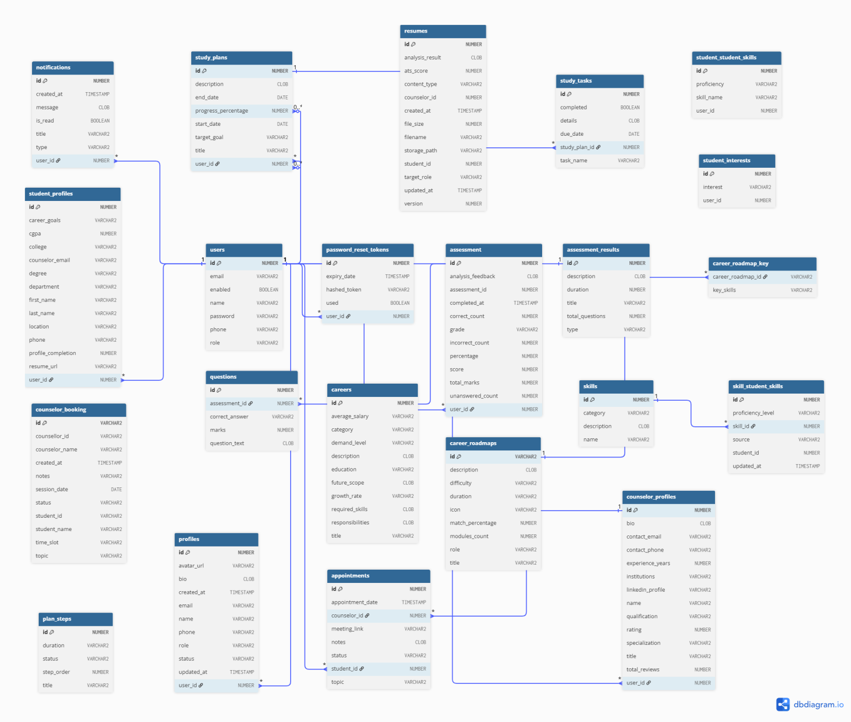

DATABASE ENTITY TABLE SPECIFICATIONS
This section provides the detailed field-level specification for each database entity/table in the VisionPath system, presented immediately following the class diagram above.

1. USERS
Field Name | Data Type | Constraints | Primary Key | Description
user_id | BIGINT | PRIMARY KEY, AUTO_INCREMENT | YES (PK) | Unique user identifier
full_name | VARCHAR(100) | NOT NULL | No | Student, Counsellor, or Administrator name
email | VARCHAR(150) | NOT NULL, UNIQUE | YES (Unique) | Login email
password_hash | VARCHAR(255) | NOT NULL | No | Hashed password
enabled | BOOLEAN | NOT NULL | No | Account activation status
phone | VARCHAR(20) | NULL | No | User contact number
role | VARCHAR(30) | NOT NULL | No | Student, Counsellor, or Administrator

2. PASSWORD_RESET_TOKENS
Field Name | Data Type | Constraints | Primary Key | Description
id | BIGINT | PRIMARY KEY, AUTO_INCREMENT | YES (PK) | Password reset token identifier
user_id | BIGINT | NOT NULL | No | User associated with the reset request
hashed_token | VARCHAR(255) | NOT NULL | No | Secure hashed reset token
expiry_date | TIMESTAMP | NOT NULL | No | Token expiration date and time
used | BOOLEAN | NOT NULL | No | Indicates whether the token has been used

3. ASSESSMENT_RESULTS
Field Name | Data Type | Constraints | Primary Key | Description
id | BIGINT | PRIMARY KEY, AUTO_INCREMENT | YES (PK) | Assessment result identifier
user_id | BIGINT | NOT NULL | No | Student who completed the assessment
assessment_id | BIGINT | NOT NULL | No | Assessment identifier
score | INTEGER | NULL | No | Score obtained
total_marks | INTEGER | NULL | No | Maximum available marks
percentage | INTEGER | NULL | No | Assessment percentage
correct_count | INTEGER | NULL | No | Number of correct answers
incorrect_count | INTEGER | NULL | No | Number of incorrect answers
unanswered_count | INTEGER | NULL | No | Number of unanswered questions
grade | VARCHAR(20) | NULL | No | Assessment grade
analysis_feedback | TEXT | NULL | No | AI-generated or system-generated feedback
completed_at | TIMESTAMP | NULL | No | Assessment completion date and time

4. ASSESSMENTS
Field Name | Data Type | Constraints | Primary Key | Description
id | BIGINT | PRIMARY KEY, AUTO_INCREMENT | YES (PK) | Assessment identifier
title | VARCHAR(255) | NOT NULL | No | Assessment title
description | TEXT | NULL | No | Assessment description
duration | INTEGER | NULL | No | Assessment duration
type | VARCHAR(100) | NULL | No | Assessment type
total_questions | INTEGER | NULL | No | Total number of questions

5. QUESTIONS
Field Name | Data Type | Constraints | Primary Key | Description
id | BIGINT | PRIMARY KEY, AUTO_INCREMENT | YES (PK) | Question identifier
assessment_id | BIGINT | NOT NULL | No | Associated assessment
question_text | TEXT | NOT NULL | No | Question content
correct_answer | VARCHAR(255) | NOT NULL | No | Correct answer
marks | INTEGER | NULL | No | Marks allocated to the question

6. CAREERS
Field Name | Data Type | Constraints | Primary Key | Description
id | BIGINT | PRIMARY KEY, AUTO_INCREMENT | YES (PK) | Career identifier
title | VARCHAR(255) | NOT NULL | No | Career title
category | VARCHAR(255) | NULL | No | Career category
description | TEXT | NULL | No | Career description
education | VARCHAR(255) | NULL | No | Required education
average_salary | VARCHAR(255) | NULL | No | Average salary information
demand_level | VARCHAR(255) | NULL | No | Current demand level
growth_rate | VARCHAR(255) | NULL | No | Expected growth rate
future_scope | TEXT | NULL | No | Future career scope
required_skills | TEXT | NULL | No | Required skills
responsibilities | TEXT | NULL | No | Main career responsibilities

7. CAREER_ROADMAPS
Field Name | Data Type | Constraints | Primary Key | Description
id | VARCHAR(255) | PRIMARY KEY | YES (PK) | Career roadmap identifier
title | VARCHAR(255) | NOT NULL | No | Roadmap title
description | VARCHAR(255) | NULL | No | Roadmap description
role | VARCHAR(255) | NULL | No | Target career role
difficulty | VARCHAR(255) | NULL | No | Roadmap difficulty
duration | VARCHAR(255) | NULL | No | Estimated roadmap duration
icon | VARCHAR(255) | NULL | No | Roadmap icon reference
match_percentage | INTEGER | NULL | No | Career match percentage
modules_count | INTEGER | NULL | No | Number of roadmap modules

8. CAREER_ROADMAP_KEY
Field Name | Data Type | Constraints | Primary Key | Description
career_roadmap_id | VARCHAR(255) | PRIMARY KEY, FOREIGN KEY | YES (PK) | Associated career roadmap
key_skills | VARCHAR(255) | NOT NULL | No | Key skill associated with roadmap

9. COUNSELOR_BOOKING
Field Name | Data Type | Constraints | Primary Key | Description
id | VARCHAR(255) | PRIMARY KEY | YES (PK) | Booking identifier
counsellor_id | VARCHAR(255) | NOT NULL | No | Counsellor identifier
counselor_name | VARCHAR(255) | NULL | No | Counsellor name
student_id | VARCHAR(255) | NOT NULL | No | Student identifier
student_name | VARCHAR(255) | NULL | No | Student name
session_date | DATE | NOT NULL | No | Counselling session date
time_slot | VARCHAR(255) | NOT NULL | No | Session time slot
topic | VARCHAR(255) | NULL | No | Counselling topic
notes | VARCHAR(255) | NULL | No | Booking notes
status | VARCHAR(255) | NOT NULL | No | Booking status
created_at | TIMESTAMP | NULL | No | Booking creation timestamp

10. COUNSELOR_PROFILES
Field Name | Data Type | Constraints | Primary Key | Description
id | BIGINT | PRIMARY KEY, AUTO_INCREMENT | YES (PK) | Counsellor profile identifier
user_id | BIGINT | NOT NULL | No | Associated user identifier
name | VARCHAR(255) | NOT NULL | No | Counsellor name
title | VARCHAR(255) | NULL | No | Professional title
qualification | VARCHAR(255) | NULL | No | Professional qualification
specialization | VARCHAR(255) | NULL | No | Counselling specialization
experience_years | INTEGER | NULL | No | Years of experience
bio | TEXT | NULL | No | Counsellor biography
contact_email | VARCHAR(255) | NULL | No | Contact email
contact_phone | VARCHAR(255) | NULL | No | Contact phone
linkedin_profile | VARCHAR(255) | NULL | No | LinkedIn profile
institutions | VARCHAR(255) | NULL | No | Associated institutions
rating | DOUBLE | NULL | No | Counsellor rating
total_reviews | INTEGER | NULL | No | Number of reviews

11. APPOINTMENTS
Field Name | Data Type | Constraints | Primary Key | Description
id | BIGINT | PRIMARY KEY, AUTO_INCREMENT | YES (PK) | Appointment identifier
counsellor_id | BIGINT | NOT NULL | No | Counsellor identifier
student_id | BIGINT | NOT NULL | No | Student identifier
appointment_date | TIMESTAMP | NOT NULL | No | Appointment date and time
meeting_link | VARCHAR(255) | NULL | No | Online meeting link
topic | VARCHAR(255) | NULL | No | Appointment topic
notes | TEXT | NULL | No | Appointment notes
status | VARCHAR(50) | NOT NULL | No | Appointment status

12. NOTIFICATIONS
Field Name | Data Type | Constraints | Primary Key | Description
id | BIGINT | PRIMARY KEY, AUTO_INCREMENT | YES (PK) | Notification identifier
user_id | BIGINT | NOT NULL | No | Recipient user identifier
title | VARCHAR(255) | NOT NULL | No | Notification title
message | TEXT | NOT NULL | No | Notification message
type | VARCHAR(255) | NULL | No | Notification type
is_read | BOOLEAN | NOT NULL | No | Read/unread status
created_at | TIMESTAMP | NOT NULL | No | Notification creation timestamp

13. RESUMES
Field Name | Data Type | Constraints | Primary Key | Description
id | BIGINT | PRIMARY KEY, AUTO_INCREMENT | YES (PK) | Resume identifier
student_id | BIGINT | NOT NULL | No | Student identifier
counselor_id | BIGINT | NULL | No | Counsellor identifier
filename | VARCHAR(255) | NOT NULL | No | Uploaded resume filename
content_type | VARCHAR(255) | NULL | No | Resume file content type
file_size | BIGINT | NULL | No | Resume file size
storage_path | VARCHAR(255) | NULL | No | Stored file path
target_role | VARCHAR(255) | NULL | No | Target career role
ats_score | INTEGER | NULL | No | ATS compatibility score
analysis_result | VARCHAR(255) | NULL | No | Resume analysis result
version | INTEGER | NULL | No | Resume version
created_at | TIMESTAMP | NOT NULL | No | Resume creation timestamp
updated_at | TIMESTAMP | NULL | No | Last update timestamp

14. SKILLS
Field Name | Data Type | Constraints | Primary Key | Description
id | BIGINT | PRIMARY KEY, AUTO_INCREMENT | YES (PK) | Skill identifier
name | VARCHAR(255) | NOT NULL | No | Skill name
category | VARCHAR(255) | NULL | No | Skill category
description | VARCHAR(255) | NULL | No | Skill description

15. STUDENT_SKILLS
Field Name | Data Type | Constraints | Primary Key | Description
id | BIGINT | PRIMARY KEY, AUTO_INCREMENT | YES (PK) | Student skill record identifier
student_id | BIGINT | NOT NULL | No | Student identifier
skill_id | BIGINT | NOT NULL | No | Skill identifier
proficiency_level | VARCHAR(255) | NULL | No | Student proficiency level
source | VARCHAR(255) | NULL | No | Source of skill information
updated_at | TIMESTAMP | NULL | No | Last update timestamp

16. STUDENT_PROFILES
Field Name | Data Type | Constraints | Primary Key | Description
id | BIGINT | PRIMARY KEY, AUTO_INCREMENT | YES (PK) | Student profile identifier
user_id | BIGINT | NOT NULL | No | Associated user identifier
first_name | VARCHAR(100) | NULL | No | Student first name
last_name | VARCHAR(100) | NULL | No | Student last name
phone | VARCHAR(20) | NULL | No | Student phone number
college | VARCHAR(255) | NULL | No | College or university
degree | VARCHAR(255) | NULL | No | Degree programme
department | VARCHAR(255) | NULL | No | Academic department
cgpa | VARCHAR(20) | NULL | No | Student CGPA
year | VARCHAR(20) | NULL | No | Current academic year
location | VARCHAR(255) | NULL | No | Student location
career_goals | TEXT | NULL | No | Student career goals
counselor_email | VARCHAR(255) | NULL | No | Assigned counsellor email
resume_url | VARCHAR(255) | NULL | No | Resume reference
profile_completion | INTEGER | NULL | No | Profile completion percentage

17. STUDENT_INTERESTS
Field Name | Data Type | Constraints | Primary Key | Description
id | BIGINT | PRIMARY KEY, AUTO_INCREMENT | YES (PK) | Interest record identifier
user_id | BIGINT | NOT NULL | No | Student user identifier
interest | VARCHAR(255) | NOT NULL | No | Student interest

18. STUDY_PLANS
Field Name | Data Type | Constraints | Primary Key | Description
id | BIGINT | PRIMARY KEY, AUTO_INCREMENT | YES (PK) | Study plan identifier
user_id | BIGINT | NOT NULL | No | Student user identifier
title | VARCHAR(255) | NOT NULL | No | Study plan title
description | TEXT | NULL | No | Study plan description
target_goal | VARCHAR(255) | NULL | No | Target learning or career goal
start_date | DATE | NULL | No | Study plan start date
end_date | DATE | NULL | No | Study plan end date
progress_percentage | INTEGER | NULL | No | Study plan completion percentage

19. STUDY_TASKS
Field Name | Data Type | Constraints | Primary Key | Description
id | BIGINT | PRIMARY KEY, AUTO_INCREMENT | YES (PK) | Study task identifier
study_plan_id | BIGINT | NOT NULL | No | Associated study plan
task_name | VARCHAR(255) | NOT NULL | No | Task name
details | TEXT | NULL | No | Task details
due_date | DATE | NULL | No | Task due date
completed | BOOLEAN | NOT NULL | No | Task completion status

20. PLAN_STEPS
Field Name | Data Type | Constraints | Primary Key | Description
id | BIGINT | PRIMARY KEY, AUTO_INCREMENT | YES (PK) | Plan step identifier
title | VARCHAR(255) | NOT NULL | No | Step title
status | VARCHAR(50) | NOT NULL | No | Step status
duration | VARCHAR(255) | NULL | No | Estimated duration
step_order | INTEGER | NOT NULL | No | Step sequence number

21. USER_PROFILES
Field Name | Data Type | Constraints | Primary Key | Description
id | BIGINT | PRIMARY KEY, AUTO_INCREMENT | YES (PK) | Profile identifier
user_id | BIGINT | NOT NULL | No | Associated user identifier
username | VARCHAR(100) | NULL | No | Username
avatar_url | VARCHAR(255) | NULL | No | Profile avatar
bio | TEXT | NULL | No | User biography
email | VARCHAR(255) | NULL | No | Profile email
name | VARCHAR(255) | NULL | No | Profile name
phone | VARCHAR(255) | NULL | No | Contact phone
role | VARCHAR(50) | NULL | No | User role
status | VARCHAR(50) | NULL | No | Profile status
created_at | TIMESTAMP | NULL | No | Profile creation timestamp
updated_at | TIMESTAMP | NULL | No | Last profile update timestamp

9. API DESIGN OVERVIEW
The tables below list the primary REST endpoints per microservice, following REST naming conventions (plural nouns for resources, HTTP verbs for actions). These form the basis of each service's Swagger/OpenAPI documentation.

Auth Service (Port: 8081)
Method | Endpoint | Auth Required | Description
POST | /auth/register | No | Register a new user (Student/Counsellor/Admin)
POST | /auth/login | No | Authenticate user; returns JWT access + refresh tokens
POST | /auth/refresh | Yes (refresh token) | Exchange a valid refresh token for a new access token
POST | /auth/logout | Yes | Invalidate the current session/refresh token

Student Service (Port: 8082)
Method | Endpoint | Auth Required | Description
GET | /students/me | Yes | Get the logged-in student's profile
PUT | /students/me | Yes | Update profile (skills, interests, education, preferences)
POST | /students/me/saved-careers | Yes | Save a career to the student's list
PUT | /students/me/goal | Yes | Set the active career/academic goal

Assessment Service (Port: 8083)
Method | Endpoint | Auth Required | Description
GET | /assessments/initial | Yes | Fetch the predefined initial assessment questions
POST | /assessments/initial/responses | Yes | Submit initial assessment responses; returns scores
GET | /assessments/personalized | Yes | Get AI-generated personalized assessment questions
POST | /assessments/personalized/responses | Yes | Submit personalized assessment responses
GET | /assessments/history | Yes | List the student's past assessment results

AI Mentor Service (Port: 8084)
Method | Endpoint | Auth Required | Description
POST | /mentor/chat | Yes | Send a message to the AI Mentor; returns the AI response
GET | /mentor/history | Yes | Retrieve chat/session history, where persisted

Career Service (Port: 8085)
Method | Endpoint | Auth Required | Description
GET | /careers/recommendations | Yes | Get AI-generated career recommendations for the student
GET | /careers/{id} | Yes | Get details of a specific career
POST | /careers/{id}/save | Yes | Save a career to the student's list
POST | /careers/{id}/select-goal | Yes | Set a saved career as the active goal

Study Plan Service (Port: 8086)
Method | Endpoint | Auth Required | Description
GET | /roadmaps | Yes | Search/browse existing study roadmaps
POST | /roadmaps/generate | Yes | Generate an AI-personalized roadmap for the student's goal
POST | /roadmaps/{id}/activate | Yes | Set a roadmap as the student's active roadmap
PUT | /roadmaps/tasks/{taskId}/complete | Yes | Mark a roadmap task as completed
GET | /roadmaps/active/progress | Yes | Get completion progress of the active roadmap

Progress Service (Port: 8087)
Method | Endpoint | Auth Required | Description
GET | /progress/me | Yes | Get the student's consolidated progress overview

Notification Service (Port: 8088)
Method | Endpoint | Auth Required | Description
GET | /notifications | Yes | List the student's notifications
PUT | /notifications/{id}/read | Yes | Mark a notification as read

Resume Analyzer Service (Port: 8089)
Method | Endpoint | Auth Required | Description
POST | /resumes/upload | Yes | Upload a resume for analysis
GET | /resumes/{id}/analysis | Yes | Get the ATS score, issues, and recommendations for a resume
GET | /resumes/history | Yes | List the student's past resume analyses

Education Service (Port: 8090)
Method | Endpoint | Auth Required | Description
GET | /education/careers/{careerId} | Yes | Get education information relevant to a career

Counsellor Service (Port: 8091)
Method | Endpoint | Auth Required | Description
GET | /counsellor/students | Yes (COUNSELLOR) | List students assigned to the counsellor
GET | /counsellor/students/{id} | Yes (COUNSELLOR) | Get detailed guidance view of an assigned student
POST | /counsellor/students/{id}/notes | Yes (COUNSELLOR) | Record a counselling note

Admin Service (Port: 8092)
Method | Endpoint | Auth Required | Description
GET | /admin/users | Yes (ADMIN) | List all users with pagination
PUT | /admin/users/{id}/status | Yes (ADMIN) | Activate / deactivate a user account
GET | /admin/monitoring | Yes (ADMIN) | View aggregated platform activity metrics

AI Integration Layer (Python FastAPI) (Port: 8000)
Method | Endpoint | Auth Required | Description
POST | /ai/assessment/personalize | Internal (service-to-service) | Generate personalized assessment questions and interpret results
POST | /ai/career/recommend | Internal (service-to-service) | Generate ranked career recommendations
POST | /ai/mentor/chat | Internal (service-to-service) | Generate an AI Mentor response
POST | /ai/roadmap/generate | Internal (service-to-service) | Generate a personalized study roadmap
POST | /ai/resume/analyze | Internal (service-to-service) | Assist resume analysis with qualitative recommendations
GET | /health | No | Health check endpoint — returns {"status":"ok"}

10. DEVOPS & DEPLOYMENT PLAN

10.1 CI/CD Pipeline — Jenkins
Stage | Stage Name | Actions
1 | Source Checkout | Jenkins pulls the latest code from the GitHub main branch via webhook on every push.
2 | Build | mvn clean package -DskipTests for each Spring Boot service; npm run build for the React frontend; pip install for the FastAPI AI service.
3 | Unit Test | mvn test runs JUnit 5 unit tests; test report generated; build fails if any test fails.
4 | Code Quality | Optional static-analysis scan (e.g., Checkstyle/SonarQube).
5 | Docker Build | docker build -t [service-name]:[git-commit-hash] for each service.
6 | Docker Push | Push images to a local Docker registry or a private Docker Hub repository.
7 | Deploy (Docker Compose) | docker-compose down && docker-compose up -d on the target environment.
8 | Health Check | curl /actuator/health (Spring services) and /health (AI service) — pipeline marked SUCCESS only if all services are healthy.
9 | Notification | Email/Slack notification to the team on pipeline success or failure.

10.2 Docker Container Configuration
Container | Image | Port Mapping | Depends On | Environment Variables
api-gateway | visionpath/api-gateway:latest | 8080:8080 | auth-service | JWT_SECRET
auth-service | visionpath/auth-service:latest | 8081:8081 | postgres | DB_URL, DB_USER, DB_PASSWORD, JWT_SECRET
student-service | visionpath/student-service:latest | 8082:8082 | postgres | DB_URL, DB_USER, DB_PASSWORD
assessment-service | visionpath/assessment-service:latest | 8083:8083 | postgres, ai-service | DB connection, AI_SERVICE_URL
mentor-service | visionpath/mentor-service:latest | 8084:8084 | postgres, ai-service | DB connection, AI_SERVICE_URL
career-service | visionpath/career-service:latest | 8085:8085 | postgres, ai-service | DB connection, AI_SERVICE_URL
study-plan-service | visionpath/study-plan-service:latest | 8086:8086 | postgres, ai-service | DB connection, AI_SERVICE_URL
progress-service | visionpath/progress-service:latest | 8087:8087 | postgres | DB connection
notification-service | visionpath/notification-service:latest | 8088:8088 | postgres | DB connection, SMTP config
resume-analyzer-service | visionpath/resume-analyzer:latest | 8089:8089 | postgres, ai-service | DB connection, AI_SERVICE_URL
education-service | visionpath/education-service:latest | 8090:8090 | postgres | DB connection
counsellor-service | visionpath/counsellor-service:latest | 8091:8091 | postgres | DB connection
admin-service | visionpath/admin-service:latest | 8092:8092 | postgres | DB connection
ai-service | visionpath/ai-service:latest | 8000:8000 | — | AI_PROVIDER_API_KEY
postgres | postgres:15 | 5432:5432 | — | POSTGRES_USER, POSTGRES_PASSWORD, POSTGRES_DB

10.3 Deployment Environments
Environment | Infrastructure | Purpose & Access
Development | localhost | Individual developer machines — docker-compose up; live reload via Spring DevTools + React dev server.
Testing / QA | Team-shared server / VM | Integration testing; Jenkins auto-deploys on merge to main.
Demo / Evaluation | Local machine / shared VM | Training-programme evaluation and faculty/mentor review; stable, accessible URL required.

11. PROJECT TIMELINE & MILESTONES
This timeline covers the 8-week project execution phase. AI Integration milestones align with Phases 1–6 from the training schedule.
Week | Phase | Deliverables & Tasks (both team members)
1 | Foundation | SRS completed and reviewed by mentor | Git repository created with branch strategy | PostgreSQL schema finalised (ER diagram) | Docker environment set up | API Gateway boilerplate running | AI Module 1 (Personalized Assessment): feature spec and prompt design started.
2 | Core Backend | Auth Service (register, login, JWT) complete and tested | Student Service CRUD endpoints complete | PostgreSQL schema migrated | Spring Security + JWT filter working end-to-end | AI Module 1: standalone FastAPI prototype for personalized-assessment generation.
3 | Full Backend | Assessment Service complete | Career Service complete | Inter-service calls (Feign/RestTemplate) working | Postman collection covering all endpoints | AI Module 2 (Career Recommendation): FastAPI endpoint deployed and integrated.
4 | Frontend Foundation | React project initialised | Login/Registration UI — JWT stored and used | Dashboard layout with role-based routing | Assessment screens connected to backend | AI Module 3 (AI Mentor): FastAPI endpoint deployed.
5 | Frontend Complete | Study Plan, Progress, Notification, and Resume Analyzer screens complete and connected to backend APIs | AI Mentor chat UI functional | AI Module 4 (Roadmap Generator + Resume Analyzer): integrated | Mobile-responsive layout verified on 375px viewport.
6 | Integration & Testing | End-to-end test: registration → assessment → recommendation → roadmap → progress → resume analysis, passing | JUnit unit tests for all service layers | Jenkins CI/CD pipeline — all stages green | Docker Compose — all containers starting cleanly.
7 | Polish & Documentation | All known bugs fixed | API documentation complete for all endpoints | README with setup instructions and architecture overview | Demo video recorded | Internal Review (Day 22) — SRS + working demo presented.
8 | Final Submission | Industry Mentor Review — feedback incorporated | GitHub repository clean and tagged v1.0 | SRS updated to v2.0 (post-review) | Final demo rehearsal | Project poster / slide deck prepared.

12. TEAM COMPOSITION & ROLE ASSIGNMENT
Member Name | Branch | Year | Responsibilities
Shalini S | CSE | 2nd | Backend microservices, AI module
Sri Muthu Nivethitha S | Cyber Security | 2nd | Frontend, DevOps

▸ Ownership Matrix
Component | Shalini S (Primary) | Sri Muthu Nivethitha S (Primary)
API Gateway | Owner | Support
Auth Service | Owner | Support
Student Service | Owner | Support
Career Service | Owner | Support
Counsellor Service | Support | Owner
Admin Service | Owner | Support
Assessment Service | Support | Owner
AI Mentor Service | Support | Owner
Study Plan Service | Owner | Support
Resume Analyzer Service | Owner | Support
skills Service | Support | Owner
AI Integration Layer (FastAPI) | Owner | Support
React Frontend | Support | Owner
Docker + Jenkins CI/CD | Owner | Support
Database Schema Design | Support | Owner
ER Diagram & Database Documentation | Support | Owner
SRS Documentation | Support | Owner
Testing (JUnit + Postman) | Support | Owner

▸ Interdisciplinary Contribution Map
Stream | Expected Contribution Area | Specific Contribution in THIS Project
CSE | Full-stack Java (Spring Boot), React frontend, database design | Shalini S develops the api gate way service ,Auth service, Student service , Career service , assessment service and Admin Services,study plan service ,resume analyzer service ,docker and CI/CD and AI Integration Layer (FastAPI).
Cyber Security | AI/ML integration, DevOps, security-conscious backend design | Sri Muthu Nivethitha S develops the Assessment, AI Mentor, counselor, skills and database documentation, and JUnit/Postman testing. Given her Cyber Security background, she also leads on securing the AI provider API key and JWT handling.

13. RISK REGISTER
Reviewed at weekly team meetings; probability and impact are rated H/M/L.
ID | Risk Description | Prob. | Impact | Mitigation Strategy
R01 | AI-generated recommendations/questions are irrelevant or low quality on a meaningful share of test cases | M | H | Iterate on prompt design with real assessment data; add a rule-based fallback for low-confidence AI output; validate manually before Internal Review.
R02 | External AI provider API becomes unavailable, rate-limited, or changes pricing | M | H | Implement the fallback paths defined in Section 6 for each AI module; cache recent responses where reasonable; keep a mock-data layer for development.
R03 | Resume parsing / ATS analysis mis-extracts content from certain resume formats | M | M | Test against a range of resume templates and file types early; clearly surface extraction failures to the student rather than silently mis-scoring.
R04 | Training/reference dataset for career and education information is incomplete or not representative | M | M | Curate a reasonably broad career/education reference set; document known gaps; expand iteratively based on mentor feedback.
R05 | One of the two team members is unable to complete an assigned microservice before a review deadline | L | H | Cross-train both members on the overall architecture in Week 1–2; maintain a 1-week buffer in the timeline; daily check-ins to surface blockers early.
R06 | Docker / docker-compose deployment fails during the live demo due to environment differences | M | M | Test deployment on a clean machine at least a week before the demo; keep a tested docker-compose.yml as a backup; record a demo video as contingency.
R07 | Accidental exposure of real personal or resume data in a development environment | L | H | Use synthetic/anonymised data in development; never commit real credentials or resumes to Git; use .env files with .gitignore.
R08 | Scope creep — the team adds features not in this SRS while core functionality remains incomplete | M | M | Freeze scope at Week 1 SRS sign-off; track feature status on GitHub Issues; add new features only in a designated stretch-goal window.
R09 | AI provider API costs exceed the available budget/quota during heavy testing | M | M | Cache/reuse AI responses during development; rate-limit AI-dependent test runs; monitor usage against provider quota.
R10 | Cross-service data inconsistency (e.g., progress not reflecting a completed task) due to the microservice architecture | M | M | Define clear service-to-service API contracts for state changes (Section 9); add integration tests covering the update-then-read path across services.

14. APPENDIX

14.1 Glossary of Domain-Specific Terms
Term | Definition
Initial Assessment | The predefined first-stage assessment covering technical, non-technical, personality, interests, skills, and education categories.
Personalized Assessment | The AI-generated second-stage assessment based on the student's initial results.
ATS Score | An estimated compatibility score indicating how well a resume is likely to be parsed and ranked by automated resume-screening software.
Roadmap | A structured, staged learning/career plan generated (or selected) toward a student's chosen goal, made up of ordered tasks.
Active Goal | The career or academic objective a student has currently set, used to drive roadmap generation.

14.2 AI Model Details — Prompting / Configuration Logs (Attach after implementation)
- Reference data used for career/education prompts: [ Name, source, number of records — to be completed once the reference dataset is finalised ]
- AI Integration Layer environment: [ Python version, library versions — to be completed after implementation ]
- Qualitative review outcomes (relevance/appropriateness): [ To be attached after Internal Review manual evaluation ]
- Prompt templates used per module: [ To be attached as an engineering appendix once finalised ]

14.3 API Request-Response Samples
Endpoint | Sample Request Body (JSON) | Sample Response Body (JSON)
POST /auth/register | { "fullName": "Arjun Kumar", "email": "arjun@example.com", "password": "SecurePass@123", "role": "STUDENT" } | { "success": true, "message": "Account created", "userId": 1001 }
POST /mentor/chat | { "message": "What skills do I need for a data analyst role?" } | { "reply": "[AI Mentor response text]", "sessionId": "sess_2044" }
[ Add further endpoints as implemented ] | { ... } | { ... }

OUTPUT SCREENSHOTS:

sign up page for student:

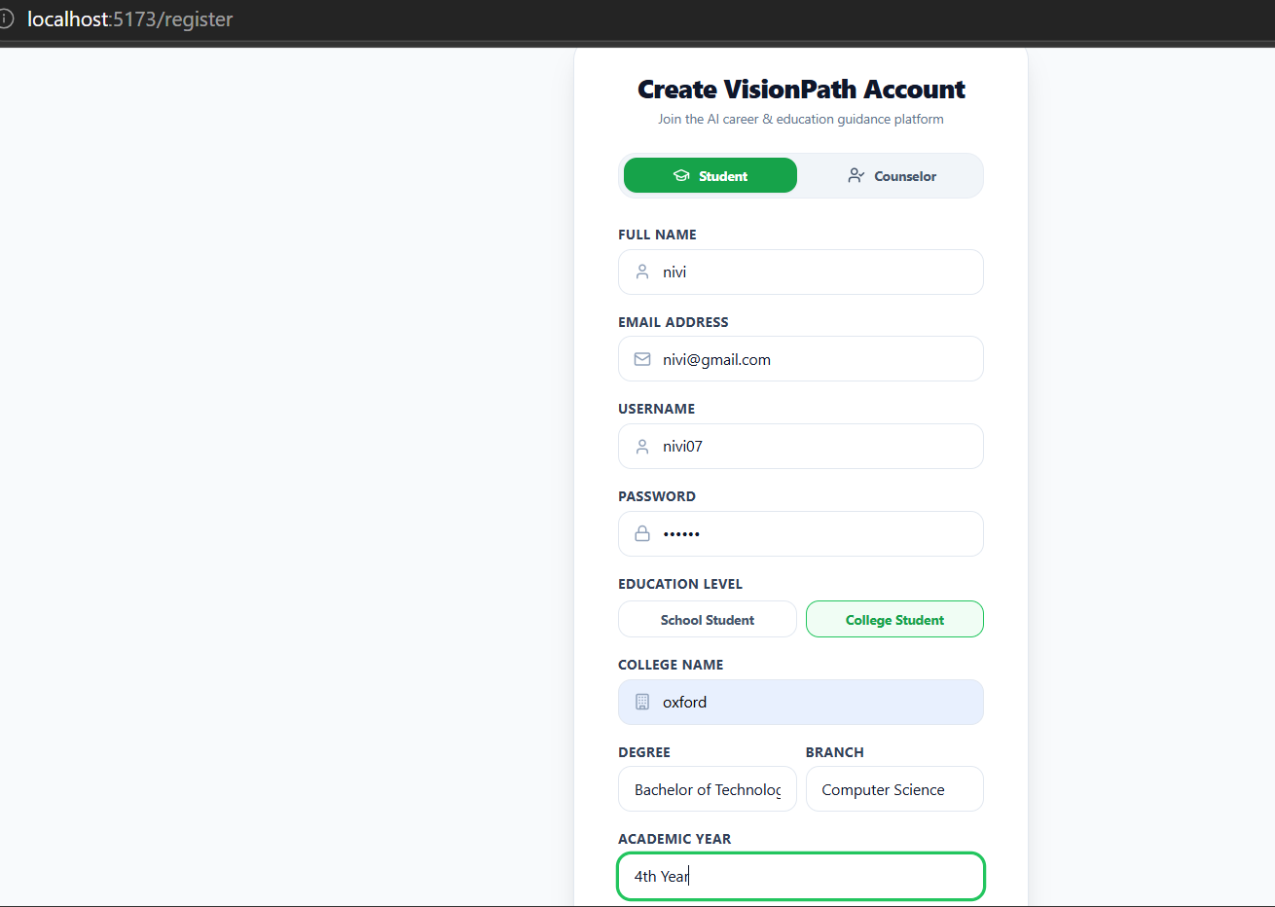:

Sign in page for student:

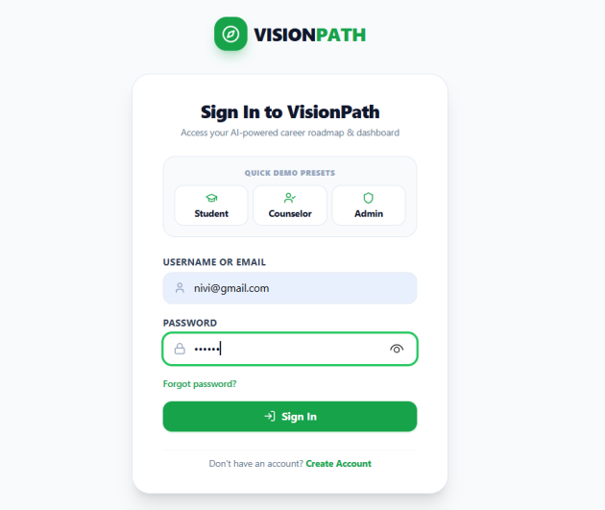

Student’s dashboard page:

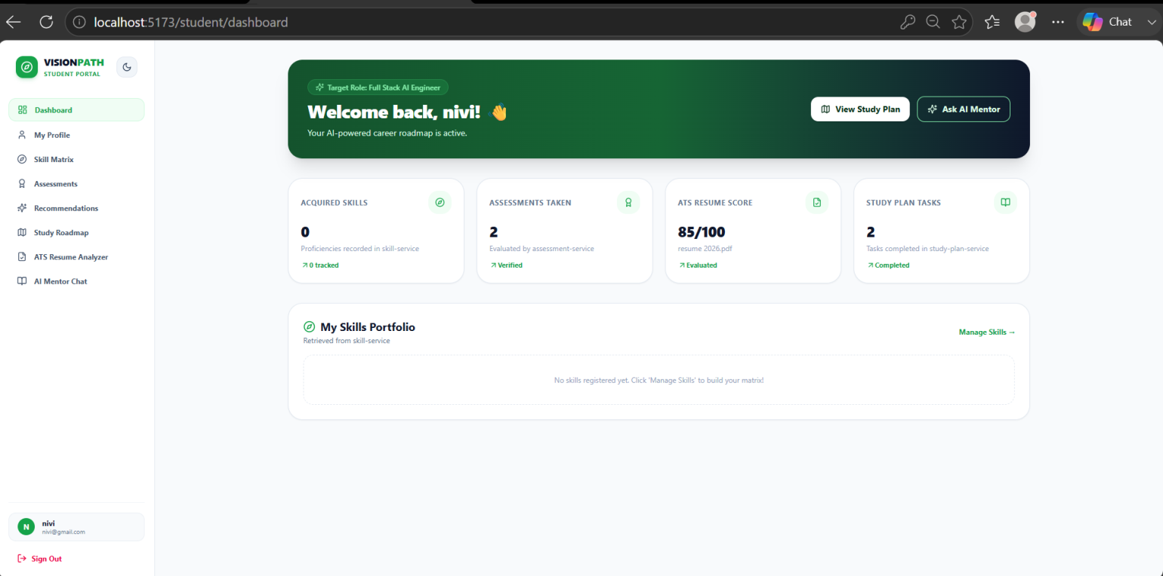

Profile page for of student:

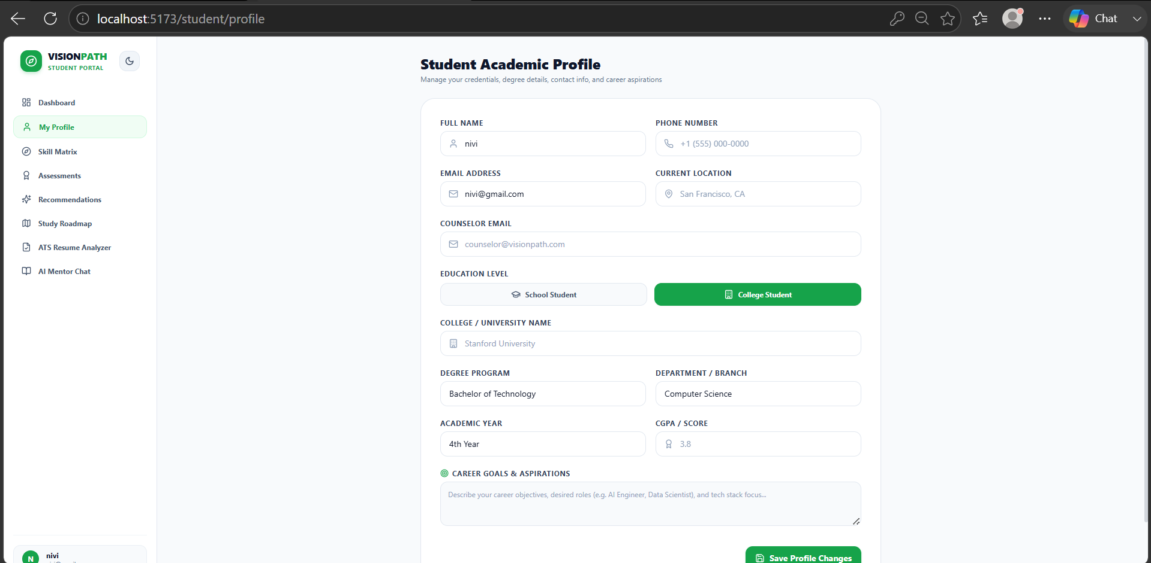

Skills page of student:

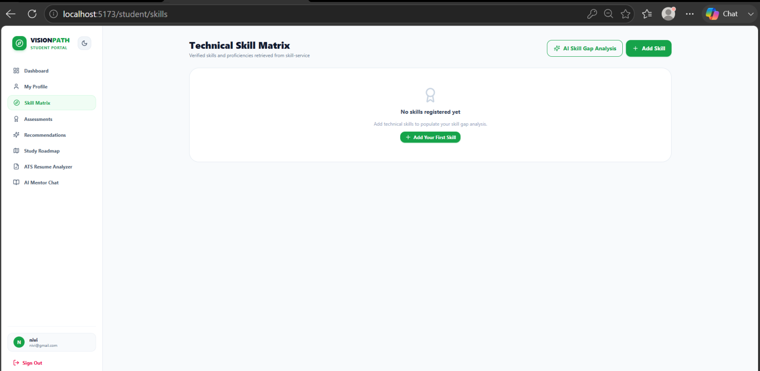

Assessment page:

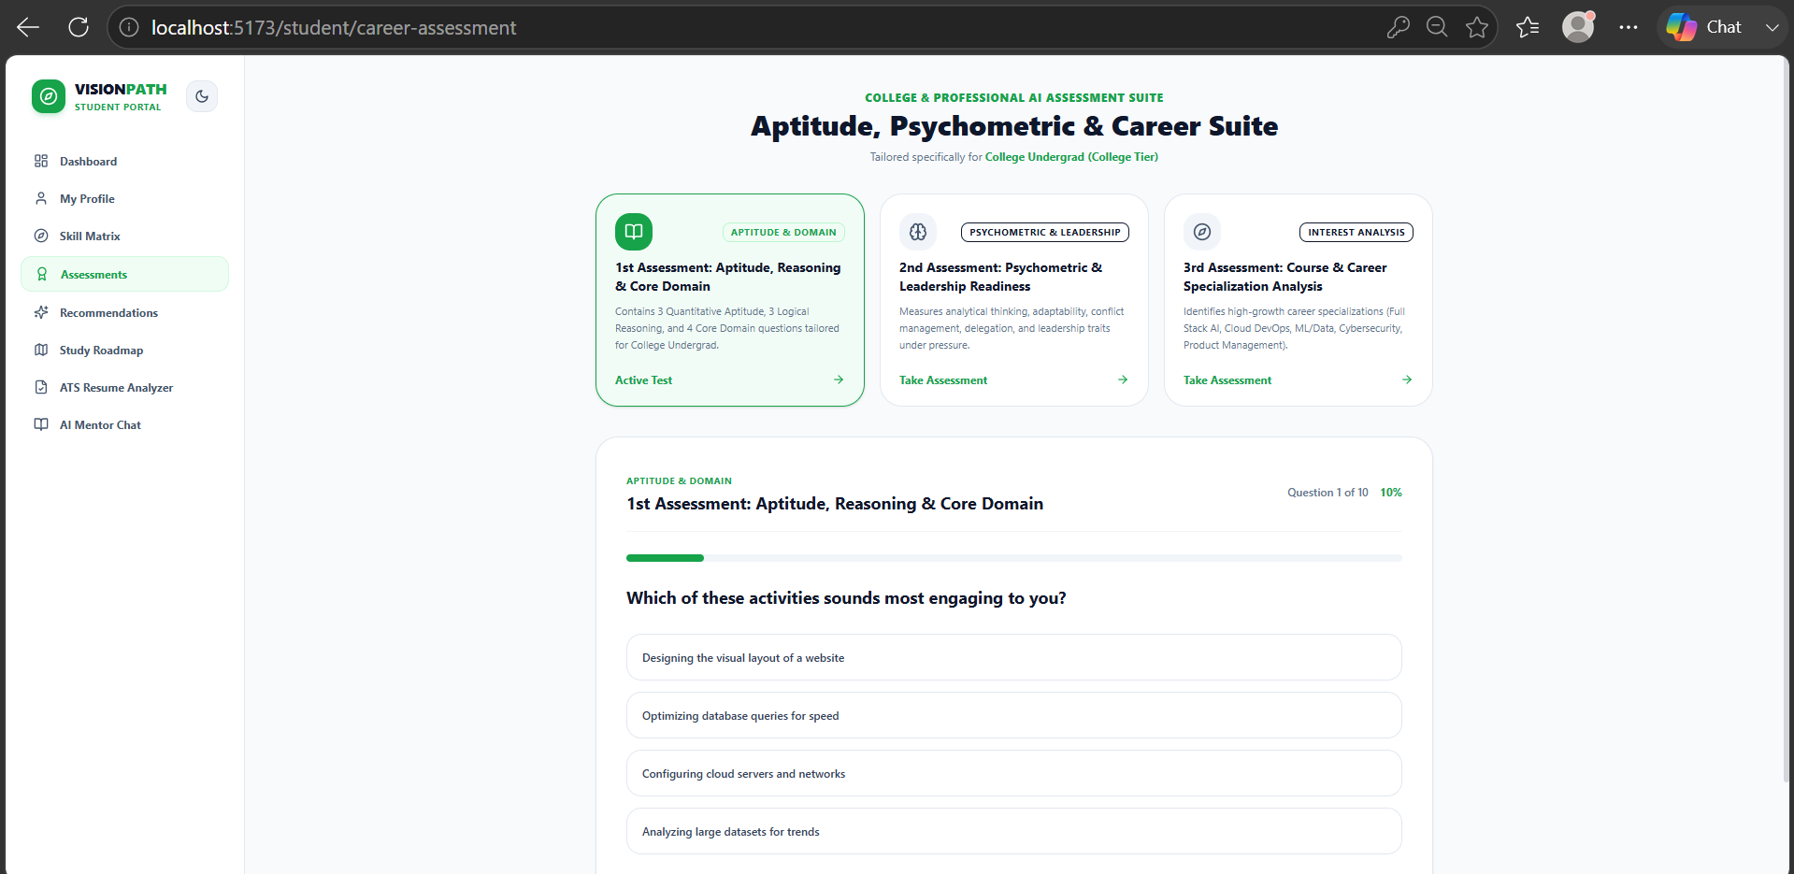

Aptitude,reasoning and core assessment:

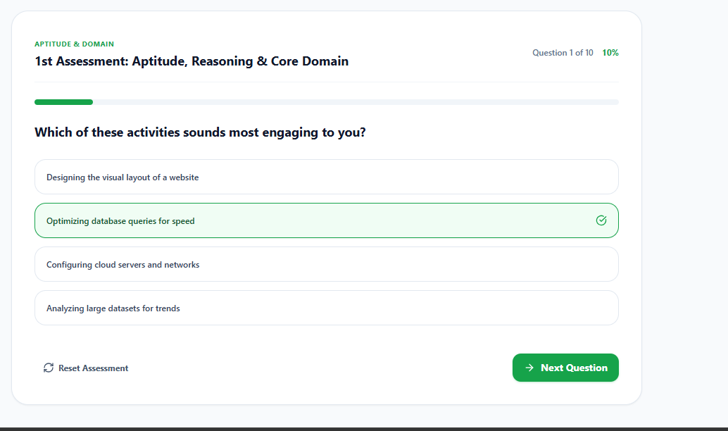

Psychometric and leadership assessment:

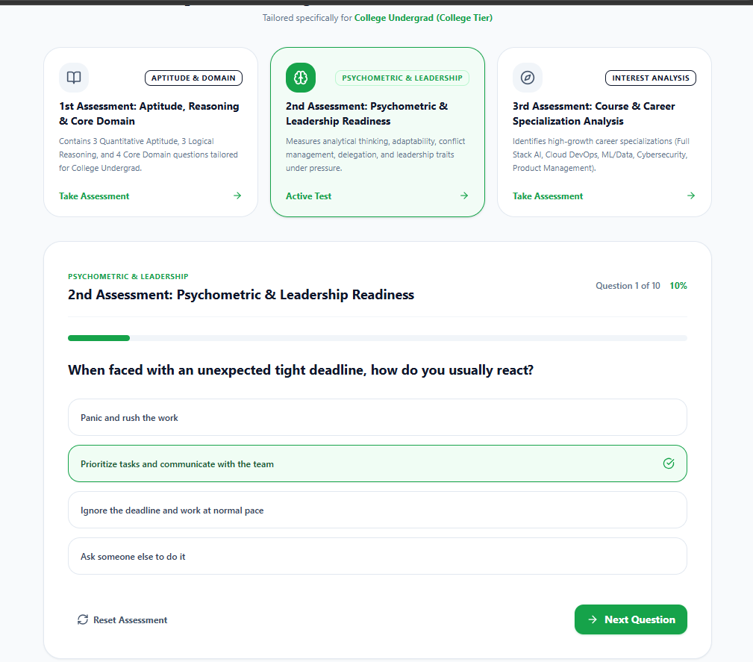

Apptitude ,psychometric and career suite assessment:

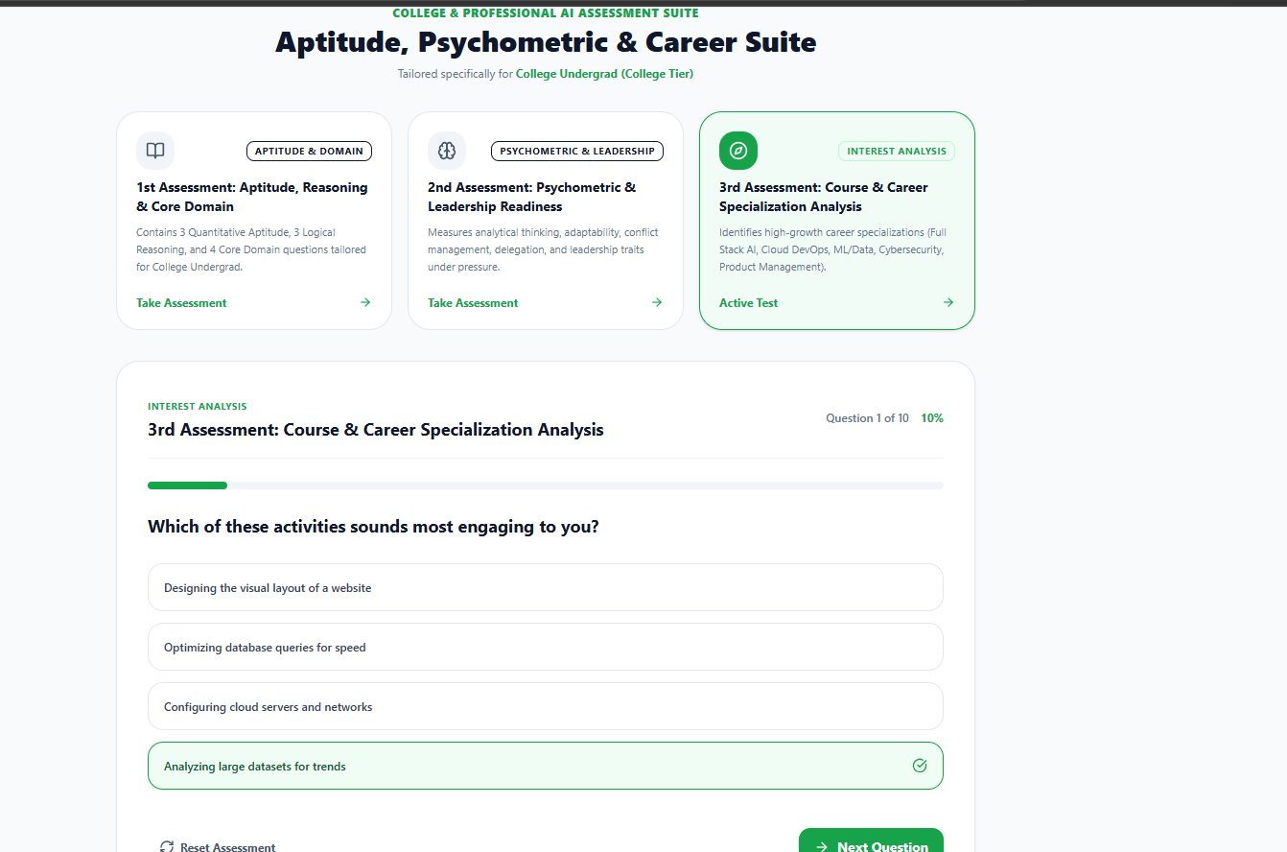

Assessment result page:

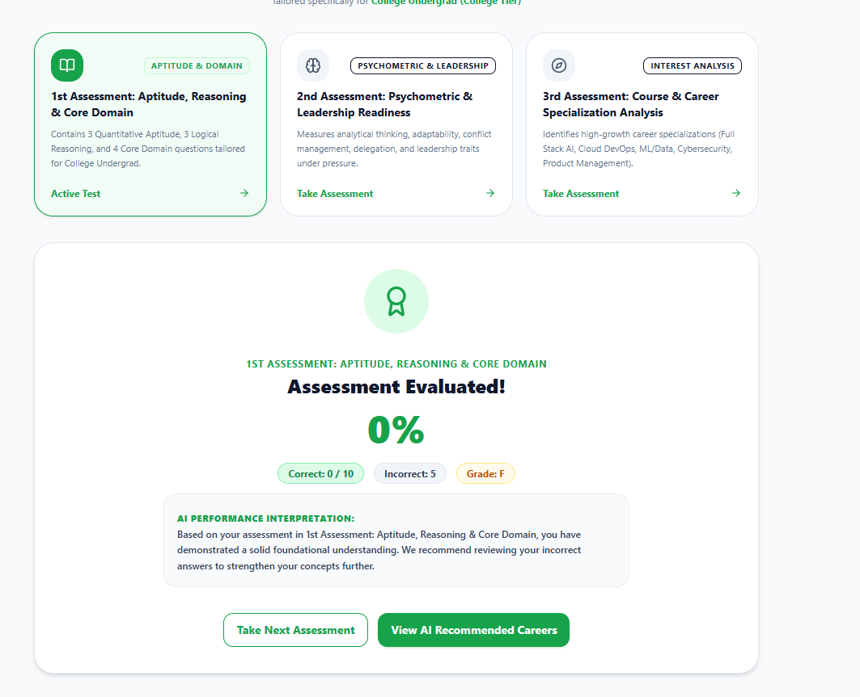

AI career recommendation page:

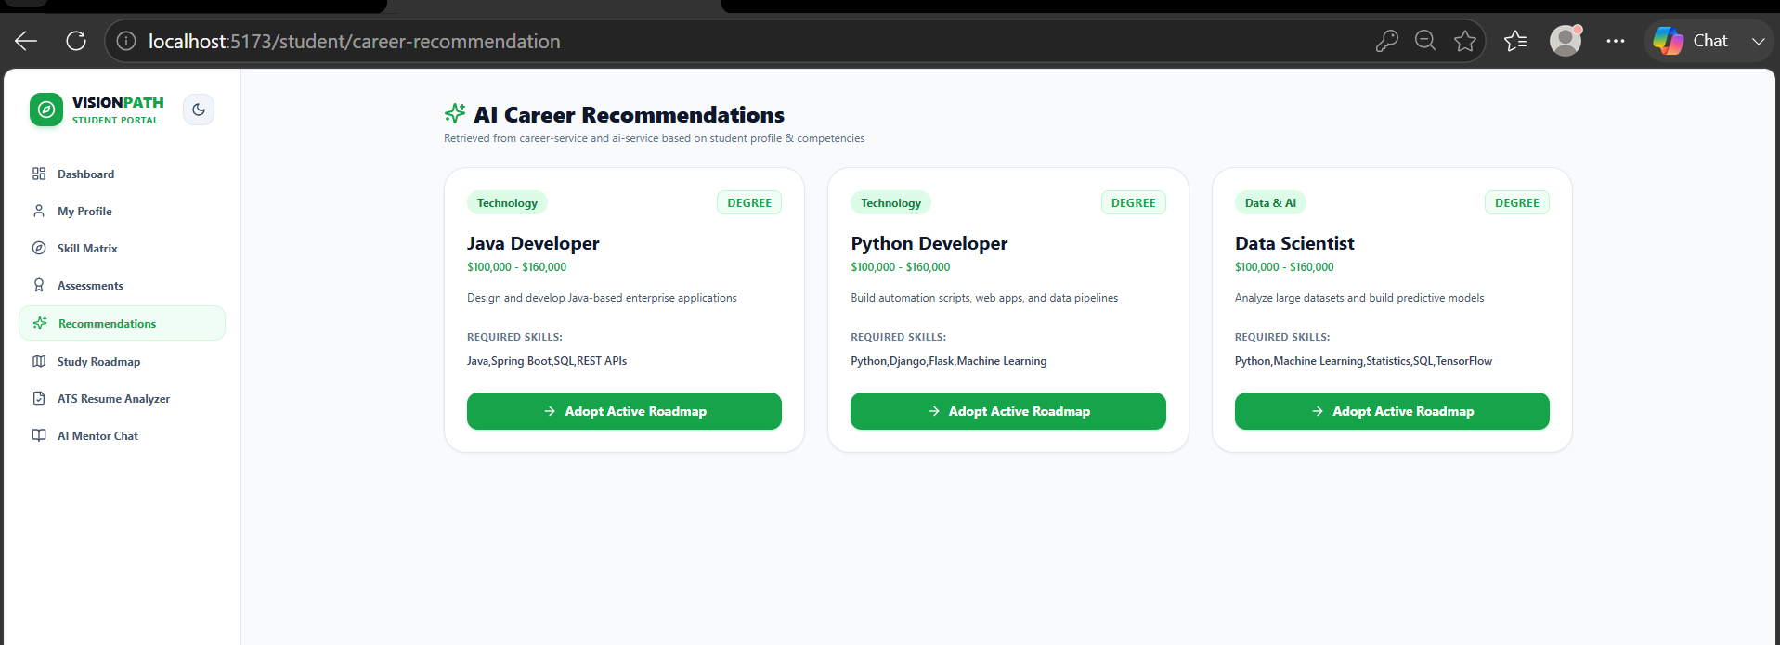

Study roadmap page:

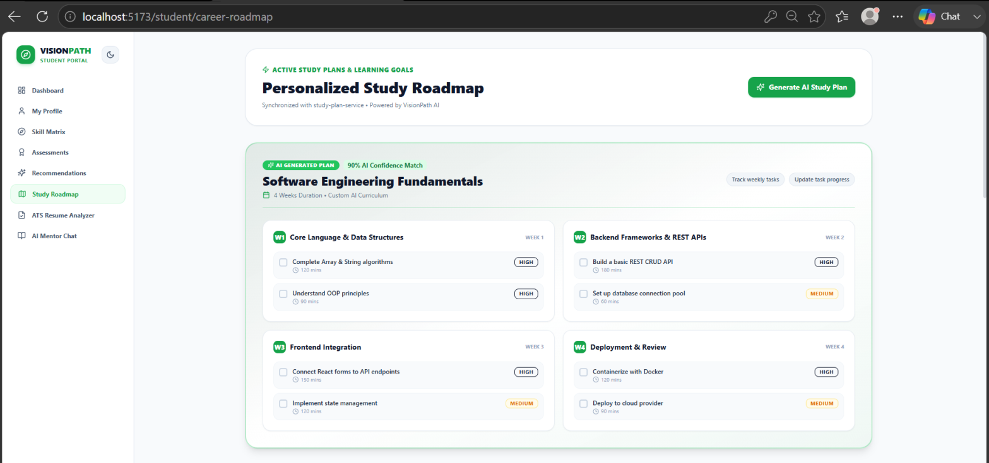

Active road maps:

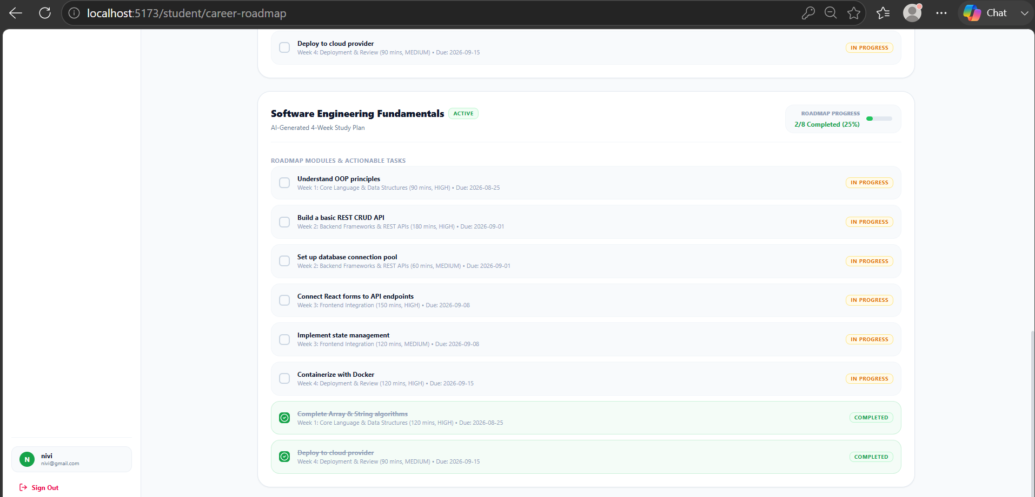

AI ATS resume analyzer page:

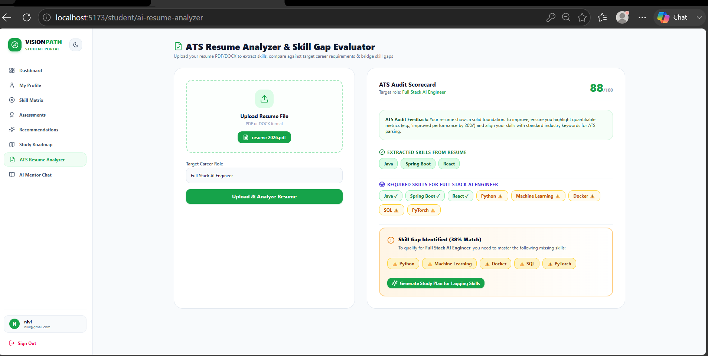

AI mentor chat page:

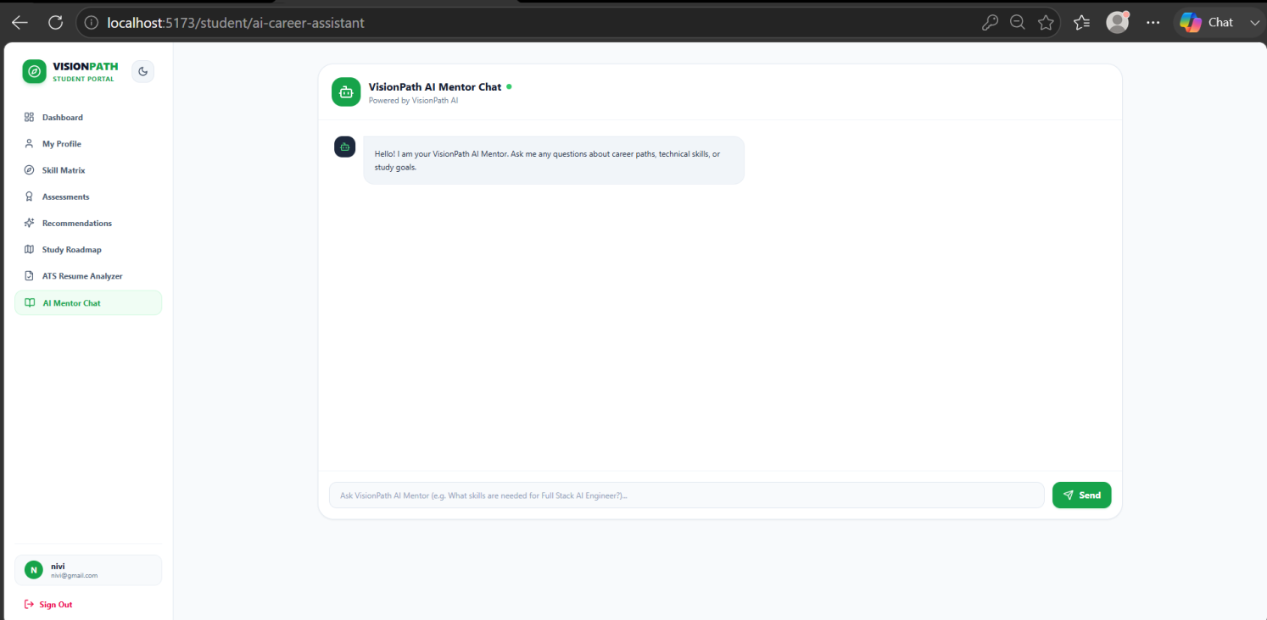

Sign up page for counselor:

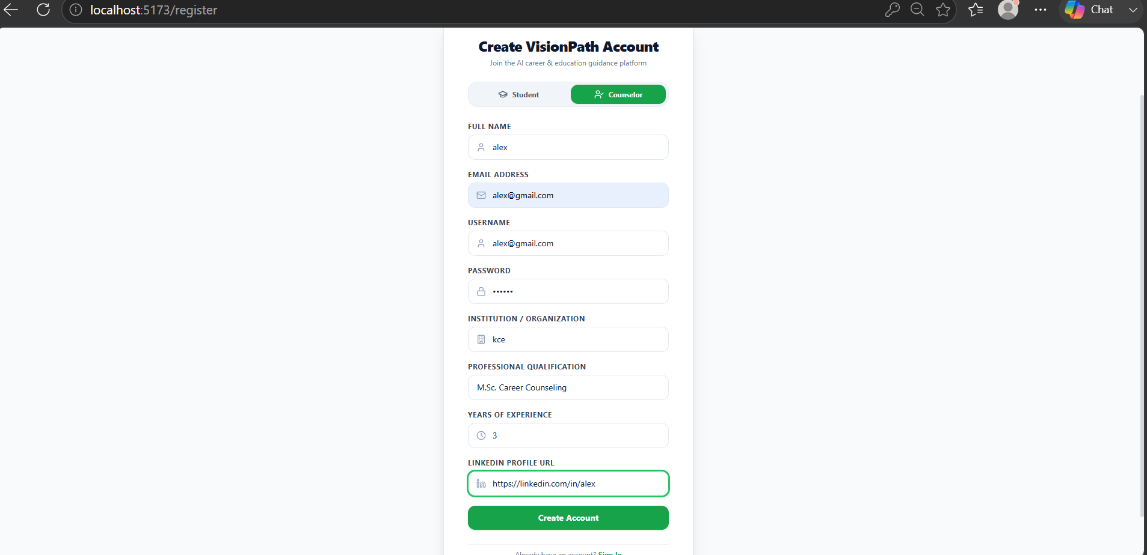

Counselor verification:

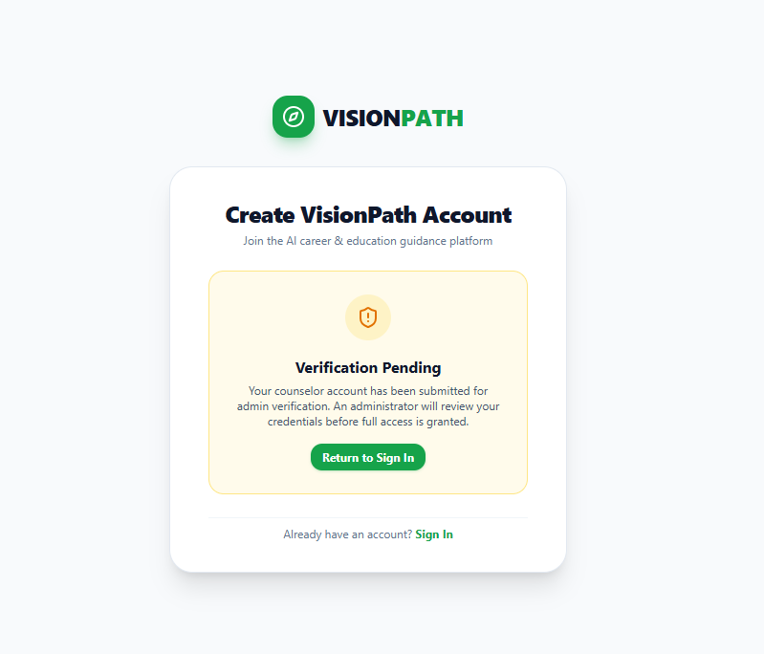

Sign in page for counselor:

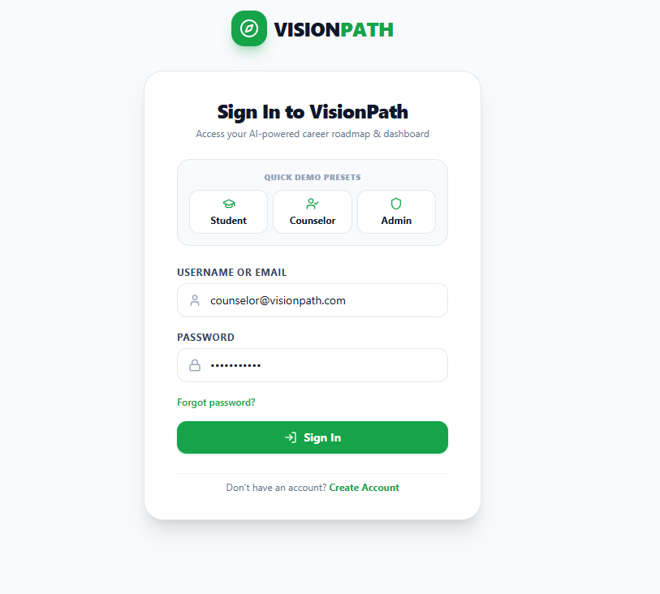

Counselor’s dashboard page:

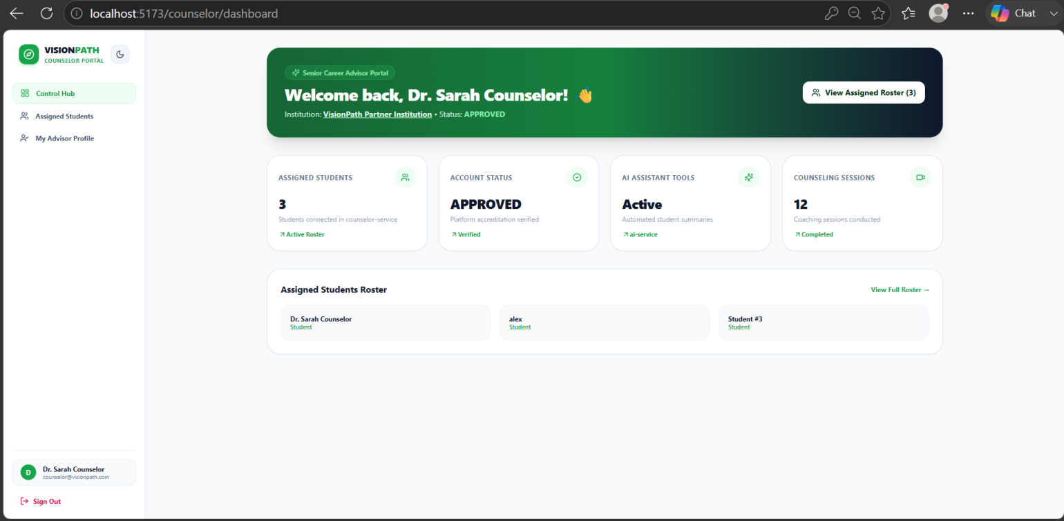

Counselor’s profile page:

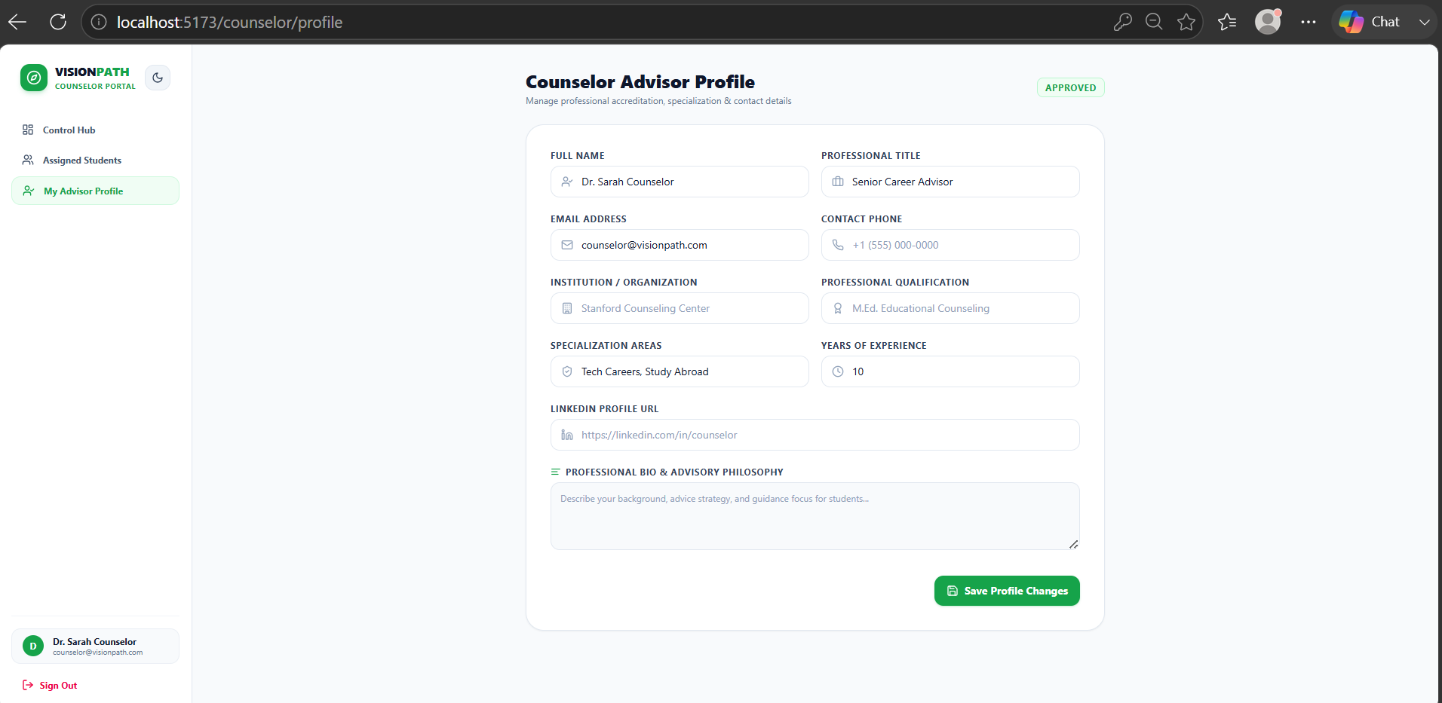

Assigned students page:

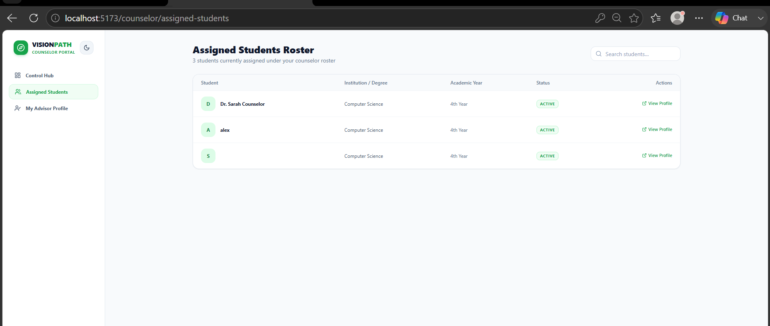

Student’s profile and ai generated summary of student’s profile:

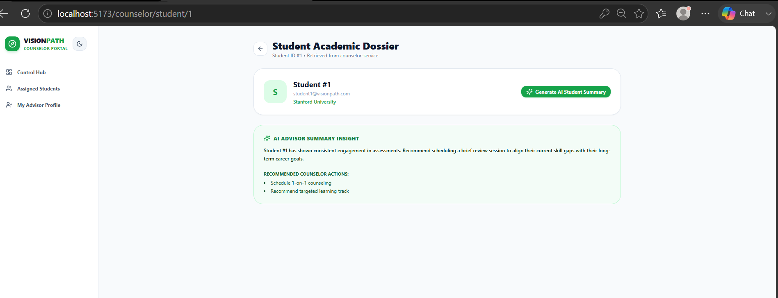

Sign in page for admin:

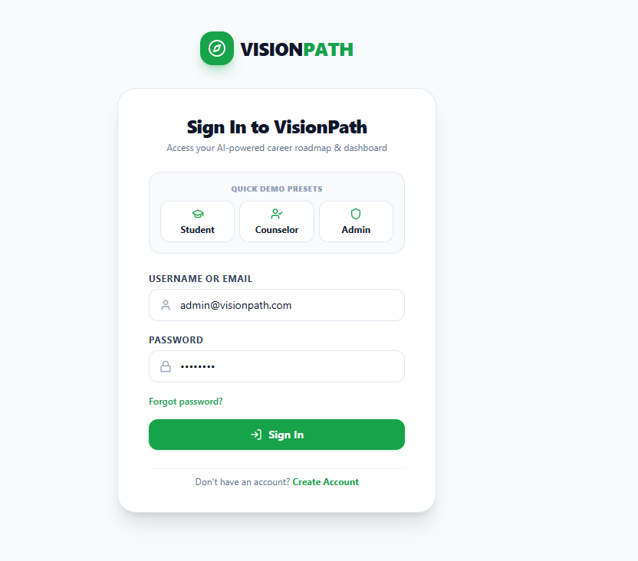

Admin dashboard page:

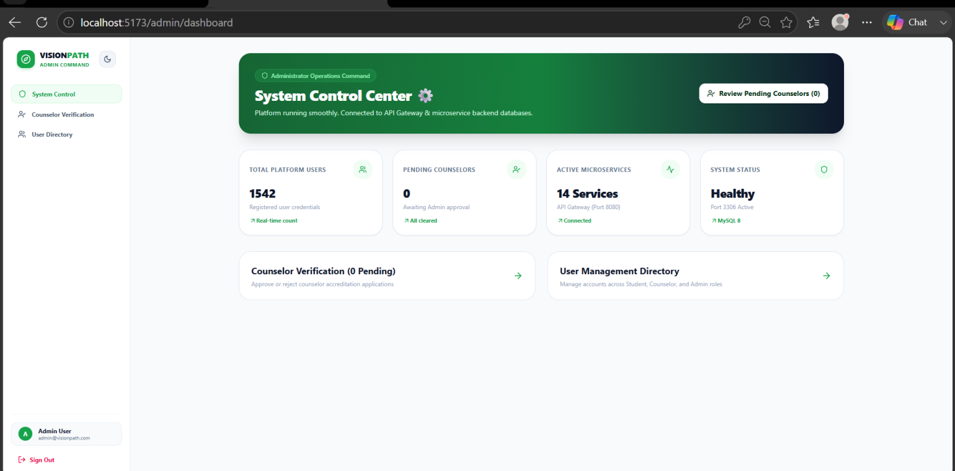

Counselor verification page:
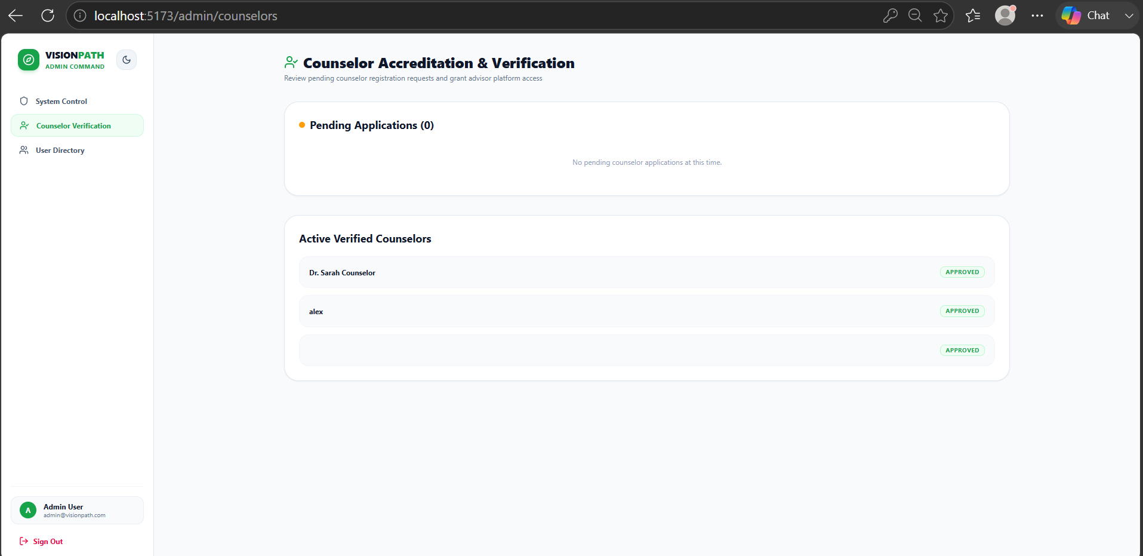

User directory page:

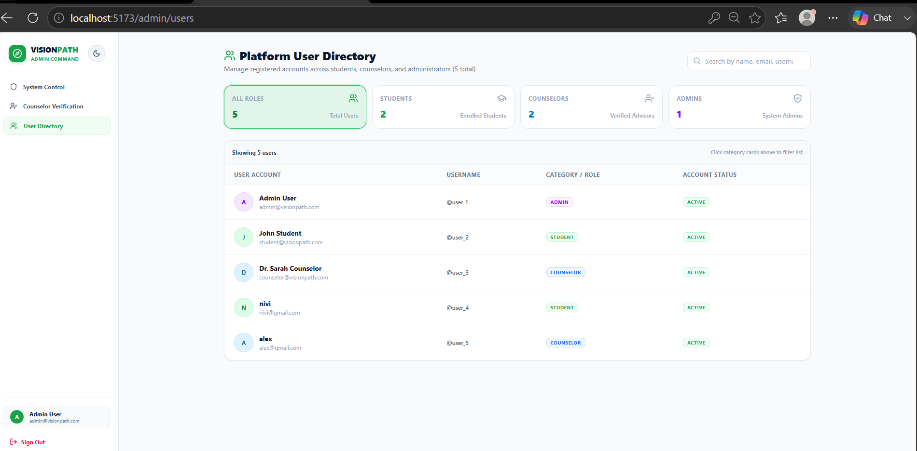

14.4 References & Citations
- [ Career/education reference dataset ] — Author/Organisation. “Dataset Name.” URL: [ link ] Accessed: [ date ]
- [ Resume-parsing/ATS reference library or API ] — documentation URL
- [ Any additional third-party library or API documentation referenced ]

END OF SRS DOCUMENT — Version 1.0
Full Stack Java (AI-Integrated) Training Programme | Dr. Arul Antran Vijay & Dr. Jothi Prakash

