**DAY 1:**

**English**

1. Learn the poem “Two Little Hands”, record a video reciting it and send it to the teacher.
2. Write the above poem in beautiful cursive handwriting.

**Hindi**

1. “Meena ka Parivar”. Read and write one page sulekh

**Mathematics**

1. Write counting 1-100.

**EVS**

1. Learn and write the names of 10 body parts.

**DAY 2:**

**English**

1. Do a conversation with your parents. (Page No. 5, Mridang)
2. Read and write. (Page no. 4 mridang)

**Hindi**

1. Read and write “Chanda mama door ke” (Page no. 7, Sarangi)
2. Read and write 10 words (**आ की मात्रा)**

**Mathematics**

1. Write reverse counting (back-counting) 100-1.

**EVS**

1. Write about yourself.
2. Make a video speaking four-five lines about yourself.

**DAY 3:**

**English**

1. Read and Write from page no. 7 Mridang.
2. Learn the alphabet song from page no. 10, record the video and send it to the teacher.

**Hindi**

1. Read and write “Dada-Dadi” (Page no. 8, Sarangi)
2. Read and write 10 words (**आ की मात्रा)**

**Mathematics**

1. Write and learn number names 1-50.

**EVS**

1. Write the name of all of your family members. Example:

* Father - __________________________
* Mother- __________________________
* Brother-__________________________
* Sister-____________________________
* Grandfather_______________________ (You can write as per your family members)

**DAY 4:**

**English**

1. Write 5 words beginning with each letter sound (A-Z).
2. Learn and say the following greetings aloud. (Page no. 15)

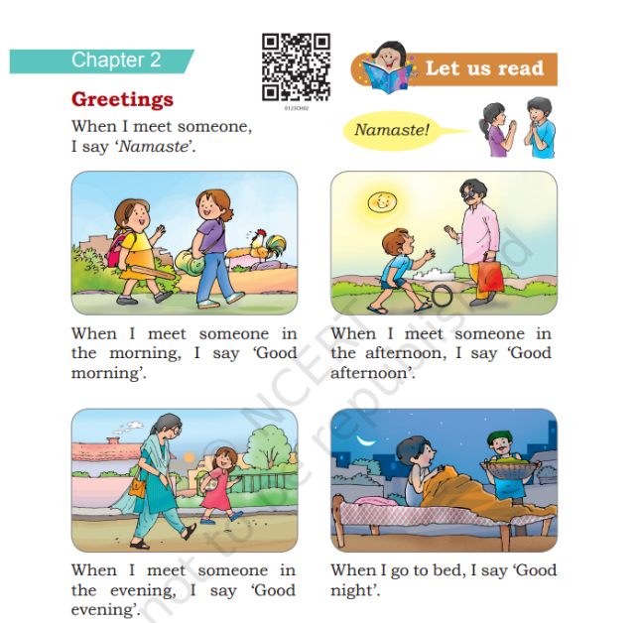

**Hindi**

1. Read and write “Reena Ka Din” (Page no. 11-12, Sarangi)
2. Read and write 10 words (**इ की मात्रा)**

**Mathematics**

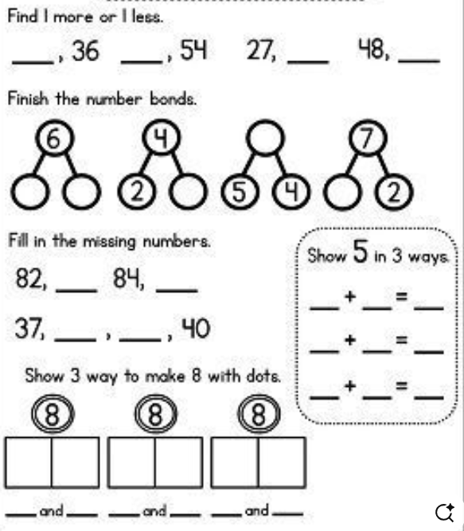

**EVS**

1. Write and learn the spellings of the seven days of the week.

**DAY 5:**

**English**

1. Learn the poem “Hop a Little”, record a video reciting it and send it to the teacher.
2. Write the above poem in beautiful cursive handwriting.

**Hindi**

**Mathematics**

**EVS**

**DAY 6:**

**English:**

1. Look at the picture and answer the given questions: (Paste a picture from net)
2. Read and write the following: (cvc words story)

**Hindi**

**Mathematics**

**EVS**

**DAY 7:**

**English**

1. Write and learn 10 action words. Also make their pictures (Page no. 24-25)
2. Read and write the following: (cvc words story)

**Hindi**

**Mathematics**

**EVS**

**DAY 8:**

**English**

1. Write and learn the following action words (give any 10)
2. Read and write the following: (cvc words story)

**Hindi**

**Mathematics**

**EVS**

**DAY 9:**

**English**

1. Complete the following words worksheet (Page no. 28)
2. Read and write the following: (cvc words story)

**Hindi**

**Mathematics**

**EVS**

**DAY 10:**

**English**

1. Picture reading (family related)
2. Read and write “My family” (Page no. 36 Mridang)

**Hindi**

**Mathematics**

**EVS**

**DAY 11:**

**English**

1. Read and write “The Sparrow family” (Page no. 37 Mridang)
2. Write the name of the family members (Page no. 30 worksheet)

**Hindi**

**Mathematics**

**EVS**

**DAY 12:**

**English**

1. Identify the pictures, write their names and learn their spellings.
2. Read and write the following: (cvcc words story)

**Hindi**

**Mathematics**

**EVS**

**DAY 13:**

**English**

1. Picture reading (Life around us) (Page no. 47)
2. Read and write the following: (cvc words story)

**Hindi**

**Mathematics**

**EVS**

**DAY 14:**

**English**

1. Learn the poem “Fun with numbers”, record a video reciting it and send it to the teacher.
2. Write the above poem in beautiful cursive handwriting.

**Hindi**

**Mathematics**

**EVS**

**DAY 15:**

**English**

1. Learn the poem “Five Little Monkeys”, record a video reciting it and send it to the teacher.
2. Write the above poem in beautiful cursive handwriting.

**Hindi**

**Mathematics**

**EVS**

**DAY 16:**

**English**

1. Worksheet make words using the given letters and sound and read them aloud (Page no. 52)
2. Read and write the following: (Phonics words story)

**Hindi**

**Mathematics**

**EVS**

**DAY 17:**

**English**

1. Read the chapter “The Cap-seller and the Mokeys” and write a page in beautiful handwriting.
2. Worksheet phonics (Identify words with same sounds or complete the spellings)

**Hindi**

**Mathematics**

**EVS**

**DAY 18:**

**English**

1. Learn the poem “Butterflies”, record a video reciting it and send it to the teacher.
2. Write the above poem in beautiful cursive handwriting.

**Hindi**

**Mathematics**

**EVS**

**DAY 19:**

**English**

1. Two syllable words phonics worksheet
2. Read and write the following: (phonics words story)

**Hindi**

**Mathematics**

**EVS**

**DAY 20:**

**English**

1. Read and write the story “Catch me if you can”
2. Phonics worksheet (Page no. 71)

**Hindi**

**Mathematics**

**EVS**

**DAY 21:**

**English**

1. Learn the poem “A Farm”, record a video reciting it and send it to the teacher.
2. Write the above poem in beautiful cursive handwriting.

**Hindi**

**Mathematics**

**EVS**

**DAY 22:**

**English**

1. Read and write a page from the chapter “Animals and Birds”
2. Phonics worksheet

**Hindi**

**Mathematics**

**EVS**

**DAY 23:**

**English**

1. Picture reding (Page 84)
2. Read and write the phonics story

**Hindi**

**Mathematics**

**EVS**

**DAY 24:**

**English**

1. Learn the poem “Fruits for all”, record a video reciting it and send it to the teacher.
2. Write the above poem in beautiful cursive handwriting.

**Hindi**

**Mathematics**

**EVS**

**DAY 25:**

**English**

1. Read and write a page from the chapter “A visit to the market”
2. Phonics worksheet (Page 93)

**Hindi**

**Mathematics**

**EVS**

**DAY 26:**

**English**

1. Page 94 and 95 worksheet
2. Read and write phonics story

**Hindi**

**Mathematics**

**EVS**

**DAY 27:**

**English**

1. Page 96 and 97 worksheet
2. Read and write phonics story

**Hindi**

**Mathematics**

**EVS**

**DAY 28:**

**English**

1. Picture reading (Page no. 101)
2. One and two syllable words reading and writing (Page no. 103)

**Hindi**

**Mathematics**

**EVS**

**DAY 29:**

**English**

1. Read and write the following sentences worksheet (Page no. 104)
2. Read and write phonics story

**Hindi**

**Mathematics**

**EVS**

**DAY 30:**

**English**

1. Learn the poem “Seasons”, record a video reciting it and send it to the teacher.
2. Write the above poem in beautiful cursive handwriting.

**Hindi**

**Mathematics**

**EVS**

**DAY 31:**

**English**

1. Learn the poem “Two Little Hands”, record a video reciting it and send it to the teacher.
2. Write the above poem in beautiful cursive handwriting.

**Hindi**

**Mathematics**

**EVS**

**DAY 32:**

**English**

1. Learn the poem “Pitter-Patter and Rain”, record a video reciting it and send it to the teacher.
2. Write the above poem in beautiful cursive handwriting.

**Hindi**

**Mathematics**

**EVS**

**DAY 33:**

**English**

1. Read and write a page from the chapter “Anandi’s Rainbow”
2. Phonics worksheet

**Hindi**

**Mathematics**

**EVS**

**DAY 34:**

**English**

**Hindi**

**Mathematics**

**EVS**

**DAY 35:**

**English**

1. Write five sentences about your school.
2. Learn and one story in English. Make a video of yourself while telling the story.

**Hindi**

**Mathematics**

**EVS**