WEEK – 01
Leet Code Problems on GCD

- Find Greatest Common Divisor of Array.
Example 1:
Input: nums = [2,5,6,9,10]
Output: 2
Explanation:
The smallest number in nums is 2.
The largest number in nums is 10.
The greatest common divisor of 2 and 10 is 2.

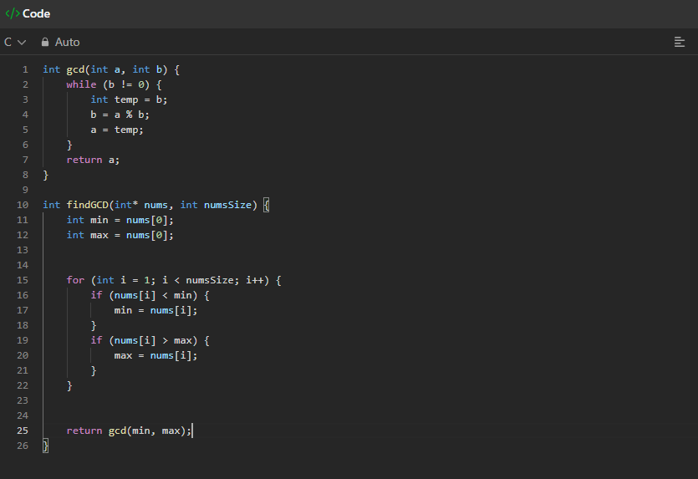

Output:
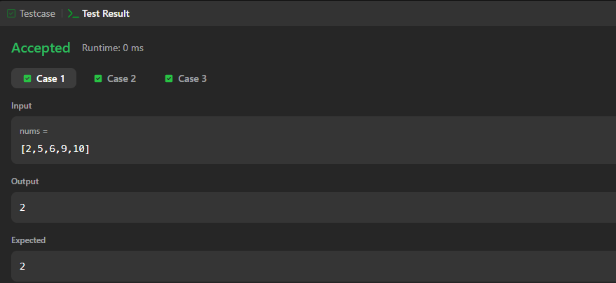

2.Greatest Common Divisor of Strings.
Example 1:
Input: str1 = "ABCABC", str2 = "ABC"
Output: "ABC"
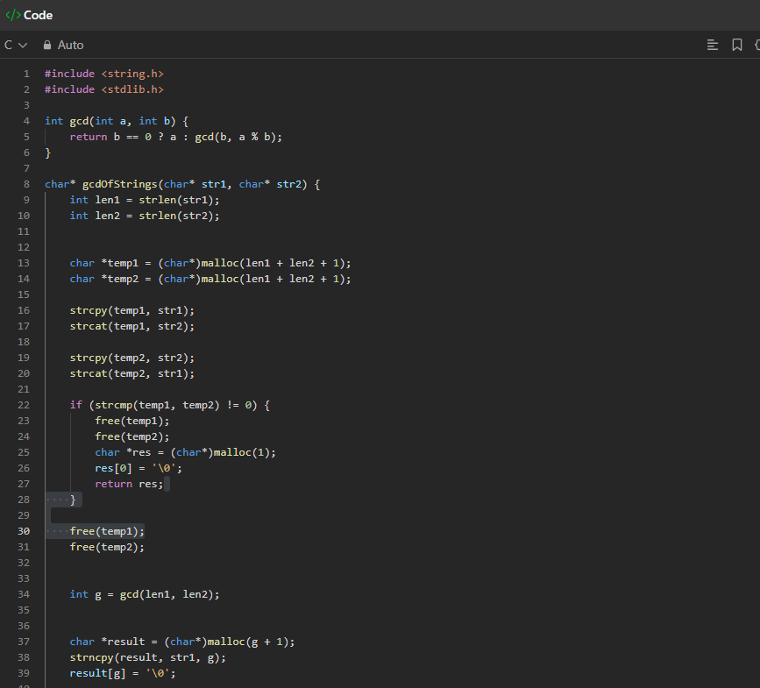

Output
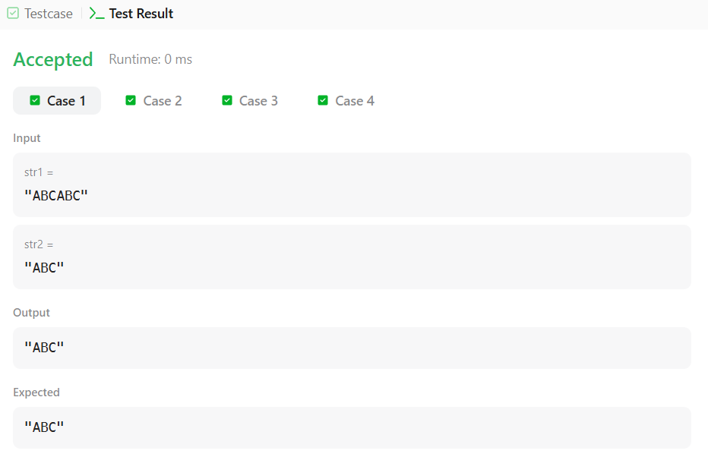

- GCD of Odd and Even Sums.
Example 1:
Input: n = 4
Output: 4
Explanation:
- Sum of the first 4 odd numbers sumOdd = 1 + 3 + 5 + 7 = 16
- Sum of the first 4 even numbers sumEven= 2 + 4 + 6 + 8 = 20
Hence, GCD(sumOdd, sumEven) = GCD(16, 20) = 4.
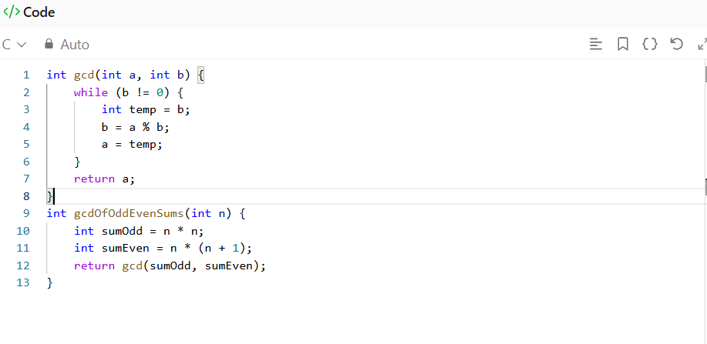
Output:
