Student Task Management System

A PROJECT REPORT

Submitted by
Shalini Pandurang Shanbhag - 1BM24MC086
in partial fulfillment for the award of the degree of Master of Computer Applications
Under the guidance of

Internal Guide External Guide
Dr. D. N. Sujatha Mr. Ramkumar
Professor, Manager
Dept. of Computer Applications Nyera Edutech & Innovations

B. M. S. College of Engineering, Bangalore-560019
Bangalore-560001



B. M. S. COLLEGE OF ENGINEERING BANGALORE-19
JUNE -2026

B.M.S. COLLEGE OF ENGINEERING
(Autonomous College under VTU, Approved by AICTE, Accredited by NAAC)

MASTER OF COMPUTER APPLICATIONS


This is to certify that Shalini Pandurang Shanbhag[1BM24MC086] has satisfactorily completed the requirements for Major Project - MMCPRJ401 entitled “Student Task Management System” as a part of the 4th Semester MCA course in this college during the year 2025.

Internal Guide
External Guide
………………………….
Mr. Ramkumar

…………………………….
Dr. D. N. Sujatha
Professor Manager
B. M. S. College of Engineering Nyera Edutech & Innovations Pvt Ltd
Bangalore- 560019 Bangalore – 560001

Head of the Department Principal

…………………………….. ………………………….
Dr. S Uma Dr. Bheemsha Arya
Professor and Head, Dept. of CA Principal,
Dept. of Computer Applications B.M.S. College of Engineering
B.M.S. College of Engineering Bangalore-560019 Bangalore- 560019

………………………….. …………………………
Examiner 1 Examiner 2

DECLARATION

I hereby declare that this project entitled “Student Task Management System” carried out at “Nyera Edutech & Innovations Pvt Ltd” is a record of project work submitted to the Department of Computer Applications, B.M.S College of Engineering, affiliated to Visvesvaraya Technological University is an original work completed by me.

To the best of my knowledge, this report has not been submitted to any other college or university or published at any time prior to this.

Date: Name: Shalini Pandurang Shanbhag
Place: Bangalore USN: 1BM24MC086

ACKNOWLEDGEMENT

No achievement is possible without the help, support, and guidance of inspirational people and this project is incomplete without an acknowledgment of the gratitude of these individuals. Each one of them has contributed in their own unique and invaluable way to the undertaking of this project.

I take this opportunity to thank all the people who have been supportive throughout this report.

First, I would like to thank my external guide Mr. Ramkumar, Manager of Nyera Edutech & Innovations Pvt Ltd. Who has been a constant support in the process of completing my Internship.

Second, I would like to thank my internal guide Dr. D. N. Sujatha, Professor, Department of Computer Applications, for his constant support and guidance in preparing this report.

Next, I would like to thank my Head of the Department Dr. S Uma for her guidance and support.

I also wish to place my deep debt of gratitude to Dr. Bheemsha Arya, Principal, B. M. S. College of Engineering for his constant help.

I would also like to thank my parents and friends for their support and guidance.

Shalini Pandurang Shanbhag
USN: 1BM24MC

ABSTRACT
The project titled “Student Task Management System” is a modern web-based productivity and academic management system developed to help students efficiently organize tasks, monitor academic activities, and analyze their overall performance through an interactive dashboard. In today’s academic environment, students often face difficulties in managing assignments, project deadlines, examinations, and daily study schedules due to the absence of a centralized and intelligent tracking platform. Traditional methods such as notebooks, spreadsheets, or simple reminder applications lack analytical capabilities, real-time accessibility, and performance monitoring features. This system aims to overcome these limitations by providing a secure, cloud-based solution that combines task management with productivity analytics.
The proposed system allows users to register and securely log in using authentication mechanisms. Students can create, update, categorize, prioritize, and track academic tasks based on deadlines and completion status. The application also provides productivity insights through visual dashboards, enabling users to analyze completed tasks, pending activities, overdue work, and category-wise performance trends. These analytical features help students improve time management, academic planning, and overall productivity.
The system is developed using modern full-stack technologies including Java Spring Boot for backend development, React.js for frontend development, and MySQL for database management. RESTful APIs are used for communication between frontend and backend components, while JWT (JSON Web Token) authentication ensures secure access control and protected user sessions. The application is deployed on cloud platforms, making it accessible anytime and from any location.
The project follows a modular and scalable software architecture that supports future enhancements such as AI-based task recommendations, mobile application integration, calendar synchronization, reminder notifications, and collaborative task management. The implementation of dashboards, analytics, authentication, and responsive design makes the system more advanced than traditional task management applications.
The “Student Task Management System” not only simplifies academic task management but also provides meaningful productivity insights that assist students in improving efficiency, reducing missed deadlines, and achieving better academic performance.
.

TABLE OF CONTENTS

- INTRODUCTION 1
  - PROJECT DESCRIPTION 1
  - MOTIVATION. 2
  - EXISTING AND PROPOSED SYSTEMS 3
    - EXISTING SYSTEM 3
    - PROPOSED SYSTEM 4
  - COMPANY PROFILE 5
  - HARDWARE AND SOFTWARE REQUIREMENTS 6
    - HARDWARE SPECIFICATIONS 6
    - SOFTWARE SPECIFICATIONS 6
- SYSTEM ANALYSIS 7
  - FEASIBLITY STUDY 7
    - TECHNICAL FEASIBLITY 7
    - OPERATIONAL FEASIBLITY 8
    - ECONOMICAL FEASIBLITY 8
    - SCHEDULING FEASIBLITY 9
- PROJECT PLAN 10
  - WORKFLOW 11
  - GANTT CHART 13
- SOFTWARE REQUIREMENTS SPECIFICATIONS 15
  - FUNCTIONAL REQUIREMENTS 15
  - NON- FUNCTIONAL REQUIREMENTS 17
- SYSTEM DESIGN 18
  - CLAS SDIAGRAM 18
  - USE CASE DIAGRAM 20
  - SEQUENCE DIAGRAM… 21
  - ACTIVITY DIAGRAM 22
- IMPLEMENTATION 23
  - TECHNOLOGY USED 23
  - SCREENSHOTS 26
- TESTING 40
  - USER REGISTRATION & LOGIN MODULE 40
  - PRODUCT BROWSING & FILTERING MODULE 41
  - SHOPPING CART MODULE 42
  - CHECKOUT & PAYMENT MODULE 42
  - ORDER MANAGEMENT MODULE 43
  - ADMIN PANEL MODULE 43
  - USER PROFILE & SETTINGS MODULE 43
- IMPACT ON SOCIETY AND ENVIRONMENT 44
  - SOCIETAL IMPACT 44
  - ENVIRONMENTAL IMPACT 44
- CONCLUSION 45
- FUTURE ENHANCEMENT 46
- TEAMWORK DETAILS 47
- BIBLIOGRPAHY 48
- PLAGIARISM REPORT 49

Table 1 Hardware Specification 6

Table 2 Software Specifications 6

Table 3 Project Plan 10
Table 4 Test Case for User Registration & Login Module 40
Table 5 Test Case for Product Browsing & Filtering Module 41
Table 6 Test Case for Shopping Cart Module 42
Table 7 Test Case for Checkout & Payment Module 42
Table 8 Test Case for Order Management Module 43
Table 9 Test Case for Admin Panel Module 43
Table 10 Test Case for User Profile & Settings Module 43
Table 11 Team Work Details 47

Figure 1 Gantt chart 13
Figure 2 Class Diagram 19
Figure 3 Use Case Diagram 20
Figure 4 Sequence Diagram 21
Figure 5 Activity Diagram 22
Figure 6 Home Page 26
Figure 7 Home Page – Personal Care Products 26
Figure 8 Home Page – Daily Essentials 27
Figure 9 Home Page – Daily Essentials 27
Figure 10 Home Page – Products 28
Figure 11 Home Page – Incredible Products 28
Figure 12 Home Page – New & Blogs 29
Figure 13 Home Page – Footer 29
Figure 14 Login Page 30
Figure 15 Password Reset Page 30
Figure 16 About Page 31
Figure 17 About Page – Footer 31
Figure 18 Product View 32
Figure 19 Product View 32
Figure 20 Product Page - Footer 33
Figure 21 Product Details 33
Figure 22 Related Products 34
Figure 23 Cart Page 34

Figure 24 Cart Page – Total Bill 35
Figure 25 Checkout Page – Address Details 35
Figure 26 Checkout Page – Address Details 36
Figure 27 Order Details 36
Figure 28 Wishlist 37
Figure 29 Wishlist Page – After Adding Product to Cart 37
Figure 32 Contact Us 38
Figure 33 Contact Us - Footer 38
Figure 34 Blog Page 39
Figure 35 Blog Page - Footer 39

INTRODUCTION

PROJECT DESCRIPTION

This project was undertaken at Nyera Edutech & Innovations Private Limited, a pioneering IT-based company leading the charge in technological innovation. With an unwavering commitment to providing comprehensive solutions that span a diverse range of domains, the organisation has set out to redefine the very fabric of the digital landscape. Its expertise encompasses a wide spectrum of services, each meticulously designed to empower businesses and individuals alike.
The project involved the design and implementation of Tasklytic — an AI-powered academic task management system developed as a final-year project. The primary objective was to create a scalable, responsive, and secure web application where students can register, authenticate, manage their academic tasks, track progress, and receive AI-generated study plans. The project was implemented using a modern JavaScript-based full-stack architecture comprising Node.js, Express.js, React.js (Vite), and MySQL — a robust combination for building performant, maintainable web applications.
The platform incorporates essential academic productivity features including user authentication and profile management, task and subtask creation with CRUD operations, AI-powered task breakdown using Google Gemini 2.5 Flash, a daily planner view, an Eisenhower priority matrix, productivity analytics with a heatmap grid, and automated email deadline reminders. An AI controller was also built to interface with the Gemini API, generating 4 to 6 actionable, time-estimated subtasks per assignment along with a personalised success strategy — providing students with structured guidance beyond a simple to-do list. Front-end development was executed using React.js for its component-based architecture and dynamic rendering capabilities, while a clean and fully responsive UI was implemented to enhance usability across devices.
The backend was powered by Node.js and Express.js, enabling a fast and non-blocking server environment. Data is stored and managed using MySQL, with the mysql2 driver handling connection pooling and structured relational queries. Routes are organised by domain — user, task, analytics, and AI — each protected by JWT-based authentication middleware to ensure secure session handling. APIs were structured according to REST principles, ensuring modularity and maintainability. A scheduled background service built with node-cron runs each morning to identify tasks due the following day and dispatches richly formatted HTML reminder emails via Nodemailer, automating the notification workflow without any manual intervention.
This project has been a valuable hands-on learning experience. It not only strengthened the understanding of full-stack web development but also exposed the development team to real-world software design principles such as modular coding, secure authentication, API integration with large language models, database modelling, and UI/UX design. Working on this project improved problem-solving skills and time management — key competencies required in professional development environments.
Overall, Tasklytic represents the successful application of theoretical knowledge to a practical, real-world academic problem. It demonstrates how AI technology can be leveraged to deliver targeted, intelligent, and user-friendly solutions that meet specific domain needs. The project has laid a solid foundation for future enhancements, including the integration of a conversational chatbot assistant, mobile application development, and collaborative study group features — all aimed at improving the overall user experience and academic value of the platform

MOTIVATION
The rapid evolution of academic technology has fundamentally reshaped how students organise, plan, and execute their coursework, with a notable shift toward intelligent digital tools. Academic task management, as a critical component of student productivity, demands a platform that is both user-centric and technologically advanced. This led to the conceptualisation and development of Tasklytic — an AI-powered academic task management system capable of meeting these emerging needs. The technical motivation behind this project lies in building a responsive, secure, scalable, and modular web application using a modern JavaScript-based full stack — a widely adopted and powerful combination of technologies that support end-to-end development. The stack is composed of four core technologies:
- React.js (Vite) – A powerful frontend library for building dynamic, component-driven user interfaces.
- Node.js – A JavaScript runtime environment that powers scalable server-side applications.
- Express.js – A minimalist and fast Node.js web application framework for building REST APIs.
- MySQL – A reliable relational database for structured storage of users, tasks, subtasks, and analytics data.
This technology stack enables full-stack development using a single language — JavaScript — which allows better team collaboration and easier debugging. It supports single-page applications (SPAs), ensuring fluid navigation and minimal full-page reloads, critical for maintaining focus and engagement in a productivity tool.
Addressing Real-World Academic Productivity Challenges:
1. Scalability and Structured Data Management
MySQL with the mysql2 driver allows Tasklytic to handle growing volumes of structured data including user accounts, tasks, subtasks, analytics records, and heatmap activity. Its relational schema ensures data integrity across linked entities, making it well-suited for tracking hierarchical relationships such as tasks containing multiple subtasks, each with their own completion state and time estimates.
2. High Performance and User Experience
React's virtual DOM offers efficient UI updates without re-rendering the entire page, ensuring a fast and smooth experience as students interact with the task list, daily planner, Eisenhower matrix, and analytics dashboard. React's component-based architecture also simplifies code reusability and state management, allowing pages like TaskDetail, Dashboard, and Analysis to share common logic cleanly.
3. Security and User Authentication
With Express.js and Node.js powering the backend, the application benefits from robust routing and middleware integration. Secure user authentication and session management were implemented using JWT (JSON Web Tokens), enabling protected routes, encrypted communication between the frontend and backend, and safe handling of sensitive user data such as credentials and security questions. A forgot-password and reset-password flow was also implemented via Nodemailer for complete account security.
4. AI Integration and Intelligent Extensibility
A key motivation for Tasklytic was the integration of generative AI into the academic workflow. The Google Gemini 2.5 Flash API was embedded directly into the task lifecycle, allowing the system to automatically decompose any assignment into 4–6 actionable, time-estimated subtasks along with a personalised success strategy and effort-level classification. This demonstrates how the modular Node.js ecosystem supports seamless integration with powerful third-party AI services, transforming a basic task manager into an intelligent study companion.
5. Automation and Proactive Notifications
The platform leverages node-cron to run scheduled background jobs that identify tasks due the following day and automatically dispatch richly formatted HTML reminder emails to users via Nodemailer. This real-time automation reduces missed deadlines without any manual intervention, demonstrating how backend scheduling can enhance user experience beyond the visible interface.
6. Developer Productivity and Maintainability
By using a unified JavaScript stack across both frontend and backend, the project benefits from reduced context switching and faster development cycles. The backend routes are organised by domain — user, task, analytics, and AI — each with dedicated controllers and services, following a clean modular folder structure. This separation of concerns improves long-term maintainability and makes the codebase straightforward to extend with future features

EXISTING AND PROPOSED SYSTEM

The existing academic task management solutions available to students are typically built on generic productivity platforms such as Microsoft To-Do, Notion, Google Tasks, or Trello. These platforms support basic functionalities such as task creation, due date setting, and simple progress tracking. However, they lack specialised features tailored for academic users, such as AI-driven task breakdown, course-category organisation, study effort estimation, or deadline-aware email notifications. Most existing systems offer a standard template with limited scope for academic personalisation, which affects student engagement and study effectiveness.
Additionally, productivity tracking features such as heatmap grids, Eisenhower priority matrices, and per-subject analytics are either absent or locked behind premium subscription tiers. Integration with AI for intelligent study guidance is either non-existent or requires expensive third-party add-ons. These platforms provide a good general foundation but do not offer the flexibility or intelligence needed to support a student's academic workflow end to end.
Disadvantages of the Existing System:
- Generic platforms are not designed for academic use and do not support course-based task categorisation, subtask time estimation, or study strategy generation.
- Most tools lack AI integration, leaving students responsible for manually breaking down complex assignments without guidance.
- Productivity analytics such as completion heatmaps, effort-level tracking, and workload distribution charts are rarely available in free-tier tools.
- Automated deadline reminder emails are either missing or require manual configuration through third-party integrations.
- Priority frameworks like the Eisenhower Matrix are not built into existing tools and must be manually replicated using workarounds.
- Existing platforms offer no daily planner view scoped to academic subtasks, making it difficult to focus on immediate workload.
- Data is stored across disconnected apps, creating fragmentation in a student's productivity system and reducing overall consistency.
1.3.2 PROPOSED SYSTEM
The proposed system is Tasklytic — a dedicated AI-powered academic task management platform tailored specifically for students managing coursework, assignments, and study schedules. Unlike generic productivity tools such as Notion or Trello, this custom-built platform aims to provide a targeted, intelligent, and student-focused experience that emphasises structured planning, AI assistance, and automated support. The project has been developed using a modern JavaScript full stack comprising React.js (Vite), Node.js, Express.js, and MySQL, ensuring the system is built on a scalable, maintainable, and efficient technology base. The goal is to create not just a to-do list, but a complete digital academic companion that guides students from assignment receipt through to completion — offering AI-generated study plans, visual progress analytics, and proactive deadline management.
Objectives of the Proposed System:
- To provide a centralised platform for students to create, organise, and track all academic tasks and subtasks in one place.
- To integrate Google Gemini AI to automatically break down assignments into structured, time-estimated subtasks with personalised study strategies.
- To improve student engagement and consistency through features like a productivity heatmap, daily planner, Eisenhower matrix, and automated email reminders.
Advantages of the Proposed System:
- Academic-Focused Experience: Tailored layout, course-based categorisation, and AI-driven recommendations specific to student workflows.
- Intelligent Task Breakdown: Gemini AI analyses each task and generates 4–6 actionable subtasks with time estimates and a success strategy, reducing cognitive load on students.
- Automated Notifications: A cron-based email reminder system dispatches deadline alerts the day before tasks are due, without requiring any manual action from the user.
- Scalable Design: The modular architecture can be expanded in future to include collaborative study groups, mobile applications, or integration with university learning management systems.
System Features:
- User Registration/Login: Secure sign-up with JWT-based authentication, password encryption via bcrypt, and a forgot/reset password flow using Nodemailer.
- Task & Subtask Management: Full CRUD operations for academic tasks with support for title, description, category, due date, priority, and status tracking.
- AI-Powered Task Breakdown: Google Gemini 2.5 Flash generates structured subtasks, time estimates, effort level, and a personalised study tip for any assignment.
- Daily Planner: A focused view surfacing subtasks due on the current day, helping students prioritise their immediate workload.
- Eisenhower Matrix: Visual quadrant-based task prioritisation by urgency and importance, enabling deliberate decision-making.
- Productivity Analytics & Heatmap: Dashboard charts showing completion trends, category distributions, and a GitHub-style daily activity heatmap for longitudinal progress tracking.
- Automated Email Reminders: Scheduled background jobs (node-cron) identify tasks due the next day and send formatted HTML reminder emails automatically.
- Settings & Profile Management: Users can update personal details, change passwords, and manage security questions from a dedicated settings page.
- Responsive Design: Fully optimised for desktops, tablets, and mobile devices

1.4 HARDWARE AND SOFTWARE REQUIREMENTS

1.4.1 HARDWARE SPECIFICATION
Table 1 Hardware Specification
Component | Specification
Processor (CPU) | Intel Core i5 / i7 or AMD Ryzen 5 / 7 (Quad-Core or higher)
RAM | Minimum 8 GB (Recommended: 16 GB for smooth multitasking)
Storage | 256 GB SSD or higher (Recommended: 512 GB SSD for fast read/write operations)
Operating System | Windows 10 / 11 (64-bit), Ubuntu 20.04+, or macOS 10.15+
Graphics | Integrated GPU (sufficient for web development); optional discrete GPU for design work
Network | Stable broadband internet connection (≥ 20 Mbps) for package installation, API testing, and deployment

1.4.2 SOFTWARE SPECIFICATION
Table 2 Software Specification
Category | Software / Technology (with Version)
Frontend | React.js v18.x (Vite 5.x build tool)
 | JavaScript ES2022
 | Axios v1.x
 | HTML5, CSS3
 | React Router DOM v6.x
Backend | Node.js v18.17.1
 | Express.js v5.2.1
Database | MySQL v8.0+ (with mysql2 v3.x driver)
ORM / Query | mysql2 with connection pooling (no ORM)
Authentication | JSON Web Token (JWT) v9.0.x + bcrypt v6.x
AI Integration | Google Gemini 2.5 Flash API (@google/generative-ai v0.24.1)
Email Service | Nodemailer v8.x
Scheduler | node-cron v4.x
Code Editor | Visual Studio Code v1.90.0
Version Control | Git v2.43.0 + GitHub
Web Server | Node.js Server with Express Middleware
Operating System | Windows 10 / 11, Ubuntu 20.04 LTS, or macOS
Browser Compatibility | Google Chrome v138.0.7204, Mozilla Firefox v140.0, Microsoft Edge v138.0.3351.65, Safari v18.5

SYSTEM ANALYSIS

2.1 FEASIBILITY STUDY
A feasibility study is an essential step in evaluating whether a project can be successfully designed, developed, and deployed. The feasibility for Tasklytic — an AI-powered academic task management system — has been assessed in the following dimensions:
- Technical Feasibility
- Operational Feasibility
- Economic Feasibility
- Scheduling Feasibility
2.1.1 TECHNICAL FEASIBILITY
The proposed Tasklytic platform is technically feasible, as it utilises a mature and reliable modern JavaScript full stack comprising React.js (Vite), Node.js, Express.js, and MySQL. Each of these technologies is open-source, widely adopted, and well-supported, making them ideal for building scalable and maintainable web applications.
- MySQL with the mysql2 driver provides structured, relational data storage for users, tasks, subtasks, analytics records, and heatmap activity. Its relational schema ensures data integrity across linked entities and supports complex queries for analytics and scheduling operations.
- Node.js and Express.js form the server-side foundation, offering a lightweight, high-performance runtime environment and a robust framework for handling API routes, authentication middleware, scheduled jobs, and server logic.
- React.js (Vite) enables the creation of a dynamic and responsive user interface, providing a smooth user experience with real-time updates, component-based architecture, and minimal page reloads.
- The stack allows full-stack development using a single language — JavaScript — simplifying the development process and enhancing long-term maintainability.
- The system leverages third-party open-source libraries for features such as JWT-based authentication, password hashing via bcrypt, automated email delivery via Nodemailer, background scheduling via node-cron, and AI-powered task breakdown via the Google Gemini 2.5 Flash API.
- Deployment is technically achievable using modern cloud platforms such as Vercel and Render, which support continuous deployment, auto-scaling, and version rollbacks, making the system production-ready with minimal infrastructure overhead.
Given these technical factors, the system is fully capable of meeting performance expectations and supporting future scalability.
2.1.2 OPERATIONAL FEASIBILITY
Operationally, the system is highly feasible, offering a practical and user-friendly solution for students managing academic workloads.
- Students can register, log in securely, create and organise tasks by course category, generate AI-powered subtask breakdowns, track daily progress through the planner, and receive automated email reminders before deadlines — all from a single platform.
- The AI integration via Google Gemini reduces the cognitive effort required to plan assignments by automatically producing structured study plans, making the platform accessible even to students unfamiliar with productivity frameworks.
- Secure JWT-based authentication ensures that only authorised users can access their data, with bcrypt-encrypted passwords and a self-service password reset flow via email for complete account security.
- The Eisenhower Matrix and productivity heatmap give students visual tools to prioritise tasks and reflect on study consistency, reducing the reliance on external tracking spreadsheets or paper planners.
- The automated cron-based email reminder system operates entirely in the background, dispatching deadline alerts without any manual intervention, reducing missed submissions and improving academic outcomes.
- The settings module allows users to independently manage their profile, password, and security preferences, minimising administrative overhead.
2.1.3 ECONOMIC FEASIBILITY
The system is economically viable and cost-effective, particularly suitable for individual student developers and academic institutions.
- The entire solution is developed using open-source technologies, eliminating the need for costly proprietary software or licensing fees.
- MySQL can be hosted on free-tier cloud database services, and platforms such as Vercel allow initial frontend and backend deployment without financial burden, with the option to scale later based on usage growth.
- The Google Gemini API provides a free usage tier sufficient for development and moderate production use, making AI integration accessible without significant cost.
- The use of a modular codebase with clearly separated controllers, services, and routes reduces long-term development and maintenance costs by making individual components easy to update or replace independently.
- Nodemailer with a standard email provider eliminates the need for paid transactional email services during early deployment stages.
- Automated task reminders, analytics, and AI guidance reduce the need for external tutoring tools or premium productivity subscriptions, delivering tangible value to students at no recurring cost.
2.1.4 SCHEDULING FEASIBILITY
The project was planned and executed using the Agile development methodology, a flexible and iterative approach that promotes rapid delivery, continuous feedback, and adaptive planning. Agile allowed the development team to efficiently respond to changing requirements while ensuring that each stage of development was systematically addressed. The overall development cycle was structured into clearly defined and sequential phases — beginning with requirement gathering, where user stories, technical specifications, and feature priorities were documented, followed by UI/UX design, where page wireframes were developed to ensure an intuitive interface aligned with student workflows.
Backend development focused on building a secure, modular architecture supporting user authentication, task and subtask management, AI integration, analytics, and scheduled email services. In parallel, frontend integration ensured that all pages were responsive and seamlessly connected to the backend through RESTful APIs. Each module was developed in sprint cycles, with individual sprints dedicated to specific components such as user registration and login, task CRUD operations, AI task breakdown, daily planner, Eisenhower matrix, heatmap analytics, and the cron-based email reminder service.
GitHub was used for version control, ensuring code consistency through branching strategies, pull requests, and frequent commits. Regular code reviews were conducted to maintain quality and identify issues early. Unit testing and integration testing were carried out across sprints to ensure all modules functioned correctly. Documentation was maintained alongside development, including API documentation and deployment guides, to support future maintenance.
Effective time management, modular task distribution, and adherence to Agile principles allowed the team to deliver a high-quality, production-ready system within the proposed timeline. The successful implementation of Tasklytic demonstrates the efficiency of Agile methodology in managing a multi-featured, AI-integrated web application while maintaining flexibility, scalability, and quality throughout the development lifecycle.

PROJECT PLAN

Table 3 Project Plan
Phase | Description
1. Requirement Analysis | Define project goals, functional/non-functional requirements, and feature list.
2. UI/UX Design | Design wireframes, page layouts, and user interaction flow.
3. Environment Setup | Set up React (Vite), Node.js, Express.js, MySQL environment, GitHub repo, and local database.
4. Backend Development | Create Express.js REST APIs, MySQL schemas, authentication logic, and cron job services.
5. Frontend Development | Build responsive React.js UI and integrate with backend APIs using Axios.
6. AI Integration Module | Implement Google Gemini API controller for AI-powered task breakdown and subtask generation.
7. Testing & Debugging | Perform unit testing, API testing, integration testing, and bug fixes.
8. Deployment & Hosting | Deploy on Vercel (frontend + backend) with cloud-hosted MySQL database.
9. Documentation & Report | Finalise project report, testing documents, and user manual.
10. Final Presentation Prep | Create PPT, demo setup, and viva readiness.

3.1 WORKFLOW
The development of Tasklytic was carried out in a structured and phased manner to ensure systematic progress, efficient task management, and high-quality output. Below is the detailed explanation of each phase involved in the workflow:
Phase 1: Requirement Analysis (1 week)
This initial phase involved understanding the project's objective, scope, and expectations. The team gathered both functional requirements (e.g., user login, task management, AI breakdown, email reminders) and non-functional requirements (e.g., performance, security, responsiveness). A clear feature list was created and user roles were identified. This phase laid the foundation for the rest of the development cycle.
Phase 2: UI/UX Design (2 weeks)
Once the requirements were finalised, the focus shifted to designing the user interface and user experience. Wireframes and mockups were created for all major pages including the login/register screens, dashboard, task list, task detail, daily planner, Eisenhower matrix, analytics, and settings. The design process prioritised usability, clarity, and a clean academic-themed visual aesthetic.
Phase 3: Environment Setup (1 week)
With the design and requirements in place, the technical environment was prepared. React.js (Vite), Node.js, Express.js, and MySQL were configured. A repository was created on GitHub for version control and collaboration. The local MySQL database was set up and development environments were configured for parallel development.
Phase 4: Backend Development (3 weeks)
This phase focused on implementing the server-side logic using Node.js and Express.js. Key REST APIs were built for user registration, login, password reset, task CRUD operations, subtask management, analytics, and AI integration. MySQL table schemas were defined for users, tasks, subtasks, and analytics records. JWT was used for secure authentication and route protection, and bcrypt was used for password hashing.
Phase 5: Frontend Development (3 weeks)
The React.js-based frontend was developed to ensure a smooth, interactive user experience. Components and pages were built for login/register, dashboard, task list, task detail, add/edit task, daily planner, Eisenhower matrix, analysis, and settings. React Router handled navigation between pages and Axios was used to consume backend APIs.
Phase 6: AI Integration Module (2 weeks)
A dedicated AI controller was developed to interface with the Google Gemini 2.5 Flash API. This module accepts a task's title, description, and course category, submits a structured prompt to the Gemini model, and parses the returned JSON to extract 4–6 actionable subtasks with time estimates, a personalised success strategy, and an effort-level classification. A deterministic fallback was implemented to ensure the feature remains functional if the API is unavailable.
Phase 7: Testing & Debugging (2 weeks)
After the core functionalities were built, the application underwent multiple levels of testing:
- Unit testing for individual functions and components
- API testing using Postman
- Integration testing between frontend and backend
- UI/UX testing across different devices and browsers
Bugs were identified and resolved at this stage to ensure system reliability and usability.
Phase 8: Deployment & Hosting (1 week)
Upon successful testing, the application was deployed. The backend and frontend were hosted on Vercel and a cloud-hosted MySQL instance was used for database management. Environment variables, JWT secrets, Gemini API keys, and email credentials were configured appropriately to ensure a smooth production setup.
3.2 GANTT CHART
A Gantt chart plays a crucial role in project scheduling by offering a clear visual representation of all development activities over a defined timeline. It allows project managers and developers to effectively map out tasks, showing each phase's start and end times with precision. This helps in avoiding scheduling conflicts, ensuring that each development activity is logically placed within the available time frame.
By plotting phases in chronological order, the Gantt chart supports real-time visibility into ongoing and upcoming tasks, making it easier to plan and prioritise effectively. It enables simultaneous tracking of multiple workstreams — such as frontend development running in parallel with backend API development — which is especially valuable in full-stack projects with interdependent modules.
Furthermore, Gantt charts enhance resource management by clearly displaying the allocation of development effort across phases. They make it easy to identify task dependencies, ensuring that activities such as AI integration and frontend wiring are scheduled only after the foundational backend APIs are in place. Their visual nature simplifies spotting bottlenecks or idle periods, allowing the team to make proactive adjustments and maintain momentum throughout the development cycle.
Phase / Activity | W1 | W2 | W3 | W4 | W5 | W6 | W7 | W8 | W9 | W10 | W11 | W12 | W13 | W14 | W15
Requirement Analysis | ✓ | ✓
System Design |  |  | ✓ | ✓
Database Design |  |  |  | ✓ | ✓
Backend – User Module |  |  |  |  | ✓ | ✓
Backend – Task Module |  |  |  |  |  | ✓ | ✓ | ✓
Backend – Analytics & AI |  |  |  |  |  |  |  | ✓ | ✓
Frontend – Auth Pages |  |  |  |  |  |  | ✓ | ✓
Frontend – Dashboard |  |  |  |  |  |  |  | ✓ | ✓ | ✓
Frontend – Tasks & Planner |  |  |  |  |  |  |  |  |  | ✓ | ✓
Frontend – Analysis & AI |  |  |  |  |  |  |  |  |  |  | ✓ | ✓
Integration Testing |  |  |  |  |  |  |  |  |  |  |  | ✓ | ✓
System & UAT Testing |  |  |  |  |  |  |  |  |  |  |  |  | ✓
Cloud Deployment |  |  |  |  |  |  |  |  |  |  |  |  |  | ✓
Documentation & Report |  |  |  |  |  |  |  |  |  |  |  |  |  | ✓ | ✓
Figure 1 Gantt Chart
Project Timeline:
- Week 1 — Project Initiation: Define the overall project scope, identify objectives, assign roles, and set up planning tools. Finalise the technology stack (React, Node.js, Express.js, MySQL, Gemini AI) and conduct the kickoff meeting.
- Weeks 2–3 — Requirement Analysis: Gather functional and non-functional requirements. Prepare use-case diagrams, flowcharts, and requirement specification documents. Finalise the prioritised feature list and define user roles.
- Weeks 4–5 — UI/UX Design: Design low- and high-fidelity wireframes. Establish design guidelines including colour themes, typography, and layout consistency. Create responsive mockups for key pages including dashboard, task detail, planner, matrix, and analytics.
- Weeks 6–7 — Frontend Development: Begin implementing the UI in React.js with Vite. Develop reusable components (layout, navigation, cards, modals) and implement page-level routes. Ensure responsive and accessible design across devices.
- Weeks 8–9 — Backend Development: Set up the Node.js and Express.js server. Create RESTful APIs for user management, task and subtask operations, analytics, and AI integration. Implement JWT authentication middleware, bcrypt password hashing, and email services via Nodemailer.
- Week 10 — Database Design: Model the MySQL database with tables for users, tasks, subtasks, and analytics. Define relationships, constraints, and indexes. Integrate the database with the backend and seed initial test data.
- Weeks 11–12 — Integration & AI Module: Connect the frontend to backend APIs using Axios. Implement the Google Gemini AI controller for task breakdown. Test complete user flows including registration, task creation, AI generation, planner, and analytics.
- Weeks 13–14 — Testing and QA: Perform unit testing on components and APIs. Conduct integration and system testing to validate full user flows. Identify and fix bugs related to UI behaviour, data handling, cron scheduling, and AI parsing logic.
- Week 15 — Deployment and Hosting: Deploy the frontend and backend to Vercel. Configure cloud MySQL hosting, environment variables, and production builds. Conduct final round testing on the live environment and prepare the system for presentation.

SOFTWARE REQUIREMENTS SPECIFICATIONS (SRS)

4.1 FUNCTIONAL REQUIREMENTS
1. User Management
- User registration and login: Enables new users to create accounts using their email and password, allowing personalised experiences and secure access to the platform.
- Profile management: Allows users to update personal details such as name, email, and profile information from the settings page.
- Password recovery via email: A secure mechanism to reset forgotten passwords through an email-based OTP or reset link flow, enhancing account accessibility.
- Security question management: Users can set and update a personal security question as an additional layer of account verification and recovery.
- Change password: Authenticated users can update their password directly from the settings page with current password verification.
2. Task Management
- Create and manage tasks: Users can add academic tasks with details including title, description, course category, due date, priority level, and completion status.
- View and filter tasks: Tasks can be browsed, searched, and filtered by category, priority, status, or due date for quick access to relevant assignments.
- Edit and delete tasks: Users can update any task attribute or remove tasks that are no longer relevant.
- Task detail view: Displays comprehensive task information including all associated subtasks, AI-generated tips, effort level, and progress indicators.
3. Subtask Management
- Add and manage subtasks: Each task can be broken down into individual subtasks with titles and estimated time, enabling granular progress tracking.
- Mark subtasks complete: Users can check off individual subtasks, with overall task progress updating accordingly.
- Edit and delete subtasks: Subtasks can be modified or removed independently without affecting the parent task.
- Daily subtask view: Surfaces subtasks due or scheduled for the current day in a focused daily planner interface.
4. AI-Powered Task Breakdown
- Automated subtask generation: The Google Gemini 2.5 Flash API analyses a task's title, description, and course category to generate 4–6 structured, time-estimated subtasks automatically.
- Personalised success strategy: Alongside subtasks, the AI provides a tailored study tip and an overall effort-level classification (low, medium, or high).
- Fallback mechanism: A deterministic fallback ensures the feature remains functional and returns sensible default subtasks if the Gemini API is unavailable.
5. Daily Planner
- Day-scoped task view: Displays all subtasks due or assigned to the current day, helping students focus on immediate priorities without distraction from distant deadlines.
- Completion tracking: Users can mark daily subtasks as complete directly from the planner view, maintaining progress records.
6. Eisenhower Matrix
- Priority quadrant visualisation: Tasks are displayed across four quadrants based on urgency and importance, giving students a clear framework for deciding what to act on first.
- Interactive task management: Users can interact with tasks directly within the matrix view to update priority or status.
7. Productivity Analytics & Heatmap
- Completion trend charts: The analytics dashboard visualises task completion rates, workload distribution by category, and progress over time.
- Activity heatmap: A GitHub-style grid displays daily task activity density over weeks and months, providing a longitudinal view of study consistency.
- Effort and category breakdown: Visual breakdowns show how effort is distributed across different courses or subjects, helping students identify imbalances.
8. Automated Email Reminders
- Scheduled deadline alerts: A cron-based background service runs daily, identifies tasks due the following day, and automatically dispatches formatted HTML reminder emails to the relevant users.
- Rich email formatting: Reminder emails include task titles, categories, due dates, and a call-to-action, providing clear and actionable information.
9. Settings & Account Management
- Profile update: Users can edit their display name and email from the settings page.
- Password change: Secure in-app password update with current password verification.
- Security question management: Users can view and update their security question and answer at any time.
- Notification preferences: Users can manage email notification settings from the settings panel.
4.2 NON-FUNCTIONAL REQUIREMENTS
1. Performance
- The system must efficiently handle multiple concurrent user sessions without lag, ensuring smooth interaction across task management, AI generation, and analytics pages.
- Fast loading times for all pages, with optimised API calls, connection pooling via mysql2, and efficient database queries for task retrieval and analytics aggregation.
- The Gemini AI integration must handle response parsing gracefully, with timeouts and fallback logic ensuring the interface remains responsive regardless of external API latency.
2. Scalability
- The application is designed using a modular, domain-separated architecture — with independent controllers, services, and routes for user, task, analytics, and AI modules — allowing future expansion without reengineering the entire system.
- The Express.js backend can be horizontally scaled by deploying additional server instances as user traffic increases.
- The MySQL database should support indexing and query optimisation strategies to maintain performance as the volume of tasks, subtasks, and analytics records grows.
- Frontend and backend services are independently deployable, enabling feature updates to either layer without disrupting the other.
3. Security
- Use of HTTPS for all user interactions ensures that data transmitted between client and server is encrypted, protecting credentials and personal information from interception.
- JWT-based authentication secures all protected API routes, with tokens verified via middleware before any user-specific data is accessed or modified.
- Passwords are hashed using bcrypt before storage, ensuring that plaintext credentials are never held in the database.
- Email-based password reset tokens are time-limited and single-use, preventing replay attacks on the account recovery flow.
- Environment variables store all sensitive credentials including JWT secrets, Gemini API keys, database credentials, and email service passwords, keeping them out of the codebase.
4. Usability
- Clean and consistent UI/UX design ensuring ease of navigation for students of all technical backgrounds.
- Fully responsive design delivering an optimal experience across desktops, tablets, and mobile devices.
- The AI task breakdown feature reduces cognitive load by generating structured study plans automatically, making the platform useful even without prior productivity training.
- Visual tools such as the Eisenhower matrix, heatmap, and daily planner provide intuitive, at-a-glance understanding of workload and progress.
5. Maintainability
- Use of version control via Git and GitHub with branching strategies for feature development and bug fixes.
- The codebase follows a modular folder structure with clearly separated concerns — routes, controllers, services, middleware, and models — aligned with MVC principles.
- API endpoints are organised and documented, supporting future integration with mobile applications or third-party tools.
- Error handling middleware in Express.js ensures consistent error responses across all API routes, simplifying debugging and monitoring.
6. Compatibility
- The web application must function correctly across all major browsers including Chrome, Firefox, Safari, and Edge.
- Compatible with different operating systems including Windows, macOS, Android, and iOS.
- The REST API architecture ensures that backend services can support future mobile application integrations without requiring significant rework.
- The responsive UI automatically adjusts to different screen resolutions, ensuring consistent usability across smartphones, tablets, and large monitors.

SYSTEM DESIGN

CLASS DIAGRAM
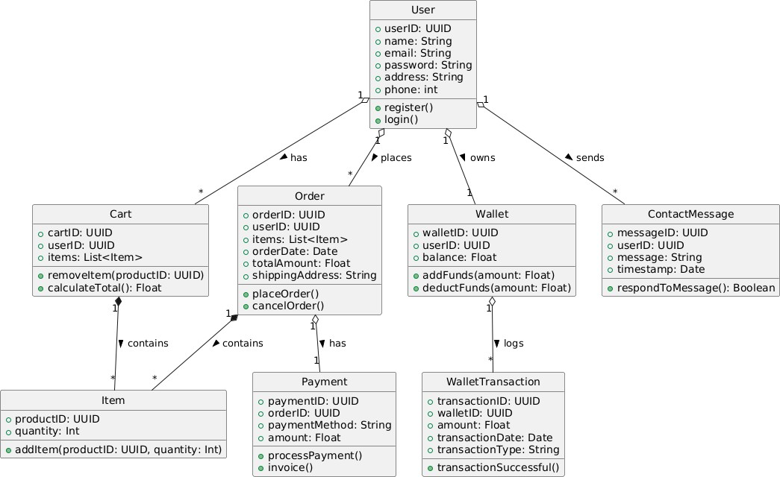
Figure 2: Class Diagram of System Architecture

The use case diagram in Figure 2 illustrates the structure and interrelationships between key backend components of the system, including core classes such as User, Product, Order, Cart, Payment, Wishlist, and ShippingDetail. Each class encapsulates relevant attributes (e.g., name, price, status) and methods (e.g., addToCart(), makePayment(), trackOrder()), enabling clear modeling of platform behavior and functionality. Relationships among entities are well- defined—for example, a User can place multiple Orders, and each Order can consist of multiple OrderItems—demonstrating one-to-many associations that reflect real-world interactions. This diagram serves as a blueprint for backend development, helping developers understand how different entities collaborate, manage data flow, and maintain consistency across the system. It provides a high-level yet precise view of the business logic, facilitating effective implementation, scalability, and future enhancements.

In addition to outlining entity relationships, the diagram also highlights the separation of concerns within the system, ensuring modularity and ease of maintenance. For instance, the inclusion of classes like Wishlist and ShippingDetail allows for extended user engagement and order tracking without overloading the core User or Order classes. Similarly, the Cart and Payment classes encapsulate their own logic for managing product selection and transaction handling, promoting reusable and testable components.

USE CASE DIAGRAM
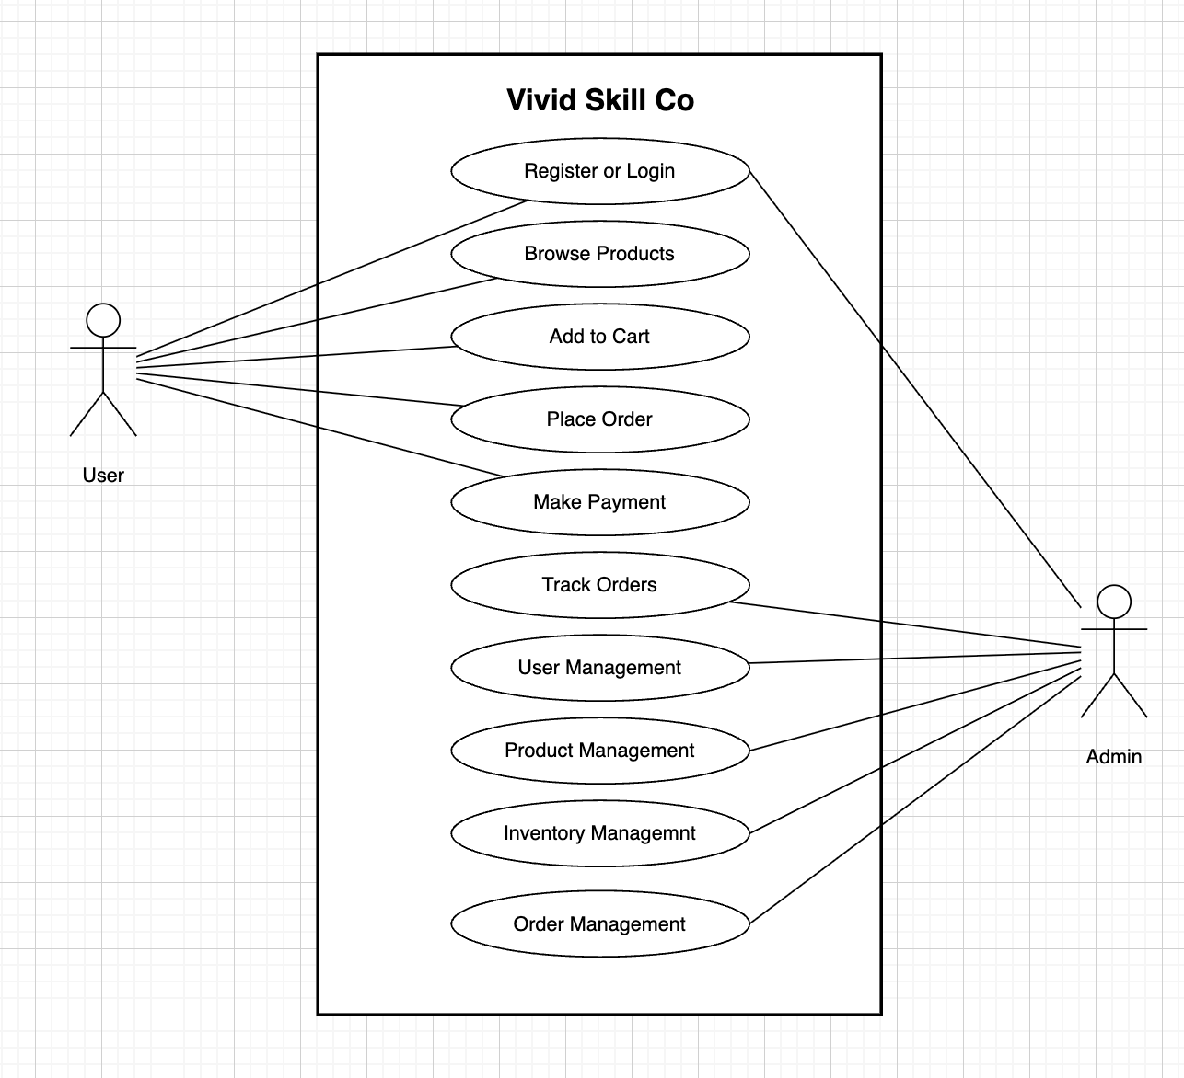
Vivid Skin Co

Figure 3: System Use Case Diagram for Vivid Skin Co

The use case diagram in Figure 3 visually represents the dynamic interactions between the system and its two primary actors User and Admin highlighting their respective roles and system access points. It outlines the key functionalities available to each actor: for Users, these include core actions such as Register/Login, Browsing Products, Adding Items to Cart, Making Payments, and Tracking Orders, all of which reflect typical user journeys in an e-commerce environment. For Admins, the diagram showcases essential operational tasks such as Managing Products, Managing Users, and Viewing Reports, emphasizing administrative control over the platform’s content and user base. These clearly defined use cases help delineate system boundaries and user permissions, making the diagram an effective tool for identifying functional requirements and user expectations early in the development lifecycle. By presenting this information in a concise, visual format, it serves as a bridge between technical teams and non-technical stakeholders, supporting better collaboration, requirement validation, and informed decision-making throughout the system design process.

SEQUENCE DIAGRAM
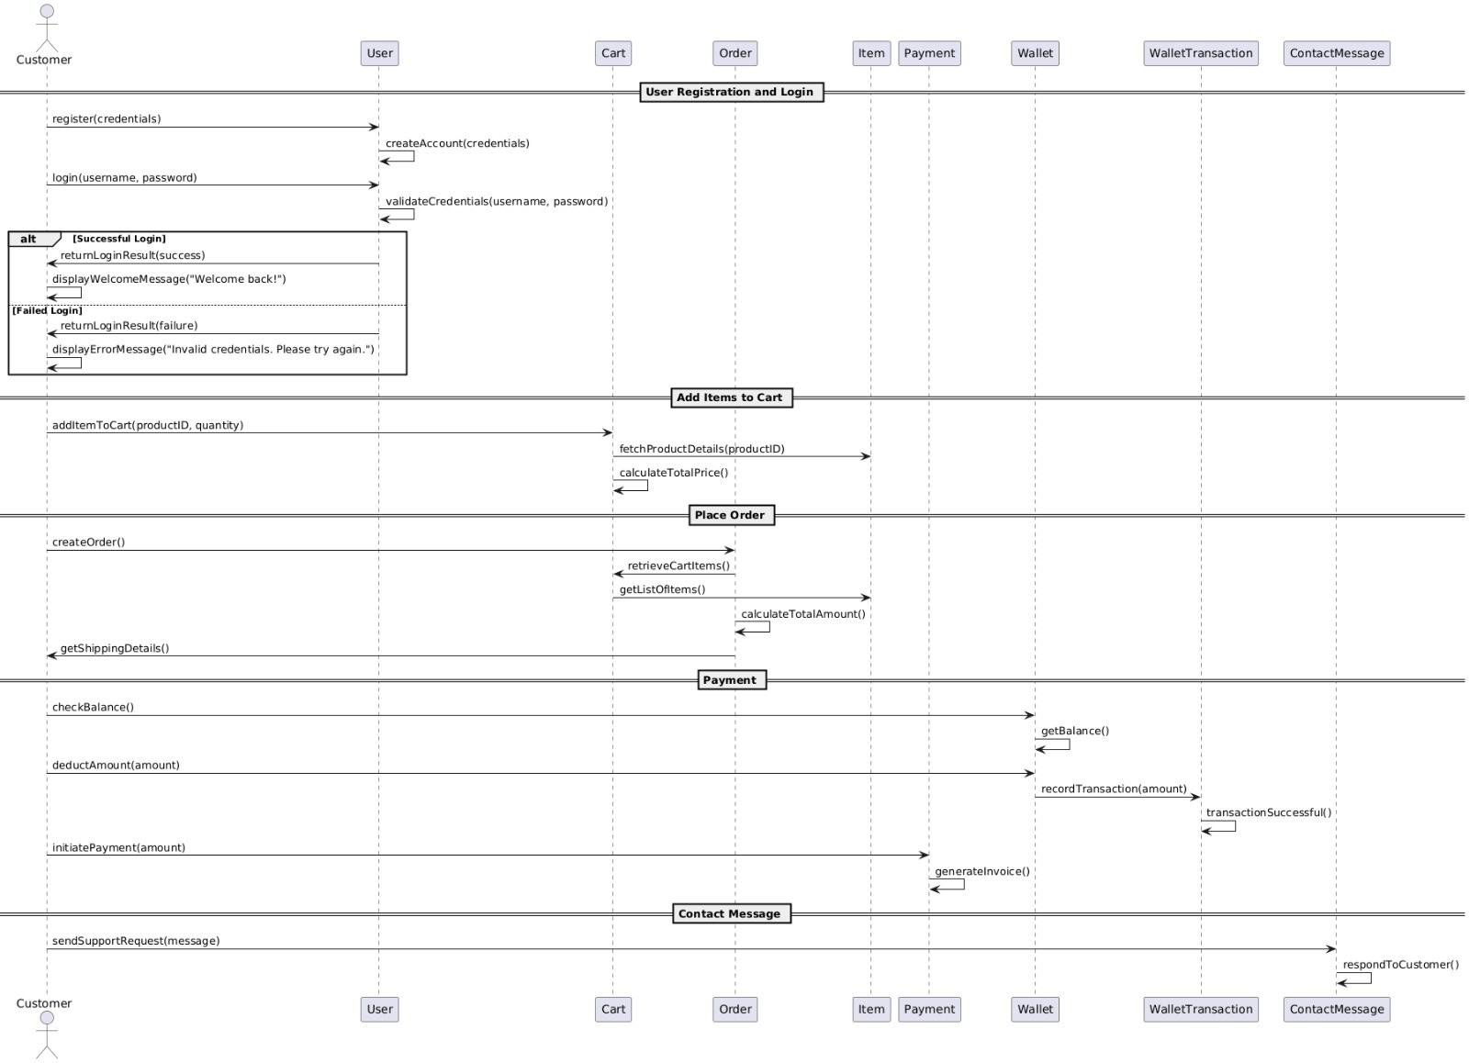
Figure 4: Sequence Diagram of Vivid Skin Co

The sequence diagram in Figure 4 offers a comprehensive and structured view of the dynamic interactions that occur between the system’s components over time, specifically focusing on a typical e-commerce order lifecycle. It begins with the Customer—the initiating actor—interacting with the system by registering or logging in, which involves method calls like createAccount() and validateCredentials(). The inclusion of an alt (alternative) control block helps to clearly illustrate branching logic for both successful and failed login attempts, thereby modeling real-world decision-making processes and responses in the application.
Following authentication, the customer proceeds to interact with the Cart and Item components through actions such as addItemToCart() and calculateTotalPrice(), which represent the shopping behavior within the system. The process continues with the creation of an Order, where the system retrieves cart contents using retrieveCartItems() and computes the overall order value through calculateTotalAmount(). This clear chronological layout not only helps in understanding dependencies between components but also assists in mapping user stories directly to implementation tasks.
In the Payment phase, a series of critical backend operations are invoked. The system checks the wallet balance using getBalance(), ensures sufficient funds, and proceeds to deduct the payment amount with deductAmount(). It then records the transaction via the WalletTransaction component and returns a success confirmation. This sequence of actions reinforces financial accuracy, security, and traceability within the platform.

ACTIVITY DIAGRAM
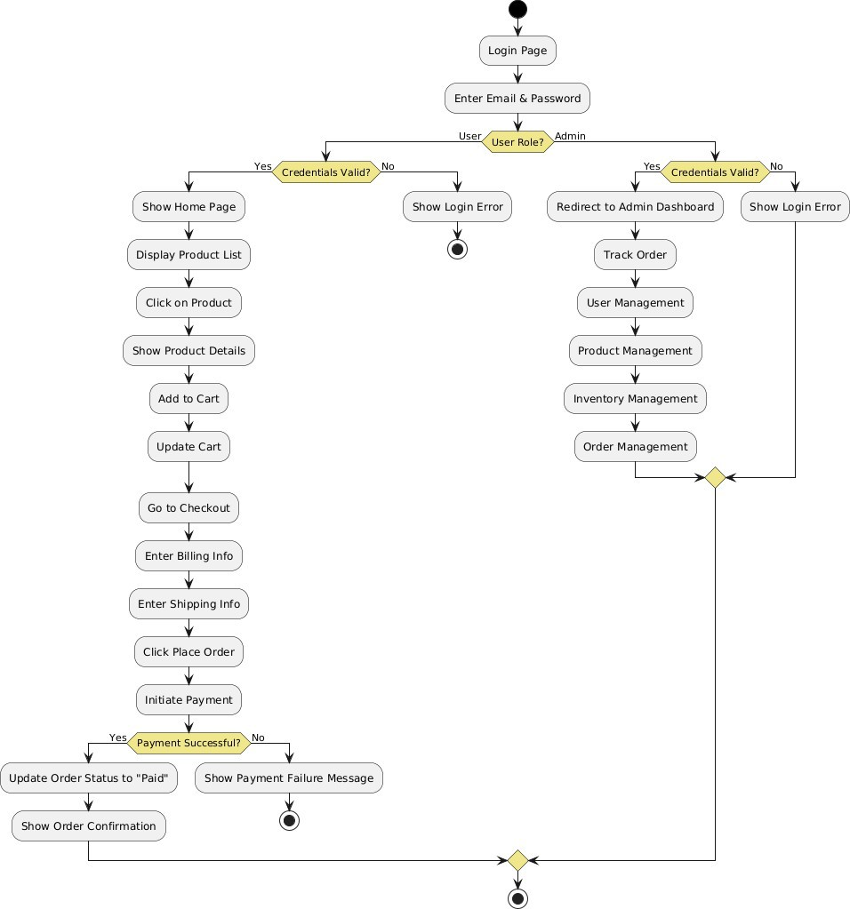
Figure 5: Activity Diagram Illustrating System Workflow

The above Activity Diagram Figure 5, illustrates the workflow of specific processes, such as user checkout or product management. For example, in the checkout process, the diagram shows the sequence of actions: User logs in → Adds products to cart → Reviews cart → Proceeds to payment → Enters shipping details → Confirms payment → Receives order confirmation. It uses actions, decision nodes, and control flows to represent the logic and possible paths. This helps in understanding and optimizing user journeys and backend processes for better usability and system performance.

IMPLEMENTATION

TECHNOLOGY USED

Frontend Modules (Client-Side)

- User Registration & Login Module

This module allows users to create an account or log in to access personalized features like placing orders, managing profiles, and viewing past purchases.
  - React.js handles form components for capturing user input (like name, email, and password), along with client-side validation and error display.
  - Axios sends the login or registration data to the backend API.
  - Upon successful login, a JWT token is returned from the server and stored in the browser’s local storage, keeping the user authenticated across sessions.

Product Browsing & Filtering Module

This module displays skincare products and allows users to filter them by various attributes such as skin type, category, brand, price, and more.

  - A dynamic grid layout using reusable React components showcases product cards.
  - Filters are implemented using React state and dropdowns or checkboxes.
  - When filters are applied, API calls are made to the backend to fetch and render only the relevant products in real time.

Shopping Cart Module

The cart module enables users to add, remove, or update the quantity of selected products before checkout.

  - Actions like “Add to Cart” update a global cart state managed by React Context API, allowing access to cart data across all components.
  - The cart dynamically displays the updated total amount, item count, and offers the option to proceed to checkout.

Checkout & Payment Module

This module is responsible for collecting shipping details and processing secure payments.

  - Users review their order summary and enter shipping information.

  - The Razorpay payment gateway is integrated with React for handling online transactions securely.
  - Once the payment is successful, Axios sends the confirmation to the backend to complete the order and store payment details.

User Dashboard Module

This module offers a personalized space for each logged-in user to manage their activity on the platform.

  - Users can view and track current orders, check order history, and update saved addresses.
  - API requests are made using the JWT token to fetch and display user-specific data securely.

Admin Dashboard (Frontend)

This admin-only module enables backend control via a custom frontend interface.

  - Admins can add, update, or delete products, manage inventory, and track user orders through protected routes.
  - Axios is used to communicate with backend endpoints, allowing admin-level operations such as changing delivery status or modifying product info.

Backend Modules (Server-Side)

- Authentication Module

This module handles the secure login and registration process for users and admins.

  - Passwords are encrypted using Bcrypt.js before being stored in the database to protect user credentials.
  - When a user logs in successfully, a JWT (JSON Web Token) is generated and sent to the frontend. This token is stored and used to verify future requests.
  - Middleware functions check the validity of the JWT token to protect sensitive routes (like user dashboards and admin operations).
  - This module ensures only authenticated users can access or modify personal or sensitive data.

Product Management Module
  - Products are stored as documents in MongoDB, and each product includes details such as name, description, price, image, category, etc.
  - Mongoose schemas are used to define the structure of product data, which helps ensure consistency.
  - Admins can perform CRUD operations (Create, Read, Update, Delete) through well- structured REST APIs, making it easy to maintain the product catalog.
  - This module ensures that the frontend always displays accurate and up-to-date product information.

Cart & Order Processing Module
  - When users add items to the cart, the data is saved either temporarily or within their profile in MongoDB.
  - On placing an order, the system assigns a status such as “Pending”, “Shipped”, or “Delivered” which can be updated by the admin later.
  - Inventory updates happen automatically based on orders and returns to prevent overselling or stockouts.
  - This module is essential for the smooth handling of purchases from cart to delivery.

Payment Integration Module
  - It uses Razorpay or Stripe SDK to generate payment orders on the server side.
  - Once the payment is made, the backend verifies the payment signature to prevent fraud.
  - If successful, the order is confirmed, and details like transaction ID and amount are saved in the database.
  - This module plays a critical role in providing users with a safe and reliable checkout experience.

User Profile & History Module
  - Each user document in MongoDB includes profile details, list of past orders, and Wishlist items.
  - API endpoints retrieve this data to display it in the user dashboard.
  - Users can also update their addresses or view the status of previous orders.
  - This module allows users to personalize their experience and maintain their account seamlessly.

Admin Backend Module
  - Admins log in through a JWT-authenticated route which restricts access to admin-only functionalities.
  - Through the backend APIs, admins can manage product inventory, update order statuses, access user information, and even generate sales reports.
  - This module helps administrators run the store effectively, keeping everything updated and under control.

SCREENSHOTS

TESTING

7.1 User Registration & Login Module
This module tests the core user authentication functionalities shown in Table 4, ensuring that users can register with valid details, log in securely, and access protected routes appropriately. It also validates error handling for invalid inputs, duplicate registrations, and unauthorised access attempts.
Table 4 User Registration & Login Module
Test ID | Test Case Description | Input | Expected Result | Actual Output | Status
TC-001 | Register with valid inputs | Valid name, email, password | Account should be created | Account created successfully | PASS
TC-002 | Register with existing email | Duplicate email | Show "Email already exists" error | Error displayed correctly | PASS
TC-003 | Login with valid credentials | Correct email & password | User logged in and redirected to dashboard | Redirected to dashboard | PASS
TC-004 | Login with wrong password | Valid email, wrong password | Show "Invalid credentials" message | Error message shown | PASS
TC-005 | Access protected page without login | No token | Redirect to login page | Redirected as expected | PASS
TC-006 | Register with invalid email format | Name, invalid email (e.g., user@com) | Show "Invalid email format" error | Error message shown | PASS
TC-007 | Login with unregistered email | Unregistered email, any password | Show "User not found" error | Error message shown | PASS
TC-008 | Registration with missing required fields | Missing password | Show "Password is required" error | No error, registration allowed | FAIL
TC-008a | (Fix) Validation added for missing fields | Missing password | Show "Password is required" error | Error message shown | PASS
TC-009 | Login with empty email and password | Blank email and password | Show "Please fill in all fields" error | Error shown correctly | PASS
7.2 Task Management Module
This module focuses on ensuring that users can effectively create, view, update, filter, and delete academic tasks. The tests cover key functionalities including task creation with valid and invalid inputs, filtering by category and priority, editing task details, and handling edge cases such as missing required fields or unauthorised access. The goal is to provide a reliable and intuitive task management experience. Table 5 below summarises the test cases executed for this module.
Table 5 Test Cases for Task Management Module
Test ID | Test Case Description | Input | Expected Result | Actual Output | Status
TC-011 | Add task with valid inputs | Valid title, category, due date, priority | Task created and shown in list | Task added successfully | PASS
TC-012 | Add task with missing title | Empty title field | Show "Title is required" error | Error message shown | PASS
TC-013 | Filter tasks by category | Select course category | Only tasks of that category displayed | Filtered correctly | PASS
TC-014 | Filter tasks by priority | Select "High" priority | Only high-priority tasks shown | Tasks filtered correctly | PASS
TC-015 | Edit an existing task | Update title and due date | Task updated and reflected in list | Task updated successfully | PASS
TC-016 | Delete a task | Click delete on a task | Task removed from list | Task deleted successfully | PASS
TC-017 | View task with no matching filter | Apply filter with no matches | Show "No tasks found" message | No tasks message displayed | PASS
TC-018 | Access another user's task | Different user ID in request | Return 404 or unauthorised error | Unauthorised error returned | PASS
7.3 Subtask & AI Breakdown Module
Table 6 Test Cases for Subtask & AI Breakdown Module
Test ID | Test Case Description | Input | Expected Result | Actual Output | Status
TC-019 | Add subtask to a task | Valid subtask title and time | Subtask saved and displayed | Subtask added successfully | PASS
TC-020 | Mark subtask as complete | Click complete checkbox | Subtask marked complete | Status updated correctly | PASS
TC-021 | Delete a subtask | Click delete on subtask | Subtask removed from list | Subtask deleted successfully | PASS
TC-022 | Generate AI breakdown with valid task | Task with title, description, category | 4–6 subtasks, tip, and effort level returned | AI breakdown displayed correctly | PASS
TC-023 | Generate AI breakdown with missing description | Task with title only | Breakdown generated using available fields | Breakdown returned with defaults | PASS
TC-024 | AI breakdown with API unavailable | Gemini API key absent | Fallback subtasks returned | Default subtasks shown | PASS
7.4 Daily Planner Module
Table 7 Test Cases for Daily Planner Module
Test ID | Test Case Description | Input | Expected Result | Actual Output | Status
TC-025 | View daily subtasks for current date | Logged-in user | Subtasks due today displayed | Correct subtasks shown | PASS
TC-026 | Mark daily subtask complete from planner | Click complete | Subtask status updated | Status updated correctly | PASS
TC-027 | View planner with no tasks due today | No subtasks scheduled | Show "No tasks for today" message | Message displayed correctly | PASS
7.5 Analytics & Heatmap Module
Table 8 Test Cases for Analytics & Heatmap Module
Test ID | Test Case Description | Input | Expected Result | Actual Output | Status
TC-028 | Load analytics dashboard | Logged-in user with tasks | Charts render with correct data | Charts displayed correctly | PASS
TC-029 | View heatmap with activity | User with completed tasks | Activity grid shows correct density | Heatmap rendered correctly | PASS
TC-030 | View analytics with no tasks | New user with no data | Show empty state or zero values | Empty state shown correctly | PASS
7.6 Email Reminder Module
Table 9 Test Cases for Email Reminder Module
Test ID | Test Case Description | Input | Expected Result | Actual Output | Status
TC-031 | Cron job triggers for tasks due tomorrow | Task with due date = tomorrow | Reminder email dispatched to user | Email received correctly | PASS
TC-032 | No email sent when no tasks due tomorrow | No matching tasks in DB | No email dispatched | No email sent as expected | PASS
TC-033 | Email content correctness | Task title and category in DB | Email contains correct task name and due date | Correct content in email | PASS
7.7 User Profile & Settings Module
Table 10 Test Cases for User Profile & Settings Module
Test ID | Test Case Description | Input | Expected Result | Actual Output | Status
TC-034 | View user profile | Logged-in user | Show name, email, and profile details | Profile displayed correctly | PASS
TC-035 | Update profile information | Edit form and submit | Info updated and reflected | Profile updated successfully | PASS
TC-036 | Change password with correct old password | Old + new password | Password updated successfully | Password changed | PASS
TC-037 | Change password with incorrect old password | Wrong old password | Show "Current password incorrect" error | Error message shown | PASS
TC-038 | Update security question | New question and answer | Security question updated | Updated successfully | PASS

- Impact on Society and Environment

Impact on Society
Tasklytic significantly contributes to enhancing the way students plan, manage, and execute their academic responsibilities. By offering a digital platform that is both intelligent and user-friendly, it empowers individuals to make better-informed decisions regarding their study habits and time allocation. The inclusion of features such as AI-generated task breakdowns, personalised success strategies, a daily planner, and automated deadline reminders makes academic productivity more accessible — especially for students who struggle with self-organisation or do not have access to academic coaching or tutoring support.
The platform supports the growing self-improvement and study-wellness movement by promoting structured planning, consistent effort tracking, and awareness of workload distribution. The Eisenhower Matrix and productivity heatmap encourage students to reflect on their priorities and study patterns, fostering habits that extend well beyond the platform itself. By centralising task information and providing intelligent guidance, Tasklytic also helps reduce academic stress and the anxiety associated with missed deadlines or poorly managed workloads.
From a broader perspective, the project demonstrates how AI technology can be democratised and applied meaningfully in educational contexts without requiring expensive institutional infrastructure. Students from any background can access the same quality of AI-assisted academic planning that would otherwise require paid productivity tools or personal tutoring. From a developer's standpoint, this project also contributes to real-world learning, building valuable skills in full-stack development, AI API integration, database design, and software engineering best practices.
Impact on Environment
Although digital platforms generally have a lower direct environmental impact compared to physical infrastructure, the environmental implications of running cloud-based web applications must still be considered. By shifting academic planning and task management entirely online, Tasklytic eliminates the need for printed planners, paper-based to-do systems, and physical study organisers — contributing to reduced paper consumption and waste associated with traditional academic planning tools.
The platform's automated email reminder system replaces the need for printed reminder sheets or physical notice boards, and its cloud-based deployment on platforms such as Vercel minimises the energy overhead associated with maintaining dedicated on-premises servers. The serverless and efficient architecture of the application ensures that computational resources are consumed only when needed, reducing idle energy usage.
However, the environmental cost of AI API calls — particularly to large language models such as Google Gemini — must be acknowledged, as inference on large models carries an energy footprint. To address this responsibly, the project incorporates a deterministic fallback mechanism that avoids unnecessary API calls when the service is unavailable, and prompts are structured to be concise and targeted, minimising token usage per request.
Future enhancements to Tasklytic could further reduce its environmental footprint by:
- Implementing response caching for commonly requested AI breakdowns to avoid redundant API calls,
- Optimising database query efficiency to reduce server processing load,
- Adopting green hosting providers that operate on renewable energy infrastructure,
- Encouraging digital-first study habits that reduce dependence on printed materials across academic institutions.
By promoting structured digital academic management and making responsible engineering decisions, Tasklytic serves as a step toward balancing technological convenience, intelligent personalisation, and environmental responsibility in the educational software space.
.

CONCLUSION & FUTURE ENHANCEMENTS
CONCLUSION
The development of Tasklytic — an AI-powered academic task management system — aimed to address the limitations found in generic productivity tools by offering a tailored, intelligent, and performance-optimised solution designed specifically for students. The platform provides structured task and subtask management, AI-generated study plans, visual productivity analytics, and automated deadline notifications, catering to the unique needs of academic users who require more than a simple to-do list to manage their coursework effectively.
Technically, the system incorporates user authentication, full CRUD task and subtask management, Google Gemini AI integration, a daily planner, Eisenhower matrix prioritisation, a productivity heatmap, and a cron-based email reminder service. Using React.js with a component-based architecture enabled code reusability and simplified maintenance, while a fully responsive design ensured a consistent experience across all devices. On the backend, Node.js and Express.js provided a flexible, non-blocking server environment, with MySQL handling structured relational data efficiently. JWT-based authentication and secure API design safeguarded user information, and modular routing across user, task, analytics, and AI domains improved scalability and long-term maintainability.
The project introduced valuable real-world experience in full-stack development, RESTful API design, AI API integration, database modelling, scheduled background services, and cloud deployment. Comprehensive testing was conducted throughout the development cycle, including unit tests for individual components, API testing via Postman, and integration testing to validate interactions between the frontend and backend systems. These practices ensured system reliability and a smooth user experience across devices and browsers.
Overall, Tasklytic strengthened technical skills across the team and demonstrated how thoughtful design, intelligent feature integration, and robust engineering can result in a professional-grade, scalable academic productivity platform. The project not only fulfilled its immediate functional goals but also laid a solid foundation for ongoing evolution in the academic technology space.
FUTURE ENHANCEMENTS
1. Conversational AI Chatbot
Integrating a conversational study assistant using tools such as the Gemini API, ChatGPT API, or Dialogflow would allow students to interact with the platform in natural language — asking questions about their tasks, requesting study tips, or getting instant breakdowns without navigating through the UI manually. An in-app chatbot could also provide motivational nudges, answer academic queries, and guide new users through the platform's features, improving engagement and onboarding significantly.
2. Mobile Application Development
Developing a dedicated mobile application using Flutter or React Native would enhance accessibility and convenience for students who primarily use smartphones for study management. Features such as push notifications for deadline reminders, offline task viewing, and biometric authentication would improve usability and encourage consistent daily engagement with the platform.
3. Collaborative Study Groups
A future version of Tasklytic could support group task management, allowing students to collaborate on shared assignments, divide subtasks among group members, and track collective progress in real time. Role-based access within groups — such as group owner, editor, and viewer — would provide structured collaboration aligned with academic team projects.
4. Integration with Learning Management Systems (LMS)
Connecting Tasklytic with institutional platforms such as Moodle, Google Classroom, or Canvas would allow tasks and deadlines to be automatically imported from a student's enrolled courses. This would eliminate manual task entry, reduce duplication across tools, and ensure the platform reflects the student's actual academic schedule in real time.
5. Advanced Analytics and Personalised Insights
Implementing deeper analytics capabilities — such as subject-level performance trends, predicted deadline risk scoring, and weekly study consistency reports — would provide students with actionable, data-driven insights into their academic habits. Integration with tools such as Google Analytics or custom reporting dashboards would also allow administrators or institutions to monitor platform usage and identify areas for improvement.
6. Subscription and Institutional Licensing
A tiered subscription model could unlock premium features such as unlimited AI breakdowns, advanced analytics, group collaboration, and LMS integration. An institutional licensing option would allow universities or schools to deploy Tasklytic as a white-labelled productivity platform for their students, expanding the platform's reach and sustainability as a long-term product.

REFERENCES
- Express.js Foundation. (n.d.). Express Documentation. Retrieved from https://expressjs.com
- React Official Documentation – Meta. (n.d.). React Docs – A JavaScript library for building user interfaces. Retrieved from https://react.dev
- Node.js Documentation – OpenJS Foundation. (n.d.). Node.js Documentation. Retrieved from https://nodejs.org/en/docs
- MySQL Documentation – Oracle Corporation. (n.d.). MySQL 8.0 Reference Manual. Retrieved from https://dev.mysql.com/doc
- mysql2 – npm Registry. (n.d.). mysql2 – Fast MySQL driver for Node.js. Retrieved from https://www.npmjs.com/package/mysql2
- Google Generative AI – Google LLC. (n.d.). Gemini API Documentation. Retrieved from https://ai.google.dev/docs
- Nodemailer – Nodemailer. (n.d.). Nodemailer – Send emails from Node.js. Retrieved from https://nodemailer.com
- node-cron – npm Registry. (n.d.). node-cron – Task scheduler for Node.js. Retrieved from https://www.npmjs.com/package/node-cron
- JSON Web Tokens – Auth0. (n.d.). Introduction to JSON Web Tokens. Retrieved from https://jwt.io/introduction
- bcrypt – npm Registry. (n.d.). bcrypt – Password hashing library for Node.js. Retrieved from https://www.npmjs.com/package/bcrypt
- Vite – Evan You & Vite Contributors. (n.d.). Vite – Next Generation Frontend Tooling. Retrieved from https://vitejs.dev
- W3Schools – W3Schools.com. (n.d.). HTML, CSS, JavaScript Tutorials. Retrieved from https://www.w3schools.com
- MDN Web Docs – Mozilla Developer Network. (n.d.). Web technology reference. Retrieved from https://developer.mozilla.org
- GitHub – GitHub Inc. (n.d.). Open-source project collaboration and version control. Retrieved from https://github.com
- GeeksforGeeks. (n.d.). Full Stack Development Tutorials and Concepts. Retrieved from https://www.geeksforgeeks.org
- Figma – Figma Inc. (n.d.). Collaborative Interface Design Tool. Used for UI wireframing and prototypes. Retrieved from https://www.figma.com

