**A REPORT ON MY STUDY EXPERIENCE IN THE LAST THREE WEEKS**

INTRODUCTION

Am happy and proud to be at AkiraChix ,for the past last weeks have learnt new things,new people,met mentors and have met different facilitators. Through our lectures have been able to learn different subjects from different teachers of which also have been an inspiration to us by sharing their stories.

BODY

Some of the subjects offered to are;

* Introduction to computer
* Graphic Design
* Html Css
* Python
* Hardware Design
* Electronics
* Lifeskills
* Entreprenueship

INTRODUCTION TO COMPUTER

The lesson it is taught by Pascal

Have learnt about the external part of a computer

Have also learn how to go incognito

How to open an email account

How to type and create a desktop



GRAPHIC DESIGN

The lesson is taught by Nyandia Kamweit is the art of combining text and pictures in advertidment,magazines and books.

I have learnt how to make curves and lines in images using the pen tool



HARDWARE DESIGN

It is taught by Mr.Yassir

Have learnt about the definition to design and process

Have learnt about Design Thinking

Have learnt about Sketching



ENTREPRENUSHIP

It is taught by mrs.kelly murungi

Have learnt about definantion of entrenuership

Have also learnt about types of entrepreneur and their characterics

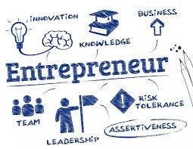

PYTHON

Its Taught by james mwai

Have learnt about basic impression plus comparison

Have learnt about comparison operators

Have learnt about concatenation; the act of combining string together

Have also learnt about a string

LIFESKILLS

It is taught by mrs.veronica

We’ve learnt about visualize our vision through vision board

We’ve learnt about sterotypes

We’ve learnt to dream big