**MACHAKOS UNIVERSITY**

**SCHOOL OF COMPUTING ENGINEERING AND TECHNOLOGY**

**DEPARTMENT OF COMPUTING AND INFORMATION TECHNOLOGY**

**DEAF CLIENT-INTERPRETER SYSTEM**

**SHALLON MARIA OMWONO**

**J17-5594-2020**

**PROJECT PROPOSAL SUBMITTED IN PARTIAL FULFILLMENT OF THE REQUIREMENTS FOR THE DEGREE OF BACHELOR OF SCIENCE IN COMPUTER SCIENCE OF MACHAKOS UNIVERSITY**

**2024**

**DECLARATION**

I declare that this work has not been previously submitted and approved for the award of a degree by this or any other University. To the best of my knowledge and belief, the project contains no material previously published or written by another person except where due reference is made in the project itself.

**STUDENT:**

SHALLON MARIA OMWONO

Signature Date

**SUPERVISOR:**

DR. ERICK O. OMUYA

Signature Date

# DEDICATION

I dedicate this project proposal to my family, friends, lecturers and supervisor whose unwavering support and guidance have been instrumental in this journey. I am deeply grateful for their love and encouragement which has been my source of strength and inspiration in completing this.

# ACKNOWLEDGMENT

I would like to express my sincere gratitude to several individuals who have supported me throughout this whole process.

I am deeply thankful to my supervisor, Dr. Erick O. Omuya for his guidance and insightful feedback. His expertise and mentorship has been instrumental in this project proposal. I am also grateful to my lecturers for the knowledge instilled in me which has guided me in writing the proposal and coming up with the project idea.

Lastly, I extend my appreciation to my family and friends for their unwavering encouragement and understanding during this academic journey.

# ABSTRACT

Deaf Client-Interpreter system is a project that will be designed to be used by the deaf community( people with hard of hearing) , interpreters and anyone who has an intention of speaking with the deaf community. The deaf community face a challenge communicating with non-deaf community because a large percentage of people do not know sign language hence making communication and interaction between these two parties difficult. It is hard for these two parties to express to each other. This creates a huge barrier between them. To solve and reduce this problem, Deaf Client-Interpreter system comes in. This project aims to tackle communication barriers faced by the deaf community through creation of a web-based system that connects them with interpreters. Globally, over 5% of the population, approximately 466 million people are affected by disabling deafness. In Kenya alone, the 2019 census reported 153,381 deaf individuals above the age of 5, highlighting the prevalence of this issue. Current challenges include language barrier hindering engagement with service providers leading to social isolation. The proposed system seeks to address these challenges by leveraging ICT to virtually or physically connect the deaf community with interpreters across various sectors. The objective for this project is to develop a user-friendly web-based system through adaptation of agile methodology to enhance communication between the involved parties. The project emphasizes the significance of breaking communication barriers, fostering inclusivity and empowering individuals with hearing disabilities.

Table of Figures

Figure 1: Conceptual Diagram 7

Figure 2: Scrum - Agile Phases 10

# ABBREVIATIONS

WHO : World Health Organization.

KIPPRA: Kenya Institute for Public Policy Research and Analysis.

ICT – Information and Communication Technology

VRI – Video Remote Interpreting

VRS – Video Relay Service

dB – Decibels

HOH – Hard Of Hearing

TDD - Telecommunications Device for the Deaf

CC – Closed Captioning

ALDs – Assistive Listening Devices

TTS – Text-to-speech

STT – Speech-to-text

Table of Contents

DEDICATION ii

ACKNOWLEDGMENT iii

ABSTRACT iv

ABBREVIATIONS v

INTRODUCTION 1

1.1 Background Study 1

1.2 Problem Statement 2

1.3 Objectives 2

1.3.1 Main Objective 2

1.3.2 Specific Objectives 3

1.4 Scope and Limitations of the Study 3

1.5 Justification 3

CHAPTER TWO 4

LITERATURE REVIEW 4

2.1 Introduction 4

2.2 Existing Systems 4

2.2.1 Video Relay System 4

2.2.2 Text-to-Speech (TTS) and Speech-to-Text (STT) Systems 4

2.2.3 Deaf-Friendly Mobile Apps 5

2.2.4 Hearing Aids 5

2.2.5 Video Remote Interpreting ( VRI ) 6

2.3 Research Gaps 6

2.4 Conceptual Framework of Proposed System 7

CHAPTER THREE 8

METHODOLOGY 8

3.1 Introduction 8

3.2 Research Design 8

3.3 Target Population 8

3.4 Sample Size 8

3.5 Data Collection Methods 8

3.5.1 Observations 9

3.5.2 Interviews 9

3.6 Data Analysis 9

3.7 Software Development – Agile Methodology 9

REFERENCES 11

APPENDICES 13

APPENDIX I Time Schedule 13

APPENDIX II Budget 14

**CHAPTER ONE**

# INTRODUCTION

## 1.1 Background Study

In general, disability is where one has any condition of the body or mind that makes it more difficult to do certain activities and interact with the world around them. According to WHO, disability has three dimensions, they include Impairment in a person’s body structure or function or mental functioning, such as loss of vision or memory loss or loss of limb, Activity limitations like difficulty in seeing, hearing, walking or problem solving and Participation restrictions in normal daily activities, such as working, social and recreation activities and obtaining health care and preventive services (WHO, 2020).

Deafness is measured by determining the loudness of the quietest sound heard, using decibels (dB). People who are not affected by deafness can hear sounds at 20dB or less across all frequencies. Over 5 per cent (466 million) of the entire population worldwide(7.6 billion) or one person out of 20 is affected by disabling deafness, that is, a degree greater than 40dB in the better-hearing ear in adults and degree greater than 30db in children (WHO, 2020).

According to the Kenya National Population Census in 2019, deaf people in Kenya who are aged above 5 years are 153,381. Where 129,518 are in rural areas and 23,843 in the urban areas. Deafness can be defined as an invisible disability where a person cannot understand speech through hearing, which implies very little hearing or no hearing. According to the Deaf People and Human Right Report (2009), Deaf (with uppercase D) refers to a community that share a language like sign language and culture, deaf (with lowercase d) are those with audiological condition of not hearing who are not recognized as part of Deaf community and hard of Hearing is one with mild to moderate hearing loss which does not have cultural affiliation with Deaf Community (Njue, 2020).

There is a communication barrier challenge to the deaf community when interacting with service providers in different setups. Nowadays, there are broadcast programs on television screens with interpreters to help those with hearing disability to understand. In public places like churches and public holidays events , there are usually assigned sign language interpreters thus bridging the gap between the deaf and those with normal hearing. There is online and physical learning of sign language , thus increasing the availability of sign language interpreters.

The proposed system will be able to connect the deaf people and interpreters when they need services where communication is a challenge with the service provider. This system will also help create job opportunities for the interpreters in a case where the organization decides to keep the interpreter in the organization.

## 1.2 Problem Statement

The deaf community face problems that they are unable to share. This is because there are few people who can understand them, and they end up seeking help from themselves. Some of them can be depressed and have a negative perspective of the society. When a person with hearing disability visits places with people who have normal hearing, they don’t engage because there is language barrier. It is hard for the deaf community to visit places for services because the service provider won’t be able to understand. Few people know sign language. Most deaf people do not engage in cultural activities like for example in museums and tourist sites. Children born with deafness find it hard to communicate unless if parents know sign language as they will grow with sign language as their first language.

Some of the systems have not been tested in different fields making them unknown among people, especially the virtual systems hence people not trusting them and preferring the physical options. Some of them are expensive and only few people who can afford them are using because people come from different backgrounds.

Using ICT, the proposed system will be a web-based user-friendly system that will be able to help the deaf community in the challenge they are facing on communication with the service provider and hearing people that is by connecting them with interpreters both virtually and physically. The proposed system will allow deaf people, service provider or hearing people to connect with the interpreter virtually or physically so as to provide interpretation services. The system will be widely used, not only in the health sector but also in all sectors where the interpretation service will be needed.

## 1.3 Objectives

### 1.3.1 Main Objective

To develop a web-based user-friendly system that connects the deaf community with interpreters for effective communication.

### 1.3.2 Specific Objectives

1. To analyze existing systems or methods used to support the deaf community in communication.
2. To design a web-based user-friendly system for the deaf community.
3. To bridge the gap between deaf community and non-deaf community.

## 1.4 Scope and Limitations of the Study

This project aims to provide a web-based platform that tries to address communication barrier for the deaf community. It tries to help the deaf community and service provider to have a seamless communication by the use of an interpreter either remotely or physically. The project also has resources that can be available to everyone who is interested in sign language or interpretation. It also increases chances for employment for the interpreters as they will be recognized. The system could also be used by deaf tourists who need interpreters hence improving tourism and culture in Kenya.

The proposed system could have some limitations such as, there could be dependence on internet connectivity for virtual interpretation services, some challenges for those individuals with limited technological literacy or access to devices, availability of qualified interpreters may vary depending on location and demand and video communication could be blurry if video quality is not good.

## 1.5 Justification

The justification for the proposed system is that it will address the communication challenges faced by the deaf community. By providing access to interpreters both virtually and physically, the proposed system aims to bridge the language barrier and enable effective communication in various sectors. This will enhance inclusivity, empower individuals with hearing disabilities and ensure equal access to services for the deaf community. Additionally, it is going to promote tourism by allowing deaf tourists and local deaf tourists use the system to get interpreters for their time. This will also promote our Kenyan culture.

# CHAPTER TWO

# LITERATURE REVIEW

## 2.1 Introduction

Various interventions have evolved over time to support the needs of the deaf community. From early manual communication methods to the development of sign language and assistive technologies. One notable example is the establishment of deaf schools, which provided education and a sense of community for deaf individuals.

Additionally, advancements in technology such as hearing aids, cochlear implants and captioning services have greatly improved accessibility and inclusion for deaf individuals. These systems have played a crucial role in facilitating communication and access for deaf individuals.

## 2.2 Existing Systems

There are some systems that are already being used to help the deaf community with their daily lives.

### 2.2.1 Video Relay System

The deaf and hard-or-hearing community experience many barriers to communicate on the phone and online. VRS also known as Video Interpreting Service (VIS) is a video telecommuication service that allows the deaf, hard-of-hearing and speech-impaired (D-HOH-SI) people to communicate with hearing people via a sign language interpreter using video telephones and similar technologies (Wikipedia, 2024).

Some of the challenges faced are, only individuals who have sign language knowledge are able to use this online video software hence limiting its use. Each country that has VRS, has different sign-up requirements, regulations and fees. VRS is a service that is not offered in every country meaning it s not widely known by many people (Aziz & LeBlanc, 2023).

### 2.2.2 Text-to-Speech (TTS) and Speech-to-Text (STT) Systems

A speech to text system(STT) converts speech into text in a human language format. A text to speech system (TTS) translates text into speech in a human language format (Saini, 2022). One of the first speech recognition systems was built by scientists at AT&T Bell Laboratories in 1952. (Matre & Cameron, 2022).

AI voice TTS technology has evolved but still TTS id still facing challenges. TTS is finding it difficult to achieve a natural-sounding human voice. The audio produced is clear and understandable but bringing human-like inflections and emotions remains a challenge. Sometimes, TTS struggles pronouncing words based on their context. Customization of voices to suit according to diverse needs such as accents is a problem. (Elevenlab, 2023). Some of the challenges people have experienced while using STT are technical challenges that compromise elements that are inherent in the technology such as word recognition errors and time required to set up the system, contextual factors like people’s lack of competency in using the tool and emotional difficulties such as feelings of anxiety or frustration with the technology (Matre & Cameron, 2022)

### 2.2.3 Deaf-Friendly Mobile Apps

It is hard for many people with hearing impairment to communicate with hearing people. Sign language is the effective way for them to communicate, sadly, it is not widely known by the hearing population. Through the advancement of technology, it has made a bit easier for them to communicate. There are numerous mobile apps designed for the deaf community. Some popular apps include: Ava (iOS and Android), Google Live Transcribe (Android), Live Transcribe (iOS), Otter AI (iOS and Android), Signly (iOS and Android), Rogervoice (iOS and Android), TapSOS (iOS and Android) and Subtitles Viewer (Rogers, 2022).

Some of the disadvantages of deaf-friendly mobile apps are some apps may have limited features or may not fully meet the specific needs or preferences of deaf individuals, most of them provide captioning which is difficult to use and understand for people who do not know how to read, some are not a great option for people who have thick accents or speech difficulties and they are limited on availability or compatibility across different operating systems (Rogers, 2022).

### 2.2.4 Hearing Aids

The first hearing aid, dating from the 17th century, was an enormous ear trumpet with a tube that channeled sound to the ear. In the late 19th century, acoustic horns were made to fit in the ear. In the 1990s, digital hearing aids were introduced, which allowed a much more customized use to do with the amplification, reduction, filtration, and direction of sound. Today, the newest hearing aid can receive sound wireless from telephones, televisions, stereos, and computers (Zárate, 2021).

Hearing aids can encounter challenges such as, they may not completely restore normal hearing and may have difficulty in noisy environments and they can be expensive, lack of benefit and discomfort such as irritation in the ear require maintenance and may not be covered by insurance.

### 2.2.5 Video Remote Interpreting ( VRI )

VRI is a system that provides sign language interpretation through video calls. The history of VRI dates to the early 2000s when advancements in video conferencing technologies made it possible to provide remote sign language interpretation. It was initially developed to bridge the gap between deaf individuals and hearing individuals in various settings, such as healthcare, education, and business (Kushalnagar et al, 2019).

VRI technology is not subject to geographical and time constraints since the interpreter can provide service from anywhere and does not have to spend time commuting to and from the appointment. VRI is often used for sessions, one-on-one visits, and patient walk-ins when an interpreter is needed immediately.

VRI is subjected to disadvantages such as, the quality of the video can sub optimal since the VRI relies on wireless connections, it may not be accessible for individuals with limited technological skills and in certain settings.

## 2.3 Research Gaps

Limited availability of sign language interpretation services is a noted research gap where services are not available everywhere or in every country. There is inadequate access to educational resources in sign language or lack of deaf-friendly communication platforms. This is evident mostly in social media pictures and videos. Most of them have no interpretation or captions to help the deaf community understand what is going on in the video for instance. There is insufficient awareness and understanding of the deaf culture and communication needs. It is caused by not understanding the sign language and limited interaction with them.

Comprehensive mental health services tailored to the deaf community is limited. People tend to focus on a group of people at large forgetting the deaf community needs a more approach. There is limited access to employment opportunities for the deaf and interpreters . Some of the means to help the deaf community are expensive and most of them cannot afford them. For example the hearing aids are expensive for most people.

## 2.4 Conceptual Framework of Proposed System

There are different variables defining the conceptual framework of Deaf Client-Interpreter System. They include independent variables, dependent variables, mediator variables, moderator variables and control variables. Provision of sign language education acts as an independent variable which creates a casual relationship with provision of interpretation services which is a dependent variable. Number of interpreters acts as a mediator variable which links independent and dependent variables. An increase in sign language education may lead to more qualified interpreters which in turn improves the provision of interpretation services.

Communication and interaction activities act as moderator variable. If communication and interaction activities are widespread in a community they enhance effectiveness of interpretation services. Awareness and attitude toward deaf culture acts as a control variable. It could influence demand of interpretation services.

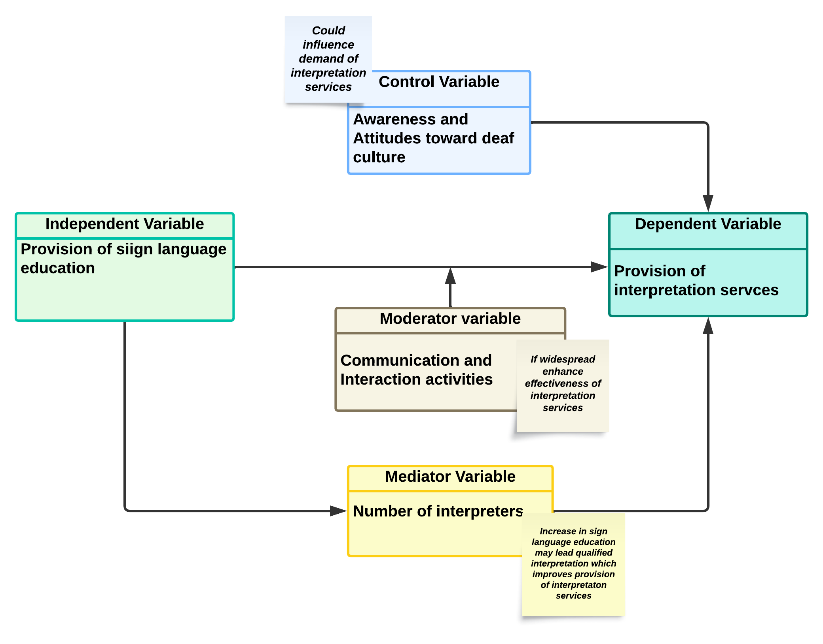Figure 1: Conceptual Diagram

# CHAPTER THREE

# METHODOLOGY

## 3.1 Introduction

In system development, there are some step-by-step procedures one must use that will allow one to measure their progress. This will ensure that the most optimal system is delivered on time.

## 3.2 Research Design

Research design refers to a plan that outlines the methods and procedures to be followed. According to my problem statement, I will use quantitative and qualitative research methods. It helps ensure a structured and systematic approach to gather and interpret data for the project. Quantitative methods will provide numerical data for identifying trends and patterns in numbers, graphs and tables while qualitative methods will give detailed information on the participant’s thoughts and experiences for example on the interviews and observations.

## 3.3 Target Population

The target population for this proposed project would be the deaf community, specifically those who face communication challenges due to language barriers when seeking services. This would include individuals who rely on sign language as their primary mode of communication. For a start, the test will be held in a school for the deaf in Machakos County and will target a sample size of approximately 30 to 50 participants.

## 3.4 Sample Size

Simple Random Sampling will be used, where each member has an equal chance of being chosen. This will minimize bias. The sample size will be approximately 30 to 50 participants for a start.

## 3.5 Data Collection Methods

This shows the techniques one uses to collect data for research. Some sources of collecting data include books, published papers, journals and the internet. The following methods will be used to collect data:

### 3.5.1 Observations

Observation method is both a qualitative and quantitative method where one must systematically watch and record events or behaviors in order to collect data intended for a particular study. In the proposed system case the observation is on our daily lives, qualitative where detailed description and interpretation of observed behaviors is obtained. The reason as to why observation is suggested, it will be easy to observe their natural behaviors and it will be possible to note where they are not able to express themselves. Observing the deaf community in the institution while they are on break times as they will be interacting with other friends.

### 3.5.2 Interviews

In this qualitative method, a respondent is asked open-ended questions about a certain subject. It will help one interact with respondents while asking questions and getting responses which are explained and get possible recommendations. Interviews will allow to get participant’s thought and experiences which may not be captured in the observation method. It will increase interaction which will increase accuracy of the data collected.

## 3.6 Data Analysis

Data analysis involves examining and interpreting data to gain insights and make informed decisions. It may include analyzing user interactions, tracking system performance, and identifying pattern trends. By analyzing data, we can better understand the needs and preferences of the deaf community, improve the system’s usability, and enhance the overall user experience. Qualitative analysis which involves interpreting non-numerical data like interviews, observation to gain insights and understand the experiences of deaf community suits.

## 3.7 Software Development – Agile Methodology

For the proposed system, agile software development methodology is considered because it will allow one to continuously gather feedback from the deaf community and adapt to the system based on their evolving needs. The proposed system will follow the scrum phases. Scrum is an iterative agile project management framework that enables teams to work together in an organized way. Scrum will be used because it allows continuous feedback from users enhancing user satisfaction and change if needed. For example priorities can be set depending on user feedback and changing of requirements. Additionally, scrum breaks tasks into manageable tasks called user stories which can be tested. It allows documentation in every phase. Scrum phases are:

**Initiation Phase:** This phase sets foundation for the rest of the project. Project vision is defined, main objectives, goals and deliverables. Project backlog is formed.

**Planning and estimates Phases:** User stories are identified so that they will be used during the sprint called sprint backlog. Sprint board is used to plan the activities.

**Implementation Phase:** Here execution of tasks and activities to accomplish goals and project deliverables. Daily stand-up meetings are used to check the status of tasks and sprint progress.

**Review and retrospective Phase:** In this phase, there is a sprint review where the project’s progress is reviewed. The progress of previous sprint is evaluated against the product backlog. Completed user stories are decided and new added if there are. There is sprint retrospective provides a chance to reflect on the experience. A new sprint begins once the previous is finished and evaluated.

**Release Phase:** This is getting the final project deliverables ready.

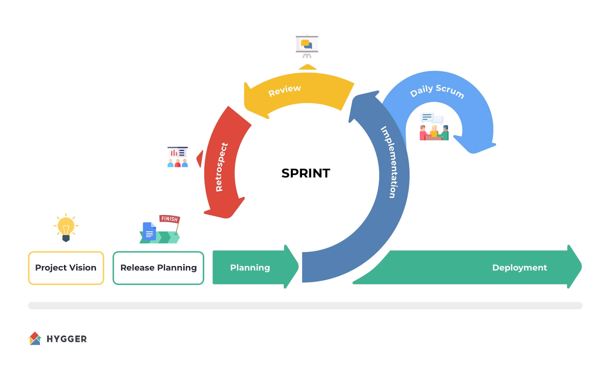Figure 2: Scrum - Agile Phases

# REFERENCES

Ladd, P. (2008). Understanding deaf culture: In search of deaf hood. Multilingual matters. [https://books.google.lv/books?id=7PRLjkES83oC&lpg=PP1&hl=lv&pg=PR16#v=onepage&q&f=false](https://books.google.lv/books?id=7PRLjkES83oC&lpg=PP1&hl=lv&pg=PR16" \l "v=onepage&q&f=false)

Brunson, J.L. (2011). Video Relay Service interpreters: Intricacies of sign language access. Gallaudet University Press. <http://www.interpretereducation.org/>

Zárate, S. (2021). Captioning and subtitling for D/deaf and hard of hearing audiences. UCL Press. <https://discovery.ucl.ac.uk/id/eprint/10117831/1/Captioning-and-Subtitling-for-Deaf-and-Hard-of-Hearing-Audiences.pdf>

Kim ,J. S., & Kim ,C.H. (2014). A review of assistive listening device and digital wireless technology for hearing instruments. Journal of audiology and otology, 18(3), 105-111.

Donato, H. (2023, January 03). What are the phases of scrum? Workamajig. Retrieved from https://www.workamajig.com/blog/scrum-methodology-guide/scrum-phases

Aziz, A. F., & LeBlanc, E. (2023, July/August 03). Video-relay services for deaf and hard-of-hearing communities. Ent & Audiology news, 32(3)

Majocha, M., Davenport, Z., Braun, D.C., & Gormally, C.(2018, March). “Everyone was nice...but I was still left out: An interview study about deaf interns’ research experiences in Science, Technology, engineering and Mathematics, 19(1). //dx.doi.org/10.1128/jmbe.v19i1.1381

Kushalnagar, P., Paludneviciene, R., & Kushalnagar, R.(2019, March 11). Video Remote Interpreting Technology in health care: Cross-sectional study of deaf patients’ experiences, 6(1), e13233. //dx.doi.org/10.2196/13233

Swaen, B. & George, T. (2024, September 05). What is a Conceptual framework? | Tips & Examples.Scribbr. Retrieved October 29, 2024, from https://www.scribbr.com/methology/conceptual-framework/

Matre, M. E., & Cameron, D. L. (2022). A scoping review on the use of speech-to-text technology for adolescents with learning difficulties in secondary education. Disability and Rehabilitation: Assistive Technology, 19(3), 1103-1116. https://doi.org/10.1080/17483107.2022.2149865

Rogers, I. (2022, December 06). Hearing impairment assistive apps. PowerMapper <https://www.powermapper.com/resources/guides/apps-hearing-impairment/>

Mahoney, K. (2023, September 01). What is closed captioning? 3Playmedia. <https://www.3playmedia.com/blog/what-is-closed-captioning/>

Njue, D. (2020, September 23). Covid-19 Emergencies response and the deaf community. The Kenya Institute for Public Policy Research and Analysis. [https://kippra.or.ke/covid-19-emergencies-response-and-the-deaf-community](https://kippra.or.ke/covid-19-emergencies-response-and-the-deaf-community/" \l ":~:text=According to the Kenya National,to urban areas (23%2C843))

Centers for Disease control and prevention. (2020, September 16). Disability and health overview [Website]. Retrieved from [https://www.cdc.gov/ncbddd/disabilityandhealth/disability.html](https://www.cdc.gov/ncbddd/disabilityandhealth/disability.html" \l ":~:text=According to the World Health Organization%2C disability has three dimensions%3A&text=Impairment in a person's body,%2C walking%2C or problem solving)

WHO. (2020). Deafness and hearing loss. World Health Organization. <https://www.who.int/news-room/fact-sheets/detail/deafness-and-hearing-loss>

Streefkerk, R. (2023, June 22). Qualitative vs. Quantitative Reasearch | Differences, Examples & Methods. Scribbr. Retrieved October 29, 2024, from https://www.Scribbr.com/methodology/qualitative-quantitative-research/

Elevenlabs. (2023, December 31). text to speech vs speech to text: What is the difference?. https://elevenlabs.io/blog/text-to-speech-vs-speech-to-text

Wikipedia. (2024, August 27) Video relay service. https://en.wikipedia.org/wiki/Video_relay_service#Telecommunications-facilitated_signing

# APPENDICES

## APPENDIX I Time Schedule

|  |  |  |  |  |  |
| --- | --- | --- | --- | --- | --- |
| PHASES | ACTIVITIES | SPRINT 1 | SPRINT 2 | SPRINT 3 | SPRINT 4 |
| Initiation Phase | Define project vision, objectives and goals  Form project and product backlog | Week 1 | - | - | - |
| Planning and Estimation | Break down backlog into user stories and prioritize tasks  Plan sprints | Week 2 | Week 4 | Week 6 | Week 8 |
| Implementation | Task execution and implementation of user stories  Daily stand-ups to track progress | Week 2-3 | Week 4-5 | Week 6-7 | Week 8-9 |
| Review and Retrospective | Conduct sprint review to determine completed tasks  Reflect sprint outcomes and gather feedback | Week 3 | Week 5 | Week 7 | Week 9 |
| Release | Preparation of final deliverables, finalizing documentation, release | - | - | - | Week 9-10 |

## APPENDIX II Budget

|  |  |
| --- | --- |
| EXPENDITURE | ESTIMATED COST |
| Laptop HP | 46,000 |
| Data collection | 7,000 |
| Hosting services, domain, and SSL certificates | 4,000 |
| TOTAL | 57,000 |