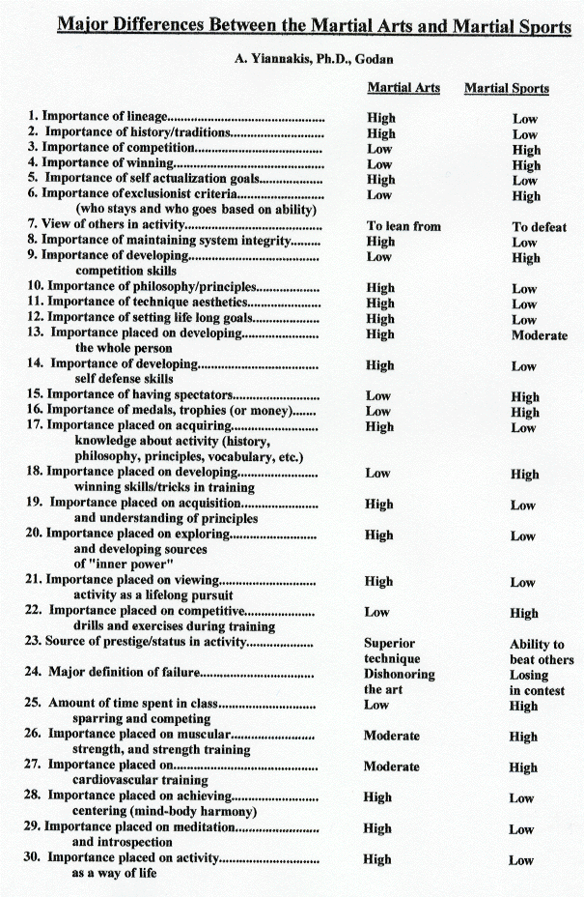
Definitions
Martial Sports
Martial sports are activities which employ martial skills in rule governed competitive contexts in which the contestants struggle to attain victory over their opponents. They typically require extensive training and the acquisition and development of effective contest skills.
Examples of martial sports include modern judo, wrestling, boxing, sumo, among others.
Martial Arts
The martial arts are systems that stress the importance of history, tradition and lineage and are engaged in as paths to self actualization. Martial skills are practiced in the context of a guiding philosophy and are employed to develop both offensive and defensive skills and test and challenge the student to grow and acquire important character traits. These include self discipline, self understanding, control and inner power, among others.
Examples of martial arts include various forms of jujutsu, aikido, older forms of karate, kung fu, kenjutsu, and the like.
Notes:
1. The differences outlined above are not about individuals, or how individuals are motivated to engage in such activities. The differences are about systems (or approaches), what they stand for, and what they stress.
2. It is possible to practice an activity as a martial art but also compete in it as a martial sport. However, when the focus of the training becomes the martial sport, the mindset, the training content and a whole host of other attributes also change in emphasis, as indicated in the model above

