Suricata-Based Intrusion Detection and Isolation System for Local Area Networks

1st Mohamed Shalman Kursheeth K
Department of Computer Science and Engineering
National Institute of Technology Puducherry Karaikal, India.
nailashalman001@gmail.com
3rd Sendil Vadivu D
Department of Computer Science and Engineering
National Institute of Technology Puducherry Karaikal, India.
ashasendilvadivu@gmail.com
5th Narendran Rajagopalan
Department of Computer Science and Engineering
National Institute of Technology Puducherry Karaikal, India.
narendran@nitpy.ac.in

2rd Thinnavalli Sree
Department of Computer Science and Engineering
National Institute of Technology Puducherry Karaikal, India.
sree.t2104@gmail.com
4th Y Sai Sri Harsha
Department of Computer Science and Engineering
National Institute of Technology Puducherry Karaikal, India.
saisriharshacsenitpy@gmail.com

Abstract— Malicious activity includes intentionally disrupting or damaging computer systems, networks, or data, including distributing malware, phishing attempts, denial of service, and unauthorized access. Criminals exploit vulnerabilities for financial gain or espionage. Effective prevention involves strong cybersecurity measures such as firewalls, anti-virus software, and user training. Failure to address vulnerabilities can result in data security breaches and financial losses. An Intrusion Detection System (IDS) is essential to cybersecurity measures. It scrutinizes network data or system operations for any indications of malicious actions. It plays a vital role in identifying potential threats and taking appropriate action to ensure the security of the network or system. An IDS simplifies identifying and reacting to accurate data, safeguarding critical data and systems from potential risks. Utilizing Suricata IDS, we put forth an Intrusion Detection and Isolation System (IDIS). This system is designed to identify any harmful nodes present in the Local Area Network (LAN) and isolate them. This is achieved by utilizing the configuration of an Access Control List (ACL) in the routers. This approach enhances the security measures, ensuring a safer network environment.
Keywords—Intrusion Detection System, cybersecurity, isolation.

Introduction
Cybersecurity refers to any threat or risk to operations in cyberspace, explicitly targeting digital assets such as computer systems, networks, and data. Cyber security can take many forms, such as malware, data breaches, Denial of Service (DoS) attacks, ransomware, phishing attacks etc. These threats can be initiated by malicious individuals, organized groups, or automated systems that aim to compromise the privacy, integrity, or accessibility of digital resources. In terms of cyber security, a victim is an individual, organization, or institution targeted by a cyber threat and suffers from its adverse consequences. Victims can range from individual users whose personal information has been compromised by phishing scams to large corporations who have experienced data breaches or software attacks. Consequences for victims may include financial loss, reputational damage, legal consequences, and disruptions in operations or services.
An IDS [1] is a vital instrument in cybersecurity. Its primary function is scrutinizing a network or system for any indications of unauthorized denial if a packet doesn't align with suspicious or abnormal behavior. The IDS can examine network traffic, system logs, or other relevant data sources to pinpoint patterns that suggest possible security measures. Upon detecting any malicious activity, the IDS promptly generates an alert to inform the security team. This immediate notification enables the security personnel to investigate and address the incident swiftly. IDS can help organizations improve their cybersecurity posture by detecting cyber threats early and enabling timely mitigation actions to prevent or reduce the impact of security incidents. ACLs are rules implemented within network devices like routers, switches, and firewalls to manage and control traffic flow. They serve as a crucial component of network security and traffic management by determining which packets can pass through the device and which are not.
Suspicious or unusual behavior. IDS can analyze network traffic, system logs, or other data sources to identify patterns that indicate potential security breaches or cyber-attacks. When suspicious activity is detected, the IDS generates an alert to notify security personnel, allowing them to investigate and respond to the incident immediately [2]. IDS can help organizations improve their cybersecurity posture by detecting cyber threats early and enabling timely mitigation actions to prevent or reduce the impact of security incidents. ACLs are rules implemented within network devices like routers, switches, and firewalls to manage and control traffic flow. They serve as a crucial component of network security and traffic management by determining which packets can pass through the device and which are not [3].
ACLs function by examining incoming or outgoing data packets based on predefined criteria set by network administrators. Each ACL comprises individual rules known as Access Control Entries (ACEs). These entries specify conditions for permitting or denying traffic. When a packet arrives at a network device, it is evaluated against the ACL rules. If it matches the criteria defined in any ACE, the corresponding action (permit or deny) is applied to the packet. The Key Components are Permit/Deny Statements: ACLs consist of permit statements, which allow traffic that matches specified criteria, and deny statements, which block traffic that meets certain conditions. Match Criteria: Source and destination IP addresses, protocol types like TCP, UDP, etc., port numbers, and other packet attributes are various factors by which the ACL evaluates the packets. Many permit statements within the ACL are implicitly denied. This default behavior ensures that only explicitly permitted traffic can pass through [4].
ACL can be standard or extended. Standard ACLs: These ACLs filter traffic based solely on the source IP address of packets. They are relatively simple to configure but provide limited control over traffic flow. Extended ACLs: Extended ACLs offer more advanced filtering capabilities by allowing criteria such as source and destination IP addresses, port numbers, protocol types, and packet attributes. They provide greater flexibility but are more complex to configure. Common Uses are Security Enforcement. ACLs enforce security policies by permitting or denying specific types of traffic based on predefined rules. They help prevent unauthorized access to network resources and protect against security threats. Traffic Optimization: ACLs can optimize network performance by controlling traffic flow. They prioritize or throttle certain types of traffic to ensure that critical applications receive adequate bandwidth. Traffic Filtering: ACLs filter unwanted or malicious traffic from entering the network. They block traffic from known malicious sources, restrict access to sensitive resources, and mitigate the impact of security breaches. Explicitly permitted traffic is allowed to pass through.
The main contribution of this article is to analyze the network with an IDS and propose an isolation strategy to safeguard it. The forthcoming segment of the article is presented as follows: Sections 2 and 3 discuss the literature review and proposed methodology, Section 4 provides the details about the network topology simulated and explains the experiment conducted for IDI, and finally, section 5 concludes the paper with future scope.

LITERATURE REVIEW

IDS is a strong aspect of cybersecurity that safeguards the network's integrity. Many researchers have contributed to this field to enhance the network's security by utilizing various tools and techniques. The authors of [5] provide an overview of various intrusion detection techniques, allowing readers to grasp the broad landscape of IDS. The comparative analysis of different IDS approaches highlights their strengths and weaknesses, aiding in selecting appropriate methods for specific applications. Additionally, the paper focuses on applying artificial intelligence in IDS, showcasing advancements and future potential. The authors address various security challenges and threats that IDS can mitigate, emphasizing its importance in maintaining cybersecurity. Furthermore, discussing different evaluation metrics for IDS performance helps assess their system's effectiveness. While the paper offers a good theoretical overview, it may lack detailed guidance on the practical implementation of IDS, which is crucial for researchers in the field. The authors in [6] leverage ensemble-based machine learning techniques to enhance the accuracy and robustness of IDS, providing a cutting-edge approach to network security. The authors effectively demonstrate the superiority of ensemble methods over single classifiers, emphasizing the improved detection rates and reduced false positives. The paper comprehensively evaluates different ensemble techniques, such as bagging, boosting, and stacking, offering valuable insights into their performance and applicability. Additionally, the study uses extensive experimental data and real-world scenarios to validate the proposed IDS framework, ensuring its practical relevance and reliability. The potential complexity and computational overhead of implementing ensemble-based machine-learning techniques are very high. These methods often require more computational resources and time, which might limit their applicability in resource-constrained environments.
The authors in [7] utilize a deep neural network (DNN) model for handling complex and high-dimensional data and improving accuracy in detecting cyber threats. The paper demonstrates how DNNs can effectively learn and identify intricate patterns of malicious activities, resulting in a robust IDS. The authors provide a detailed explanation of the model architecture and the training process, ensuring transparency and reproducibility of their work. Additionally, the paper includes comprehensive experimental results highlighting the superior performance of the DNN-based IDS compared to traditional methods. Using a large and diverse dataset for training and validation further strengthens the reliability of the findings. One key disadvantage is the high computational cost of training and deploying DNN models. The extensive computational resources required may limit the practical applicability of the proposed IDS in environments with limited resources. There is also a potential risk of overfitting due to the complexity of the DNN, which may affect the system's ability to generalize to unseen data.
To analyze and optimize ACL the authors in [8] introduce a structured framework designed to analyze and optimize ACLs, addressing a critical need in network security management. The framework's ability to identify and eliminate redundant or conflicting rules enhances the efficiency and performance of network security configurations. The authors provide a comprehensive methodology for implementing the ACLA framework, including detailed algorithms and step-by-step procedures, which ensures clarity and ease of adoption. These results highlight significant improvements in ACL performance and network security post-optimization. Furthermore, the discussion on integrating ACLA with existing network management tools and its potential to automate ACL maintenance processes adds practical value to the study. By focusing on the analytical and practical aspects of ACL management, the paper makes a substantial contribution to cybersecurity. The paper might not fully address the challenges related to the initial setup and configuration of the framework, potentially limiting its accessibility to smaller organizations with limited IT capabilities. The focus on optimization algorithms might also overlook other important aspects of ACL management, such as user training and policy compliance.
Various open-source tools for IDS are available, and selecting an appropriate one for the application is crucial, so in [9], a detailed and comparative evaluation of two prominent IDS, Snort and Suricata. One of the primary advantages is its comprehensive analysis of the performance metrics of both IDS, including detection accuracy, throughput, and resource utilization. This thorough evaluation helps practitioners and researchers understand the strengths and weaknesses of each system in different operational scenarios. Additionally, the paper discusses the configuration and tuning of both Snort and Suricata, offering practical insights into optimizing these systems for improved performance. Including various attack scenarios and the corresponding detection rates provides a clear picture of how each IDS handles different threats. Overall, the paper is a valuable resource for anyone looking to make an informed decision about deploying Snort or Suricata in their network security infrastructure. The paper might also benefit from a more in-depth discussion on integrating these IDS with other security tools and their role within a broader security strategy.
TABLE I. Summary of the literature review.
Source | Objective | Model/Technique | Contribution
[6] | To propose an ensemble model for intrusion detection. | Random Forest (RF) | An accuracy of 99% is achieved in detecting the intrusion.
[7] | To propose a network-based intrusion detection system. | deep neural network. | An accuracy of 99.4% is achieved by evaluating the proposed model with KDDCUP 99 and CICDDoS datasets.
[8] | To propose ACLA (ACL Analyzer) as a library. | - | Automation of ACL analysis is done to reduce network administrator tasks.
[9] | To provide an in-depth comparison between suricata and snort. | - | Suricata proved to be better performing than snort.
[10] | To provide a comparative analysis of Snort 3 and Suricata. | - | Suricata proved to be better than Snort 3.

In [10], the authors compare Snort 3 and Suricata, highlighting their performance, capabilities, and features. The authors employ a rigorous methodology, using diverse and realistic network traffic scenarios to evaluate systems detection accuracy, processing speed, and resource utilization. The paper also discusses the improvements and new features introduced in Snort 3, providing valuable insights into its advancements over previous versions. Additionally, the authors present detailed configuration and optimization guidelines, which are beneficial for practitioners aiming to maximize the effectiveness of these IDS. By offering a balanced analysis of strengths and weaknesses, the paper aids organizations in making informed decisions about which IDS to implement based on their specific needs and constraints. The paper might also focus predominantly on quantitative metrics, possibly neglecting qualitative aspects such as user experience, ease of deployment, and the quality of community support and documentation. The paper could benefit from a more detailed discussion on integrating Snort 3 and Suricata with other cybersecurity tools and their role within a comprehensive security framework. Table 1 presents a summary of the related works. The literature review shows that Suricata will be the better NIDS, and ACL can be analyzed and optimized for better network management. Hence, this article proposes an IDI with suricata and ACL analysis.

PROPOSED METHODOLOGY

An Intrusion Detection System detects the network's malicious activity and sends a notification of the network status. It only detects the threat, but protection is crucial in safeguarding the network. It is vital to secure the nodes within a Router and between Routers. So, an Intrusion Isolation System is proposed to detect the threat and block the particular node for further transmission. Figure 1 shows the proposed workflow.

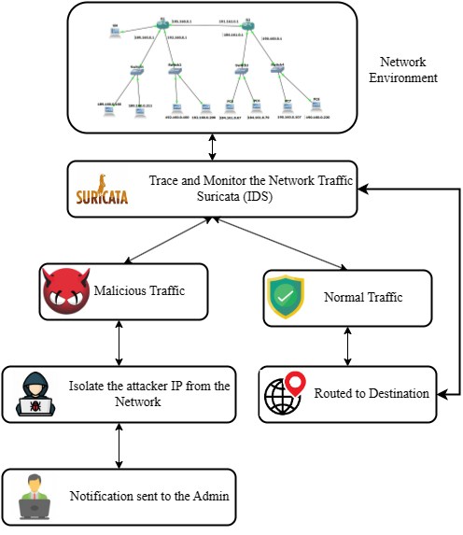
- Proposed Intrusion Isolation System.

Experiment and analysis

Network Topology Creation
Figure 1 shows the network simulated in GNS3 [11] with different LANs and a virtual machine, Kali Linux, running Suricata. The Intrusion Detection System is developed in Kali Linux with Suricata's help, which continuously monitors the network for suspicious activities. Router1 and Router2 are routers of different LAN where it communicates with each other. We consider a PC an intruder under Switch2 and Router1 for experimental purposes.

Suricata [12], as an IDS, continuously monitors the network from the KaliLinux-1 VM and reports the router when the attack or malicious packets enter the network. In the first scenario, we consider an intruder in LAN1 and isolate the PC from the network for further communication. In the second scenario, we consider LAN1 to be the local network where we configured the rules for IDS and LAN2 to be a remote network from where an intruder tries to communicate with the legitimate node of the local network.

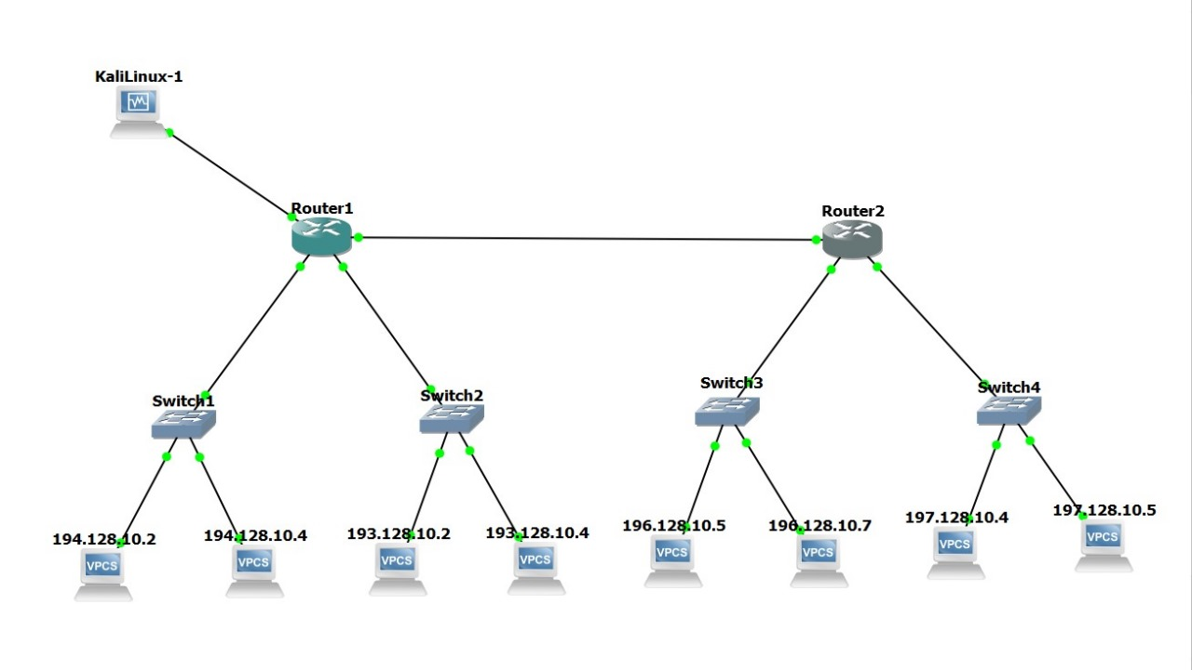
- Simulated Network Environment.

INTRUSION ISOLATION SYSTEM
If a malicious packet enters the network from any node, the Suricata sends an alert message to the admin. The ACL of the router is configured accordingly to isolate the particular attacker's IP from the network. Below are the steps to configure ACL and isolate that specific IP from the network.
- Access the Router's Command Line Interface (CLI)
  - Action: Open the router's CLI within the GNS3 environment.
  - Purpose: Initiate the configuration process by accessing the router's CLI.
- Enter Privileged EXEC Mode
  - Command: enable
  - Purpose: Switch from user EXEC mode to privileged EXEC mode to access advanced commands.
- Enter Global Configuration Mode
  - Command: configure terminal
  - Purpose: Enter global configuration mode to allow for changes to the router's configuration.
- Create an ACL to Block Traffic from the Target PC
  - Command: access-list 101 deny ip host <PC_IP_Address> any
  - Purpose: Create an Access Control List (ACL) with the number 101 to block all IP traffic from the specified host. Replace <PC_IP_Address> with the actual IP address of the PC you want to isolate.
- Specify the Interface to Apply the ACL
  - Command: interface <interface_name>
  - Purpose: Enter interface configuration mode by specifying the interface connected to the target PC. Replace <interface_name> with the actual interface name (e.g., FastEthernet0/0).
- Apply the ACL to the Interface
  - Command: ip access-group 101 in
  - Purpose: Apply the created ACL (number 101) to the specified interface in the inbound direction, ensuring that incoming traffic from the specified IP address is blocked.
- Verify the Configuration
  - Command: show running-config
  - Purpose: Display the current running configuration of the router to verify that the ACL has been correctly applied to the interface.
- Test the Isolation
  - Command: ping <target_IP>
  - Purpose: From the isolated PC, attempt to ping another device on the network. Replace <target_IP> with the IP address of another network device. The ping should fail, indicating that the PC is effectively isolated.

Configuration Code Snippet
enable
configure terminal

access-list 101 deny ip host <PC_IP_Address> any

interface <interface_name>
ip access-group 101 in
- Replace <PC_IP_Address> with the IP address of the PC you want to isolate.
- Replace <interface_name> with the name of the interface connected to the PC.

Verifying and Testing the Configuration
- Verify Configuration
  - Command: show running-config
  - Purpose: Confirm that the ACL is correctly configured and applied to the appropriate interface.
- Test Isolation
  - Command: ping <target_IP>
  - Purpose: Perform a ping test from the isolated PC to another device on the network. A failed ping test will indicate successful isolation.
This detailed guide provides a clear, step-by-step process for isolating a specific PC from the network using ACLs, ensuring enhanced security by blocking traffic from a specified IP address in a simulated environment.
4o
Top of Form
Bottom of Form

RESULTS
Considering an intruder in the network, once Suricata identifies the malicious packet, the particular router is configured to isolate the attacker from the network, as shown below.

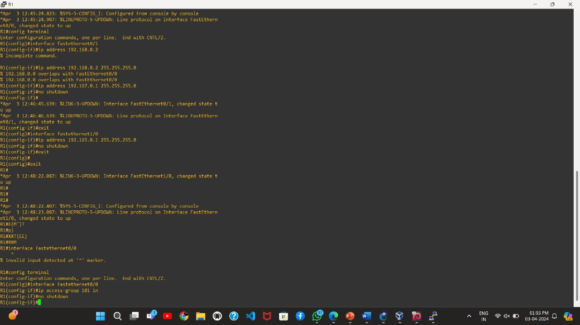

- Configuration of ACL of Router R1
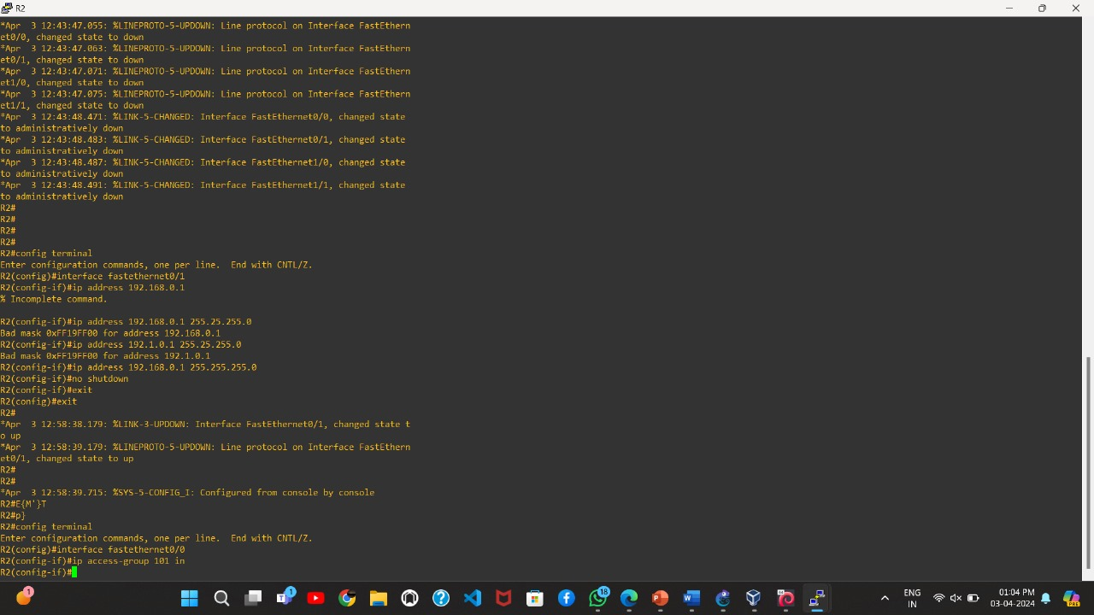
- Configuration of ACL of Router R2
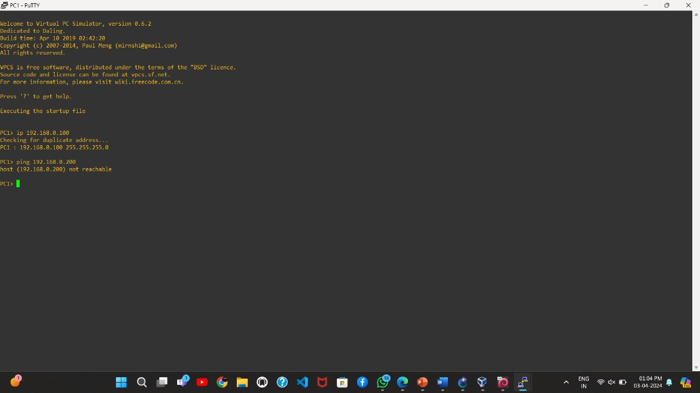
- The attacker node is isolated and denied for further communication.

Figure 3 and Figure 4 show the ACL configuration in Router 1 and Router 2. Figure 5 shows the denied communication for the attacker IP after the malicious activity.

Conclusion and future scope
Malicious activity included intentionally disrupting or damaging computer systems, networks, or data, including distributing malware, phishing attempts, denial of service, and unauthorized access. Criminals exploited vulnerabilities for financial gain or espionage. Failure to address vulnerabilities could result in data security breaches and economic losses. An IDS is a critical cybersecurity tool that monitors network traffic or system activity for signs of malicious activity. IDS identifies anomalies by analyzing data packets or logs and alerts the network. The isolation strategy allows isolating a particular IP from the network. IDI made detecting and responding to actual data easy, protecting sensitive data and systems from potential threats.

Switch-level configuration and integration of Machine Learning (ML) into the existing system to augment detecting malicious activities is a good step toward future work. By leveraging ML, the system can adapt and evolve to new threats in real time, improving its efficacy in identifying and mitigating security breaches. It involves researching and implementing advanced network analysis methods to accurately trace the source of such attacks. By enhancing our ability to attribute malicious activities, we can take more targeted and effective countermeasures, thereby bolstering the overall security posture.

References

- Liao, Hung-Jen, et al. "Intrusion detection system: A comprehensive review." Journal of Network and Computer Applications 36.1 (2013): 16-24.
- Bace, Rebecca Gurley, and Peter Mell. "Intrusion detection systems." (2001).
- Kizza, J. M. (2024). Access control and authorization. In Guide to Computer Network Security (pp. 195-214). Cham: Springer International Publishing .
- https://sushantkatare.medium.com/understanding-access-control-lists-acls-for-robust-cybersecurity-428b1926d6df
- Tiwari, M., Kumar, R., Bharti, A., & Kishan, J. (2017). Intrusion detection system. International Journal of Technical Research and Applications, 5(2), 38-44.
- Hossain, M. A., & Islam, M. S. (2023). Ensuring network security with a robust intrusion detection system using ensemble-based machine learning. Array, 19, 100306.
- Ramaiah, M., Vanmathi, C., Khan, M. Z., Vanitha, M., & Deepa, M. (2023). An Efficient Intrusion Detection System to Combat Cyber Threats using a Deep Neural Network Model. Journal of ICT Research & Applications, 17(3).
- Qian, J., Hinrichs, S., & Nahrstedt, K. (2001). ACLA: A framework for access control list (ACL) analysis and optimization. In Communications and Multimedia Security Issues of the New Century: IFIP TC6/TC11 Fifth Joint Working Conference on Communications and Multimedia Security (CMS’01) May 21–22, 2001, Darmstadt, Germany (pp. 197-211). Springer US.
- White, J. S., Fitzsimmons, T., & Matthews, J. N. (2013, May). Quantitative analysis of intrusion detection systems: Snort and Suricata. In Cyber sensing 2013 (Vol. 8757, pp. 10-21). SPIE.
- Boukebous, A. A. E., Fettache, M. I., Bendiab, G., & Shiaeles, S. (2023, May). A comparative analysis of Snort 3 and Suricata. In 2023 IEEE IAS Global Conference on Emerging Technologies (GlobConET) (pp. 1-6). IEEE.
- Sarrió Ferrández, M. (2024). GNS3-network simulator for evaluation of network projects using scripts (Doctoral dissertation, Universitat Politècnica de València).
- Kumar, B., & Sethia, R. (2024). Analysing the Effectiveness of Intrusion Detection Systems against the Mirai Botnet: A Comparative Study. Grenze International Journal of Engineering & Technology (GIJET), 10.

