Portfolio CMS User Guide
This document explains how to update the portfolio website through the CMS, add images and documents to the repository, reference those files in the CMS, and push changes to GitHub.

CMS Login Details
CMS path:
http://localhost:3000/admin
Password:
shalmoly2024

1. Open The CMS
Open the CMS in a browser:
http://localhost:3000/admin
Enter the admin password:
shalmoly2024
CMS login screen

After login, the CMS opens with tabs for every editable section of the site.
CMS site tab
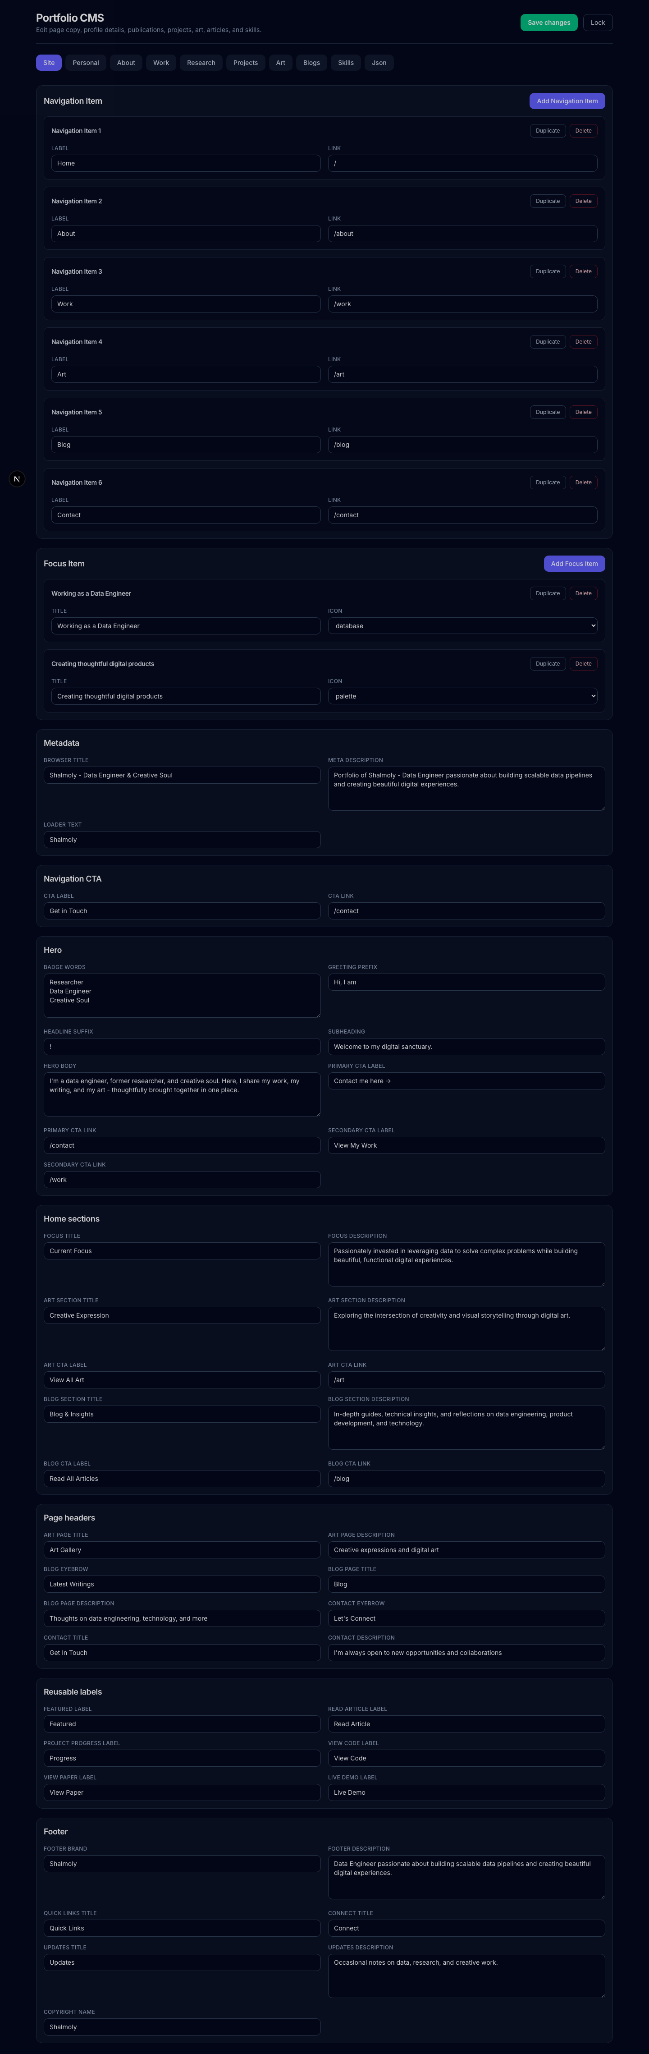

2. CMS Tabs
• site: page titles, navigation, hero copy, section titles, labels, footer text, metadata.
• personal: name, title, bio, email, location, social links.
• about: about page text, personal cards, currently reading/listening/enjoying items.
• work: work page labels, experience, education.
• research: research description, thesis link, publications, journal articles, conference papers, book chapters.
• projects: project cards, technologies, links, featured state.
• art: art gallery items and image paths.
• blogs: blog/article cards, external URLs, featured state, images.
• skills: grouped skills lists.
• json: advanced full-data editor. Use carefully.

3. Save Changes
• Edit the fields you need.
• Click Save changes.
• Wait for: Saved. Public pages have been revalidated.
• Open or refresh the public page to confirm the change.
CMS changes are stored in:
data/portfolio.json

4. Add Or Edit Projects
CMS projects tab
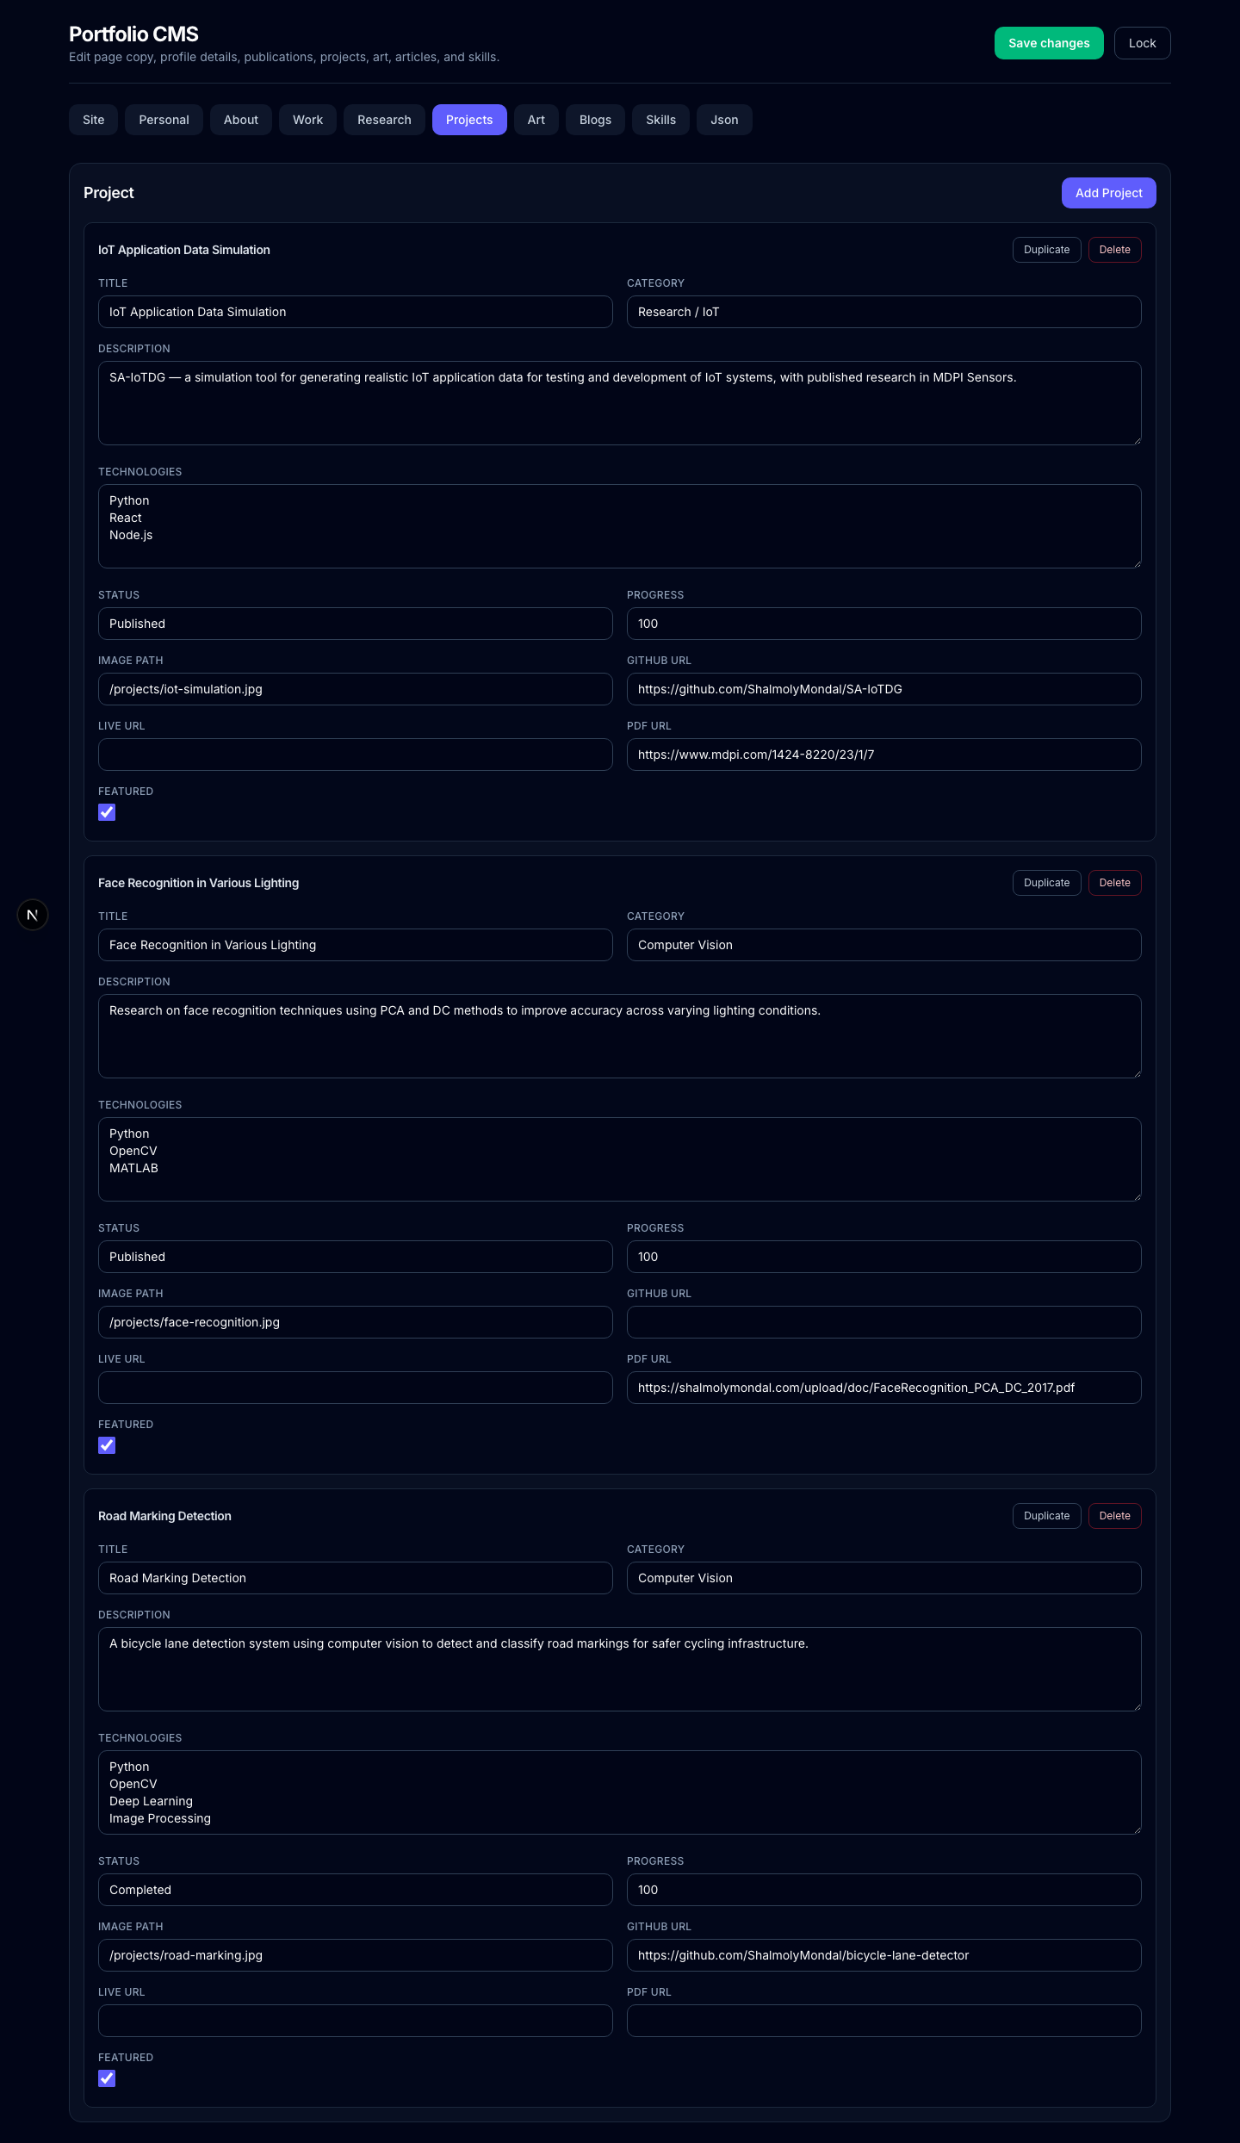
• Open the projects tab.
• Click Add Project.
• Fill in Title, Category, Description, Technologies, Status, and links.
• Add an image path if the project has an image.
• Tick Featured if it should appear on the work page featured area.
• Click Save changes.
For technologies, enter one item per line:
Python
OpenCV
Deep Learning
Image Processing

5. Add Research, Journals, Articles, Papers, Or Documents
CMS research tab
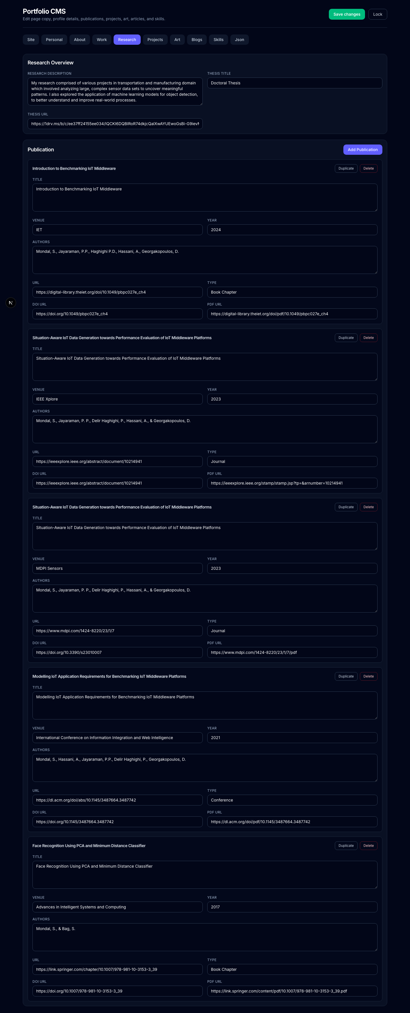
• Open the research tab.
• Click Add Publication.
• Fill in Title, Venue, Year, Authors, URL, Type, DOI URL, and PDF URL.
• Click Save changes.
Use Type values like Journal, Conference, Book Chapter, Article, or Report.
If a PDF is stored inside the repo, put it under public/docs and reference it from the CMS as /docs/file-name.pdf.

6. Add Blog Or Article Links
• Open the blogs tab.
• Click Add Article.
• Fill in title, category, excerpt, date, read time, and URL.
• Add an image path if there is a cover image.
• Tick Featured if needed.
• Click Save changes.

7. Add Photos And Documents To The Repo
All public files should go inside the public folder. Recommended folders:
• public/art
• public/blog
• public/docs
• public/education
• public/projects
Example repo file paths:
public/projects/iot-dashboard.png
public/art/mandala-2026.jpg
public/blog/data-pipeline-cover.png
public/docs/research-paper.pdf
public/docs/resume.pdf

8. Reference Files In The CMS
Do not include public in CMS paths.
Repo file: public/projects/iot-dashboard.png
CMS path: /projects/iot-dashboard.png
Repo file: public/docs/research-paper.pdf
CMS path: /docs/research-paper.pdf
Common CMS path examples:
/projects/project-image.png
/art/artwork.jpg
/blog/article-cover.png
/docs/paper.pdf
/docs/resume.pdf
/education/university-logo.png

9. Verify On The Public Site
After saving in the CMS, open the matching public page:
/
/about
/work
/art
/blog
/contact
Public work page example
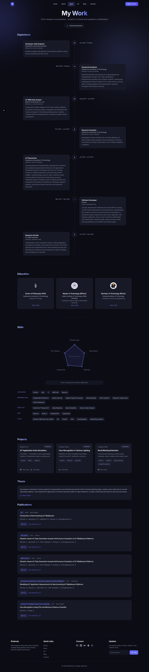
If a new image does not show, check that the file is inside public, the CMS path starts with /, spelling and file extension match, and the public page has been refreshed.

10. Use The JSON Tab Carefully
CMS JSON tab
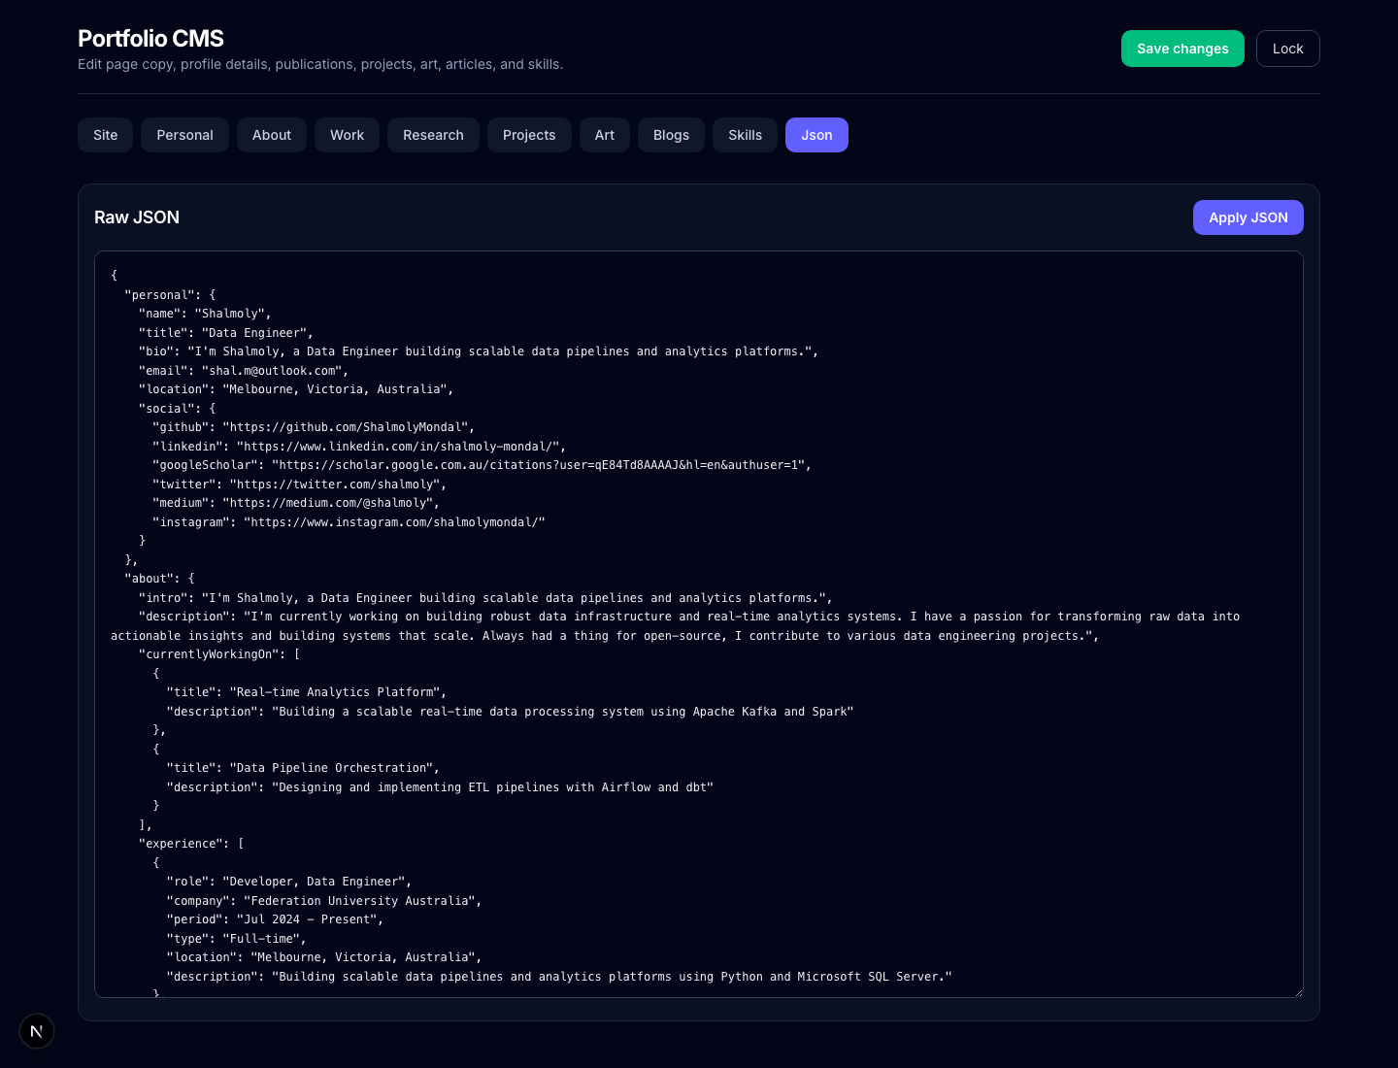
The json tab exposes the full CMS data object. Use it only for bulk edits or copying full data between environments.
• Edit the JSON.
• Click Apply JSON.
• If there is no JSON error, click Save changes.

11. Push Changes To GitHub
After CMS edits or adding files, check what changed:
git status
Review the diff:
git diff
Add changed files:
git add data/portfolio.json public docs app components lib next.config.ts
Or add everything:
git add .
Commit:
git commit -m "Update portfolio CMS content"
Push:
git push
If this is a new branch:
git push -u origin your-branch-name

12. Recommended Update Workflow
• Add new images or PDFs under public.
• Open http://localhost:3000/admin.
• Update the CMS fields.
• Click Save changes.
• Check the public pages.
• Run npm run lint, npx tsc --noEmit, and npm run build.
• Commit and push.

13. Important Notes
• CMS changes are stored in data/portfolio.json.
• Images and documents are stored in public.
• CMS paths never include the word public.
• /admin is the CMS route.
• /admit redirects to /admin.
• Keep file names lowercase, without spaces, using hyphens.
Good file name:
data-pipeline-cover.png
Avoid:
Data Pipeline Cover Final Version 2.png

