JAVA ASSIGNMENT
STUDENT DATA ENTRY AND RETRIEVAL PORTAL
(https://github.com/ShalmonAnandas/school_details_proj.git)

Shalmon Anandas [91]
Liza Patel [113]
Rucha Divekar [97]
Vidhi Desai [96]
Kaustubh Pahurkar [109]

Code for Frame 1
/*
* To change this license header, choose License Headers in Project Properties.
* To change this template file, choose Tools | Templates
* and open the template in the editor.
*/
package school_details_code;

/**
*
* @author Kaustubh
*/
public class login_select extends javax.swing.JFrame {

/**
* Creates new form login_select
*/
public login_select() {
initComponents();
}

/**
* This method is called from within the constructor to initialize the form.
* WARNING: Do NOT modify this code. The content of this method is always
* regenerated by the Form Editor.
*/
@SuppressWarnings("unchecked")
// <editor-fold defaultstate="collapsed" desc="Generated Code">
private void initComponents() {

jLabel1 = new javax.swing.JLabel();
jButton1 = new javax.swing.JButton();
jButton2 = new javax.swing.JButton();

setDefaultCloseOperation(javax.swing.WindowConstants.EXIT_ON_CLOSE);

jLabel1.setFont(new java.awt.Font("Tahoma", 1, 36)); // NOI18N
jLabel1.setText("Student Details Portal");

jButton1.setFont(new java.awt.Font("Tahoma", 1, 18)); // NOI18N
jButton1.setText("Student Login");
jButton1.addActionListener(new java.awt.event.ActionListener() {
public void actionPerformed(java.awt.event.ActionEvent evt) {
jButton1ActionPerformed(evt);
}
});

jButton2.setFont(new java.awt.Font("Tahoma", 1, 18)); // NOI18N
jButton2.setText("Admin Login");
jButton2.addActionListener(new java.awt.event.ActionListener() {
public void actionPerformed(java.awt.event.ActionEvent evt) {
jButton2ActionPerformed(evt);
}
});

javax.swing.GroupLayout layout = new javax.swing.GroupLayout(getContentPane());
getContentPane().setLayout(layout);
layout.setHorizontalGroup(
layout.createParallelGroup(javax.swing.GroupLayout.Alignment.LEADING)
.addGroup(layout.createSequentialGroup()
.addGap(34, 34, 34)
.addGroup(layout.createParallelGroup(javax.swing.GroupLayout.Alignment.LEADING)
.addComponent(jButton2, javax.swing.GroupLayout.PREFERRED_SIZE, 401, javax.swing.GroupLayout.PREFERRED_SIZE)
.addComponent(jButton1, javax.swing.GroupLayout.PREFERRED_SIZE, 401, javax.swing.GroupLayout.PREFERRED_SIZE)
.addComponent(jLabel1))
.addContainerGap(35, Short.MAX_VALUE))
);
layout.setVerticalGroup(
layout.createParallelGroup(javax.swing.GroupLayout.Alignment.LEADING)
.addGroup(layout.createSequentialGroup()
.addContainerGap()
.addComponent(jLabel1)
.addGap(18, 18, 18)
.addComponent(jButton1, javax.swing.GroupLayout.PREFERRED_SIZE, 74, javax.swing.GroupLayout.PREFERRED_SIZE)
.addGap(18, 18, 18)
.addComponent(jButton2, javax.swing.GroupLayout.PREFERRED_SIZE, 72, javax.swing.GroupLayout.PREFERRED_SIZE)
.addContainerGap(21, Short.MAX_VALUE))
);
pack();
}// </editor-fold>

private void jButton1ActionPerformed(java.awt.event.ActionEvent evt) {
new frame1().setVisible(true);
login_select.this.setVisible(false);
}

private void jButton2ActionPerformed(java.awt.event.ActionEvent evt) {
new admin_login().setVisible(true);
login_select.this.setVisible(false);
}
/**
* @param args the command line arguments
*/
public static void main(String args[]) {
/* Set the Nimbus look and feel */
//<editor-fold defaultstate="collapsed" desc=" Look and feel setting code (optional) ">
/* If Nimbus (introduced in Java SE 6) is not available, stay with the default look and feel.
* For details see http://download.oracle.com/javase/tutorial/uiswing/lookandfeel/plaf.html
*/
try {
for (javax.swing.UIManager.LookAndFeelInfo info : javax.swing.UIManager.getInstalledLookAndFeels()) {
if ("Windows".equals(info.getName())) {
javax.swing.UIManager.setLookAndFeel(info.getClassName());
break;
}
}
} catch (ClassNotFoundException ex) {
java.util.logging.Logger.getLogger(login_select.class.getName()).log(java.util.logging.Level.SEVERE, null, ex);
} catch (InstantiationException ex) {
java.util.logging.Logger.getLogger(login_select.class.getName()).log(java.util.logging.Level.SEVERE, null, ex);
} catch (IllegalAccessException ex) {
java.util.logging.Logger.getLogger(login_select.class.getName()).log(java.util.logging.Level.SEVERE, null, ex);
} catch (javax.swing.UnsupportedLookAndFeelException ex) {
java.util.logging.Logger.getLogger(login_select.class.getName()).log(java.util.logging.Level.SEVERE, null, ex);
}
//</editor-fold>

/* Create and display the form */
java.awt.EventQueue.invokeLater(new Runnable() {
public void run() {
new login_select().setVisible(true);
}
});
}
// Variables declaration - do not modify
private javax.swing.JButton jButton1;
private javax.swing.JButton jButton2;
private javax.swing.JLabel jLabel1;
// End of variables declaration
}
CODE FOR FRAME 2
/*
* To change this license header, choose License Headers in Project Properties.
* To change this template file, choose Tools | Templates
* and open the template in the editor.
*/
package school_details_code;

import java.sql.Connection;
import java.sql.DriverManager;
import java.sql.ResultSet;
import java.sql.SQLException;
import java.sql.Statement;
import javax.swing.JOptionPane;

/**
*
* @author shalmon
*/
public class admin_login extends javax.swing.JFrame {

/**
* Creates new form admin_login
*/
public admin_login() {
initComponents();
}

/**
* This method is called from within the constructor to initialize the form.
* WARNING: Do NOT modify this code. The content of this method is always
* regenerated by the Form Editor.
*/
@SuppressWarnings("unchecked")
// <editor-fold defaultstate="collapsed" desc="Generated Code">
private void initComponents() {

jLabel1 = new javax.swing.JLabel();
jLabel2 = new javax.swing.JLabel();
jLabel3 = new javax.swing.JLabel();
jTextField1 = new javax.swing.JTextField();
jTextField2 = new javax.swing.JTextField();
jButton1 = new javax.swing.JButton();

setDefaultCloseOperation(javax.swing.WindowConstants.EXIT_ON_CLOSE);
setBackground(new java.awt.Color(0, 255, 204));

jLabel1.setFont(new java.awt.Font("Tahoma", 1, 24)); // NOI18N
jLabel1.setText("ADMIN LOGIN");

jLabel2.setFont(new java.awt.Font("Tahoma", 0, 18)); // NOI18N
jLabel2.setText("Username:");

jLabel3.setFont(new java.awt.Font("Tahoma", 0, 18)); // NOI18N
jLabel3.setText("Password:");

jTextField1.setFont(new java.awt.Font("Tahoma", 0, 14)); // NOI18N

jTextField2.setFont(new java.awt.Font("Tahoma", 0, 14)); // NOI18N

jButton1.setFont(new java.awt.Font("Tahoma", 1, 18)); // NOI18N
jButton1.setText("LOGIN");
jButton1.addActionListener(new java.awt.event.ActionListener() {
public void actionPerformed(java.awt.event.ActionEvent evt) {
jButton1ActionPerformed(evt);
}
});

javax.swing.GroupLayout layout = new javax.swing.GroupLayout(getContentPane());
getContentPane().setLayout(layout);
layout.setHorizontalGroup(
layout.createParallelGroup(javax.swing.GroupLayout.Alignment.LEADING)
.addGroup(layout.createSequentialGroup()
.addGroup(layout.createParallelGroup(javax.swing.GroupLayout.Alignment.LEADING)
.addGroup(layout.createSequentialGroup()
.addGap(25, 25, 25)
.addGroup(layout.createParallelGroup(javax.swing.GroupLayout.Alignment.TRAILING)
.addComponent(jButton1, javax.swing.GroupLayout.PREFERRED_SIZE, 337, javax.swing.GroupLayout.PREFERRED_SIZE)
.addGroup(layout.createSequentialGroup()
.addGroup(layout.createParallelGroup(javax.swing.GroupLayout.Alignment.LEADING)
.addComponent(jLabel2)
.addComponent(jLabel3))
.addGap(34, 34, 34)
.addGroup(layout.createParallelGroup(javax.swing.GroupLayout.Alignment.LEADING, false)
.addComponent(jTextField1)
.addComponent(jTextField2, javax.swing.GroupLayout.DEFAULT_SIZE, 219, Short.MAX_VALUE)))))
.addGroup(layout.createSequentialGroup()
.addGap(106, 106, 106)
.addComponent(jLabel1)))
.addContainerGap(25, Short.MAX_VALUE))
);
layout.setVerticalGroup(
layout.createParallelGroup(javax.swing.GroupLayout.Alignment.LEADING)
.addGroup(layout.createSequentialGroup()
.addContainerGap()
.addComponent(jLabel1)
.addGap(18, 18, 18)
.addGroup(layout.createParallelGroup(javax.swing.GroupLayout.Alignment.LEADING)
.addComponent(jLabel2)
.addComponent(jTextField1, javax.swing.GroupLayout.PREFERRED_SIZE, javax.swing.GroupLayout.DEFAULT_SIZE, javax.swing.GroupLayout.PREFERRED_SIZE))
.addGap(18, 18, 18)
.addGroup(layout.createParallelGroup(javax.swing.GroupLayout.Alignment.LEADING, false)
.addComponent(jLabel3, javax.swing.GroupLayout.DEFAULT_SIZE, javax.swing.GroupLayout.DEFAULT_SIZE, Short.MAX_VALUE)
.addComponent(jTextField2))
.addGap(18, 18, 18)
.addComponent(jButton1, javax.swing.GroupLayout.PREFERRED_SIZE, 44, javax.swing.GroupLayout.PREFERRED_SIZE)
.addContainerGap(javax.swing.GroupLayout.DEFAULT_SIZE, Short.MAX_VALUE))
);

pack();
}// </editor-fold>

private void jButton1ActionPerformed(java.awt.event.ActionEvent evt) {
String user_name = jTextField1.getText();
String user_pass = jTextField1.getText();
String user_name_data = null;
String user_pass_data = null;

try{
//initialize jdbc driver
Class.forName("com.mysql.cj.jdbc.Driver");
System.out.println("Registered");

//connecting with mysql database
Connection con;
con=DriverManager.getConnection("jdbc:mysql://localhost/student_details","root","Anandas!#66");
System.out.println("Connection Successful");
Statement smt;
smt = con.createStatement();

//create statement to retrieve sr_no
String query = "SELECT admin_name, admin_pass from admin_login";

//execute retreive statement
ResultSet rs = smt.executeQuery(query);

//check if record exists
while(rs.next()){
user_name_data = rs.getString("admin_name");
user_pass_data = rs.getString("admin_pass");

if(user_name.equals(user_name_data) && user_pass.equals(user_pass_data)){
new frame2().setVisible(true);
admin_login.this.setVisible(false);
}
else{
JOptionPane.showMessageDialog(jButton1, "The username or password is incorrect");
}
}
}
//catch statements
catch(SQLException se){
se.printStackTrace();
}
catch(Exception e){
e.printStackTrace();
}
}

/**
* @param args the command line arguments
*/
public static void main(String args[]) {
/* Set the Nimbus look and feel */
//<editor-fold defaultstate="collapsed" desc=" Look and feel setting code (optional) ">
/* If Nimbus (introduced in Java SE 6) is not available, stay with the default look and feel.
* For details see http://download.oracle.com/javase/tutorial/uiswing/lookandfeel/plaf.html
*/
try {
for (javax.swing.UIManager.LookAndFeelInfo info : javax.swing.UIManager.getInstalledLookAndFeels()) {
if ("Windows".equals(info.getName())) {
javax.swing.UIManager.setLookAndFeel(info.getClassName());
break;
}
}
} catch (ClassNotFoundException ex) {
java.util.logging.Logger.getLogger(admin_login.class.getName()).log(java.util.logging.Level.SEVERE, null, ex);
} catch (InstantiationException ex) {
java.util.logging.Logger.getLogger(admin_login.class.getName()).log(java.util.logging.Level.SEVERE, null, ex);
} catch (IllegalAccessException ex) {
java.util.logging.Logger.getLogger(admin_login.class.getName()).log(java.util.logging.Level.SEVERE, null, ex);
} catch (javax.swing.UnsupportedLookAndFeelException ex) {
java.util.logging.Logger.getLogger(admin_login.class.getName()).log(java.util.logging.Level.SEVERE, null, ex);
}
//</editor-fold>

/* Create and display the form */
java.awt.EventQueue.invokeLater(new Runnable() {
public void run() {
new admin_login().setVisible(true);
}
});
}

// Variables declaration - do not modify
private javax.swing.JButton jButton1;
private javax.swing.JLabel jLabel1;
private javax.swing.JLabel jLabel2;
private javax.swing.JLabel jLabel3;
private javax.swing.JTextField jTextField1;
private javax.swing.JTextField jTextField2;
// End of variables declaration
}

CODE FOR FRAME 3
/*
* To change this license header, choose License Headers in Project Properties.
* To change this template file, choose Tools | Templates
* and open the template in the editor.
*/
package school_details_code;

/**
*
* @author Liza
*/
import java.sql.*;
import javax.swing.JOptionPane;
public class frame2 extends javax.swing.JFrame {

/**
* Creates new form frame2
*/
public frame2() {
initComponents();
}

/**
* This method is called from within the constructor to initialize the form.
* WARNING: Do NOT modify this code. The content of this method is always
* regenerated by the Form Editor.
*/
@SuppressWarnings("unchecked")
// <editor-fold defaultstate="collapsed" desc="Generated Code">
private void initComponents() {

jLabel1 = new javax.swing.JLabel();
jLabel2 = new javax.swing.JLabel();
jLabel3 = new javax.swing.JLabel();
jLabel4 = new javax.swing.JLabel();
jButton1 = new javax.swing.JButton();
jTextField1 = new javax.swing.JTextField();
jTextField2 = new javax.swing.JTextField();
jTextField3 = new javax.swing.JTextField();

setDefaultCloseOperation(javax.swing.WindowConstants.EXIT_ON_CLOSE);

jLabel1.setFont(new java.awt.Font("Tahoma", 1, 24)); // NOI18N
jLabel1.setText("Create Login Details");

jLabel2.setFont(new java.awt.Font("Tahoma", 0, 18)); // NOI18N
jLabel2.setText("Username:");

jLabel3.setFont(new java.awt.Font("Tahoma", 0, 18)); // NOI18N
jLabel3.setText("Password:");

jLabel4.setFont(new java.awt.Font("Tahoma", 0, 18)); // NOI18N
jLabel4.setText("Confirm Password:");

jButton1.setFont(new java.awt.Font("Tahoma", 1, 14)); // NOI18N
jButton1.setText("SUBMIT");
jButton1.addActionListener(new java.awt.event.ActionListener() {
public void actionPerformed(java.awt.event.ActionEvent evt) {
jButton1ActionPerformed(evt);
}
});

jTextField1.setFont(new java.awt.Font("Tahoma", 0, 14)); // NOI18N
jTextField1.addActionListener(new java.awt.event.ActionListener() {
public void actionPerformed(java.awt.event.ActionEvent evt) {
jTextField1ActionPerformed(evt);
}
});

jTextField2.setFont(new java.awt.Font("Tahoma", 0, 14)); // NOI18N

jTextField3.setFont(new java.awt.Font("Tahoma", 0, 14)); // NOI18N

javax.swing.GroupLayout layout = new javax.swing.GroupLayout(getContentPane());
getContentPane().setLayout(layout);
layout.setHorizontalGroup(
layout.createParallelGroup(javax.swing.GroupLayout.Alignment.LEADING)
.addGroup(layout.createSequentialGroup()
.addGap(25, 25, 25)
.addGroup(layout.createParallelGroup(javax.swing.GroupLayout.Alignment.LEADING)
.addComponent(jButton1, javax.swing.GroupLayout.Alignment.TRAILING, javax.swing.GroupLayout.PREFERRED_SIZE, 347, javax.swing.GroupLayout.PREFERRED_SIZE)
.addGroup(layout.createSequentialGroup()
.addGroup(layout.createParallelGroup(javax.swing.GroupLayout.Alignment.TRAILING)
.addComponent(jLabel4)
.addComponent(jLabel2, javax.swing.GroupLayout.Alignment.LEADING)
.addComponent(jLabel3, javax.swing.GroupLayout.Alignment.LEADING))
.addGap(40, 40, 40)
.addGroup(layout.createParallelGroup(javax.swing.GroupLayout.Alignment.LEADING, false)
.addComponent(jTextField3, javax.swing.GroupLayout.DEFAULT_SIZE, 159, Short.MAX_VALUE)
.addComponent(jTextField2)
.addComponent(jTextField1))))
.addContainerGap(20, Short.MAX_VALUE))
.addGroup(javax.swing.GroupLayout.Alignment.TRAILING, layout.createSequentialGroup()
.addContainerGap(javax.swing.GroupLayout.DEFAULT_SIZE, Short.MAX_VALUE)
.addComponent(jLabel1)
.addGap(74, 74, 74))
);
layout.setVerticalGroup(
layout.createParallelGroup(javax.swing.GroupLayout.Alignment.LEADING)
.addGroup(layout.createSequentialGroup()
.addContainerGap()
.addComponent(jLabel1)
.addGap(18, 18, 18)
.addGroup(layout.createParallelGroup(javax.swing.GroupLayout.Alignment.TRAILING)
.addComponent(jTextField1, javax.swing.GroupLayout.PREFERRED_SIZE, javax.swing.GroupLayout.DEFAULT_SIZE, javax.swing.GroupLayout.PREFERRED_SIZE)
.addComponent(jLabel2))
.addGap(18, 18, 18)
.addGroup(layout.createParallelGroup(javax.swing.GroupLayout.Alignment.BASELINE)
.addComponent(jLabel3)
.addComponent(jTextField2, javax.swing.GroupLayout.PREFERRED_SIZE, javax.swing.GroupLayout.DEFAULT_SIZE, javax.swing.GroupLayout.PREFERRED_SIZE))
.addGap(18, 18, 18)
.addGroup(layout.createParallelGroup(javax.swing.GroupLayout.Alignment.BASELINE)
.addComponent(jLabel4)
.addComponent(jTextField3, javax.swing.GroupLayout.PREFERRED_SIZE, javax.swing.GroupLayout.DEFAULT_SIZE, javax.swing.GroupLayout.PREFERRED_SIZE))
.addGap(18, 18, 18)
.addComponent(jButton1, javax.swing.GroupLayout.PREFERRED_SIZE, 47, javax.swing.GroupLayout.PREFERRED_SIZE)
.addContainerGap(javax.swing.GroupLayout.DEFAULT_SIZE, Short.MAX_VALUE))
);

pack();
}// </editor-fold>

private void jButton1ActionPerformed(java.awt.event.ActionEvent evt) {
//getting values from
String user_name = jTextField1.getText();
String user_pass = jTextField2.getText();
String pass_conf = jTextField3.getText();

if(user_pass.equals(pass_conf)){
try{
//initialize jdbc driver
Class.forName("com.mysql.cj.jdbc.Driver");
System.out.println("Registered");

//connecting with mysql database
Connection con;
Statement smt;
con=DriverManager.getConnection("jdbc:mysql://localhost/student_details","root","Anandas!#66");
System.out.println("Connection Successful");

//creating statement for inserting values in database
smt=con.createStatement();
String sql = "insert into login_details values(NULL,'" + user_name + "', '" + user_pass +"')";
smt.executeUpdate(sql);

//close statment and con
smt.close();
con.close();

//transition to next frame
new frame3().setVisible(true);
frame2.this.setVisible(false);
}
//catch statements
catch(SQLException se){
se.printStackTrace();
}
catch(Exception e){
e.printStackTrace();
}
}
//error handling if passwords dont match
else{
JOptionPane.showMessageDialog(jButton1, "PASSWORDS DONT MATCH");
}
}

/**
* @param args the command line arguments
*/
public static void main(String args[]) {
/* Set the Nimbus look and feel */
//<editor-fold defaultstate="collapsed" desc=" Look and feel setting code (optional) ">
/* If Nimbus (introduced in Java SE 6) is not available, stay with the default look and feel.
* For details see http://download.oracle.com/javase/tutorial/uiswing/lookandfeel/plaf.html
*/
try {
for (javax.swing.UIManager.LookAndFeelInfo info : javax.swing.UIManager.getInstalledLookAndFeels()) {
if ("Windows".equals(info.getName())) {
javax.swing.UIManager.setLookAndFeel(info.getClassName());
break;
}
}
} catch (ClassNotFoundException ex) {
java.util.logging.Logger.getLogger(frame2.class.getName()).log(java.util.logging.Level.SEVERE, null, ex);
} catch (InstantiationException ex) {
java.util.logging.Logger.getLogger(frame2.class.getName()).log(java.util.logging.Level.SEVERE, null, ex);
} catch (IllegalAccessException ex) {
java.util.logging.Logger.getLogger(frame2.class.getName()).log(java.util.logging.Level.SEVERE, null, ex);
} catch (javax.swing.UnsupportedLookAndFeelException ex) {
java.util.logging.Logger.getLogger(frame2.class.getName()).log(java.util.logging.Level.SEVERE, null, ex);
}
//</editor-fold>

/* Create and display the form */
java.awt.EventQueue.invokeLater(new Runnable() {
public void run() {
new frame2().setVisible(true);
}
});
}

// Variables declaration - do not modify
private javax.swing.JButton jButton1;
private javax.swing.JLabel jLabel1;
private javax.swing.JLabel jLabel2;
private javax.swing.JLabel jLabel3;
private javax.swing.JLabel jLabel4;
private javax.swing.JTextField jTextField1;
private javax.swing.JTextField jTextField2;
private javax.swing.JTextField jTextField3;
// End of variables declaration
}

CODE FOR FRAME 4
/*
* To change this license header, choose License Headers in Project Properties.
* To change this template file, choose Tools | Templates
* and open the template in the editor.
*/
package school_details_code;
/**
*
* @author Liza
*/
import java.sql.*;
import javax.swing.JOptionPane;
public class frame3 extends javax.swing.JFrame {

/**
* Creates new form Frame3
*/
public frame3() {
initComponents();
}

/**
* This method is called from within the constructor to initialize the form.
* WARNING: Do NOT modify this code. The content of this method is always
* regenerated by the Form Editor.
*/
@SuppressWarnings("unchecked")
// <editor-fold defaultstate="collapsed" desc="Generated Code">
private void initComponents() {

buttonGroup1 = new javax.swing.ButtonGroup();
jLabel1 = new javax.swing.JLabel();
jLabel2 = new javax.swing.JLabel();
jLabel3 = new javax.swing.JLabel();
jLabel4 = new javax.swing.JLabel();
jLabel5 = new javax.swing.JLabel();
jLabel6 = new javax.swing.JLabel();
jTextField1 = new javax.swing.JTextField();
jTextField2 = new javax.swing.JTextField();
jTextField3 = new javax.swing.JTextField();
jTextField4 = new javax.swing.JTextField();
jButton1 = new javax.swing.JButton();
jRadioButton1 = new javax.swing.JRadioButton();
jRadioButton2 = new javax.swing.JRadioButton();
jRadioButton3 = new javax.swing.JRadioButton();
jRadioButton4 = new javax.swing.JRadioButton();
jLabel7 = new javax.swing.JLabel();
jTextField5 = new javax.swing.JTextField();

setDefaultCloseOperation(javax.swing.WindowConstants.EXIT_ON_CLOSE);

jLabel1.setFont(new java.awt.Font("Tahoma", 1, 24)); // NOI18N
jLabel1.setText("Enter Student Course Details");

jLabel2.setFont(new java.awt.Font("Tahoma", 0, 18)); // NOI18N
jLabel2.setText("First Name:");

jLabel3.setFont(new java.awt.Font("Tahoma", 0, 18)); // NOI18N
jLabel3.setText("Father's Name:");

jLabel4.setFont(new java.awt.Font("Tahoma", 0, 18)); // NOI18N
jLabel4.setText("Mother's Name:");

jLabel5.setFont(new java.awt.Font("Tahoma", 0, 18)); // NOI18N
jLabel5.setText("Course:");

jLabel6.setFont(new java.awt.Font("Tahoma", 0, 18)); // NOI18N
jLabel6.setText("Final Grade:");

jTextField1.setFont(new java.awt.Font("Tahoma", 0, 14)); // NOI18N
jTextField1.addActionListener(new java.awt.event.ActionListener() {
public void actionPerformed(java.awt.event.ActionEvent evt) {
jTextField1ActionPerformed(evt);
}
});

jTextField2.setFont(new java.awt.Font("Tahoma", 0, 14)); // NOI18N

jTextField3.setFont(new java.awt.Font("Tahoma", 0, 14)); // NOI18N

jTextField4.setFont(new java.awt.Font("Tahoma", 0, 14)); // NOI18N

jButton1.setFont(new java.awt.Font("Tahoma", 1, 14)); // NOI18N
jButton1.setText("SUBMIT");
jButton1.addActionListener(new java.awt.event.ActionListener() {
public void actionPerformed(java.awt.event.ActionEvent evt) {
jButton1ActionPerformed(evt);
}
});

buttonGroup1.add(jRadioButton1);
jRadioButton1.setFont(new java.awt.Font("Tahoma", 0, 14)); // NOI18N
jRadioButton1.setText("Bioinformatics");
jRadioButton1.setActionCommand("Bioinformatics");

buttonGroup1.add(jRadioButton2);
jRadioButton2.setFont(new java.awt.Font("Tahoma", 0, 14)); // NOI18N
jRadioButton2.setText("Microbiology");
jRadioButton2.setActionCommand("Microbiology");

buttonGroup1.add(jRadioButton3);
jRadioButton3.setFont(new java.awt.Font("Tahoma", 0, 14)); // NOI18N
jRadioButton3.setText("Biotechnology");
jRadioButton3.setActionCommand("Biotechnology");

buttonGroup1.add(jRadioButton4);
jRadioButton4.setFont(new java.awt.Font("Tahoma", 0, 14)); // NOI18N
jRadioButton4.setText("Chemistry");
jRadioButton4.setActionCommand("Chemistry");

jLabel7.setFont(new java.awt.Font("Tahoma", 0, 18)); // NOI18N
jLabel7.setText("Last Name:");

jTextField5.setFont(new java.awt.Font("Tahoma", 0, 14)); // NOI18N

javax.swing.GroupLayout layout = new javax.swing.GroupLayout(getContentPane());
getContentPane().setLayout(layout);
layout.setHorizontalGroup(
layout.createParallelGroup(javax.swing.GroupLayout.Alignment.LEADING)
.addGroup(layout.createSequentialGroup()
.addGap(26, 26, 26)
.addGroup(layout.createParallelGroup(javax.swing.GroupLayout.Alignment.LEADING, false)
.addGroup(layout.createSequentialGroup()
.addComponent(jLabel6)
.addPreferredGap(javax.swing.LayoutStyle.ComponentPlacement.RELATED, javax.swing.GroupLayout.DEFAULT_SIZE, Short.MAX_VALUE)
.addComponent(jTextField4, javax.swing.GroupLayout.PREFERRED_SIZE, 262, javax.swing.GroupLayout.PREFERRED_SIZE))
.addComponent(jButton1, javax.swing.GroupLayout.PREFERRED_SIZE, 427, javax.swing.GroupLayout.PREFERRED_SIZE)
.addGroup(layout.createSequentialGroup()
.addGroup(layout.createParallelGroup(javax.swing.GroupLayout.Alignment.LEADING)
.addComponent(jLabel4)
.addComponent(jLabel3)
.addComponent(jLabel5)
.addComponent(jLabel7)
.addComponent(jLabel2))
.addGap(41, 41, 41)
.addGroup(layout.createParallelGroup(javax.swing.GroupLayout.Alignment.LEADING, false)
.addComponent(jTextField1)
.addComponent(jTextField2, javax.swing.GroupLayout.DEFAULT_SIZE, 262, Short.MAX_VALUE)
.addComponent(jTextField3)
.addComponent(jRadioButton2)
.addGroup(javax.swing.GroupLayout.Alignment.TRAILING, layout.createSequentialGroup()
.addComponent(jRadioButton1)
.addPreferredGap(javax.swing.LayoutStyle.ComponentPlacement.RELATED, javax.swing.GroupLayout.DEFAULT_SIZE, Short.MAX_VALUE)
.addGroup(layout.createParallelGroup(javax.swing.GroupLayout.Alignment.LEADING)
.addComponent(jRadioButton4)
.addComponent(jRadioButton3))
.addGap(10, 10, 10))
.addComponent(jTextField5))))
.addContainerGap(22, Short.MAX_VALUE))
.addGroup(javax.swing.GroupLayout.Alignment.TRAILING, layout.createSequentialGroup()
.addContainerGap(javax.swing.GroupLayout.DEFAULT_SIZE, Short.MAX_VALUE)
.addComponent(jLabel1)
.addGap(61, 61, 61))
);
layout.setVerticalGroup(
layout.createParallelGroup(javax.swing.GroupLayout.Alignment.LEADING)
.addGroup(layout.createSequentialGroup()
.addContainerGap()
.addComponent(jLabel1)
.addGap(27, 27, 27)
.addGroup(layout.createParallelGroup(javax.swing.GroupLayout.Alignment.BASELINE)
.addComponent(jLabel2)
.addComponent(jTextField1, javax.swing.GroupLayout.PREFERRED_SIZE, javax.swing.GroupLayout.DEFAULT_SIZE, javax.swing.GroupLayout.PREFERRED_SIZE))
.addPreferredGap(javax.swing.LayoutStyle.ComponentPlacement.UNRELATED)
.addGroup(layout.createParallelGroup(javax.swing.GroupLayout.Alignment.LEADING)
.addComponent(jTextField5, javax.swing.GroupLayout.PREFERRED_SIZE, javax.swing.GroupLayout.DEFAULT_SIZE, javax.swing.GroupLayout.PREFERRED_SIZE)
.addComponent(jLabel7))
.addGap(18, 18, 18)
.addGroup(layout.createParallelGroup(javax.swing.GroupLayout.Alignment.BASELINE)
.addComponent(jLabel3)
.addComponent(jTextField2, javax.swing.GroupLayout.PREFERRED_SIZE, javax.swing.GroupLayout.DEFAULT_SIZE, javax.swing.GroupLayout.PREFERRED_SIZE))
.addPreferredGap(javax.swing.LayoutStyle.ComponentPlacement.RELATED, javax.swing.GroupLayout.DEFAULT_SIZE, Short.MAX_VALUE)
.addGroup(layout.createParallelGroup(javax.swing.GroupLayout.Alignment.LEADING)
.addComponent(jTextField3, javax.swing.GroupLayout.PREFERRED_SIZE, javax.swing.GroupLayout.DEFAULT_SIZE, javax.swing.GroupLayout.PREFERRED_SIZE)
.addComponent(jLabel4))
.addGap(18, 18, 18)
.addGroup(layout.createParallelGroup(javax.swing.GroupLayout.Alignment.BASELINE)
.addComponent(jRadioButton4)
.addComponent(jRadioButton1)
.addComponent(jLabel5))
.addGap(18, 18, 18)
.addGroup(layout.createParallelGroup(javax.swing.GroupLayout.Alignment.BASELINE)
.addComponent(jRadioButton2)
.addComponent(jRadioButton3))
.addGap(18, 18, 18)
.addGroup(layout.createParallelGroup(javax.swing.GroupLayout.Alignment.BASELINE)
.addComponent(jLabel6)
.addComponent(jTextField4, javax.swing.GroupLayout.PREFERRED_SIZE, javax.swing.GroupLayout.DEFAULT_SIZE, javax.swing.GroupLayout.PREFERRED_SIZE))
.addGap(18, 18, 18)
.addComponent(jButton1, javax.swing.GroupLayout.PREFERRED_SIZE, 43, javax.swing.GroupLayout.PREFERRED_SIZE)
.addGap(25, 25, 25))
);

pack();
}// </editor-fold>

private void jButton1ActionPerformed(java.awt.event.ActionEvent evt) {
//getting values from
String stu_name = jTextField1.getText() +" "+ jTextField5.getText();
String fat_name = jTextField2.getText() + " "+ jTextField5.getText();
String mot_name = jTextField3.getText() + " "+ jTextField5.getText();
String course = buttonGroup1.getSelection().getActionCommand();
String grade = jTextField4.getText();

try{
//initialize jdbc driver
Class.forName("com.mysql.cj.jdbc.Driver");
System.out.println("Registered");

//connecting with mysql database
Connection con;
Statement smt;
con=DriverManager.getConnection("jdbc:mysql://localhost/student_details","root","Anandas!#66");
System.out.println("Connection Successful");

//creating statement for inserting values in database
smt=con.createStatement();
String sql = "insert into student_details values(NULL, '"+stu_name+"', '"+fat_name+"', '"+mot_name+"', '"+course+"', '"+grade+"')";
smt.executeUpdate(sql);

//close statment and con
smt.close();
con.close();

//transition to next frame
new marks().setVisible(true);
frame3.this.setVisible(false);
}
//catch statements
catch(SQLException se){
se.printStackTrace();
}
catch(Exception e){
e.printStackTrace();
}
}

/**
* @param args the command line arguments
*/
public static void main(String args[]) {
/* Set the Nimbus look and feel */
//<editor-fold defaultstate="collapsed" desc=" Look and feel setting code (optional) ">
/* If Nimbus (introduced in Java SE 6) is not available, stay with the default look and feel.
* For details see http://download.oracle.com/javase/tutorial/uiswing/lookandfeel/plaf.html
*/
try {
for (javax.swing.UIManager.LookAndFeelInfo info : javax.swing.UIManager.getInstalledLookAndFeels()) {
if ("Windows".equals(info.getName())) {
javax.swing.UIManager.setLookAndFeel(info.getClassName());
break;
}
}
} catch (ClassNotFoundException ex) {
java.util.logging.Logger.getLogger(frame3.class.getName()).log(java.util.logging.Level.SEVERE, null, ex);
} catch (InstantiationException ex) {
java.util.logging.Logger.getLogger(frame3.class.getName()).log(java.util.logging.Level.SEVERE, null, ex);
} catch (IllegalAccessException ex) {
java.util.logging.Logger.getLogger(frame3.class.getName()).log(java.util.logging.Level.SEVERE, null, ex);
} catch (javax.swing.UnsupportedLookAndFeelException ex) {
java.util.logging.Logger.getLogger(frame3.class.getName()).log(java.util.logging.Level.SEVERE, null, ex);
}
//</editor-fold>
//</editor-fold>

/* Create and display the form */
java.awt.EventQueue.invokeLater(new Runnable() {
public void run() {
new frame3().setVisible(true);
}
});
}

// Variables declaration - do not modify
private javax.swing.ButtonGroup buttonGroup1;
private javax.swing.JButton jButton1;
private javax.swing.JLabel jLabel1;
private javax.swing.JLabel jLabel2;
private javax.swing.JLabel jLabel3;
private javax.swing.JLabel jLabel4;
private javax.swing.JLabel jLabel5;
private javax.swing.JLabel jLabel6;
private javax.swing.JLabel jLabel7;
private javax.swing.JRadioButton jRadioButton1;
private javax.swing.JRadioButton jRadioButton2;
private javax.swing.JRadioButton jRadioButton3;
private javax.swing.JRadioButton jRadioButton4;
private javax.swing.JTextField jTextField1;
private javax.swing.JTextField jTextField2;
private javax.swing.JTextField jTextField3;
private javax.swing.JTextField jTextField4;
private javax.swing.JTextField jTextField5;
// End of variables declaration
}

CODE FOR FRAME 5
/*
* To change this license header, choose License Headers in Project Properties.
* To change this template file, choose Tools | Templates
* and open the template in the editor.
*/
package school_details_code;

import java.sql.Connection;
import java.sql.DriverManager;
import java.sql.SQLException;
import java.sql.Statement;
import javax.swing.JOptionPane;

/**
*
* @author Shalmon
*/
public class marks extends javax.swing.JFrame {

/**
* Creates new form marks
*/
public marks() {
initComponents();
}

/**
* This method is called from within the constructor to initialize the form.
* WARNING: Do NOT modify this code. The content of this method is always
* regenerated by the Form Editor.
*/
@SuppressWarnings("unchecked")
// <editor-fold defaultstate="collapsed" desc="Generated Code">
private void initComponents() {

jLabel1 = new javax.swing.JLabel();
jLabel2 = new javax.swing.JLabel();
jLabel3 = new javax.swing.JLabel();
jLabel4 = new javax.swing.JLabel();
jLabel5 = new javax.swing.JLabel();
jTextField1 = new javax.swing.JTextField();
jTextField2 = new javax.swing.JTextField();
jTextField3 = new javax.swing.JTextField();
jTextField4 = new javax.swing.JTextField();
jButton1 = new javax.swing.JButton();

setDefaultCloseOperation(javax.swing.WindowConstants.EXIT_ON_CLOSE);

jLabel1.setFont(new java.awt.Font("Tahoma", 1, 24)); // NOI18N
jLabel1.setText("Enter Student Marks");

jLabel2.setFont(new java.awt.Font("Tahoma", 0, 18)); // NOI18N
jLabel2.setText("Paper 1:");

jLabel3.setFont(new java.awt.Font("Tahoma", 0, 18)); // NOI18N
jLabel3.setText("Paper 2:");

jLabel4.setFont(new java.awt.Font("Tahoma", 0, 18)); // NOI18N
jLabel4.setText("Paper 3:");

jLabel5.setFont(new java.awt.Font("Tahoma", 0, 18)); // NOI18N
jLabel5.setText("Paper 4:");

jTextField1.setFont(new java.awt.Font("Tahoma", 0, 14)); // NOI18N

jTextField2.setFont(new java.awt.Font("Tahoma", 0, 14)); // NOI18N

jTextField3.setFont(new java.awt.Font("Tahoma", 0, 14)); // NOI18N

jTextField4.setFont(new java.awt.Font("Tahoma", 0, 14)); // NOI18N

jButton1.setFont(new java.awt.Font("Tahoma", 1, 14)); // NOI18N
jButton1.setText("SUBMIT");
jButton1.addActionListener(new java.awt.event.ActionListener() {
public void actionPerformed(java.awt.event.ActionEvent evt) {
jButton1ActionPerformed(evt);
}
});

javax.swing.GroupLayout layout = new javax.swing.GroupLayout(getContentPane());
getContentPane().setLayout(layout);
layout.setHorizontalGroup(
layout.createParallelGroup(javax.swing.GroupLayout.Alignment.LEADING)
.addGroup(layout.createSequentialGroup()
.addGroup(layout.createParallelGroup(javax.swing.GroupLayout.Alignment.LEADING)
.addGroup(layout.createSequentialGroup()
.addGap(25, 25, 25)
.addGroup(layout.createParallelGroup(javax.swing.GroupLayout.Alignment.LEADING, false)
.addGroup(layout.createSequentialGroup()
.addComponent(jLabel2)
.addGap(18, 18, 18)
.addComponent(jTextField1, javax.swing.GroupLayout.PREFERRED_SIZE, 261, javax.swing.GroupLayout.PREFERRED_SIZE))
.addGroup(javax.swing.GroupLayout.Alignment.TRAILING, layout.createSequentialGroup()
.addComponent(jLabel3)
.addGap(18, 18, 18)
.addComponent(jTextField2, javax.swing.GroupLayout.PREFERRED_SIZE, 261, javax.swing.GroupLayout.PREFERRED_SIZE))
.addGroup(layout.createSequentialGroup()
.addComponent(jLabel4)
.addGap(18, 18, 18)
.addComponent(jTextField3))
.addGroup(layout.createSequentialGroup()
.addComponent(jLabel5)
.addGap(18, 18, 18)
.addComponent(jTextField4))
.addComponent(jButton1, javax.swing.GroupLayout.DEFAULT_SIZE, javax.swing.GroupLayout.DEFAULT_SIZE, Short.MAX_VALUE)))
.addGroup(layout.createSequentialGroup()
.addGap(76, 76, 76)
.addComponent(jLabel1)))
.addContainerGap(24, Short.MAX_VALUE))
);
layout.setVerticalGroup(
layout.createParallelGroup(javax.swing.GroupLayout.Alignment.LEADING)
.addGroup(layout.createSequentialGroup()
.addContainerGap()
.addComponent(jLabel1)
.addGap(18, 18, 18)
.addGroup(layout.createParallelGroup(javax.swing.GroupLayout.Alignment.LEADING)
.addComponent(jLabel2)
.addComponent(jTextField1, javax.swing.GroupLayout.PREFERRED_SIZE, javax.swing.GroupLayout.DEFAULT_SIZE, javax.swing.GroupLayout.PREFERRED_SIZE))
.addGap(18, 18, 18)
.addGroup(layout.createParallelGroup(javax.swing.GroupLayout.Alignment.BASELINE)
.addComponent(jLabel3)
.addComponent(jTextField2, javax.swing.GroupLayout.PREFERRED_SIZE, javax.swing.GroupLayout.DEFAULT_SIZE, javax.swing.GroupLayout.PREFERRED_SIZE))
.addGap(18, 18, 18)
.addGroup(layout.createParallelGroup(javax.swing.GroupLayout.Alignment.LEADING)
.addComponent(jLabel4)
.addComponent(jTextField3, javax.swing.GroupLayout.PREFERRED_SIZE, javax.swing.GroupLayout.DEFAULT_SIZE, javax.swing.GroupLayout.PREFERRED_SIZE))
.addGap(18, 18, 18)
.addGroup(layout.createParallelGroup(javax.swing.GroupLayout.Alignment.LEADING)
.addComponent(jLabel5)
.addComponent(jTextField4, javax.swing.GroupLayout.PREFERRED_SIZE, javax.swing.GroupLayout.DEFAULT_SIZE, javax.swing.GroupLayout.PREFERRED_SIZE))
.addGap(18, 18, 18)
.addComponent(jButton1, javax.swing.GroupLayout.PREFERRED_SIZE, 48, javax.swing.GroupLayout.PREFERRED_SIZE)
.addContainerGap(javax.swing.GroupLayout.DEFAULT_SIZE, Short.MAX_VALUE))
);

pack();
}// </editor-fold>

private void jButton1ActionPerformed(java.awt.event.ActionEvent evt) {
String paper1_marks = jTextField1.getText();
String paper2_marks = jTextField2.getText();
String paper3_marks = jTextField3.getText();
String paper4_marks = jTextField4.getText();

try{
//initialize jdbc driver
Class.forName("com.mysql.cj.jdbc.Driver");
System.out.println("Registered");

//connecting with mysql database
Connection con;
Statement smt;
con=DriverManager.getConnection("jdbc:mysql://localhost/student_details","root","Anandas!#66");
System.out.println("Connection Successful");

//creating statement for inserting values in database
smt=con.createStatement();
String sql = "insert into student_marks values(NULL, '"+paper1_marks+"', '"+paper2_marks+"', '"+paper3_marks+"', '"+paper4_marks+"' )";
smt.executeUpdate(sql);

//close statment and con
smt.close();
con.close();

//transition to next frame
JOptionPane.showMessageDialog(jButton1, "All the details have been successfully entered");
marks.this.setVisible(false);
}
//catch statements
catch(SQLException se){
se.printStackTrace();
}
catch(Exception e){
e.printStackTrace();
}
}

/**
* @param args the command line arguments
*/
public static void main(String args[]) {
/* Set the Nimbus look and feel */
//<editor-fold defaultstate="collapsed" desc=" Look and feel setting code (optional) ">
/* If Nimbus (introduced in Java SE 6) is not available, stay with the default look and feel.
* For details see http://download.oracle.com/javase/tutorial/uiswing/lookandfeel/plaf.html
*/
try {
for (javax.swing.UIManager.LookAndFeelInfo info : javax.swing.UIManager.getInstalledLookAndFeels()) {
if ("Windows".equals(info.getName())) {
javax.swing.UIManager.setLookAndFeel(info.getClassName());
break;
}
}
} catch (ClassNotFoundException ex) {
java.util.logging.Logger.getLogger(marks.class.getName()).log(java.util.logging.Level.SEVERE, null, ex);
} catch (InstantiationException ex) {
java.util.logging.Logger.getLogger(marks.class.getName()).log(java.util.logging.Level.SEVERE, null, ex);
} catch (IllegalAccessException ex) {
java.util.logging.Logger.getLogger(marks.class.getName()).log(java.util.logging.Level.SEVERE, null, ex);
} catch (javax.swing.UnsupportedLookAndFeelException ex) {
java.util.logging.Logger.getLogger(marks.class.getName()).log(java.util.logging.Level.SEVERE, null, ex);
}
//</editor-fold>

/* Create and display the form */
java.awt.EventQueue.invokeLater(new Runnable() {
public void run() {
new marks().setVisible(true);
}
});
}

// Variables declaration - do not modify
private javax.swing.JButton jButton1;
private javax.swing.JLabel jLabel1;
private javax.swing.JLabel jLabel2;
private javax.swing.JLabel jLabel3;
private javax.swing.JLabel jLabel4;
private javax.swing.JLabel jLabel5;
private javax.swing.JTextField jTextField1;
private javax.swing.JTextField jTextField2;
private javax.swing.JTextField jTextField3;
private javax.swing.JTextField jTextField4;
// End of variables declaration
}

CODE FOR FRAME 6
/*
* To change this license header, choose License Headers in Project Properties.
* To change this template file, choose Tools | Templates
* and open the template in the editor.
*/
package school_details_code;

import java.sql.Connection;
import java.sql.DriverManager;
import java.sql.ResultSet;
import java.sql.SQLException;
import java.sql.Statement;
import javax.swing.JLabel;
import javax.swing.JOptionPane;

/**
*
* @author Shalmon
*/

public class frame1 extends javax.swing.JFrame {

/**
* Creates new form frame1
*/
public frame1() {
initComponents();
}

public void frame_1(String user_name, String user_pass){
//declaring variables
int sr_no = 0;
String stu_name = null;
String fat_name = null;
String mot_name = null;
String course = null;
String grade = null;

//start of code
try{
//initialize jdbc driver
Class.forName("com.mysql.cj.jdbc.Driver");
System.out.println("Registered");

//connecting with mysql database
Connection con;
con=DriverManager.getConnection("jdbc:mysql://localhost/student_details","root","Anandas!#66");
System.out.println("Connection Successful");
Statement smt;
smt = con.createStatement();

//create statement to retrieve sr_no
String query = "SELECT sr_no, user_pass FROM login_details WHERE user_name='" + user_name+"'";

//execute retreive statement
ResultSet rs = smt.executeQuery(query);

//check if record exists
System.out.println("Records Exists = " + rs.next());

//assign the sr_no value
sr_no = rs.getInt("sr_no");

//close the first resultset
rs.close();

//show which record is being accessed
System.out.println(sr_no);

//make statement to retrieve data from student_details
String sql = "SELECT stu_name, fat_name, mot_name, course, grade from student_details WHERE sr_no='"+sr_no+"'";

//execute retrieve statement
ResultSet rs2 = smt.executeQuery(sql);

//confirmation
System.out.println("data retrieved");

//put the data into variables
rs2.next();
stu_name = rs2.getString("stu_name");
fat_name = rs2.getString("fat_name");
mot_name = rs2.getString("mot_name");
course = rs2.getString("course");
grade = rs2.getString("grade");

new frame4(stu_name, fat_name, mot_name, course, grade).setVisible(true);

}
//catch statements
catch(SQLException se){
se.printStackTrace();
}
catch(Exception e){
e.printStackTrace();
}
}

/**
* This method is called from within the constructor to initialize the form.
* WARNING: Do NOT modify this code. The content of this method is always
* regenerated by the Form Editor.
*/
@SuppressWarnings("unchecked")
// <editor-fold defaultstate="collapsed" desc="Generated Code">
private void initComponents() {

jLabel1 = new javax.swing.JLabel();
jLabel2 = new javax.swing.JLabel();
jLabel3 = new javax.swing.JLabel();
jTextField1 = new javax.swing.JTextField();
jTextField2 = new javax.swing.JTextField();
jButton1 = new javax.swing.JButton();

setDefaultCloseOperation(javax.swing.WindowConstants.EXIT_ON_CLOSE);

jLabel1.setFont(new java.awt.Font("Tahoma", 1, 24)); // NOI18N
jLabel1.setText("STUDENT LOGIN");

jLabel2.setFont(new java.awt.Font("Tahoma", 0, 18)); // NOI18N
jLabel2.setText("Username:");

jLabel3.setFont(new java.awt.Font("Tahoma", 0, 18)); // NOI18N
jLabel3.setText("Password:");
jLabel3.setToolTipText("");

jTextField1.setFont(new java.awt.Font("Tahoma", 0, 14)); // NOI18N

jTextField2.setFont(new java.awt.Font("Tahoma", 0, 14)); // NOI18N

jButton1.setFont(new java.awt.Font("Tahoma", 1, 14)); // NOI18N
jButton1.setText("LOGIN");
jButton1.addActionListener(new java.awt.event.ActionListener() {
public void actionPerformed(java.awt.event.ActionEvent evt) {
jButton1ActionPerformed(evt);
}
});

javax.swing.GroupLayout layout = new javax.swing.GroupLayout(getContentPane());
getContentPane().setLayout(layout);
layout.setHorizontalGroup(
layout.createParallelGroup(javax.swing.GroupLayout.Alignment.LEADING)
.addGroup(layout.createSequentialGroup()
.addGroup(layout.createParallelGroup(javax.swing.GroupLayout.Alignment.LEADING)
.addGroup(layout.createSequentialGroup()
.addGap(28, 28, 28)
.addGroup(layout.createParallelGroup(javax.swing.GroupLayout.Alignment.LEADING)
.addGroup(layout.createSequentialGroup()
.addGroup(layout.createParallelGroup(javax.swing.GroupLayout.Alignment.LEADING)
.addComponent(jLabel2)
.addComponent(jLabel3))
.addGap(46, 46, 46)
.addGroup(layout.createParallelGroup(javax.swing.GroupLayout.Alignment.LEADING, false)
.addComponent(jTextField2, javax.swing.GroupLayout.DEFAULT_SIZE, 230, Short.MAX_VALUE)
.addComponent(jTextField1)))
.addComponent(jButton1, javax.swing.GroupLayout.PREFERRED_SIZE, 360, javax.swing.GroupLayout.PREFERRED_SIZE)))
.addGroup(layout.createSequentialGroup()
.addGap(105, 105, 105)
.addComponent(jLabel1)))
.addContainerGap(25, Short.MAX_VALUE))
);
layout.setVerticalGroup(
layout.createParallelGroup(javax.swing.GroupLayout.Alignment.LEADING)
.addGroup(layout.createSequentialGroup()
.addContainerGap()
.addComponent(jLabel1, javax.swing.GroupLayout.DEFAULT_SIZE, javax.swing.GroupLayout.DEFAULT_SIZE, Short.MAX_VALUE)
.addGap(18, 18, 18)
.addGroup(layout.createParallelGroup(javax.swing.GroupLayout.Alignment.BASELINE)
.addComponent(jTextField1, javax.swing.GroupLayout.PREFERRED_SIZE, javax.swing.GroupLayout.DEFAULT_SIZE, javax.swing.GroupLayout.PREFERRED_SIZE)
.addComponent(jLabel2, javax.swing.GroupLayout.DEFAULT_SIZE, javax.swing.GroupLayout.DEFAULT_SIZE, Short.MAX_VALUE))
.addGap(18, 18, 18)
.addGroup(layout.createParallelGroup(javax.swing.GroupLayout.Alignment.BASELINE)
.addComponent(jTextField2, javax.swing.GroupLayout.PREFERRED_SIZE, javax.swing.GroupLayout.DEFAULT_SIZE, javax.swing.GroupLayout.PREFERRED_SIZE)
.addComponent(jLabel3, javax.swing.GroupLayout.DEFAULT_SIZE, javax.swing.GroupLayout.DEFAULT_SIZE, Short.MAX_VALUE))
.addGap(25, 25, 25)
.addComponent(jButton1, javax.swing.GroupLayout.PREFERRED_SIZE, 39, javax.swing.GroupLayout.PREFERRED_SIZE)
.addContainerGap())
);

pack();
}// </editor-fold>

private void jButton1ActionPerformed(java.awt.event.ActionEvent evt) {
String user_name = jTextField1.getText();
String user_pass = jTextField2.getText();
String pass = null;
try{
//initialize jdbc driver
Class.forName("com.mysql.cj.jdbc.Driver");
System.out.println("Registered");

//connecting with mysql database
Connection con;
con=DriverManager.getConnection("jdbc:mysql://localhost/student_details","root","Anandas!#66");
System.out.println("Connection Successful");
Statement smt;
smt = con.createStatement();

//create statement to retrieve sr_no
String query = "SELECT sr_no, user_pass FROM login_details WHERE user_name='" + user_name+"'";

//execute retreive statement
ResultSet rs = smt.executeQuery(query);

//check if record exists
System.out.println("Records Exists = " + rs.next());

//assign the sr_no value
pass = rs.getString("user_pass");

//close the first resultset
rs.close();

//show which record is being accessed
System.out.println(pass);

//confirmation
System.out.println("data retrieved");
}
//catch statements
catch(SQLException se){
se.printStackTrace();
}
catch(Exception e){
e.printStackTrace();
}

if(user_pass.equals(pass)){
frame1 fr1 = new frame1();
fr1.frame_1(user_name, user_pass);
frame1.this.setVisible(false);
}
else{
JOptionPane.showMessageDialog(jButton1, "The username or password is incorrect");
}

}

/**
* @param args the command line arguments
*/
public static void main(String args[]) {
/* Set the Nimbus look and feel */
//<editor-fold defaultstate="collapsed" desc=" Look and feel setting code (optional) ">
/* If Nimbus (introduced in Java SE 6) is not available, stay with the default look and feel.
* For details see http://download.oracle.com/javase/tutorial/uiswing/lookandfeel/plaf.html
*/
try {
for (javax.swing.UIManager.LookAndFeelInfo info : javax.swing.UIManager.getInstalledLookAndFeels()) {
if ("Windows".equals(info.getName())) {
javax.swing.UIManager.setLookAndFeel(info.getClassName());
break;
}
}
} catch (ClassNotFoundException ex) {
java.util.logging.Logger.getLogger(frame1.class.getName()).log(java.util.logging.Level.SEVERE, null, ex);
} catch (InstantiationException ex) {
java.util.logging.Logger.getLogger(frame1.class.getName()).log(java.util.logging.Level.SEVERE, null, ex);
} catch (IllegalAccessException ex) {
java.util.logging.Logger.getLogger(frame1.class.getName()).log(java.util.logging.Level.SEVERE, null, ex);
} catch (javax.swing.UnsupportedLookAndFeelException ex) {
java.util.logging.Logger.getLogger(frame1.class.getName()).log(java.util.logging.Level.SEVERE, null, ex);
}
//</editor-fold>

/* Create and display the form */
java.awt.EventQueue.invokeLater(new Runnable() {
public void run() {
new frame1().setVisible(true);
}
});
}

// Variables declaration - do not modify
private javax.swing.JButton jButton1;
private javax.swing.JLabel jLabel1;
private javax.swing.JLabel jLabel2;
private javax.swing.JLabel jLabel3;
private javax.swing.JTextField jTextField1;
private javax.swing.JTextField jTextField2;
// End of variables declaration
}

CODE FOR FRAME 7
/*
* To change this license header, choose License Headers in Project Properties.
* To change this template file, choose Tools | Templates
* and open the template in the editor.
*/
package school_details_code;

/**
*
* @author Rucha
*/
import java.sql.*;
import javax.swing.JOptionPane;
public class frame4 extends javax.swing.JFrame {

/**
* Creates new form frame4
*/
public frame4() {
initComponents();
}

public String paper1 = null;
public String paper2 = null;
public String paper3 = null;
public String paper4 = null;

public frame4(String name, String father, String mother, String course, String grade) {
initComponents();
jLabel7.setText(name);
jLabel8.setText(father);
jLabel9.setText(mother);
jLabel10.setText(course);
jLabel11.setText(grade);
int sr_no = 0;
//start of code
try{
//initialize jdbc driver
Class.forName("com.mysql.cj.jdbc.Driver");
System.out.println("Registered");

//connecting with mysql database
Connection con;
con=DriverManager.getConnection("jdbc:mysql://localhost/student_details","root","Anandas!#66");
System.out.println("Connection Successful");
Statement smt;
smt = con.createStatement();

//create statement to retrieve sr_no
String query = "SELECT sr_no FROM student_details WHERE stu_name='" + name +"'";

//execute retreive statement
ResultSet rs = smt.executeQuery(query);

//check if record exists
System.out.println("Records Exists = " + rs.next());

//assign the sr_no value
sr_no = rs.getInt("sr_no");

//close the first resultset
rs.close();

//show which record is being accessed
System.out.println("sr_no");

//make statement to retrieve data from student_marks
String sql = "SELECT paper1, paper2, paper3, paper4 FROM student_marks WHERE sr_no='" + sr_no + "'";

//execute retrieve statement
ResultSet rs2 = smt.executeQuery(sql);

//check if record exists
System.out.println("Records Exists = " + rs2.next());

//confirmation
System.out.println("data retrieved");

//put the data into variables
paper1 = rs2.getString("paper1");
paper2 = rs2.getString("paper2");
paper3 = rs2.getString("paper3");
paper4 = rs2.getString("paper4");

new show_marks(paper1, paper2, paper3, paper4);
}
//catch statements
catch(SQLException se){
se.printStackTrace();
}
catch(Exception e){
e.printStackTrace();
}
}

/**
* This method is called from within the constructor to initialize the form.
* WARNING: Do NOT modify this code. The content of this method is always
* regenerated by the Form Editor.
*/
@SuppressWarnings("unchecked")
// <editor-fold defaultstate="collapsed" desc="Generated Code">
private void initComponents() {

jLabel1 = new javax.swing.JLabel();
jLabel2 = new javax.swing.JLabel();
jLabel3 = new javax.swing.JLabel();
jLabel4 = new javax.swing.JLabel();
jLabel5 = new javax.swing.JLabel();
jLabel6 = new javax.swing.JLabel();
jLabel7 = new javax.swing.JLabel();
jLabel8 = new javax.swing.JLabel();
jLabel9 = new javax.swing.JLabel();
jLabel10 = new javax.swing.JLabel();
jLabel11 = new javax.swing.JLabel();
jButton1 = new javax.swing.JButton();

setDefaultCloseOperation(javax.swing.WindowConstants.EXIT_ON_CLOSE);

jLabel1.setFont(new java.awt.Font("Tahoma", 1, 24)); // NOI18N
jLabel1.setText("STUDENT DETAILS");

jLabel2.setFont(new java.awt.Font("Tahoma", 0, 18)); // NOI18N
jLabel2.setText("Name:");

jLabel3.setFont(new java.awt.Font("Tahoma", 0, 18)); // NOI18N
jLabel3.setText("Father's Name:");

jLabel4.setFont(new java.awt.Font("Tahoma", 0, 18)); // NOI18N
jLabel4.setText("Mother's Name:");

jLabel5.setFont(new java.awt.Font("Tahoma", 0, 18)); // NOI18N
jLabel5.setText("Course Opted:");

jLabel6.setFont(new java.awt.Font("Tahoma", 0, 18)); // NOI18N
jLabel6.setText("Final Grade:");

jLabel7.setFont(new java.awt.Font("Tahoma", 0, 18)); // NOI18N
jLabel7.setText("jLabel7");

jLabel8.setFont(new java.awt.Font("Tahoma", 0, 18)); // NOI18N
jLabel8.setText("jLabel8");

jLabel9.setFont(new java.awt.Font("Tahoma", 0, 18)); // NOI18N
jLabel9.setText("jLabel9");

jLabel10.setFont(new java.awt.Font("Tahoma", 0, 18)); // NOI18N
jLabel10.setText("jLabel10");

jLabel11.setFont(new java.awt.Font("Tahoma", 0, 18)); // NOI18N
jLabel11.setText("jLabel11");

jButton1.setFont(new java.awt.Font("Tahoma", 1, 14)); // NOI18N
jButton1.setText("SHOW MARKS");
jButton1.setToolTipText("");
jButton1.addActionListener(new java.awt.event.ActionListener() {
public void actionPerformed(java.awt.event.ActionEvent evt) {
jButton1ActionPerformed(evt);
}
});

javax.swing.GroupLayout layout = new javax.swing.GroupLayout(getContentPane());
getContentPane().setLayout(layout);
layout.setHorizontalGroup(
layout.createParallelGroup(javax.swing.GroupLayout.Alignment.LEADING)
.addGroup(layout.createSequentialGroup()
.addContainerGap()
.addGroup(layout.createParallelGroup(javax.swing.GroupLayout.Alignment.LEADING)
.addGroup(layout.createSequentialGroup()
.addGroup(layout.createParallelGroup(javax.swing.GroupLayout.Alignment.LEADING)
.addComponent(jLabel2)
.addComponent(jLabel3)
.addComponent(jLabel4)
.addComponent(jLabel5)
.addComponent(jLabel6))
.addGroup(layout.createParallelGroup(javax.swing.GroupLayout.Alignment.LEADING)
.addGroup(layout.createSequentialGroup()
.addGap(38, 38, 38)
.addGroup(layout.createParallelGroup(javax.swing.GroupLayout.Alignment.LEADING, false)
.addComponent(jLabel8, javax.swing.GroupLayout.DEFAULT_SIZE, javax.swing.GroupLayout.DEFAULT_SIZE, Short.MAX_VALUE)
.addComponent(jLabel9, javax.swing.GroupLayout.DEFAULT_SIZE, javax.swing.GroupLayout.DEFAULT_SIZE, Short.MAX_VALUE)
.addComponent(jLabel10, javax.swing.GroupLayout.DEFAULT_SIZE, 210, Short.MAX_VALUE)
.addComponent(jLabel11, javax.swing.GroupLayout.DEFAULT_SIZE, javax.swing.GroupLayout.DEFAULT_SIZE, Short.MAX_VALUE))
.addGap(0, 0, Short.MAX_VALUE))
.addGroup(javax.swing.GroupLayout.Alignment.TRAILING, layout.createSequentialGroup()
.addPreferredGap(javax.swing.LayoutStyle.ComponentPlacement.RELATED, javax.swing.GroupLayout.DEFAULT_SIZE, Short.MAX_VALUE)
.addComponent(jLabel7, javax.swing.GroupLayout.PREFERRED_SIZE, 210, javax.swing.GroupLayout.PREFERRED_SIZE))))
.addComponent(jButton1, javax.swing.GroupLayout.DEFAULT_SIZE, javax.swing.GroupLayout.DEFAULT_SIZE, Short.MAX_VALUE))
.addContainerGap())
.addGroup(layout.createSequentialGroup()
.addGap(79, 79, 79)
.addComponent(jLabel1)
.addContainerGap(javax.swing.GroupLayout.DEFAULT_SIZE, Short.MAX_VALUE))
);
layout.setVerticalGroup(
layout.createParallelGroup(javax.swing.GroupLayout.Alignment.LEADING)
.addGroup(layout.createSequentialGroup()
.addContainerGap()
.addComponent(jLabel1)
.addGap(18, 18, 18)
.addGroup(layout.createParallelGroup(javax.swing.GroupLayout.Alignment.BASELINE)
.addComponent(jLabel2)
.addComponent(jLabel7))
.addGap(18, 18, 18)
.addGroup(layout.createParallelGroup(javax.swing.GroupLayout.Alignment.LEADING)
.addComponent(jLabel3)
.addComponent(jLabel8))
.addGap(18, 18, 18)
.addGroup(layout.createParallelGroup(javax.swing.GroupLayout.Alignment.LEADING)
.addComponent(jLabel4)
.addComponent(jLabel9))
.addGap(18, 18, 18)
.addGroup(layout.createParallelGroup(javax.swing.GroupLayout.Alignment.LEADING)
.addComponent(jLabel5)
.addComponent(jLabel10))
.addGap(18, 18, 18)
.addGroup(layout.createParallelGroup(javax.swing.GroupLayout.Alignment.LEADING)
.addComponent(jLabel6)
.addComponent(jLabel11))
.addGap(18, 18, 18)
.addComponent(jButton1, javax.swing.GroupLayout.DEFAULT_SIZE, 31, Short.MAX_VALUE)
.addContainerGap())
);

jLabel7.getAccessibleContext().setAccessibleDescription("");

pack();
}// </editor-fold>

private void jButton1ActionPerformed(java.awt.event.ActionEvent evt) {
new show_marks(paper1,paper2,paper3,paper4).setVisible(true);
}

/**
* @param args the command line arguments
*/
public static void main(String args[]) {
/* Set the Nimbus look and feel */
//<editor-fold defaultstate="collapsed" desc=" Look and feel setting code (optional) ">
/* If Nimbus (introduced in Java SE 6) is not available, stay with the default look and feel.
* For details see http://download.oracle.com/javase/tutorial/uiswing/lookandfeel/plaf.html
*/
try {
for (javax.swing.UIManager.LookAndFeelInfo info : javax.swing.UIManager.getInstalledLookAndFeels()) {
if ("Windows".equals(info.getName())) {
javax.swing.UIManager.setLookAndFeel(info.getClassName());
break;
}
}
} catch (ClassNotFoundException ex) {
java.util.logging.Logger.getLogger(frame4.class.getName()).log(java.util.logging.Level.SEVERE, null, ex);
} catch (InstantiationException ex) {
java.util.logging.Logger.getLogger(frame4.class.getName()).log(java.util.logging.Level.SEVERE, null, ex);
} catch (IllegalAccessException ex) {
java.util.logging.Logger.getLogger(frame4.class.getName()).log(java.util.logging.Level.SEVERE, null, ex);
} catch (javax.swing.UnsupportedLookAndFeelException ex) {
java.util.logging.Logger.getLogger(frame4.class.getName()).log(java.util.logging.Level.SEVERE, null, ex);
}
//</editor-fold>

/* Create and display the form */
java.awt.EventQueue.invokeLater(new Runnable() {
public void run() {
new frame4().setVisible(true);
}
});
}

// Variables declaration - do not modify
private javax.swing.JButton jButton1;
private javax.swing.JLabel jLabel1;
private javax.swing.JLabel jLabel10;
private javax.swing.JLabel jLabel11;
private javax.swing.JLabel jLabel2;
private javax.swing.JLabel jLabel3;
private javax.swing.JLabel jLabel4;
private javax.swing.JLabel jLabel5;
private javax.swing.JLabel jLabel6;
private javax.swing.JLabel jLabel7;
private javax.swing.JLabel jLabel8;
private javax.swing.JLabel jLabel9;
// End of variables declaration
}

CODE FOR PRAME 8
/*
* To change this license header, choose License Headers in Project Properties.
* To change this template file, choose Tools | Templates
* and open the template in the editor.
*/
package school_details_code;

/**
*
* @author Vidhi
*/
public class show_marks extends javax.swing.JFrame {

/**
* Creates new form show_marks
*/
public show_marks() {
initComponents();
}

public show_marks(String paper1, String paper2, String paper3, String paper4){
initComponents();
jLabel6.setText(paper1+ "/100");
jLabel7.setText(paper2+ "/100");
jLabel8.setText(paper3+ "/100");
jLabel9.setText(paper4+ "/100");
}

/**
* This method is called from within the constructor to initialize the form.
* WARNING: Do NOT modify this code. The content of this method is always
* regenerated by the Form Editor.
*/
@SuppressWarnings("unchecked")
// <editor-fold defaultstate="collapsed" desc="Generated Code">
private void initComponents() {

jLabel1 = new javax.swing.JLabel();
jLabel2 = new javax.swing.JLabel();
jLabel3 = new javax.swing.JLabel();
jLabel4 = new javax.swing.JLabel();
jLabel5 = new javax.swing.JLabel();
jLabel6 = new javax.swing.JLabel();
jLabel7 = new javax.swing.JLabel();
jLabel8 = new javax.swing.JLabel();
jLabel9 = new javax.swing.JLabel();

setDefaultCloseOperation(javax.swing.WindowConstants.EXIT_ON_CLOSE);

jLabel1.setFont(new java.awt.Font("Tahoma", 1, 24)); // NOI18N
jLabel1.setText("MARKS");

jLabel2.setFont(new java.awt.Font("Tahoma", 0, 18)); // NOI18N
jLabel2.setText("Paper 1:");

jLabel3.setFont(new java.awt.Font("Tahoma", 0, 18)); // NOI18N
jLabel3.setText("Paper 2:");

jLabel4.setFont(new java.awt.Font("Tahoma", 0, 18)); // NOI18N
jLabel4.setText("Paper 3:");

jLabel5.setFont(new java.awt.Font("Tahoma", 0, 18)); // NOI18N
jLabel5.setText("Paper 4:");

jLabel6.setFont(new java.awt.Font("Tahoma", 0, 18)); // NOI18N
jLabel6.setText("jLabel6");

jLabel7.setFont(new java.awt.Font("Tahoma", 0, 18)); // NOI18N
jLabel7.setText("jLabel7");

jLabel8.setFont(new java.awt.Font("Tahoma", 0, 18)); // NOI18N
jLabel8.setText("jLabel8");

jLabel9.setFont(new java.awt.Font("Tahoma", 0, 18)); // NOI18N
jLabel9.setText("jLabel9");

javax.swing.GroupLayout layout = new javax.swing.GroupLayout(getContentPane());
getContentPane().setLayout(layout);
layout.setHorizontalGroup(
layout.createParallelGroup(javax.swing.GroupLayout.Alignment.LEADING)
.addGroup(layout.createSequentialGroup()
.addGap(28, 28, 28)
.addGroup(layout.createParallelGroup(javax.swing.GroupLayout.Alignment.TRAILING)
.addComponent(jLabel8)
.addGroup(layout.createSequentialGroup()
.addGroup(layout.createParallelGroup(javax.swing.GroupLayout.Alignment.TRAILING)
.addComponent(jLabel3)
.addComponent(jLabel2)
.addComponent(jLabel4)
.addComponent(jLabel5))
.addGroup(layout.createParallelGroup(javax.swing.GroupLayout.Alignment.LEADING)
.addGroup(layout.createSequentialGroup()
.addGap(46, 46, 46)
.addComponent(jLabel9))
.addGroup(javax.swing.GroupLayout.Alignment.TRAILING, layout.createSequentialGroup()
.addPreferredGap(javax.swing.LayoutStyle.ComponentPlacement.RELATED)
.addGroup(layout.createParallelGroup(javax.swing.GroupLayout.Alignment.LEADING)
.addComponent(jLabel7, javax.swing.GroupLayout.Alignment.TRAILING)
.addComponent(jLabel6, javax.swing.GroupLayout.Alignment.TRAILING)))))
.addGroup(layout.createSequentialGroup()
.addComponent(jLabel1)
.addGap(38, 38, 38)))
.addContainerGap(46, Short.MAX_VALUE))
);
layout.setVerticalGroup(
layout.createParallelGroup(javax.swing.GroupLayout.Alignment.LEADING)
.addGroup(layout.createSequentialGroup()
.addContainerGap()
.addComponent(jLabel1)
.addGap(18, 18, 18)
.addGroup(layout.createParallelGroup(javax.swing.GroupLayout.Alignment.BASELINE)
.addComponent(jLabel2)
.addComponent(jLabel6))
.addGap(18, 18, 18)
.addGroup(layout.createParallelGroup(javax.swing.GroupLayout.Alignment.BASELINE)
.addComponent(jLabel3)
.addComponent(jLabel7))
.addGap(18, 18, 18)
.addGroup(layout.createParallelGroup(javax.swing.GroupLayout.Alignment.BASELINE)
.addComponent(jLabel4)
.addComponent(jLabel8))
.addGap(18, 18, 18)
.addGroup(layout.createParallelGroup(javax.swing.GroupLayout.Alignment.BASELINE)
.addComponent(jLabel5)
.addComponent(jLabel9))
.addContainerGap(21, Short.MAX_VALUE))
);

pack();
}// </editor-fold>

/**
* @param args the command line arguments
*/
public static void main(String args[]) {
/* Set the Nimbus look and feel */
//<editor-fold defaultstate="collapsed" desc=" Look and feel setting code (optional) ">
/* If Nimbus (introduced in Java SE 6) is not available, stay with the default look and feel.
* For details see http://download.oracle.com/javase/tutorial/uiswing/lookandfeel/plaf.html
*/
try {
for (javax.swing.UIManager.LookAndFeelInfo info : javax.swing.UIManager.getInstalledLookAndFeels()) {
if ("Windows".equals(info.getName())) {
javax.swing.UIManager.setLookAndFeel(info.getClassName());
break;
}
}
} catch (ClassNotFoundException ex) {
java.util.logging.Logger.getLogger(show_marks.class.getName()).log(java.util.logging.Level.SEVERE, null, ex);
} catch (InstantiationException ex) {
java.util.logging.Logger.getLogger(show_marks.class.getName()).log(java.util.logging.Level.SEVERE, null, ex);
} catch (IllegalAccessException ex) {
java.util.logging.Logger.getLogger(show_marks.class.getName()).log(java.util.logging.Level.SEVERE, null, ex);
} catch (javax.swing.UnsupportedLookAndFeelException ex) {
java.util.logging.Logger.getLogger(show_marks.class.getName()).log(java.util.logging.Level.SEVERE, null, ex);
}
//</editor-fold>

/* Create and display the form */
java.awt.EventQueue.invokeLater(new Runnable() {
public void run() {
new show_marks().setVisible(true);
}
});
}

// Variables declaration - do not modify
private javax.swing.JLabel jLabel1;
private javax.swing.JLabel jLabel2;
private javax.swing.JLabel jLabel3;
private javax.swing.JLabel jLabel4;
private javax.swing.JLabel jLabel5;
private javax.swing.JLabel jLabel6;
private javax.swing.JLabel jLabel7;
private javax.swing.JLabel jLabel8;
private javax.swing.JLabel jLabel9;
// End of variables declaration
}

GUI APPLICATION
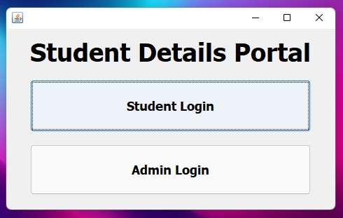
Frame 1: Login type selection
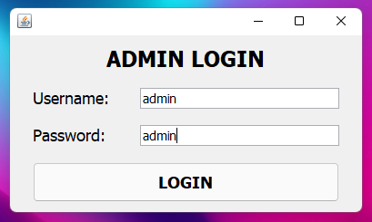
Frame 2: Admin Login

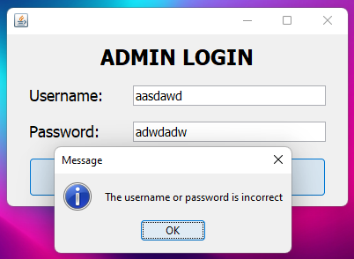
Frame 2.2: Error when the wrong username or password is entered (admin)
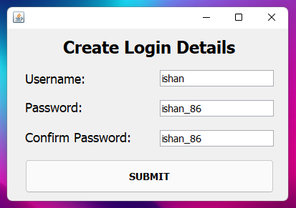
Frame 3: Creating Login Details for Student
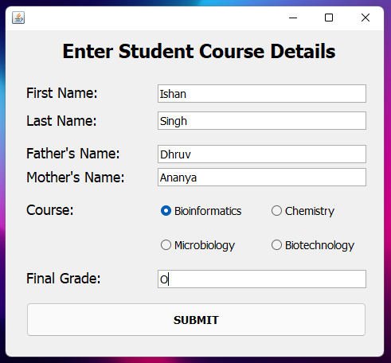
Frame 4: Entering Student details
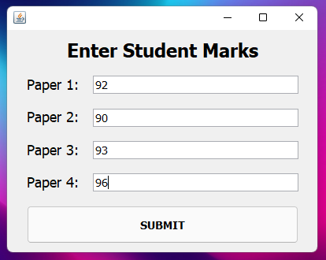
Frame 5.1: Entering Student Marks
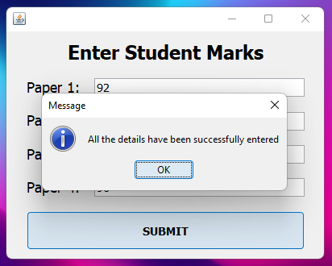
Frame 5.2: Confirmation that the details have been entered successfully
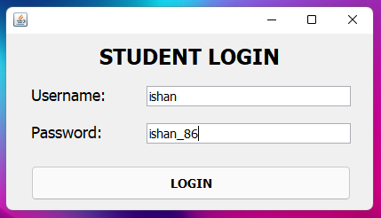
Frame 6: Student login
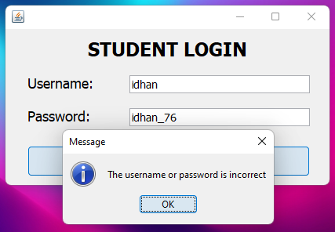
Frame 6.2: Error when the wrong username or password is entered (student)

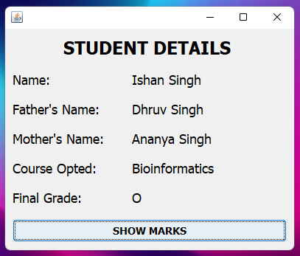
Frame 7: Showing details of the student
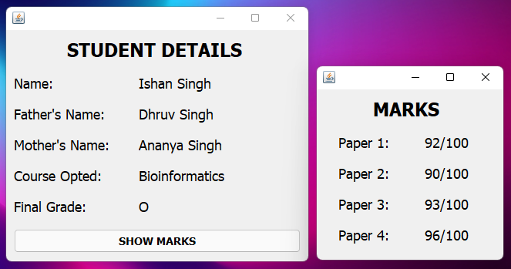
Frame 8: Showing marks of the student
SQL DATABASE
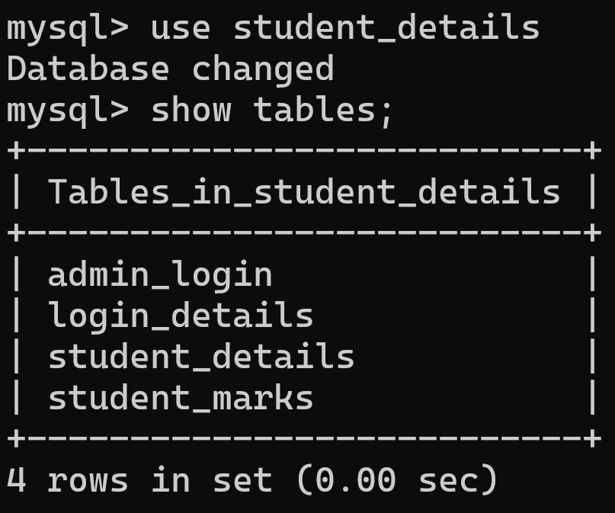Fig1: Name of all tables in the database
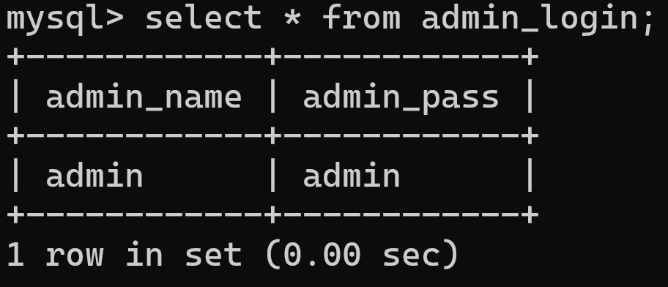Fig2: Entries in admin_login table
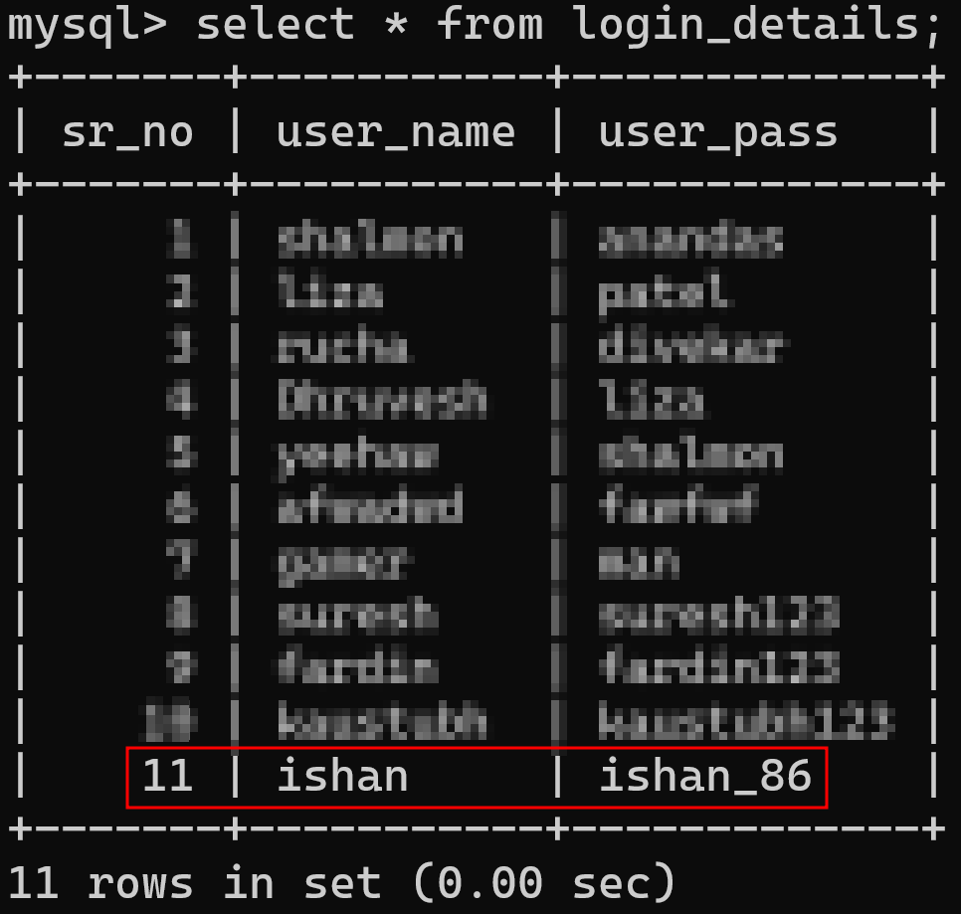Fig3: Entries in login_details table (student login)
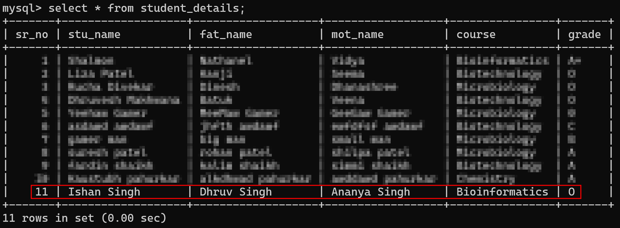Fig4: Entries in student_details table
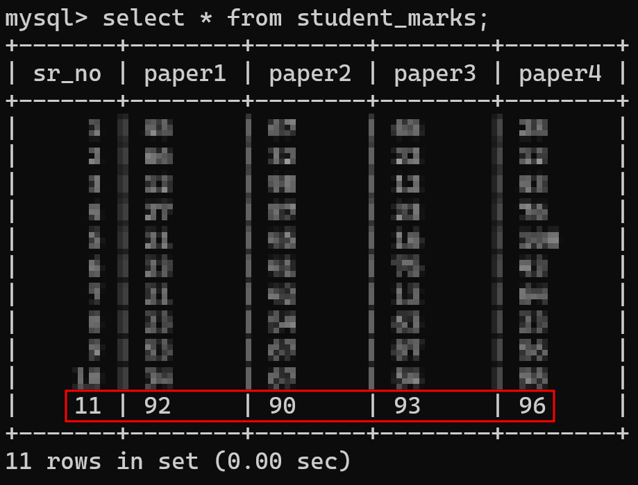Fig5: Entries in student_marks table

