**NAME: PRADEEP D. CHAVAN**

**CLASS: M.Sc. PART – I**

**COURSE: BIOINFORMATICS**

**ACADEMIC YEAR: 2021-2022**

**ROLL NO: 95**

**PAPER CODE: GNKPSBI204 (PAPER 4)**

**COURSE TITLE: Basic and Advanced Java, Introduction to Linux**

**GURU NANAK KHALSA COLLEGE**

**MATUNGA, MUMBAI – 400019**

**DEPARTMENT OF BIOINFORMATICS**

**CERTIFICATE**

This is to certify that Mr. **Pradeep D. Chavan** of M.Sc. Part I Bioinformatics has satisfactorily completed the practical semester II course prescribed by the university of Mumbai during the academic year 2021-2022

**TEACHER IN CHARGE HEAD OF DEPARTMENT**

**INDEX**

|  |  |  |  |  |
| --- | --- | --- | --- | --- |
| **Sr No** | **Title** | **Date** | **Pg No.** | **Signature** |
| **1** | **Classes and Constructors in Java** | **02-03-22** | **4** |  |
| **2** | **Inheritance & Polymorphism** | **21-03-22** | **11** |  |
| **3** | **Arrays, Loops and Conditional Statements** | **21-03-22** | **21** |  |
| **4** | **AWT** | **15-04-22** | **28** |  |
| **5** | **Swing** | **15-04-22** | **47** |  |

**PRACTICAL 1**

**CLASSES AND CONSTRUCTORS IN JAVA**

**Classes:**

A class is a user defined blueprint or prototype from which objects are created. It represents the set of properties or methods that are common to all objects of one type. In general, class declarations can include these components, in order:

1. Modifiers: A class can be public or has default access (Refer this for details).
2. class keyword: class keyword is used to create a class.
3. Class name: The name should begin with an initial letter (capitalized by convention).
4. Superclass(if any): The name of the class’s parent (superclass), if any, preceded by the keyword extends. A class can only extend (subclass) one parent.
5. Interfaces(if any): A comma-separated list of interfaces implemented by the class, if any, preceded by the keyword implements. A class can implement more than one interface.
6. Body: The class body surrounded by braces, { }.

The basic syntax is

public class <classname> {

public static void main(String []args) {

<code>

}

}

**Constructors:**

Java constructors is a terminology been used to construct something in our programs. A constructor in Java is a special method that is used to initialize objects. The constructor is called when an object of a class is created. It can be used to set initial values for object attributes.

In Java, a constructor is a block of codes similar to the method. It is called when an instance of the class is created. At the time of calling the constructor, memory for the object is allocated in the memory. It is a special type of method which is used to initialize the object. Every time an object is created using the new() keyword, at least one constructor is called. Constructors are different from methods in these ways:

1. Constructors must have the same name as the class within which it is defined while it is not necessary for the method in Java.
2. Constructors do not return any type while method(s) have the return type or void if does not return any value.
3. Constructors are called only once at the time of Object creation while method(s) can be called any number of times.

The syntax is:

public class <classname> {

public <classname>() {

<code>

}

public static void main(String[] args) {

<classname> <objname> = new <classname>();

<code>

}

}

**Q1. Write a java program to Create a class named Calculate and find area and perimeter a rectangle**

package practical1;

public class calculate {

public void area()

{

int l,b,area;

l = 4;

b = 6;

area = l * b;

System.out.println("The area of a rectange is " + area);

}

public void peri()

{

int l,b,peri;

l = 4;

b = 6;

peri = (2*l) + (2*b);

System.out.println("The area of a perimeter is " + peri);

}

public static void main(String[] args) {

calculate c1=new calculate();

c1.area();

c1.peri();

}

}

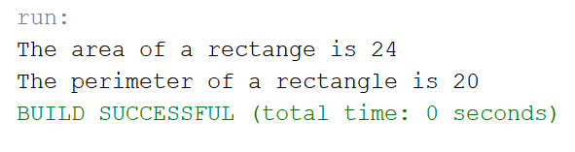

**Q2. Create a class named “Student” with String variable “name” and integer variable “roll_no”. Assign the value of roll_no as “2” and that of name as “John” by creating an object of the class Student.**

package practical1;

public class Student {

int roll_no;

String name;

public static void main(String[] args){

Student s1=new Student();

s1.roll_no = 2;

s1.name = "John";

System.out.println("Name of student is " + s1.name);

System.out.println("Roll no of student is " + s1.roll_no);

}

}

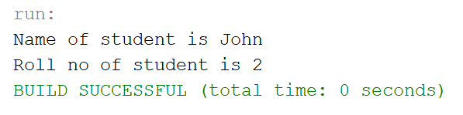

**Q3. Write a program to print the area of two rectangles having sides (4,5) and (5,8) respectively by creating a class named “Rectangle” with a method named “Area” which returns the area and length and breadth passed as parameters to its constructor.**

package practical1;

public class Rectangle{

public void Area(int length, int breadth){

int a;

a = length * breadth;

System.out.println("The area of the rectangle is " + a);

}

public static void main(String[] args){

Rectangle a1=new Rectangle();

a1.Area(4, 5);

a1.Area(5, 8);

}

}

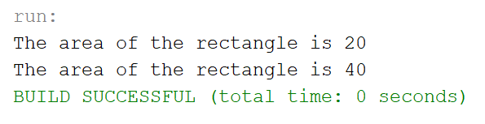

**Q4. Print the average of three numbers entered by user by creating a class named “Average” having a method to calculate and print the average.**

package practical1;

import java.util.Scanner;

public class Average {

public void calculate(int a, int b, int c){

int avg = (a + b + c ) / 3;

System.out.println("The average of entered numbers is:" + avg);

}

public static void main(String[] args){

Scanner scan = new Scanner(System.in);

System.out.print("Enter the first number: ");

int num1 = scan.nextInt();

System.out.print("Enter the second number: ");

int num2 = scan.nextInt();

System.out.print("Enter the third number: ");

int num3 = scan.nextInt();

scan.close();

Average a1=new Average();

a1.calculate(num1,num2,num3);

}

}

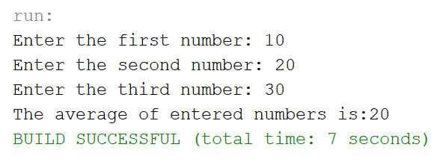

**Q5. Write a program that would print the information (name, year of joining, salary, address) of three employees by creating a class named "Employee" The output should be as follows:**

**Name        Year of joining        Address**

**Robert           1994             64C- WallsStreat**

**Sam               2000             68D- WallsStreat**

**John              1999            26B- WallsStreat**

package practical1;

public class Employee {

public void showData(String name, int yearofjoining, int salary, String add){

System.out.println(name + "\t" + yearofjoining + "\t\t " + salary + "\t" + add);

}

public static void main(String[] args){

System.out.println("Name Year of joining Salary Address");

Employee e1=new Employee();

e1.showData("Robert", 1994, 50000, "64C-WallStreet");

e1.showData("Sam", 2000, 30000, "68D-WallStreet");

e1.showData("John", 1999, 40000, "26B-WallStreet");

}

}

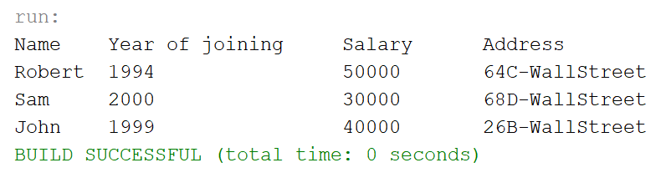

**PRACTICAL 2**

**INHERITANCE AND POLYMORPHISM**

**INHERITANCE:**

* Inheritance is an important pillar of OOP (Object-Oriented Programming). It is the mechanism in java by which one class is allowed to inherit the features (fields and methods) of another class.
* Important terminology:
  + **Super Class**: The class whose features are inherited is known as superclass (or a base class or a parent class).
  + **Sub Class**: The class that inherits the other class is known as a subclass (or a derived class, extended class, or child class). The subclass can add its own fields and methods in addition to the superclass fields and methods.
  + **Reusability**: Inheritance supports the concept of "reusability", i.e., when we want to create a new class and there is already a class that includes some of the code that we want, we can derive our new class from the existing class. By doing this, we are reusing the fields and methods of the existing class.
* Types on inheritance:
  + Single
    - When a class inherits another class, it is known as a single inheritance. In the example given below, Dog class inherits the Animal class, so there is the single inheritance.
  + Multilevel
    - When there is a chain of inheritance, it is known as multilevel inheritance. As you can see in the example given below, BabyDog class inherits the Dog class which again inherits the Animal class, so there is a multilevel inheritance.
  + Hierarchical
    - When two or more classes inherits a single class, it is known as hierarchical inheritance. In the example given below, Dog and Cat classes inherits the Animal class, so there is hierarchical inheritance.
  + Multiple
    - To reduce the complexity and simplify the language, multiple inheritance is not supported in java.
    - To fill this gap we have interface
    - The interface in Java is a mechanism to achieve abstraction. There can be only abstract methods in the Java interface, not method body. It is used to achieve abstraction and multiple inheritance in Java.
      * interface <interface_name>{
      * // declare constant fields
      * // declare methods that abstract
      * // by default.
      * }
  + Hybrid
    - Hybrid inheritance in Java is a combination of two or more types of inheritances. The purpose of using hybrid inheritance in Java is to modularize the codebase into well-defined classes and provide code reusability.
* **Syntax**:
  + class derived-class extends base-class
  + {
  + //methods and fields
  + }

**POLYMORPHISM**

* The word polymorphism means having many forms. In simple words, we can define polymorphism as the ability of a message to be displayed in more than one form.
* In Java polymorphism is mainly divided into two types:
  + Compile time polymorphism
    - It is also known as static polymorphism. This type of polymorphism is achieved by function overloading or operator overloading.
  + Runtime polymorphism
    - It is also known as Dynamic Method Dispatch. It is a process in which a function call to the overridden method is resolved at Runtime. This type of polymorphism is achieved by Method Overriding.

**Q1.**

package practical2;

class Perimeter{

public void Perimeter(){

System.out.println("Perimeters will be printed: ");

}

}

public class Peri_Square extends Perimeter{

public void Peri_Square(){

int a = 5;

int peri_sq = a*4;

System.out.println("Perimeter of the square is " + peri_sq);

}

public static void main(String[] args) {

Peri_Square p1=new Peri_Square();

p1.Perimeter();

p1.Peri_Square();

}

}

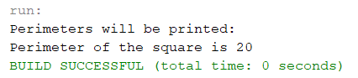

**Q2.**

package practical2;

class Perimeter{

public void Perimeter(){

System.out.println("Perimeters will be printed: ");

}

}

class Peri_Triangle extends Perimeter{

public void Peri_Triangle(){

int a = 5, b = 5, c = 6;

int peri_tri = a + b + c;

System.out.println("Perimeter of the triangle is " + peri_tri);

}

}

public class Peri_Square extends Peri_Triangle {

public void Peri_Square_2(){

int a = 5;

int peri_sq = a*4;

System.out.println("Perimeter of the square is " + peri_sq);

}

public static void main(String[] args){

Peri_Square p1 = new Peri_Square();

p1.Perimeter();

p1.Peri_Triangle();

p1.Peri_Square();

}

}

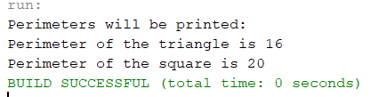

**Q3.**

package practical2;

class Perimeter{

public void Perimeter(){

System.out.println("Perimeters will be printed: ");

}

}

class Peri_Triangle extends Perimeter{

public void Peri_Triangle(){

int a = 5, b = 5, c = 6;

int peri_tri = a + b + c;

System.out.println("Perimeter of the triangle is " + peri_tri);

}

}

public class Peri_Square extends Perimeter {

public void Peri_Square_3(){

int a = 5;

int peri_sq = a*4;

System.out.println("Perimeter of the square is " + peri_sq);

}

public static void main(String[] args){

Peri_Square ps = new Peri_Square();

Peri_Triangle pt = new Peri_Triangle();

ps.Perimeter();

ps.Peri_Square();

pt.Perimeter();

pt.Peri_Triangle();

}

}

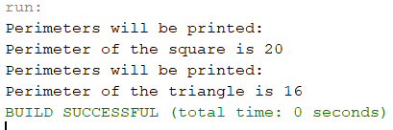

**Q4.**

**package practical2;**

**interface Peri_Square{**

**default void Peri_Square(){**

**int a = 5;**

**int peri_sq = a*4;**

**System.out.println("Perimeter of the square is " + peri_sq);**

**}**

**}**

**interface Peri_Triangle{**

**default void Peri_Triangle(){**

**int a = 5, b = 5, c = 6;**

**int peri_tri = a + b + c;**

**System.out.println("Perimeter of the triangle is " + peri_tri);**

**}**

**}**

**public class Perimeter implements Peri_Square, Peri_Triangle{**

**public void PeriMeter(){**

**System.out.println("Perimeters will be printed: ");**

**Peri_Square.super.Peri_Square();**

**Peri_Triangle.super.Peri_Triangle();**

**}**

**public static void main(String[] args){**

**Perimeter p = new Perimeter();**

**p.PeriMeter();**

**}**

**}**

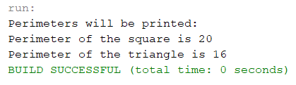

**Q5. Write a java program to create class Area and method named as calarea() to find area of a square and rectangle using method overloading.**

**package practical2;**

**public class Area {**

**void calarea(int a){**

**int area = a*a;**

**System.out.println("Area of Square is: " + area);**

**}**

**void calarea(int a, int b){**

**int area = a*b;**

**System.out.println("Area of Rectangle is: " + area);**

**}**

**public static void main(String[] args){**

**Area a1 = new Area();**

**a1.calarea(5);**

**a1.calarea(4, 5);**

**}**

**}**

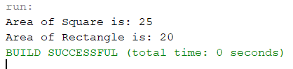

**Q6. Write a java program to create class Calculator and method named as add()-two number and create another class Addition who inherit class Calculator and method named as add()-three number using overriding.**

**package practical2;**

**class Calculator{**

**void add(){**

**int a, b, sum;**

**a = 5;**

**b = 5;**

**sum = a+b;**

**System.out.println("Addition of two numbers is: " + sum);**

**}**

**}**

**public class Addition extends Calculator {**

**void add(){**

**int a, b, c, sum;**

**a = 5;**

**b = 5;**

**c = 5;**

**sum = a + b + c;**

**System.out.println("Addition of three numbers is: " + sum);**

**}**

**public static void main(String[] args){**

**Calculator c1 = new Calculator();**

**c1.add();**

**c1 = new Addition();**

**c1.add();**

**}**

**}**

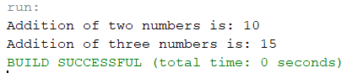

**PRACTICAL 3**

**ARRAYS AND LOOPS AND CONDITIONAL STATEMENTS**

**ARRAYS:**

* An array in Java is a group of like-typed variables referred to by a common name. Arrays in Java work differently than they do in C/C++. Following are some important points about Java arrays.
* In Java, all arrays are dynamically allocated.
* Since arrays are objects in Java, we can find their length using the object property length. This is different from C/C++, where we find length using sizeof.
* Since arrays are objects in Java, we can find their length using the object property length. This is different from C/C++, where we find length using sizeof.
* The variables in the array are ordered, and each has an index beginning from 0.
* Java array can be also be used as a static field, a local variable, or a method parameter.
* The size of an array must be specified by int or short value and not long.
* The direct superclass of an array type is Object.
* An array can contain primitives (int, char, etc.) and object (or non-primitive) references of a class depending on the definition of the array. In the case of primitive data types, the actual values are stored in contiguous memory locations. In the case of class objects, the actual objects are stored in a heap segment.

**LOOPS:**

* The Java for loop is used to iterate a part of the program several times. If the number of iterations is fixed, it is recommended to use for loop.
* There are three types of loop in java:
  + For loop: The java for loop is used to iterate a part of the program several times. If the number of iterations is fixed, it is recommended to use for loop.
    - for(initialization; condition; increment/decrement){
    - //statement or code to be executed
    - }
  + While loop: The Java while loop is used to iterate a part of the program several times. If the number of iterations is not fixed it is recommended to use while loop.
    - while (condition) {
    - // code block to be executed
    - }
  + Do-while loop: The Java do-while loop is to iterate a part of the program several times. Use it if the number of iterations is not fixed and you must have to execute the loop at least once.
    - do{
    - //code to be executed / loop body
    - //update statement
    - }while (condition);

**CONDITIONAL STATEMENTS:**

* Java supports the usual logical conditions.
* Java has the following conditional statements:
  + Use if to specify a block of code to be executed, if a specified condition is true
    - if (condition) {
    - // block of code to be executed if the condition is true
    - }
  + Use else to specify a block of code to be executed, if the same condition is false
    - if (condition) {
    - // block of code to be executed if the condition is true
    - } else {
    - // block of code to be executed if the condition is false
    - }
  + Use else if to specify a new condition to test, if the first condition is false
    - if (condition1) {
    - // block of code to be executed if condition1 is true
    - } else if (condition2) {
    - // block of code to be executed if the condition1 is false and condition2 is true
    - } else {
    - // block of code to be executed if the condition1 is false and condition2 is false
    - }

**Q1. Write a java program to Calculate the sum of all elements of an array.**

**package practical3;**

**import java.util.Scanner;**

**public class sum_of_all {**

**public static void main(String[] args) {**

**// take input for array**

**Scanner scan = new Scanner(System.in);**

**System.out.print("Enter 10 numbers: ");**

**int[] arr = new int[10];**

**for (int i = 0; i < 10; i++) {**

**arr[i] = scan.nextInt();**

**}**

**// calculate sum**

**int sum = 0;**

**for (int i = 0; i < 10; i++) {**

**sum = sum + arr[i];**

**}**

**// print sum**

**System.out.println("Sum of all the entered number is " + sum);**

**}**

**}**

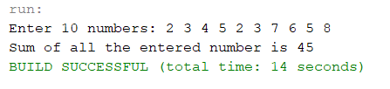

**Q2. Write a program in java that takes a number as input and prints its multiplication table upto 10.**

**package practical3;**

**import java.util.Scanner;**

**public class mul_table {**

**public static void main(String[] args) {**

**Scanner scan = new Scanner(System.in);**

**System.out.println("Which multiplication table do you want: ");**

**int multiplicand = scan.nextInt();**

**for (int multiplier = 0; multiplier <= 10; multiplier++) {**

**System.out.println(multiplicand + " x " + multiplier + " = " + (multiplicand * multiplier));**

**}**

**}**

**}**

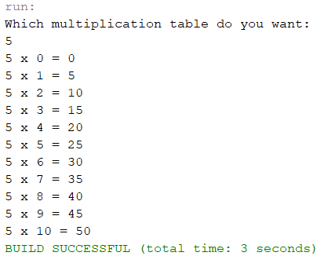

**Q3. Write a java program to accept angles of a triangle and display equilateral, isosceles and scalene.**

**package practical3;**

**import java.util.Scanner;**

**public class display_traingle_type {**

**public static void main(String[] args) {**

**Scanner scan = new Scanner(System.in);**

**System.out.print("Enter lengths of side of a triangle: ");**

**int a = scan.nextInt();**

**int b = scan.nextInt();**

**int c = scan.nextInt();**

**if (a == b && b == c)**

**System.out.println("It is an equilateral triangle");**

**else if (a == b || b == c || a == c)**

**System.out.println("It is an isoceles triangle");**

**else**

**System.out.println("it is a scalene triangle");**

**}**

**}**

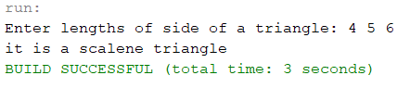

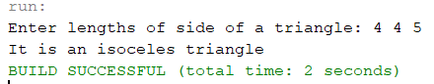

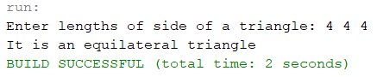

**Q4. Write a java program to count the number of occurrences of given number in an array of integers.**

**package practical3;**

**import java.util.Scanner;**

**public class occur_in_array {**

**public static void main(String[] args) {**

**int arr[] = { 1, 2, 3, 4, 4, 5, 2, 2, 3, 7, 6, 5, 4, 4, 3, 2, 2, 1, 1, 4, 5, 3, 8, 8, 9, 6, 7, 2 };**

**int arr_len = arr.length;**

**Scanner scan = new Scanner(System.in);**

**System.out.println("Which number do you want to count: ");**

**int arr_find = scan.nextInt();**

**int count = 0;**

**for (int i = 0; i < arr_len; i++)**

**if (arr_find == arr[i])**

**count++;**

**System.out.println("The number occurs " + count + " times");**

**}**

**}**

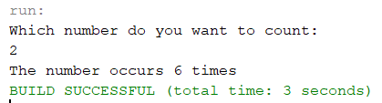

**Q5. Write a java program to accept 3x3 matrix and display the transpose of a given matrix.**

**package practical3;**

**public class transpose_of_matrix {**

**public static void main(String[] args) {**

**int matrix[][] = { { 1, 2, 3 }, { 4, 5, 6 }, { 7, 8, 9 } };**

**int transpose[][] = new int[3][3];**

**// printing original matrix**

**System.out.println("The matrix is: ");**

**for (int i = 0; i < 3; i++) {**

**for (int j = 0; j < 3; j++) {**

**System.out.print(matrix[i][j] + " ");**

**}**

**System.out.println();**

**}**

**// print transpose of matrix**

**System.out.println("The transpose of the matrix is: ");**

**for (int i = 0; i < 3; i++) {**

**for (int j = 0; j < 3; j++) {**

**System.out.print(matrix[j][i] + " ");**

**}**

**System.out.println();**

**}**

**}**

**}**

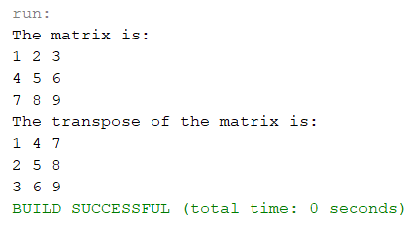

**PRACTICAL 4**

**AWT**

**Introduction:**

1. Java AWT is an API to develop Graphical User Interface (GUI) or windows-based applications in JAVA
2. Java AWT components are platform-dependent, i.e., Components are displayed according to the view of operation system. Which means the components will have a different look depending on the platform it is run on like Windows, MacOS, Linux, etx.
3. AWT is heavyweight because its components used the resources of the underlying operation system.
4. In short AWT applications will look like a Windows application in Windows whereas it will look like a Mac application in MacOS.
5. The java.aet package provides classes for AWT API components such as TextField, Label, TextArea, RadioButton, CheckBox, Choice, List, etc

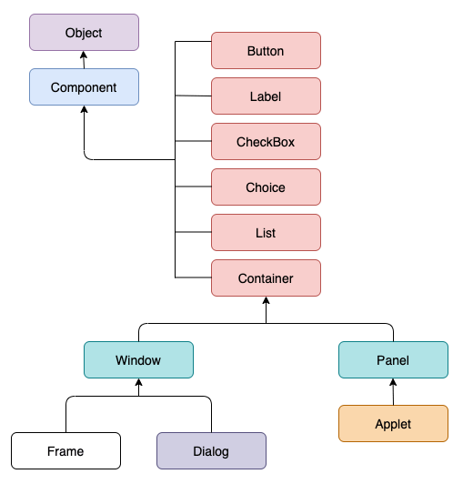

**Figure 1: Hierarchy of Container and component classes in AWT**

1. **Components**: All the elements like **button, text fields, scroll bars, etc**, are all called components. In AWT each component has a class. To add a component to the application we need to add them to a **container**
2. **Containers:** 
   1. The container is a components that can contain other components like **buttons, textfields, etc.**
   2. Types of containers:
      1. Window
         1. This container has no borders and menu bars.
         2. You must use frame or dialogue to make use of window container
         3. We need to create an instance of Window class to create this container
      2. Panel
         1. This container doesn’t have title bar, border or menu bar
         2. It is a generic container for holding components like button, textfield, etc.
         3. An instance of Panel class creates a container, in which we can add components.
      3. Frame
         1. Frame is a container that has title bar, border and menu bars.
         2. It can hold other components like button, textfield, scrollbar, etc.
         3. This is the most widely use container while developing an AWT application
      4. Dialog
         1. The dialog control represents a top-level window with a border and a title used to take some form of input from the user.
         2. This container inherits the window class.
         3. Unlike the Frame container, it doesn’t have maximize and minimize buttons

**Q1. Write a program to create an AWT GUI and handle event**

**CODE:**

/*

* To change this license header, choose License Headers in Project Properties.

* To change this template file, choose Tools | Templates

* and open the template in the editor.

*/

package practical_4;

/**

*

* @author Pradeep

*/

public class question_1 extends java.awt.Frame {

/**

* Creates new form question_1

*/

public question_1() {

initComponents();

}

/**

* This method is called from within the constructor to initialize the form.

* WARNING: Do NOT modify this code. The content of this method is always

* regenerated by the Form Editor.

*/

// <editor-fold defaultstate="collapsed" desc="Generated Code">

private void initComponents() {

label1 = new java.awt.Label();

label2 = new java.awt.Label();

textField1 = new java.awt.TextField();

textField2 = new java.awt.TextField();

button1 = new java.awt.Button();

label3 = new java.awt.Label();

label4 = new java.awt.Label();

setCursor(new java.awt.Cursor(java.awt.Cursor.DEFAULT_CURSOR));

setMinimumSize(new java.awt.Dimension(400, 350));

addWindowListener(new java.awt.event.WindowAdapter() {

public void windowClosing(java.awt.event.WindowEvent evt) {

exitForm(evt);

}

});

setLayout(new org.netbeans.lib.awtextra.AbsoluteLayout());

label1.setText("Username:");

add(label1, new org.netbeans.lib.awtextra.AbsoluteConstraints(70, 90, -1, -1));

label2.setText("Password:");

add(label2, new org.netbeans.lib.awtextra.AbsoluteConstraints(70, 130, -1, -1));

add(textField1, new org.netbeans.lib.awtextra.AbsoluteConstraints(180, 90, 90, -1));

add(textField2, new org.netbeans.lib.awtextra.AbsoluteConstraints(180, 130, 90, -1));

button1.setLabel("Login");

button1.setName(""); // NOI18N

button1.addActionListener(new java.awt.event.ActionListener() {

public void actionPerformed(java.awt.event.ActionEvent evt) {

button1ActionPerformed(evt);

}

});

add(button1, new org.netbeans.lib.awtextra.AbsoluteConstraints(140, 180, -1, -1));

label3.setText("Success");

label3.setVisible(false);

add(label3, new org.netbeans.lib.awtextra.AbsoluteConstraints(140, 240, -1, -1));

label4.setText("ENTER DETAILS FIRST!!");

label4.setVisible(false);

add(label4, new org.netbeans.lib.awtextra.AbsoluteConstraints(140, 240, -1, -1));

pack();

}// </editor-fold>

/**

* Exit the Application

*/

private void exitForm(java.awt.event.WindowEvent evt) {

System.exit(0);

}

private void button1ActionPerformed(java.awt.event.ActionEvent evt) {

if(textField1.getText().length() > 0 && textField2.getText().length() > 0){

label4.setVisible(false);

label3.setVisible(true);

}

else{

label3.setVisible(false);

label4.setVisible(true);

}

}

/**

* @param args the command line arguments

*/

public static void main(String args[]) {

java.awt.EventQueue.invokeLater(new Runnable() {

public void run() {

new question_1().setVisible(true);

}

});

}

// Variables declaration - do not modify

private java.awt.Button button1;

private java.awt.Label label1;

private java.awt.Label label2;

private java.awt.Label label3;

private java.awt.Label label4;

private java.awt.TextField textField1;

private java.awt.TextField textField2;

// End of variables declaration

}

**OUTPUT:**

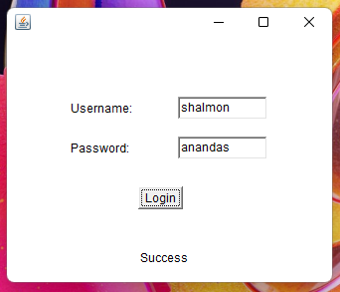 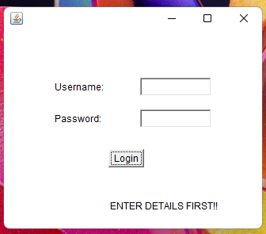

**Q2. Write a program to create an AWT GUI and perform the following operation**

**CODE:**

/*

* To change this license header, choose License Headers in Project Properties.

* To change this template file, choose Tools | Templates

* and open the template in the editor.

*/

package practical_4;

/**

*

* @author Pradeep

*/

public class question_2 extends java.awt.Frame {

/**

* Creates new form question_2

*/

public question_2() {

initComponents();

}

/**

* This method is called from within the constructor to initialize the form.

* WARNING: Do NOT modify this code. The content of this method is always

* regenerated by the Form Editor.

*/

// <editor-fold defaultstate="collapsed" desc="Generated Code">

private void initComponents() {

label1 = new java.awt.Label();

label2 = new java.awt.Label();

label3 = new java.awt.Label();

textField1 = new java.awt.TextField();

textField2 = new java.awt.TextField();

button1 = new java.awt.Button();

button2 = new java.awt.Button();

button3 = new java.awt.Button();

button4 = new java.awt.Button();

button5 = new java.awt.Button();

label4 = new java.awt.Label();

textField3 = new java.awt.TextField();

setPreferredSize(new java.awt.Dimension(400, 300));

addWindowListener(new java.awt.event.WindowAdapter() {

public void windowClosing(java.awt.event.WindowEvent evt) {

exitForm(evt);

}

});

setLayout(new org.netbeans.lib.awtextra.AbsoluteLayout());

label1.setFont(new java.awt.Font("Dialog", 1, 18)); // NOI18N

label1.setName(""); // NOI18N

label1.setText("CALCULATOR");

add(label1, new org.netbeans.lib.awtextra.AbsoluteConstraints(130, 40, -1, -1));

label2.setText("Enter First Number:");

add(label2, new org.netbeans.lib.awtextra.AbsoluteConstraints(30, 90, -1, -1));

label3.setText("Enter Second Number:");

add(label3, new org.netbeans.lib.awtextra.AbsoluteConstraints(30, 130, -1, -1));

add(textField1, new org.netbeans.lib.awtextra.AbsoluteConstraints(210, 90, 150, -1));

add(textField2, new org.netbeans.lib.awtextra.AbsoluteConstraints(210, 130, 150, -1));

button1.setLabel("ADD");

button1.setName(""); // NOI18N

button1.addActionListener(new java.awt.event.ActionListener() {

public void actionPerformed(java.awt.event.ActionEvent evt) {

button1ActionPerformed(evt);

}

});

add(button1, new org.netbeans.lib.awtextra.AbsoluteConstraints(30, 210, 60, -1));

button2.setLabel("SUB");

button2.addActionListener(new java.awt.event.ActionListener() {

public void actionPerformed(java.awt.event.ActionEvent evt) {

button2ActionPerformed(evt);

}

});

add(button2, new org.netbeans.lib.awtextra.AbsoluteConstraints(120, 210, 60, -1));

button3.setLabel("MUL");

button3.addActionListener(new java.awt.event.ActionListener() {

public void actionPerformed(java.awt.event.ActionEvent evt) {

button3ActionPerformed(evt);

}

});

add(button3, new org.netbeans.lib.awtextra.AbsoluteConstraints(210, 210, 60, -1));

button4.setLabel("DIV");

button4.addActionListener(new java.awt.event.ActionListener() {

public void actionPerformed(java.awt.event.ActionEvent evt) {

button4ActionPerformed(evt);

}

});

add(button4, new org.netbeans.lib.awtextra.AbsoluteConstraints(300, 210, 60, -1));

button5.setLabel("CLEAR");

button5.addActionListener(new java.awt.event.ActionListener() {

public void actionPerformed(java.awt.event.ActionEvent evt) {

button5ActionPerformed(evt);

}

});

add(button5, new org.netbeans.lib.awtextra.AbsoluteConstraints(120, 250, 150, -1));

label4.setText("Result:");

add(label4, new org.netbeans.lib.awtextra.AbsoluteConstraints(30, 170, -1, -1));

add(textField3, new org.netbeans.lib.awtextra.AbsoluteConstraints(210, 170, 150, -1));

pack();

}// </editor-fold>

/**

* Exit the Application

*/

private void exitForm(java.awt.event.WindowEvent evt) {

System.exit(0);

}

private void button3ActionPerformed(java.awt.event.ActionEvent evt) {

int a = Integer.parseInt(textField1.getText());

int b = Integer.parseInt(textField2.getText());

int c = a * b;

textField3.setText(String.valueOf(c));

}

private void button1ActionPerformed(java.awt.event.ActionEvent evt) {

int a = Integer.parseInt(textField1.getText());

int b = Integer.parseInt(textField2.getText());

int c = a + b;

textField3.setText(String.valueOf(c));

}

private void button2ActionPerformed(java.awt.event.ActionEvent evt) {

int a = Integer.parseInt(textField1.getText());

int b = Integer.parseInt(textField2.getText());

int c = a - b;

textField3.setText(String.valueOf(c));

}

private void button4ActionPerformed(java.awt.event.ActionEvent evt) {

int a = Integer.parseInt(textField1.getText());

int b = Integer.parseInt(textField2.getText());

int c = a / b;

textField3.setText(String.valueOf(c));

}

private void button5ActionPerformed(java.awt.event.ActionEvent evt) {

textField1.setText("");

textField2.setText("");

textField3.setText("");

}

/**

* @param args the command line arguments

*/

public static void main(String args[]) {

java.awt.EventQueue.invokeLater(new Runnable() {

public void run() {

new question_2().setVisible(true);

}

});

}

// Variables declaration - do not modify

private java.awt.Button button1;

private java.awt.Button button2;

private java.awt.Button button3;

private java.awt.Button button4;

private java.awt.Button button5;

private java.awt.Label label1;

private java.awt.Label label2;

private java.awt.Label label3;

private java.awt.Label label4;

private java.awt.TextField textField1;

private java.awt.TextField textField2;

private java.awt.TextField textField3;

// End of variables declaration

}

**OUTPUT:**

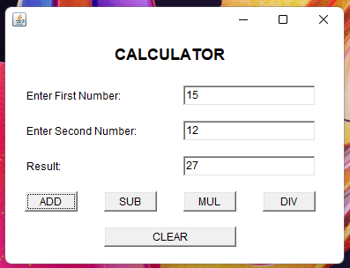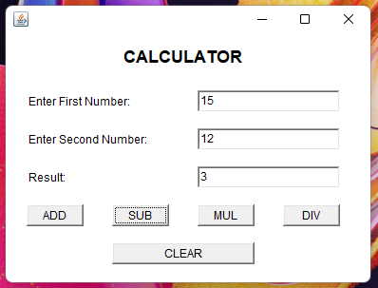

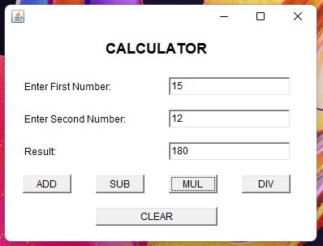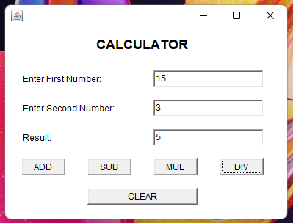

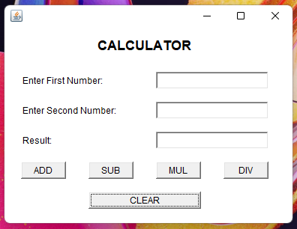

**Q3. Write a program to create an AWT GUI**

**CODE:**

/*

* To change this license header, choose License Headers in Project Properties.

* To change this template file, choose Tools | Templates

* and open the template in the editor.

*/

package practical_4;

/**

*

* @author Pradeep

*/

public class question_3 extends java.awt.Frame {

/**

* Creates new form question_3

*/

public question_3() {

initComponents();

}

/**

* This method is called from within the constructor to initialize the form.

* WARNING: Do NOT modify this code. The content of this method is always

* regenerated by the Form Editor.

*/

// <editor-fold defaultstate="collapsed" desc="Generated Code">

private void initComponents() {

label1 = new java.awt.Label();

textField1 = new java.awt.TextField();

label2 = new java.awt.Label();

label3 = new java.awt.Label();

textField2 = new java.awt.TextField();

label4 = new java.awt.Label();

checkbox1 = new java.awt.Checkbox();

checkbox2 = new java.awt.Checkbox();

checkbox3 = new java.awt.Checkbox();

button1 = new java.awt.Button();

label5 = new java.awt.Label();

addWindowListener(new java.awt.event.WindowAdapter() {

public void windowClosing(java.awt.event.WindowEvent evt) {

exitForm(evt);

}

});

setLayout(new org.netbeans.lib.awtextra.AbsoluteLayout());

label1.setName(""); // NOI18N

label1.setText("Name:");

add(label1, new org.netbeans.lib.awtextra.AbsoluteConstraints(40, 40, -1, -1));

textField1.addActionListener(new java.awt.event.ActionListener() {

public void actionPerformed(java.awt.event.ActionEvent evt) {

textField1ActionPerformed(evt);

}

});

add(textField1, new org.netbeans.lib.awtextra.AbsoluteConstraints(160, 40, 190, -1));

label2.setText("Student Details:");

add(label2, new org.netbeans.lib.awtextra.AbsoluteConstraints(40, 80, -1, -1));

label3.setText("Contact Number:");

add(label3, new org.netbeans.lib.awtextra.AbsoluteConstraints(40, 120, -1, -1));

add(textField2, new org.netbeans.lib.awtextra.AbsoluteConstraints(160, 120, 190, -1));

label4.setText("Course Offered:");

add(label4, new org.netbeans.lib.awtextra.AbsoluteConstraints(40, 160, -1, -1));

checkbox1.setLabel("Bioinformatics");

add(checkbox1, new org.netbeans.lib.awtextra.AbsoluteConstraints(160, 160, -1, -1));

checkbox2.setLabel("Botany");

add(checkbox2, new org.netbeans.lib.awtextra.AbsoluteConstraints(160, 190, -1, -1));

checkbox3.setLabel("Biochemistry");

add(checkbox3, new org.netbeans.lib.awtextra.AbsoluteConstraints(160, 220, -1, -1));

button1.setLabel("SUBMIT");

button1.addActionListener(new java.awt.event.ActionListener() {

public void actionPerformed(java.awt.event.ActionEvent evt) {

button1ActionPerformed(evt);

}

});

add(button1, new org.netbeans.lib.awtextra.AbsoluteConstraints(290, 250, -1, -1));

label5.setText("Successfull!!!");

label5.setVisible(false);

add(label5, new org.netbeans.lib.awtextra.AbsoluteConstraints(40, 250, 80, -1));

pack();

}// </editor-fold>

/**

* Exit the Application

*/

private void exitForm(java.awt.event.WindowEvent evt) {

System.exit(0);

}

private void textField1ActionPerformed(java.awt.event.ActionEvent evt) {

// TODO add your handling code here:

}

private void button1ActionPerformed(java.awt.event.ActionEvent evt) {

if(textField1.getText().length() > 0 && textField2.getText().length() > 0){

label5.setText("Successfull!!");

label5.setVisible(true);

}

else{

label5.setText("Enter Details!!");

label5.setVisible(true);

}

}

/**

* @param args the command line arguments

*/

public static void main(String args[]) {

java.awt.EventQueue.invokeLater(new Runnable() {

public void run() {

new question_3().setVisible(true);

}

});

}

// Variables declaration - do not modify

private java.awt.Button button1;

private java.awt.Checkbox checkbox1;

private java.awt.Checkbox checkbox2;

private java.awt.Checkbox checkbox3;

private java.awt.Label label1;

private java.awt.Label label2;

private java.awt.Label label3;

private java.awt.Label label4;

private java.awt.Label label5;

private java.awt.TextField textField1;

private java.awt.TextField textField2;

// End of variables declaration

}

**OUTPUT:**

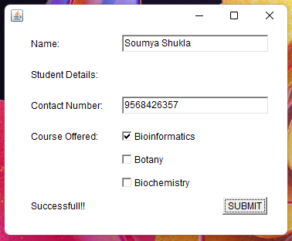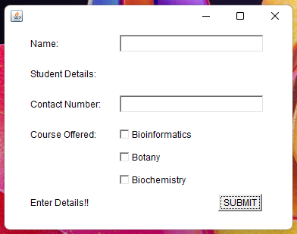

**Q4. Write a program to create a GUI and add MouseListener**

**CODE:**

/*

* To change this license header, choose License Headers in Project Properties.

* To change this template file, choose Tools | Templates

* and open the template in the editor.

*/

package practical_4;

/**

*

* @author Pradeep

*/

public class question_4 extends java.awt.Frame {

/**

* Creates new form question_4

*/

public question_4() {

initComponents();

}

/**

* This method is called from within the constructor to initialize the form.

* WARNING: Do NOT modify this code. The content of this method is always

* regenerated by the Form Editor.

*/

// <editor-fold defaultstate="collapsed" desc="Generated Code">

private void initComponents() {

textField1 = new java.awt.TextField();

setBackground(java.awt.Color.blue);

setMinimumSize(new java.awt.Dimension(400, 300));

addWindowListener(new java.awt.event.WindowAdapter() {

public void windowClosing(java.awt.event.WindowEvent evt) {

exitForm(evt);

}

});

setLayout(new org.netbeans.lib.awtextra.AbsoluteLayout());

textField1.setFont(new java.awt.Font("Dialog", 1, 12)); // NOI18N

textField1.setForeground(new java.awt.Color(255, 0, 0));

textField1.addMouseListener(new java.awt.event.MouseAdapter() {

public void mouseClicked(java.awt.event.MouseEvent evt) {

textField1MouseClicked(evt);

}

public void mouseEntered(java.awt.event.MouseEvent evt) {

textField1MouseEntered(evt);

}

public void mouseExited(java.awt.event.MouseEvent evt) {

textField1MouseExited(evt);

}

});

add(textField1, new org.netbeans.lib.awtextra.AbsoluteConstraints(70, 110, 260, 50));

pack();

}// </editor-fold>

/**

* Exit the Application

*/

private void exitForm(java.awt.event.WindowEvent evt) {

System.exit(0);

}

private void textField1MouseEntered(java.awt.event.MouseEvent evt) {

textField1.setText("Mouse Entered");

}

private void textField1MouseExited(java.awt.event.MouseEvent evt) {

textField1.setText("Mouse Exited");

}

private void textField1MouseClicked(java.awt.event.MouseEvent evt) {

textField1.setText("Mouse Clicked");

}

/**

* @param args the command line arguments

*/

public static void main(String args[]) {

java.awt.EventQueue.invokeLater(new Runnable() {

public void run() {

new question_4().setVisible(true);

}

});

}

// Variables declaration - do not modify

private java.awt.TextField textField1;

// End of variables declaration

}

**OUTPUT:**

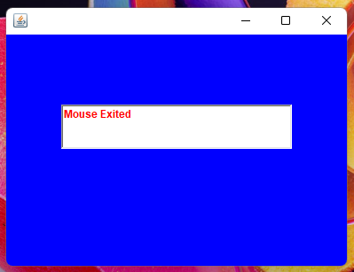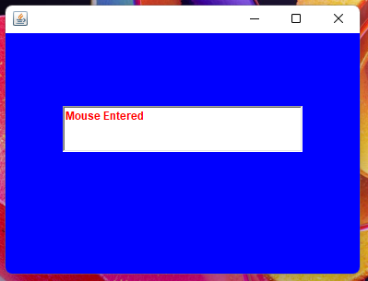

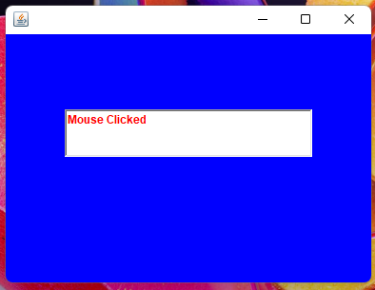

**PRACTICAL 5**

**SWING**

**Introduction:**

1. Swing API is a set of extensible GUI components to ease the life of developers in creating Java based Front end/GUI applications
2. It is built on top of AWT API and acts as a replacement for AWT API, since it has every control corresponding to AWT controls
3. Swing components follow a Model-View-Controller (MVC) architecture to fulfil the following criteria:
   1. A single API is to be sufficient to support multiple look and feel
   2. API is to be model driven so that the highest level API is not required to have data.
4. MVC architecture:
   1. Model represents component’s data
   2. View represents visual presentation of the component’s data
   3. Controller acts as an interface between model and view
5. Swing has **Model** as a separate element, **View** and **Controller** are clubbed in the **User Interface elements**.
6. Due to this approach, Swing has a pluggable look-and-feel architecture
7. Features of Swing include:
   1. Light Weight:
      1. Swing is independent of the native Operation System and is run using pure Java code, unlike AWT which uses Operating System calls
   2. Rich controls
      1. It has a rich set of advanced controls like:
         1. T:ree
         2. TabbedPane
         3. Slider
         4. Colorpicker
         5. Table controls
   3. Highly Customizable:
      1. The controls can be easily customized because the look of the components is independent of the operating system
   4. Pluggable look-and-feel
      1. SWING GUI application’s look and feel can be changed at run-time

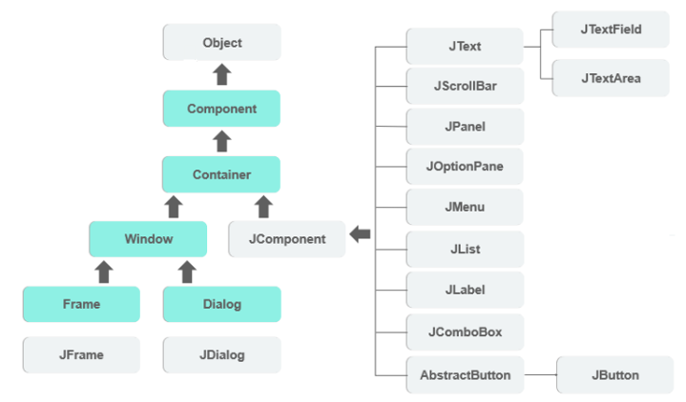**Figure: Class hierarchy of Swing components**

**Q1. Write a program to create a Swing GUI and handle event display the dialog box when item selected**

**CODE:**

/*

* To change this license header, choose License Headers in Project Properties.

* To change this template file, choose Tools | Templates

* and open the template in the editor.

*/

package practical_5;

import javax.swing.JOptionPane;

/**

*

* @author Pradeep

*/

public class question_1 extends javax.swing.JFrame {

/**

* Creates new form question_1

*/

public question_1() {

initComponents();

}

/**

* This method is called from within the constructor to initialize the form.

* WARNING: Do NOT modify this code. The content of this method is always

* regenerated by the Form Editor.

*/

@SuppressWarnings("unchecked")

// <editor-fold defaultstate="collapsed" desc="Generated Code">

private void initComponents() {

jLabel1 = new javax.swing.JLabel();

jComboBox1 = new javax.swing.JComboBox<>();

setDefaultCloseOperation(javax.swing.WindowConstants.EXIT_ON_CLOSE);

jLabel1.setText("SELECT YOUR COUNTRY:");

jComboBox1.setModel(new javax.swing.DefaultComboBoxModel<>(new String[] { "Afghanistan", "Albania", "Algeria", "Andorra", "Angola", "Antigua and Barbuda", "Argentina", "Armenia", "Australia", "Austria", "Azerbaijan", "Bahamas", "Bahrain", "Bangladesh", "Barbados", "Belarus", "Belgium", "Belize", "Benin", "Bhutan", "Bolivia", "Bosnia and Herzegovina", "Botswana", "Brazil", "Brunei", "Bulgaria", "Burkina Faso", "Burundi", "Cabo Verde", "Cambodia", "Cameroon", "Canada", "Central African Republic (CAR)", "Chad", "Chile", "China", "Colombia", "Comoros", "Congo, Democratic Republic of the", "Congo, Republic of the", "Costa Rica", "Cote d'Ivoire", "Croatia", "Cuba", "Cyprus", "Czechia", "Denmark", "Djibouti", "Dominica", "Dominican Republic", "Ecuador", "Egypt", "El Salvador", "Equatorial Guinea", "Eritrea", "Estonia", "Eswatini", "Ethiopia", "Fiji", "Finland", "France", "Gabon", "Gambia", "Georgia", "Germany", "Ghana", "Greece", "Grenada", "Guatemala", "Guinea", "Guinea-Bissau", "Guyana", "Haiti", "Honduras", "Hungary", "Iceland", "India", "Indonesia", "Iran", "Iraq", "Ireland", "Israel", "Italy", "Jamaica", "Japan", "Jordan", "Kazakhstan", "Kenya", "Kiribati", "Kosovo", "Kuwait", "Kyrgyzstan", "Laos", "Latvia", "Lebanon", "Lesotho", "Liberia", "Libya", "Liechtenstein", "Lithuania", "Luxembourg", "Madagascar", "Malawi", "Malaysia", "Maldives", "Mali", "Malta", "Marshall Islands", "Mauritania", "Mauritius", "Mexico", "Micronesia", "Moldova", "Monaco", "Mongolia", "Montenegro", "Morocco", "Mozambique", "Myanmar", "Namibia", "Nauru", "Nepal", "Netherlands", "New Zealand", "Nicaragua", "Niger", "Nigeria", "North Korea", "North Macedonia", "Norway", "Oman", "Pakistan", "Palau", "Palestine", "Panama", "Papua New Guinea", "Paraguay", "Peru", "Philippines", "Poland", "Portugal", "Qatar", "Romania", "Russia", "Rwanda", "Saint Kitts and Nevis", "Saint Lucia", "Saint Vincent and the Grenadines", "Samoa", "San Marino", "Sao Tome and Principe", "Saudi Arabia", "Senegal", "Serbia", "Seychelles", "Sierra Leone", "Singapore", "Slovakia", "Slovenia", "Solomon Islands", "Somalia", "South Africa", "South Korea", "South Sudan", "Spain", "Sri Lanka", "Sudan", "Suriname", "Sweden", "Switzerland", "Syria", "Taiwan", "Tajikistan", "Tanzania", "Thailand", "Timor-Leste", "Togo", "Tonga", "Trinidad and Tobago", "Tunisia", "Turkey", "Turkmenistan", "Tuvalu", "Uganda", "Ukraine", "United Arab Emirates (UAE)", "United Kingdom (UK)", "United States of America (USA)", "Uruguay", "Uzbekistan", "Vanuatu", "Vatican City (Holy See)", "Venezuela", "Vietnam", "Yemen", "Zambia", "Zimbabwe" }));

jComboBox1.addActionListener(new java.awt.event.ActionListener() {

public void actionPerformed(java.awt.event.ActionEvent evt) {

jComboBox1ActionPerformed(evt);

}

});

javax.swing.GroupLayout layout = new javax.swing.GroupLayout(getContentPane());

getContentPane().setLayout(layout);

layout.setHorizontalGroup(

layout.createParallelGroup(javax.swing.GroupLayout.Alignment.LEADING)

.addGroup(layout.createSequentialGroup()

.addGap(24, 24, 24)

.addComponent(jLabel1)

.addGap(29, 29, 29)

.addComponent(jComboBox1, javax.swing.GroupLayout.PREFERRED_SIZE, 198, javax.swing.GroupLayout.PREFERRED_SIZE)

.addContainerGap(27, Short.MAX_VALUE))

);

layout.setVerticalGroup(

layout.createParallelGroup(javax.swing.GroupLayout.Alignment.LEADING)

.addGroup(layout.createSequentialGroup()

.addGap(49, 49, 49)

.addGroup(layout.createParallelGroup(javax.swing.GroupLayout.Alignment.BASELINE)

.addComponent(jLabel1, javax.swing.GroupLayout.PREFERRED_SIZE, 20, javax.swing.GroupLayout.PREFERRED_SIZE)

.addComponent(jComboBox1, javax.swing.GroupLayout.PREFERRED_SIZE, javax.swing.GroupLayout.DEFAULT_SIZE, javax.swing.GroupLayout.PREFERRED_SIZE))

.addContainerGap(231, Short.MAX_VALUE))

);

pack();

}// </editor-fold>

private void jComboBox1ActionPerformed(java.awt.event.ActionEvent evt) {

JOptionPane.showMessageDialog(jComboBox1, jComboBox1.getSelectedItem()+" was selected");

}

/**

* @param args the command line arguments

*/

public static void main(String args[]) {

/* Set the Nimbus look and feel */

//<editor-fold defaultstate="collapsed" desc=" Look and feel setting code (optional) ">

/* If Nimbus (introduced in Java SE 6) is not available, stay with the default look and feel.

* For details see http://download.oracle.com/javase/tutorial/uiswing/lookandfeel/plaf.html

*/

try {

for (javax.swing.UIManager.LookAndFeelInfo info : javax.swing.UIManager.getInstalledLookAndFeels()) {

if ("Windows".equals(info.getName())) {

javax.swing.UIManager.setLookAndFeel(info.getClassName());

break;

}

}

} catch (ClassNotFoundException ex) {

java.util.logging.Logger.getLogger(question_1.class.getName()).log(java.util.logging.Level.SEVERE, null, ex);

} catch (InstantiationException ex) {

java.util.logging.Logger.getLogger(question_1.class.getName()).log(java.util.logging.Level.SEVERE, null, ex);

} catch (IllegalAccessException ex) {

java.util.logging.Logger.getLogger(question_1.class.getName()).log(java.util.logging.Level.SEVERE, null, ex);

} catch (javax.swing.UnsupportedLookAndFeelException ex) {

java.util.logging.Logger.getLogger(question_1.class.getName()).log(java.util.logging.Level.SEVERE, null, ex);

}

//</editor-fold>

/* Create and display the form */

java.awt.EventQueue.invokeLater(new Runnable() {

public void run() {

new question_1().setVisible(true);

}

});

}

// Variables declaration - do not modify

private javax.swing.JComboBox<String> jComboBox1;

private javax.swing.JLabel jLabel1;

// End of variables declaration

}

**OUTPUT:**

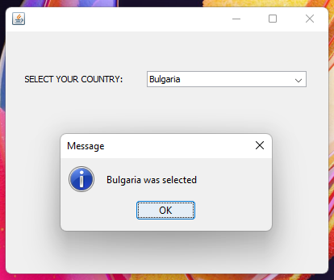

**Q2. Write a program to create a Swing GUI and handle event when the item is selected**

**CODE:**

/*

* To change this license header, choose License Headers in Project Properties.

* To change this template file, choose Tools | Templates

* and open the template in the editor.

*/

package practical_5;

/**

*

* @author Pradeep

*/

import javax.swing.JOptionPane;

public class question_2 extends javax.swing.JFrame {

/**

* Creates new form question_2

*/

public question_2() {

initComponents();

}

/**

* This method is called from within the constructor to initialize the form.

* WARNING: Do NOT modify this code. The content of this method is always

* regenerated by the Form Editor.

*/

@SuppressWarnings("unchecked")

// <editor-fold defaultstate="collapsed" desc="Generated Code">

private void initComponents() {

jScrollPane1 = new javax.swing.JScrollPane();

jList1 = new javax.swing.JList<>();

setDefaultCloseOperation(javax.swing.WindowConstants.EXIT_ON_CLOSE);

jList1.setModel(new javax.swing.AbstractListModel<String>() {

String[] strings = { "DOG", "CAT", "RABBIT", "BIRD" };

public int getSize() { return strings.length; }

public String getElementAt(int i) { return strings[i]; }

});

jList1.setSelectionMode(javax.swing.ListSelectionModel.SINGLE_SELECTION);

jList1.setName(""); // NOI18N

jList1.addMouseListener(new java.awt.event.MouseAdapter() {

public void mouseClicked(java.awt.event.MouseEvent evt) {

jList1MouseClicked(evt);

}

});

jScrollPane1.setViewportView(jList1);

javax.swing.GroupLayout layout = new javax.swing.GroupLayout(getContentPane());

getContentPane().setLayout(layout);

layout.setHorizontalGroup(

layout.createParallelGroup(javax.swing.GroupLayout.Alignment.LEADING)

.addGroup(layout.createSequentialGroup()

.addGap(125, 125, 125)

.addComponent(jScrollPane1, javax.swing.GroupLayout.PREFERRED_SIZE, 139, javax.swing.GroupLayout.PREFERRED_SIZE)

.addContainerGap(136, Short.MAX_VALUE))

);

layout.setVerticalGroup(

layout.createParallelGroup(javax.swing.GroupLayout.Alignment.LEADING)

.addGroup(layout.createSequentialGroup()

.addGap(75, 75, 75)

.addComponent(jScrollPane1, javax.swing.GroupLayout.PREFERRED_SIZE, javax.swing.GroupLayout.DEFAULT_SIZE, javax.swing.GroupLayout.PREFERRED_SIZE)

.addContainerGap(95, Short.MAX_VALUE))

);

pack();

}// </editor-fold>

private void jList1MouseClicked(java.awt.event.MouseEvent evt) {

JOptionPane.showMessageDialog(jList1, jList1.getSelectedValue()+" was selected!!");

}

/**

* @param args the command line arguments

*/

public static void main(String args[]) {

/* Set the Nimbus look and feel */

//<editor-fold defaultstate="collapsed" desc=" Look and feel setting code (optional) ">

/* If Nimbus (introduced in Java SE 6) is not available, stay with the default look and feel.

* For details see http://download.oracle.com/javase/tutorial/uiswing/lookandfeel/plaf.html

*/

try {

for (javax.swing.UIManager.LookAndFeelInfo info : javax.swing.UIManager.getInstalledLookAndFeels()) {

if ("Windows".equals(info.getName())) {

javax.swing.UIManager.setLookAndFeel(info.getClassName());

break;

}

}

} catch (ClassNotFoundException ex) {

java.util.logging.Logger.getLogger(question_2.class.getName()).log(java.util.logging.Level.SEVERE, null, ex);

} catch (InstantiationException ex) {

java.util.logging.Logger.getLogger(question_2.class.getName()).log(java.util.logging.Level.SEVERE, null, ex);

} catch (IllegalAccessException ex) {

java.util.logging.Logger.getLogger(question_2.class.getName()).log(java.util.logging.Level.SEVERE, null, ex);

} catch (javax.swing.UnsupportedLookAndFeelException ex) {

java.util.logging.Logger.getLogger(question_2.class.getName()).log(java.util.logging.Level.SEVERE, null, ex);

}

//</editor-fold>

/* Create and display the form */

java.awt.EventQueue.invokeLater(new Runnable() {

public void run() {

new question_2().setVisible(true);

}

});

}

// Variables declaration - do not modify

private javax.swing.JList<String> jList1;

private javax.swing.JScrollPane jScrollPane1;

// End of variables declaration

}

**OUTPUT:**

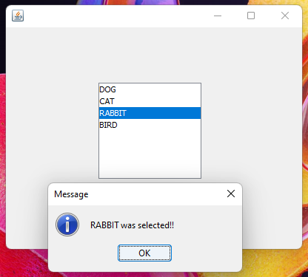

**Q3. Write a program to create a Swing GUI and handle event when the item is selected**

**CODE:**

/*

* To change this license header, choose License Headers in Project Properties.

* To change this template file, choose Tools | Templates

* and open the template in the editor.

*/

package practical_5;

import javax.swing.JOptionPane;

/**

*

* @author Pradeep

*/

public class question_3 extends javax.swing.JFrame {

/**

* Creates new form question_3

*/

public question_3() {

initComponents();

}

/**

* This method is called from within the constructor to initialize the form.

* WARNING: Do NOT modify this code. The content of this method is always

* regenerated by the Form Editor.

*/

@SuppressWarnings("unchecked")

// <editor-fold defaultstate="collapsed" desc="Generated Code">

private void initComponents() {

buttonGroup1 = new javax.swing.ButtonGroup();

jRadioButton1 = new javax.swing.JRadioButton();

jRadioButton2 = new javax.swing.JRadioButton();

jRadioButton3 = new javax.swing.JRadioButton();

setDefaultCloseOperation(javax.swing.WindowConstants.EXIT_ON_CLOSE);

buttonGroup1.add(jRadioButton1);

jRadioButton1.setText("French Fries");

jRadioButton1.addActionListener(new java.awt.event.ActionListener() {

public void actionPerformed(java.awt.event.ActionEvent evt) {

jRadioButton1ActionPerformed(evt);

}

});

buttonGroup1.add(jRadioButton2);

jRadioButton2.setText("Onion Rings");

jRadioButton2.addActionListener(new java.awt.event.ActionListener() {

public void actionPerformed(java.awt.event.ActionEvent evt) {

jRadioButton2ActionPerformed(evt);

}

});

buttonGroup1.add(jRadioButton3);

jRadioButton3.setText("Ice Cream");

jRadioButton3.addActionListener(new java.awt.event.ActionListener() {

public void actionPerformed(java.awt.event.ActionEvent evt) {

jRadioButton3ActionPerformed(evt);

}

});

javax.swing.GroupLayout layout = new javax.swing.GroupLayout(getContentPane());

getContentPane().setLayout(layout);

layout.setHorizontalGroup(

layout.createParallelGroup(javax.swing.GroupLayout.Alignment.LEADING)

.addGroup(layout.createSequentialGroup()

.addGap(136, 136, 136)

.addGroup(layout.createParallelGroup(javax.swing.GroupLayout.Alignment.TRAILING, false)

.addComponent(jRadioButton1, javax.swing.GroupLayout.Alignment.LEADING, javax.swing.GroupLayout.DEFAULT_SIZE, javax.swing.GroupLayout.DEFAULT_SIZE, Short.MAX_VALUE)

.addComponent(jRadioButton2, javax.swing.GroupLayout.Alignment.LEADING, javax.swing.GroupLayout.DEFAULT_SIZE, javax.swing.GroupLayout.DEFAULT_SIZE, Short.MAX_VALUE)

.addComponent(jRadioButton3, javax.swing.GroupLayout.Alignment.LEADING, javax.swing.GroupLayout.DEFAULT_SIZE, javax.swing.GroupLayout.DEFAULT_SIZE, Short.MAX_VALUE))

.addContainerGap(179, Short.MAX_VALUE))

);

layout.setVerticalGroup(

layout.createParallelGroup(javax.swing.GroupLayout.Alignment.LEADING)

.addGroup(layout.createSequentialGroup()

.addGap(74, 74, 74)

.addComponent(jRadioButton1)

.addGap(18, 18, 18)

.addComponent(jRadioButton2)

.addGap(18, 18, 18)

.addComponent(jRadioButton3)

.addContainerGap(121, Short.MAX_VALUE))

);

pack();

}// </editor-fold>

private void jRadioButton2ActionPerformed(java.awt.event.ActionEvent evt) {

JOptionPane.showMessageDialog(jRadioButton2, "Onion Rings Ordered");

}

private void jRadioButton1ActionPerformed(java.awt.event.ActionEvent evt) {

JOptionPane.showMessageDialog(jRadioButton2, "French Fries Ordered");

}

private void jRadioButton3ActionPerformed(java.awt.event.ActionEvent evt) {

JOptionPane.showMessageDialog(jRadioButton2, "Ice Cream Ordered");

}

/**

* @param args the command line arguments

*/

public static void main(String args[]) {

/* Set the Nimbus look and feel */

//<editor-fold defaultstate="collapsed" desc=" Look and feel setting code (optional) ">

/* If Nimbus (introduced in Java SE 6) is not available, stay with the default look and feel.

* For details see http://download.oracle.com/javase/tutorial/uiswing/lookandfeel/plaf.html

*/

try {

for (javax.swing.UIManager.LookAndFeelInfo info : javax.swing.UIManager.getInstalledLookAndFeels()) {

if ("Windows".equals(info.getName())) {

javax.swing.UIManager.setLookAndFeel(info.getClassName());

break;

}

}

} catch (ClassNotFoundException ex) {

java.util.logging.Logger.getLogger(question_3.class.getName()).log(java.util.logging.Level.SEVERE, null, ex);

} catch (InstantiationException ex) {

java.util.logging.Logger.getLogger(question_3.class.getName()).log(java.util.logging.Level.SEVERE, null, ex);

} catch (IllegalAccessException ex) {

java.util.logging.Logger.getLogger(question_3.class.getName()).log(java.util.logging.Level.SEVERE, null, ex);

} catch (javax.swing.UnsupportedLookAndFeelException ex) {

java.util.logging.Logger.getLogger(question_3.class.getName()).log(java.util.logging.Level.SEVERE, null, ex);

}

//</editor-fold>

/* Create and display the form */

java.awt.EventQueue.invokeLater(new Runnable() {

public void run() {

new question_3().setVisible(true);

}

});

}

// Variables declaration - do not modify

private javax.swing.ButtonGroup buttonGroup1;

private javax.swing.JRadioButton jRadioButton1;

private javax.swing.JRadioButton jRadioButton2;

private javax.swing.JRadioButton jRadioButton3;

// End of variables declaration

}

**OUTPUT:**

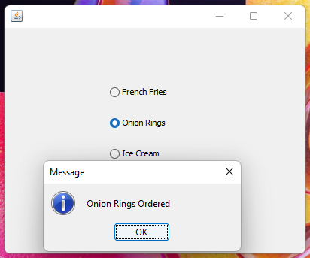

**Q4. Write a program to create a Swing GUI and handle event.**

**CODE:**

/*

* To change this license header, choose License Headers in Project Properties.

* To change this template file, choose Tools | Templates

* and open the template in the editor.

*/

package practical_5;

import java.awt.Color;

import javax.swing.JOptionPane;

/**

*

* @author Pradeep

*/

public class question_4 extends javax.swing.JFrame {

/**

* Creates new form question_4

*/

public question_4() {

initComponents();

}

/**

* This method is called from within the constructor to initialize the form.

* WARNING: Do NOT modify this code. The content of this method is always

* regenerated by the Form Editor.

*/

@SuppressWarnings("unchecked")

// <editor-fold defaultstate="collapsed" desc="Generated Code">

private void initComponents() {

jLabel1 = new javax.swing.JLabel();

jLabel2 = new javax.swing.JLabel();

jLabel3 = new javax.swing.JLabel();

jTextField1 = new javax.swing.JTextField();

jTextField2 = new javax.swing.JTextField();

jButton1 = new javax.swing.JButton();

setDefaultCloseOperation(javax.swing.WindowConstants.EXIT_ON_CLOSE);

setBackground(new java.awt.Color(102, 255, 204));

addComponentListener(new java.awt.event.ComponentAdapter() {

public void componentShown(java.awt.event.ComponentEvent evt) {

formComponentShown(evt);

}

});

jLabel1.setFont(new java.awt.Font("Tahoma", 1, 18)); // NOI18N

jLabel1.setText("LOGIN FORM");

jLabel2.setText("Username:");

jLabel3.setText("Password:");

jButton1.setText("Click here to LOGIN");

jButton1.addActionListener(new java.awt.event.ActionListener() {

public void actionPerformed(java.awt.event.ActionEvent evt) {

jButton1ActionPerformed(evt);

}

});

javax.swing.GroupLayout layout = new javax.swing.GroupLayout(getContentPane());

getContentPane().setLayout(layout);

layout.setHorizontalGroup(

layout.createParallelGroup(javax.swing.GroupLayout.Alignment.LEADING)

.addGroup(layout.createSequentialGroup()

.addGroup(layout.createParallelGroup(javax.swing.GroupLayout.Alignment.LEADING)

.addGroup(layout.createSequentialGroup()

.addGap(38, 38, 38)

.addGroup(layout.createParallelGroup(javax.swing.GroupLayout.Alignment.LEADING)

.addComponent(jLabel3)

.addComponent(jLabel2, javax.swing.GroupLayout.PREFERRED_SIZE, 78, javax.swing.GroupLayout.PREFERRED_SIZE))

.addGap(22, 22, 22)

.addGroup(layout.createParallelGroup(javax.swing.GroupLayout.Alignment.LEADING, false)

.addComponent(jLabel1)

.addComponent(jTextField1)

.addComponent(jTextField2, javax.swing.GroupLayout.DEFAULT_SIZE, 211, Short.MAX_VALUE)))

.addGroup(layout.createSequentialGroup()

.addGap(129, 129, 129)

.addComponent(jButton1)))

.addContainerGap(51, Short.MAX_VALUE))

);

layout.setVerticalGroup(

layout.createParallelGroup(javax.swing.GroupLayout.Alignment.LEADING)

.addGroup(layout.createSequentialGroup()

.addGap(37, 37, 37)

.addComponent(jLabel1)

.addGap(23, 23, 23)

.addGroup(layout.createParallelGroup(javax.swing.GroupLayout.Alignment.BASELINE)

.addComponent(jLabel2)

.addComponent(jTextField1, javax.swing.GroupLayout.PREFERRED_SIZE, javax.swing.GroupLayout.DEFAULT_SIZE, javax.swing.GroupLayout.PREFERRED_SIZE))

.addGap(18, 18, 18)

.addGroup(layout.createParallelGroup(javax.swing.GroupLayout.Alignment.BASELINE)

.addComponent(jLabel3)

.addComponent(jTextField2, javax.swing.GroupLayout.PREFERRED_SIZE, javax.swing.GroupLayout.DEFAULT_SIZE, javax.swing.GroupLayout.PREFERRED_SIZE))

.addGap(36, 36, 36)

.addComponent(jButton1)

.addContainerGap(101, Short.MAX_VALUE))

);

pack();

}// </editor-fold>

private void jButton1ActionPerformed(java.awt.event.ActionEvent evt) {

if(jTextField1.getText().length() > 0 && jTextField2.getText().length() > 0){

JOptionPane.showMessageDialog(jButton1, "LOGIN SUCCESSFULL");

}

else{

JOptionPane.showMessageDialog(jButton1, "ENTER YOUR DETAILS FIRST!");

}

}

private void formComponentShown(java.awt.event.ComponentEvent evt) {

question_4.this.getContentPane().setBackground(new java.awt.Color(204,255,255));

}

/**

* @param args the command line arguments

*/

public static void main(String args[]) {

/* Set the Nimbus look and feel */

//<editor-fold defaultstate="collapsed" desc=" Look and feel setting code (optional) ">

/* If Nimbus (introduced in Java SE 6) is not available, stay with the default look and feel.

* For details see http://download.oracle.com/javase/tutorial/uiswing/lookandfeel/plaf.html

*/

try {

for (javax.swing.UIManager.LookAndFeelInfo info : javax.swing.UIManager.getInstalledLookAndFeels()) {

if ("Windows".equals(info.getName())) {

javax.swing.UIManager.setLookAndFeel(info.getClassName());

break;

}

}

} catch (ClassNotFoundException ex) {

java.util.logging.Logger.getLogger(question_4.class.getName()).log(java.util.logging.Level.SEVERE, null, ex);

} catch (InstantiationException ex) {

java.util.logging.Logger.getLogger(question_4.class.getName()).log(java.util.logging.Level.SEVERE, null, ex);

} catch (IllegalAccessException ex) {

java.util.logging.Logger.getLogger(question_4.class.getName()).log(java.util.logging.Level.SEVERE, null, ex);

} catch (javax.swing.UnsupportedLookAndFeelException ex) {

java.util.logging.Logger.getLogger(question_4.class.getName()).log(java.util.logging.Level.SEVERE, null, ex);

}

//</editor-fold>

/* Create and display the form */

java.awt.EventQueue.invokeLater(new Runnable() {

public void run() {

new question_4().setVisible(true);

}

});

}

// Variables declaration - do not modify

private javax.swing.JButton jButton1;

private javax.swing.JLabel jLabel1;

private javax.swing.JLabel jLabel2;

private javax.swing.JLabel jLabel3;

private javax.swing.JTextField jTextField1;

private javax.swing.JTextField jTextField2;

// End of variables declaration

}

**OUTPUT:**

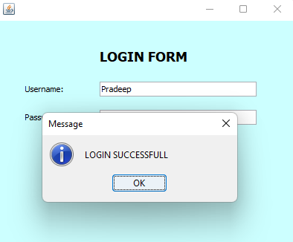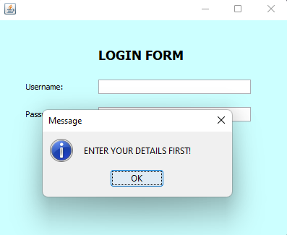

**Q5. Create the following Swing GUI Component in Java, insert an image and after registration it should go to login page which we have already created.**

**CODE:**/*

* To change this license header, choose License Headers in Project Properties.

* To change this template file, choose Tools | Templates

* and open the template in the editor.

*/

package practical_5;

import javax.swing.JOptionPane;

/**

*

* @author Pradeep

*/

public class question_5 extends javax.swing.JFrame {

/**

* Creates new form question_5

*/

public question_5() {

initComponents();

}

/**

* This method is called from within the constructor to initialize the form.

* WARNING: Do NOT modify this code. The content of this method is always

* regenerated by the Form Editor.

*/

@SuppressWarnings("unchecked")

// <editor-fold defaultstate="collapsed" desc="Generated Code">

private void initComponents() {

buttonGroup1 = new javax.swing.ButtonGroup();

jLabel1 = new javax.swing.JLabel();

jLabel2 = new javax.swing.JLabel();

jLabel3 = new javax.swing.JLabel();

jTextField1 = new javax.swing.JTextField();

jLabel4 = new javax.swing.JLabel();

jTextField2 = new javax.swing.JTextField();

jLabel5 = new javax.swing.JLabel();

jTextField3 = new javax.swing.JTextField();

jLabel6 = new javax.swing.JLabel();

jRadioButton1 = new javax.swing.JRadioButton();

jRadioButton2 = new javax.swing.JRadioButton();

jButton1 = new javax.swing.JButton();

setDefaultCloseOperation(javax.swing.WindowConstants.EXIT_ON_CLOSE);

addComponentListener(new java.awt.event.ComponentAdapter() {

public void componentShown(java.awt.event.ComponentEvent evt) {

formComponentShown(evt);

}

});

jLabel1.setIcon(new javax.swing.ImageIcon("D:\\Sem2_msc_notes\\rani_maam\\Practical_5\\resources\\gnkhalsalogo.png")); // NOI18N

jLabel1.setToolTipText("");

jLabel1.setBorder(javax.swing.BorderFactory.createLineBorder(new java.awt.Color(0, 0, 0), 2));

jLabel2.setFont(new java.awt.Font("Tahoma", 1, 18)); // NOI18N

jLabel2.setText("REGISTRATION FORM");

jLabel2.setToolTipText("");

jLabel3.setText("Enrollment Number:");

jLabel3.setCursor(new java.awt.Cursor(java.awt.Cursor.DEFAULT_CURSOR));

jLabel4.setText("Name:");

jLabel5.setText("Course:");

jLabel6.setText("Gender:");

buttonGroup1.add(jRadioButton1);

jRadioButton1.setText("Male");

buttonGroup1.add(jRadioButton2);

jRadioButton2.setText("Female");

jButton1.setText("REGISTER");

jButton1.addActionListener(new java.awt.event.ActionListener() {

public void actionPerformed(java.awt.event.ActionEvent evt) {

jButton1ActionPerformed(evt);

}

});

javax.swing.GroupLayout layout = new javax.swing.GroupLayout(getContentPane());

getContentPane().setLayout(layout);

layout.setHorizontalGroup(

layout.createParallelGroup(javax.swing.GroupLayout.Alignment.LEADING)

.addGroup(layout.createSequentialGroup()

.addGroup(layout.createParallelGroup(javax.swing.GroupLayout.Alignment.LEADING)

.addGroup(layout.createSequentialGroup()

.addGap(113, 113, 113)

.addComponent(jLabel2))

.addGroup(layout.createSequentialGroup()

.addGap(19, 19, 19)

.addGroup(layout.createParallelGroup(javax.swing.GroupLayout.Alignment.LEADING, false)

.addComponent(jLabel1)

.addGroup(layout.createSequentialGroup()

.addGroup(layout.createParallelGroup(javax.swing.GroupLayout.Alignment.LEADING)

.addComponent(jLabel3)

.addComponent(jLabel4)

.addComponent(jLabel5)

.addComponent(jLabel6))

.addGap(44, 44, 44)

.addGroup(layout.createParallelGroup(javax.swing.GroupLayout.Alignment.LEADING)

.addComponent(jTextField1)

.addComponent(jTextField2)

.addComponent(jTextField3)

.addGroup(layout.createSequentialGroup()

.addComponent(jRadioButton1)

.addPreferredGap(javax.swing.LayoutStyle.ComponentPlacement.RELATED, javax.swing.GroupLayout.DEFAULT_SIZE, Short.MAX_VALUE)

.addComponent(jRadioButton2)

.addGap(71, 71, 71))))))

.addGroup(layout.createSequentialGroup()

.addGap(110, 110, 110)

.addComponent(jButton1, javax.swing.GroupLayout.PREFERRED_SIZE, 194, javax.swing.GroupLayout.PREFERRED_SIZE)))

.addContainerGap(21, Short.MAX_VALUE))

);

layout.setVerticalGroup(

layout.createParallelGroup(javax.swing.GroupLayout.Alignment.LEADING)

.addGroup(layout.createSequentialGroup()

.addGap(21, 21, 21)

.addComponent(jLabel1)

.addPreferredGap(javax.swing.LayoutStyle.ComponentPlacement.UNRELATED)

.addComponent(jLabel2)

.addGap(18, 18, 18)

.addGroup(layout.createParallelGroup(javax.swing.GroupLayout.Alignment.BASELINE)

.addComponent(jLabel3)

.addComponent(jTextField1, javax.swing.GroupLayout.PREFERRED_SIZE, javax.swing.GroupLayout.DEFAULT_SIZE, javax.swing.GroupLayout.PREFERRED_SIZE))

.addGap(18, 18, 18)

.addGroup(layout.createParallelGroup(javax.swing.GroupLayout.Alignment.BASELINE)

.addComponent(jLabel4)

.addComponent(jTextField2, javax.swing.GroupLayout.PREFERRED_SIZE, javax.swing.GroupLayout.DEFAULT_SIZE, javax.swing.GroupLayout.PREFERRED_SIZE))

.addGap(18, 18, 18)

.addGroup(layout.createParallelGroup(javax.swing.GroupLayout.Alignment.BASELINE)

.addComponent(jLabel5)

.addComponent(jTextField3, javax.swing.GroupLayout.PREFERRED_SIZE, javax.swing.GroupLayout.DEFAULT_SIZE, javax.swing.GroupLayout.PREFERRED_SIZE))

.addGap(18, 18, 18)

.addGroup(layout.createParallelGroup(javax.swing.GroupLayout.Alignment.BASELINE)

.addComponent(jLabel6)

.addComponent(jRadioButton1)

.addComponent(jRadioButton2))

.addGap(18, 18, 18)

.addComponent(jButton1)

.addContainerGap(32, Short.MAX_VALUE))

);

pack();

}// </editor-fold>

private void jButton1ActionPerformed(java.awt.event.ActionEvent evt) {

new question_4().setVisible(true);

JOptionPane.showMessageDialog(jButton1, "Registered successfully");

question_5.this.setVisible(false);

}

private void formComponentShown(java.awt.event.ComponentEvent evt) {

question_5.this.getContentPane().setBackground(new java.awt.Color(204,255,255));

}

/**

* @param args the command line arguments

*/

public static void main(String args[]) {

/* Set the Nimbus look and feel */

//<editor-fold defaultstate="collapsed" desc=" Look and feel setting code (optional) ">

/* If Nimbus (introduced in Java SE 6) is not available, stay with the default look and feel.

* For details see http://download.oracle.com/javase/tutorial/uiswing/lookandfeel/plaf.html

*/

try {

for (javax.swing.UIManager.LookAndFeelInfo info : javax.swing.UIManager.getInstalledLookAndFeels()) {

if ("Windows".equals(info.getName())) {

javax.swing.UIManager.setLookAndFeel(info.getClassName());

break;

}

}

} catch (ClassNotFoundException ex) {

java.util.logging.Logger.getLogger(question_5.class.getName()).log(java.util.logging.Level.SEVERE, null, ex);

} catch (InstantiationException ex) {

java.util.logging.Logger.getLogger(question_5.class.getName()).log(java.util.logging.Level.SEVERE, null, ex);

} catch (IllegalAccessException ex) {

java.util.logging.Logger.getLogger(question_5.class.getName()).log(java.util.logging.Level.SEVERE, null, ex);

} catch (javax.swing.UnsupportedLookAndFeelException ex) {

java.util.logging.Logger.getLogger(question_5.class.getName()).log(java.util.logging.Level.SEVERE, null, ex);

}

//</editor-fold>

/* Create and display the form */

java.awt.EventQueue.invokeLater(new Runnable() {

public void run() {

new question_5().setVisible(true);

}

});

}

// Variables declaration - do not modify

private javax.swing.ButtonGroup buttonGroup1;

private javax.swing.JButton jButton1;

private javax.swing.JLabel jLabel1;

private javax.swing.JLabel jLabel2;

private javax.swing.JLabel jLabel3;

private javax.swing.JLabel jLabel4;

private javax.swing.JLabel jLabel5;

private javax.swing.JLabel jLabel6;

private javax.swing.JRadioButton jRadioButton1;

private javax.swing.JRadioButton jRadioButton2;

private javax.swing.JTextField jTextField1;

private javax.swing.JTextField jTextField2;

private javax.swing.JTextField jTextField3;

// End of variables declaration

}

**OUTPUT:**

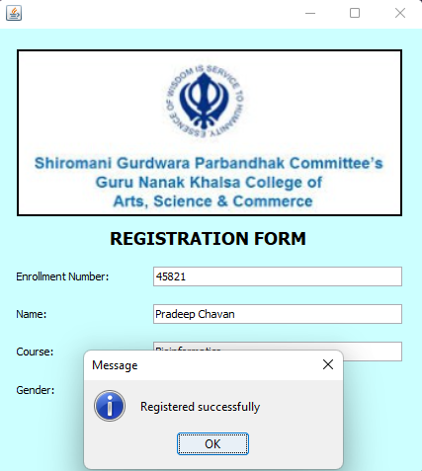

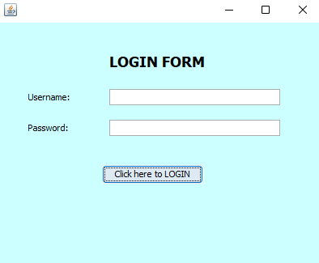

**Q6. Create a Swing GUI**

**CODE:**

/*

* To change this license header, choose License Headers in Project Properties.

* To change this template file, choose Tools | Templates

* and open the template in the editor.

*/

package practical_5;

/**

*

* @author Pradeep

*/

public class question_6 extends javax.swing.JFrame {

/**

* Creates new form question_6

*/

public question_6() {

initComponents();

}

/**

* This method is called from within the constructor to initialize the form.

* WARNING: Do NOT modify this code. The content of this method is always

* regenerated by the Form Editor.

*/

@SuppressWarnings("unchecked")

// <editor-fold defaultstate="collapsed" desc="Generated Code">

private void initComponents() {

jLabel1 = new javax.swing.JLabel();

jLabel2 = new javax.swing.JLabel();

jLabel3 = new javax.swing.JLabel();

jLabel4 = new javax.swing.JLabel();

jCheckBox1 = new javax.swing.JCheckBox();

jTextField1 = new javax.swing.JTextField();

jTextField2 = new javax.swing.JTextField();

jCheckBox2 = new javax.swing.JCheckBox();

jCheckBox3 = new javax.swing.JCheckBox();

jButton1 = new javax.swing.JButton();

jLabel5 = new javax.swing.JLabel();

setDefaultCloseOperation(javax.swing.WindowConstants.EXIT_ON_CLOSE);

setBackground(new java.awt.Color(102, 255, 204));

addComponentListener(new java.awt.event.ComponentAdapter() {

public void componentShown(java.awt.event.ComponentEvent evt) {

formComponentShown(evt);

}

});

jLabel1.setFont(new java.awt.Font("Tahoma", 1, 18)); // NOI18N

jLabel1.setText("Student Details:");

jLabel2.setFont(new java.awt.Font("Tahoma", 0, 14)); // NOI18N

jLabel2.setText("Name:");

jLabel3.setFont(new java.awt.Font("Tahoma", 0, 14)); // NOI18N

jLabel3.setText("Contact Number:");

jLabel4.setFont(new java.awt.Font("Tahoma", 0, 14)); // NOI18N

jLabel4.setText("Course Opted:");

jCheckBox1.setFont(new java.awt.Font("Tahoma", 0, 14)); // NOI18N

jCheckBox1.setText("Bioinformatics");

jCheckBox2.setFont(new java.awt.Font("Tahoma", 0, 14)); // NOI18N

jCheckBox2.setText("Botany");

jCheckBox3.setFont(new java.awt.Font("Tahoma", 0, 14)); // NOI18N

jCheckBox3.setText("Biochemistry");

jButton1.setText("Submit");

jButton1.addActionListener(new java.awt.event.ActionListener() {

public void actionPerformed(java.awt.event.ActionEvent evt) {

jButton1ActionPerformed(evt);

}

});

jLabel5.setFont(new java.awt.Font("Tahoma", 0, 14)); // NOI18N

jLabel5.setText("Success!!");

jLabel5.setToolTipText("");

javax.swing.GroupLayout layout = new javax.swing.GroupLayout(getContentPane());

getContentPane().setLayout(layout);

layout.setHorizontalGroup(

layout.createParallelGroup(javax.swing.GroupLayout.Alignment.LEADING)

.addGroup(layout.createSequentialGroup()

.addGroup(layout.createParallelGroup(javax.swing.GroupLayout.Alignment.LEADING)

.addGroup(layout.createSequentialGroup()

.addGap(128, 128, 128)

.addComponent(jLabel1))

.addGroup(layout.createSequentialGroup()

.addGap(27, 27, 27)

.addComponent(jLabel2)

.addGap(101, 101, 101)

.addComponent(jTextField1, javax.swing.GroupLayout.PREFERRED_SIZE, 195, javax.swing.GroupLayout.PREFERRED_SIZE))

.addGroup(layout.createSequentialGroup()

.addGap(27, 27, 27)

.addComponent(jLabel3)

.addGap(34, 34, 34)

.addComponent(jTextField2, javax.swing.GroupLayout.PREFERRED_SIZE, 195, javax.swing.GroupLayout.PREFERRED_SIZE))

.addGroup(layout.createSequentialGroup()

.addGap(27, 27, 27)

.addComponent(jLabel4)

.addGap(51, 51, 51)

.addComponent(jCheckBox1))

.addGroup(layout.createSequentialGroup()

.addGap(168, 168, 168)

.addComponent(jCheckBox2))

.addGroup(layout.createSequentialGroup()

.addGap(168, 168, 168)

.addComponent(jCheckBox3))

.addGroup(layout.createSequentialGroup()

.addGap(27, 27, 27)

.addComponent(jLabel5)

.addGap(134, 134, 134)

.addComponent(jButton1, javax.swing.GroupLayout.PREFERRED_SIZE, 145, javax.swing.GroupLayout.PREFERRED_SIZE)))

.addContainerGap(28, Short.MAX_VALUE))

);

layout.setVerticalGroup(

layout.createParallelGroup(javax.swing.GroupLayout.Alignment.LEADING)

.addGroup(layout.createSequentialGroup()

.addGap(11, 11, 11)

.addComponent(jLabel1)

.addGap(18, 18, 18)

.addGroup(layout.createParallelGroup(javax.swing.GroupLayout.Alignment.LEADING)

.addComponent(jLabel2)

.addComponent(jTextField1, javax.swing.GroupLayout.PREFERRED_SIZE, javax.swing.GroupLayout.DEFAULT_SIZE, javax.swing.GroupLayout.PREFERRED_SIZE))

.addGap(18, 18, 18)

.addGroup(layout.createParallelGroup(javax.swing.GroupLayout.Alignment.LEADING)

.addComponent(jLabel3)

.addComponent(jTextField2, javax.swing.GroupLayout.PREFERRED_SIZE, javax.swing.GroupLayout.DEFAULT_SIZE, javax.swing.GroupLayout.PREFERRED_SIZE))

.addGap(18, 18, 18)

.addGroup(layout.createParallelGroup(javax.swing.GroupLayout.Alignment.LEADING)

.addGroup(layout.createSequentialGroup()

.addGap(4, 4, 4)

.addComponent(jLabel4))

.addComponent(jCheckBox1))

.addGap(3, 3, 3)

.addComponent(jCheckBox2)

.addGap(3, 3, 3)

.addComponent(jCheckBox3)

.addGap(18, 18, 18)

.addGroup(layout.createParallelGroup(javax.swing.GroupLayout.Alignment.LEADING)

.addGroup(layout.createSequentialGroup()

.addGap(6, 6, 6)

.addComponent(jLabel5))

.addComponent(jButton1, javax.swing.GroupLayout.PREFERRED_SIZE, 33, javax.swing.GroupLayout.PREFERRED_SIZE))

.addContainerGap(28, Short.MAX_VALUE))

);

pack();

}// </editor-fold>

private void jButton1ActionPerformed(java.awt.event.ActionEvent evt) {

jLabel5.setVisible(true);

}

private void formComponentShown(java.awt.event.ComponentEvent evt) {

jLabel5.setVisible(false);

}

/**

* @param args the command line arguments

*/

public static void main(String args[]) {

/* Set the Nimbus look and feel */

//<editor-fold defaultstate="collapsed" desc=" Look and feel setting code (optional) ">

/* If Nimbus (introduced in Java SE 6) is not available, stay with the default look and feel.

* For details see http://download.oracle.com/javase/tutorial/uiswing/lookandfeel/plaf.html

*/

try {

for (javax.swing.UIManager.LookAndFeelInfo info : javax.swing.UIManager.getInstalledLookAndFeels()) {

if ("Windows".equals(info.getName())) {

javax.swing.UIManager.setLookAndFeel(info.getClassName());

break;

}

}

} catch (ClassNotFoundException ex) {

java.util.logging.Logger.getLogger(question_6.class.getName()).log(java.util.logging.Level.SEVERE, null, ex);

} catch (InstantiationException ex) {

java.util.logging.Logger.getLogger(question_6.class.getName()).log(java.util.logging.Level.SEVERE, null, ex);

} catch (IllegalAccessException ex) {

java.util.logging.Logger.getLogger(question_6.class.getName()).log(java.util.logging.Level.SEVERE, null, ex);

} catch (javax.swing.UnsupportedLookAndFeelException ex) {

java.util.logging.Logger.getLogger(question_6.class.getName()).log(java.util.logging.Level.SEVERE, null, ex);

}

//</editor-fold>

/* Create and display the form */

java.awt.EventQueue.invokeLater(new Runnable() {

public void run() {

new question_6().setVisible(true);

}

});

}

// Variables declaration - do not modify

private javax.swing.JButton jButton1;

private javax.swing.JCheckBox jCheckBox1;

private javax.swing.JCheckBox jCheckBox2;

private javax.swing.JCheckBox jCheckBox3;

private javax.swing.JLabel jLabel1;

private javax.swing.JLabel jLabel2;

private javax.swing.JLabel jLabel3;

private javax.swing.JLabel jLabel4;

private javax.swing.JLabel jLabel5;

private javax.swing.JTextField jTextField1;

private javax.swing.JTextField jTextField2;

// End of variables declaration

}

**OUTPUT:**

