**NAME: - SHALMON NATHANEL ANANDAS**

**CLASS: - M.Sc. PART - II**

**COURSE: - BIOINFORMATICS**

**ACADEMIC YEAR: - 2022-2023**

**ROLL NO.: - 92**

**PAPER CODE: - GNKPSBǀP304**

**COURSE TITLE: - INTRODUCTION TO PERL AND MONGODB**

**GURU NANAK KHALSA COLLEGE**

**MATUNGA, MUMBAI-400 019.**

**DEPARTMENT OF BIOINFORMATICS**

**CERTIFICATE**

This is to certify that **Ms. Shalmon Nathanel Anandas (Roll.No.91)** of M.Sc. Part ⅠI Bioinformatics has satisfactorily completed the practical Semester ⅠII course prescribed by the University of Mumbai during the academic year 2022-2023.

**TEACHER INCHARGE HEAD OF DEPARTMENT**

**INDEX:**

|  |  |  |  |  |
| --- | --- | --- | --- | --- |
| **SR.NO.** | **EXPERIMENTS** | **PAGE**  **NO.** | **DATE** | **SIGN** |
| 1. | Simple programs on Variable types used in Perl | 1 | 09/07/22 |  |
| 2. | Conditional statements and Loops | 4 | 09/07/22 |  |
| 3. | Operators used on scalar, array and hash variables | 11 | 20/07/22 |  |
| 4. | Subroutine | 20 | 01/08/22 |  |
| 5. | References and Dereferences, and Scope of variables | 22 | 01/08/22 |  |
| 6. | Regular Expressions | 25 | 03/08/22 |  |
| 7. | Metacharacters, Quantifiers and Substrings | 28 | 18/08/22 |  |
| 8. | Perl Formatting | 36 | 12/09/22 |  |
| 9. | OOPs in Perl | 47 | 09/10/22 |  |
| 10. | DBI in Perl | 54 | 08/10/22 |  |
| 11. | File handling and directory | 65 | 10/10/22 |  |
| 12. | MongoDB basic commands | 73 | 19/11/22 |  |

**Practical 1**

**Simple Programs on Variable types using Perl**

**Date:09/07/22**

**Aim**: To understand and write simple Perl programs on variable and data types

**Theory**:

* Created by Larry Wall in 1987, Perl is a general-purpose programming language originally developed for text manipulation and now used for a wide range of tasks including system administration, web development, network programming, GUI development and more.
* Pros:
  + Good for Quick and complex scripts
  + Parsing & restructuring data
  + High level programming, Networking, Graphical, Database
* Cons:
  + Hardware Drivers
  + Many modules are incomplete
* Basics:
  + Statement must end in ;
  + Comment is #
  + Multiline comment:
    - =begin
    - =cut
  + Naming Scheme is .pl
  + The Perl interpreter ignores whitespaces
  + Single quote [‘’] the statement in printed as is
  + Double quote [“”] the statement operators are executed
* Data types / Variable types
  + Perl has 3 Basic Data types
  + Scalar: Scalars are simple variables. They are preceded by a dollar sign ($). A scalar is either a number, a string, or a reference. A reference is actually an address of a variable.
  + Array: Arrays are ordered lists of scalars that you access with a numeric index, which starts with 0. They are preceded by an "at" sign (@).
  + Hash: Hashes are unordered sets of key/value pairs that you access using the keys as subscripts. They are preceded by a percent sign (%).

Q1. Write a Perl Script to store DNA sequence in Scalar variable entered by user and display an output

CODE:

print("Enter your DNA seq: ");

$seq = <stdin>;

print("This is the DNA seq you entered: $seq");

OUTPUT:



Q2. Write a Perl script to ask user to enter RNA sequence using an array without loops

CODE:

@sequence;

print("Enter the first RNA sequence: ");

$sequence[0] = <stdin>;

print("Enter the Second RNA sequence: ");

$sequence[1] = <stdin>;

print("Enter the Third RNA sequence: ");

$sequence[2] = <stdin>;

print("Enter the fourth RNA sequence: ");

$sequence[3] = <stdin>;

print("Enter the fifth RNA sequence: ");

$sequence[4] = <stdin>;

print("The sequences you entered are: \n");

print("Sequence 1: $sequence[0]");

print("Sequence 2: $sequence[1]");

print("Sequence 3: $sequence[2]");

print("Sequence 4: $sequence[3]");

print("Sequence 5: $sequence[4]");

OUTPUT:

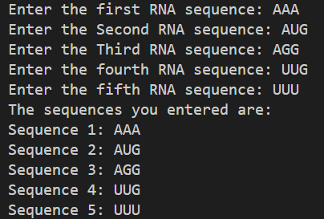

Q3. Write a perl script to store codon using hash varibles

CODE:

%codons = (1 => AUG, 2 => AAA, 3 => UUU, 4 => AGG);

print("codon 1 is $codons{1}\n");

print("codon 2 is $codons{2}\n");

print("codon 3 is $codons{3}\n");

print("codon 4 is $codons{4}\n");

OUTPUT:

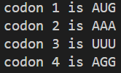

**Practical 2**

**Conditional Statements and loop**

**Date:09/07/22**

**Aim**: To understand and write code using conditional statements and loops

**Theory**:

* Perl conditional statements helps in the decision making, which require that the programmer specifies one or more conditions to be evaluated or tested by the program
* Along with a statement or statements to be executed if the condition is determined to be true, and optionally, other statements to be executed if the condition is determined to be false.
* Syntax

if(boolean_expression) {

# statement(s) will execute if the given condition is true

}

* A perl statement can be followed by an optional else statement, which execute when the Boolean expression is false
* Syntax

if(boolean_expression) {

# statement(s) will execute if the given condition is true

} else {

# statement(s) will execute if the given condition is false

}

* An if statement can be followed by an optional elsif…else statement, which is very useful to test the various conditions using single if…elsif statement

if(boolean_expression 1) {

# Executes when the boolean expression 1 is true

} elsif( boolean_expression 2) {

# Executes when the boolean expression 2 is true

} elsif( boolean_expression 3) {

# Executes when the boolean expression 3 is true

} else {

# Executes when the none of the above condition is true

}

* A Perl unless statement consists of a Boolean expression followed by one or more statements

unless(boolean_expression) {

# statement(s) will execute if the given condition is false

}

* The unless statement can then again be followed by an else statement

unless(boolean_expression) {

# statement(s) will execute if the given condition is false

} else {

# statement(s) will execute if the given condition is true

}

* This unless statement can then also be followed by an elsif statement

unless(boolean_expression 1) {

# Executes when the boolean expression 1 is false

} elsif( boolean_expression 2) {

# Executes when the boolean expression 2 is true

} elsif( boolean_expression 3) {

# Executes when the boolean expression 3 is true

} else {

# Executes when the none of the above condition is met

}

* A switch statement allows a variable to be tested for equality against a list of values. Each value is called a case and the variable being switched on is checked fo each switch case

use Switch;

switch(argument) {

case 1 { print "number 1" }

case "a" { print "string a" }

case [1..10,42] { print "number in list" }

case (\@array) { print "number in list" }

case /\w+/ { print "pattern" }

case qr/\w+/ { print "pattern" }

case (\%hash) { print "entry in hash" }

case (\&sub) { print "arg to subroutine" }

else { print "previous case not true" }

}

* A loop statement allows us to execute a statement or group of statements multiple times
* While loop statement in perl programming language repeatedly executes a target statement as long as a given condition is true

while(condition) {

statement(s);

}

* An until loop statement in perl programming language repeatedly executes a target statement as long as a given condition is false

until(condition) {

statement(s);

}

* A for loop is a repetition control structure that allows you to efficiently write a loop that needs to execute a specific number of times

for ( init; condition; increment ) {

statement(s);

}

* The foreach loop iterates over a list value and sets the control variable to be each element of the list in turn

foreach var (list) {

...

}

* A do…while loop is similar to the while loop except that a do while loop is guaranteed to execute at least one time

do {

statement(s);

}while( condition );

* A loop can be nested inside of another loop, this is known as a nested for loop

for ( init; condition; increment ) {

for ( init; condition; increment ) {

statement(s);

}

statement(s);

}

Q1. Write a perl script to ask user to enter a number and check whether entering number is even or odd

CODE:

print("Enter a number: ");

$num = <stdin>;

if($num % 2 == 0){

print("Number is Even\n");

}else{

print("Number is Odd\n");

}

OUTPUT:

 

Q2. Write a perl script to ask user to enter number to display Fibonacci series

CODE:

print("How many digits of fibonacci are to be printed: ");

$limit = <stdin>;

$cur_num = 1;

$prev_num = 0;

print("$prev_num, $cur_num");

for($i=1; $i<=($limit-2); $i++){

$ans = $cur_num + $prev_num;

$prev_num = $cur_num;

$cur_num= $ans;

print("$ans ");

}

OUTPUT:



Q3. Write a Perl script to ask user to entera number and check where entered number is negative or positive

CODE:

print("Enter a number: ");

$number = <stdin>;

if($number % 2 == 0){

print("Number is even\n");

}else{

print("Number is odd\n");

}

OUTPUT:

 

Q4. Write a Perl script to ask user to enter RNA sequence using an array with for and foreach loops

CODE:

@rna_seq;

for($i=0;$i<5;$i++){

print("Enter sequence #$i: ");

$rna_seq[$i] = <stdin>;

}

foreach $seq(@rna_seq){

print("Sequence: $seq");

}

OUTPUT:

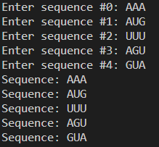

Q5. Write a Perl script to ask user to enter DNA sequence using a hash and display keys and values separately

CODE:

%dna_seq;

for($i=0;$i<5;$i++){

$num = $i+1;

print("Enter sequence $num: ");

$dna_seq{$i} = <stdin>;

}

for($i=0; $i<5;$i++){

$num = $i+1;

print("Sequence{$num} = $dna_seq{$i}");

}

OUTPUT:

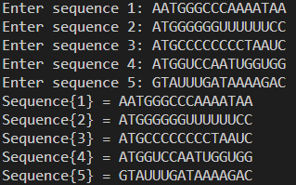

Q6. Write a Perl script to ask user to enter number and find factorial of an entered number

CODE:

print("Enter a number: ");

$number = <stdin>;

$ans = 1;

for($i=$number;$i>=1;$i--){

$ans = $i*$ans;

}

print("Factorial of $number is $ans\n");

OUTPUT:



Q7. Write a Perl script to store DNA sequence and check entered sequence is DNA or not

CODE:

print "Enter a sequence: ";

$dna = <stdin>;

if($dna eq "a\n"){

print "The given sequence is DNA";

}elsif($dna eq "t\n"){

print "The given sequence is DNA";

}elsif($dna eq "g\n"){

print "The given sequence is DNA";

}elsif($dna eq "c\n"){

print "The given sequence is DNA";

}else{

print "The given sequence is not DNA";

}

OUTPUT:





Q8. Perl script to display the following pattern

A AAAA

A AAA

A AA

A A

A

CODE:

$num = 5;

for($i=0;$i<6;$i++){

for($j=$num;$j>0;$j--){

print("A");}

print("\n");

$num--;

}

OUTPUT:

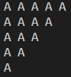

**Practical 3**

**Operators used on scalar, array and hash variables**

**Date:20/07/22**

**Aim**: To understand and write perl programs for operators used on scalar, array and hash variables

**Theory**:

* An operator can be explain by using the expression 4+5 =9 where 4 and 5 are operands and + is the operator
* Perl support many operator types,
  + Arithmetic Operator
  + Logical Operators
  + Equality Operators
  + Miscellaneous Operators
* Arithmetic operators are:
  + + Addition (Adds elements)
  + – Subtraction (Subtracts elements)
  + * Multiplication (Multiplies elements)
  + / Division (Divides elements and returns quotient)
  + % Modulus (Divides elements and returns remainder)
  + ** Exponent (Gives exponents of a number up to the number specified)
* Equality operators are:
  + == Equal to (Checks if left and right values are equal to each other)
  + ⬄ Comparison (Checks if value are equal or not and returns -1, 0, 1 depending on whether the left value is less than, equal to, grater than the right value
  + > Greater than (Checks if left value is greater than the right value)
  + < Less than (Checks if left value is less than the right value)
  + >= Greater than or equal to (Checks if left value is greater than or equal to the right value)
  + <= Less than or equal to (Checks if left value is less than or equal to the right value)
  + The following operators are used for strings
  + lt : Less than
  + gt : Greater than
  + le : Lass than or equal to
  + ge : Greater than or equal to
  + eq : Equal to
  + ne : Not equal to
  + cmp : Compares and returns values -1, 0, 1 depending on which values Is greater or lesser
* Logical operators are:
  + && (and) : IF both operands are true then the condition becomes true
  + || (or) : If one or the other operand is true then the condition becomes true
  + Not : Used to reverse the condition
* Miscellanous operators are:
  + . dot operator (combines 2 strings)
  + x repeat operator (String on the left is repeated the amount of times specified on the right
  + ++ increment operator (Increases the values of the int by 1)
  + – decrement operator (Decreases the values of the int by 1)
  + -> Arrow operator (Used in dereferencing a method or variable from an object or a class name

Q1. Write a Perl script accept two number and a string and perform the following operations

1. Perl Arithmetic Operators
2. Miscellaneous Operators

CODE:

print("Enter 1st Number: ");

$num1 = <stdin>;

print("Enter 2nd Number: ");

$num2 = <stdin>;

print("Enter 1st String: ");

$string1 = <stdin>;

print("Enter 2nd String: ");

$string2 = <stdin>;

print(“\nExecuting arithmetic operators...\n");

print("Addition: ");

print($num1+$num2);

print("\n");

print("Subtraction: ");

print($num1-$num2);

print("\n");

print("Division: ");

print($num/$num2);

print("\n");

print("Multiplication: ");

print($num*$num2);

print("\n");

print("Modulo ");

print($num%$num2);

print("\n");

print("Exponent ");

print($num**$num2);

print("\n");

print("\nExecutingmiscellenous...\n");

print("Concatenate: ");

print("$string1.$string2");

print("\n");

print("Repetition ");

print("$string1"x3);

print("\n");

print("Range ");

print($num1..$num2);

print("\n");

print("Autoincrement(num1): ");

print($num1++);

print("\n");

print("Autodecrement(num1) ");

print($num1--);

print("\n");

OUTPUT:

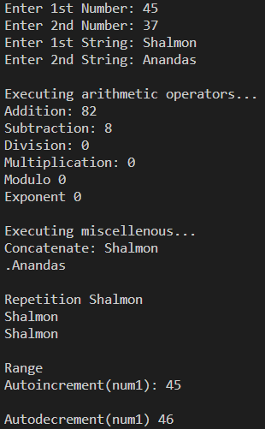

Q2. Write a perl script to accept three number and display smallest number

CODE:

print("Enter #1: ");

$a = <stdin>;

print("Enter #2: ");

$b = <stdin>;

print("Enter #3: ");

$c = <stdin>;

if($a < $b && $a < $c){

print("Biggest number is $a");

}elsif($b < $a && $b < $c){

print("Smallest number is $b");

}elsif($c < $a && $c < $b){

print("Smallest number is $c");

}

OUTPUT:

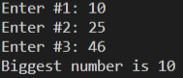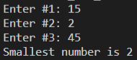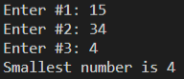

Q3. Write a perl script to enter two string and check wheter its equal or not

CODE:

print("Enter 1st String: ");

$string1 = <stdin>;

print("Enter 2nd String: ");

$string2 = <stdin>;

if($string1 eq $string2){

print("\nStrings are equal\n");

}else{

print("\nStrings are not equal\n");

}

OUTPUT:

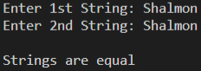 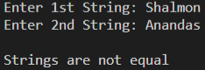

Q4. Write a Perl script to store elements in an array and perform the following

1. Find length of the array
2. Add one element at end of an array
3. Remove one element at beginning of an array
4. Add one element at beginning of an array
5. Remove on element at end of an array

CODE:

@array = (45,6,3,42,35,22,67,54,23);

print("Array is @array\n");

print("\nLength of the array is $#array\n");

print("\nAdding 25 to the end of the array...\n");

push(@array, 25);

print("Array after adding 25 is @array\n");

print("\nRemoving an element from beginning of the array...\n");

shift(@array);

print("Array after removing element from beginning is @array\n");

print("\nAdding 25 to the beginning of the array...\n");

unshift(@array, 25);

print("Array after adding element to beginning is @array\n");

print("\nRemoving an element from end of the array...\n");

pop(@array);

print("Array after removing element from end of array is @array\n");

OUTPUT:

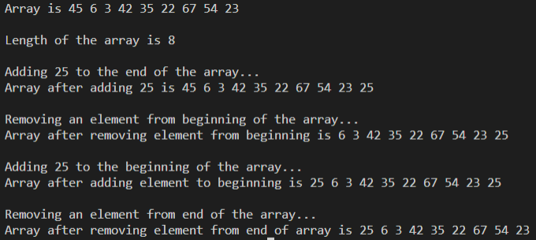

Q5. Write a perl script create elements in an array like ATGCA, ATTG, AATGC, AAAT and perform the following:

1. Find length of an array
2. Add one element i.e., ATGC at bottom of an array
3. Remove one element at beginning of an array
4. Add one element i.e., ATGCC at top of an array
5. Remove one element at end of an array

CODE:

@element=("ATGCA","ATTG","AATGC","AAAT");

@elem = qw/ATGCA ATTG AATGC AAAT/;

print "The length of the array is $#element\n";

push(@element,"ATGC"); #add elem at the end

print"\nThe array after adding is

@element\n";

shift(@element); #remove elem from start

print"\nArray after removing one element from start

@element\n";

unshift(@element, "ATGCC"); #add elem from start

print"\nArray after adding one element from start

@element\n";

pop(@element); #remove one elem from end

print"\nArray after removing one from start:

@element\n";

OUTPUT:

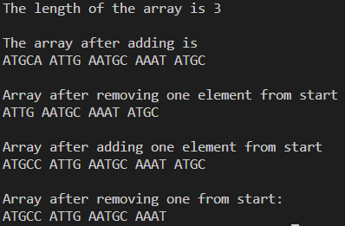

Q6. Write a perl script to create an array and perform following operations such as merge, reverse and sorting

CODE:

@array1= (1,2,3,4,5,7);

@array2= (8,9,11,10,13,12);

@array3= (@array1, @array2);

@chr= qw/a b d s e f g y z/;

print"@array3\n";

@sorted=sort {$a <=> $b} @array3;

print("@sorted\n");

@rev = reverse(@sorted);

print("@rev\n");

OUTPUT:



Q7. Display array in descending order:

CODE:

@array1= (1,2,3,4,5,7,8,9,10,11,12);

Print(“@array1\n”);

@sorted=sort {$b <=> $a} @array1;

print("@sorted\n");

OUTPUT:



Q8.Write a perl script to store string of an array and display index number 3,4,5 at once

CODE:

@strings = ("ATGU", "ATTG", "ATCG", "TGAC", "TCGA", "TACG", "GCTA");

print(@strings[3..5]);

OUTPUT:



Q9. Write a perl script to demonstrate splice operator

CODE:

@arr = (0..9);

print("Complete array @arr\n");

@replacement = splice(@arr, 3, 4, a..d);

print("Added Elements @arr\n");

OUTPUT:



Q10. Write a perl script to sort hashes using keys

CODE:

%data = ('b' => 2, 'a' => 1, 'e' => 5, 'd' => 4, 'c' => 3);

@data_sorted = sort(%data);

print(@data_sorted);

OUTPUT:



Q11. Write a Perl program to determine the frequency of nucleotide bases in given nucleotide sequence using nested if else

CODE:

$seq = <stdin>;

$a = 0;

$t = 0;

$g = 0;

$c = 0;

for($i=0; $i<length($seq); $i++){

$n = substr($seq, $i, 1);

if($n eq "a"){

$a++;

}elsif($n eq "t"){

$t++;

}elsif($n eq "g"){

$g++;

}elsif($n eq "c"){

$c++;

}

}

print("a was found $a times\n");

print("t was found $t times\n");

print("g was found $g times\n");

print("c was found $c times\n");

OUTPUT:

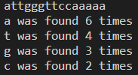

**Practical 4**

**Subroutines**

**Date: 01/08/22**

**Aim**: To understand and write program for perl subroutine

**Theory**:

* Perl subroutines are functions in which a group of statements that together perform a task
* Code can be divided among various subroutines and each subroutine can perform a specific task which increases the modularity of the code
* The terms subroutine, method and function are used interchangeably in perl
* Subroutine is defined as

sub subroutine_name {

body of the subroutine

}

* This subroutine is then called by doing

subroutine_name( list of arguments );

* Arguments can be passed to a subroutine by using the special array @_;
* Arrays hashes can be passed as normal scalar arguments

Q1. Write a perl program to create a subroutine named calculate and find area and perimeter of rectangle

CODE:

sub Calculate{

print("Give length of the rectangle: ");

$len = <stdin>;

print("Give breadth of the rectangle: ");

$bre = <stdin>;

$area = $len * $bre;

$peri = 2*($len + $bre);

print("Area of the rectangle is $area\n");

print("Perimeter of the rectangle is $peri\n");

}

Calculate();

OUTPUT:

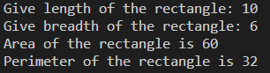

Q2. Write a perl program to create a subroutine named calculate and find area and perimeter of a rectangle with parameters

CODE:

sub Calculate{

my($l, $b) = @_;

$area = $l*$b;

$peri = 2*$l + 2*$b;

print("Area of the Rectangle is $area\n");

print("Perimeter of the Rectangle is $peri\n");

}

print("Enter length of the Rectangle: ");

$l = <stdin>;

print("Enter breadth of the Rectangle: ");

$b = <stdin>;

Calculate($l,$b);

OUTPUT:

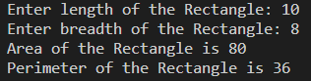

**Practical 5**

**References and Dereferences, and scope of variables**

**Date:01/08/22**

**Aim**: To understand and write perl program for references and dereferences and scope of variables

**Theory**:

* References is a scalar datatype that holds the location of another value which could be scalar, array or hash.
* Because of its scalar nature, areference can be used anywhere a scalar can be used
* References are created by

$scalarref = \$foo;

$arrayref = \@ARGV;

$hashref = \%ENV;

$coderef = \&handler;

$globref = \*foo;

* Dereferencing returns the value from a reference point to the location.
* Deferencing is done by simple using $, @ or % prefix of the reference variable depending on whether the reference is pointing to which datatype
* References to functions are done by using the \& signal handler

$cref = \&PrintHash;

&$cref(%hash);

* By defaultperl using global variables which means the variables can be accessed from anywhere in the program. But you can create a private variable by using the my keyword

sub somefunc {

my $variable; # $variable is invisible outside somefunc()

my ($another, @an_array, %a_hash); # declaring many variables at once

}

* State variables are variables whose values can be changed once they are initialized

state $count = 0;

Q1. Write a perl script to accept a number and create reference of scalar variable and display a value using dereferencing

CODE:

print("Enter a number: ");

$num = <stdin>;

$ref_num = \$num;

print("Number entered and stored in Reference is ",${$ref_num},"\n");

OUTPUT:



Q2. Write a perl script to store an array and use reference and dereference

CODE:

@arr = qw/Biology Zoology Mathematics Physics Chemistry/;

$ref_arr = \@arr;

print("Array entered and stored in Refenrence is ", @{$ref_arr},"\n");

OUTPUT:



Q3. Write a perl script to store a hash and use reference and derefencing

CODE:

%subjects = (1=>"Biology", 2=>"Zoology", 3=>"Mathematics", 4=>"Physics", 5=>"Chemistry");

$ref_hash = \%subjects;

print("Hash entered and stored in Refenrence is ",%{$ref_hash},"\n");

OUTPUT:



Q4. Write a perl script to create a subroutine and use reference and dereferencing

CODE:

sub default{

print("This is a subroutine\n");

}

$sub_ref = \&default;

print("The reference will be called now\n\n");

&{$sub_ref;}

OUTPUT:



Q5. Write a perl script to store number in global variable and demonstrate the scope of it

CODE:

sub g_pr{

$global_num = 70;

print("Printing global variable inside the subroutine it was declared in: $global_num\n");

}

g_pr();

print("Printing global variable outside the subroutine it was declared in: $global_num\n");

OUTPUT:



Q6. Write a perl script to store a number in private variable and demonstrate the scope of it

CODE:

sub pr_var{

my $private_var = 70;

print("Printing Private variable inside the subroutine it was declared in: $private_var\n");

}

pr_var();

print("Priting private variable outside the subroutine it was declared in: $private_var\n");

OUTPUT:



Q7. Write a perl script to store a number in state variable and display an OUTPUT

CODE:

use feature 'state';

state $static_number = 70;

print("Printing Static variable $static_number\n");

print("Trying to change value of static variable from 70 to 100\n");

$static_number = "shalmon";

print("Printing Static variable after changing $static_number\n");

OUTPUT:

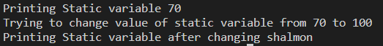

**Practical 6**

**Regular Expression**

**Date:03/08/22**

**Aim:** To understand concepts revolving around regular expressions and solve problems related to it.

**Theory:**

* A regular expression is a string of characters that defines the pattern or patterns you are viewing.
* Perl syntax for regex is similar to that of other programs that support regex
* Regular expression is applied by using a binding operator “=~” and “!~”.
* There are a total of 3 operators withing regex in perl
  + Match operator : m/PATTERN/MODIFIERS
    - Match operator has modifiers that can be stated at the end of the regex. These modifiers are:
      * i – matches case insensitive
      * m – specifies that if the string has newline or carriage return characters
      * o – Evaluates the expression only one
      * s – allows used of . to match newline character
      * x – Allows use of whitespace in the expression
      * g – globally finds all matches
      * cg – continues search even after global match fails
  + Substitute operator: s/PATTERN/REPLACEMENT/MODIFIERS
    - Substitute operator has almost the same modifiers as the math operator. Those are:
      * i – matches case insensitive
      * m – specifies that if the string has newline or carriage return characters
      * o – Evaluates the expression only one
      * s – allows used of . to match newline character
      * x – Allows use of whitespace in the expression
      * g – globally finds all matches
      * e – Evaluates the replacement as if it were a perl statement and uses it sreturn value as the replacement text
  + Transliterate operator: tr/SEARCHLIST/REPLACEMENT/MODIFIERS
    - Transliterate has the least amount of modifiers
      * c – complements SEARCHLIST
      * d – deletes found but unreplaced characters
      * s – squashes duplicate replaced character

Q1. Write a perl script to accept a DNA sequence and match against pattern “aatg” is found on entered sequence and check whether the match case case insensitive

CODE:

print("Enter DNA sequence: ")

seq = <stdin>;

if($seq =~ m/aatg/i){

print("aatg exists in the entered sequence.\n");

}else{

print("aatg does not exist in the entered sequence");}

OUTPUT:



Q2. Write a perl script to accept DNA sequence from user and search pattern “att” and replace with “agt”

CODE:

print("Enter DNA sequence: ");

$seq = <stdin>;

if($seq =~ m/att/){

$seq =~ s/att/agt/;

print("Sequence has been replaced...\n");

print("New sequence is $seq\n");

}else{

print("att does not exist in sequence");

}

OUTPUT:

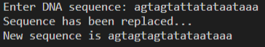

Q3. Write a perl script to accept RNA sequence form user and search pattern “auu” and replace with “agcu” in whose sequence

CODE:

print("Enter RNA sequence: ");

$seq = <stdin>;

if($seq =~ m/auu/){

print("Replacing in sequence.....\n");

$seq =~ s/auu/agcu/g;

print("The new sequence is $seq\n");

}else{

print("The patter 'auu' does not exist in the sequence");

}

OUTPUT:



Q4. Write a perl script to accept RNA sequence and convert that into DNA sequence

CODE:

print("Enter an RNA sequence: ");

$seq = <stdin>;

if($seq =~ m/u/){

print("The entered RNA sequence will now be converted into DNA sequence...\n");

$seq =~ s/u/t/g;

print("The converted sequence is : $seq");

}else{

print("Enter an RNA sequence!!");

}

OUTPUT:

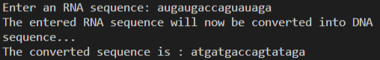

Q5. Write a perl script to accept a string and remove duplicate characters from entered string

CODE:

print("Enter a string: ");

$string = <stdin>;

$string =~ tr/a-z/a-z/s;

print("Entered string without duplicate letters is: $string\n");

OUTPUT:



**Practical 7**

**Metacharacters, Quantifiers and Substring**

**Date:18/08/22**

**Aim:**

To understand concepts revolving around metacharacters, quantifiers and substring egular expressions and solve problems related to it.

**Theory:**

For all their power and expressivity, patters in perl recognize the same 12 traditional metacharacters found in many other regular expression packages: \ | ( ) [ { & $ * + ? .

Some simple metacharacters stand by themselves, like . and ^ and $ they don’t directly affect anything around them. Some metacharacters work like prefix operators, governing what follows them, like \. Other work like postfix operators, governing what immediately precedes them, like *, +, and ?. One metacharacter, |, acts like an infix operator, standing between the operands it governs. There are even bracketing metacharacters that work like circumfix operators, governing something contained inside them, like (…) and […]. Parentheses are particularly important, because they specify the bounds of | on the inside, and of *, +, and ? on the outside.

If you learn only one of the twelve metacharacters, choose the backslash. That’s because backslash disables the other. When a backslash precedes a nonalphanumeric characters in a perl pattern, it always makes the next character a literal. If you need to match one of the twelve metacharacters in a pattern literally, you wirite them wit a backslash in front. Thus, \, matches a real dot, \$ a real dollar sign, \\ a real backslash, and so on. This known as “escaping” the metacharacter, or “quoting it” or sometimes just “backslashing” it.

**Metacharacters:**

|  |  |
| --- | --- |
| Symbol | Meaning |
| \... | De-meta next nonalphanumeric character, meta next alphanumeric character (maybe) |
| ....|… | Alternation (match one or the other) |
| (…) | Grouping (treat as a unit) |
| […] | Character class (Match one character from a set) |
| ^ | Truw at beginning of string(or after newline, maybe) |
| . | Match one character (Except newline, normally) |
| $ | True at end of string (or before any newline, maybe) |

**Quantifiers:**

|  |  |
| --- | --- |
| Symbol | Meaning |
| * | Match 0 or more time (maximal) |
| + | Match 1or more times (maximal) |
| ? | Match 1 or 0 times (maximal) |
| {COUNT} | Match exactly COUNT times |
| {MIN,} | Match at least MIN times {maximal} |
| {MIN,MAX} | Match at least MIN but not more than MAX times (maximal) |
| *? | Match 0 or more times (minimal) |
| +? | Match 1 or more times (minimal) |
| ?? | Match 0 or 1 time (minimal) |
| {MIN,} | Match at least MIN times (minimal) |
| {MIN, MAX} | Match atleast MIN but not more |

Q1. Write a perl program to check that a string contains only a certain set of characters (in this case a-z, A-Z, 0-9)

Code:

print("Enter a string: ");

$string = <stdin>;

if($string =~ m/\w/){

print("its a match\n");

}else{

print("Its not a match\n");

}

Output:





Q2. Write a perl program that matches a string that has an a followed by zero or more t’s

Code:

print("Enter a sequence: ");

$seq = <stdin>;

if($seq =~ m/at*/){

print("There is an a followed by 0 or more t's\n");

}else{

print("There is not an a followed by 0 or more t's\n");

}

Output:





Q3. Write a perl program that matches a string that has an a followed by one or more b’s

Code:

print("Enter a sequence: ");

$string = <stdin>;

if($string =~ m/ab+/){

print("TRUE\n");

}else{

print("FALSE\n");

}

Output:





Q4. Write a perl program that matches a string that has an ‘a’ followed by anything, ending in ‘b’

Code:

print("Enter a string: ");

$string = <stdin>;

if($string =~ m/a/ && $string =~ m/b$/){

print("TRUE\n");

}else{

print("FALSE\n");

}

Output:





Q5. Write a perl program that matches a word at the beginning of a string

Code:

print("Enter a string that starts with 'Quintessential': ");

$string = <stdin>;

if($string =~ m/^Quintessential/){

print("You followed the order\n");

}else{

print("You did not follow the order\n");

}

Output:





Q6. Write a perl program to check for a number at the end of a string

Code:

print("Enter a string with a number at the end: ");

$string = <stdin>;

if($string =~ m/\d$/){

print("You followed the order\n");

}else{

print("You did not follow the order\n");

}

Output:





Q7. Write a Perl program to demonstrate substr() function

Code:

$string = "This is Department of bioinformatics";

$sub_string =substr($string, 5, 10);

print("$string\n");

print("$sub_string\n");

Output:



Q8. Write a perl program to count number of nucleotides in a sequence using regex

Code:

print("Enter a string: ");

$string = <stdin>;

print("Length of the string is: ");

print($string =~ s/\w/\w/g);

print("\n");

Output:



Q9. Write a perl program accept a string fro user and convert into upper case, lower case, and display length

Code:

print("Enter a string: ");

$string = <stdin>;

print("Lowercase: ");

$string =~ tr/a-zA-Z/a-z/;

print($string);

print("Uppercase: ");

$string =~ tr/a-zA-Z/A-Z/;

print($string);

print("Length: ");

print($string =~ s/\w/\w/g);

print("\n");

Output:

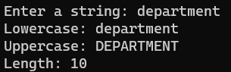

Q10. Write a perl program accept an RNA sequence and display the index number of an entered character

Code:

print("Enter an RNA sequence: ");

$string = <stdin>;

print("Which nucleaotide do you want: ");

$char = <stdin>;

$in_string = index($string, $char);

print($in_string);

Output:

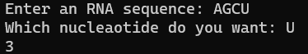

Q11. Write a perl program to match pattern t or u from an entered sequence

Code:  
$seq = <stdin>;

if($seq =~ m/t/ || $seq =~ m/u/){

print("True");

}else{

print("False");

}

Output:







Q12. Write a perl script to split on character “#”

Code:

print("Enter a sentence with '#': ");

$string = <stdin>;

@split_string = split("#", $string);

foreach $n(@split_string){

print("$n\n");

}

Output:

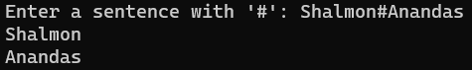

Q13. Write a perl script to split on pattern i.e. whitespaces

Code:

print("Enter a sentence: ");

$string = <stdin>;

@split_string = split(" ", $string);

foreach $n(@split_string){

print("$n\n");

}

Output:

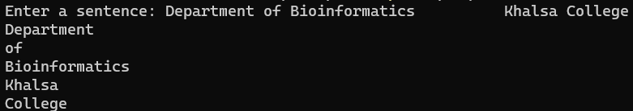

Q14. Write a perl script to split on digit and join using single comma

Code:

print("Enter a sentence: ");

$string = <stdin>;

@string_split = split(/\d/, $string);

print(@string_split);

$string_join = join(",", @string_split);

print($string_join);

Output:

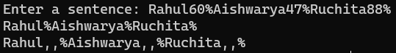

Q15. Write a perl script to demonstrate on splitting on string

Code:

print("Enter a sentence: ");

$string = <stdin>;

@split_string = split(" ", $string);

foreach $n(@split_string){

print("$n\n");

}

Output:

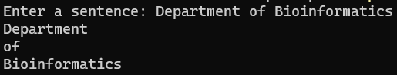

**Practical 8**

**Perl Formatting**

**Date:12/09/22**

AIM:

Perl uses a writing template called a ‘format’ to output reports. To use the format feature of Perl, you have to define a format first and then you can use the format to write formatted data

format FormatName =

fieldline

value_one, value_two, value_three

fieldline

value_one, value_two

.

Here FormatName represent the name of the format.The fieldline is the specific way, the data should be formatted. The values lines represent the values that will be entered into the field line. You end the format with a single period.

Next field can contain any text or fieldholder. The fieldholders hold space for data that will be placed there at a later date. A fieldholder has the format

@<<<<<<<<<

@>>>>>>>>>

@|||||||||||||||||||||

Q1. Write a perl script to display text at center

Code:  
format CENTER =

=============================================================

@||||||||||||||||||||||||||||||||||||||||||||||||||||||||||||

$string

=============================================================

.

select(STDOUT);

$~ = CENTER;

$string = "Department of Bioinformatics";

write;

Output:

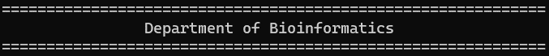

Q2. Write a perlsript to accept a number and display using perl formatter

Code:

format NUMBER =

========

@|||||

$number

========

.

select(STDOUT);

$~ = NUMBER;

$number = <stdin>;

write;

Output:

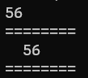

Q3. Write a perl script to accept an array and display the values using perl formatter

Code:

format ARRAY =

===============================

@||||||||||||||||||||||||||||||

$n

===============================

.

select(STDOUT);

$~ = ARRAY;

@array = qw/mondaytuesdaywednesdaythursdayfridaysaturdaysunday/;

foreach $n(@array){

$n;

write;

}

Output:

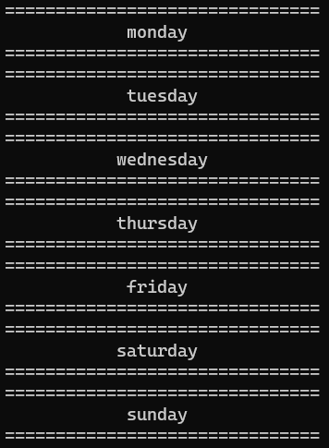

Q4. Write a perl script to accept an array and display only keys using right/center formatting

Code:

format ARRAY =

===============================

@||||||||||||||||||||||||||||||

$n

===============================

.

select(STDOUT);

$~ = ARRAY;

%hash = ("Rohan" => 1, "Aishwarya" => 2, "Aniket" => 3, "Rama" => 4);

foreach $n(keys %hash){

$n;

write;

}

Output:

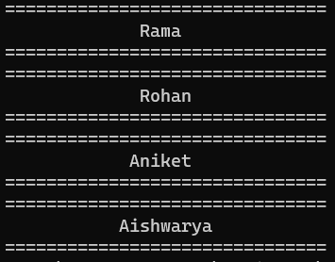

Q5. Write a perl script to accept a decimanl number and display only 4 values adter decimal using formatting

Code:

format DECIMAL =

============

@######.####

$number

============

.

select(STDOUT);

$~ = DECIMAL;

$number = <stdin>;

write;

Output:

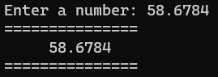

Q6. Write a perl script to display name, age and salary by name employee using formatting

Code:

format EMPLOYEE =

@<<<<<<<<<<<@<<<<<<<<<<<@<<<<<<<<<

$name,$age,$salary

===============================

.

select(STDOUT);

$~ = EMPLOYEE;

@name = qw/Rohan Aishwarya Abhishek Rachael/;

@age = qw/25 27 26 23/;

@salary = qw/60000 43000 28000 54000/;

foreach (@name){

$name = $_;

$age = $age[$i];

$salary = $salary[$i++];

write;

}

Output:

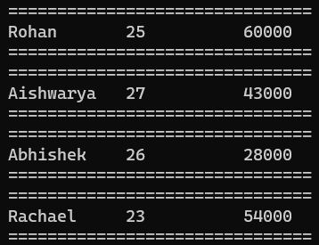

Q7. Write a perl script to diaply name, age and salary by name employee using report formatting

Code:

format EMPLOYEE_TOP =

==============================

Page Number @<

$%

==============================

Name Age Salary

==============================

.

format EMPLOYEE =

@<<<<<<<<<<<@<<<<<<<<<<<@<<<<<<<<<

$name,$age,$salary

===============================

.

select(STDOUT);

$^ = EMPLOYEE_TOP;

$~ = EMPLOYEE;

@name = qw/Rohan Aishwarya Abhishek Rachael/;

@age = qw/25 27 26 23/;

@salary = qw/60000 43000 28000 54000/;

foreach (@name){

$name = $_;

$age = $age[$i];

$salary = $salary[$i++];

write;

}

Output:

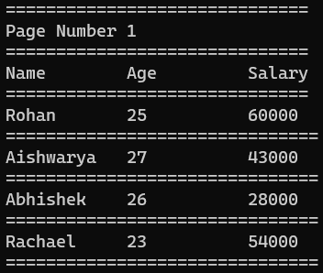

Q8. Write a perl script to display patient_name, patient_age, health_issue and cost_of_treatment of a Patient_Details using formatting

Code:

format PATIENT_TOP =

==============================

Patient Details Page @<

$%

=================================================================

Name Age Health Issue Cost of Treatment

=================================================================

.

format PATIENT =

@<<<<<<<<<<<<<<<@<<<<<<<<<<<@<<<<<<<<<<<<<<<<<<<@<<<<<<<<

$name,$age,$health_issue,$cost_of_treatment

=================================================================

.

select(STDOUT);

$^ = PATIENT_TOP;

$~ = PATIENT;

@name = qw/Sumitra Paresh Vidya Shalmon/;

@age = qw/25 27 26 23/;

@health_issue = qw/Diabetes Covid Scoliosis Cataract/;

@cost_of_treatment = qw/15000 4000 8000 55000/;

foreach (@name){

$name = $_;

$age = $age[$i];

$health_issue = $health_issue[$i];

$cost_of_treatment = $cost_of_treatment[$i++];

write;

}

Output:

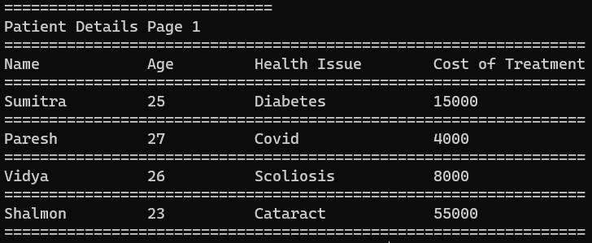

Q9. Write a perl script to diaplysequence_id sequence and alphabet name using report formatting

Code:

format SEQUENCE_DETAILS_TOP =

=================================================================

Sequence Details Page @<

$%

====================================================================================================

SEQ ID SEQUENCE ALPHABET NAME

====================================================================================================

.

format SEQUENCE_DETAILS =

@<<<<<<<<<<<<<<<@<<<<<<<<<<<<<<<<<<<<<<<<<<<<<<<<<<<<<<<<<<<<<<<<<<<<<<<<<<<<<<<<<<<<<<@<<<<<<<<<<

$sequence_id,$sequence,$alphabet_name

====================================================================================================

.

select(STDOUT);

$^ = SEQUENCE_DETAILS_TOP;

$~ = SEQUENCE_DETAILS;

@sequence_id = qw/Q59RL7 Q9ULY5 Q9R0Q8 Q03331/;

@sequence = qw/MSAAKQLFKIVPLTPTEINFLQSLAPVVKEHGVTVTSTMYKYMFQTYPEVRSYFNMTNQK MLSQYDEQLAAGDNNGFNKQGNATLYSFDFVDADDFLDSISGALPNNGHNNVNPNTNDIS MNSTKSPASHHTERGCFKNSQVLSWTIAGASILFLSGCFITRCVVTYRSSQISGQNLQPH MNSSKSSETQCTERGCFSSQMFLWTVAGIPILFLSACFITRCVVTFRIFQTCDEKKFQLP/;

@alphabet_name = qw/FHP_CANNO CPH2_CANAL CLC4E_MOUSE CLC4E_HUMAN/;

foreach (@sequence_id){

$sequence_id = $_;

$sequence = $sequence[$i];

$alphabet_name = $alphabet_name[$i++];

write;

}

Output:

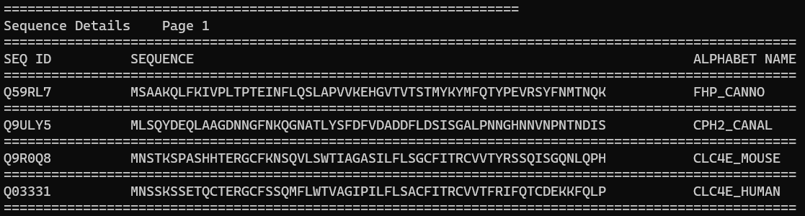

**Practical 9**

**OOPS in Perl**

**Date:09/10/22**

**Aim:**

To understand OOPS concept in perl and write programs to apply the concepts.

**Introduction:**

As the name suggests, Object-Oriented Programming or OOPs refers to languages that uses objects in programming. Object-oriented programming aims to implement real-world entities like inheritance, hiding, polymorphism, etc in programming. The main aim of OOP is to bind together the data and the functions that operate on them so that no other part of the code can access this data except that function.

**Class:**

A class is a user defined blueprint or prototype from which objects are created. It represents the set of properties or methods that are common to all objects of one type. In general, class declarations can include these components, in order:

* **Class name:** The name should begin with a initial letter (capitalized by convention).
* **Superclass(if any):** The name of the class’s parent (superclass), if any, preceded by the keyword ‘use’.
* **Constructors(if any):**Constructors in Perl subroutines returns an object which is an instance of the class. In Perl, the convention is to name the constructor “new”.
* **Body:** The class body surrounded by braces, { }.

**Object:**

It is a basic unit of Object Oriented Programming and represents the real life entities. A typical Perl program creates many objects, which as you know, interact by invoking methods. An object consists of :

* **State** : It is represented by attributes of an object. It also reflects the properties of an object.
* **Behavior** : It is represented by methods of an object. It also reflects the response of an object with other objects.
* **Identity** : It gives a unique name to an object and enables one object to interact with other objects.

**Method:**

A method is a collection of statements that perform some specific task and return result to the caller. A method can perform some specific task without returning anything. Methods are time savers and help us to reuse the code without retyping the code.

**Polymorphism:**

Polymorphism refers to the ability of OOPs programming languages to differentiate between entities with the same name efficiently. This is done by Perl with the help of the signature and declaration of these entities.

Polymorphism in Perl are mainly of 2 types:

* Overloading in Perl
* Overriding in Perl

**Inheritance:**

Inheritance is an important pillar of OOP(Object Oriented Programming). It is the mechanism in perl by which one class is allowed to inherit the features(fields and methods) of another class.

Important Terminology:

* **Super Class**: The class whose features are inherited is known as superclass(or a base class or a parent class).
* **Sub Class**: The class that inherits the other class is known as subclass(or a derived class, extended class, or child class). The subclass can add its own fields and methods in addition to the superclass fields and methods.
* **Reusability**: Inheritance supports the concept of “reusability”, i.e. when we want to create a new class and there is already a class that includes some of the code that we want, we can derive our new class from the existing class. By doing this, we are reusing the fields and methods of the existing class.
* Class can be created using packages
  + >use package_name

**Encapsulation:**

Encapsulation is defined as the wrapping up of data under a single unit. It is the mechanism that binds together code and the data it manipulates. Another way to think about encapsulation is, it is a protective shield that prevents the data from being accessed by the code outside this shield.

* Technically in encapsulation, the variables or data of a class is hidden from any other class and can be accessed only through any member function of own class in which they are declared.
* As in encapsulation, the data in a class is hidden from other classes, so it is also known as data-hiding.
* Encapsulation can be achieved by: Declaring all the variables in the class as private and writing public methods in the class to set and get the values of variables.

**Abstraction:**

Data Abstraction is the property by virtue of which only the essential details are displayed to the user. The trivial or the non-essentials units are not displayed to the user. Ex: A car is viewed as a car rather than its individual components.

Data Abstraction may also be defined as the process of identifying only the required characteristics of an object ignoring the irrelevant details. The properties and behaviors of an object differentiate it from other objects of similar type and also help in classifying/grouping the objects.

Consider a real-life example of a man driving a car. The man only knows that pressing the accelerators will increase the speed of car or applying brakes will stop the car but he does not know about how on pressing the accelerator the speed is actually increasing, he does not know about the inner mechanism of the car or the implementation of accelerator, brakes, etc in the car. This is what abstraction is.

Q1. Write a Perl Script to create class Square and find area of square

Code:  
package Square;

sub new{

$class = shift;

$ref = {};

bless $ref, $class;

return $ref;

}

sub area{

my $ans, $side;

$side = 43;

$ans = $side * $side;

print("Area of the square is $ans\n");

}

1;

use Square;

$obj = new Square();

$obj -> area();

Output:



Q2. Write a Perl script to create student class and initialize it with name and roll number by using hash reference. Make methods to Display. It should display all information’s of the student

Code:

package Student;

sub new{

$class = shift;

$ref = {name => shift, roll=>shift};

bless $ref, $class;

return $ref;

}

sub display{

$ref = shift;

$name_of_stu = $ref -> {name};

$roll_of_stu = $ref -> {roll};

print("Name: $name_of_stu\n");

print("Roll number: $roll_of_stu\");

}

1;

use Student;

$obj = new Student('Shalmon','92');

$obj -> display();

Output:



Q3. Write a Perl script to create class Perimeter to calculate perimeter of a square and triangle using inheritance

Code:

package Triangle_peri;

sub new{

$class = shift;

$ref = {};

bless $ref, $class;

return $ref;

}

sub tri_peri{

$ans, $side1, $side2, $side3;

$side1=24;

$side2=53;

$side3=24;

$ans = $side1+$side2+$side3;

print("Perimeter of the triangle is $ans\n");

}

1;

package Square_peri;

sub new{

$class = shift;

$ref = {};

bless $ref, $class;

return $ref;

}

sub sq_peri{

$ans, $side;

$side=26;

$ans = 4*$side;

print("Perimeter of the square is $ans\n");

}

1;

package Perimeter;

use parent 'Square_peri';

use parent 'Triangle_peri';

sub new{

$class = shift;

$ref = {};

bless $ref, $class;

return $ref;

}

1;

use Perimeter;

$obj = new Perimeter();

$obj->sq_peri;

$obj->tri_peri;

Output:



Q4. Write a perl program that would print the information (name, year of joining, salary, address) of three employees by creating a class named ‘Employee’. The output should be as follows:

Name Year of joining Address

Robert 1994 64C- WallsStreat

Sam 2000 68D- WallsStreat

John 1999 26B- WallsStreat

Code:

package Employee;

sub new{

$class = shift;

$ref = {};

bless $ref, $class;

return $ref;

}

sub display{

@name = qw/Robert Sam John/;

@yoj = qw/1994 2000 1999/;

@addr = qw/64C-WallStreet 68C-WallStreet 26C-WallStreet/;

print("Name Year of Joining Address\n");

for($i=0;$i<=$#name;$i++){

print("@name[$i] @yoj[$i] @addr[$i]\n");

}

}

1;

use Employee;

$obj = new Employee();

$obj -> display();

Output:

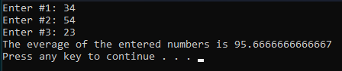

Q6. Write a Perl script create class and display only DNA sequence by applying conditions

CODE:

Dna.pm

package Dna;

sub new{

$class = shift;

$ref = {seq => shift};

bless $ref, $class;

return $ref;

}

sub display{

$ref = shift;

$seq = $ref -> {seq};

if($seq =~ m/[^atgc]/g){

print "DNA sequence is not present\n";

}else{

print "DNA sequence present is $seq\n";

}

}

1;

q6.pl

use Dna;

$dna_seq = "atgccgttttggcgaggtaataaa";

$rna_seq = "auuugggccguguauuaauggcuc";

$obj = new Dna($dna_seq);

$obj -> display();

$obj = new Dna($rna_seq);

$obj -> display();

**Practical 10**

**DBI in perl**

**Date:08/10/22**

**Aim:**

To understand how DBI in Perl works and write programs to Apply the concepts

**Introduction:**

Perl DBI module provides a useful and easy-to-use API that allows you to interact with many of databases including Oracle, SQL Server, MySQL, Sybase, etc. In this tutorial, we are going to show you to interact with the MySQL database.

Accessing a Database in Perl generally takes two steps. The DBI module provides an API for database access. A program uses the functions of DBI to manipulate the database. The second stage of database access from Perl is a database driver (DBD) module. Each different database system requires its own driver. This approach allows a Perl database application program to be relatively independent of the particular database it will access.

**Database Independent Interface (DBI):**

As the name suggests, DBI provides an independent interface for Perl programs. This means that the Perl code doesn’t depend on the database running in the backend. DBI module provides abstraction, i.e, we can write our code without worrying about the database that runs in the back-end.

To import the functions of the Database Independent Interface module, we need to import or include the module with the help of “use” pragma. The use DBI pragma allows us to use DBI module to manipulate the database that we are connecting to.

> Use DBI;

**Connecting to the database:**

The connect() method is used to connect to the specified database. It takes three arguments:

* A string of three values separated by a ‘:’ in this example, it is “DBI:mysql:test”. The first value specifies that we are using DBI. the second value specifies the database engine, which, in this case, is MySQL. the third value specifies the name of the database that you want to connect to.
* The next argument to the connect() method is the username. In this case, user is ‘root’.
* The last argument is the password of your local system. In this example, it is ‘password’

> my $dbh = DBI->connect (“DBI:mysql:test”, “root”, “password”) or die “Can’t connect: ” . DBI->errstr();

**Preparing Queries:**

The prepare() method takes in one parameter, the SQL query to be executed. The SQL query is taken in the form of a string that contains the SQL statement. This SQL statement is the same as the SQL statements that you would execute in MySQL. It returns an object called a statement handle that can be used to execute queries.

> my $sth = $dbh->prepare( ” CREATE TABLE emp( id INT PRIMARY KEY, name VARCHAR(10), salary INT, “);

**Executing the queries:**

The execute() method executes the query written in the prepare() method. It does not take any arguments. It is called using the statement handle object created when the ‘prepare‘ statement is executed.

> $sth->execute();

**Fetching Values from the result:**

The fetchrow() method is used to retrieve the next row of data from the result of the executed query. If a select query is executed, then the fetchrow() method fetches the next row from the result. It returns one row from the result which can be assigned to variables. When used in a while loop, we can fetch and display all the rows in the database using the fetchrow() method.

> ($id, $name, $salary) = $sth->fetchrow();

Q1. Write a Perl script to make a connection with MySQL for any database

Code:

use DBI;

$dbh = DBI->connect("DBI:mysql:database=PRAC10", "root", "root") or die $DBI::errstr;

print("DBI connected\n");

Output:

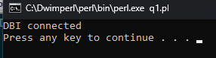

Q2. Write a Perl Script to create table Employee under database Company.

Code:

use DBI;

$dbh = DBI->connect("DBI:mysql:database=Company", "root", "root") or die $DBI::errstr;

print("Database Connected\n");

$sth = $dbh->prepare("CREATE TABLE Employee(NAME varchar(50), ID int(6))");

$sth->execute() or die $DBI::errstr;

$sth->finish();

print("New table 'Employee' created in database 'Company' with columns 'NAME' and 'ID'\n");

Output:



Q3. Write a Perl Script to insert two values (one without binding Values and one with binding Values respectively).

Code:

use DBI;

$dbh = DBI->connect("DBI:mysql:College", "root", "123") or die $DBI::errstr;

print("Database connected\n");

$sth = $dbh->prepare("insert into STUDENT(NAME, ROLLNO, SUBJECT) values ('Shalmon', '24', 'Bioinformatics')");

$sth->execute() or die DBI::errstr;

$sth->finish();

print("Values inserted into Table without using Binding values\n");

$sth = $dbh->prepare("insert into STUDENT(NAME, ROLLNO, SUBJECT) values (?,?,?)");

$sth->execute("Ramesh", 22, "Chemistry");

print("Values inserted into Table using Binding values\n");

Output:

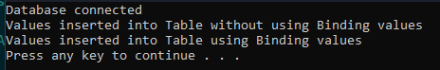

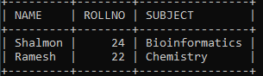

Q4. Write a Perl Script to display all data from employee table.

Code:

use DBI;

$dbh = DBI->connect("DBI:mysql:OFFICE", "root", "123") or die $DBI::errstr;

print("Database connected\n");

$sth = $dbh->prepare("select * from EMPLOYEE");

$sth->execute();

while(my @row = $sth->fetchrow()){

my($first_name, $last_name, $employee_id, $salary) = @row;

print("

First Name : $first_name

Last Name : $last_name

Employee ID : $employee_id

Salary : $salary

\n");

}

$sth->finish();

Output:

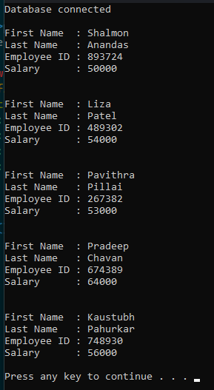

Q5. Write a Perl Script to display the employee data who salary greater than entered salary using binding values (ask user to enter).

Code:

use DBI;

$dbh = DBI->connect("DBI:mysql:OFFICE", "root", "root") or die $DBI::errstr;

print("Database connected\n");

print("Enter a salary value: ");

$threshold = <stdin>;

$sth = $dbh->prepare("select SALARY from EMPLOYEE where SALARY>$threshold");

$sth->execute();

print("First Name Last Name Employee ID Salary\n");

while(@row = $sth->fetchrow()){

my($salary) = @row;

$sth2 = $dbh->prepare("select * from EMPLOYEE where SALARY=$salary");

$sth2->execute();

while(@details = $sth2->fetchrow()){

print("$details[0] $details[1] $details[2] $details[3]\n");

}

}

Output:

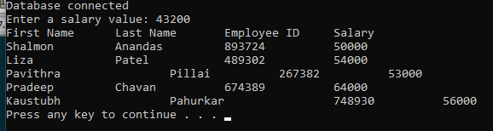

Q6. Write a Perl Script to update a record of employee whose employee id is 4 and 5 using one without binding Values and one with binding Values respectively.

Code:

use DBI;

$dbh = DBI->connect("DBI:mysql:q6", "root", "root") or die $DBI::errstr;

print("Database connected\n");

# display the table without any changes

$sth1 = $dbh->prepare("select * from details");

$sth1->execute() or die $DBI::errstr;

print("==============\n");

print("Current Table\n");

print("==============\n");

while(my(@row) = $sth1->fetchrow()){

my(@details) = @row;

print("@details\n");

}

$sth1->finish();

# make changes to the table

$sth2 = $dbh->prepare("update details set NAME='Rakesh', DEPT='Marketing' where EMP_ID=4") or die $DBI::errstr;

$sth2->execute() or die $DBI::errstr;

$sth2->finish();

# display table after making changes

$sth2 = $dbh->prepare("select * from details");

$sth2->execute();

print("\n======================================================\n");

print("Table after table updated without using binding values\n");

print("======================================================\n");

while(my(@row) = $sth2->fetchrow()){

my(@details) = @row;

print("@details\n");

}

$sth2->finish();

# make changes to the table

$name = "Santosh";

$dept = "Accounts";

$sth3 = $dbh->prepare("update details set NAME=?, DEPT=? where EMP_ID=5") or die $DBI::errstr;

$sth3->execute($name, $dept) or die $DBI::errstr;

$sth3->finish();

# display table after making changes

$sth3 = $dbh->prepare("select * from details");

$sth3->execute();

print("\n======================================================\n");

print("Table after table updated using binding values\n");

print("======================================================\n");

while(my(@row) = $sth3->fetchrow()){

my(@details) = @row;

print("@details\n");

}

$sth3->finish();

Output:

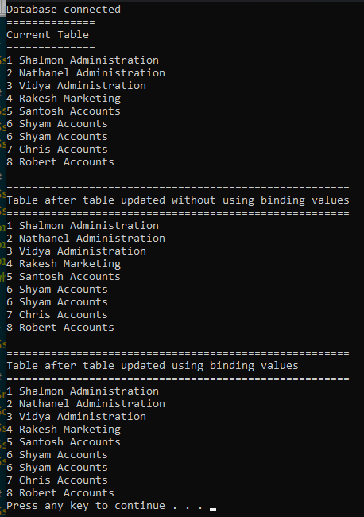

Q7. Write a Perl Script to delete a record of employee whose employee id is 4 and 5 using one without binding Values and one with binding Values respectively.

Code:

use DBI;

$dbh = DBI->connect("DBI:mysql:q6", "root", "root") or die $DBI::errstr;

print("Database connected\n");

# display the table without any changes

$sth1 = $dbh->prepare("select * from q7_details");

$sth1->execute() or die $DBI::errstr;

print("==============\n");

print("Current Table\n");

print("==============\n");

while(my(@row) = $sth1->fetchrow()){

my(@details) = @row;

print("@details\n");

}

$sth1->finish();

# make changes to the table

$sth2 = $dbh->prepare("delete from q7_details where EMP_ID=4") or die $DBI::errstr;

$sth2->execute() or die $DBI::errstr;

$sth2->finish();

# display table after making changes

$sth2 = $dbh->prepare("select * from q7_details");

$sth2->execute();

print("\n======================================================\n");

print("Table after table updated without using binding values\n");

print("======================================================\n");

while(my(@row) = $sth2->fetchrow()){

my(@details) = @row;

print("@details\n");

}

$sth2->finish();

# make changes to the table

$sth3 = $dbh->prepare("delete from q7_details where EMP_ID=?") or die $DBI::errstr;

$sth3->execute(5) or die $DBI::errstr;

$sth3->finish();

# display table after making changes

$sth3 = $dbh->prepare("select * from q7_details");

$sth3->execute();

print("\n======================================================\n");

print("Table after table updated using binding values\n");

print("======================================================\n");

while(my(@row) = $sth3->fetchrow()){

my(@details) = @row;

print("@details\n");

}

$sth3->finish();

Output:

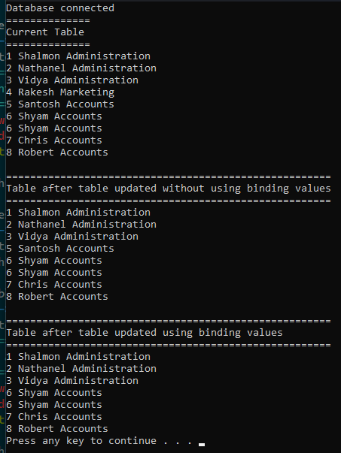

Q8. Write a Perl Script to drop employee table.

Code:

use DBI;

$dbh = DBI->connect("DBI:mysql:q6", "root", "root") or die $DBI::errstr;

print("Database connected\n\n");

$sth = $dbh->prepare("drop table employee");

$sth->execute() or die $DBI::errstr;

$sth->finish();

print("Table Deleted\n");

Output:

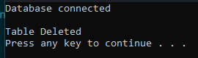

**Practical 11**

**File handling and Directory**

**Date:10/10/22**

**AIM:**

To understand and write perl programs for file handling and directory.

**THEORY:**

The basics of handling files are simple: you associate a filehandle with an external entity (usually a file) and then use a variety of operators and functions within Perl to read and update the data stored within the data stream associated with the filehandle.

A filehandle is a named internal Perl structure that associates a physical file with a name. All filehandles are capable of read/write access, so you can read from and update any file or device associated with a filehandle. However, when you associate a filehandle, you can specify the mode in which the filehandle is opened.

**Opening and Closing Files:**

There are following two functions with multiple forms, which can be used to open any new or existing file in Perl. open FILEHANDLE, EXPR open FILEHANDLE

Here FILEHANDLE is the file handle returned by the open function and EXPR is the expression having file name and mode of opening the file.

**Open Function**

Following is the syntax to open file.txt in read-only mode. Here less than < sign indicates that file has to be opend in read-only mode. open(DATA, "<file.txt");

Here DATA is the file handle, which will be used to read the file. Here is the example, which will open a file and will print its content over the screen. #!/usr/bin/perl open(DATA, "<file.txt") or die "Couldn't open file file.txt, $!"; while(<DATA>) { print "$_";

}

**Following is the syntax to open file.txt in writing mode**. Here less than > sign indicates that file has to be

opend in the writing mode.

open(DATA, ">file.txt") or die "Couldn't open file file.txt, $!";

This example actually truncates (empties) the file before opening it for writing, which may not be the desired

effect. If you want to open a file for reading and writing, you can put a plus sign before the > or < characters.

For example, to open a file for updating without truncating it −

open(DATA, "+<file.txt"); or die "Couldn't open file file.txt, $!";

To truncate the file first −

open DATA, "+>file.txt" or die "Couldn't open file file.txt, $!";

You can open a file in the append mode. In this mode, writing point will be set to the end of the file.

open(DATA,">>file.txt") || die "Couldn't open file file.txt, $!";

A double >> opens the file for appending, placing the file pointer at the end, so that you can immediately start

appending information. However, you can't read from it unless you also place a plus sign in front of it −

open(DATA,"+>>file.txt") || die "Couldn't open file file.txt, $!";

Following is the table, which gives the possible values of different modes

Sr.No.

**Entities & Definition**

|  |  |
| --- | --- |
| **Sr. NO** | **Entities & Definition** |
| 1 | < or r  Read only access |
| 2 | > or w  Creates, write, and truncates |
| 3 | >> or a  write, appends and creates |
| 4 | +< or r+  Reads and writes |
| 5 | +> or w+  Reads, writes, creates, truncates |
| 6 | +>> or a+  Reads, writes, appends and creates |

**Close Function**

To close a filehandle, and therefore disassociate the filehandle from the corresponding file, you use the close

function. This flushes the filehandle's buffers and closes the system's file descriptor.

close FILEHANDLE

close

If no FILEHANDLE is specified, then it closes the currently selected filehandle. It returns true only if it could

successfully flush the buffers and close the file.

close(DATA) || die "Couldn't close file properly";

**Reading and Writing Files**

Once you have an open filehandle, you need to be able to read and write information. There are a number of

different ways of reading and writing data into the file.

The <FILEHANDL> Operator

The main method of reading the information from an open filehandle is the <FILEHANDLE> operator. In a

scalar context, it returns a single line from the filehandle. For example −

#!/usr/bin/perl

print "What is your name?\n";

$name = <STDIN>;

print "Hello $name\n";

When you use the <FILEHANDLE> operator in a list context, it returns a list of lines from the specified

filehandle. For example, to import all the lines from a file into an array −

#!/usr/bin/perl

open(DATA,"<import.txt") or die "Can't open data";

@lines = <DATA>;

close(DATA);

**getc Function**

The getc function returns a single character from the specified FILEHANDLE, or STDIN if none is specified −

102getc FILEHANDLE

getc

If there was an error, or the filehandle is at end of file, then undef is returned instead.

**read Function**

The read function reads a block of information from the buffered filehandle: This function is used to read binary

data from the file.

read FILEHANDLE, SCALAR, LENGTH, OFFSET

read FILEHANDLE, SCALAR, LENGTH

The length of the data read is defined by LENGTH, and the data is placed at the start of SCALAR if no

OFFSET is specified. Otherwise data is placed after OFFSET bytes in SCALAR. The function returns the

number of bytes read on success, zero at end of file, or undef if there was an error.

**Perl - Directories**

Following are the standard functions used to play with directories.

opendir DIRHANDLE, EXPR # To open a directory

readdir DIRHANDLE # To read a directory

rewinddir DIRHANDLE # Positioning pointer to the begining

telldir DIRHANDLE # Returns current position of the dir

seekdir DIRHANDLE, POS # Pointing pointer to POS inside dir

closedir DIRHANDLE # Closing a directory.

**Display all the Files**

There are various ways to list down all the files available in a particular directory. First let's use the simple way

to get and list down all the files using the glob operator −

#!/usr/bin/perl

# Display all the files in /tmp directory.

$dir = "/tmp/*";

my @files = glob( $dir );

foreach (@files ) {

print $_ . "\n";

}

**Create new Directory**

103You can use mkdir function to create a new directory. You will need to have the required permission to create a directory.

#!/usr/bin/perl

$dir = "/tmp/perl"; # This creates perl directory in /tmp directory.

mkdir( $dir ) or die "Couldn't create $dir directory, $!";

print "Directory created successfully\n";

**Remove a directory**

You can use rmdir function to remove a directory. You will need to have the required permission to remove a directory. Additionally this directory should be empty before you try to remove it.

#!/usr/bin/perl

$dir = "/tmp/perl"; # This removes perl directory from /tmp directory.

rmdir( $dir ) or die "Couldn't remove $dir directory, $!";

print "Directory removed successfully\n";

**Change a Directory**

You can use chdir function to change a directory and go to a new location. You will need to have the required permission to change a directory and go inside the new directory. #!/usr/bin/perl $dir = "/home"; # This changes perl directory and moves you inside /home directory. chdir( $dir ) or die "Couldn't go inside $dir directory, $!"; print "Your new location is $dir\n";

**Q1. Write a perl script to re the file named as dna.txt and display the sequence as an output without using getc() and read() function**

**CODE:**

open(fh, "dna.txt") or die "File can't be opened";

@seq = <fh>;

print("@seq");

Output:

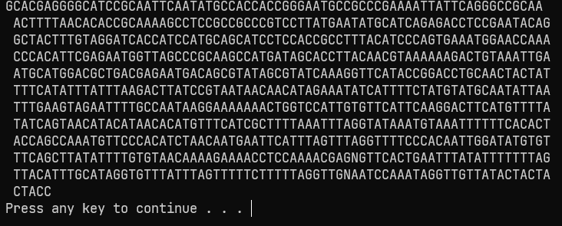

**Q2. Write a perl script to read the file named as tna.txt and display the sequence as an output using getc() and read() function**

CODE:

open(fh, "dna.txt") or die "File can't be opened";

while($char = getc(fh)){

print("$char");

}

close(fh);

print "\n\n\n";

open(file, "dna.txt") or die "File can't be opened";

while(read(file, $buffer, 200)){

print("$buffer\n");

}

close(file);

OUTPUT:

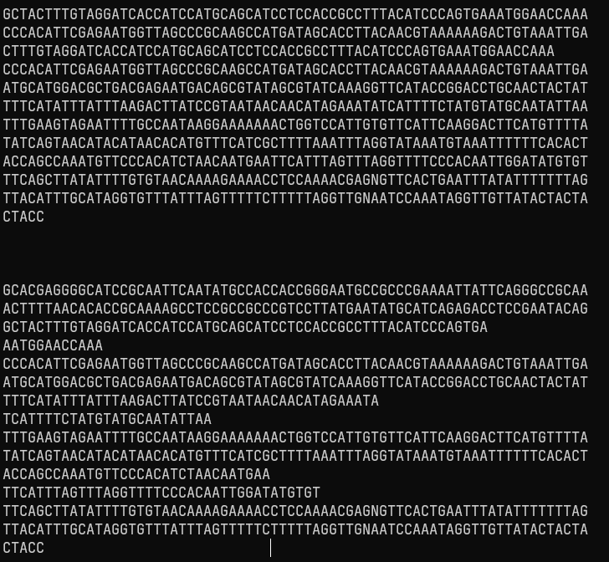

**Q3. Write a perl script to write a sequence ie. atuauua in file named rna.txt**

CODE:

open(fh, '>', 'rna.txt');

$seq = "atuauua";

print fh $seq;

close(fh);

OUTPUT:



**Q4. Write a perl script for following**

* 1. **Make a new directory**
  2. **Rename a directory**
  3. **Changes a directory**
  4. **Removes a directory**

CODE:

$dirname = "q4_folder";

mkdir $dirname, 0755;

print("Directory Created\n");

$dirname2 = "q4_folder_new";

rename($dirname, $dirname2);

print("Directory Renamed\n");

chdir $dirname2;

print("Changed into Directory q4_folder_new\n");

chdir "..";

print("Moved out of directory q4_folder_new\n");

rmdir $dirname2;

print("Directory Removed\n");

OUTPUT:

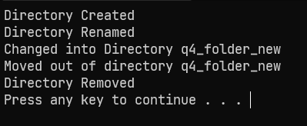

**Q5. Write a perl script to demonstrate -d and glob function**

CODE:

print("Demonstrating glob function\n");

@files = glob('C:/Sem3_msc_notes/rani_maam/perl/prac11\*');

foreach $n(@files){

print("$n\n");

}

print("Demonstrating -d function\n");

if(-d('perl')){

print("directory exists\n");

}else{

print("Directory does not exist\n");

} ("Directory does not exist\n");

}

OUTPUT:

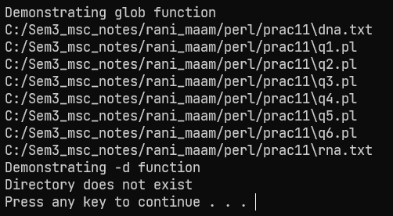

**Q6. Write a perl script to opn, read and clos directory using directory handle**

CODE:

opendir(DIR, 'C:/Sem3_msc_notes/rani_maam/perl/prac11/') or die "Directory couldn't be opened";

print("Directory Opened\n\n");

print("Reading Directory...\n");

while($directory = readdir DIR){

print("$directory\n");

}

print("\n");

closedir DIR;

print("Directory closed\n");

OUTPUT:

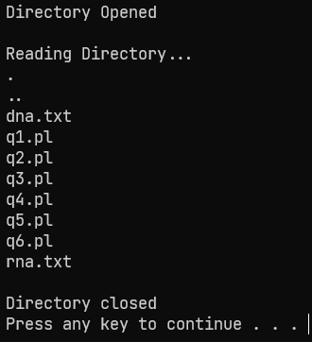

**Practical 12**

**MongoDB Basic Commands**

**Date:19/11/22**

**AIM:**

To understand and write MongoDB basic commands

**THEORY:**

MongoDB is an open-source document database and leading NoSQL database. MongoDB is written in C++. This tutorial will give you great understanding on MongoDB concepts needed to create and deploy a highly scalable and performance-oriented database. MongoDB is a cross-platform, document-oriented database that provides, high performance, high availability, and easy scalability. MongoDB works on concept of collection and document.

Database - Database is a physical container for collections. Each database gets its own set of files on the file system. A single MongoDB server typically has multiple databases.

Collection - Collection is a group of MongoDB documents. It is the equivalent of an RDBMS table. A collection exists within a single database. Collections do not enforce a schema. Documents within a collection can have different fields. Typically, all documents in a collection are of similar or related purpose.

Document -A document is a set of key-value pairs. Documents have dynamic schema. Dynamic schema means that documents in the same collection do not need to have the same set of fields or structure, and common fields in a collection's documents may hold different types of data.

The following table shows the relationship of RDBMS terminology with MongoDB.

|  |  |
| --- | --- |
| **RDBMS** | **MongoDB** |
| Database | Database |
| Table | Collection |
| Tuple/Row | Document |
| Column | Field |
| Table Join | Embedded Documents |
| Primary Key | Primary Key (Default key _id provided by MongoDB itself) |
| Mysqld/Oracle | mysql/sqlplus | Mongod | Mongo |

Sample Document - Following example shows the document structure of a blog site, which is simply a comma separated key value pair.

**The use Command:**

MongoDB **use DATABASE_NAME** is used to create database. The command will create a new database if it doesn't exist, otherwise it will return the existing database.

**Syntax**

Basic syntax of **use DATABASE** statement is as follows –

use DATABASE_NAME

The dropDatabase() Method

MongoDB **db.dropDatabase()** command is used to drop a existing database. Syntax Basic syntax of dropDatabase() command is as follows – db.dropDatabase()

This will delete the selected database. If you have not selected any database, then it will delete default 'test' database.

**The createCollection() Method**

MongoDB **db.createCollection(name, options)** is used to create collection.

**Syntax**

Basic syntax of **createCollection()** command is as follows –

db.createCollection(name, options)

In the command, name is name of collection to be created. Options is a document and is used to specify configuration of collection.

|  |  |  |
| --- | --- | --- |
| Parameter | Tpye | Desccription |
| Name | String | Name of the collection to be created |
| Options | Document | (Optional) Specify options about memory size and indexing |

Options parameter is optional, so you need to specify only the name of the collection. Following is the list of options you can use −

|  |  |  |
| --- | --- | --- |
| Field | Type | Description |
| Capped | Boolean | (Optional) If true, enables a capped collection. Capped collection is a fixed size collection that automatically overwrites its oldest entries when it reaches its maximum size. If you specify true, you need to specify size parameter also. |
| autoIndexId | Boolean | (Optional) If true, automatically create index on _id field.s Default value is false. |
| Size | Number | (Optional) Specifies a maximum size in bytes for a capped collection. If capped is true, then you need to specify this field also. |
| Max | Number | (Optional) Specifies the maximum number of documents allowed in the capped collection. |

While inserting the document, MongoDB first checks size field of capped collection, then it checks max field.

You can check the created collection by using the command show collections.

>show collections

mycollection

system.indexes

In MongoDB, you don't need to create collection. MongoDB creates collection automatically, when you insert

some document.

**The drop() Method**

MongoDB's **db.collection.drop()** is used to drop a collection from the database.

**Syntax**

Basic syntax of **drop()** command is as follows −

db.COLLECTION_NAME.drop()

The insert() Method

To insert data into MongoDB collection, you need to use MongoDB's insert() or save() method.

**Syntax**

The basic syntax of **insert()** command is as follows −

>db.COLLECTION_NAME.insert(document)

Here **mycol** is our collection name, as created in the previous chapter. If the collection doesn't exist in the

database, then MongoDB will create this collection and then insert a document into it.

**The insertOne() method**

If you need to insert only one document into a collection you can use this method.

**Syntax**

The basic syntax of insert() command is as follows –

>db.COLLECTION_NAME.insertOne(document)

**The insertMany() method**

You can insert multiple documents using the insertMany() method. To this method you need to pass an array of documents.

MongoDB's **update()** and **save()** methods are used to update document into a collection. The update() method updates the values in the existing document while the save() method replaces the existing document with the document passed in save() method.

**MongoDB Update() Method**

The update() method updates the values in the existing document.

**Syntax**

The basic syntax of update() method is as follows –

>db.COLLECTION_NAME.update(SELECTION_CRITERIA, UPDATED_DATA)

**The remove() Method**

MongoDB's **remove()** method is used to remove a document from the collection. remove() method accepts two parameters. One is deletion criteria and second is justOne flag.

* deletion criteria − (Optional) deletion criteria according to documents will be removed.
* justOne − (Optional) if set to true or 1, then remove only one document.

**Syntax**

Basic syntax of **remove()** method is as follows –

>db.COLLECTION_NAME.remove(DELLETION_CRITTERIA)

**The Limit() Method**

To limit the records in MongoDB, you need to use limit() method. The method accepts one number type argument, which is the number of documents that you want to be displayed.

**Syntax**

The basic syntax of **limit()** method is as follows –

>db.COLLECTION_NAME.find().limit(NUMBER)

**Q1. Create database called Company1 and collection called as Employee with First_name, Last_Name, Date_Of_Birth, e_mail and phone**

**Solution:**

use Company1;

db.createCollection(“Employee”);

A. Inserts document into a collection:

solution:

db.Employee.insertMany([

{

First_Name: "Radhika",

Last_Name: "Sharma",

Date_Of_Birth: "1995-09-26",

e_mail: "radhika_sharma.123@gmail.com",

phone: "9000012345"

}, {

First_Name: "Rachel",

Last_Name: "Christopher",

Date_Of_Birth: "1990-02-16",

e_mail: "Rachel_Christopher.123@gmail.com",

phone: "9000054321"

}, {

First_Name: "Fathima",

Last_Name: "Sheik",

Date_Of_Birth: "1990-02-16",

e_mail: "Fathima_Sheik.123@gmail.com",

phone: "9000054321" }

] );

OUTPUT:

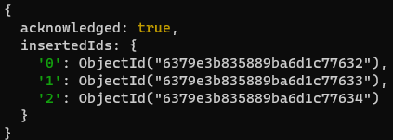

B. retrieve all the documents

Solution:

db.Employee.find();

Or

Db.Employee.find().pretty()

OUTPUT:

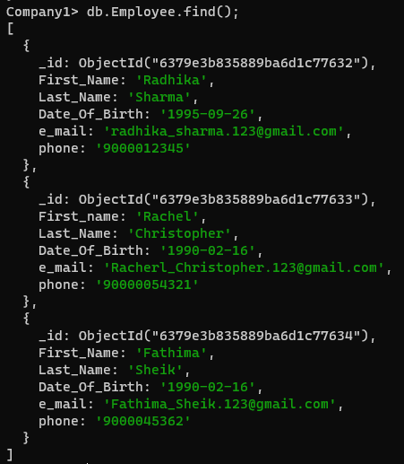

C. retrieves all the documents of first two employees

Solution:

db.Employee.find().limit(2);

Or

db.Employee.find().pretty().limit(2);

OUTPUT:

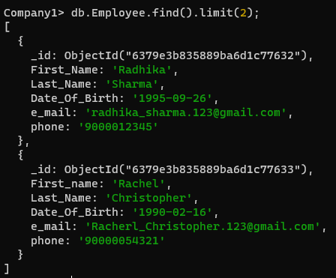

D. retrieve the only First Name of first two matching employees but excluding object id

Solution:

db.Employee.find({},{“First_Name”:1, _id:0}.pretty().limit(2);

OUTPUT:



E. retrieves the only first name of employees whose date of birth is 1990-02-16 by excluding object id

Solution:

db.Employee.find({Date_Of_Birth: “1990-02-16},{“First_Name”:1,_id:0}).pretty();

OUTPUT:



F. retrieves the only First Name of employees whose last name start with letter C by excluding object id

Solution:

db.Employee.find({Last_Name: {‘$regex’: ‘^C’} }, {First_Name”:1,_id:0}).pretty();

OUTPUT:



G. Update the document whose first nae if “Fathima” to “Fathi”

Solution:

db.Employee.update({First_Name: “Fathima”}, {$set:{First_Name: “Fathi”,}});

OUTPUT:

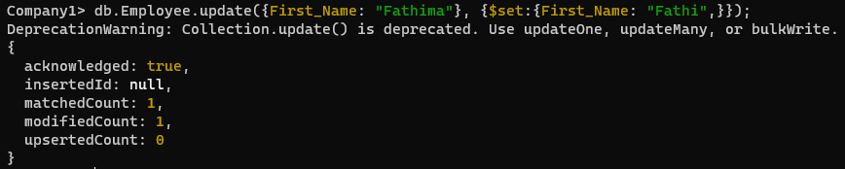

H. Remove the document whose first name is “Fathima”

Solution:

db.Employee.remove({First_Name:”Fathima”});

OUTPUT:



I . drop the collection

Solution:

db.Employee.drop();

OUTPUT:



J. drop the database

Solution:

db.dropDatabase();

OUTPUT:



**Q2. Create a ‘restaurants’ collection of restaurant_id, name, address, cuisine, score:**

Solution:

use Hotel;

db.createCollection(“restaurants”);

db.restaurants.insertMany(

[

{

restaurant_id: "1",

name: "WilGokul",

address: "sion",

cuisine: "North Indian",

score: "10"

}, {

restaurant_id: "2",

name: "cesFoo",

address: "sion",

cuisine: "Japanese",

score: "08"

}, {

restaurant_id: "3",

name: "Blabber",

address: "Borivali east",

cuisine: "Lebanese",

score: "10"

}

]

);

Output: 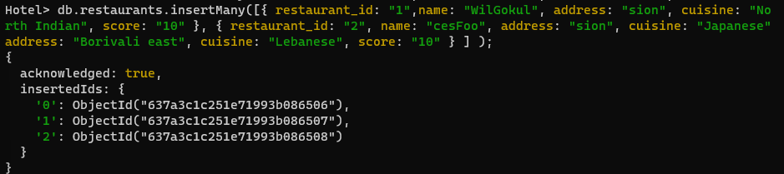

1. write MongoDB query to display all the documents in the collection restaurants.

Solution:

db.restaurants.find();

output:

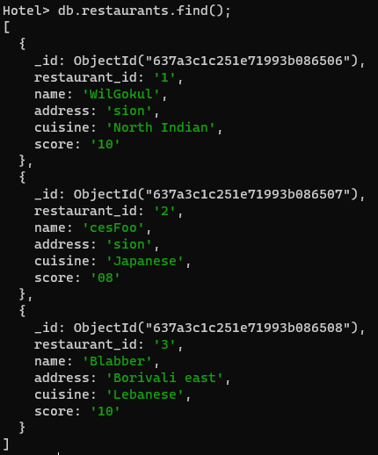

1. Write a MongoDB query to display the field restaurant_id, name and cuisine for all the documents in the collection restaurant.

db.restaurants.find({},{”restaurant_id”:1,, “name”:1, “cuisine”:1});

OUTPUT:

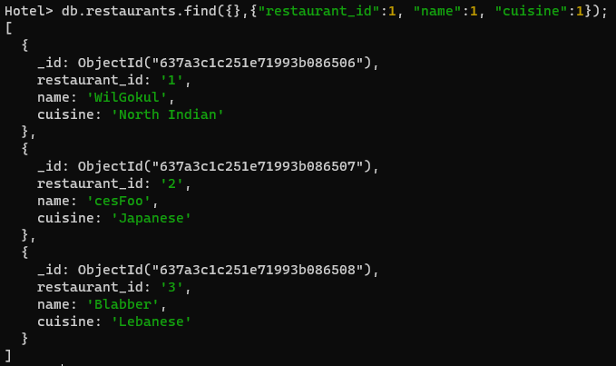

1. Write a MongoDB query to display the fields restaurant_id, name, cuisine, but exclude the filed _id for all the documents in the collection restaurant

db.restaurants.find({},{“restaurant_id”:1, “name”:1, “cuisine”:1,_id:0});

OUTPUT:

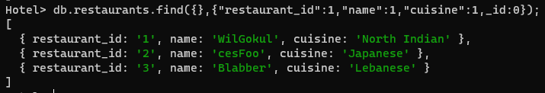

1. Write a MongoDB query to display the fields restaurant_id, name by exclude the field _id for all the documents in the collection restaurant

db.restaurants.find({},{“restaurant_id”:1,”name”:1,_id:0});

OUTPUT:

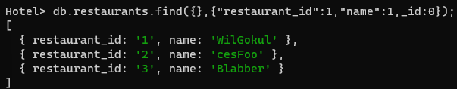

1. Write a MongoDB query to display all the restaurants which is in the sion address

db.restaurants.find({“address”:”sion”});

OUTPUT:

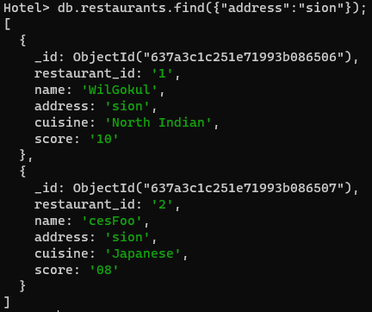

1. Write a MongoDB query to display the first 2 restaurant which is in sion.

db.restaurants.find({“address”:”sion”}).limit(2);

OUTPUT:

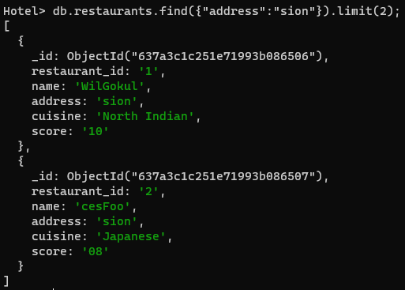

1. Write a MongoDB query to find restaurants who achieved a score more than 8

db.restaurants.find({score: {$elemMatch:{“score:{$gt:8}}}});

OUTPUT:



1. Write a MongoDB query to find the restaurant_id, anme and cuisine for those restaurants which contain ‘Wil” as the first three letters for its name

db.restaurants.find({name:/^Wil/}, {“restaurant_id”:1,”name”:1,”cuisine”:1});

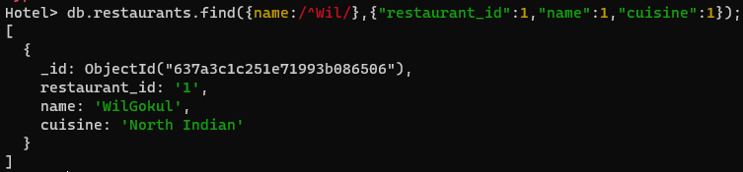

1. Write a MongoDB query to find the restaurant_id, name and cuisine for those restaurants which contain ‘ces’ as last three letters for its name

db.restaurants.find({name:/^ces/},{“restaurants_id”:1,”name”:1,”cuisine”:1});

OUTPUT:

