**11-11-2024**

**CODING PRACTICE PROBLEMS**

1. **0-1 knapsack problem**

import java.util.*;

import java.util.Scanner;

class Problem1 {

public static int knapsack(int capacity, int[] val, int[] wt, int n) {

int[][] dp = new int[n + 1][capacity + 1];

for (int i = 0; i <= n; i++) {

for (int w = 0; w <= capacity; w++) {

if (i == 0 || w == 0) {

dp[i][w] = 0;

} else if (wt[i - 1] <= w) {

dp[i][w] = Math.max(val[i - 1] + dp[i - 1][w - wt[i - 1]], dp[i - 1][w]);

} else {

dp[i][w] = dp[i - 1][w];

}

}

}

return dp[n][capacity];

}

public static void main(String[] args) {

Scanner sc = new Scanner(System.in);

System.out.print("Enter the capacity of the knapsack: ");

int capacity = sc.nextInt();

System.out.print("Enter the number of items: ");

int n = sc.nextInt();

int[] val = new int[n];

int[] wt = new int[n];

System.out.println("Enter the values of the items: ");

for (int i = 0; i < n; i++) {

val[i] = sc.nextInt();

}

System.out.println("Enter the weights of the items: ");

for (int i = 0; i < n; i++) {

wt[i] = sc.nextInt();

}

int result = knapsack(capacity, val, wt, n);

System.out.println("Maximum value in knapsack = " + result);

sc.close();

}

}

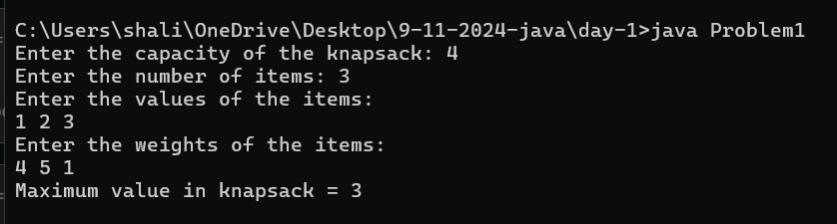

1. **Floor in sorted array**

import java.util.*;

import java.util.Scanner;

class Problem2 {

public static int findFloor(int[] arr, int k) {

int low = 0, high = arr.length - 1;

int result = -1;

while (low <= high) {

int mid = low + (high - low) / 2;

if (arr[mid] == k) {

return mid;

} else if (arr[mid] < k) {

result = mid;

low = mid + 1;

} else {

high = mid - 1;

}

}

return result;

}

public static void main(String[] args) {

Scanner sc = new Scanner(System.in);

System.out.print("Enter the size of the array: ");

int n = sc.nextInt();

int[] arr = new int[n];

System.out.println("Enter the elements of the sorted array: ");

for (int i = 0; i < n; i++) {

arr[i] = sc.nextInt();

}

System.out.print("Enter the value of k: ");

int k = sc.nextInt();

int index = findFloor(arr, k);

if (index == -1) {

System.out.println("No element less than or equal to " + k + " found.");

} else {

System.out.println("The index of the largest element less than or equal to " + k + " is: " + index);

}

sc.close();

}

}

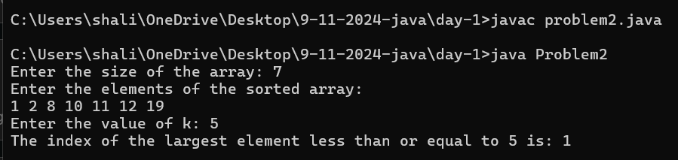

1. **Check equal arrays**

import java.util.*;

import java.util.HashMap;

import java.util.Scanner;

class Problem3 {

public static boolean areArraysEqual(int[] arr1, int[] arr2) {

if (arr1.length != arr2.length) {

return false;

}

HashMap<Integer, Integer> map = new HashMap<>();

for (int num : arr1) {

map.put(num, map.getOrDefault(num, 0) + 1);

}

for (int num : arr2) {

if (!map.containsKey(num)) {

return false;

}

int count = map.get(num);

if (count == 1) {

map.remove(num);

} else {

map.put(num, count - 1);

}

}

return map.isEmpty();

}

public static void main(String[] args) {

Scanner sc = new Scanner(System.in);

System.out.print("Enter the size of the first array: ");

int n1 = sc.nextInt();

int[] arr1 = new int[n1];

System.out.println("Enter the elements of the first array: ");

for (int i = 0; i < n1; i++) {

arr1[i] = sc.nextInt();

}

System.out.print("Enter the size of the second array: ");

int n2 = sc.nextInt();

int[] arr2 = new int[n2];

System.out.println("Enter the elements of the second array: ");

for (int i = 0; i < n2; i++) {

arr2[i] = sc.nextInt();

}

boolean result = areArraysEqual(arr1, arr2);

if (result) {

System.out.println("The arrays are equal.");

} else {

System.out.println("The arrays are not equal.");

}

sc.close();

}

}

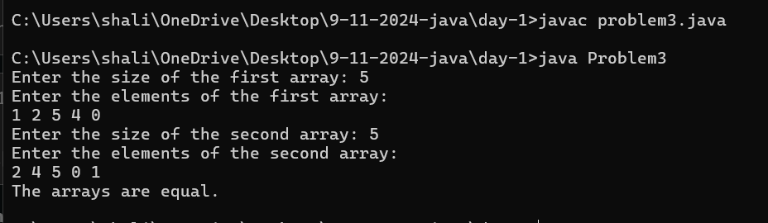

1. **Palindrome linked list**

import java.util.*;

import java.util.Scanner;

class Problem4 {

static class ListNode {

int val;

ListNode next;

ListNode(int x) {

val = x;

next = null;

}

}

public static boolean isPalindrome(ListNode head) {

if (head == null || head.next == null) {

return true;

}

ListNode slow = head;

ListNode fast = head;

while (fast != null && fast.next != null) {

slow = slow.next;

fast = fast.next.next;

}

ListNode prev = null;

ListNode curr = slow;

while (curr != null) {

ListNode next = curr.next;

curr.next = prev;

prev = curr;

curr = next;

}

ListNode firstHalf = head;

ListNode secondHalf = prev;

while (secondHalf != null) {

if (firstHalf.val != secondHalf.val) {

return false;

}

firstHalf = firstHalf.next;

secondHalf = secondHalf.next;

}

return true;

}

public static void main(String[] args) {

Scanner sc = new Scanner(System.in);

System.out.print("Enter the number of nodes: ");

int n = sc.nextInt();

System.out.println("Enter the values of the nodes: ");

ListNode head = new ListNode(sc.nextInt());

ListNode current = head;

for (int i = 1; i < n; i++) {

int value = sc.nextInt();

current.next = new ListNode(value);

current = current.next;

}

boolean result = isPalindrome(head);

if (result) {

System.out.println("The linked list is a palindrome.");

} else {

System.out.println("The linked list is not a palindrome.");

}

sc.close();

}

}

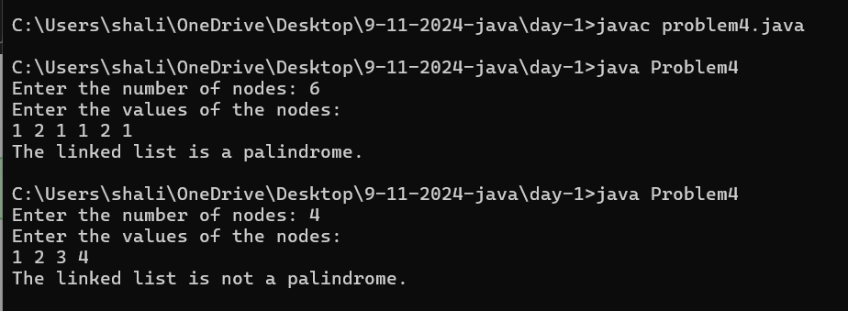

1. **Balanced tree check**

Import java.util.*;

import java.util.Scanner;

class Problem5 {

static class TreeNode {

int val;

TreeNode left;

TreeNode right;

TreeNode(int x) {

val = x;

left = null;

right = null;

}

}

public static boolean isBalanced(TreeNode root) {

return height(root) != -1;

}

private static int height(TreeNode node) {

if (node == null) {

return 0;

}

int leftHeight = height(node.left);

int rightHeight = height(node.right);

// If left or right subtree is unbalanced, return -1

if (leftHeight == -1 || rightHeight == -1) {

return -1;

}

// If the current node is unbalanced, return -1

if (Math.abs(leftHeight - rightHeight) > 1) {

return -1;

}

// Return the height of the current node

return Math.max(leftHeight, rightHeight) + 1;

}

public static TreeNode buildTree(Scanner sc) {

System.out.print("Enter the value of the node (-1 for no node): ");

int val = sc.nextInt();

if (val == -1) {

return null;

}

TreeNode node = new TreeNode(val);

System.out.println("Enter left child of " + val + ":");

node.left = buildTree(sc);

System.out.println("Enter right child of " + val + ":");

node.right = buildTree(sc);

return node;

}

public static void main(String[] args) {

Scanner sc = new Scanner(System.in);

System.out.println("Enter the binary tree structure:");

TreeNode root = buildTree(sc);

if (isBalanced(root)) {

System.out.println("1"); // The tree is balanced

} else {

System.out.println("0"); // The tree is not balanced

}

sc.close();

}

}

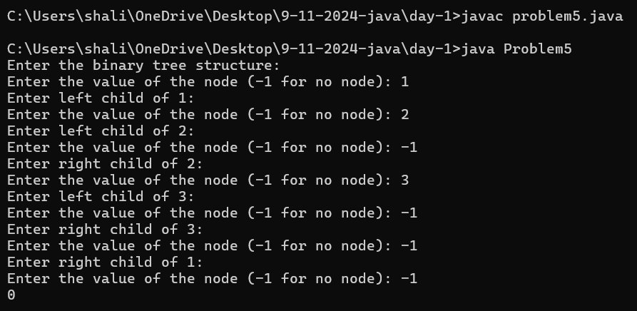

1. **Triplet sum in array**

import java.util.*;

import java.util.Scanner;

class Problem6 {

public static boolean findTriplet(int[] arr, int n, int x) {

for (int i = 0; i < n - 2; i++) {

for (int j = i + 1; j < n - 1; j++) {

for (int k = j + 1; k < n; k++) {

if (arr[i] + arr[j] + arr[k] == x) {

return true;

}

}

}

}

return false;

}

public static void main(String[] args) {

Scanner sc = new Scanner(System.in);

System.out.print("Enter the size of the array: ");

int n = sc.nextInt();

int[] arr = new int[n];

System.out.println("Enter the elements of the array: ");

for (int i = 0; i < n; i++) {

arr[i] = sc.nextInt();

}

System.out.print("Enter the value of x: ");

int x = sc.nextInt();

if (findTriplet(arr, n, x)) {

System.out.println("1");

} else {

System.out.println("0");

}

sc.close();

}

}

