BSc (Hons) in Information Technology
Year 3
Lab Exercise - JUnit
SE3010 – SEPQM | Semester 1
JUnit is an open source unit testing framework for JAVA. It is useful for java developers to write and run
repeatable tests. Using JUnit, you can easily and incrementally build a test suite that will help you measure
your progress, spot unintended side effects, and focus on your development efforts.
Key JUnit Notions
•  •  •  •  •  • | Tested Class – The class that is being tested  Tested Method – The method that is tested  Test Case – The testing of a class’s method against some specified conditions Test Case Class – A class performing the test cases  Test Case Method – A Test Case Class’s method implementing a test case Test Suite – A collection of test cases that can be tested in a single batch
Step 1:
There should be a class to test. Thus, first create a java project and create a class called “Calculation.java” to add two numbers.
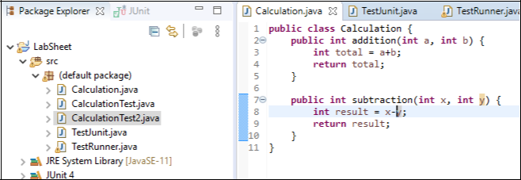
1

BSc (Hons) in Information Technology
Year 3
Lab Exercise - JUnit
SE3010 – SEPQM | Semester 1
Step 2: Adding a test case to the project
1.Right click on the created class Select “New” |  | Click “JUnit Test Case”
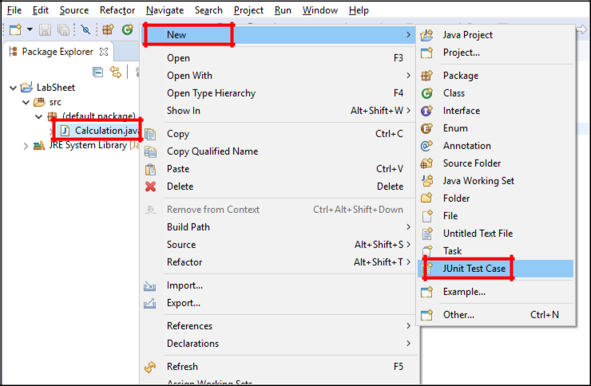
2.Then you would be navigated to the following window. Select the radio button “New JUnit 4 test” and then click on the “next” button.
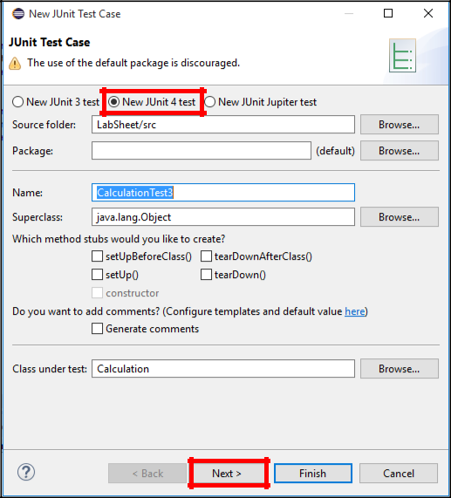
2

BSc (Hons) in Information Technology
Year 3
Lab Exercise - JUnit
SE3010 – SEPQM | Semester 1
3. Now you would get following window. Select the units (methods) you want to test and click finish.
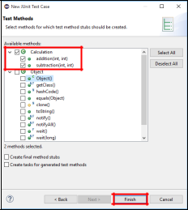
4.Now you would be able to see the “TestCase class”.
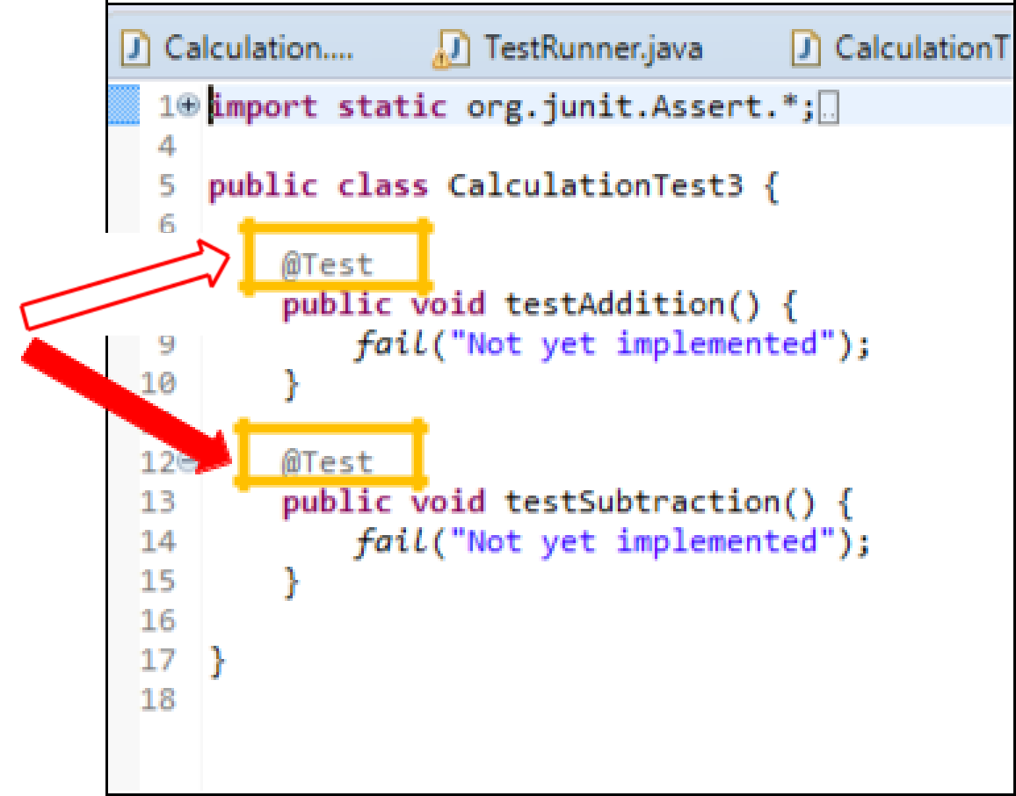
@Test Annotation
3

BSc (Hons) in Information Technology
Year 3
Lab Exercise - JUnit
SE3010 – SEPQM | Semester 1
5.Assertions
The org.junit.Assert class provides a group of assertion methods which are useful for writing
tests. Some important methods of the Assert class are follows:
Method | Description
assertEquals(boolean expected, boolean actual) | Is used to test the equality of two primitives/objects.
assertArrayEquals(expectedArray, resultArray) | Is used to test whether two arrays are equal.
assertTrue(boolean condition) | Is used to test whether a condition is true.
assertFalse(boolean condition) | Is used to test whether a condition is false.
assertNull(Object object) | Is used to test whether an object is null.
assertNotNull(Object object) | Is used to test whether an object is not null.
assertSame(object1, object2) | Is used to test whether two object references are pointing to the same object
assertNotSame(object1, object2) | Is used to test whether two object references are not pointing to the same object
4

BSc (Hons) in Information Technology
Year 3
Lab Exercise - JUnit
SE3010 – SEPQM | Semester 1
5.1. Include the appropriate assert method(s) and complete the code.
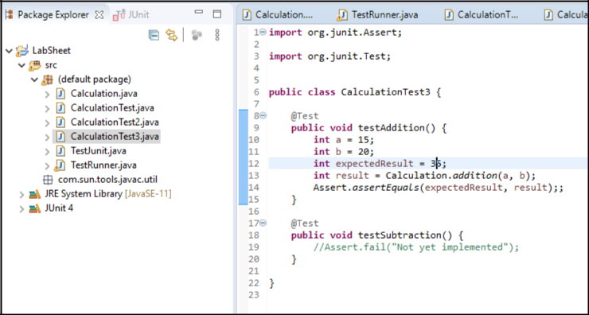
5.2. Next, right click on your test case class and run it as a JUnit test. Then, you would get a window such as the following:
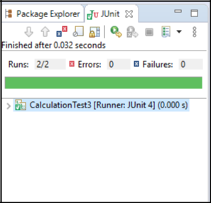
5

BSc (Hons) in Information Technology
Year 3
Lab Exercise - JUnit
SE3010 – SEPQM | Semester 1
6.Annotations: Annotations were introduced in Junit4. They are like meta-tags which can be added to
ajava code for better readability. They provide the following information about test methods: ▪The methods which are going to run before and after test methods
▪The methods which run before and after all the methods
▪The methods or classes that will be ignored during the execution
Following table provides a list of important and frequently used annotations:
Annotation | Description
@Test | This annotation indicates that public void method to which it is attached can  be executed as a test case.
@Before | This annotation can be used to execute some statement(s) such as preconditions before each test case.
@BeforeClass | This annotation can be used to execute some statement(s) before all the test  cases.  This annotation can be used to execute some statement(s) after each test case.
@After
@AfterClass | This annotation can be used to execute some statement(s) after all test cases.  This annotation can be used to ignore some statement(s) during test execution.  This annotation can be used to specify a time limit for the execution of a test.
@Ignores
@Test(timeout=500)

6.1. Add the @Before annotation to your code and run it.
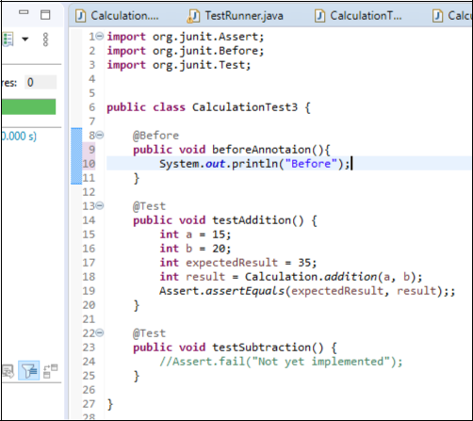
6

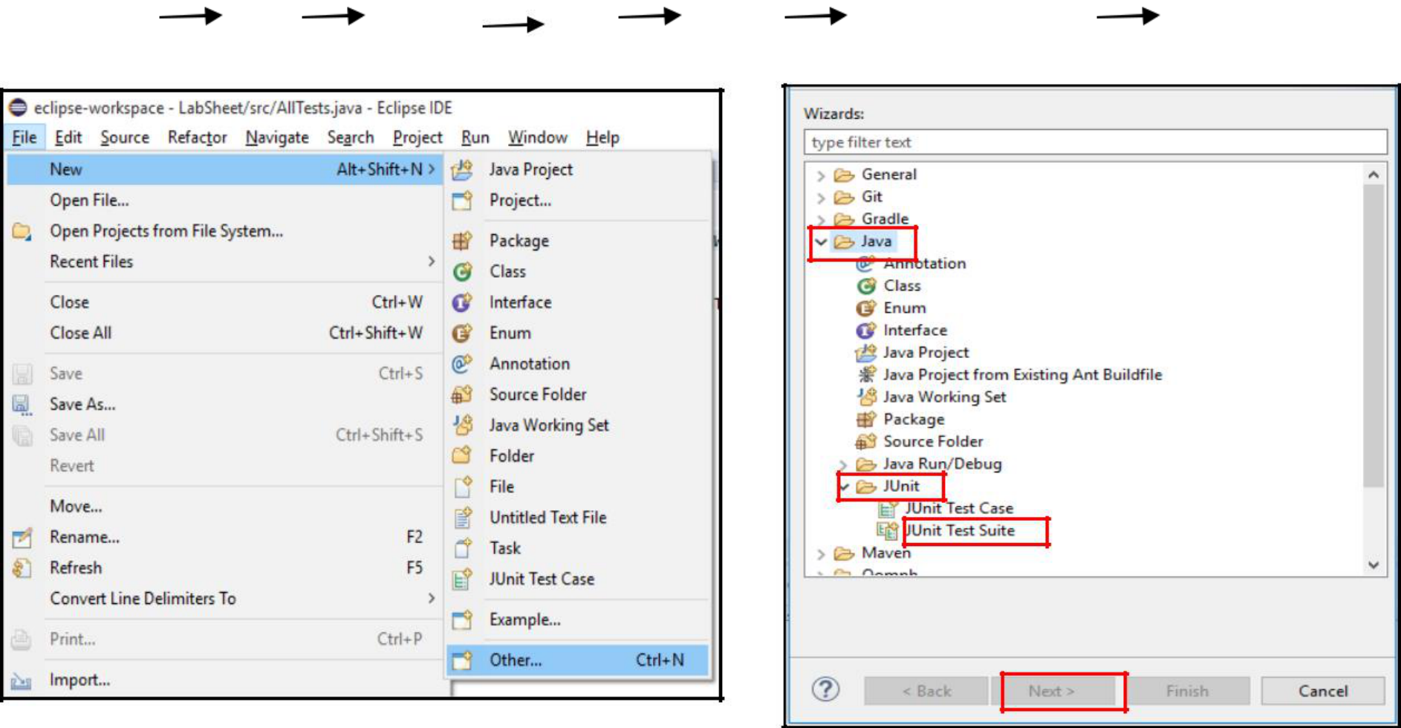
BSc (Hons) in Information Technology
Year 3
Lab Exercise - JUnit
SE3010 – SEPQM | Semester 1
Step 3: Test Suite
We have performed tests on only one class, i.e. we have tested methods under the consideration that they belong to the same class. However, in large projects there are many classes with methods that should be tested. For testing multiple classes, Eclipse and JUnit introduced the concept of Test Suit. A Test Suite is a simple way running a collection of test cases as a single batch. To open a Test Suite, follow the following steps:
1. Select File | New | Other... | Java | JUnit | JUnit Test Suite | Next
2. Next, select which test classes that you wish to test together and click finish.
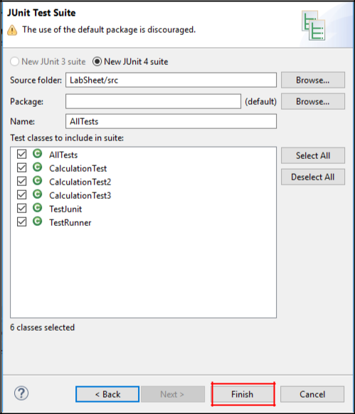
7

BSc (Hons) in Information Technology
Year 3
Lab Exercise - JUnit
SE3010 – SEPQM | Semester 1
3. Then, you would get the code related to the test suite, which can be altered according to your needs.
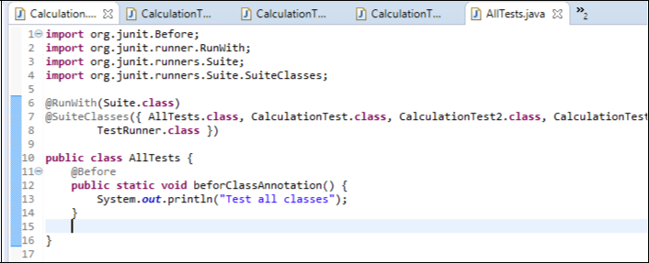
8

