

Sri Lanka Institute of Information Technology
Modern Topics in IT : IT4020
Test Cases Documentation
Microservices Architecture Implementation

Name | IT Number
Jayaweera R.C | IT22215574
A. D. H. R. Sumanaweera | IT22283344
Jayaweera J.P.S.P | IT22277572

Table of Contents
Introduction 3
Automated Testing Overview 4
Identified Defects 5
Conclusion 5
References 5
Appendix 6

Introduction

- This document presents the detailed testing activities carried out on the PixelsSuite “https://www.pixelssuite.com” web application.
- The testing process includes both manual and automated testing approaches to evaluate system functionality, usability, and reliability. The Transliteration feature was excluded as per assignment instructions.
- Manual testing was performed by dividing features among group members, while automated testing was conducted using different tools by each member to cover the overall system.

Manual Testing Documentation Overview

Manual testing was performed to validate system functionality, UI behavior, and edge cases. Test cases were designed and executed across multiple modules including navigation, PDF tools, image conversion, and user interface interactions.

Member-wise Test Cases

Jayaweera J P S P– Editor (PDF Editor)

Test Case ID | Test Scenario | Preconditions | Test Steps | Expected Result | Actual Result | Status
MT-PDF-001 | Verify PDF Editor  page loads successfully | url correct and successful internet connection | Go to https://www.pixelssuite.com/pdf-editor  Wait until page finishes loading | PDF Editor page loads successfully without blank screen or error page | Load the page successfully | Pass
MT-PDF-002 | Verify PDF Editor heading is visible | PDF Editor page loaded | Open PDF Editor page  Observe page heading | PDF Editor” heading is visible and readable | “PDF Editor” heading is visible at the top of the page | Pass
MT-PDF-003 | Verify toolbar section is visible | PDF Editor page loaded | Open PDF Editor page  Observe toolbar panel | Toolbar section is visible and properly aligned | Toolbar section is visible | Pass
MT-PDF-004 | Verify Choose File button is visible and clickable | PDF Editor page loaded | Open PDF Editor page  Observe file selection area | Choose File button is visible and clickable | choose file button is visible and clickable | Pass
MT-PDF-005 | Verify undo button is visible | PDF Editor page loaded | Open PDF Editor page  Observe top-right action icons | Undo button is visible and clickable | undo button is visible | Pass
MT-PDF-006 | Verify Ctrl + Z keyboard shortcut performs undo action | PDF Editor page loaded  A PDF file is uploaded  At least one edit action is performed | Perform an edit action on the PDF  Press Ctrl + Z on the keyboard | The last performed action is undone successfully  Behavior is same as clicking the Undo button | perform undo action with ctrl+z click | Pass
MT-PDF-007 | Verify text selection does not distort or overlap UI | PDF Editor page loaded  PDF file uploaded | Open PDF Editor page  Upload a PDF file  Select any text on the document | Selected text is highlighted clearly  No visual distortion or overlay appears  Text remains fully visible and readable | A black/grey overlay appears under the selected text  Text becomes partially hidden and UI is distorted | Fail
MT-PDF-008 | Verify horizontal scrolling works after zooming in | PDF Editor page loaded  A PDF file is uploaded | Open PDF Editor page  Upload a PDF file  Increase zoom level using the zoom slider  Observe whether some content moves out of visible area  Use the horizontal scrollbar at the bottom  Check whether hidden content becomes visible | Horizontal scrollbar is displayed when content exceeds visible area  User can scroll horizontally to view hidden PDF content  No content becomes permanently inaccessible | Horizontal scrollbar appeared after zooming in  Hidden PDF content could be viewed by scrolling horizontally | Pass
MT-PDF-009 | Verify page section and PDF viewing container are visible | PDF Editor page loaded  A PDF file is uploaded successfully | Open PDF Editor page  Upload a PDF file (e.g., JUnit.pdf)  Scroll down to the "Page" section if not visible  Observe the page navigation controls and PDF display area | "Page" section is visible  Page navigation controls (Prev, page number, Next) are displayed  PDF content container is visible below the controls  PDF page is properly rendered inside the container  No UI overlap or broken layout | Page section, navigation controls  (Prev, Next, page number), and PDF  container are visible and properly  displayed. | Pass
MT-PDF-010 | Verify added text can be repositioned (drag and move) | PDF Editor page loaded  A PDF file is uploaded | Select text tool  Click on PDF and add text  Try to drag the text to a different position | User should be able to click and drag the text box  Text should move freely to desired position | Text cannot be dragged or repositioned  Text remains fixed at initial position | Fail
MT-PDF-011 | Verify font selection applies correctly to added text | Select font "Helvetica"  Add text on PDF  Select font "Times New Roman"  Add another text  Compare both texts visually | Text appearance should change based on selected font  Different fonts should produce visibly different styles | Text appearance should change based on selected font  Different fonts should produce visibly different styles | Font selection does not visibly change text appearance  All text appears in same font style | Fail
MT-PDF-012 | Verify user can add text to the PDF | PDF Editor page loaded  A PDF file is uploaded | Select text tool  Click on the PDF  Select Letter T icon  Type sample text | Typed text is added and visible on the PDF | Text is added and visible on the PDF | Pass
MT-PDF-013 | Verify alignment selection can be changed with L C R | PDF Editor page loaded  A PDF file is uploaded and added text | Click L  Click C  Click R  Observe selected state | Selected alignment option is visually highlighted when chosen L-left,R-right,C-center in text field | Selected alignment option changes visually | Pass
MT-PDF-014 | Verify highlight tool applies color to selected area | PDF Editor page loaded  A PDF file is uploaded | Select highlight tool  Drag over any text on the PDF  Observe highlighted area | Selected text area is highlighted with background color  Text remains visible and readable  Highlight is aligned with selected region | Highlight appears correctly over selected text and remains readable | Pass
MT-PDF-015 | Verify whiteout tool removes selected text | PDF Editor page loaded  A PDF file is uploaded | Select whiteout/eraser tool  Apply it over a portion of text (e.g., "Technology")  Observe the result | Selected portion of text is removed or hidden  Whiteout area is applied correctly | Selected portion of the word "Technology" was removed  Remaining text appears broken (e.g., "T logy") | Pass

R C Jayaweera -

Test Case ID | Test Scenario | Preconditions | Test Steps | Expected Result | Actual Result | Status

IT22283344 A D H R Sumanaweera – Image Converter

Test Case ID | Test Scenario | Preconditions | Test Steps | Expected Result | Actual Result | Status
MT-M1-001 | Verify converter page loads | Internet available | Open converter page | Page loads without error | Page loads correctly | Pass
MT-M1-002 | Verify drag & drop area visible | Page loaded | Observe upload section | Upload area visible | Upload area visible | Pass
MT-M1-003 | Verify “Select files” button works | Page loaded | Click button | File dialog opens | File dialog opens | Pass
MT-M1-004 | Verify supported formats shown | Page loaded | Observe text | PNG, JPG, WEBP shown | Formats displayed correctly | Pass
MT-M1-005 | Verify Convert section visible | Page loaded | Check upload info | Convert section visible | Section visible | Pass
MT-M1-006 | Verify Preview section visible | Page loaded | Open preview area | Preview panel visible | Panel visible | Pass
MT-M1-007 | Verify “No image yet” message | No file uploaded | Open preview area | Should show default message | Message displayed | Pass
MT-M1-008 | Verify instructions match selected format | Converter page open | Read instructions | Instructions should mention selected format | Instructions are generic | Fail
MT-M1-009
MT-M1-0010
MT-M1-001
MT-M1-001

Member 4 – UI / Edge Cases

Test Case ID | Test Scenario | Preconditions | Test Steps | Expected Result | Actual Result | Status

Member wise Automated Test Cases

Member 1 – Playwright
Tool Used
- Playwright
- JavaScript/Node.js
- Chrome browser
Test Case ID | Automated Scenario | Script File | Test Method
ATC-PW-001 | Homepage loads successfully | tests/homepage.spec.js | Homepage › should load homepage successfully
ATC-PW-002 | Homepage title is displayed correctly | Homepage title is displayed correctly | Homepage title is displayed correctly
ATC-PW-003 | Main heading or hero section is visible | Main heading or hero section is visible | Main heading or hero section is visible
ATC-PW-004 | Homepage does not show blank page | Homepage does not show blank page | Homepage does not show blank page
ATC-PW-005 | Main sections are visible | Main sections are visible | Main sections are visible
ATC-PW-006 | Navigation area is visible | Navigation area is visible | Navigation area is visible
ATC-PW-007 | Logo or site branding is visible | Logo or site branding is visible | Logo or site branding is visible
ATC-PW-008 | User can navigate to PDF Editor page | User can navigate to PDF Editor page | User can navigate to PDF Editor page
ATC-PW-009 | Browser back works after navigation | Browser back works after navigation | Browser back works after navigation
ATC-PW-010 | PDF Editor page loads successfully | PDF Editor page loads successfully | PDF Editor page loads successfully
ATC-PW-011 | PDF Editor heading is visible | PDF Editor heading is visible | PDF Editor heading is visible
ATC-PW-012 | Upload area is visible in PDF Editor | Upload area is visible in PDF Editor | Upload area is visible in PDF Editor
ATC-PW-013 | Upload button is visible | Upload button is visible | Upload button is visible
ATC-PW-014 | Zoom controls are visible | tests/pdf-editor-controls.spec.js | tests/pdf-editor-controls.spec.js
ATC-PW-015 | Page navigation controls are visible | Page navigation controls are visible | Page navigation controls are visible
ATC-PW-016 | PDF Editor page remains stable on refresh | PDF Editor page remains stable on refresh | PDF Editor page remains stable on refresh

Sample Automation Scripts and outputs

Script | Test results
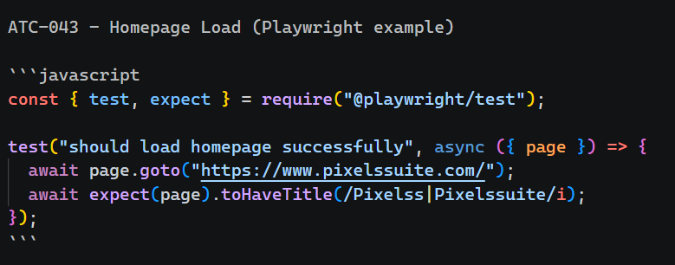  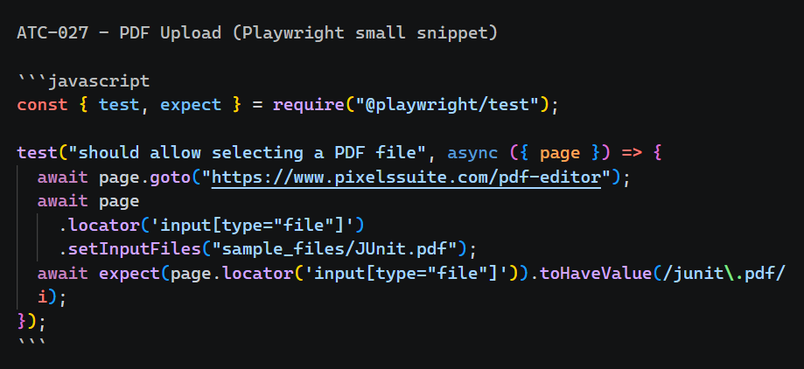 | 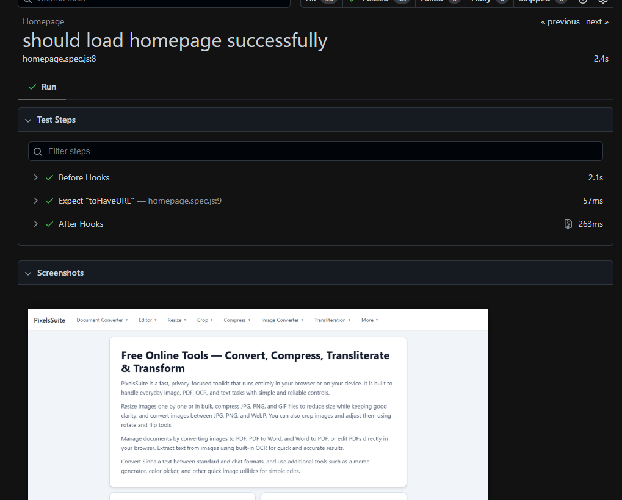  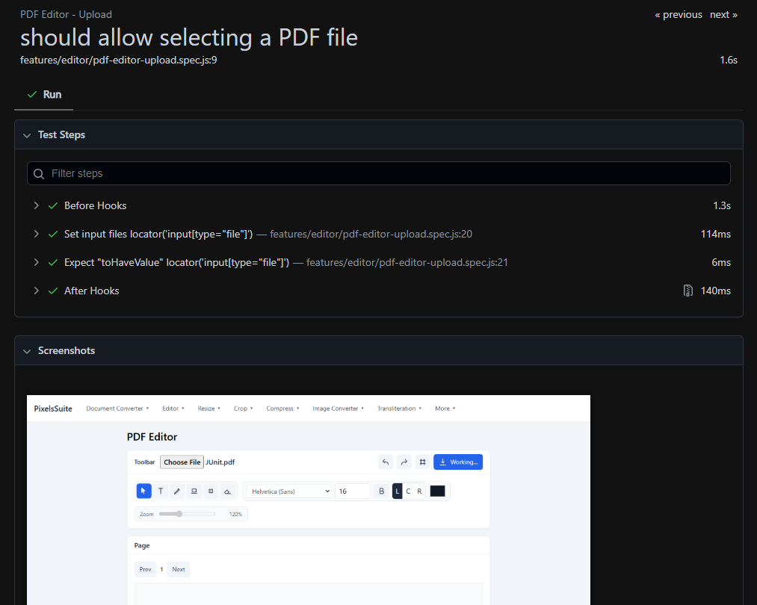
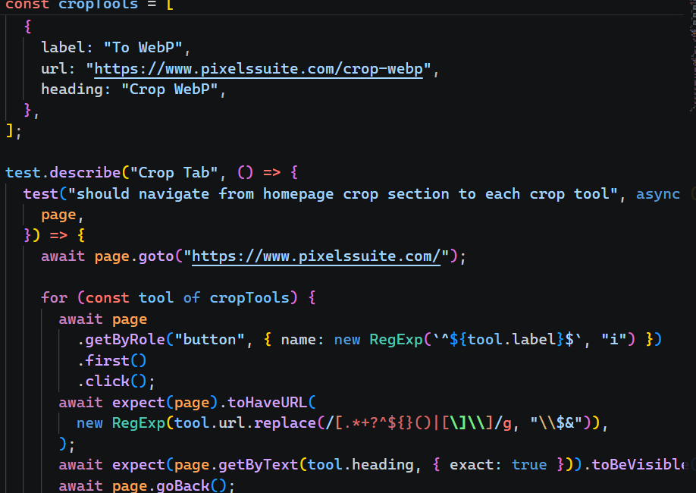  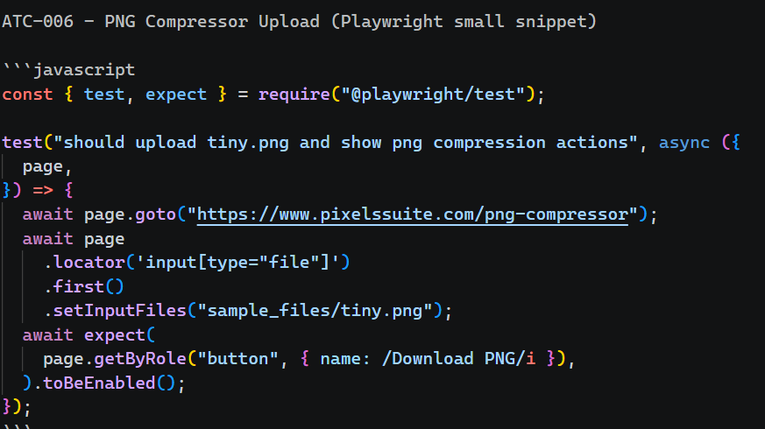 | 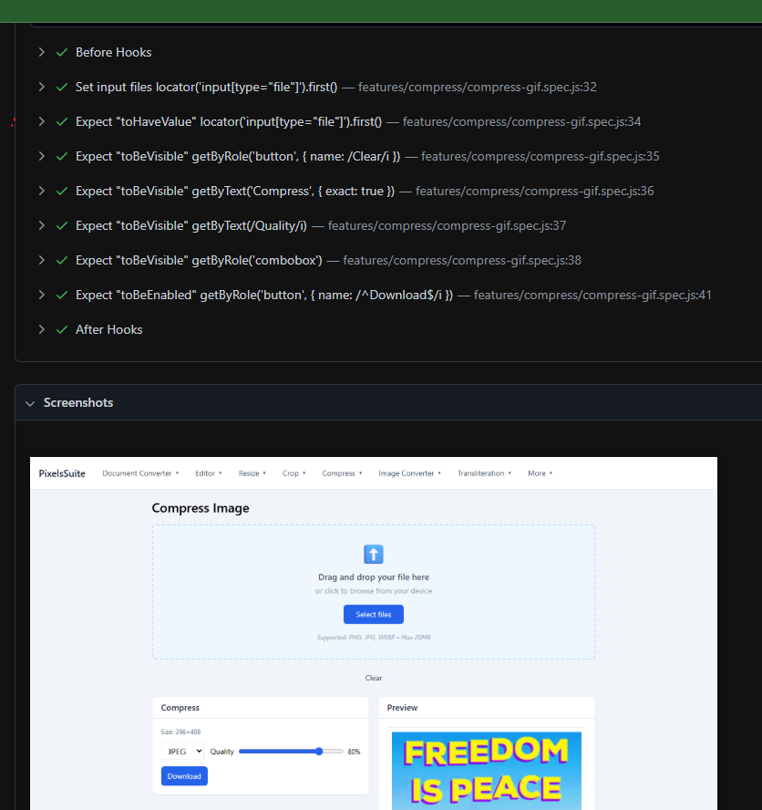  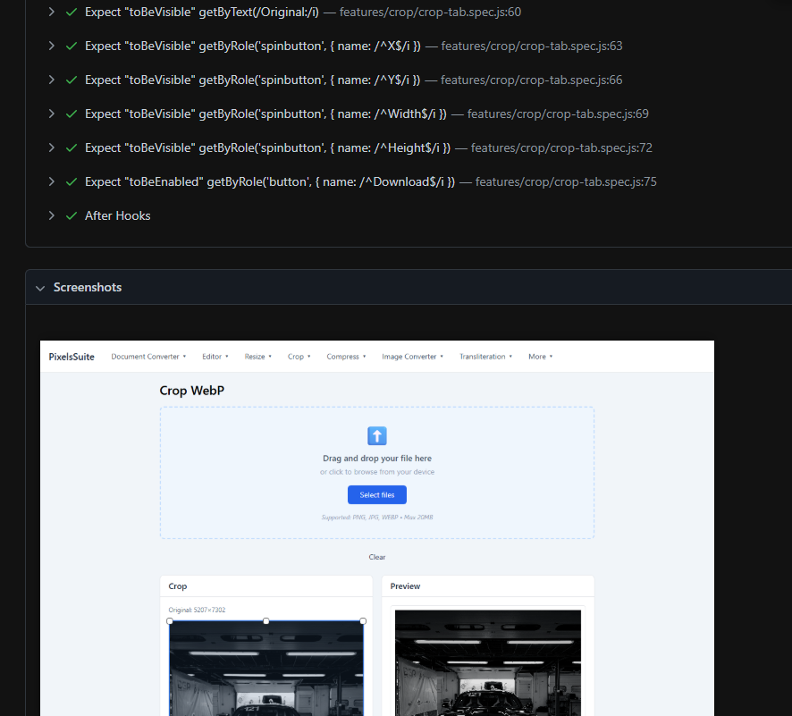

Member 2 – Selenium
Tool Used
- Tool stack used: Selenium WebDriver + Pytest + pytest-html
- Programming language: Python
- Browser used: Chrome (Headless)

Test Case ID | Automated Scenario | Script File | Test Method
ATC-SE-001 | Homepage loads successfully | Homepage loads successfully | Homepage loads successfully
ATC-SE-002 | Homepage navigation menu is present | Homepage navigation menu is present | Homepage navigation menu is present
ATC-SE-003 | GIF compressor page loads | GIF compressor page loads | GIF compressor page loads
ATC-SE-004 | GIF upload and controls display | GIF upload and controls display | GIF upload and controls display
ATC-SE-005 | Crop image upload works | Crop image upload works | Crop image upload works
ATC-SE-006 | Crop aspect ratio options available | Crop aspect ratio options available | Crop aspect ratio options available
ATC-SE-007 | PDF to Word page loads | PDF to Word page loads | PDF to Word page loads
ATC-SE-008 | Word file upload works | Word file upload works | Word file upload works
ATC-SE-009 | PDF upload to editor works | Word file upload works | Word file upload works
ATC-SE-010 | Image editor upload flow works | Word file upload works | Word file upload works
ATC-SE-011 | Image converter page loads | Word file upload works | Word file upload works
ATC-SE-012 | JPG upload and conversion controls work | JPG upload and conversion controls work | JPG upload and conversion controls work
ATC-SE-013 | Rotate tool upload works | Rotate tool upload works | Rotate tool upload works
ATC-SE-014 | OCR image upload works | OCR image upload works | OCR image upload works
ATC-SE-015 | Resize inputs available | Resize inputs available | Resize inputs available
ATC-SE-016 | Bulk resize supports multiple files | Bulk resize supports multiple files | Bulk resize supports multiple files

Script | Test Result
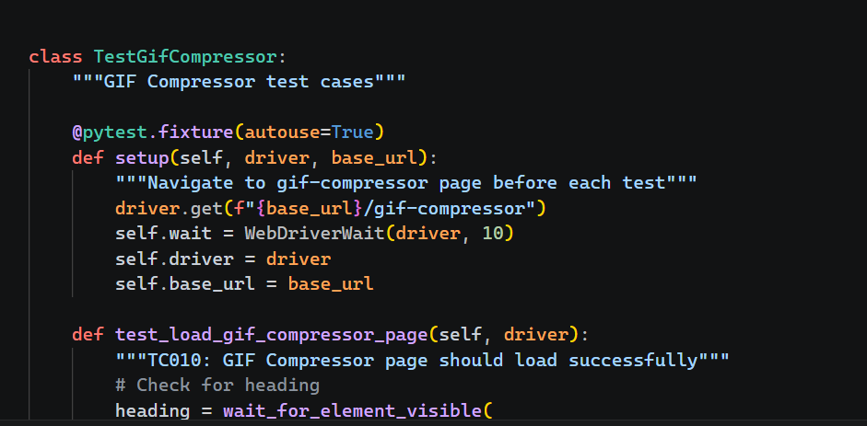  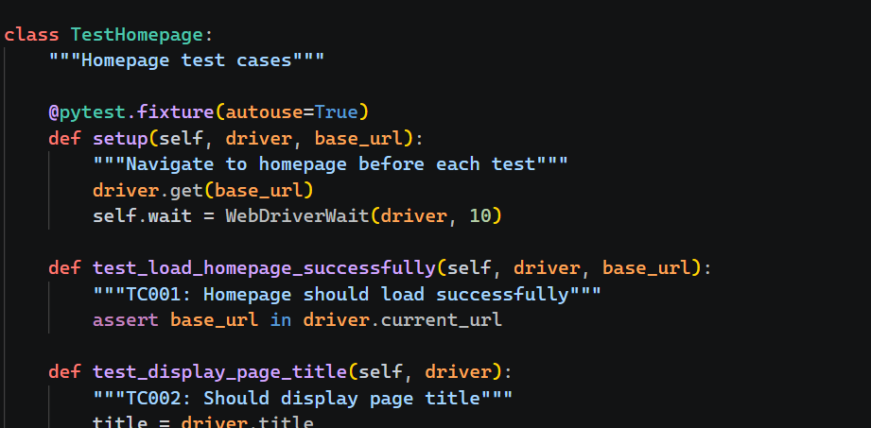  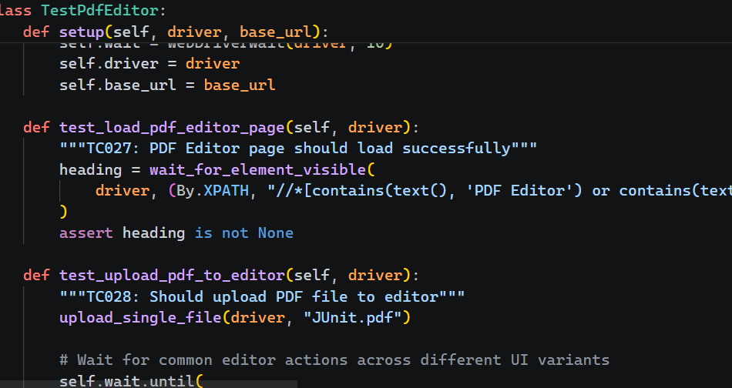  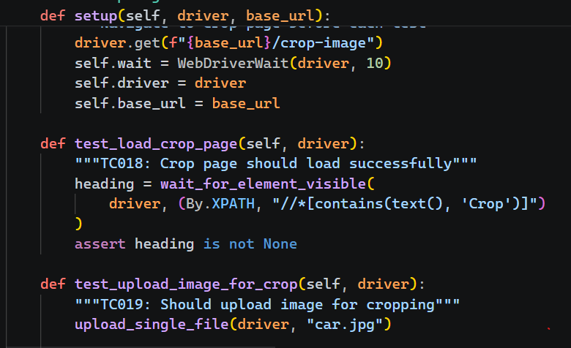 | 