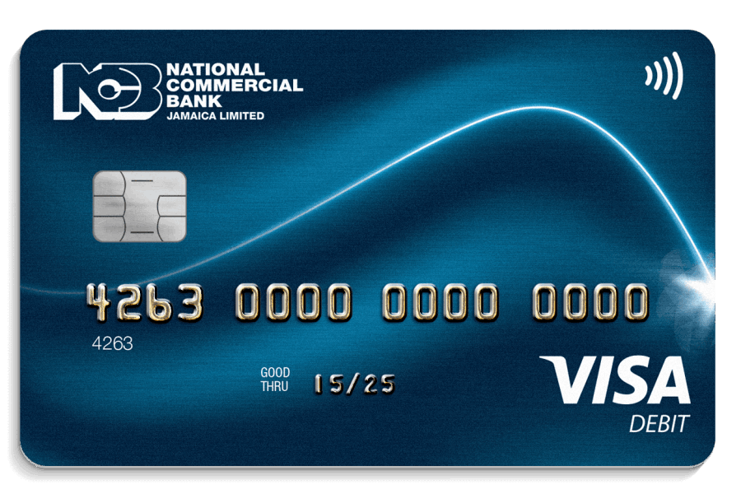

**Bank Name**

**1234 5678 9876 4356**

**123 Month/year**

**VALID/THRU 12/99**

CARDHOLDER