Sample Table - Employee_Dept_Table

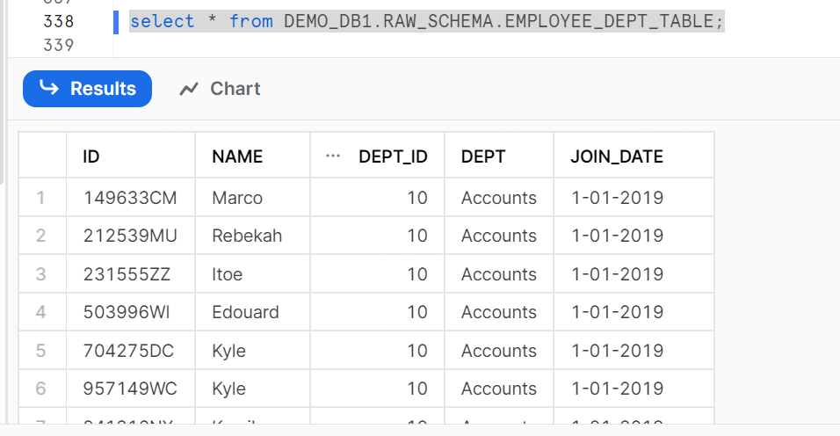

Dataset Table:

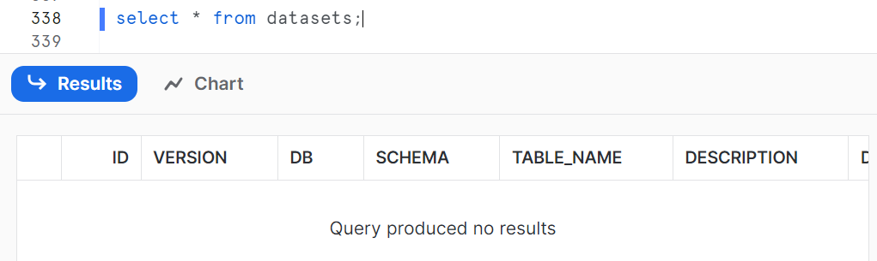

Attributes Table:

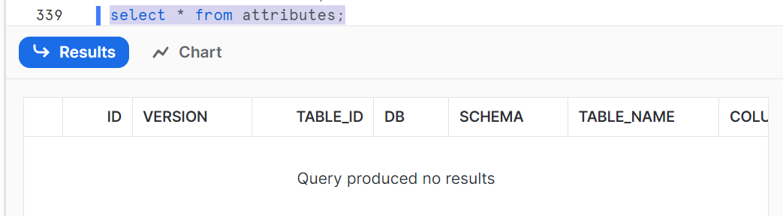

Call create_metadata stored proc. This populates data in both Dataset and Attributes Tables.

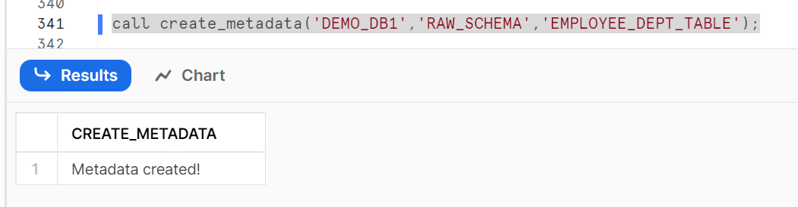

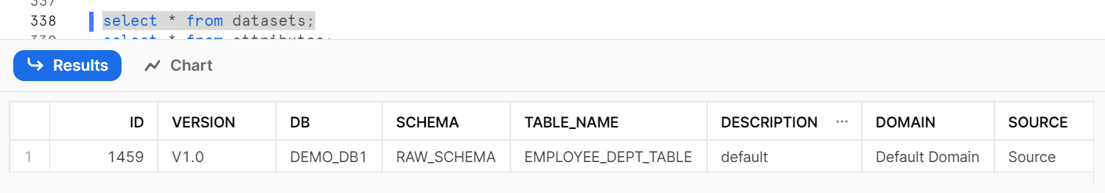

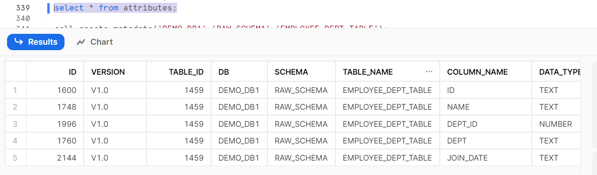

DQ_RULES Table:

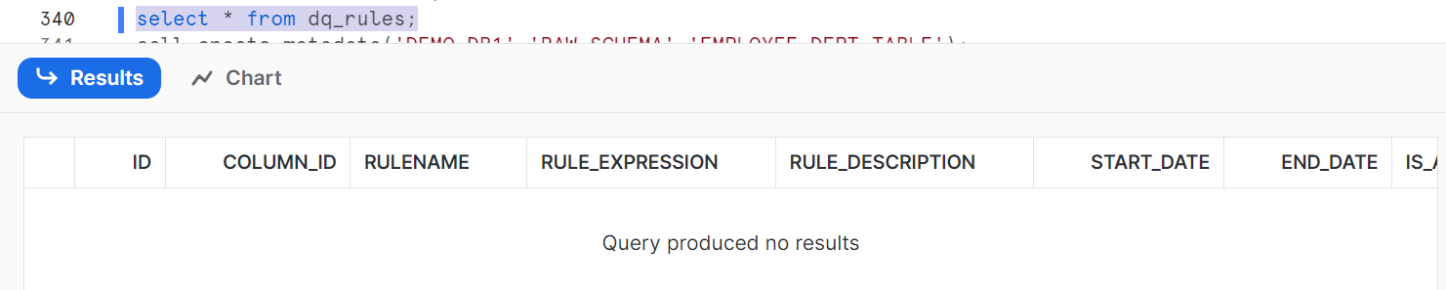

List of Data Validation Functions and sample expression can be found in GE_FUNCTION_RULE_MAP Table

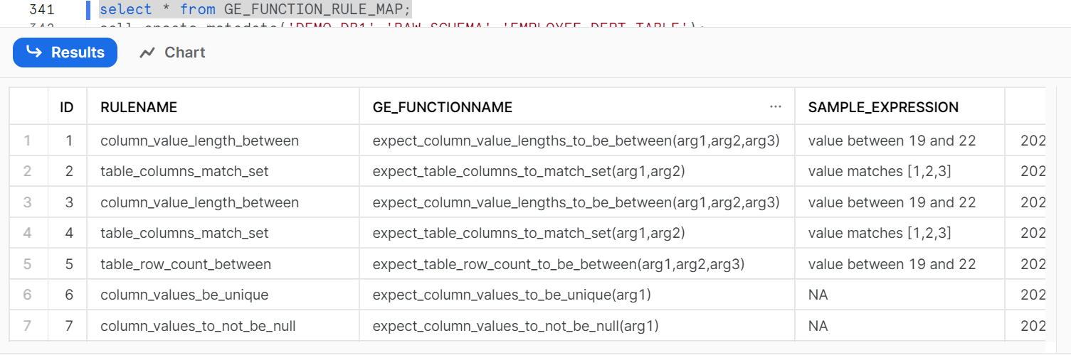

Call create_dq_rule stored procedure with required expression.

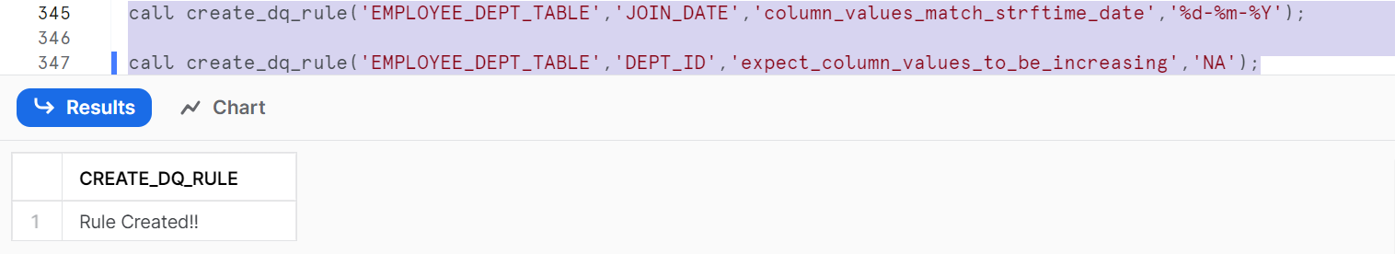

This populates data in dq_rules table.

