Sample File Having text, image and table
We are working on project named document structure extraction and reconstruction for multilingual machine translation.
We will be working on –
- Docx
- RTF
- PPT
- Excel
- PDF
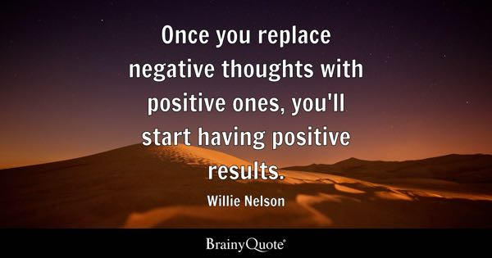

Table
Shambhavi | Paragraph | Done
Samia | Image | Done
Shalvi | Table | Done

