WEEK 1 INTERNSHIP REPORT
BUILDSIGHT BI
A Power BI-Based Business Intelligence Framework for Construction Project Performance
Turning Construction Data into Actionable Intelligence
Strategic Planning for Virtual Construction Intelligence

Internship | Virtual Construction Business Intelligence Intern
Platform | YuvaIntern
Internship period | 24 August 2026 - 5 October 2026 (6 weeks)
Assignment | Week 1: Strategic Planning for Virtual Construction Intelligence
Submitted by | Shalvi Atul Surve
Submitter Organization | Vellore
Submission date | 01.10.2026

BuildSight BI is a conceptual project created for this internship. It is not an existing commercial organization or an implemented product.

Internship Information
Title | Virtual Construction Business Intelligence Intern
Platform | YuvaIntern
Duration | 6 weeks, 24 August 2026 - 5 October 2026
Focus | Applying business intelligence methods to construction scenarios using Microsoft Power BI
Week 1 assignment | Strategic Planning for Virtual Construction Intelligence

Weekly assignments
Week | Assignment
1 | Strategic Planning for Virtual Construction Intelligence (this report)
2 | Data Sourcing, Import, and Transformation for Construction Metrics
3 | Building Advanced Data Models and DAX Calculations
4 | Designing Interactive Power BI Dashboards for Construction Analytics
5 | Implementing Predictive Analytics in Virtual Construction
6 | Comprehensive Evaluation and Performance Metrics Reporting

Project Information
Project name | BuildSight BI
Project title | A Power BI-Based Business Intelligence Framework for Construction Project Performance
Tagline | Turning Construction Data into Actionable Intelligence
Nature | Conceptual framework for a simulated construction organization
Focus areas | Project performance; cost and budget; schedule and progress; workforce productivity; material and procurement; project risk
Market context | India (primary), with international references where relevant
Status at Week 1 | Strategic planning only. No dataset collected; no model, dashboard or prediction built

Executive Summary
Construction is a large part of the Indian economy and one in which cost, schedule, labour and material information is often held in separate records. BuildSight BI is a proposed Power BI-based framework, for a simulated construction organization, that would bring this information into one governed model with standard KPIs. This Week 1 report is a strategic planning document; it does not present any implemented system or analysis.
Research findings. MoSPI's provisional estimates show construction at about 8% of nominal gross value added in FY 2025-26, with real construction GVA of Rs 26.71 lakh crore (2022-23 prices) and 7.4% growth. Union capital expenditure is budgeted at Rs 12.2 lakh crore for 2026-27. MoSPI-monitored central infrastructure projects show a reported cost overrun of Rs 2.88 lakh crore (about 9.4% of original cost) in August 2026, and June 2026 wholesale price inflation ranged from 1.84% for non-metallic mineral products to 12.31% for basic metals.
Proposals. The report proposes six strategic objectives, five stakeholder groups, five use cases (project performance, cost and budget, workforce, material and procurement, and risk) and a KPI framework with defined formulas, noting that CPI and SPI need Earned Value Management data. It outlines a data strategy that separates public market data, internal operational data and possible future demonstration data, and flags unverified sources. Power BI is the central platform, supported by Power Query, DAX, Excel/CSV, Python (future) and the Power BI service.
Future work. A six-week roadmap is proposed. Data preparation, modelling, DAX, dashboards and predictive analytics are planned for Weeks 2-6 and are not claimed as done.

Table of Contents
Internship Information i
Weekly assignments i
Project Information i
Executive Summary ii
Table of Contents iii
List of Figures v
List of Tables vi
Abbreviations vii
Chapter 1: Introduction 1
1.1 Background 1
1.2 Internship Overview 1
1.3 Project Overview 1
1.4 Problem Statement 2
1.5 Project Vision and Objectives 2
1.6 Scope of the Report 3
Chapter 2: Construction Industry Market Analysis 4
2.1 Indian Construction Industry Overview 4
2.2 Industry Growth and Infrastructure Trends 5
2.3 Construction Industry Challenges 5
2.4 Digital Transformation Trends 7
2.5 Market Opportunities 8
2.6 Relevance of Business Intelligence 9
Chapter 3: Proposed BuildSight BI Strategy 10
3.1 Project Vision and Mission 10
3.2 Business Objectives 10
3.3 Stakeholder Analysis 10
3.4 Business Intelligence Requirements 11
3.5 Strategic Priorities 12
Chapter 4: Proposed BI Use Cases 13
4.1 Project Performance Monitoring 13
4.2 Cost and Budget Intelligence 14
4.3 Workforce and Productivity Analytics 14
4.4 Material and Procurement Analytics 15
4.5 Project Risk Intelligence 15
4.6 Use-Case Comparison and Prioritization 15
Chapter 5: KPI Framework 17
5.1 KPI Selection Approach 17
5.2 Financial KPIs 17
5.3 Schedule KPIs 18
5.4 Workforce KPIs 19
5.5 Material and Procurement KPIs 19
5.6 Risk KPIs 19
5.7 KPI-to-Objective Mapping 20
Chapter 6: Data Sourcing and Accessibility 21
6.1 Data Requirements 21
6.2 Publicly Available Market Data 21
6.3 Potential Government and Industry Sources 21
6.4 Operational Data Requirements 22
6.5 Data Accessibility and Limitations 22
Chapter 7: Technology and Power BI Integration 24
7.1 Technology Selection Criteria 24
7.2 Proposed Technology Stack 24
7.3 Power BI Integration Strategy 25
7.4 Proposed BI Architecture 25
7.5 Conceptual Analytical Workflow 26
Chapter 8: Implementation Strategy 27
8.1 Strategic Roadmap 27
8.2 Six-Week Internship Alignment 27
8.3 Future Development Considerations 28
Chapter 9: SWOT and Expected Business Value 29
9.1 SWOT Analysis 29
9.2 Expected Benefits 29
9.3 Risks and Limitations 29
9.4 Proposed Success Criteria 30
Chapter 10: Conclusion 31
References 32
Appendix A: Research Source Register 34
Appendix B: Verification Notes and Limitations of Evidence 35

If page numbers or entries appear blank, right-click the table and choose Update Field (or press F9) in Microsoft Word.

List of Figures
Figure 1 BuildSight BI project identity and analytical focus areas
Figure 2 Construction real GVA (2022-23 to 2025-26) and quarterly growth in FY 2025-26
Figure 3 Union Government capital expenditure: FY 2014-15, FY 2025-26 (BE) and FY 2026-27 (BE)
Figure 4 Original versus revised cost of MoSPI-monitored central infrastructure projects, August 2026
Figure 5 WPI year-on-year inflation for selected groups relevant to construction, June 2026
Figure 6 Industry challenges mapped to proposed BuildSight BI opportunities
Figure 7 Stakeholder-to-information flow
Figure 8 Strategic alignment from industry research to expected outcomes
Figure 9 Five proposed BI use cases as analytical modules
Figure 10 Proposed KPI framework by category and linked objectives
Figure 11 Data accessibility map
Figure 12 Proposed Power BI conceptual architecture
Figure 13 Proposed six-week roadmap
Figure 14 SWOT analysis of the proposed BuildSight BI framework

List of Tables
Table 1 Scope boundaries of the Week 1 report
Table 2 Findings-to-opportunity mapping
Table 3 Strategic business objectives, analytical support and KPIs (proposed)
Table 4 Stakeholder mapping (proposed)
Table 5 Comparison of the five proposed use cases
Table 6 Financial KPIs (proposed)
Table 7 Schedule KPIs (proposed)
Table 8 Workforce KPIs (proposed)
Table 9 Material and procurement KPIs (proposed)
Table 10 Risk KPIs (proposed)
Table 11 Mapping of KPI categories to objectives and use cases
Table 12 Data-source mapping
Table 13 Proposed technology stack (proposal)
Table 14 Power BI compared with Tableau and Looker Studio on project requirements
Table 15 Conceptual Power BI integration stages (proposed)
Table 16 Analytical views by role (conceptual)
Table 17 Roadmap summary
Table 18 Proposed success criteria
Table 19 Research source register (Week 1)

Abbreviations
Abbreviation | Meaning
AC | Actual Cost
BAC | Budget at Completion
BE | Budget Estimate
BI | Business Intelligence
BIM | Building Information Modelling
CPI | Cost Performance Index
CPWD | Central Public Works Department
CSV | Comma-Separated Values
CV | Cost Variance
DAX | Data Analysis Expressions
EAC | Estimate at Completion
EV | Earned Value
EVM | Earned Value Management
FRE | First Revised Estimate
FY | Financial Year
GFCF | Gross Fixed Capital Formation
GVA | Gross Value Added
IoT | Internet of Things
KPI | Key Performance Indicator
MoSPI | Ministry of Statistics and Programme Implementation
PE | Provisional Estimate
PLFS | Periodic Labour Force Survey
PPU | Premium Per User
PV | Planned Value
SPI | Schedule Performance Index
SV | Schedule Variance
SWOT | Strengths, Weaknesses, Opportunities, Threats
UC | Use Case
WPI | Wholesale Price Index

Chapter 1: Introduction

1.1 Background
Construction is a project-based industry in which cost, schedule, labour and material information is generated continuously but is often recorded in separate places: site registers, accounting entries, procurement files and planning schedules. When these records are not brought together, a manager can see individual numbers but not the overall health of a project. Business intelligence (BI) addresses this gap by combining data from different sources into a single, governed model and presenting it through interactive reports.
This report is the first deliverable of a six-week virtual internship in construction business intelligence. It is a strategic planning document. It sets out what should be built, why it is needed and how it could be approached. It does not present a finished data model, dashboard or predictive result; those belong to later weeks.

1.2 Internship Overview
Internship title | Virtual Construction Business Intelligence Intern
Platform | YuvaIntern
Internship period | 24 August 2026 - 5 October 2026 (six weeks)
Primary tool | Microsoft Power BI
This submission | Week 1: Strategic Planning for Virtual Construction Intelligence

The six weekly assignments progress from planning to evaluation: Week 1 strategic planning; Week 2 data sourcing, import and transformation; Week 3 data models and DAX calculations; Week 4 interactive dashboards; Week 5 predictive analytics; and Week 6 comprehensive evaluation and performance-metrics reporting.

1.3 Project Overview
BuildSight BI is a proposed, conceptual BI framework for a simulated construction organization. Its tagline is Turning Construction Data into Actionable Intelligence. It was created specifically for this internship; it is not an existing commercial organization or an implemented product. The framework is organized around five analytical focus areas, shown in Figure 1: project performance, cost and budget, workforce productivity, material and procurement, and project risk.
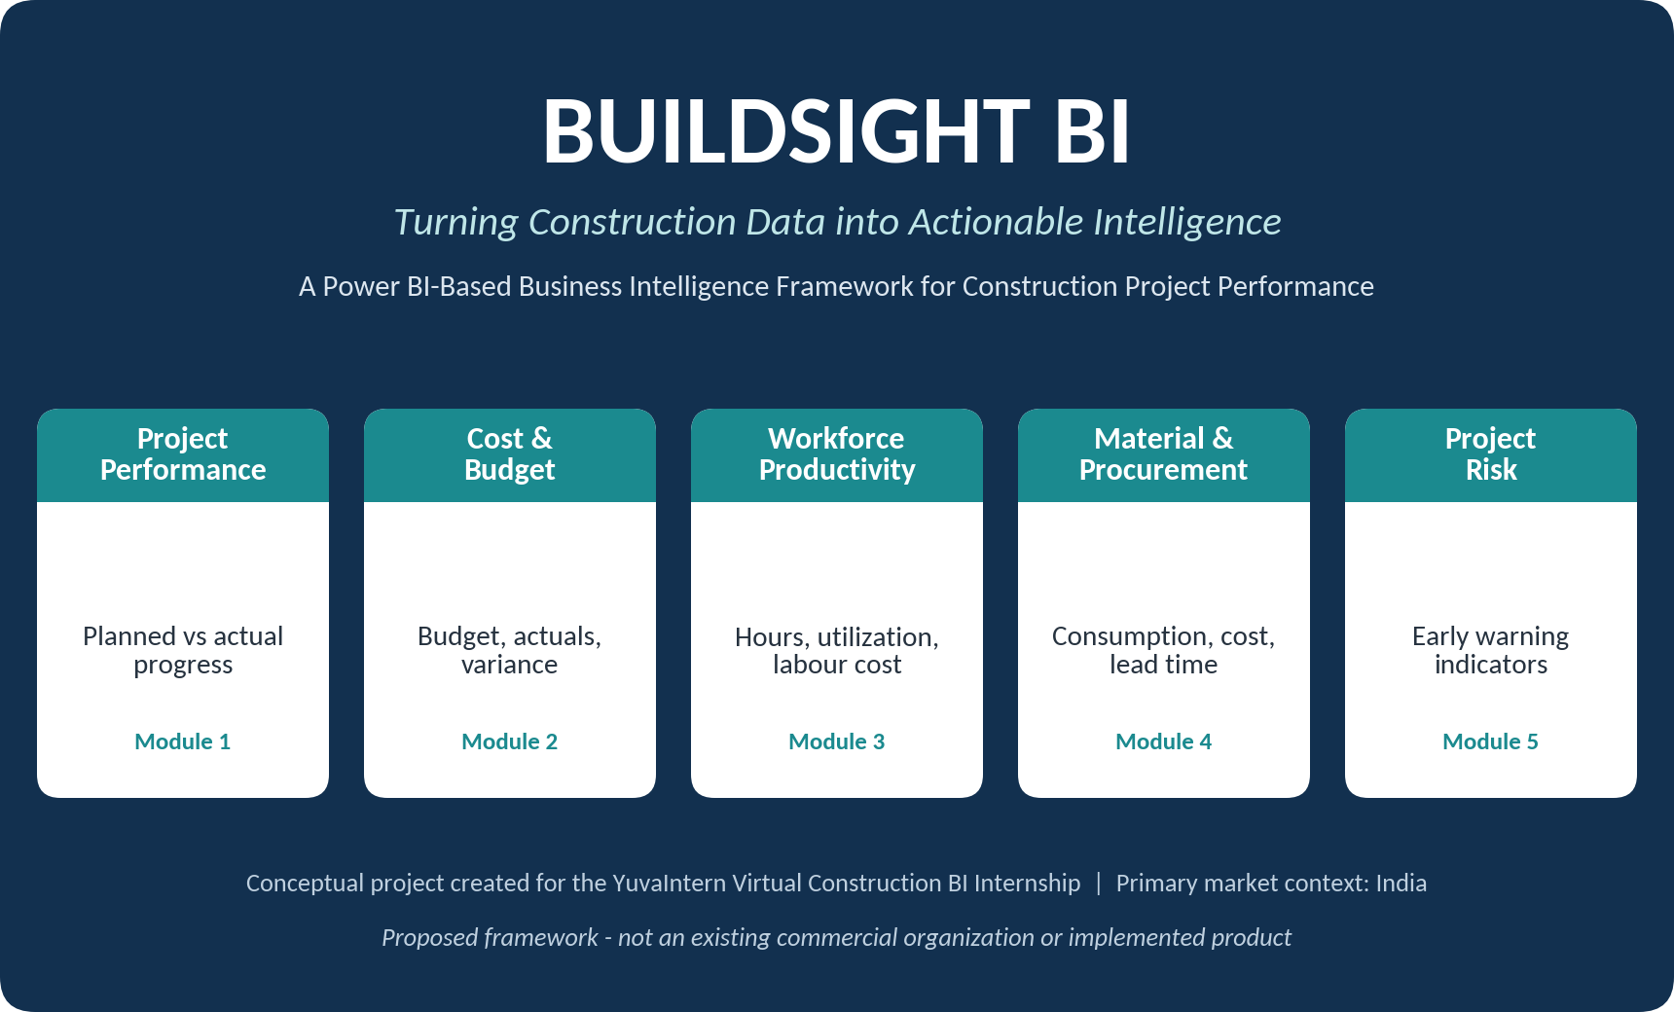
Figure 1: BuildSight BI project identity and analytical focus areas
Source: Prepared by the author (conceptual design).
India is the primary market context, because the internship is based in India and Indian government statistical publications provide authoritative, recent evidence. International sources are used only as supplementary references and are labelled as such.

1.4 Problem Statement
PROPOSAL Central business problem (proposed). In a typical construction organization, financial, operational, workforce, material and scheduling information sits in separate records and systems. Managers therefore find it difficult to obtain a unified, timely and consistent view of how each project is performing against plan. Without that view, cost and schedule deviations tend to be discovered late, resource decisions rely on partial information, and performance cannot be compared fairly across projects.
This problem statement is a planning premise derived from the market evidence in Chapter 2 and from the structure of project data. It is not itself an empirical finding about any specific organization. Chapter 2 separates what is evidenced (for example, reported cost and time overruns in monitored infrastructure projects) from what is inferred (for example, that fragmented data contributes to late visibility).

1.5 Project Vision and Objectives
Vision. To give construction managers a single, trusted and interactive view of project performance so that deviations are seen early and decisions are made on evidence.
Objectives of this Week 1 report are to: (i) establish the market and business context with verified research; (ii) define strategic objectives, stakeholders and use cases; (iii) propose a KPI framework; (iv) identify data requirements and realistic data sources; (v) select technology and propose a Power BI integration approach; and (vi) outline a roadmap for Weeks 2-6.

1.6 Scope of the Report
Table 1: Scope boundaries of the Week 1 report
In scope (Week 1) | Out of scope (later weeks)
Market analysis and research findings  Strategic objectives and stakeholders  Five use cases at planning level  KPI definitions and formulas  Data requirements and source strategy  Technology selection and conceptual architecture  Roadmap and SWOT | Dataset creation, import and cleaning (Week 2)  Power Query transformations (Week 2)  Data modelling and DAX measures (Week 3)  Dashboard design and build (Week 4)  Predictive modelling (Week 5)  Evaluation of results (Week 6)
Source: Prepared by the author.

Chapter 2: Construction Industry Market Analysis
This chapter presents verified research on the Indian construction industry and links each major finding to a business challenge, an analytical requirement and a BuildSight BI opportunity. Statistics are given with their year, coverage and source. Where a figure comes from a secondary summary rather than the original publication, this is stated.

2.1 Indian Construction Industry Overview
RESEARCH FINDING According to the National Statistics Office, Ministry of Statistics and Programme Implementation (MoSPI), construction accounted for about 8% of nominal gross value added (GVA) in FY 2025-26, and its real GVA was estimated at Rs 26.71 lakh crore at constant 2022-23 prices (provisional estimates, 5 June 2026). Growth was 7.4% in FY 2025-26, following 7.3% in FY 2024-25 and 9.9% in FY 2023-24 (MoSPI, 2026a).
Using the same MoSPI series, construction real GVA rose from Rs 21.09 lakh crore in 2022-23 to Rs 26.71 lakh crore in 2025-26, a cumulative increase of roughly 27% (author's calculation from MoSPI, 2026a). Gross fixed capital formation was about 32% of GDP at constant prices in FY 2025-26, which shows how large a share of national output is directed to building assets (MoSPI, 2026a).
A methodological note is important. MoSPI released a new national accounts series with base year 2022-23 on 27 February 2026, replacing the 2011-12 base (MoSPI, 2026b). Figures from the new series should not be compared directly with older published growth rates; this report uses only the new-series values from the June 2026 press note.
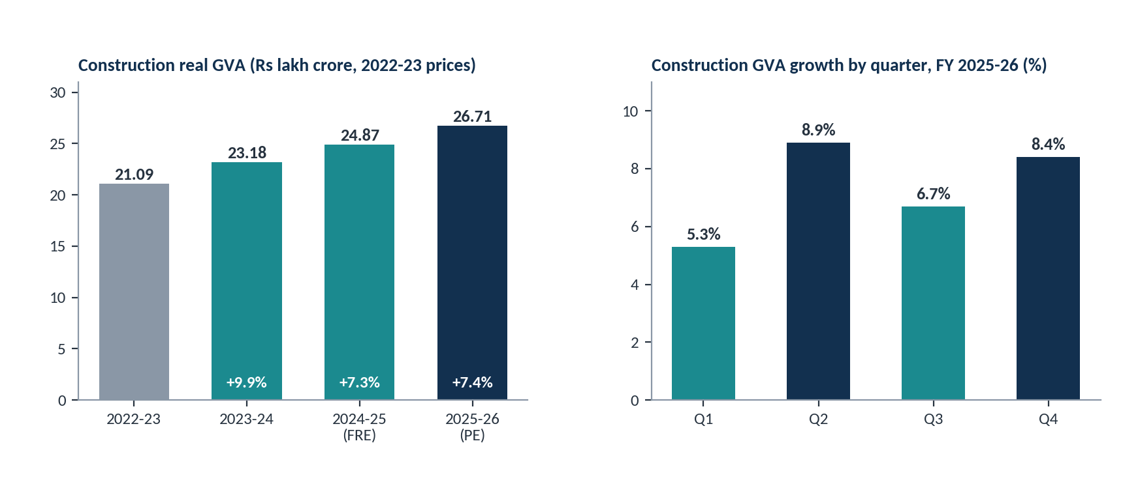
Figure 2: Construction real GVA (2022-23 to 2025-26) and quarterly growth in FY 2025-26
Source: MoSPI (2026a), Statements 3 and 6. FRE = First Revised Estimate; PE = Provisional Estimate. India, constant 2022-23 prices.
RESEARCH FINDING Construction is also a large source of employment. A summary of the MoSPI Periodic Labour Force Survey (PLFS) Annual Report 2025 reports construction at about 12.0% of workers in 2025, marginally lower than 12.3% in 2024 (Vision IAS, 2026). This figure is taken from a secondary summary and should be checked against the original PLFS report before any formal use.

2.2 Industry Growth and Infrastructure Trends
RESEARCH FINDING The Union Budget 2026-27, presented on 1 February 2026, set central government capital expenditure at Rs 12.2 lakh crore, up from Rs 11.2 lakh crore budgeted for 2025-26. The Finance Minister noted that this compares with about Rs 2 lakh crore in 2014-15 (Outlook Business, 2026; IANS, 2026).
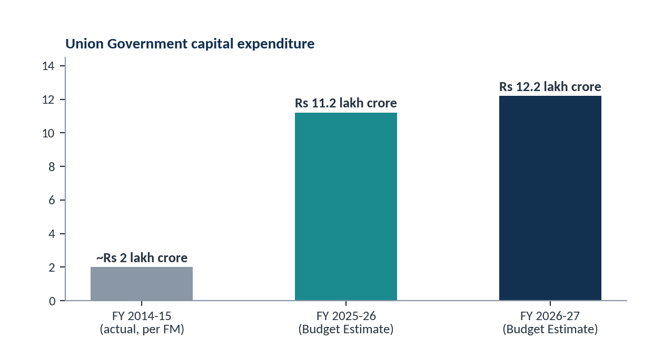
Figure 3: Union Government capital expenditure: FY 2014-15, FY 2025-26 (BE) and FY 2026-27 (BE)
Source: Outlook Business (2026), reporting the Union Budget 2026-27 speech. BE = Budget Estimate. Only these three verified points are plotted; intermediate years are not shown.
The Economic Survey 2025-26, as summarized by Indian Infrastructure (2026), reports a national highway construction target of 10,000 km for 2025-26, with about 4,938 km completed by December 2025, and a public-private partnership pipeline of 13,400 km with an estimated cost of Rs 8.3 trillion. The same summary describes infrastructure spending as shifting from asset creation toward integrated, system-level development (India Brand Equity Foundation [IBEF], n.d.). The original Economic Survey document was not directly accessed for this report (see Appendix B).
Material-demand indicators in the MoSPI press note point the same way: the cement production index grew 8.7% and finished steel consumption grew 8.0% during FY 2025-26 (MoSPI, 2026a, Annexure).

2.3 Construction Industry Challenges

Project delays and cost overruns
RESEARCH FINDING In its August 2026 monthly report, MoSPI's infrastructure project monitoring covered 1,731 ongoing central-sector projects each costing Rs 150 crore or more. Their combined revised cost was Rs 33.60 lakh crore against an original cost of Rs 30.72 lakh crore, a reported cumulative cost overrun of Rs 2.88 lakh crore, or about 9.4% of original cost (author's calculation). Cumulative expenditure was Rs 16.33 lakh crore, or 48.59% of revised cost. The report did not state how many individual projects exceeded their budgets (PSU Watch, 2026).
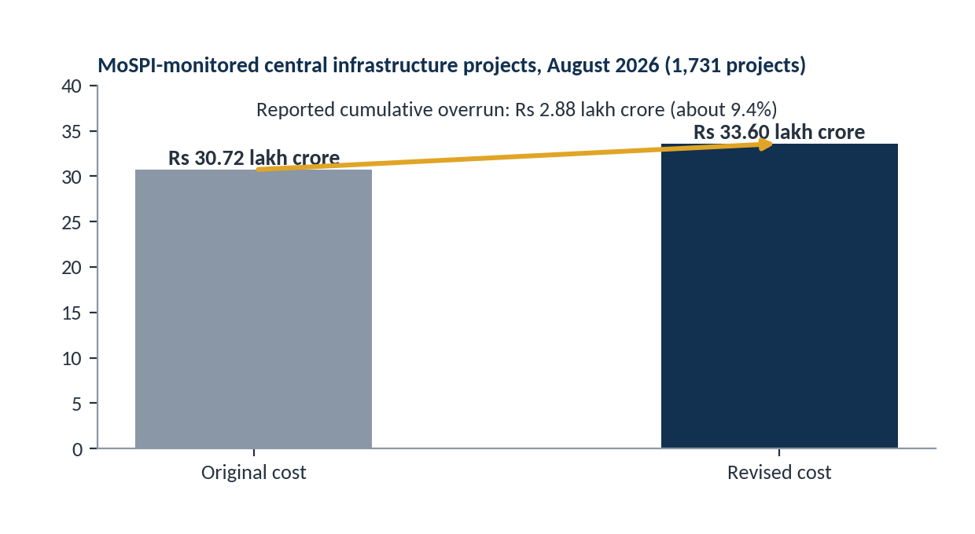
Figure 4: Original versus revised cost of MoSPI-monitored central infrastructure projects, August 2026
Source: PSU Watch (2026), reporting the MoSPI August 2026 flash report. Central-sector projects of Rs 150 crore and above; not private building contractors. Original MoSPI report not directly accessed.
Two cautions apply. First, these are large central-sector infrastructure projects, not the portfolio of a typical building contractor, so they are an indicator of the delivery challenge in India, not a direct benchmark for BuildSight BI. Second, monthly totals vary with the set of projects monitored; for example, a June 2026 report covered 1,847 projects with a larger reported overrun (Millennium Post, 2026). The figures are therefore treated as indicative.
RESEARCH FINDING An earlier MoSPI report (January 2024) attributed delays to land acquisition, forest and environmental clearances and missing infrastructure linkages, and cautioned that overruns are probably under-reported because many agencies do not report revised costs or commissioning schedules (Deccan Herald, 2024). This is relevant to BuildSight BI in two ways: some delay causes are external and cannot be solved by analytics, but incomplete reporting is a data problem that a standardized BI framework is designed to reduce.

Material price fluctuations
RESEARCH FINDING The Office of the Economic Adviser reported all-commodity Wholesale Price Index (WPI, base 2022-23) inflation of 9.87% year-on-year for June 2026 (provisional). Basic metals rose 12.31%, fabricated metal products 6.12%, rubber and plastic products 9.94% and fuel and power 27.41%, while other non-metallic mineral products (a group that includes cement) rose only 1.84% (Office of the Economic Adviser, 2026).
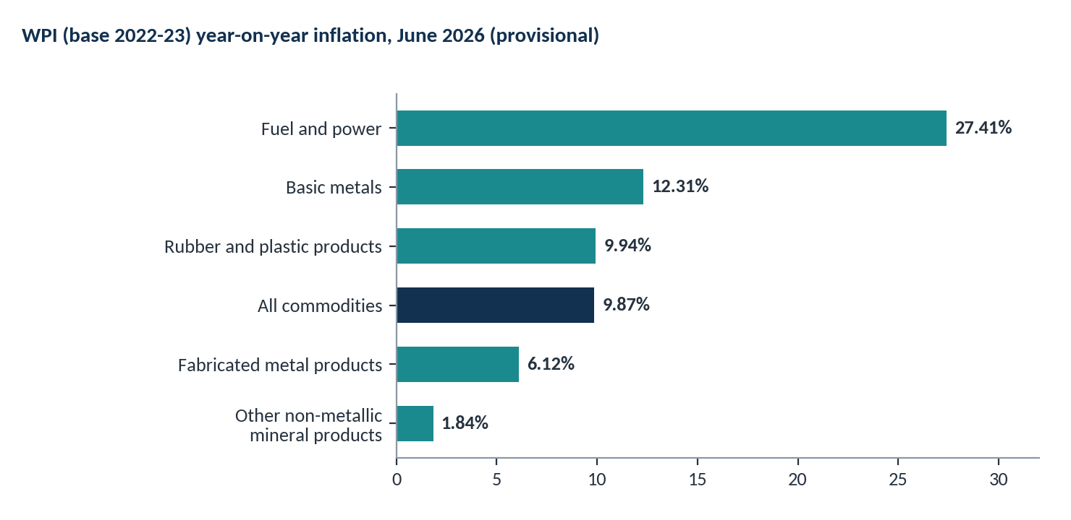
Figure 5: WPI year-on-year inflation for selected groups relevant to construction, June 2026
Source: Office of the Economic Adviser (2026), Annexure II. India, provisional estimates, base year 2022-23. Groups are indicative of, not identical to, construction material baskets.
The spread between groups shows why material cost cannot be managed with a single average: steel-related and energy-linked inputs moved very differently from mineral products. A construction organization needs item-level tracking against its own budgeted rates.

Labour productivity and resource allocation
RESEARCH FINDING At global level, McKinsey Global Institute reported that construction labour-productivity growth averaged about 1% a year over two decades, compared with 2.8% for the world economy (McKinsey Global Institute, 2017). McKinsey (2016) also reported that large projects typically take 20% longer than scheduled and run up to 80% over budget. Both are global, older figures and are used here only as international context, not as Indian evidence.
Deloitte's 2026 outlook for the engineering and construction sector, which is United States-focused, lists rising material costs, persistent labour shortages and shifting project demand among the pressures on firms, and presents digital transformation as one way to improve efficiency (Deloitte, 2026). India-specific verified labour-wage data from the Labour Bureau were not accessed in Week 1 and are listed for further investigation in Chapter 6.

Fragmented operational data and delayed reporting
PROPOSAL No verified Indian statistic on how fragmented contractor data is was found in Week 1, so this challenge is presented as a planning premise, supported indirectly by the MoSPI observation on under-reporting above. It will be tested in later weeks by documenting how data must be combined across sources.

2.4 Digital Transformation Trends
RESEARCH FINDING McKinsey (2016) identified five trends expected to shape construction and capital projects: higher-definition surveying and geolocation, 5D building information modelling (BIM), digital collaboration and mobility, the internet of things and advanced analytics, and future-proof design and construction. Deloitte (2026) describes digital transformation as a way to offset labour shortages and rising costs, and notes growing use of safety-focused computer vision.
For BuildSight BI the relevant trend is the move toward data-driven management: using consistent data and analytics to monitor projects rather than relying on periodic manual reports. BIM, IoT and advanced analytics appear in this report only as future extensions (Chapter 9), because the internship scope is a Power BI-based framework.

2.5 Market Opportunities
Table 2 applies the required chain Industry Finding → Business Challenge → Analytical Requirement → BuildSight BI Opportunity to each major finding. Figure 6 summarizes the challenge-to-opportunity mapping.
Table 2: Findings-to-opportunity mapping
Industry finding (source) | Business challenge | Analytical requirement | BuildSight BI opportunity
Central capex raised to Rs 12.2 lakh crore for 2026-27 (Outlook Business, 2026) | Many concurrent projects compete for management attention | Cross-project comparison on common measures | Portfolio view; project ranking by performance (UC1, UC5)
Monitored infrastructure projects show Rs 2.88 lakh crore overrun, Aug 2026 (PSU Watch, 2026) | Cost and time deviations accumulate before they are acted on | Planned-versus-actual tracking at project level | Cost and schedule monitoring (UC1, UC2)
Wide spread in WPI inflation across material groups, June 2026 (Office of the Economic Adviser, 2026) | Material price volatility erodes budgets unevenly | Item-level material cost against budgeted rates | Material and procurement analytics (UC4)
Slow construction labour-productivity growth globally (McKinsey Global Institute, 2017) | Labour inefficiency is hard to see without hours data | Labour hours, utilization and output measures | Workforce and productivity analytics (UC3)
Agencies under-report revised costs and schedules (Deccan Herald, 2024) | Inconsistent, incomplete reporting weakens visibility | Standard definitions and one governed data model | Centralized KPI reporting; risk flags (UC5)
Source: Prepared by the author from the cited sources. Mapping from finding to opportunity is a proposal.
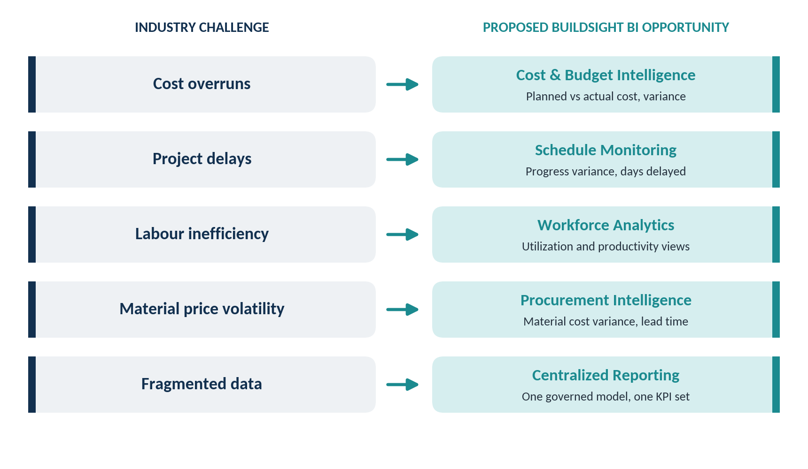
Figure 6: Industry challenges mapped to proposed BuildSight BI opportunities
Source: Prepared by the author. Mapping is a proposal based on Chapter 2 research.

2.6 Relevance of Business Intelligence
The evidence supports a measured conclusion. Public investment in construction is large and rising, delivery performance in monitored projects shows visible cost and schedule deviations, and input prices vary widely by material. These conditions create a need for timely, consistent performance information. They do not prove that any particular BI tool will reduce overruns. BuildSight BI is therefore positioned as an enabler of earlier visibility and better-informed decisions, with outcomes to be assessed in Week 6.
Microsoft's BI strategic-planning guidance recommends starting from business objectives, keeping the initial scope small, and treating the strategy as iterative (Microsoft, 2024). This report follows that approach.

Chapter 3: Proposed BuildSight BI Strategy
This chapter converts the research in Chapter 2 into a proposed strategy. Everything in it is a proposal developed for BuildSight BI and is labelled accordingly.

3.1 Project Vision and Mission
PROPOSAL Vision: Every construction decision-maker in the organization works from one trusted, current view of project performance.
PROPOSAL Mission: Organize cost, schedule, workforce, material and risk information into a consistent Power BI model with standard KPIs, so that deviations are visible early and decisions are supported by evidence.

3.2 Business Objectives
Six strategic objectives are proposed. They follow the objectives-and-key-results style described in Microsoft's BI strategic-planning guidance, in which each objective is linked to measurable results (Microsoft, 2024). The objectives are measurable in principle; no improvement targets are claimed at this stage.
Table 3: Strategic business objectives, analytical support and KPIs (proposed)
# | Objective | Business problem | Proposed analytical support | Relevant KPI
O1 | Improve project cost visibility | Budget and actual cost are tracked separately, so overruns surface late | Budget-versus-actual cost views by project and cost category | Cost Variance; Cost Variance %; Budget Utilization
O2 | Standardize project progress monitoring | Progress is reported in different ways by different teams | One progress definition and planned-versus-actual comparison | Planned Progress %; Actual Progress %; Schedule Variance
O3 | Enable consistent performance measurement | Projects cannot be compared fairly without common definitions | Single KPI dictionary applied through shared measures | CPI and SPI (where EVM data exist); Days Delayed
O4 | Improve workforce and resource analysis | Labour effort and idle time are not linked to output | Labour hours, utilization and output analysis | Labour Hours; Workforce Utilization; Labour Productivity
O5 | Strengthen material and procurement monitoring | Price movements and long lead times are noticed after purchase | Material cost against budget; lead-time analysis by supplier | Material Cost Variance; Procurement Lead Time
O6 | Support early identification of project risks | Risk is judged informally and inconsistently | Rule-based risk flags from cost and schedule indicators | High-Risk Projects; Cost Overrun Risk; Schedule Delay Risk
Source: Prepared by the author (proposal).

3.3 Stakeholder Analysis
Five intended user groups are identified. Microsoft advises engaging stakeholders at different organizational levels, not only executives, so that the solution reflects day-to-day needs (Microsoft, 2024). In this internship the stakeholders are simulated roles; their needs are assumptions to be validated in a real engagement.
Table 4: Stakeholder mapping (proposed)
Stakeholder | Responsibilities | Key business questions | Decisions to support | Relevant KPIs
Project Manager | Delivery of scope on time; site coordination | Which activities are behind plan? What is causing delay? | Re-plan, re-sequence, request resources | Planned vs Actual Progress; Schedule Variance; Days Delayed; SPI
Finance Manager | Budget control and cost reporting | Where are we over budget? What will the final cost be? | Release or hold funds; re-forecast | Cost Variance %; Budget Utilization; CPI
Operations Manager | Labour and equipment deployment across sites | Are crews fully utilized? Where is productivity low? | Reallocate crews; adjust shifts | Labour Hours; Workforce Utilization; Labour Productivity
Procurement Manager | Purchasing, supplier performance, material availability | Which materials are costing more than budgeted? Which suppliers are late? | Reorder, change supplier, lock rates | Material Cost Variance; Procurement Lead Time; Material Consumption
Senior Management | Portfolio performance and strategic priorities | Which projects need attention? How do projects compare? | Prioritize, escalate, invest | High-Risk Projects; portfolio roll-up of cost and schedule KPIs
Source: Prepared by the author (proposal). Roles and needs are simulated assumptions.
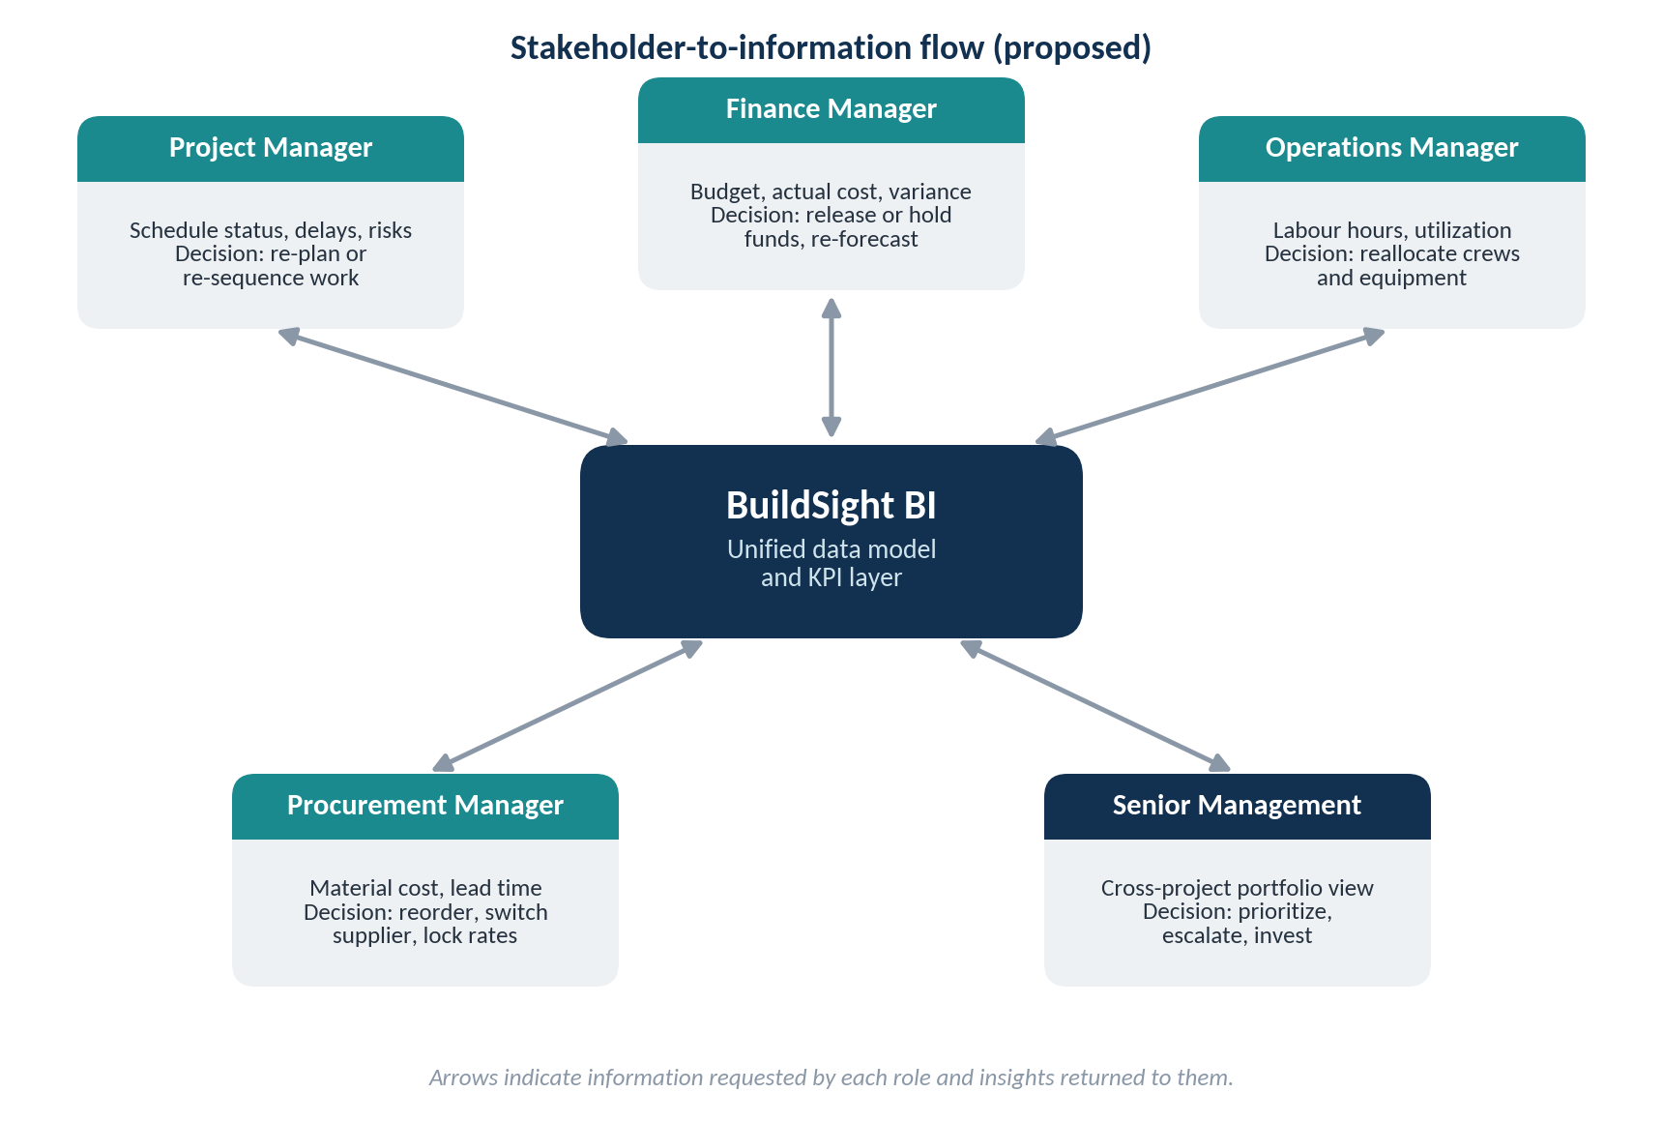
Figure 7: Stakeholder-to-information flow
Source: Prepared by the author (conceptual).

3.4 Business Intelligence Requirements
From the objectives and stakeholder questions, the following high-level requirements are proposed. They are expressed at a planning level; detailed specifications are deferred to Weeks 2-4.
- Single view: a combined view of cost, schedule, workforce, material and risk information for each project.
- Standard definitions: every KPI has one documented formula and one data owner.
- Drill-down: movement from portfolio to project to cost category or activity.
- Role-based views: different starting views for the five stakeholder groups, with access control where needed.
- Data quality visibility: missing or inconsistent source records are made visible, not hidden.
- Refresh and traceability: a defined refresh routine and a way to trace each figure to its source.

3.5 Strategic Priorities
Priorities are set by dependency and value. Cost and schedule monitoring (Use Cases 1 and 2) are proposed first because the other modules build on project, cost and progress data. Workforce and material analytics (Use Cases 3 and 4) follow. Risk intelligence (Use Case 5) depends on the indicators produced by the others and is therefore last. Figure 8 shows the intended traceability from research to outcomes.
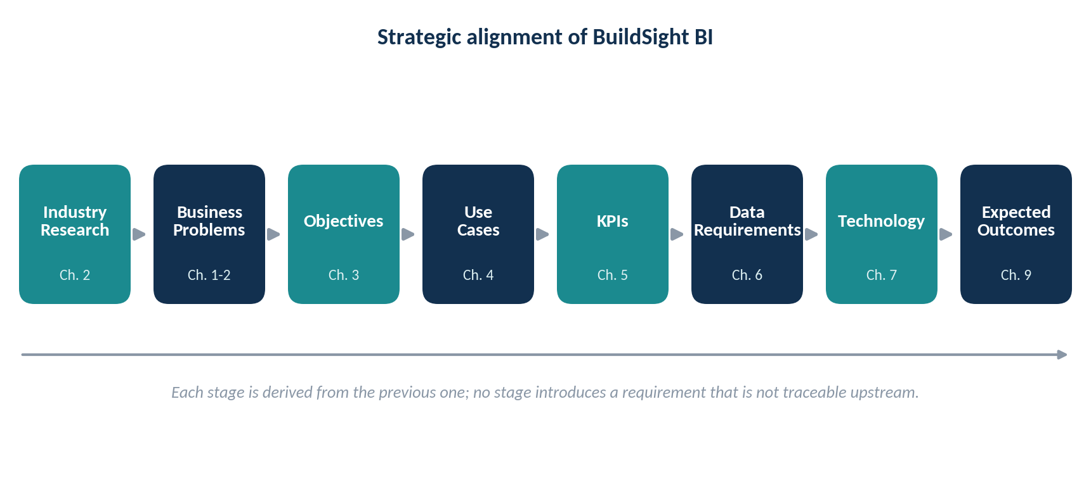
Figure 8: Strategic alignment from industry research to expected outcomes
Source: Prepared by the author (conceptual). Chapter references show where each stage is developed.

Chapter 4: Proposed BI Use Cases
Five use cases are proposed. The assignment requires at least three; five give enough strategic depth to cover the main management questions in a construction organization. Each use case is described at planning level. No dashboards are designed and no calculations are performed here. Figure 9 shows the five use cases as distinct analytical modules.
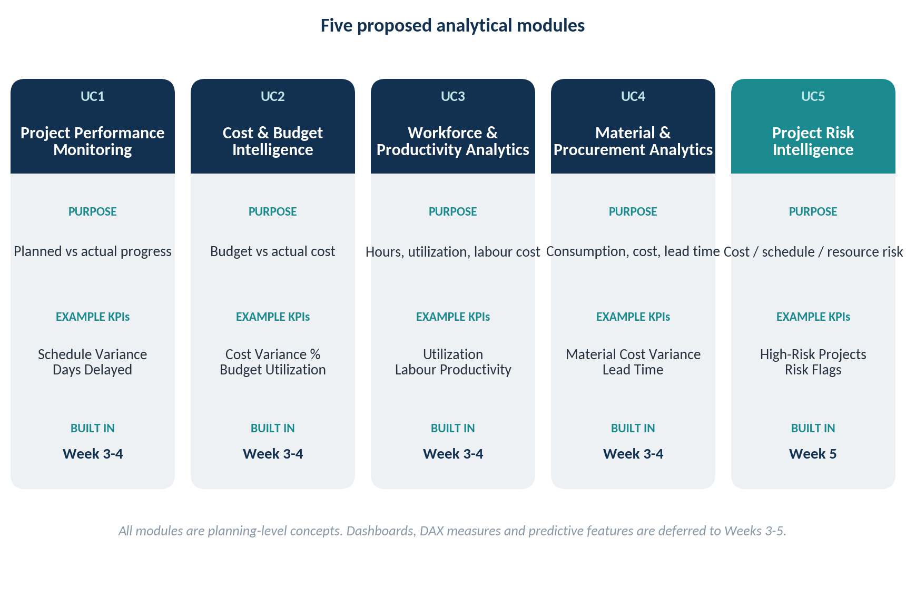
Figure 9: Five proposed BI use cases as analytical modules
Source: Prepared by the author (conceptual).

4.1 Project Performance Monitoring
Business context | Project managers and senior management need to know whether work is progressing as planned.
Problem addressed | Schedule deviations are noticed late because planned and actual progress are held in separate files or reported inconsistently.
Objective | Monitor planned versus actual progress and identify schedule deviations (supports O2, O3).
Target users | Project Manager; Operations Manager; Senior Management.
Required information | Project timelines (baseline start and finish); planned progress; actual progress; completion status; reasons for delay.
Proposed KPIs | Planned Progress %; Actual Progress %; Schedule Variance; Days Delayed; SPI where EVM data exist.
Proposed Power BI approach | A progress fact table linked to project and calendar tables; shared measures comparing planned and actual progress over time; filters by project, phase and status.
Decisions supported | Whether to re-plan, re-sequence activities or add resources.
Expected (potential) benefits | Earlier sight of delay; one agreed definition of progress.
Connection to later weeks | Week 2: prepare progress data. Week 3: measures. Week 4: progress views.

4.2 Cost and Budget Intelligence
Business context | Finance and project teams must control expenditure against approved budgets.
Problem addressed | Budget and actual expenditure are compared manually and late, so overruns are found after money is spent.
Objective | Provide visibility of expenditure and financial deviations (supports O1, O3).
Target users | Finance Manager; Project Manager; Senior Management.
Required information | Planned budget; actual expenditure; cost categories; project-level cost records; for EVM, earned value.
Proposed KPIs | Total Budget; Actual Cost; Cost Variance; Cost Variance %; Budget Utilization; CPI where suitable EVM data exist.
Proposed Power BI approach | A cost fact table by project, category and period; measures for variance and utilization; comparison across projects.
Decisions supported | Fund release, re-forecasting, cost-control action.
Expected (potential) benefits | Clearer view of where spending departs from budget; consistent cost reporting.
Connection to later weeks | Week 2: cost data preparation. Week 3: variance and CPI measures. Week 4: cost views.

4.3 Workforce and Productivity Analytics
Business context | Labour is a major cost and a major source of schedule risk.
Problem addressed | Labour hours are recorded but not linked to productive output, so under-use and idle time are hard to see.
Objective | Understand workforce allocation, utilization and productivity (supports O4).
Target users | Operations Manager; Project Manager.
Required information | Labour hours; productive hours; workforce categories; labour cost; output quantities (for productivity).
Proposed KPIs | Total Labour Hours; Workforce Utilization; Labour Productivity.
Proposed Power BI approach | A labour fact table by project, trade and date; utilization and productivity measures; trend and comparison views.
Decisions supported | Crew reallocation, shift planning, training or supervision focus.
Expected (potential) benefits | Visibility of where labour effort is not converting to output.
Connection to later weeks | Week 2: labour data preparation. Week 3: measures. Week 4: workforce views. Week 5: possible productivity forecasting.

4.4 Material and Procurement Analytics
Business context | Material is a large share of construction cost, and WPI data show that prices move unevenly (Chapter 2).
Problem addressed | Price changes and long delivery times are noticed after orders are placed.
Objective | Monitor material expenditure and procurement performance (supports O5).
Target users | Procurement Manager; Finance Manager; Project Manager.
Required information | Material quantities; material costs; budgeted rates; purchase orders and delivery dates; supplier information.
Proposed KPIs | Material Consumption; Material Cost; Material Cost Variance; Procurement Lead Time.
Proposed Power BI approach | Purchase and consumption fact tables linked to material and supplier dimensions; variance and lead-time measures; optional benchmark against public WPI indices.
Decisions supported | Reordering, supplier change, early bulk purchase.
Expected (potential) benefits | Earlier view of cost pressure by material; supplier comparison.
Connection to later weeks | Week 2: procurement and WPI data preparation. Week 3: measures. Week 4: material views.

4.5 Project Risk Intelligence
Business context | Management needs to know which projects are most likely to miss budget or schedule.
Problem addressed | Risk is judged informally, and warning signs in cost and schedule data are not combined.
Objective | Support identification of projects with financial, scheduling or operational risk (supports O6).
Target users | Senior Management; Project Manager; Finance Manager.
Required information | Outputs of Use Cases 1-4: cost deviation, schedule deviation, resource constraints; risk categories and a risk register.
Proposed KPIs | Number of High-Risk Projects; Cost Overrun Risk; Schedule Delay Risk.
Proposed Power BI approach | Rule-based flags with thresholds agreed with stakeholders; a portfolio watch-list view.
Decisions supported | Escalation, additional review, contingency allocation.
Expected (potential) benefits | A consistent, transparent way to flag projects for attention.
Connection to later weeks | Week 4: watch-list design. Week 5: rule-based flags are the baseline against which predictive approaches (for example, forecasting cost or delay) could be explored.

4.6 Use-Case Comparison and Prioritization
Table 5: Comparison of the five proposed use cases
Use case | Primary users | Core data | Key KPIs | Dependency | Priority
UC1 Project Performance | Project Manager | Progress, schedule | Schedule Variance; Days Delayed | Project master data | High
UC2 Cost and Budget | Finance Manager | Budget, actual cost | Cost Variance %; Budget Utilization | Project master data | High
UC3 Workforce | Operations Manager | Hours, labour cost, output | Utilization; Productivity | Project and trade data | Medium
UC4 Material and Procurement | Procurement Manager | Quantities, cost, orders | Material Cost Variance; Lead Time | Project and supplier data | Medium
UC5 Risk | Senior Management | Outputs of UC1-4 | High-Risk Projects | UC1-UC4 | Later (Week 5)
Source: Prepared by the author (proposal). Priority reflects dependency order, not importance to the business.

Chapter 5: KPI Framework

5.1 KPI Selection Approach
Each proposed KPI must (i) support at least one strategic objective, (ii) have a single unambiguous formula, (iii) be computable from data that an organization can realistically hold, and (iv) lead to a decision. KPIs are grouped into five categories matching the use cases. The framework is a proposed measurement design. No KPI values are calculated or invented in this report.
Earned Value Management (EVM) metrics require three quantities defined on the same baseline: planned value (PV), earned value (EV) and actual cost (AC). Cost Performance Index (CPI = EV / AC) and Schedule Performance Index (SPI = EV / PV) are meaningful only if EV is measured using an agreed rule for crediting completed work (Project Management Institute, n.d.). Where such data do not exist, these two indices are not calculated and simpler budget-based variances are used.
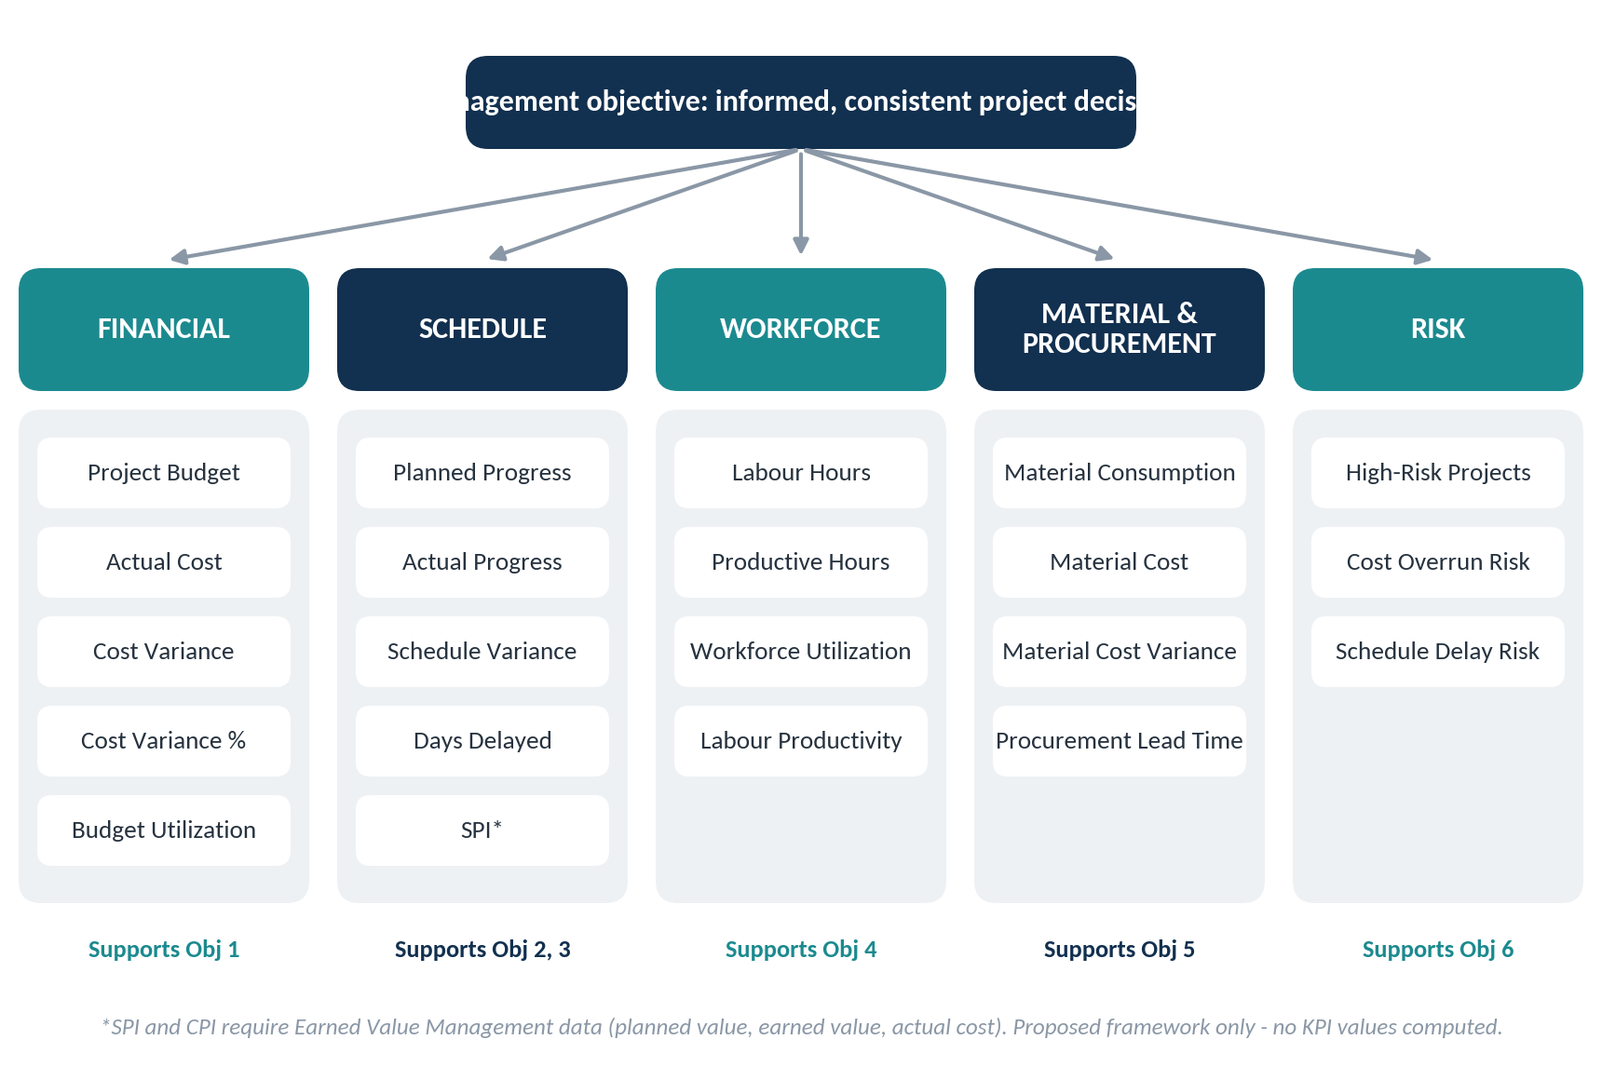
Figure 10: Proposed KPI framework by category and linked objectives
Source: Prepared by the author (proposal). Objective numbers refer to Table 3.

5.2 Financial KPIs
Table 6: Financial KPIs (proposed)
KPI | Meaning | Formula / definition | Required information | Unit | Business relevance
Project Budget | Approved total budget (budget at completion, BAC) | Approved baseline budget for the project | Approved budget by project and cost category | Rs | Reference point for all cost KPIs
Actual Cost (AC) | Cost incurred to date | Sum of recorded expenditure to the status date | Cost ledger by project, category, date | Rs | Shows what has been spent
Cost Variance (CV) | Difference between budgeted cost of work performed and actual cost | CV = EV - AC. Positive = under budget; negative = over budget. Without EVM data: Budget Variance = Budgeted cost for the period - AC | EV (or period budget) and AC on the same basis | Rs | Direct measure of cost deviation (O1)
Cost Variance % | CV relative to the budgeted cost of work performed | Cost Variance % = (CV / EV) x 100 | EV (or period budget), AC | % | Allows comparison across projects of different size
Budget Utilization | Share of total budget already spent | Budget Utilization = (AC / BAC) x 100 | AC, BAC | % | Shows spend relative to total budget; interpret with progress, since high utilization may be normal late in a project
Source: Prepared by the author; EVM relationships per Project Management Institute (n.d.).

5.3 Schedule KPIs
Table 7: Schedule KPIs (proposed)
KPI | Meaning | Formula / definition | Required information | Unit | Business relevance
Planned Progress | Share of work planned to be complete by the status date | Planned Progress % = (PV / BAC) x 100, or planned % complete from the baseline schedule | Baseline schedule; planned value | % | Reference for progress comparison (O2)
Actual Progress | Share of work actually complete | Actual Progress % = (EV / BAC) x 100, or measured % complete using a defined rule | Progress measurements; earning rule | % | Shows real status
Schedule Variance (SV) | Gap between actual and planned progress | Progress points: Actual % - Planned %. EVM form: SV = EV - PV (Rs). Negative = behind plan | Planned and actual progress | % points or Rs | Identifies slippage
Days Delayed | Calendar days a project or activity is late | Days Delayed = max(0, forecast or actual finish date - baseline finish date) | Baseline and forecast/actual dates | Days | Easily understood measure of delay
Schedule Performance Index (SPI) | Schedule efficiency | SPI = EV / PV. SPI < 1 = behind plan; > 1 = ahead | Valid EVM data (PV, EV on one baseline); PV > 0 | Ratio | Compact comparison across projects (O3). Only where EVM data exist
Source: Prepared by the author; SPI and SV per Project Management Institute (n.d.).

5.4 Workforce KPIs
Table 8: Workforce KPIs (proposed)
KPI | Meaning | Formula / definition | Required information | Unit | Business relevance
Labour Hours | Total labour effort booked | Sum of hours recorded in timesheets or attendance records | Timesheets by worker, trade, project, date | Hours | Basis for workforce analysis (O4)
Productive Hours | Hours spent on value-adding work | Hours coded to productive tasks (excluding idle, waiting and rework time) | Hours classified by activity type | Hours | Separates effort from useful effort; needs a clear coding rule
Workforce Utilization | Share of labour hours that were productive | Utilization = (Productive Hours / Total Labour Hours) x 100 | Productive and total hours | % | Shows idle or lost time
Labour Productivity | Output per unit of labour | Productivity = Output quantity completed / Labour Hours (for example, m3 of concrete per hour) | Output quantities by activity; labour hours | Units per hour | Core efficiency measure; compare only like with like
Source: Prepared by the author (proposal).

5.5 Material and Procurement KPIs
Table 9: Material and procurement KPIs (proposed)
KPI | Meaning | Formula / definition | Required information | Unit | Business relevance
Material Consumption | Quantity of material used | Sum of quantities issued or used in a period; compare with planned (bill-of-quantities) quantity | Material issue records; planned quantities | Units (tonnes, m3, bags) | Detects over-use and waste (O5)
Material Cost | Value of material purchased or used | Sum of (quantity x unit rate) | Quantities and unit rates | Rs | Shows material expenditure
Material Cost Variance | Difference between budgeted and actual material cost | Budgeted material cost for work performed - Actual material cost. Positive = favourable | Budgeted rates and quantities; actual cost | Rs | Shows price and usage effects
Procurement Lead Time | Time from order to delivery | Lead Time = delivery date - purchase-order date (average by material or supplier) | Purchase order and receipt dates | Days | Identifies slow suppliers and schedule risk
Source: Prepared by the author (proposal).

5.6 Risk KPIs
Table 10: Risk KPIs (proposed)
KPI | Meaning | Formula / definition | Required information | Unit | Business relevance
Number of High-Risk Projects | Count of projects flagged high risk | Count of projects meeting management-defined risk rules | Cost, schedule and resource indicators; thresholds | Count | Directs management attention (O6)
Cost Overrun Risk | Likelihood or size of final cost exceeding budget | Forecast overrun % = ((EAC - BAC) / BAC) x 100, where EAC = BAC / CPI if current cost performance continues | BAC; CPI (EVM data) | % | Early indicator of financial risk; depends on reliable EVM data
Schedule Delay Risk | Likelihood or size of finishing late | Indicative forecast duration = planned duration / SPI; flag if forecast exceeds a management threshold | Planned duration; SPI | Days or flag | Early indicator of delay; a simple indicator, not a full schedule forecast
Source: Prepared by the author. EAC = BAC / CPI is a standard EVM forecast under the assumption that current cost performance continues. Risk thresholds are to be agreed with stakeholders; none are set here.

5.7 KPI-to-Objective Mapping
Table 11: Mapping of KPI categories to objectives and use cases
KPI category | Objectives supported | Use case | Primary stakeholders
Financial | O1, O3 | UC2 | Finance Manager; Senior Management
Schedule | O2, O3 | UC1 | Project Manager; Senior Management
Workforce | O4 | UC3 | Operations Manager
Material and Procurement | O5 | UC4 | Procurement Manager
Risk | O6 | UC5 | Senior Management; Project Manager
Source: Prepared by the author (proposal).

Chapter 6: Data Sourcing and Accessibility
This chapter identifies the information BuildSight BI would need and where it could come from. It is a data strategy; it does not attempt the data preparation work of Week 2. No dataset has been downloaded, cleaned or integrated at this stage.

6.1 Data Requirements
The KPI framework in Chapter 5 implies five groups of data: project master data (projects, phases, locations); progress and schedule data; cost and budget data; labour data; and material and procurement data. Public market data can add context but cannot replace project-level records.

6.2 Publicly Available Market Data
RESEARCH FINDING During Week 1, the following public publications were found to be accessible and were read for this report: the MoSPI press note on provisional GDP estimates for 2025-26 (MoSPI, 2026a); the Office of the Economic Adviser press release on WPI for June 2026 (Office of the Economic Adviser, 2026); and the United States Census Bureau's current construction-spending release (U.S. Census Bureau, 2026). Reading a press release is not the same as downloading a structured dataset, and the table below distinguishes the two.

6.3 Potential Government and Industry Sources
Table 12: Data-source mapping
Data category | Potential source | Accessibility | Proposed use
Construction sector output (GVA, growth) | MoSPI national accounts press notes | Press note accessed and read (Week 1). Structured tables not downloaded; requires further verification | Market context and benchmark growth
Central infrastructure project cost and time overrun | MoSPI infrastructure project monitoring flash reports | Original report not directly accessed; figures taken from press coverage. Requires further verification | Illustrative benchmark of cost and schedule deviation
Material price indices | Office of the Economic Adviser, WPI (base 2022-23) | Press release accessed; it states item-wise data are available on the Office's website. Download not tested; requires further verification | Optional benchmark for material cost KPIs (UC4)
Construction employment share | MoSPI PLFS | Secondary summary only; original report requires verification | Workforce context
Construction wages | Labour Bureau, Government of India | Not accessed in Week 1; requires further verification | Possible labour-rate reference (UC3)
Building cost indices and schedules of rates | Central Public Works Department (CPWD) | Not verified from the official site in Week 1; requires further verification | Possible cost benchmark (UC2)
Construction spending (international) | U.S. Census Bureau, construction spending | Monthly release page accessed; historical downloadable data requires further verification | International reference only
Project budgets, actual cost, progress | Organization's internal project and cost records | Not public; would be supplied by the organization | Core data for UC1, UC2, UC5
Labour hours and labour cost | Internal timesheets and payroll | Not public | Core data for UC3
Material quantities, purchase orders, suppliers | Internal procurement and store records | Not public | Core data for UC4
Source: Prepared by the author. 'Requires further verification' means access or structure has not been confirmed in Week 1.
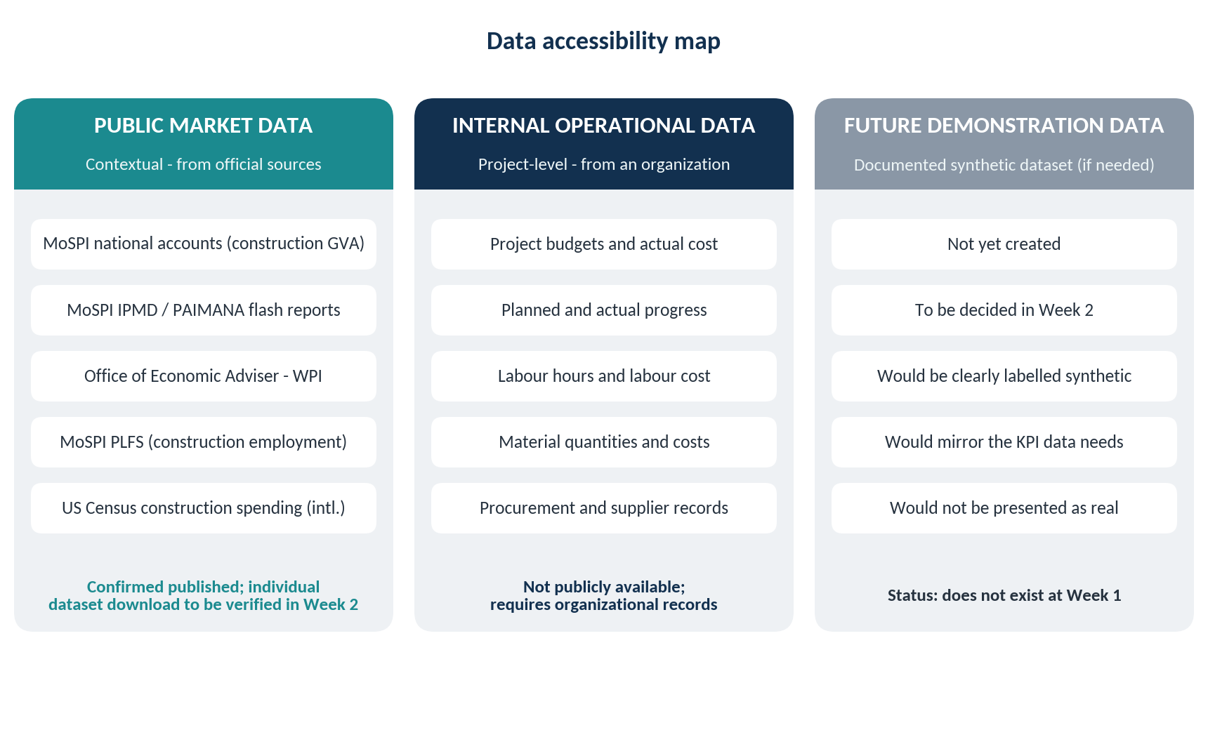
Figure 11: Data accessibility map
Source: Prepared by the author. Status as at Week 1.

6.4 Operational Data Requirements
Project-level commercial data, such as budgets, actual expenditure, labour hours and procurement records, are normally held in an organization's internal systems and are not published. A real BuildSight BI deployment would therefore start by agreeing data access, ownership and refresh arrangements with the organization. Typical source formats are spreadsheets, accounting exports and project-planning exports; Excel and CSV are the proposed starting formats (Chapter 7).
FUTURE WORK If no suitable project-level data can be obtained in the internship, an appropriately documented synthetic dataset may be considered during Week 2. Such a dataset does not exist at the time of writing. If created, it will be clearly labelled as synthetic and will not be presented as real project data.

6.5 Data Accessibility and Limitations
- Public data describe the market, not any one organization, so they provide context but cannot drive project KPIs.
- Source publications differ in base year, coverage and revision status (for example, the 2022-23 base-year revision of national accounts), so series must not be mixed without care.
- Press coverage of official reports is useful for orientation but must be checked against the original before formal use.
- Data quality is a risk in itself: even official monitoring reports caution about incomplete reporting of revised costs and schedules (Deccan Herald, 2024).

Chapter 7: Technology and Power BI Integration

7.1 Technology Selection Criteria
Tools are proposed against criteria drawn from the business requirements in Chapter 3 and the internship context: (i) fit with the KPI and data-model needs; (ii) ability to combine data from several sources; (iii) interactive, role-based reporting; (iv) availability to an intern and low initial cost; (v) alignment with the internship's Power BI focus; and (vi) a clear path to later predictive work. Only tools that contribute to these criteria are included.

7.2 Proposed Technology Stack
Table 13: Proposed technology stack (proposal)
Tool | Purpose and relevance | Requirement addressed | Internship relevance | Limitations and licensing
Microsoft Power BI Desktop | Builds the data model, measures and interactive reports; the central analytical platform | Single view; interactive, role-based reporting | Core tool for Weeks 2-6 | Free to use for authoring; runs on Windows. Publishing and sharing require the Power BI service
Power Query | Connects to sources and prepares data (clean, shape, combine) | Data integration; data quality | Week 2 transformation work | Suited to structured, tabular data; complex source systems may need additional integration
DAX | Defines KPI measures and calculations in the model | Standard KPI definitions (O3) | Week 3 measures | Requires a well-designed model; time-intelligence needs a proper calendar table
Excel / CSV | Initial structured data sources for project, cost, labour and material records | Realistic starting format for internal data | Week 2 data input | Manual files can contain inconsistencies; not a substitute for governed source systems
Python | Potential future predictive analytics and data-quality checks | Early risk identification (O6), Week 5 | Week 5 exploration only | Not required for Weeks 1-4; use depends on the environment available
Power BI service | Publishing, sharing, scheduled refresh and access control | Distribution to the five stakeholder groups | Possible sharing of results (Weeks 4-6) | A paid Pro or Premium Per User licence is required to publish to shared workspaces and to share content (Microsoft, n.d.-a)
Source: Prepared by the author. Licence statement per Microsoft Learn (Microsoft, n.d.-a). Pricing is not quoted because published prices were inconsistent across sources and change over time.

Why Power BI is the central platform
Power BI is specified by the internship, combines data preparation (Power Query), modelling and measures (DAX) and interactive reporting in one environment, and integrates with Excel, which is the likely first data format. Microsoft also provides a structured planning approach for BI strategy that this report follows (Microsoft, 2024).

Brief comparison with alternatives
Table 14: Power BI compared with Tableau and Looker Studio on project requirements
Requirement | Power BI | Tableau | Looker Studio
Fit with internship | Specified tool; all weeks | Not specified | Not specified
Data preparation and modelling in one tool | Power Query and DAX model | Separate preparation tooling is commonly used | Limited modelling; relies on source preparation
Excel / CSV as starting sources | Direct connection | Supported | Supported, typically through Google Sheets or uploads
Low-cost authoring for an intern | Desktop is free to author | Licence normally required | Free web tool
Role-based sharing | Requires paid licence for sharing | Licence-based | Google account-based sharing
Source: Prepared by the author from general product knowledge. These comparative statements were not verified against vendor documentation in Week 1 and are indicative only; the choice is driven mainly by the internship requirement.

7.3 Power BI Integration Strategy
Eight conceptual stages describe how Power BI would be incorporated in the workflow. They are a plan; none has been implemented.
Table 15: Conceptual Power BI integration stages (proposed)
# | Stage | Activity | Power BI component | Week
1 | Identify business data sources | List internal and public sources per KPI | Documentation | 1-2
2 | Data ingestion | Connect to Excel / CSV and, where relevant, public indices | Power Query connectors | 2
3 | Data preparation | Clean, standardize, combine and check data | Power Query | 2
4 | Data organization and modelling | Fact and dimension tables; relationships; calendar table | Data model | 3
5 | KPI development | Create measures for variances, utilization, lead time | DAX | 3
6 | Interactive reports | Role-based report pages with filters and drill-down | Report canvas | 4
7 | Presentation to stakeholders | Share views with the five roles; access control | Power BI service | 4-6
8 | Management decision-making | Use insights in review meetings; record actions | Process, not tool | 6
Source: Prepared by the author (proposal).

7.4 Proposed BI Architecture
Figure 12 shows the conceptual flow from data sources to business decisions. It is a conceptual architecture, not an implemented system.
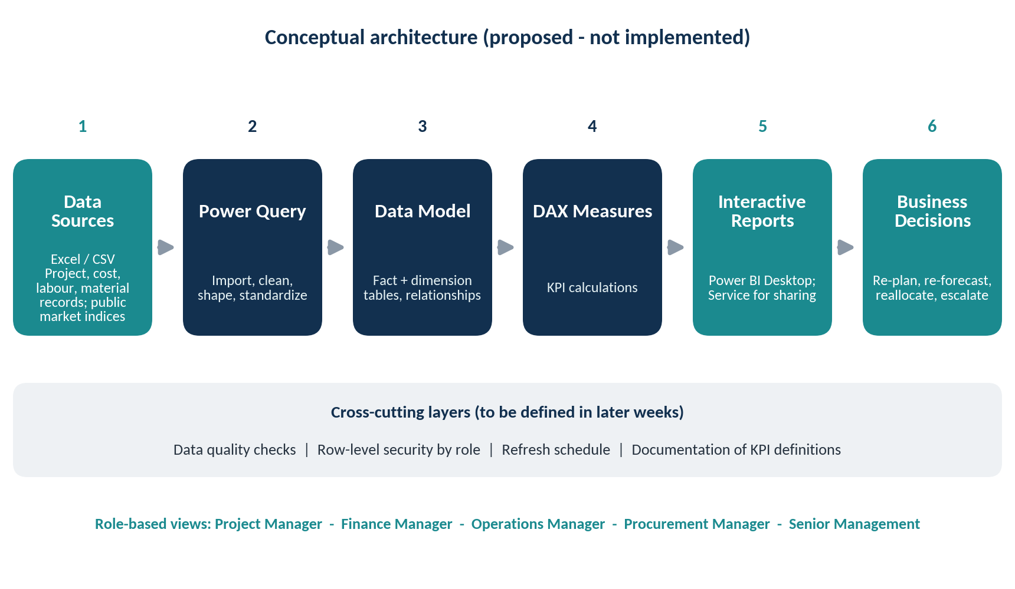
Figure 12: Proposed Power BI conceptual architecture
Source: Prepared by the author (conceptual design). Not an implemented system.

7.5 Conceptual Analytical Workflow
The same governed model could serve different analytical views. Table 16 shows the intended starting view for each role. Detailed dashboard design belongs to Week 4.
Table 16: Analytical views by role (conceptual)
Role | Starting view | Typical drill-down
Project Manager | Progress and schedule status for own projects | Activity or phase; reasons for delay
Finance Manager | Budget, actual cost and variance by project | Cost category; period
Operations Manager | Labour hours, utilization, productivity | Trade; site; date
Procurement Manager | Material cost variance and lead time | Material; supplier
Senior Management | Portfolio summary and risk watch-list | Project; KPI category
Source: Prepared by the author (proposal). Row-level security and workspace design will be explored in later weeks; Microsoft provides documentation on these capabilities at its Power BI documentation hub (Microsoft, n.d.-b).

Chapter 8: Implementation Strategy

8.1 Strategic Roadmap
FUTURE WORK The roadmap below lists proposed activities. Only Week 1 (this report) is complete; no later-week work has been carried out.
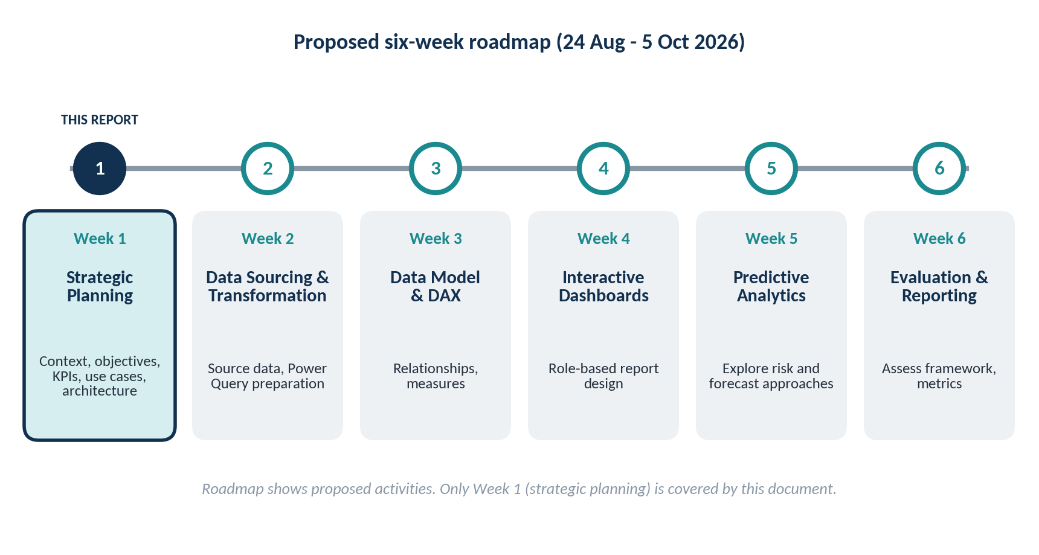
Figure 13: Proposed six-week roadmap
Source: Prepared by the author. Internship period 24 August - 5 October 2026.
Table 17: Roadmap summary
Week | Focus | Proposed activity | Status
1 | Strategic Planning | Establish business context, objectives, KPIs, use cases and architecture | This report
2 | Data Preparation | Identify and prepare relevant data; decide on data source or documented synthetic data | Not started
3 | Data Modeling | Develop relationships and DAX measures for the KPI framework | Not started
4 | Dashboard Design | Design interactive Power BI dashboards for the five roles | Not started
5 | Predictive Analytics | Explore predictive approaches for cost, schedule or risk | Not started
6 | Evaluation | Evaluate the overall analytical framework and performance metrics | Not started
Source: Prepared by the author (proposal).

8.2 Six-Week Internship Alignment
Each Week 1 element feeds a specific later task: the data requirements in Chapter 6 define Week 2 preparation; the KPI formulas in Chapter 5 become the DAX measures of Week 3; the stakeholder views in Chapter 7 guide Week 4 dashboard design; the risk use case prepares Week 5 predictive exploration; and the success criteria in Chapter 9 define what Week 6 will assess.

8.3 Future Development Considerations
- Data source decision (Week 2): confirm whether real project-level data can be obtained or whether a documented synthetic dataset is needed.
- KPI governance: record each KPI definition, owner and data source in a data dictionary.
- Security and sharing: decide how access by role would be controlled before any sharing.
- Adoption: plan short training so that stakeholders can read and act on the reports.
- Extensions (beyond the internship): BIM and IoT data feeds, and more advanced analytics.

Chapter 9: SWOT and Expected Business Value

9.1 SWOT Analysis
Figure 14 summarizes the strengths, weaknesses, opportunities and threats of the proposed BuildSight BI framework. It is a project-specific assessment made at the planning stage.
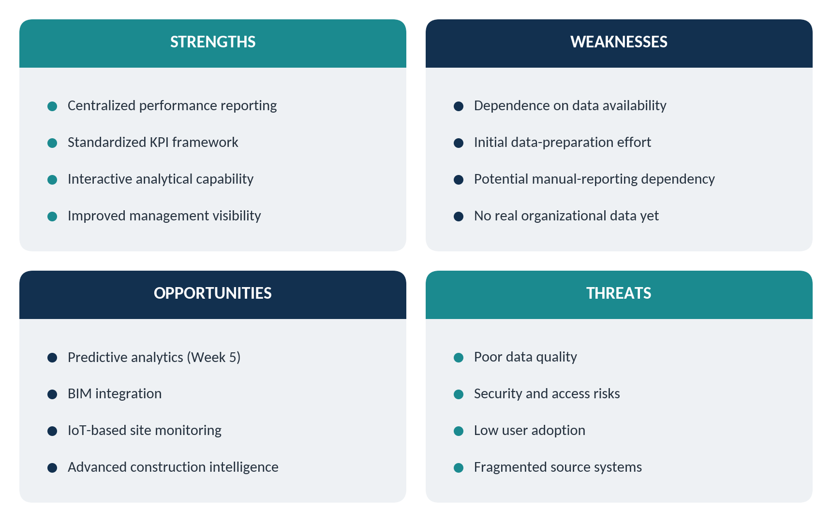
Figure 14: SWOT analysis of the proposed BuildSight BI framework
Source: Prepared by the author (proposal).

9.2 Expected Benefits
The following are expected or potential benefits if the framework is later implemented with reliable data. They are not results; no improvement has been measured or is claimed.
- Better visibility of project performance in one place.
- Earlier sight of cost, schedule and material deviations.
- Consistent KPI reporting through shared definitions.
- More informed allocation of labour and other resources.
- Clearer communication of project status to management.

9.3 Risks and Limitations
- Reliable source data: the framework is only as good as the records it uses.
- Internal project records: project-level data may not be available in the internship, which may require a synthetic dataset.
- Integration complexity: combining cost, schedule, labour and procurement records is demanding.
- Standard KPI definitions: these need agreement across roles; EVM indices need properly defined baselines.
- User training: users must be able to interpret and act on reports.
- Licensing and sharing: sharing in the Power BI service requires paid licences (Microsoft, n.d.-a).
- Evidence limits: several market statistics come from secondary summaries and require verification against original publications (Appendix B).

9.4 Proposed Success Criteria
Success criteria are qualitative and tied to the later weeks. They do not set numerical improvement targets.
Table 18: Proposed success criteria
Criterion | Assessed in
Every KPI in Chapter 5 has a documented definition, owner and data source | Week 3
Data preparation steps are documented and repeatable, and any synthetic data are clearly labelled | Week 2
Report totals reconcile to the source data | Weeks 3-4
Each stakeholder view can answer that stakeholder's key questions from Table 4 | Week 4
Limitations and assumptions are stated openly in the final evaluation | Week 6
Source: Prepared by the author (proposal).

Chapter 10: Conclusion
This report has established a strategic foundation for BuildSight BI, a conceptual Power BI framework for construction project performance. Verified Indian market evidence shows a large and growing construction sector, a rising public capital-expenditure programme, visible cost and time deviations in monitored infrastructure projects, and uneven movement in input prices. These findings support a need for consistent, timely performance information, although they do not by themselves show that a particular tool will improve outcomes.
Based on this evidence, the report proposed six strategic objectives, five stakeholder groups, five use cases and a KPI framework with technically defined formulas, noting where Earned Value Management data are required. It set out a realistic data strategy that distinguishes public market data, internal operational data and possible future demonstration data, and that marks unverified sources as requiring further verification. It selected a technology stack centred on Power BI and described a conceptual architecture and a six-week roadmap.
No dataset has been downloaded or analysed, and no model, measure, dashboard or prediction has been built. Week 2 will begin by deciding the data source and preparing the data that the KPI framework requires.

References
References follow APA 7th edition as far as practical. Items marked as news or summary sources are secondary and are identified as such in Appendix B.
Deccan Herald. (2024, February 25). MoSPI says 431 infra projects hit by cost overrun of Rs 4.80 lakh crore in January [PTI report]. https://www.deccanherald.com/business/mospi-says-431-infra-projects-hit-by-cost-overrun-of-rs-480-lakh-crore-in-january-2909272
Deloitte. (2026). 2026 engineering and construction industry outlook. https://www.deloitte.com/us/en/insights/industry/engineering-and-construction/engineering-and-construction-industry-outlook.html
India Brand Equity Foundation. (n.d.). Economic Survey 2025-26: Analysis and key findings. https://dev.ibef.org/economy/economic-survey-2025-26
Indian Infrastructure. (2026, January 30). Key highlights from Economic Survey 2025-26 for infrastructure sectors. https://indianinfrastructure.com/2026/01/30/key-highlights-from-economic-survey-2025-26-for-infrastructure-sectors/
IANS. (2026, February 1). Budget 2026-27 hikes Govt capex to Rs 12.2 lakh crore in big push to infra. https://ianslive.in/budget-2026-27-hikes-govt-capex-to-rs-122-lakh-crore-in-big-push-to-infra--20260201113904
McKinsey & Company. (2016, June). Imagining construction's digital future. https://mckinsey.com/~/media/mckinsey/business%20functions/operations/our%20insights/imagining%20constructions%20digital%20future/imagining-constructions-digital-future.pdf
McKinsey Global Institute. (2017). Reinventing construction through a productivity revolution. https://www.mckinsey.com/mgi/our-research/reinventing-construction-through-a-productivity-revolution
Microsoft. (2024, December 30). Power BI implementation planning: BI strategic planning. Microsoft Learn. https://learn.microsoft.com/en-us/power-bi/guidance/powerbi-implementation-planning-bi-strategy-bi-strategic-planning
Microsoft. (n.d.-a). Licenses and subscriptions for business users. Microsoft Learn. https://learn.microsoft.com/power-bi/fundamentals/end-user-license
Microsoft. (n.d.-b). Power BI documentation. Microsoft Learn. https://learn.microsoft.com/en-us/power-bi/
Millennium Post. (2026, July 29). Infra projects register cost overrun of around Rs 4,92,752 crore, says MoSPI. https://www.millenniumpost.in/business/infra-projects-register-cost-overrun-of-around-492752-crore-says-mospi-670065
Ministry of Statistics and Programme Implementation. (2026a, June 5). Press note on provisional estimates of annual gross domestic product for 2025-26 and quarterly estimates of gross domestic product for the fourth quarter (January-March) of 2025-26. National Statistics Office, Government of India. https://www.mospi.gov.in/uploads/latestReleases/latestrelease17806558575365ac01869-ca4a-422d-b7a7-57b81da60932PressNoteonGDPEstimatesforQ42025-26andPEFY2025-26F.pdf
Ministry of Statistics and Programme Implementation. (2026b, February 27). Press note on new series of GDP estimates with base year 2022-23. National Statistics Office, Government of India. https://www.mospi.gov.in/uploads/latestReleases/latestrelease1772189865181f040336d-bc57-4aed-b80f-586d9ccb279ePressNoteonNewSeriesofGDPEstimateswithBaseYear2022-2327022026.pdf
Office of the Economic Adviser. (2026, July 14). Provisional estimates of Wholesale Price Index, Output Producer Price Index, and trial Input Producer Price Index for the month of June 2026, and final estimates for the month of April 2026 [Press release]. Ministry of Commerce and Industry, Government of India. https://eaindustry.nic.in/pressrelease/pressrelease_202607.pdf
Outlook Business. (2026, February 1). Union Budget 2026: FM Sitharaman raises capex for FY27 to Rs 12.2 lakh crore. https://www.outlookbusiness.com/budget/budget-2026-fm-sitharaman-raises-capex-for-fy27-to-122-lakh-crore
Project Management Institute. (n.d.). The practical calculation of schedule variance in terms of schedule. PMI Learning Library. https://www.pmi.org/learning/library/practical-calculation-schedule-variance-7028
PSU Watch. (2026, September 25). Infrastructure projects record Rs 2.88 lakh crore cost overrun: MoSPI. https://psuwatch.com/newsupdates/infrastructure-projects-record-rs-288-lakh-crore-cost-overrun-mospi
U.S. Census Bureau. (2026, June 1). Monthly construction spending, April 2026 (Release CB26-91). https://www.census.gov/construction/c30/current/
Vision IAS. (2026, May 22). Periodic Labour Force Survey (PLFS) Annual Report, 2025. https://visionias.in/current-affairs/monthly-magazine/2026-05-22/economy/periodic-labour-force-survey-plfs-annual-report-2025

Appendix A: Research Source Register
This register lists the sources recommended in the assignment brief, what was done with each in Week 1, and its status. It is included for transparency.
Table 19: Research source register (Week 1)
Source | Use in this report | Status in Week 1
MoSPI national accounts press notes | Construction GVA, growth, GFCF share, cement and steel indicators; base-year revision | Accessed and read in full (June 2026 press note); new-series values used
MoSPI infrastructure project monitoring (flash reports) | Cost and time overrun context | Original report not directly accessed; figures taken from press coverage
MoSPI PLFS Annual Report 2025 | Construction share of employment | Secondary summary only; original not accessed
Economic Survey 2025-26 (Ministry of Finance) | Infrastructure context | Original document not directly accessed; secondary summaries cited
Office of the Economic Adviser (WPI) | Material price indicators | Press release accessed and read; item-wise data download not tested
Union Budget 2026-27 | Capital expenditure | Reported by news sources; official document not accessed
CPWD | Cost indices and schedules of rates | Not verified from official site; not used for facts
Labour Bureau | Construction wages | Not accessed; not used
U.S. Census Bureau | International construction-spending reference | Monthly release page accessed; not used for statistics in the text
US Bureau of Labor Statistics; World Bank | International indicators | Not used; no material contribution to Week 1
Deloitte; McKinsey | Industry challenges and digital trends | Deloitte outlook and McKinsey publications reviewed through accessible pages; international context only
Autodesk; Turner & Townsend | Digital adoption; cost conditions | Not accessed; not used
Microsoft Learn (strategic planning; licensing) | BI planning method; licensing facts | Strategic-planning page read in full; licensing page reviewed
Microsoft Learn (tactical planning; documentation hub) | Method and capability reference | Tactical-planning page not reviewed; hub cited generally only
PMI | EVM definitions | One PMI Learning Library article reviewed
Source: Prepared by the author.

Appendix B: Verification Notes and Limitations of Evidence
- Construction growth varies by release. Construction growth for FY 2025-26 appears as 7.0% in the first advance estimate (January 2026, 2011-12 base), 7.1% in the second advance estimate and 7.4% in the provisional estimate (June 2026, 2022-23 base). Only the June 2026 provisional values are used, and they may be revised.
- Infrastructure monitoring figures vary by month. The June 2026 report covered 1,847 projects and the August 2026 report 1,731 projects, with different overrun totals. The August 2026 figures are used and are treated as indicative. The 9.4% overrun share is the author's calculation (2,88,122 / 30,71,947).
- Secondary sources. The PLFS employment share, Economic Survey highlights, Union Budget capital expenditure and infrastructure monitoring figures were taken from summaries or news reports. They should be checked against the original publications before formal use.
- Older and international evidence. McKinsey (2016) and McKinsey Global Institute (2017) are global and several years old; Deloitte (2026) is United States-focused. They are used as context only.
- Power BI price not quoted. Published per-user prices were inconsistent across the sources reviewed, so only the licensing requirement from Microsoft Learn is stated.
- Tool comparison. The Tableau and Looker Studio comparison is based on general product knowledge and was not verified against vendor documentation.
- Calculations by the author. Cumulative construction GVA growth of about 27% (2022-23 to 2025-26) and the 9.4% overrun share are the author's calculations from the cited figures.
- No data were collected. No dataset was downloaded, cleaned or analysed in Week 1.

