WEEK 2 INTERNSHIP REPORT
BUILDSIGHT BI
A Power BI-Based Business Intelligence Framework for Construction Project Performance
Turning Construction Data into Actionable Intelligence
Data Sourcing, Import, and Transformation for Construction Metrics

Internship | Virtual Construction Business Intelligence Intern
Platform | YuvaIntern
Internship period | 24 August 2026 - 5 October 2026 (6 weeks)
Assignment | Week 2: Data Sourcing, Import, and Transformation of Construction Metrics
Submitted by | Shalvi Atul Surve
Submitter Organization | Vellore Institute of Technology (VIT), Vellore
Submission date | 03.10.2026
Primary Tool | Microsoft Power BI Desktop (Power Query Editor)
Dataset | MDoNER NESetu Projects Dashboard (North Eastern Region of India)

BuildSight BI is a conceptual project created for this internship. It is not an existing commercial organization or an implemented product.

Internship Information
Title | Virtual Construction Business Intelligence Intern
Platform | YuvaIntern
Duration | 6 weeks, 24 August 2026 - 5 October 2026
Focus | Applying business intelligence methods to construction scenarios using Microsoft Power BI
Week 2 assignment | Data Sourcing, Import, and Transformation of Construction Metrics

Weekly assignments
Week | Assignment
1 | Strategic Planning for Virtual Construction Intelligence
2 | Data Sourcing, Import, and Transformation for Construction Metrics (this report)
3 | Building Advanced Data Models and DAX Calculations
4 | Designing Interactive Power BI Dashboards for Construction Analytics
5 | Implementing Predictive Analytics in Virtual Construction
6 | Comprehensive Evaluation and Performance Metrics Reporting

Project Information
Project name | BuildSight BI
Project title | A Power BI-Based Business Intelligence Framework for Construction Project Performance
Tagline | Turning Construction Data into Actionable Intelligence
Nature | Conceptual framework for a simulated construction organization
Focus areas | Project performance; cost and budget; schedule and progress; workforce productivity; material and procurement; project risk
Market context | India (primary), with international references where relevant
Status at Week 2 | Completed data sourcing, import, cleaning, and transformation in Power BI, with the process and data-quality checks documented.

Table of Contents
1. Executive Summary 4
2. Introduction 5
3. Week 2 Objectives and Scope 5
3.1 Objectives 5
3.2 Coverage of the assignment requirements 5
3.3 Scope boundaries 6
4. Data Sourcing and Source Selection 7
4.1 Data requirements for construction BI 7
4.2 Source actually used in this Week 2 workflow 7
4.3 Source-selection rationale 8
4.4 Geographic and temporal scope 8
4.5 Suitability and limitations 8
4.6 Potential supplementary public sources (future candidates only) 9
5. Raw Dataset Overview 11
5.1 Field groups and naming 11
6. Data Ingestion and Power BI Import 13
6.1 Import workflow 13
6.2 Import evidence and items to confirm 14
6.3 Format compatibility 14
6.4 The Source and Navigation steps 14
7. Power Query Data Preparation and Transformation 16
7.1 Worksheet structure and header preparation 16
7.2 Blank-row handling and column standardisation 20
7.3 Record filtering 23
7.4 Text standardisation 25
7.5 Complete transformation sequence 26
8. Data Quality Assessment and Missing-Value Handling 30
8.1 Observed data-quality information 31
8.2 How missing values were handled 31
8.3 Observations from the profile 32
9. Data Normalization and Standardization 32
10. Multi-Source Integration: Current Status and Future Scope 33
11. Challenges, Limitations, and Mitigation Strategies 34
12. Final Prepared Dataset and Workflow Outcome 34
13. Recommendations and Next Steps 35
14. Conclusion 35
References 37
Appendix A — Screenshot Evidence 38
Appendix B — Transformation Evidence Summary 39
B.1 Applied Steps in order 39
B.2 The two filtering formulas 39
B.3 Reproduction notes for another intern 39

1. Executive Summary
This report documents the Week 2 task of the BuildSight BI project: sourcing a publicly available project dataset, importing it into Microsoft Power BI Desktop, and preparing it in Power Query for later analysis. The aim was to demonstrate, with evidence, how raw public data can be turned into a traceable, analysis-ready table in a virtual construction business intelligence setting.
The dataset used is the All Schemes Projects listing published on the NESetu Projects Dashboard of the Ministry of Development of North Eastern Region (MDoNER), with a snapshot date of 31 August 2026. It was held as the Excel workbook mdoner_projects_raw.xlsx (worksheet overall-schemes-2026-08-31) with 15 columns covering project identification, location, sector, scheme, executing department, sanctioned and scheduled completion dates, approved cost, financial expenditure, utilisation certificate (UC) receipt and project status. The raw workbook was preserved unmodified; all preparation was done as repeatable steps inside Power Query.
The query, named overall-schemes-2026-08-31, contains 15 Applied Steps, ending with Filtered Rows1. In sequence, the workflow navigated to the worksheet, removed a title row sitting above the real header row, promoted the correct headers, assigned data types, removed fully blank rows, standardised column names, excluded records with a null Project Name or a null/empty Serial Number, and trimmed and cleaned seven text columns. Column Quality and Column Distribution were then used to inspect the result. Missing date values were retained rather than deleted.
Two points deserve emphasis. First, the outcome of Week 2 is a prepared dataset and a documented Power Query workflow, not an analytical dashboard; no data model, DAX measure or forecast was built. Second, the dataset is administrative and financial: it does not directly measure labour productivity, physical progress, or actual schedule performance. The report states this limitation where it matters and keeps what was demonstrated separate from what is proposed.
Table 1. Week 2 at a glance
Item | Detail
Source organization / platform | Ministry of Development of North Eastern Region (MDoNER) / NESetu Projects Dashboard
Geographic coverage | North Eastern Region of India (not a nationwide dataset)
Raw file and worksheet | mdoner_projects_raw.xlsx / overall-schemes-2026-08-31
Snapshot | As on 31 August 2026 (worksheet title and name)
Tool | Microsoft Power BI Desktop, Power Query Editor
Query name (visible in Query Settings) | overall-schemes-2026-08-31
Columns | 15 (raw and final)
Applied Steps | 15; final step shown is Filtered Rows1
Screenshots documented | 20 (Figures 1–20), plus one workflow schematic (Figure 21)
Final row count | Not recorded as a single figure in the supplied evidence; the Serial Number profile in Screenshot 20 shows 3,774 distinct values
Outcome | Prepared dataset and documented, repeatable transformation workflow

2. Introduction
Construction business intelligence depends on three recurring questions: what projects cost, how long they take, and how efficiently resources are used. Dashboards that answer them are only as reliable as the data beneath them. In practice, public and operational data seldom arrives in analysis-ready form: files carry title rows above the real headers, blank rows, inconsistent column labels, stray whitespace and missing values. Sourcing and preparation therefore come before any visual analysis, and the decisions made at this stage determine what can be trusted later.
BuildSight BI is the project through which this internship builds a construction-focused business intelligence capability. Week 2 addresses the foundation layer: finding a credible public data source, bringing it into Power BI, and transforming it in Power Query so that every change is recorded as an ordered, inspectable step. This is useful in a virtual construction context because the same steps can be replayed when a refreshed snapshot of the data is published.
The report is organised to follow the workflow. Section 4 covers data sourcing; Section 5 describes the raw dataset; Sections 6 and 7 document import and transformation with the supporting screenshots; Section 8 reviews data quality; Sections 9 and 10 address standardisation and multi-source integration; Sections 11 to 14 cover challenges, outcome, recommendations and conclusion.

3. Week 2 Objectives and Scope

3.1 Objectives
The assignment asks for an editable report on the end-to-end process of data sourcing, import, cleansing and transformation using Power BI. For this work, that was translated into the following objectives:
- Identify and evaluate a publicly available, construction-related dataset and explain its relevance to cost management and project timelines.
- Import the dataset into Power BI Desktop and open it in Power Query, with the original file left unmodified.
- Clean and transform the data step by step, so that the sequence is traceable and repeatable.
- Inspect missing values and data-quality indicators and record how they were handled.
- Standardise column names, data types and text fields to prepare for later analysis.
- Assess honestly what the dataset can and cannot support, and outline how additional sources could be bridged in future.

3.2 Coverage of the assignment requirements
Table 2. Assignment requirements and how this report addresses them
Assignment requirement | Where and how addressed | Status
1. Research and identify public data sources | Section 4: the MDoNER source (used) and a verified table of potential complementary sources (not used) | Completed
2. Import into Power BI; format compatibility; Power Query extraction | Section 6, Figures 3–5 | Completed
3. Step-by-step cleansing and transformation | Section 7, Figures 6–19 and 21 | Completed
4. Missing values and data-quality issues | Section 8, Figures 19–20 | Completed
5. Normalisation and standardisation | Section 9: standardisation actually performed is listed; database or statistical normalisation was not performed | Standardisation completed
6. Challenges and strategies | Section 11 | Completed
7. Screenshots and flowcharts | All 20 screenshots in body; workflow schematic in Section 7.5; index in Appendix A | Completed
8. Professional presentation | Entire document | Completed

3.3 Scope boundaries
Demonstrated in the screenshots: importing one Excel workbook; Power Query header, type, blank-row, renaming, filtering, trimming and cleaning steps; and inspection with Column Quality and Column Distribution.
Not demonstrated, and therefore not claimed: merging or appending multiple sources; removing duplicate records; building a data model, DAX measures or dashboard visuals; forecasting; and measuring labour productivity, physical progress or actual schedule variance. The assignment’s estimated 30–35 hours is the expected duration of the task and is not a statement of time spent.

4. Data Sourcing and Source Selection

4.1 Data requirements for construction BI
The assignment frames three construction themes: cost management, labour productivity and project timelines. Each needs a different kind of data, and a single public listing rarely covers all of them. Table 3 sets out what each theme typically requires and how far the MDoNER dataset reaches.
Table 3. Construction BI themes and coverage by the MDoNER dataset
Theme | Typical data required | Coverage by the dataset used
Cost management | Approved or budgeted cost, expenditure to date, cost by sector or scheme, funding status | Partial. Approved Cost and three expenditure fields are present, in Rs. crore. No itemised cost, variation or forecast-at-completion data.
Project timelines | Sanction date, planned and actual start and finish, milestones, delays | Partial. Sanctioned Date and Scheduled Completion Date are present. No actual start, actual completion or milestone dates.
Labour productivity | Worker-hours, output quantities, crew size, wage and attendance data | None. The dataset contains no labour or output information.

4.2 Source actually used in this Week 2 workflow
The source used is the Projects Dashboard on MDoNER’s NESetu platform (https://www.nesetu.mdoner.gov.in/projects/project-list). It is the source actually used and imported in Week 2. MDoNER is the Government of India ministry responsible for development of the North Eastern Region, and the dashboard publishes a listing titled “All Schemes Projects”, shown as on 31 August 2026. The platform is publicly accessible; the supplied notes classify the content as public project information covering the North Eastern Region of India.
Figure 1 — Original Dataset Source
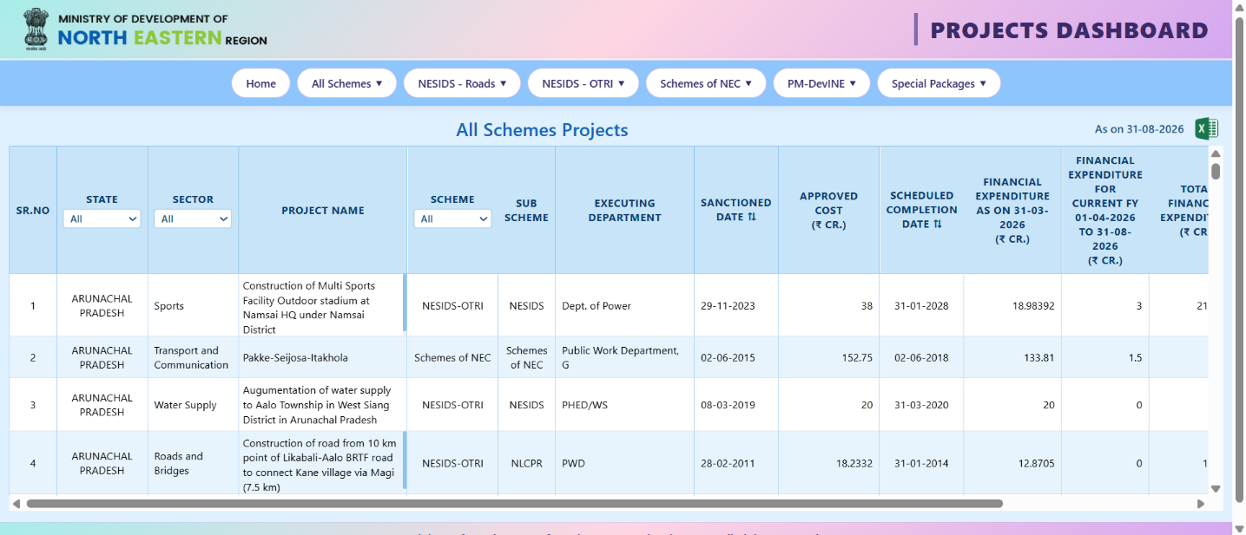
Figure 1. Original MDoNER NESetu Projects Dashboard (All Schemes Projects, as on 31-08-2026).
What the screenshot shows. The dashboard header names the Ministry of Development of North Eastern Region and the “Projects Dashboard”. Navigation tabs include Home, All Schemes, NESIDS - Roads, NESIDS - OTRI, Schemes of NEC, PM-DevINE and Special Packages. The “All Schemes Projects” table is dated “As on 31-08-2026” and carries an Excel icon beside the date. Visible columns include SR.NO, State, Sector, Project Name, Scheme, Sub Scheme, Executing Department, Sanctioned Date, Approved Cost (₹ Cr.), Scheduled Completion Date and the financial expenditure columns. The sample rows are from Arunachal Pradesh.
Why it matters. This establishes the provenance of the data: a government project-monitoring dashboard, openly accessible, listing projects with cost, date and expenditure fields. Those fields are what make it relevant to project cost and timeline monitoring. The Excel icon suggests an export option; the supplied notes identify the resulting file as mdoner_projects_raw.xlsx.

4.3 Source-selection rationale
- Public and official. The data is published by a central government ministry on a publicly accessible dashboard, so no private or restricted data is involved.
- Relevant fields. Approved cost, expenditure, sanctioned date and scheduled completion date map directly to cost and timeline monitoring.
- Structured and tabular. One row per project in a spreadsheet form suits Power Query and later Power BI modelling.
- Substantial and current. The Serial Number profile in Screenshot 20 shows 3,774 distinct values, and the snapshot is dated 31 August 2026.
- Regionally focused. The coverage of the North Eastern Region allows state, district, sector and scheme comparisons within a defined geography.

4.4 Geographic and temporal scope
Geographically, the data covers projects in the North Eastern Region of India only; it should not be described or analysed as a nationwide construction dataset. Temporally, it is a point-in-time snapshot as on 31 August 2026, taken from the worksheet title and name. Sanctioned dates in the visible sample range from 2011 to 2026, so the listing mixes recent and long-running projects.

4.5 Suitability and limitations
Having established what the dataset contains, it is important to separate three classes of metrics so that nothing is implied beyond the evidence.
Table 4. Metrics available, derivable after validation, and requiring additional data
Class | Examples | Condition
1. Available in the dataset used | Project name and serial number  State, district, sector, scheme, executing department  Sanctioned date, scheduled completion date  Approved cost, three expenditure fields, UC received  Project status | Present as fields in the worksheet; quality varies by column (Section 8)
2. Derivable after appropriate validation | Expenditure relative to approved cost  Planned duration (scheduled completion minus sanctioned date)  Counts and cost totals by state, sector, scheme or department  Elapsed time against the scheduled completion date for projects still shown as ongoing | Needs date type conversion, unit and meaning checks. Elapsed-time indicators are administrative, not measured delay.
3. Requiring additional data sources | Labour productivity or worker-level output  Physical construction progress  Actual completion and true schedule variance  Contractor productivity  Site-level resource utilisation | Not in this dataset; would need other sources (Table 5 lists candidates)
Further limitations are the single-region coverage, the single snapshot (no history of changes), and the absence of any physical-progress measure: a project with high expenditure is not necessarily physically advanced.

4.6 Potential supplementary public sources (future candidates only)
The sources below were checked against their official or institutional web pages on 3 October 2026 to confirm that they exist and what they publish. None was downloaded, imported, cleaned or merged in Week 2. They are listed to show how the BuildSight BI data landscape could be extended.
Table 5. Source evaluation: used source and future candidates
Source / organisation | Official access point | Type of information | Relevant metric | Potential use in BuildSight BI | Week 2 status
MDoNER NESetu Projects Dashboard | https://www.nesetu.mdoner.gov.in/projects/project-list | Project-level administrative and financial listing for the North Eastern Region | Cost; timeline (planned) | Core dataset for cost and schedule indicators | Used
Open Government Data (OGD) Platform India (MeitY / NIC) | https://data.gov.in | Catalogue of government datasets in machine-readable form, under the Government Open Data License – India | Varies by dataset | Search for project, expenditure or sector datasets that share keys with the MDoNER data | Future candidate
Central Public Procurement Portal (CPPP), Ministry of Finance / NIC | https://eprocure.gov.in | Tender enquiries, corrigenda and award details for central government procurement | Cost (tendered and awarded values); timeline (bid dates) | Compare tender and award values with approved cost, where projects can be matched | Future candidate
Labour Bureau, Ministry of Labour and Employment | https://labourbureau.gov.in | Wage rates, wage rate indices and other labour statistics | Labour cost (not worker-level output) | Contextual wage trends for labour-cost analysis | Future candidate
Office of the Economic Adviser, DPIIT | https://eaindustry.nic.in | Wholesale Price Index data and releases (series and base year should be confirmed on the portal) | Material and commodity price trends | Price-escalation context for cost analysis; relevance of specific commodity groups to be checked | Future candidate
Bhuvan geoportal, ISRO / NRSC | https://bhuvan.nrsc.gov.in | Satellite imagery, thematic layers and downloadable earth-observation data for India (some downloads need registration) | Physical progress (spatial) | Possible future spatial monitoring of project sites | Future candidate
Copernicus Data Space Ecosystem (EU) | https://dataspace.copernicus.eu | Free and open Sentinel satellite data | Physical progress (spatial) | Possible change detection at project sites; would need GIS skills and coordinates | Future candidate
Note on verification. Source descriptions come from the official or institutional pages found during research. Dataset availability, formats and licence terms can change, so each source should be re-checked before use. No project-level coordinates or project identifiers shared with the MDoNER dataset were confirmed, so the feasibility of linking is untested.

5. Raw Dataset Overview
The original dataset is held in the Excel workbook mdoner_projects_raw.xlsx, which contains the worksheet overall-schemes-2026-08-31. The workbook was preserved without modification; every change described in this report was made inside Power Query, so the raw file remains available for audit and re-import.
Figure 2 — Raw Dataset
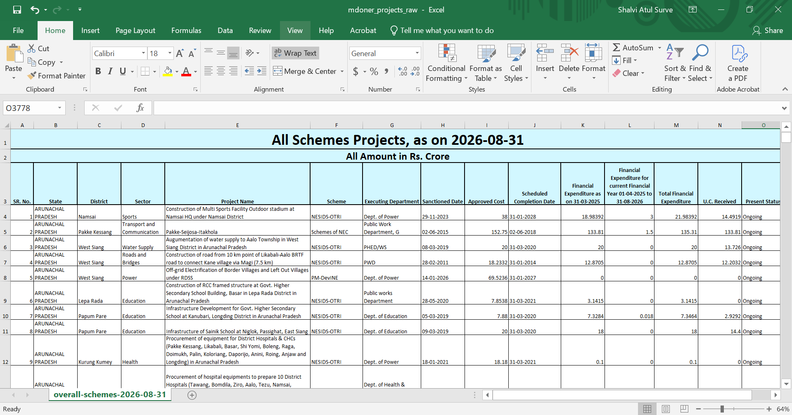
Figure 2. The raw Excel workbook `mdoner_projects_raw.xlsx`, worksheet `overall-schemes-2026-08-31`.
What the screenshot shows. The Excel title bar shows mdoner_projects_raw and the sheet tab shows overall-schemes-2026-08-31. Row 1 holds a merged title, “All Schemes Projects, as on 2026-08-31”, and row 2 states “All Amount in Rs. Crore”. The actual column headings sit in row 3, across columns A to O (15 columns), and project records begin in row 4. Headings visible include SR. No., State, District, Sector, Project Name, Scheme, Executing Department, Sanctioned Date, Approved Cost, Scheduled Completion Date, the financial expenditure columns, U.C. Received and Present Status.
Why it matters. This is the reference state of the data before any Power BI work. It shows why preparation was needed: two title rows precede the header row, so a straight import would not place the real column names at the top. It also supplies the unit of all monetary fields (Rs. crore), which must be carried into later analysis.

5.1 Field groups and naming
The 15 columns fall into logical groups. Table 6 lists the original heading in the workbook and the name after the two renaming steps. Original and transformed names are shown separately, because several were changed in Power Query (Section 7.2).
Table 6. Field groups with original and transformed column names
Group | Original heading (workbook) | Name after Power Query | Type at Changed Type1
Project identification | SR. No. | Serial Number (renamed) | Whole number (Int64)
Project identification | Project Name | Project Name | Text
Location | State | State | Text
Location | District | District | Text
Sector and scheme | Sector | Sector | Text
Sector and scheme | Scheme | Scheme | Text
Executing department | Executing Department | Executing Department | Text
Dates | Sanctioned Date | Sanctioned Date | Text
Dates | Scheduled Completion Date | Scheduled Completion Date | Text
Approved cost | Approved Cost | Approved Cost | Decimal number
Financial expenditure | Financial Expenditure as on 31-03-2025 | Financial Expenditure (as of 31 Aug 2026) (see note) | Decimal number
Financial expenditure | Financial Expenditure for current Financial Year 01-04-2025 to 31-08-2026 | Financial Expenditure (FY 2025-26 to Aug 2026) (renamed) | Decimal number
Financial expenditure | Total Financial Expenditure | Total Financial Expenditure | Decimal number
UC received | U.C. Received | UC Received (renamed) | Decimal number
Project status | Present Status | Status (renamed) | Text

Two further observations on the source. The on-screen dashboard (Screenshot 1) shows a Sub Scheme column and no District column in the visible area, whereas the workbook (Screenshot 2) has District and no Sub Scheme column; the 15-column description here follows the workbook. The title rows also carry two facts that are not columns: the snapshot date (31 August 2026) and the currency unit (Rs. crore).

6. Data Ingestion and Power BI Import

6.1 Import workflow
The Excel workbook was imported with Microsoft Power BI Desktop and opened in the Power Query Editor, where all preparation takes place before any report or model is built. The workflow, as evidenced by Figures 3 to 5, was:
- Launch Power BI Desktop with a blank report.
- Choose the Excel workbook as the data source and select mdoner_projects_raw.xlsx from the project data folder (the file dialog in Figure 3 shows a data > raw location).
- Select the worksheet overall-schemes-2026-08-31 from the workbook contents.
- Open the data in the Power Query Editor, where the Source and Navigation steps are created automatically (Figures 4 and 5).
- Apply the cleaning and transformation steps described in Section 7.
Figure 3 — Power BI Import
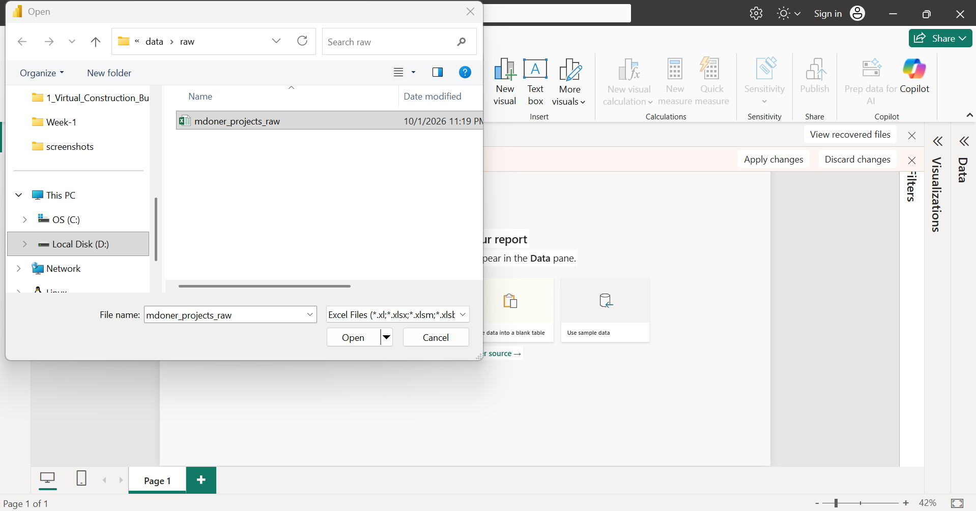
Figure 3. Power BI Desktop file-open dialog selecting `mdoner_projects_raw.xlsx`.
What the screenshot shows. A Windows file dialog opened from Power BI Desktop, in a folder path ending data > raw. The file mdoner_projects_raw is selected, with a modified date of 10/1/2026 11:19 PM, and the file-type filter reads “Excel Files”. Behind the dialog is the blank Power BI Desktop report canvas with the Data and Visualizations panes. The project folder tree on the left includes folders named Week-1 and screenshots.
Why it matters. This captures the point at which the raw workbook is selected for import. The folder name raw is consistent with keeping the original file separate from prepared output. The screenshot shows file selection only; the later steps show that the workbook loaded into Power Query.

6.2 Import evidence and items to confirm
Table 7. Import evidence summary
Item | Value | Evidence
Tool | Microsoft Power BI Desktop; Power Query Editor | Figures 3–5
Import method | Excel workbook | Figure 3 (Excel Files filter); Figure 4 (Excel.Workbook)
Source file | mdoner_projects_raw.xlsx | Figure 3
Selected worksheet | overall-schemes-2026-08-31 | Figures 4 and 5
Query name | overall-schemes-2026-08-31 | Name field under Properties in Query Settings, Figures 4–20
Import status | Workbook loaded into Power Query Editor; Source and Navigation steps present; no error visible | Figures 4 and 5.
Folder path | BuildSight-BI > week-2_data-sourcing-and-preparation > data\raw\mdoner_projects_raw.xlsx

6.3 Format compatibility
Power Query reads Excel workbooks through the Excel.Workbook function, which appears in the Source formula (Figure 4). Excel suits this dataset because it is a single rectangular table, with one row per project and consistent columns, and because Power Query can list the sheets in a workbook and let the user select one. The file dialog in Figure 3 also shows that Power BI Desktop accepts several Excel formats (the filter lists .xl, .xlsx, .xlsm and further extensions). No other file formats (for example CSV or JSON) were tested in this work, so no comparison is made.

6.4 The Source and Navigation steps
Figure 4 — Source Step
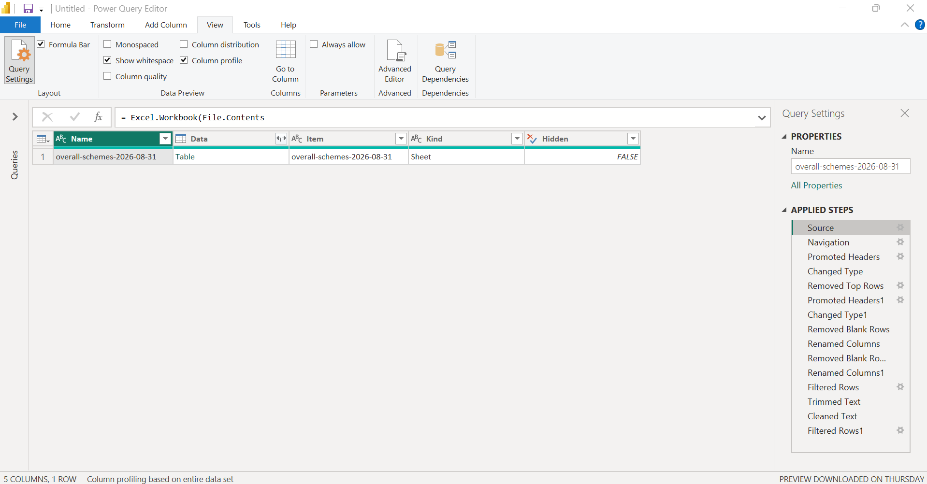
Figure 4. Power Query Editor, Applied Step `Source`.
Figure 4 (detail). Enlarged crop of the formula bar from Screenshot 04; the formula is truncated in the original capture.
What the screenshot shows. The formula bar reads = Excel.Workbook(File.Contents and is cut off, so the file path and remaining arguments are not visible. The preview is a one-row table with columns Name, Data, Item, Kind and Hidden: the row shows overall-schemes-2026-08-31 as Name, a Table in Data, the same text as Item, Sheet as Kind, and FALSE for Hidden. The status bar reads “5 COLUMNS, 1 ROW”. Query Settings lists all 15 Applied Steps, from Source to Filtered Rows1.
Why it matters. The Source step ties the query to the original workbook and returns an inventory of what the workbook contains, here a single visible sheet. Because the query reads the file rather than a pasted copy, the transformation stays traceable to the raw data and can be refreshed or replayed when a new snapshot is saved under the same structure.
Figure 5 — Navigation Step
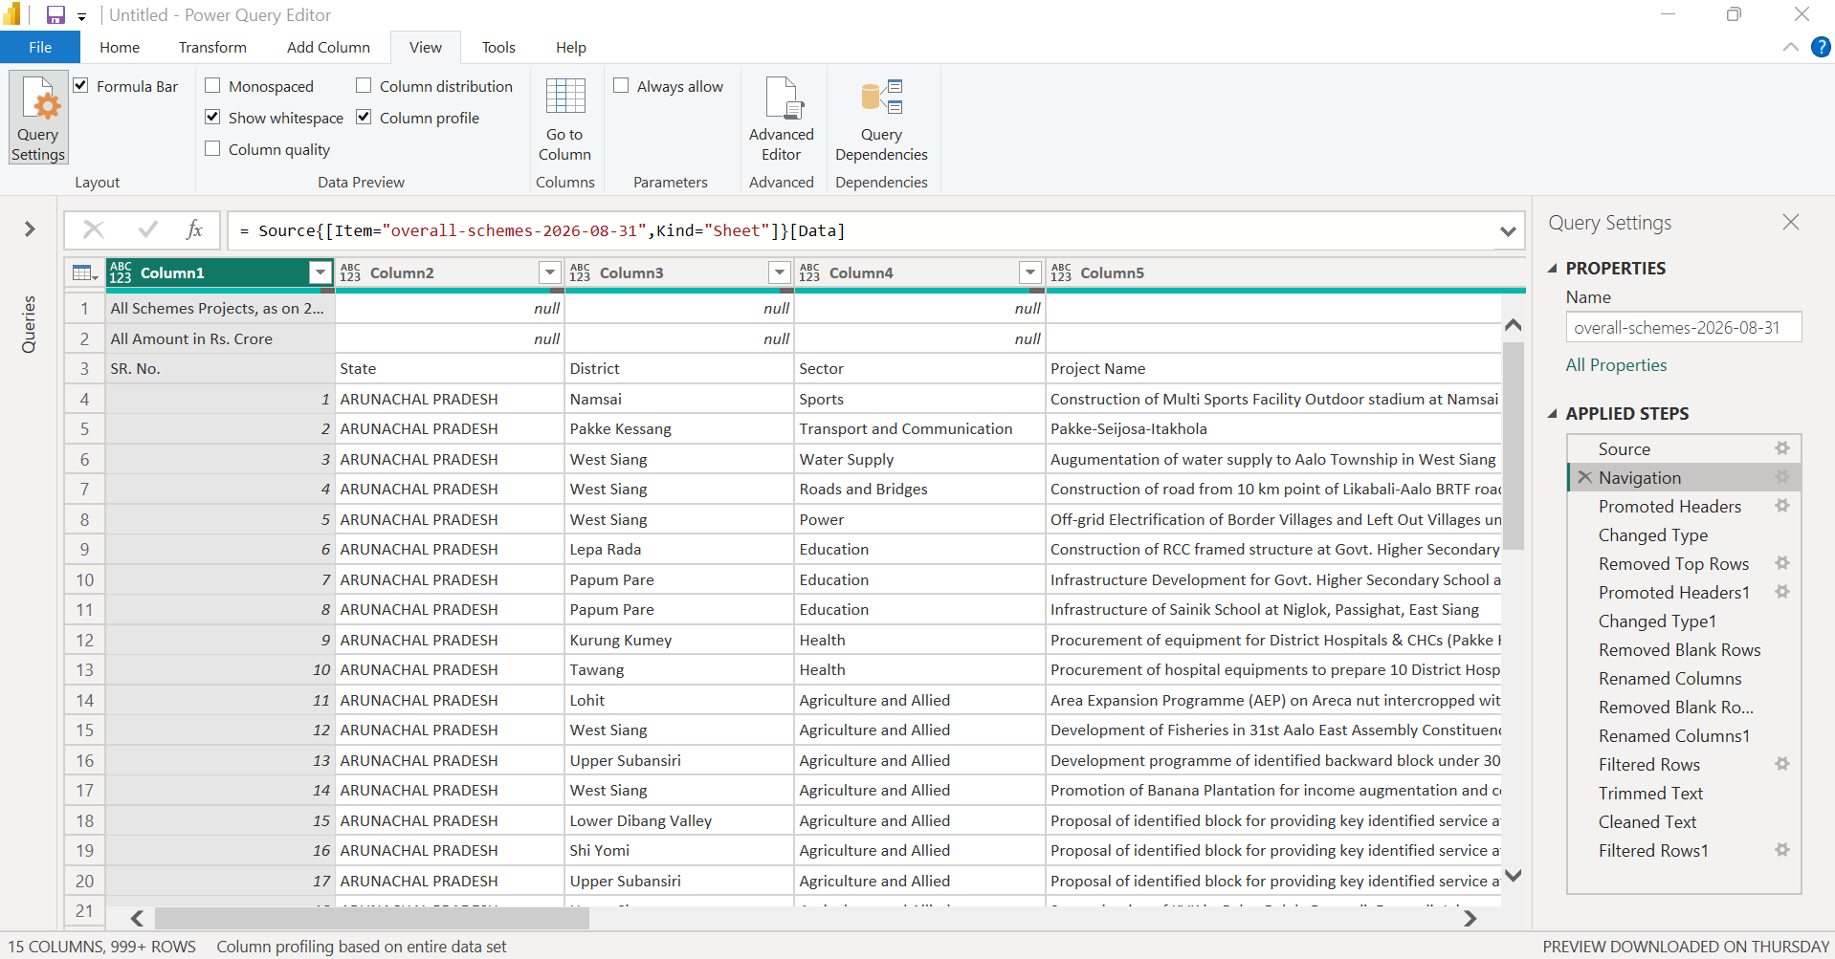
Figure 5. Power Query Editor, Applied Step `Navigation`.
Figure 5 (detail). Enlarged crop of the formula bar from Screenshot 05.
= Source{[Item="overall-schemes-2026-08-31",Kind="Sheet"]}[Data]
What the screenshot shows. The formula selects the worksheet by name and kind from the Source table. The resulting preview has generic names, Column1 to Column5 and onward. Row 1 shows “All Schemes Projects, as on 2...”, row 2 shows “All Amount in Rs. Crore”, and row 3 holds the real headings (SR. No., State, District, Sector, Project Name). Records begin from row 4. The status bar shows 15 columns and 999+ rows; “999+” is the preview’s display limit, not a row count.
Why it matters. Navigation moves from “the workbook” to “the data on one sheet”. It also exposes the layout problem solved in Section 7.1: the sheet has two title rows above the header row, so the data cannot yet be used as a proper table.

7. Power Query Data Preparation and Transformation
Power Query is the data-preparation engine inside Power BI. Each transformation is recorded as a named entry under Applied Steps in the Query Settings pane and written in the M language, which is visible in the formula bar. Steps run from top to bottom, and each takes the output of the previous one as input. This gives three practical benefits: the sequence can be read and audited, a step can be inspected by clicking it, and the whole sequence can be re-applied to a refreshed file.
The query contains 15 Applied Steps. They are explained below in logical stages, with the matching screenshot at each point. Figures are numbered according to the original screenshot numbers, which follow the Applied Steps order.

7.1 Worksheet structure and header preparation
This stage covers Source, Navigation, Promoted Headers, Changed Type, Removed Top Rows, Promoted Headers1 and Changed Type1. The first two were explained in Section 6. The remaining five turn a sheet with title rows into a table with proper column names and types. Because Power Query’s automatic steps are applied in order, the header row had to be exposed by removing the rows above it before the final headers and types could be set.
Figure 6 — Initial Header Promotion
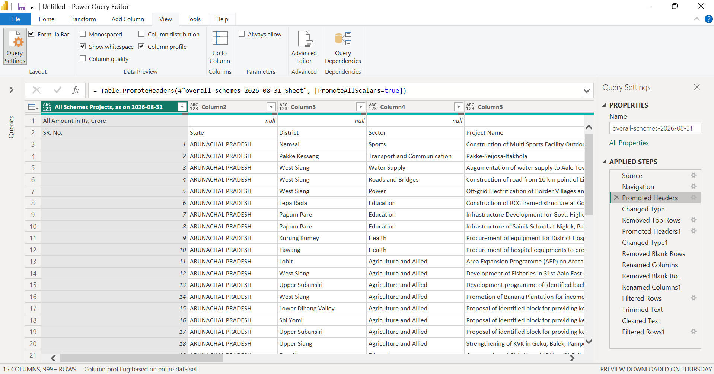
Figure 6. Applied Step `Promoted Headers`: the first row promoted to column headers.
Figure 6 (detail). Enlarged crop of the formula bar from Screenshot 06.
= Table.PromoteHeaders(#"overall-schemes-2026-08-31_Sheet", [PromoteAllScalars=true])
What the screenshot shows. The first row of the sheet became the header of the first column, which now reads “All Schemes Projects, as on 2026-08-31”. The other columns keep generic names (Column2, Column3, Column4, Column5). The row “All Amount in Rs. Crore” is now the first data row, and the real headings (SR. No., State, District, Sector, Project Name) are the second data row.
Why it matters. This step shows that promoting the first row was not enough. The title text, not the field names, was promoted, so the headers at this stage were not usable. This is the reason for the further clean-up in the next steps. The formula also shows the name of the preceding step, #"overall-schemes-2026-08-31_Sheet", which Power Query displays as Navigation.
Figure 7 — Initial Data Type Assignment
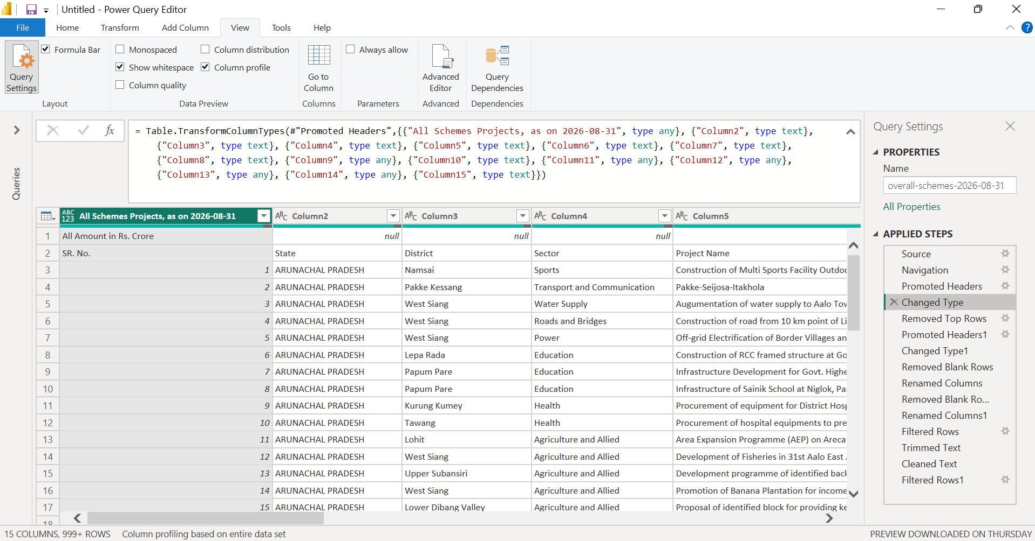
Figure 7. Applied Step `Changed Type`: types assigned while the title rows were still present.
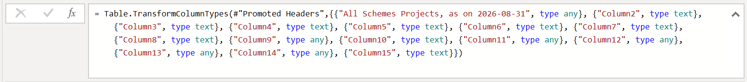
Figure 7 (detail). Enlarged crop of the formula bar from Screenshot 07.
What the screenshot shows. The Table.TransformColumnTypes formula assigns type any to the first column and to Column9 and Column11 to Column14, and type text to Column2 to Column8, Column10 and Column15. Judging by their position in the worksheet, the “any” columns correspond to the numeric fields (Approved Cost and the expenditure and UC columns) and the first column to the serial number. The preview still shows the title row and the heading row as data.
Why it matters. This type assignment is applied automatically on import, and it was made against the wrong header layout. Types set while the header row sits among the data rows may not match the real columns, so the types were reviewed again after the headers were corrected, as Changed Type1.
Figure 8 — Top Rows Removal
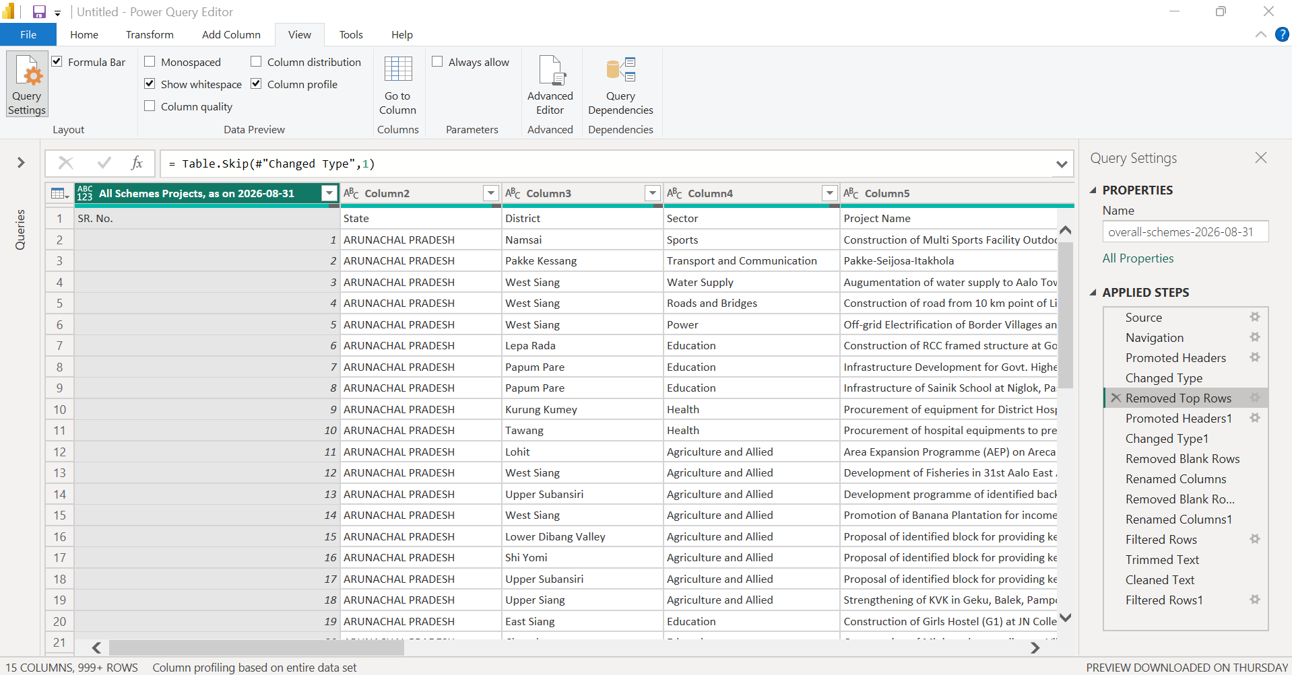
Figure 8. Applied Step `Removed Top Rows` (`Table.Skip`).
Figure 8 (detail). Enlarged crop of the formula bar from Screenshot 08.
= Table.Skip(#"Changed Type",1)
What the screenshot shows. The formula is legible and shows Table.Skip with a count of 1, so one row was removed from the top. At this stage, that row was “All Amount in Rs. Crore” (visible in Figure 7). After the step, the first row of the preview is the heading row: SR. No., State, District, Sector, Project Name.
Why it matters. The first title row had already been consumed by Promoted Headers, so only one further row needed to be skipped to leave the real header row at the top. A consequence is that the title text “All Schemes Projects, as on 2026-08-31”, with its snapshot date, is no longer inside the table; that date remains in the worksheet and query names. The unit (Rs. crore) also disappears from the table and should be recorded in the data dictionary.
Figure 9 — Final Header Promotion
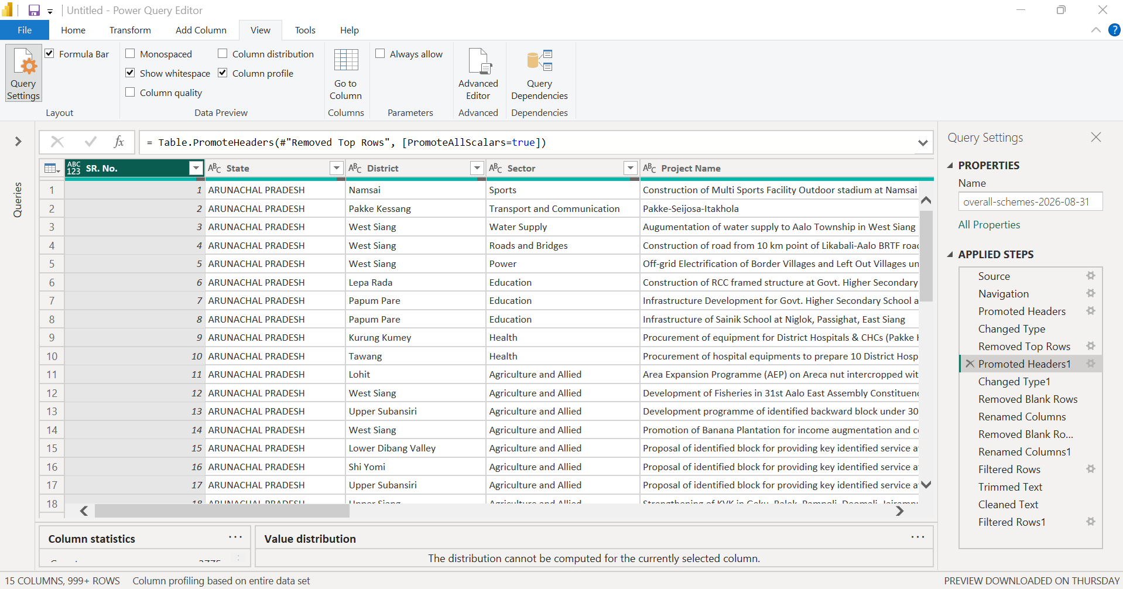
Figure 9. Applied Step `Promoted Headers1`: the correct header row promoted.
Figure 9 (detail). Enlarged crop of the formula bar from Screenshot 09.
= Table.PromoteHeaders(#"Removed Top Rows", [PromoteAllScalars=true])
What the screenshot shows. The column headings are now the real field names. The first five visible are SR. No., State, District, Sector and Project Name; the remaining headings are off-screen but are all named in the formula of the next step (Figure 10). Record rows now start at row 1 with Serial Number 1, ARUNACHAL PRADESH, Namsai, Sports. A Column statistics panel is partly visible at the bottom of the screen.
Why it matters. With the correct headers in place, every later step can refer to columns by meaningful names. Several of those steps, such as the filters and the text trimming, depend on that.
Figure 10 — Data Type Assignment After Header Promotion
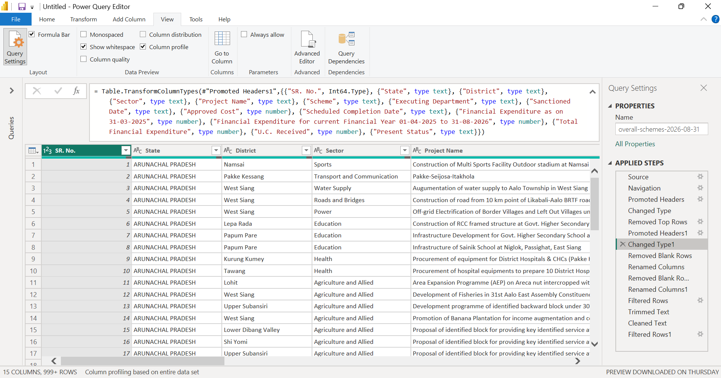
Figure 10. Applied Step `Changed Type1`: data types assigned to the finalised columns.
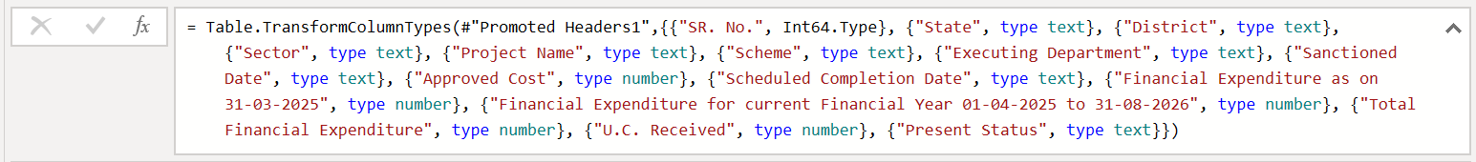
Figure 10 (detail). Enlarged crop of the formula bar from Screenshot 10, showing the full list of column names and types.
What the screenshot shows. The formula assigns the following types: SR. No. as Int64.Type (whole number); State, District, Sector, Project Name, Scheme, Executing Department, Sanctioned Date, Scheduled Completion Date and Present Status as type text; and Approved Cost, Financial Expenditure as on 31-03-2025, Financial Expenditure for current Financial Year 01-04-2025 to 31-08-2026, Total Financial Expenditure and U.C. Received as type number. The Serial Number column now shows a whole-number icon.
Why it matters. Numeric fields typed as numbers can be summed and compared, and text fields can be grouped. The one point to note is that the two date columns are typed as text, not date. No later Applied Step changes them, so in the documented query they remain text (see Section 8 and Section 13).

7.2 Blank-row handling and column standardisation
This stage covers Removed Blank Rows, Renamed Columns, Removed Blank Rows1 and Renamed Columns1. A fully blank row is one in which every field is empty or null; it carries no project information and can safely be removed. This is different from a record with a missing value in one field (for example, a project with no completion date), which still describes a project and should not be discarded for that reason alone.
Figure 11 — Blank Row Removal
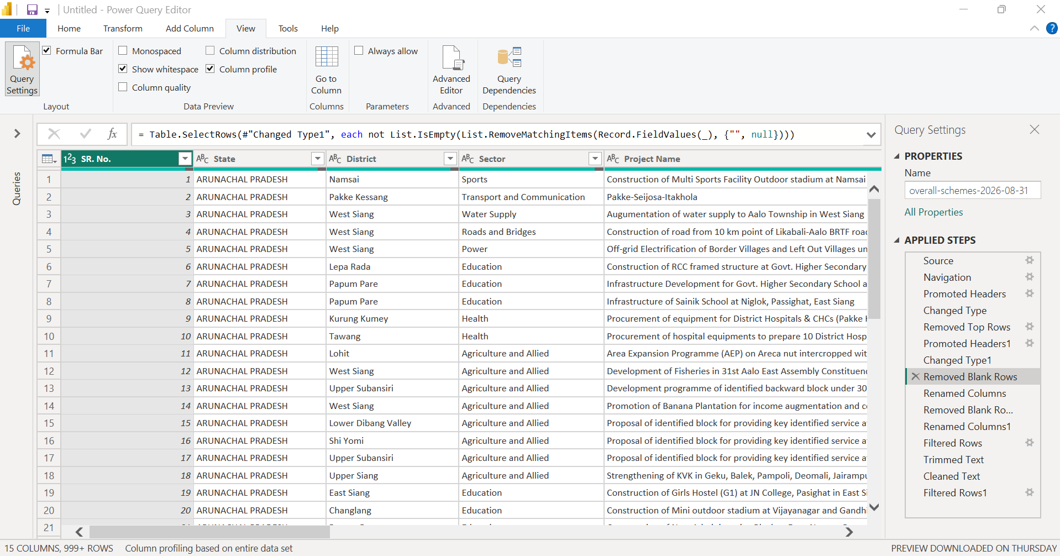
Figure 11. Applied Step `Removed Blank Rows`.
Figure 11 (detail). Enlarged crop of the formula bar from Screenshot 11.
= Table.SelectRows(#"Changed Type1", each not List.IsEmpty(List.RemoveMatchingItems(Record.FieldValues(_), {"", null})))
What the screenshot shows. This is the formula Power Query generates for “Remove Blank Rows”. For each row it takes the list of all field values, removes empty strings and nulls, and keeps the row only if anything is left. A row survives if at least one field has a value. The preview shows project records from Serial Number 1.
Why it matters. The test is applied to the whole row, so a record with one missing field is kept. The number of rows removed by this step was not separately quantified in the screenshot, and is not stated here.
Figure 12 — First Column Renaming
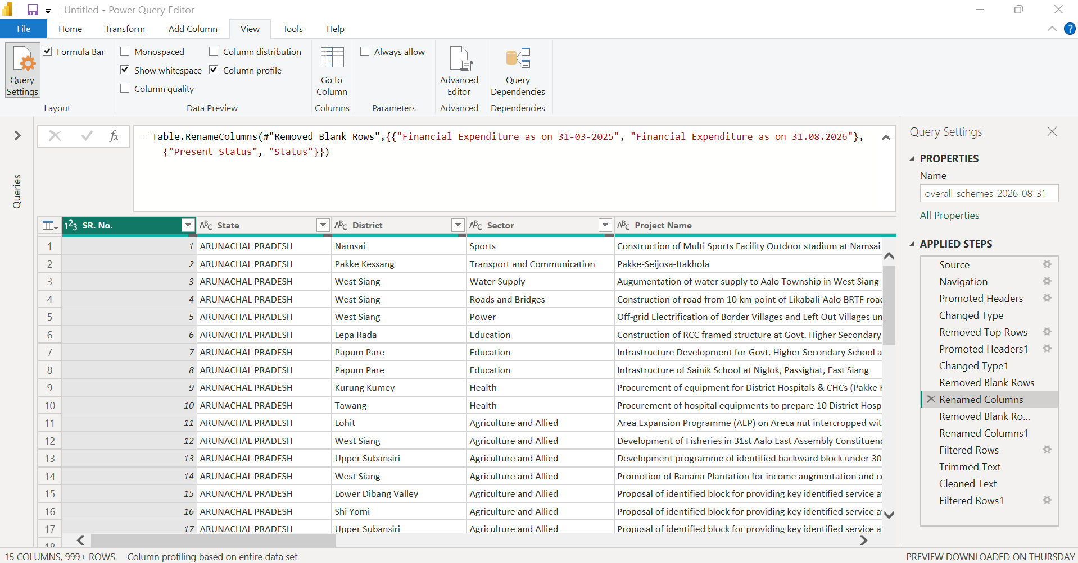
Figure 12. Applied Step `Renamed Columns`.
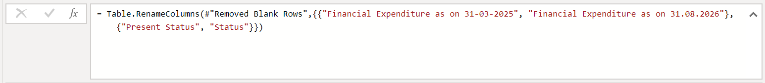
Figure 12 (detail). Enlarged crop of the formula bar from Screenshot 12.
= Table.RenameColumns(#"Removed Blank Rows",{{"Financial Expenditure as on 31-03-2025", "Financial Expenditure as on 31.08.2026"}, {"Present Status", "Status"}})
What the screenshot shows. Two renamings are visible in the formula. Financial Expenditure as on 31-03-2025 becomes Financial Expenditure as on 31.08.2026, and Present Status becomes Status.
Why it matters. Shorter labels such as Status are easier to use in later work. The first renaming, however, changes the date stated in the label, which is different from the heading in the workbook; see the observation in Section 5.1. This is flagged for confirmation and no claim is made here about which date is correct.
Figure 13 — Additional Blank Row Removal
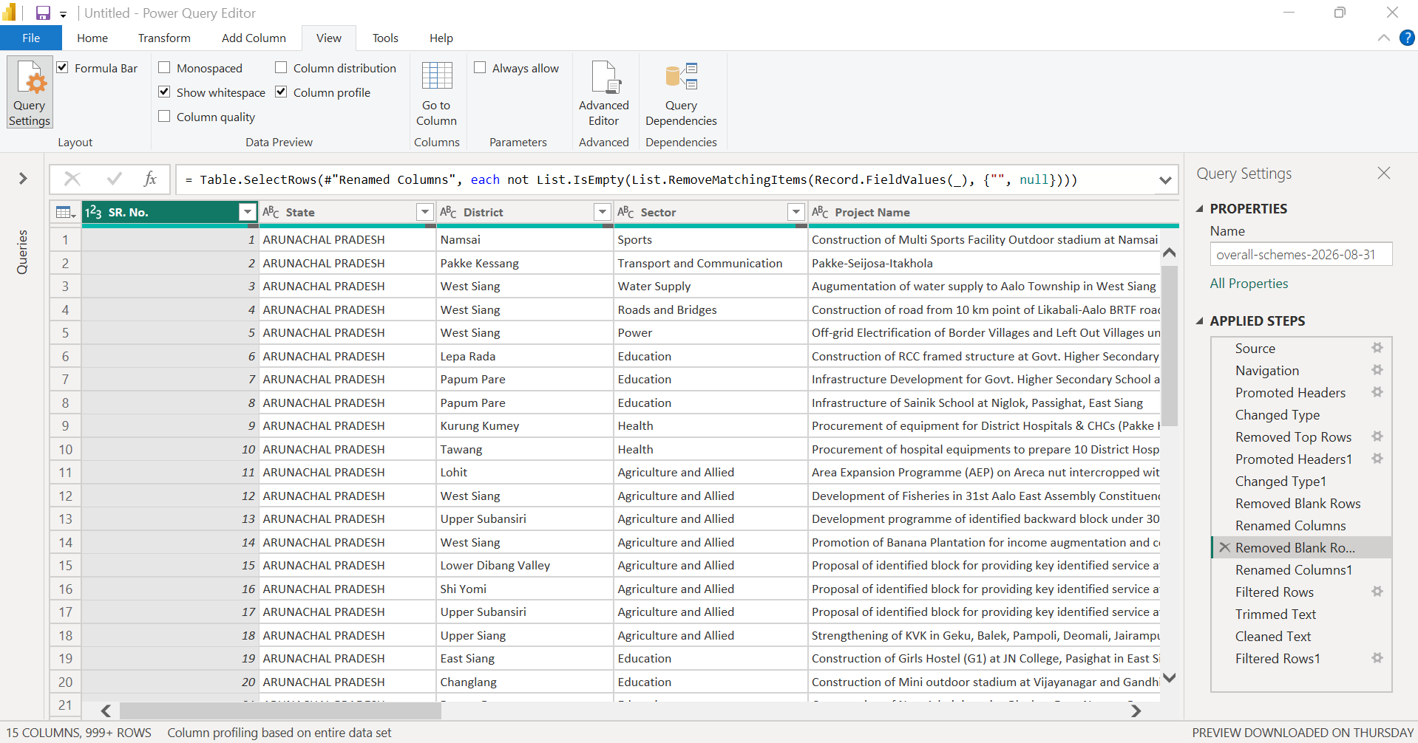
Figure 13. Applied Step `Removed Blank Rows1`.
Figure 13 (detail). Enlarged crop of the formula bar from Screenshot 13.
= Table.SelectRows(#"Renamed Columns", each not List.IsEmpty(List.RemoveMatchingItems(Record.FieldValues(_), {"", null})))
What the screenshot shows. The same blank-row logic is applied again, this time to the output of Renamed Columns. In the Applied Steps list it appears as a separate step, shown with a truncated name (“Removed Blank Ro...”) because of the pane width.
Why it matters. It is a distinct step in the sequence, positioned after the first renaming. The screenshot does not show whether it changed the row count, and the count is not recorded, so no effect on the data is claimed.
Figure 14 — Second Column Renaming
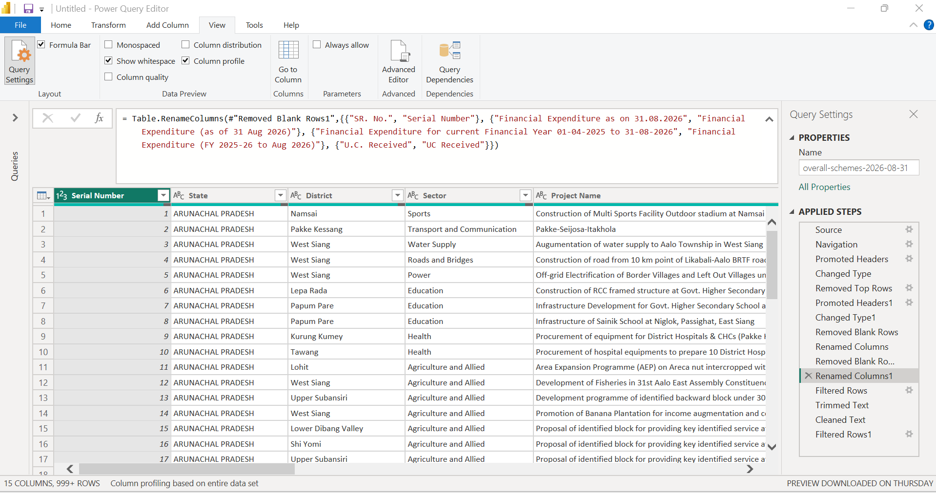
Figure 14. Applied Step `Renamed Columns1`.
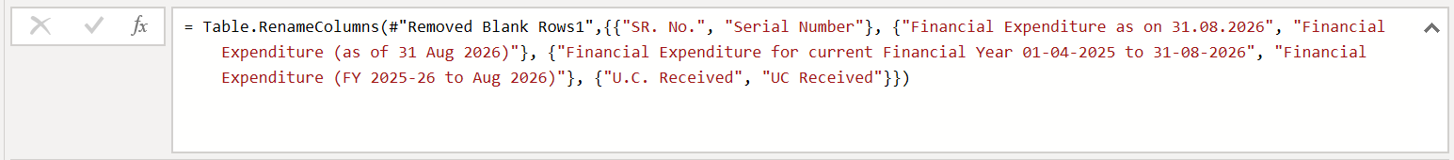
Figure 14 (detail). Enlarged crop of the formula bar from Screenshot 14.
= Table.RenameColumns(#"Removed Blank Rows1",{{"SR. No.", "Serial Number"},
{"Financial Expenditure as on 31.08.2026", "Financial Expenditure (as of 31 Aug 2026)"},
{"Financial Expenditure for current Financial Year 01-04-2025 to 31-08-2026", "Financial Expenditure (FY 2025-26 to Aug 2026)"},
{"U.C. Received", "UC Received"}})
What the screenshot shows. Four renamings are visible: SR. No. to Serial Number; Financial Expenditure as on 31.08.2026 to Financial Expenditure (as of 31 Aug 2026); Financial Expenditure for current Financial Year 01-04-2025 to 31-08-2026 to Financial Expenditure (FY 2025-26 to Aug 2026); and U.C. Received to UC Received. The first column of the preview now reads Serial Number. Executing Department and Total Financial Expenditure are not renamed, so the name Executing Department is the one used in the final query.
Why it matters. Removing punctuation and shortening long headings makes the columns easier to reference in formulas and visuals, and the new names are the ones used by the later filter and text steps. As noted in Section 5.1, the period wording inside the two expenditure labels should be confirmed: the second label says “FY 2025-26” while its period runs to 31 August 2026.

7.3 Record filtering
Two steps remove records on the basis of a key field. They are separated by the two text-standardisation steps of Section 7.4 in the Applied Steps order, which is why Figure 15 is followed by Figures 16 and 17 and then Figure 18; both filters are presented together here because they share a purpose. Filtering rows with a missing identifying value is a deliberate decision, and it reduces the dataset: the number of rows removed by either step is not recorded in the screenshots.
Figure 15 — Project Name Filter
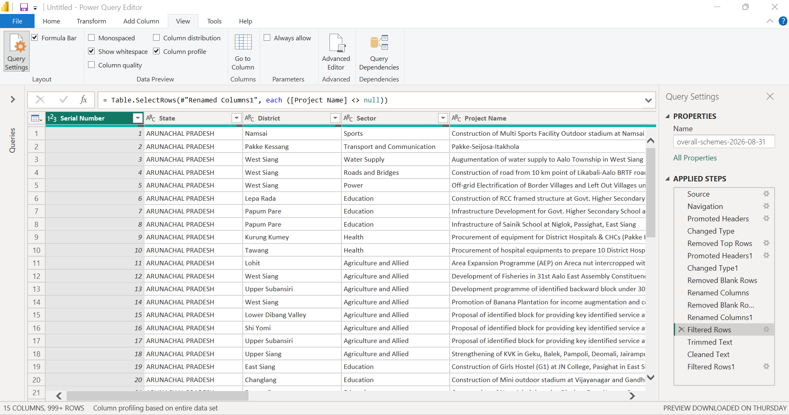
Figure 15. Applied Step `Filtered Rows`: rows with a null Project Name excluded.
Figure 15 (detail). Enlarged crop of the formula bar from Screenshot 15.
= Table.SelectRows(#"Renamed Columns1", each ([Project Name] <> null))
What the screenshot shows. The formula keeps only rows in which Project Name is not null; rows with a null Project Name are excluded. The Applied Step shows a filter icon in the step list.
Why it matters. The project name is the main human-readable identifier of a record. A row with no project name cannot be recognised as a project, so it is excluded. This is a specific filtering decision: it excludes null values only, and a project name that is an empty string (not null) would not be removed by this formula.
Figure 18 — Serial Number Filter
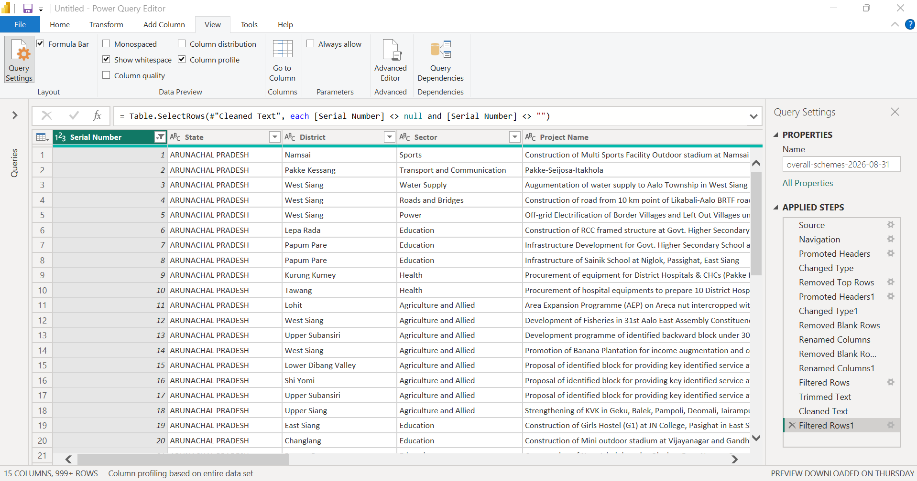
Figure 18. Applied Step `Filtered Rows1`: rows with a null or empty Serial Number excluded.
Figure 18 (detail). Enlarged crop of the formula bar from Screenshot 18.
= Table.SelectRows(#"Cleaned Text", each [Serial Number] <> null and [Serial Number] <> "")
What the screenshot shows. The formula keeps rows in which Serial Number is neither null nor an empty string. The Serial Number column header carries a filter icon. This is the last step in the list, and it takes Cleaned Text as its input.
Why it matters. The serial number is a record-identification field in the source listing. Requiring it to be present removes any row that is not a numbered record. The screenshots do not show which rows, if any, were removed by this step. Note that Serial Number is a position number in this listing; it has not been verified as a globally unique project identifier, although the profile in Screenshot 20 shows 3,774 distinct values and 3,774 unique ones.

7.4 Text standardisation
Two steps standardise the text columns. Trimming removes leading and trailing spaces from a text value. Cleaning removes non-printable control characters. They solve different problems: a value with a stray space at the end looks the same on screen but is a different value to a grouping or filter, while a value containing a control character (for example, a line break carried in from the source) can break a display or a match in a way that is hard to see.
Figure 16 — Text Trimming
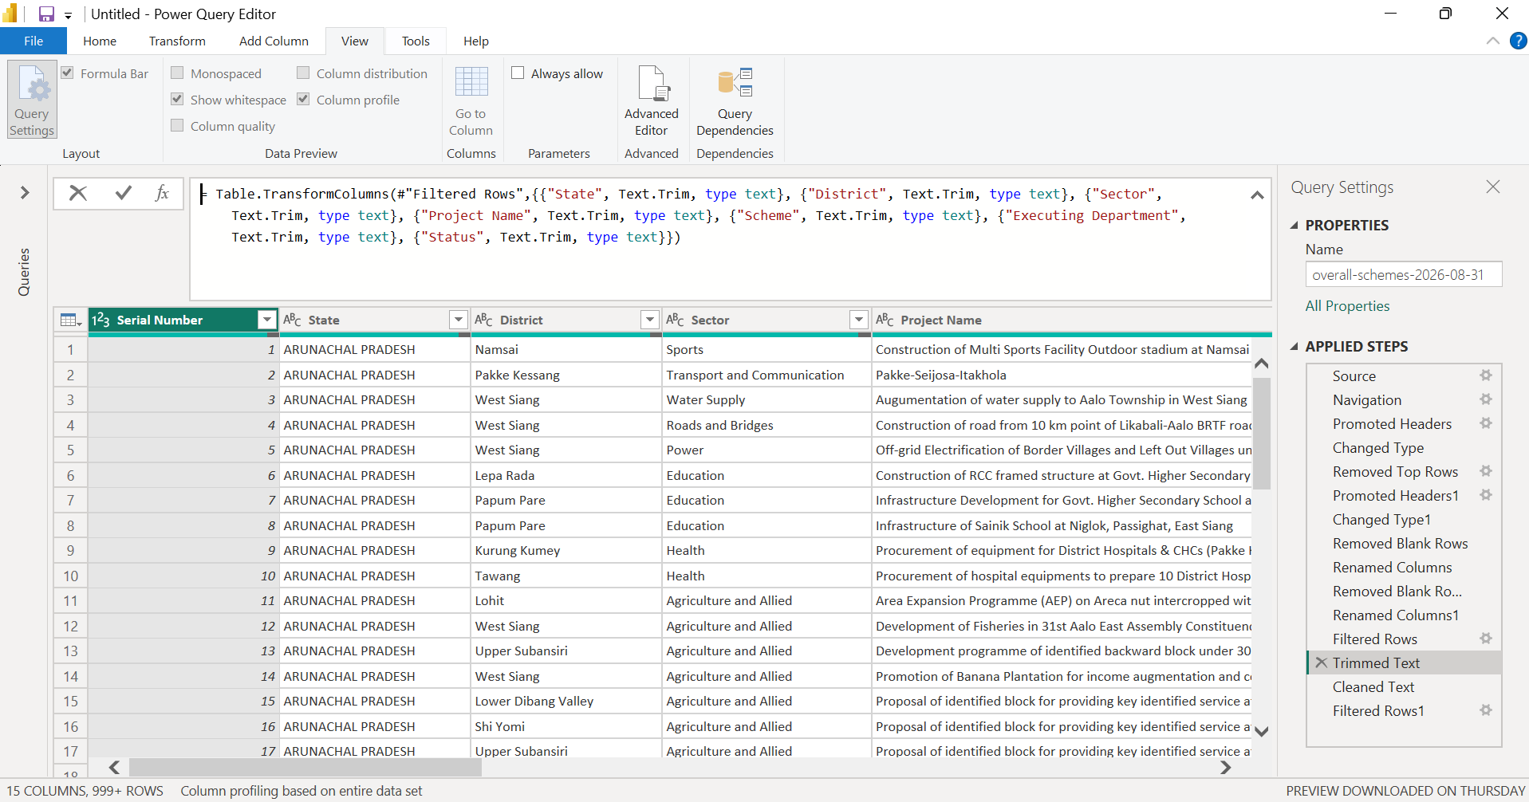
Figure 16. Applied Step `Trimmed Text`.
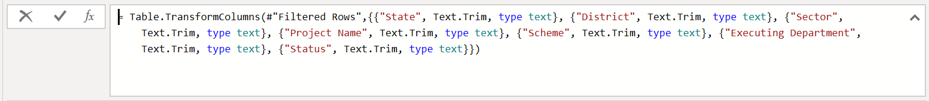
Figure 16 (detail). Enlarged crop of the formula bar from Screenshot 16.
= Table.TransformColumns(#"Filtered Rows",{{"State", Text.Trim, type text}, {"District", Text.Trim, type text}, {"Sector", Text.Trim, type text}, {"Project Name", Text.Trim, type text}, {"Scheme", Text.Trim, type text}, {"Executing Department", Text.Trim, type text}, {"Status", Text.Trim, type text}})
What the screenshot shows. Text.Trim is applied to seven columns: State, District, Sector, Project Name, Scheme, Executing Department and Status. The date columns (typed as text) and Serial Number are not in the list.
Why it matters. These are the categorical fields that will be used for grouping, slicing and filtering. Removing hidden leading or trailing spaces prevents two visually identical values from being counted as different. The screenshots do not show how many values actually contained extra spaces.
Figure 17 — Text Cleaning
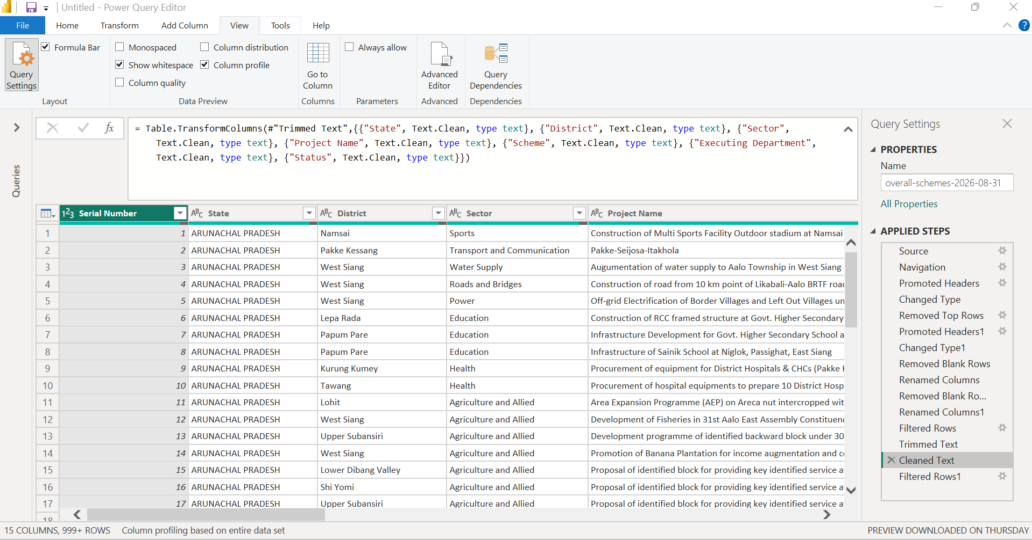
Figure 17. Applied Step `Cleaned Text`.
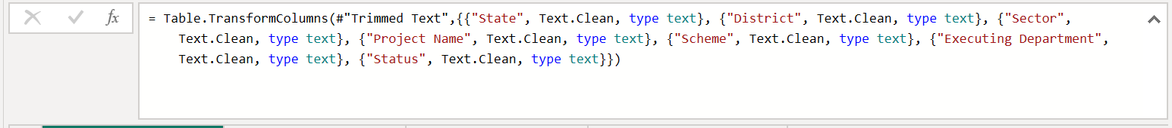
Figure 17 (detail). Enlarged crop of the formula bar from Screenshot 17.
= Table.TransformColumns(#"Trimmed Text",{{"State", Text.Clean, type text}, {"District", Text.Clean, type text}, {"Sector", Text.Clean, type text}, {"Project Name", Text.Clean, type text}, {"Scheme", Text.Clean, type text}, {"Executing Department", Text.Clean, type text}, {"Status", Text.Clean, type text}})
What the screenshot shows. Text.Clean is applied to the same seven columns, on the output of Trimmed Text.
Why it matters. Cleaning removes non-printable characters that trimming does not. It does not correct spelling, merge name variants or change meaning, so inconsistencies of that kind, if present, remain. Whether any such characters were present is not shown.

7.5 Complete transformation sequence
Figure 19 shows the Query Settings pane with the complete list of Applied Steps, and the Column Quality bars of the first five columns. It confirms the sequence below and that the current final step is Filtered Rows1.
Figure 19 — Complete Applied Steps
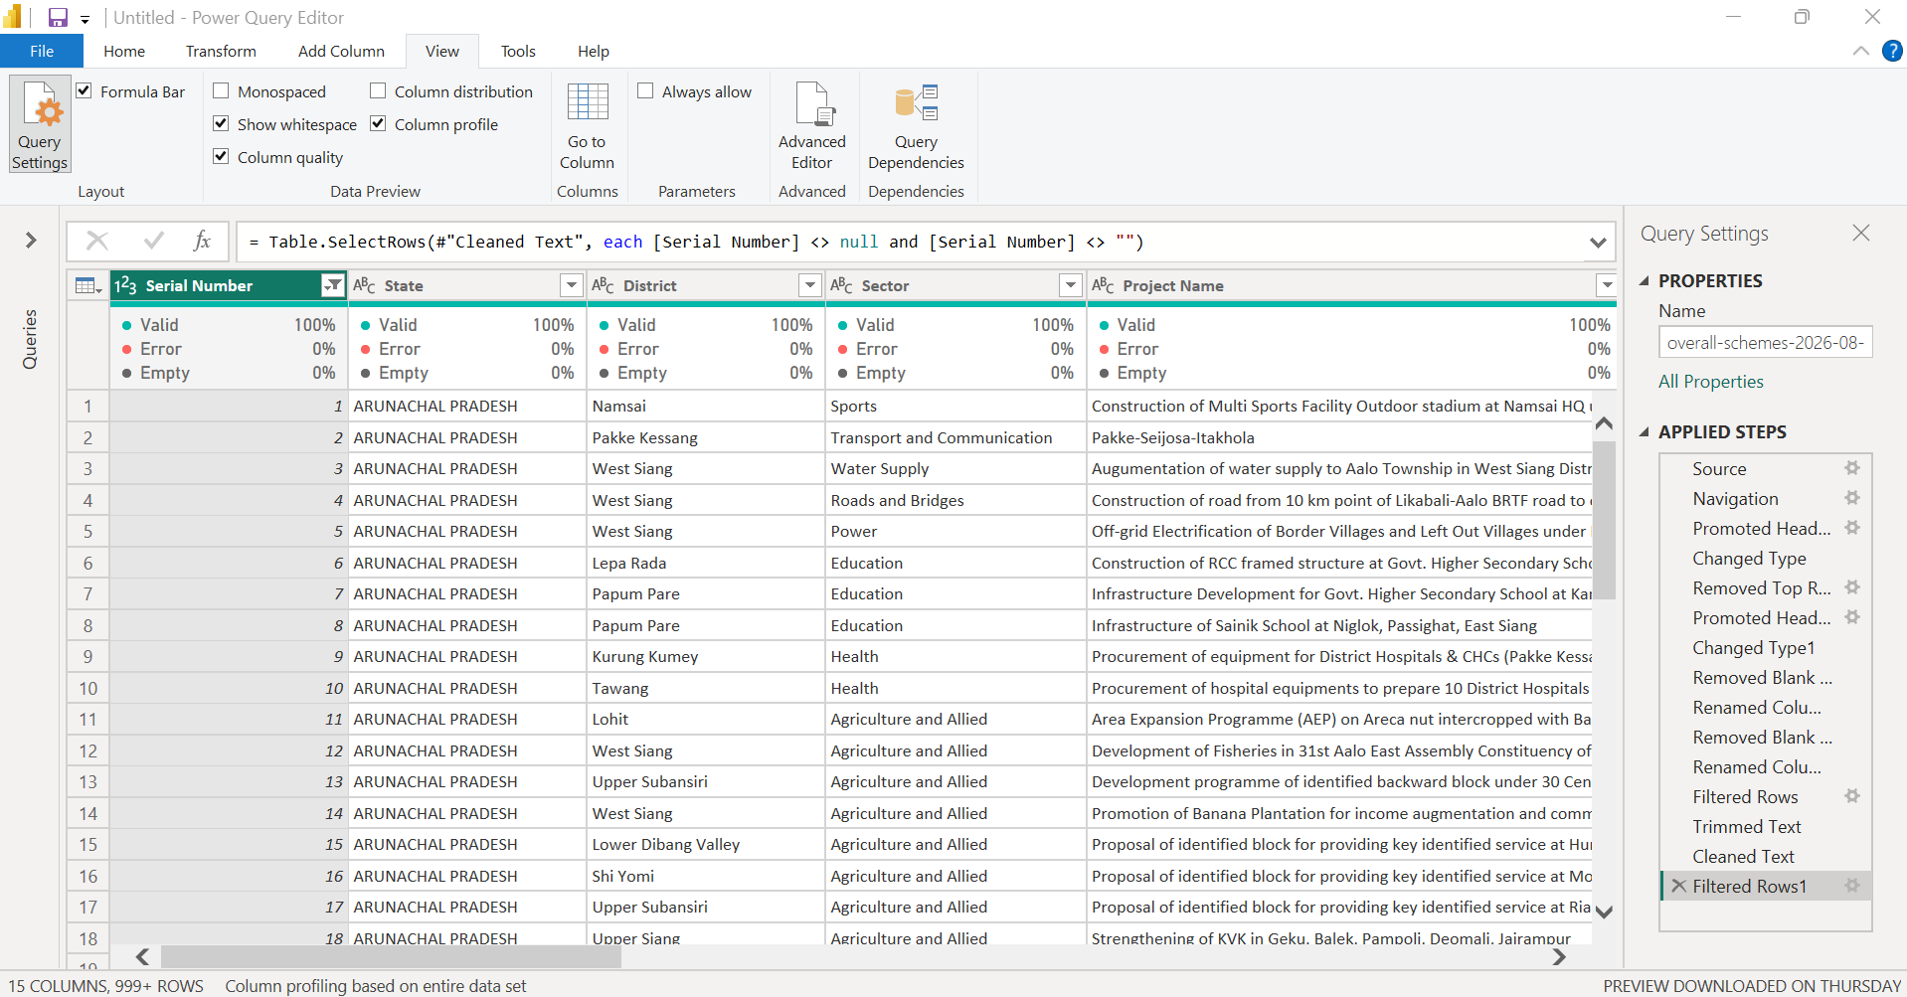
Figure 19. Complete Applied Steps sequence for the query `overall-schemes-2026-08-31`, ending at `Filtered Rows1`.
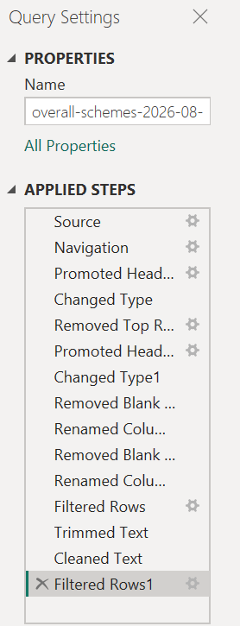
Figure 19 (detail). Enlarged crop of the Applied Steps pane from Screenshot 19 (some names are truncated by the pane width).
What the screenshot shows. The 15 steps are listed in order, with Filtered Rows1 highlighted as the current step. The formula bar shows the Filtered Rows1 formula. Column Quality is switched on, and the first five columns (Serial Number, State, District, Sector, Project Name) each show 100% valid, 0% error and 0% empty. The status bar reads “15 COLUMNS, 999+ ROWS” and “Column profiling based on entire data set”.
Why it matters. The ordered list is the audit trail of the whole preparation. Anyone opening the query can click each step in turn and see the data as it stood at that point, and the sequence can be re-run on a refreshed workbook.
Table 8. The 15 Applied Steps in order
# | Step name | Operation | Purpose | Data-handling implication | Figure
1 | Source | Excel.Workbook(File.Contents ...) | Link the query to the workbook | Traceable to the raw file | 4
2 | Navigation | Select sheet overall-schemes-2026-08-31 | Reach the data table | Exposes two title rows above headers | 5
3 | Promoted Headers | Table.PromoteHeaders | First row to headers | Title text promoted; headers not yet usable | 6
4 | Changed Type | Table.TransformColumnTypes (any/text) | Initial typing | Typed against the wrong layout; reviewed later | 7
5 | Removed Top Rows | Table.Skip(..., 1) | Remove one row above the header row | Header row now first | 8
6 | Promoted Headers1 | Table.PromoteHeaders | Promote the real header row | Meaningful column names | 9
7 | Changed Type1 | Table.TransformColumnTypes | Type the final columns | Numbers typed; dates left as text | 10
8 | Removed Blank Rows | Blank-row filter | Drop fully blank rows | Count not recorded | 11
9 | Renamed Columns | Table.RenameColumns (2 columns) | Shorter labels | Expenditure label period to be confirmed | 12
10 | Removed Blank Rows1 | Blank-row filter (repeat) | Repeat blank-row removal | Count not recorded | 13
11 | Renamed Columns1 | Table.RenameColumns (4 columns) | Standardise column names | Final names set | 14
12 | Filtered Rows | [Project Name] <> null | Exclude rows without a project name | Null names excluded; count not recorded | 15
13 | Trimmed Text | Text.Trim on 7 text columns | Remove leading/trailing spaces | Cleaner grouping keys | 16
14 | Cleaned Text | Text.Clean on 7 text columns | Remove non-printable characters | Does not fix spelling or naming variants | 17
15 | Filtered Rows1 | [Serial Number] <> null and <> "" | Exclude rows without a serial number | Null/empty serials excluded; count not recorded | 18

Figure 21 — Workflow schematic
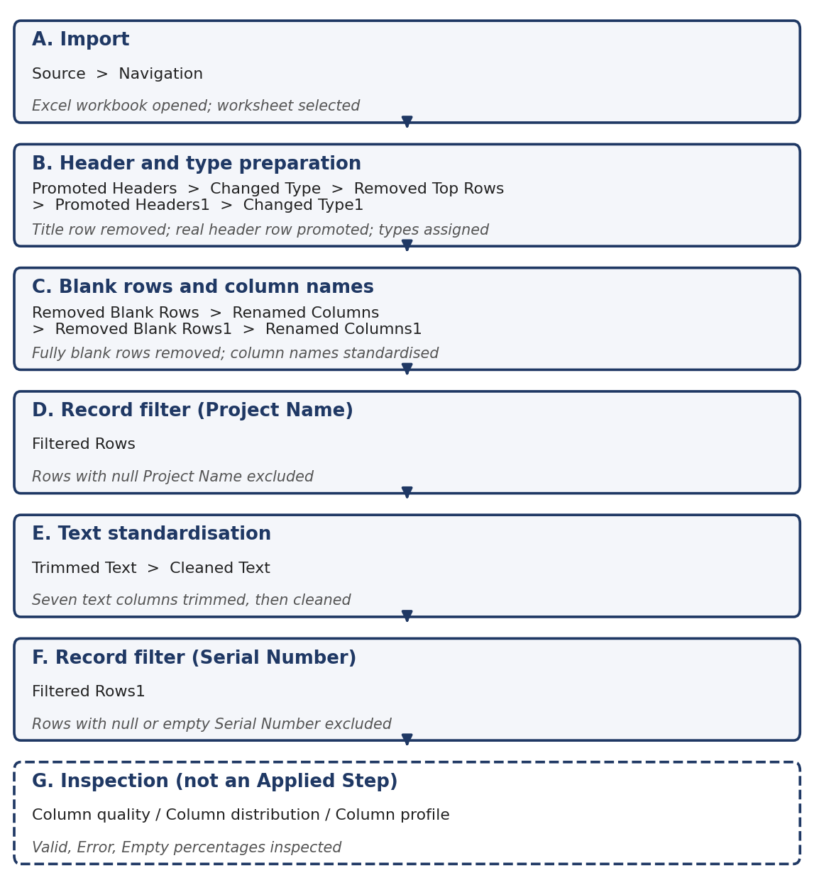
Figure 21. Schematic of the Week 2 preparation stages in Applied Steps order. This is a process diagram drawn for this report, not a Power BI screenshot.

8. Data Quality Assessment and Missing-Value Handling
Power Query’s data-profiling tools provide a quick view of the state of each column. Column Quality shows the share of values that are Valid, in Error or Empty. Column Distribution shows how many distinct values a column holds, and how many of those occur exactly once (unique), with a small bar chart of the value frequencies. Profiling in the screenshots is set to “based on entire data set”, so the percentages relate to all rows, not only the first 1,000.
Figure 20 — Final Prepared Dataset Preview and Data Profiling
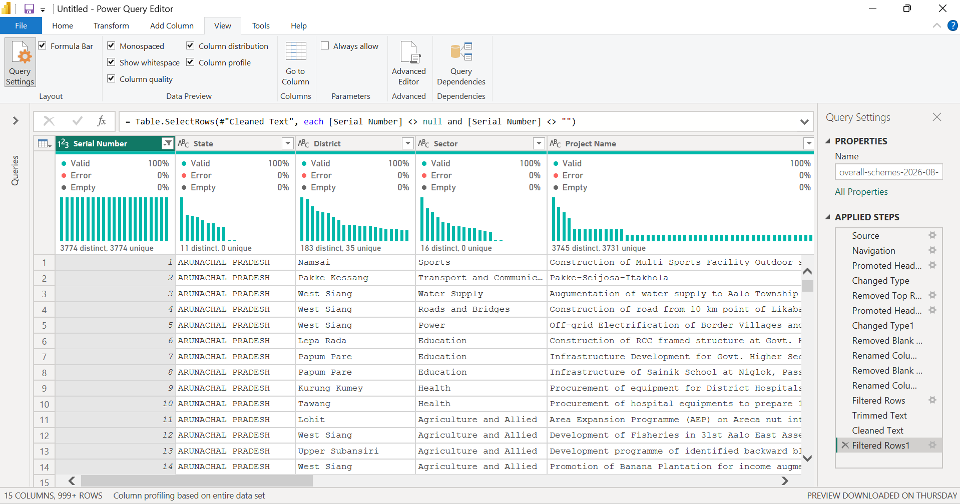
Figure 20. Final prepared dataset preview with Column Quality and Column Distribution indicators (after `Filtered Rows1`).
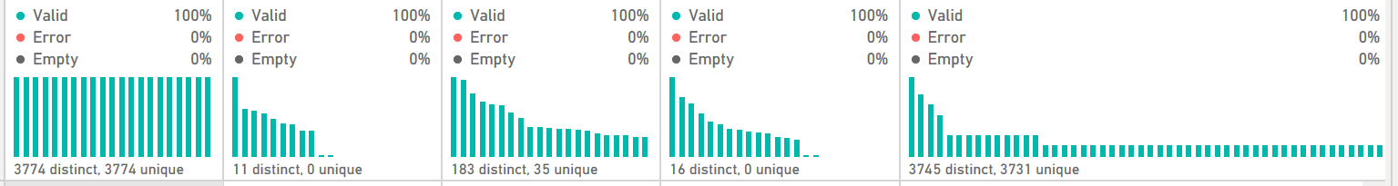
Figure 20 (detail). Enlarged crop of the profiling area from Screenshot 20.
What the screenshot shows. The View ribbon shows Monospaced, Column distribution, Column quality and Column profile switched on. For the first five columns the visible profile reads: Serial Number, 100% valid, 0% error, 0% empty, 3774 distinct and 3774 unique; State, 100% valid, 11 distinct, 0 unique; District, 100% valid, 183 distinct, 35 unique; Sector, 100% valid, 16 distinct, 0 unique; Project Name, 100% valid, 3745 distinct, 3731 unique. The formula bar still shows the Filtered Rows1 formula, and the list of Applied Steps ends at that step.
Why it matters. This is the validation view of the prepared table. It shows that the identification and categorical columns have no empty or error values after the filters, and it gives a first picture of how varied they are. The date, cost, expenditure and UC columns lie further to the right and are not visible in this capture, so their percentages are taken from the screenshot notes, as set out below.

8.1 Observed data-quality information
Table 9. Column-quality indicators
Column | Valid | Error | Empty
Serial Number | 100% | 0% | 0%
State | 100% | 0% | 0%
District | 100% | 0% | 0%
Sector | 100% | 0% | 0%
Project Name | 100% | 0% | 0%
Sanctioned Date | ~99% | 0% | <1%
Scheduled Completion Date | ~99% | 0% | <1%
UC Received | 100% | 0% | 0%
Approved Cost | 100% | 0% | 0%
Financial Expenditure (as of 31 Aug 2026) | 100% | 0% | 0%
Financial Expenditure (FY 2025-26 to Aug 2026) | 100% | 0% | 0%
Total Financial Expenditure | 100% | 0% | 0%
Scheme | 100% | 0% | 0%
Executing Department | 61% | 0% | 39%
Status | 100% | 0% | 0%

8.2 How missing values were handled
- Missing values are not automatically errors. Power Query counts a missing value as Empty and a failed conversion as Error. The date columns show a small Empty share and no errors, so what is seen is missing information, not a broken conversion.
- Missing dates were retained. Records were not deleted because a Sanctioned Date or Scheduled Completion Date was missing. The query contains no step that filters on either date column. Those projects remain available for analysis that does not need the date.
- Fully blank rows were handled separately from incomplete records, by the two blank-row steps (Section 7.2).
- Records missing a Project Name or a Serial Number were filtered out by Filtered Rows and Filtered Rows1, because those fields identify the record.
- Types need review. The date columns are typed as text in the documented query. A “valid” percentage for a text column means the cell is not empty; it does not prove that each value is a real date. Converting to a date type, with an explicit locale for the dd-mm-yyyy format seen in the data, would reveal any unparseable values as errors.
- Profiling is a first check, not proof of correctness. A 100% valid column can still hold wrong, outdated or inconsistently labelled values.

8.3 Observations from the profile
The distribution counts in Screenshot 20 give a few observations that are recorded here for follow-up, not as corrections already made:
- Serial Number has 3,774 distinct and 3,774 unique values, consistent with a 3,774-row table in which each serial appears once.
- Project Name has 3,745 distinct values, of which 3,731 occur once. By subtraction, 14 project names occur more than once (3,745 − 3,731), across 43 rows (3,774 − 3,731, assuming a 3,774-row table). No duplicate-removal step was applied; repeated names may be genuinely different projects (for example, similar works in different districts) and need review.
- State has 11 distinct values. The North Eastern Region has eight states, so the extra values (for example, multi-state entries or spelling variants) should be inspected.

9. Data Normalization and Standardization
The work in Week 2 was standardisation: making column names, types and text values consistent so that fields can be used reliably later. It was not normalisation in the database or statistical sense. Table 10 states what was done and what was not.
Table 10. Standardisation performed and techniques not performed
Technique | Performed? | Evidence and effect
Data type assignment | Yes | Changed Type and Changed Type1 (Figures 7, 10). Serial Number as whole number; cost, expenditure and UC fields as number; remaining fields as text. Dates left as text.
Column renaming | Yes | Renamed Columns and Renamed Columns1 (Figures 12, 14): Serial Number, Status, UC Received and two expenditure labels.
Text trimming | Yes | Trimmed Text on seven text columns (Figure 16).
Text cleaning | Yes | Cleaned Text on the same seven columns (Figure 17).
Blank-row and record filtering | Yes | Two blank-row steps and two key-field filters (Figures 11, 13, 15, 18).
Database normalisation (1NF to 3NF) | No | The table was kept as a single flat table; it was not split into related tables.
Scaling or statistical normalisation | No | No values were rescaled.
Currency or unit conversion | No | Monetary values remain in Rs. crore as in the source.
Date standardisation to a date type | No | Date columns remain text in the documented query.
Category harmonisation (spelling, name variants) | No | Not performed; the profile suggests State and Project Name warrant a check.
Duplicate removal | No | No such step exists in the Applied Steps.

10. Multi-Source Integration: Current Status and Future Scope
The assignment mentions bridging or combining data from multiple sources. In this work, only one source workbook was imported, and the Applied Steps contain no Merge Queries or Append Queries operation. Multi-source integration was therefore not performed in Week 2, and it is described below as a proposed future enhancement.
Table 11. Proposed approach for future integration (not completed work)
# | Stage | What to check or do
1 | Identify a complementary public dataset | Choose a source that adds a missing metric (for example tender values or wage data, Table 5), after confirming its terms of use and format.
2 | Compare coverage | Check that the geography and the time period overlap with the MDoNER snapshot (North Eastern Region, as on 31 August 2026).
3 | Inspect definitions and units | Read field definitions; confirm units (Rs. crore versus rupees or lakhs) and the meaning of dates and status values.
4 | Find a reliable common key | Look for a shared project identifier, or a defensible combination such as state, district and sector. Project name matching alone is unreliable.
5 | Standardise types and categories | Align data types, date formats and category labels before any join.
6 | Check granularity and duplicates | Confirm that one row means the same thing in both tables (project, contract, state-month) so that a join does not multiply rows.
7 | Merge or Append only when valid | Use Merge Queries for a relationship on a key, and Append Queries only when the tables share the same row meaning and columns.
8 | Validate the result | Compare row counts before and after, and list unmatched records for review.

11. Challenges, Limitations, and Mitigation Strategies
Table 12 lists the data-handling challenges and considerations. The column “Evidence / status” states whether each one is evidenced in the screenshots or is a data-handling consideration, meaning a reasonable point to check that the screenshots do not show as a problem that actually occurred. No failed imports or broken files are claimed.
Table 12. Challenges, data-handling considerations and mitigation
Challenge or consideration | Evidence / status | Potential impact | Strategy or mitigation
Title rows above the real header row | Evidenced: Figures 5–9 | Wrong headers and misaligned types if imported as-is | Promote headers, remove the extra row with Table.Skip, promote the correct header row, re-apply types
Blank rows | Evidenced: two blank-row steps (Figures 11, 13); counts not recorded | Empty records distorting counts | Remove fully blank rows; record before/after row counts in future
Long or inconsistent column names | Evidenced: Figures 10, 12, 14 | Harder formulas and reports | Standardise names in Power Query; keep a data dictionary of original and final names
Period wording in expenditure headers | Data-handling consideration: Figures 1, 2, 10, 12, 14 | Fields may be mislabelled and misinterpreted | Confirm the intended periods against the source; re-label if needed
Whitespace and hidden characters in text | Data-handling consideration: trimming and cleaning applied (Figures 16, 17); amount present not shown | Duplicate-looking categories | Trim and clean text columns; profile Column Distribution afterwards
Missing date values | Evidenced: ~99% valid, <1% empty (notes, Figure 20) | Gaps in timeline measures | Retain records; handle missing dates explicitly in each measure
Dates held as text | Evidenced: Figure 10 | Cannot compute durations; “valid” may hide bad dates | Convert to a date type with an explicit locale; review errors
Records without Project Name or Serial Number | Evidenced: Figures 15, 18; counts not recorded | Some rows removed | Record row counts before and after each filter
Repeated project names | Observation: 3,745 distinct vs 3,731 unique (Figure 20) | Possible double counting or genuinely similar projects | Review manually; do not delete on name similarity alone
State field has 11 distinct values | Observation: Figure 20 | Region totals may be inflated or split | Inspect the distinct values; harmonise only after review
Limited geographic and metric coverage | Evidenced by the dataset’s content | Cannot assess productivity or physical progress | State limits in outputs; seek complementary sources (Table 5)
Single source only | Evidenced: no merge/append step | No cross-source validation | Plan integration per Section 10

12. Final Prepared Dataset and Workflow Outcome
The demonstrated outcome of Week 2 is a prepared table in Power Query, overall-schemes-2026-08-31, built through 15 documented Applied Steps. Specifically:
- One public Excel source was imported, and the raw workbook was preserved unmodified.
- The relevant worksheet was selected, and the title row above the header row was removed so that the real headers were promoted.
- Data types were assigned after the final headers were set.
- Fully blank rows were removed, and column names were standardised in two steps.
- Records with a null Project Name, and records with a null or empty Serial Number, were filtered out.
- Seven text columns were trimmed and then cleaned.
- Missing date values were retained.
- Column Quality and Column Distribution were used to inspect the result, and the ordered Applied Steps were documented.
What is not established. A single final row count was not recorded in the supplied evidence (the Serial Number profile suggests 3,774 rows). Row counts before and after the blank-row and filter steps were not recorded, and the quality percentages of the cost and expenditure columns remain. The prepared table has not been loaded into a data model, and no analysis has been run on it.

13. Recommendations and Next Steps
The items below are recommendations for continued work. They are not completed work.
Table 13. Recommended next steps
# | Recommendation | Reason
1 | Confirm final column names and data types, and document them in a data dictionary | Includes units (Rs. crore), snapshot date and the meaning of each expenditure field
2 | Resolve the expenditure-label question (Section 5.1) | The renamed labels give a date that does not match the original heading; confirm before analysis
3 | Record row counts before and after each filter and blank-row step | Quantifies what was removed; supports reconciliation with the worksheet
4 | Convert Sanctioned Date and Scheduled Completion Date to a date type | Enables duration measures; surfaces unparseable values as errors
5 | Review repeated project names and the 11 State values | Avoids double counting without deleting records solely on similar names
6 | Validate numeric values and units | Check negative values, zero expenditure, and cases where expenditure exceeds approved cost
7 | Confirm quality percentages for cost, expenditure and UC columns | Completes Table 9
8 | Export or load the prepared dataset | Prepares it for the model; keep the raw file untouched
9 | Identify a compatible supplementary dataset (Section 10) | Addresses the productivity and progress gaps
10 | Create a dashboard only after the data is validated | Prevents reporting on unverified fields

14. Conclusion
Week 2 moved BuildSight BI from an idea of what data is needed to a concrete, inspectable dataset. A public project listing from MDoNER’s NESetu dashboard was identified and imported from its Excel workbook. The data was then prepared in Power Query through 15 recorded steps, covering header correction, typing, blank-row removal, column renaming, record filtering and text standardisation, with Column Quality and Column Distribution used to inspect the result.
The work gives a traceable foundation: the raw file is intact, each change is an ordered step that can be reviewed or replayed, and the limitations are stated. The dataset supports cost and planned-timeline indicators for the North Eastern Region, but not labour productivity, physical progress or actual schedule variance. Open items, such as the expenditure-label period, the date types and the missing quality percentages, are flagged for confirmation. With those resolved, the table is ready for the next stage of the project.

References
- Ministry of Development of North Eastern Region (MDoNER). NESetu Projects Dashboard: Project List. https://www.nesetu.mdoner.gov.in/projects/project-list (source of the dataset used; as shown in Screenshot 01).
- Open Government Data (OGD) Platform India. https://data.gov.in (verified 3 October 2026; not used for data in Week 2).
- Central Public Procurement Portal. https://eprocure.gov.in (verified 3 October 2026; not used for data in Week 2).
- Labour Bureau, Ministry of Labour and Employment. https://labourbureau.gov.in (verified 3 October 2026; not used for data in Week 2).
- Office of the Economic Adviser, DPIIT. https://eaindustry.nic.in (verified 3 October 2026; not used for data in Week 2).
- Bhuvan, ISRO geoportal (NRSC). https://bhuvan.nrsc.gov.in (verified 3 October 2026; not used for data in Week 2).
- Copernicus Data Space Ecosystem. https://dataspace.copernicus.eu (verified 3 October 2026; not used for data in Week 2).
- Microsoft Learn. Using the data profiling tools (Power Query). https://learn.microsoft.com/en-us/power-query/data-profiling-tools (consulted for Column Quality and Column Distribution terminology).
Publication dates and document titles beyond those shown above are not given, because they were not verified.

Appendix A — Screenshot Evidence
All 20 screenshots appear in the body of the report beside their explanations. This index lists them in order.
Figure | Screenshot | Title | Applied Step or evidence | Report section
1 | 01 | Original Dataset Source | MDoNER NESetu dashboard | 4.2
2 | 02 | Raw Dataset | Raw Excel workbook | 5
3 | 03 | Power BI Import | File-open dialog | 6.1
4 | 04 | Source Step | Source | 6.4
5 | 05 | Navigation Step | Navigation | 6.4
6 | 06 | Initial Header Promotion | Promoted Headers | 7.1
7 | 07 | Initial Data Type Assignment | Changed Type | 7.1
8 | 08 | Top Rows Removal | Removed Top Rows | 7.1
9 | 09 | Final Header Promotion | Promoted Headers1 | 7.1
10 | 10 | Data Type Assignment After Header Promotion | Changed Type1 | 7.1
11 | 11 | Blank Row Removal | Removed Blank Rows | 7.2
12 | 12 | First Column Renaming | Renamed Columns | 7.2
13 | 13 | Additional Blank Row Removal | Removed Blank Rows1 | 7.2
14 | 14 | Second Column Renaming | Renamed Columns1 | 7.2
15 | 15 | Project Name Filter | Filtered Rows | 7.3
16 | 16 | Text Trimming | Trimmed Text | 7.4
17 | 17 | Text Cleaning | Cleaned Text | 7.4
18 | 18 | Serial Number Filter | Filtered Rows1 | 7.3
19 | 19 | Complete Applied Steps | Query Settings, 15 steps | 7.5
20 | 20 | Final Prepared Dataset and Data Profiling | Column Quality, Column Distribution | 8

Appendix B — Transformation Evidence Summary

B.1 Applied Steps in order
- Source
- Navigation
- Promoted Headers
- Changed Type
- Removed Top Rows
- Promoted Headers1
- Changed Type1
- Removed Blank Rows
- Renamed Columns
- Removed Blank Rows1
- Renamed Columns1
- Filtered Rows
- Trimmed Text
- Cleaned Text
- Filtered Rows1

B.2 The two filtering formulas
Filtered Rows (Figure 15):
= Table.SelectRows(#"Renamed Columns1", each ([Project Name] <> null))
Filtered Rows1 (Figure 18):
= Table.SelectRows(#"Cleaned Text", each [Serial Number] <> null and [Serial Number] <> "")

B.3 Reproduction notes for another intern
- In Power BI Desktop, import mdoner_projects_raw.xlsx and select the worksheet overall-schemes-2026-08-31; open Transform Data.
- Check that Query Settings shows Source and Navigation; the Source formula begins = Excel.Workbook(File.Contents. The file path is not visible in the screenshot, so use the local path of the file: "D > NSDC_Yuva_Intern_Internship > 1_Virtual_Construction_Business_Intellience_Intern > BuildSight-BI > week-2_data-sourcing-and-preparation > data > raw > mdoner_projects_raw.xlsx"
- Promote the first row to headers; set types; remove the top 1 row; promote headers again; set types per Figure 10.
- Remove blank rows; rename the two columns in Figure 12; remove blank rows again; rename the four columns in Figure 14.
- Filter out null Project Name; trim and then clean the seven text columns; filter out null or empty Serial Number.
- Turn on Column quality, Column distribution and Column profile (View tab) and set profiling to the entire data set to inspect the result.
The M code below is assembled only from the formulas legible in Screenshots 5 to 18, to help reproduction. The Source line is incomplete (truncated in Screenshot 4) and must be completed before it is run; it has not been executed.
let
Source = Excel.Workbook(File.Contents("<path to mdoner_projects_raw.xlsx - to be confirmed>") /* remaining arguments not visible */),
#"overall-schemes-2026-08-31_Sheet" = Source{[Item="overall-schemes-2026-08-31",Kind="Sheet"]}[Data],
#"Promoted Headers" = Table.PromoteHeaders(#"overall-schemes-2026-08-31_Sheet", [PromoteAllScalars=true]),
#"Changed Type" = Table.TransformColumnTypes(#"Promoted Headers",{{"All Schemes Projects, as on 2026-08-31", type any},
{"Column2", type text}, {"Column3", type text}, {"Column4", type text}, {"Column5", type text},
{"Column6", type text}, {"Column7", type text}, {"Column8", type text}, {"Column9", type any},
{"Column10", type text}, {"Column11", type any}, {"Column12", type any}, {"Column13", type any},
{"Column14", type any}, {"Column15", type text}}),
#"Removed Top Rows" = Table.Skip(#"Changed Type",1),
#"Promoted Headers1" = Table.PromoteHeaders(#"Removed Top Rows", [PromoteAllScalars=true]),
#"Changed Type1" = Table.TransformColumnTypes(#"Promoted Headers1",{{"SR. No.", Int64.Type}, {"State", type text},
{"District", type text}, {"Sector", type text}, {"Project Name", type text}, {"Scheme", type text},
{"Executing Department", type text}, {"Sanctioned Date", type text}, {"Approved Cost", type number},
{"Scheduled Completion Date", type text}, {"Financial Expenditure as on 31-03-2025", type number},
{"Financial Expenditure for current Financial Year 01-04-2025 to 31-08-2026", type number},
{"Total Financial Expenditure", type number}, {"U.C. Received", type number}, {"Present Status", type text}}),
#"Removed Blank Rows" = Table.SelectRows(#"Changed Type1", each not List.IsEmpty(List.RemoveMatchingItems(Record.FieldValues(_), {"", null}))),
#"Renamed Columns" = Table.RenameColumns(#"Removed Blank Rows",{{"Financial Expenditure as on 31-03-2025", "Financial Expenditure as on 31.08.2026"}, {"Present Status", "Status"}}),
#"Removed Blank Rows1" = Table.SelectRows(#"Renamed Columns", each not List.IsEmpty(List.RemoveMatchingItems(Record.FieldValues(_), {"", null}))),
#"Renamed Columns1" = Table.RenameColumns(#"Removed Blank Rows1",{{"SR. No.", "Serial Number"},
{"Financial Expenditure as on 31.08.2026", "Financial Expenditure (as of 31 Aug 2026)"},
{"Financial Expenditure for current Financial Year 01-04-2025 to 31-08-2026", "Financial Expenditure (FY 2025-26 to Aug 2026)"},
{"U.C. Received", "UC Received"}}),
#"Filtered Rows" = Table.SelectRows(#"Renamed Columns1", each ([Project Name] <> null)),
#"Trimmed Text" = Table.TransformColumns(#"Filtered Rows",{{"State", Text.Trim, type text}, {"District", Text.Trim, type text},
{"Sector", Text.Trim, type text}, {"Project Name", Text.Trim, type text}, {"Scheme", Text.Trim, type text},
{"Executing Department", Text.Trim, type text}, {"Status", Text.Trim, type text}}),
#"Cleaned Text" = Table.TransformColumns(#"Trimmed Text",{{"State", Text.Clean, type text}, {"District", Text.Clean, type text},
{"Sector", Text.Clean, type text}, {"Project Name", Text.Clean, type text}, {"Scheme", Text.Clean, type text},
{"Executing Department", Text.Clean, type text}, {"Status", Text.Clean, type text}}),
#"Filtered Rows1" = Table.SelectRows(#"Cleaned Text", each [Serial Number] <> null and [Serial Number] <> "")
in
#"Filtered Rows1"

