WEEK - 2: SCREENSHOTS AND THEIR RELEVANT EXPLANATION

Screenshot 01 — Original Dataset Source
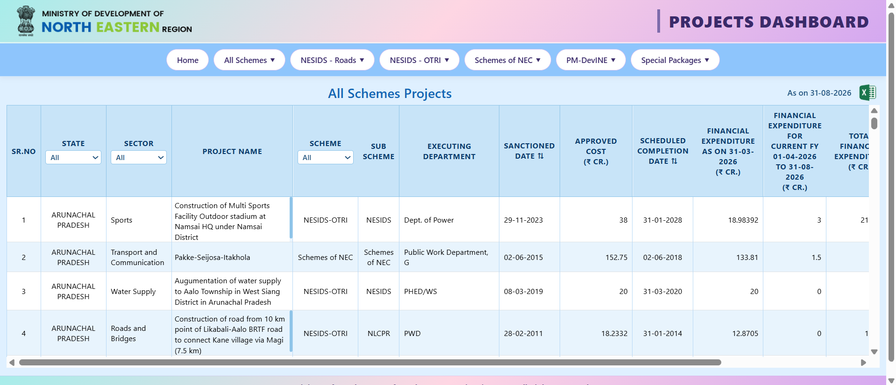
- Source organisation: Ministry of Development of North Eastern Region (MDoNER)
- Source platform: NESetu Projects Dashboard
- Dataset page: https://www.nesetu.mdoner.gov.in/projects/project-list
- Data category: Public project information
- Geographic coverage: North Eastern Region of India
- Access method: Publicly accessible dashboard
- Screenshot purpose: Establishes the original source of the dataset.

Screenshot 02 — Raw Dataset
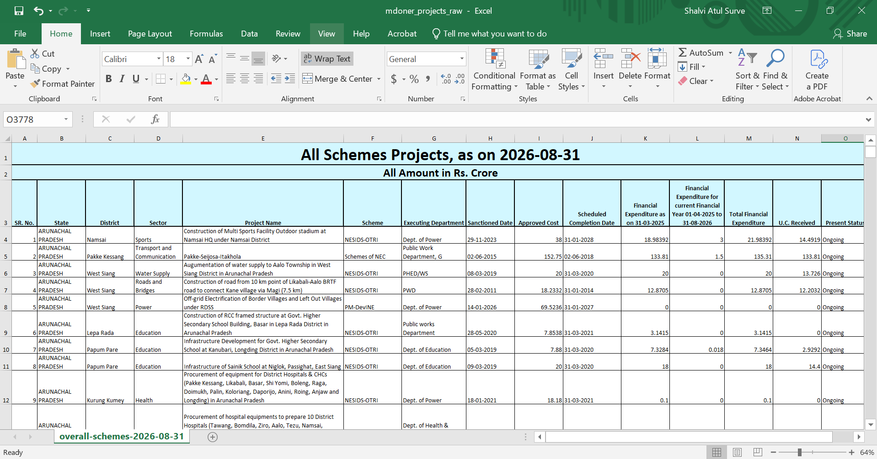
- Original filename: mdoner_projects_raw.xlsx
- Worksheet: overall-schemes-2026-08-31
- Original format: Excel workbook
- Original dataset preserved without modification: Yes
- Number of columns: 15 (verify against the workbook)
- Main information categories:
- Project identification
- Location
- Sector and scheme
- Executing department
- Sanctioned and scheduled dates
- Approved cost
- Financial expenditure
- UC received
- Project status
- Screenshot purpose: Shows the raw dataset before Power BI preparation.
Screenshot 03 — Power BI Import
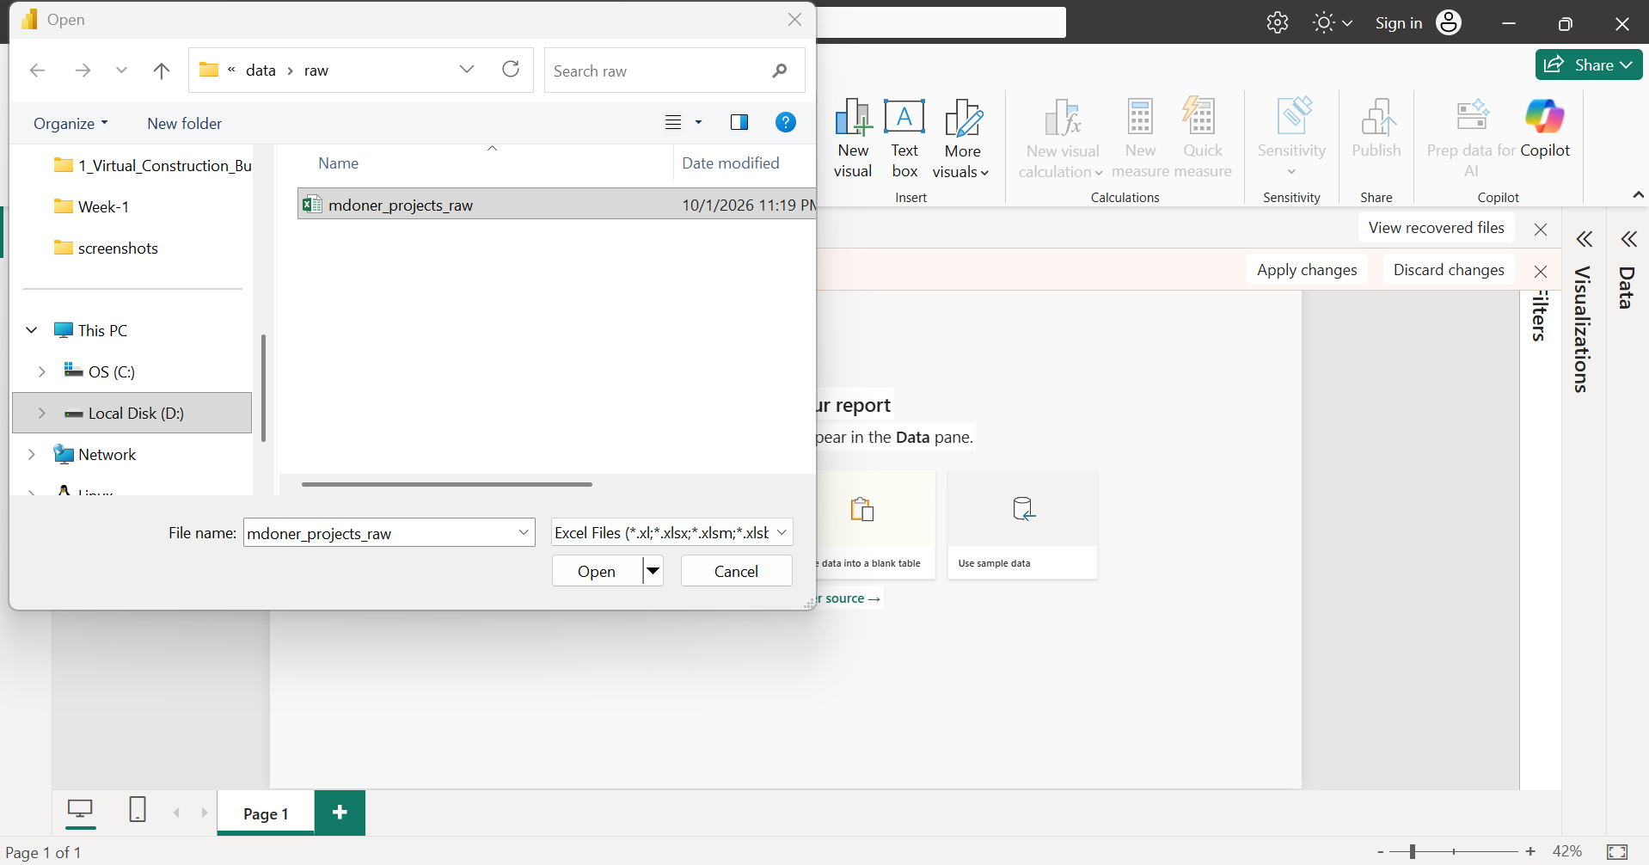
- Tool: Microsoft Power BI Desktop
- Import method: Excel workbook
- Source file: mdoner_projects_raw.xlsx
- Selected worksheet: overall-schemes-2026-08-31
- Query created: [Record the actual query name shown in Power Query]
- Import status: [Successful / issue encountered]
- Screenshot purpose: Demonstrates the Excel dataset being imported into Power BI and made available for - Transformation in Power Query.

Screenshot 04 — Source Step
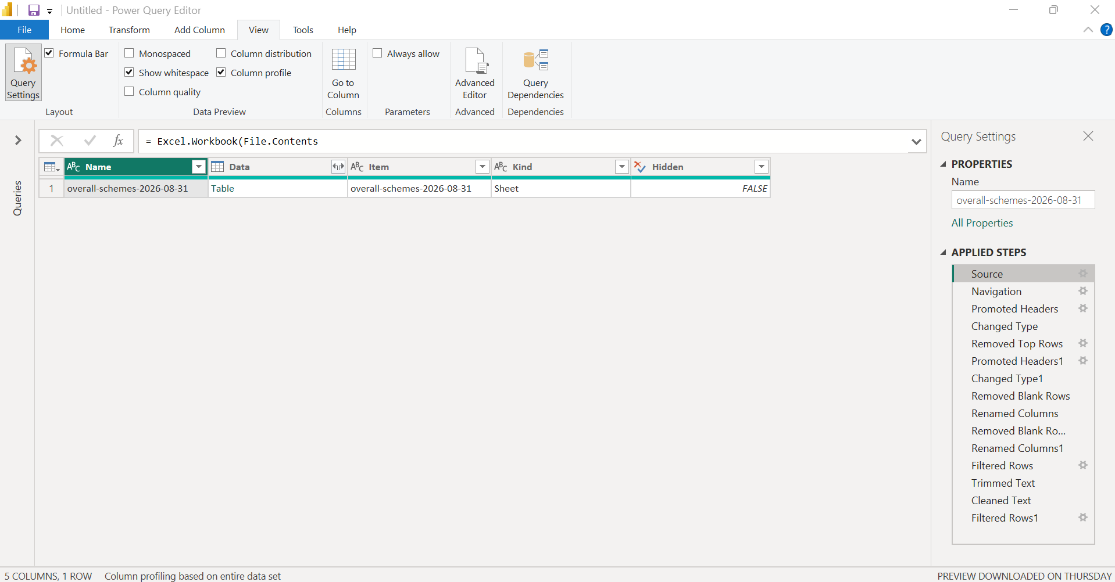
- Tool: Microsoft Power BI Desktop – Power Query Editor
- Applied Step: Source
- Source type: Excel workbook
- Source file: mdoner_projects_raw.xlsx
- Source location: [Record the folder path, if visible; otherwise write “Local project data folder”]
- Visible evidence: [Record what is shown in the preview or formula bar]
- Screenshot purpose: Establishes the original workbook as the data source for the Power Query workflow.

Screenshot 05 — Navigation Step
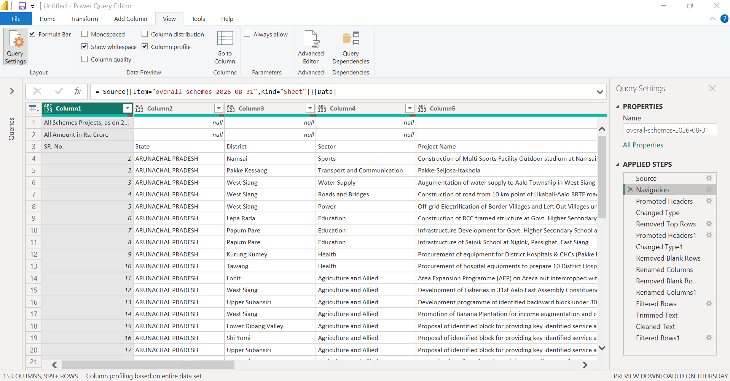
- Tool: Microsoft Power BI Desktop – Power Query Editor
- Applied Step: Navigation
- Selected object: Worksheet overall-schemes-2026-08-31
- Source workbook: mdoner_projects_raw.xlsx
- Visible evidence: [Record the selected worksheet/table and preview]
- Screenshot purpose: Demonstrates that the required worksheet was selected from the imported Excel workbook.

Screenshot 06 — Initial Header Promotion
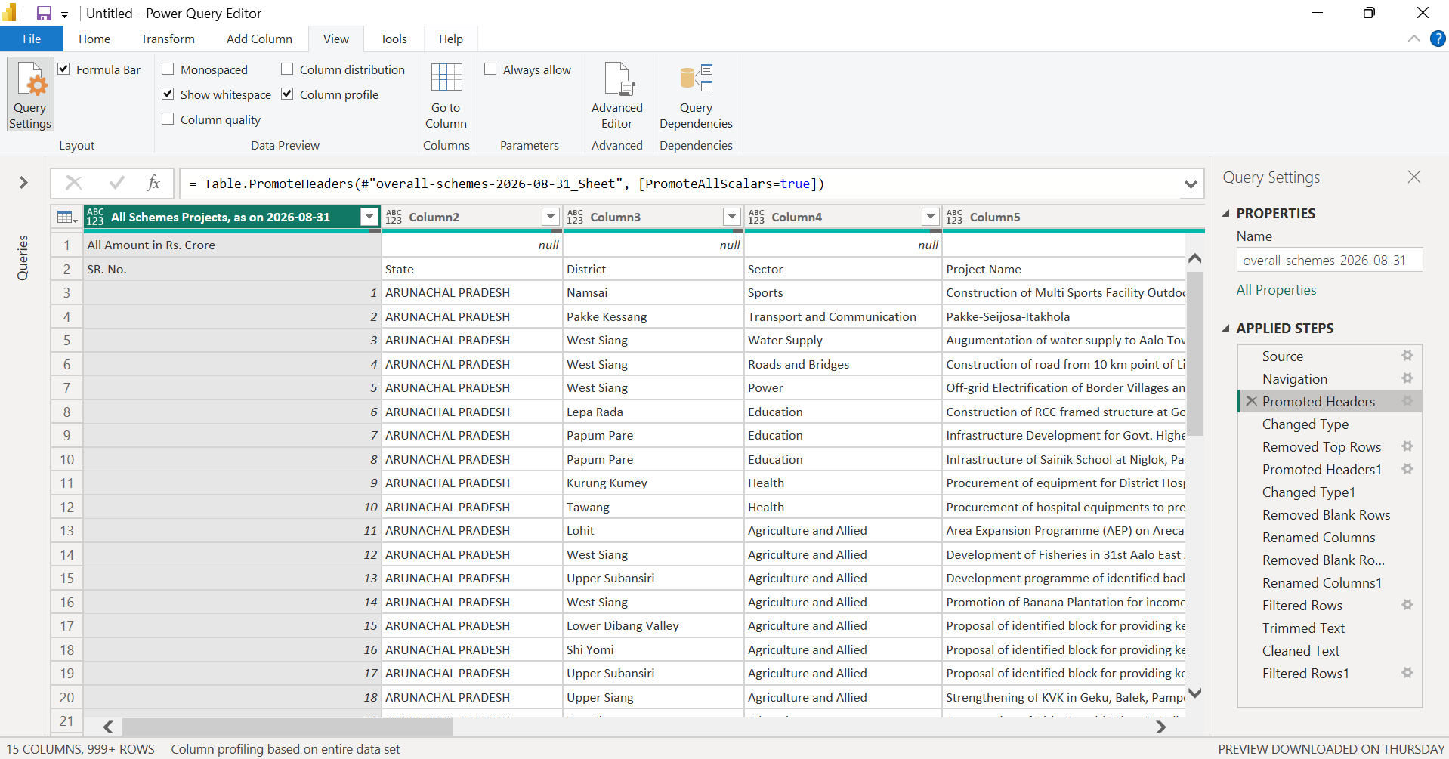
- Tool: Microsoft Power BI Desktop – Power Query Editor
- Applied Step: Promoted Headers
- Transformation: First row promoted to column headers
- Visible evidence: [Record the column names visible after this step]
- Screenshot purpose: Shows the initial conversion of the worksheet’s first row into column headings.

Screenshot 07 — Initial Data Type Assignment
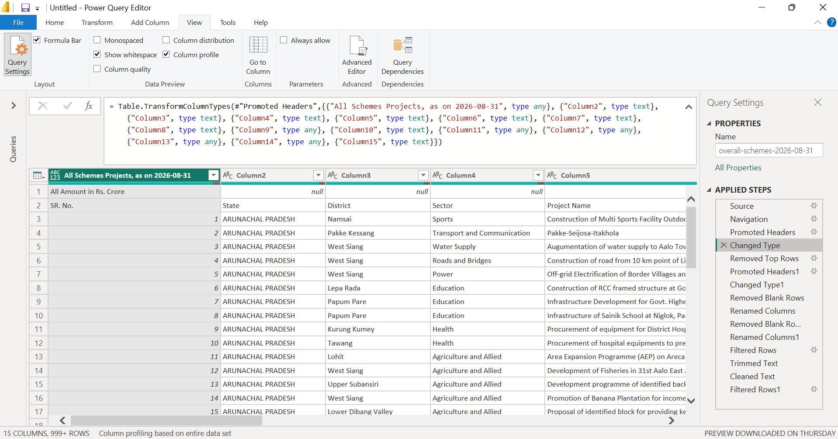
- Tool: Microsoft Power BI Desktop – Power Query Editor
- Applied Step: Changed Type
- Transformation: [Record the data types assigned at this step, if visible]
- Visible evidence: [Record any visible type icons or formula-bar details]
- Screenshot purpose: Documents the initial data-type assignment performed during the import process.

Screenshot 08 — Top Rows Removal
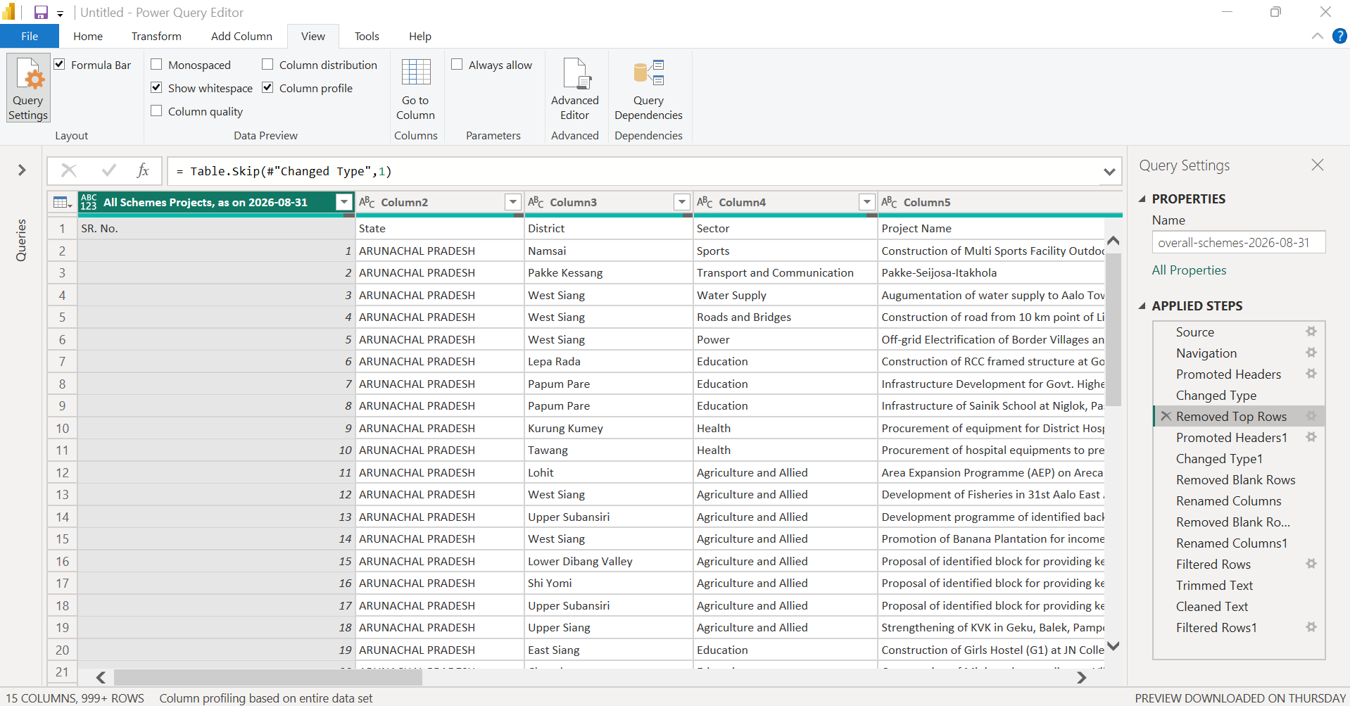
- Tool: Microsoft Power BI Desktop – Power Query Editor
- Applied Step: Removed Top Rows
- Transformation: Removed [number of] rows from the top of the worksheet
- Reason: [Record the reason only if confirmed from the source layout or step formula]
- Formula / evidence: [Copy the formula-bar expression, if visible]
- Screenshot purpose: Demonstrates the removal of top rows before the worksheet headers were finalized. This step should be documented using the actual number of rows removed.

Screenshot 09 — Final Header Promotion
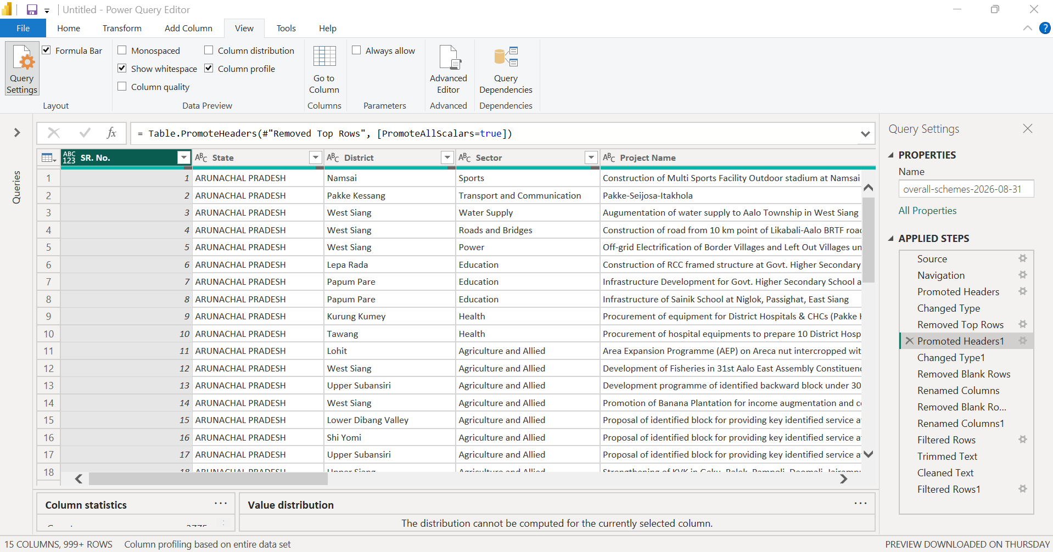
- Tool: Microsoft Power BI Desktop – Power Query Editor
- Applied Step: Promoted Headers1
- Transformation: First row of the remaining data promoted to column headers
- Visible evidence: [Record the resulting column names]
- Screenshot purpose: Shows the promotion of the correct header row after the top rows were removed.

Screenshot 10 — Data Type Assignment After Header Promotion
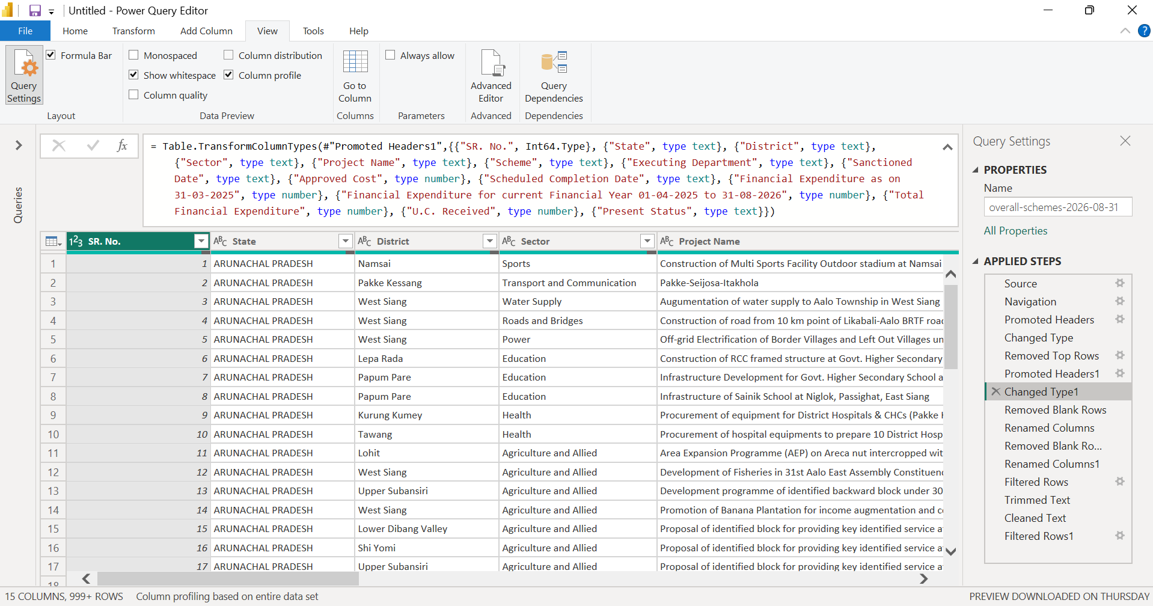
- Tool: Microsoft Power BI Desktop – Power Query Editor
- Applied Step: Changed Type1
- Transformation: Data types assigned to the finalized columns
- Visible evidence: [Record the types visible for important columns]
- Screenshot purpose: Documents the data-type assignment after the final column headers were established.

Screenshot 11 — Blank Row Removal
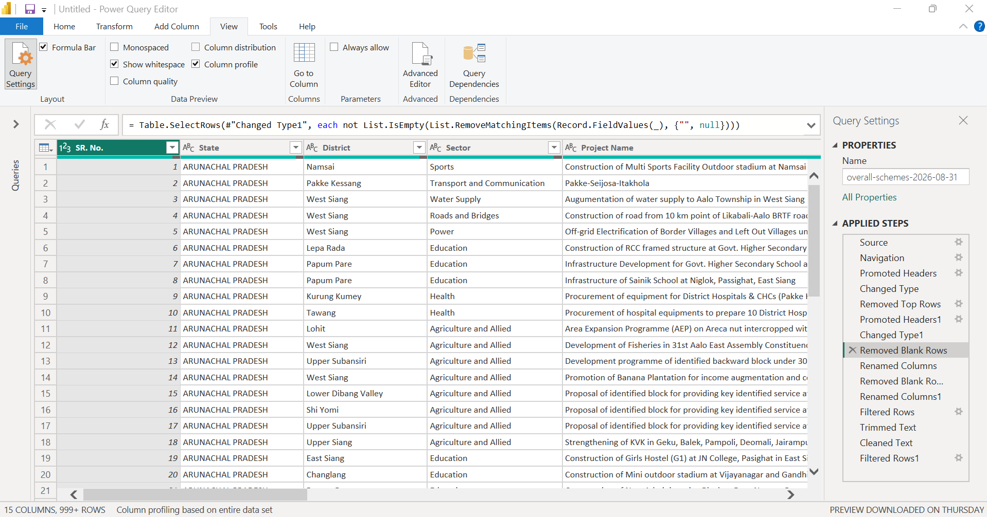
- Tool: Microsoft Power BI Desktop – Power Query Editor
- Applied Step: Removed Blank Rows
- Transformation: Removed rows identified as blank by Power Query
- Rows removed: [Record the count, if available; otherwise write “Not separately quantified in the current view”]
- Screenshot purpose: Demonstrates the removal of fully blank rows from the imported worksheet.

Screenshot 12 — First Column Renaming
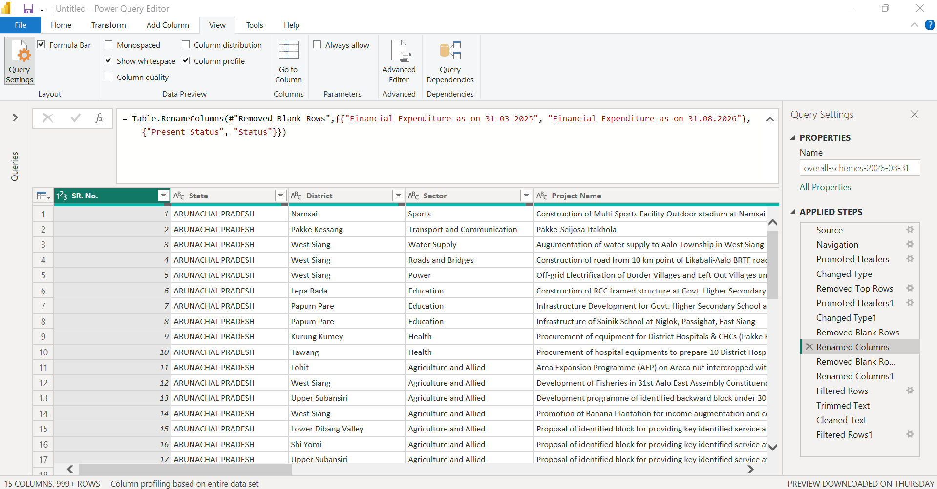
- Tool: Microsoft Power BI Desktop – Power Query Editor
- Applied Step: Renamed Columns
- Transformation: [Record the exact column name changes visible in this step]
Example: SR. No. → Serial Number [include only if this is what the step shows]
- Screenshot purpose: Documents the first set of column-name changes made to improve readability and consistency.

Screenshot 13 — Additional Blank Row Removal
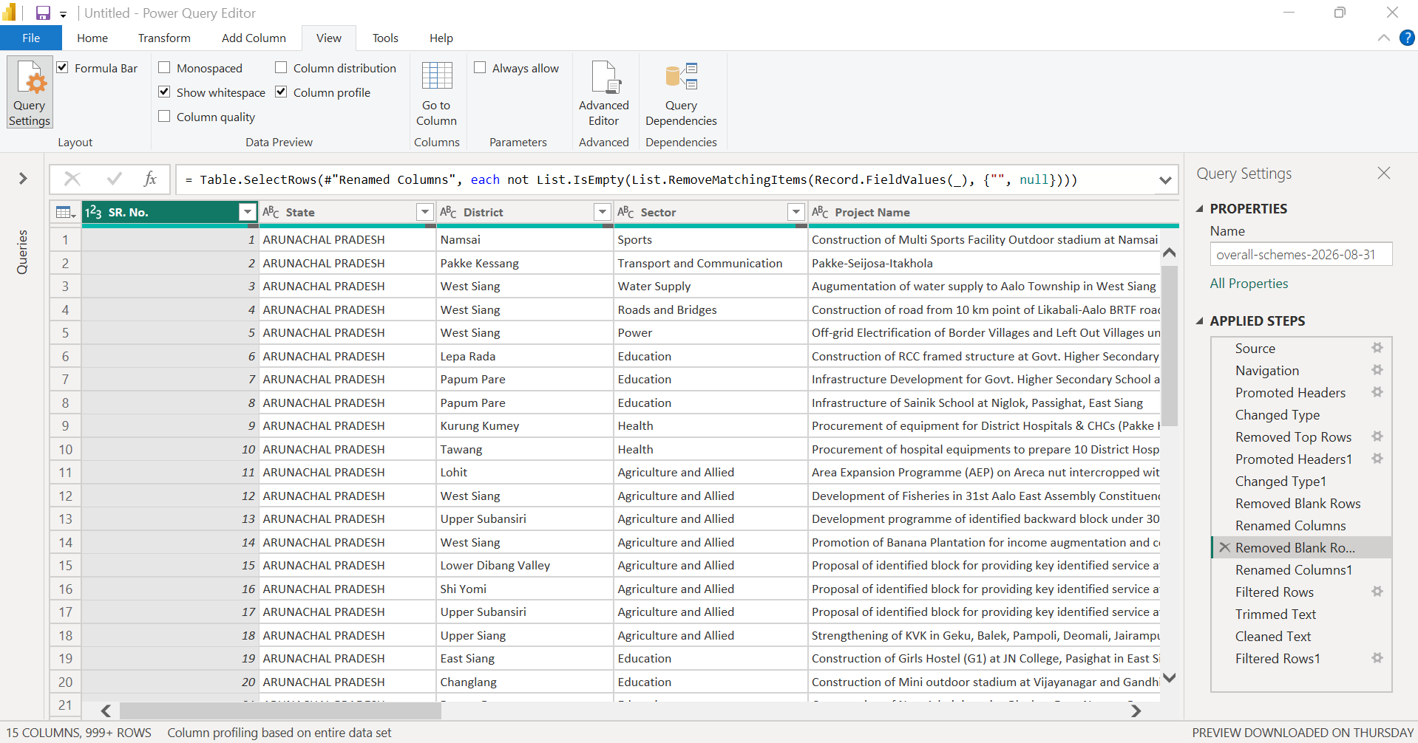
- Tool: Microsoft Power BI Desktop – Power Query Editor
- Applied Step: Removed Blank Rows1
- Transformation: Removed additional rows identified as blank
- Rows removed: [Record the count, if available; otherwise write “Not separately quantified in the current view”]
- Screenshot purpose: Shows the subsequent blank-row removal step in the query’s - Transformation sequence.

Screenshot 14 — Second Column Renaming
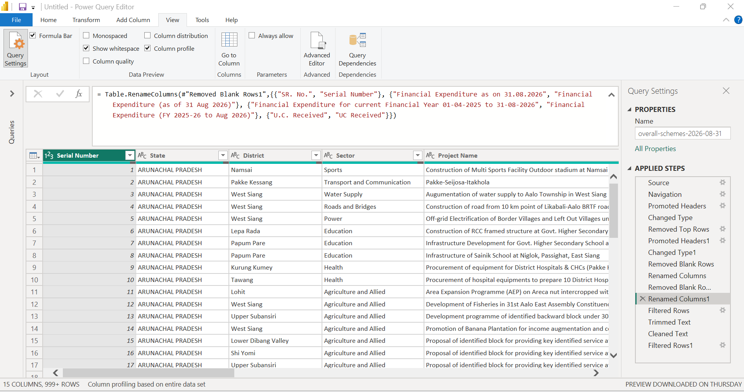
- Tool: Microsoft Power BI Desktop – Power Query Editor
- Applied Step: Renamed Columns1
- Transformation: [Record the exact column name changes visible in this step]
- Example: Executive Department → Executing Department [include only if confirmed]
- Screenshot purpose: Documents the additional column-name standardization applied to the dataset.

Screenshot 15 — Project Name Filter
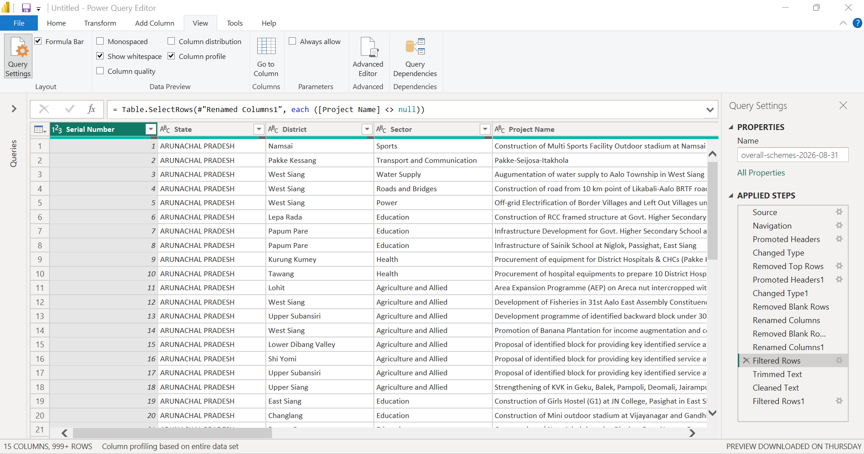
- Tool: Microsoft Power BI Desktop – Power Query Editor
- Applied Step: Filtered Rows
- Transformation: Retained rows where Project Name is not null
- Formula: = Table.SelectRows(#"Renamed Columns1", each ([Project Name] <> null))
- Data handling: Rows with a null Project Name were excluded at this step.
- Screenshot purpose: Demonstrates the removal of records without a project name while retaining the remaining project records.

Screenshot 16 — Text Trimming
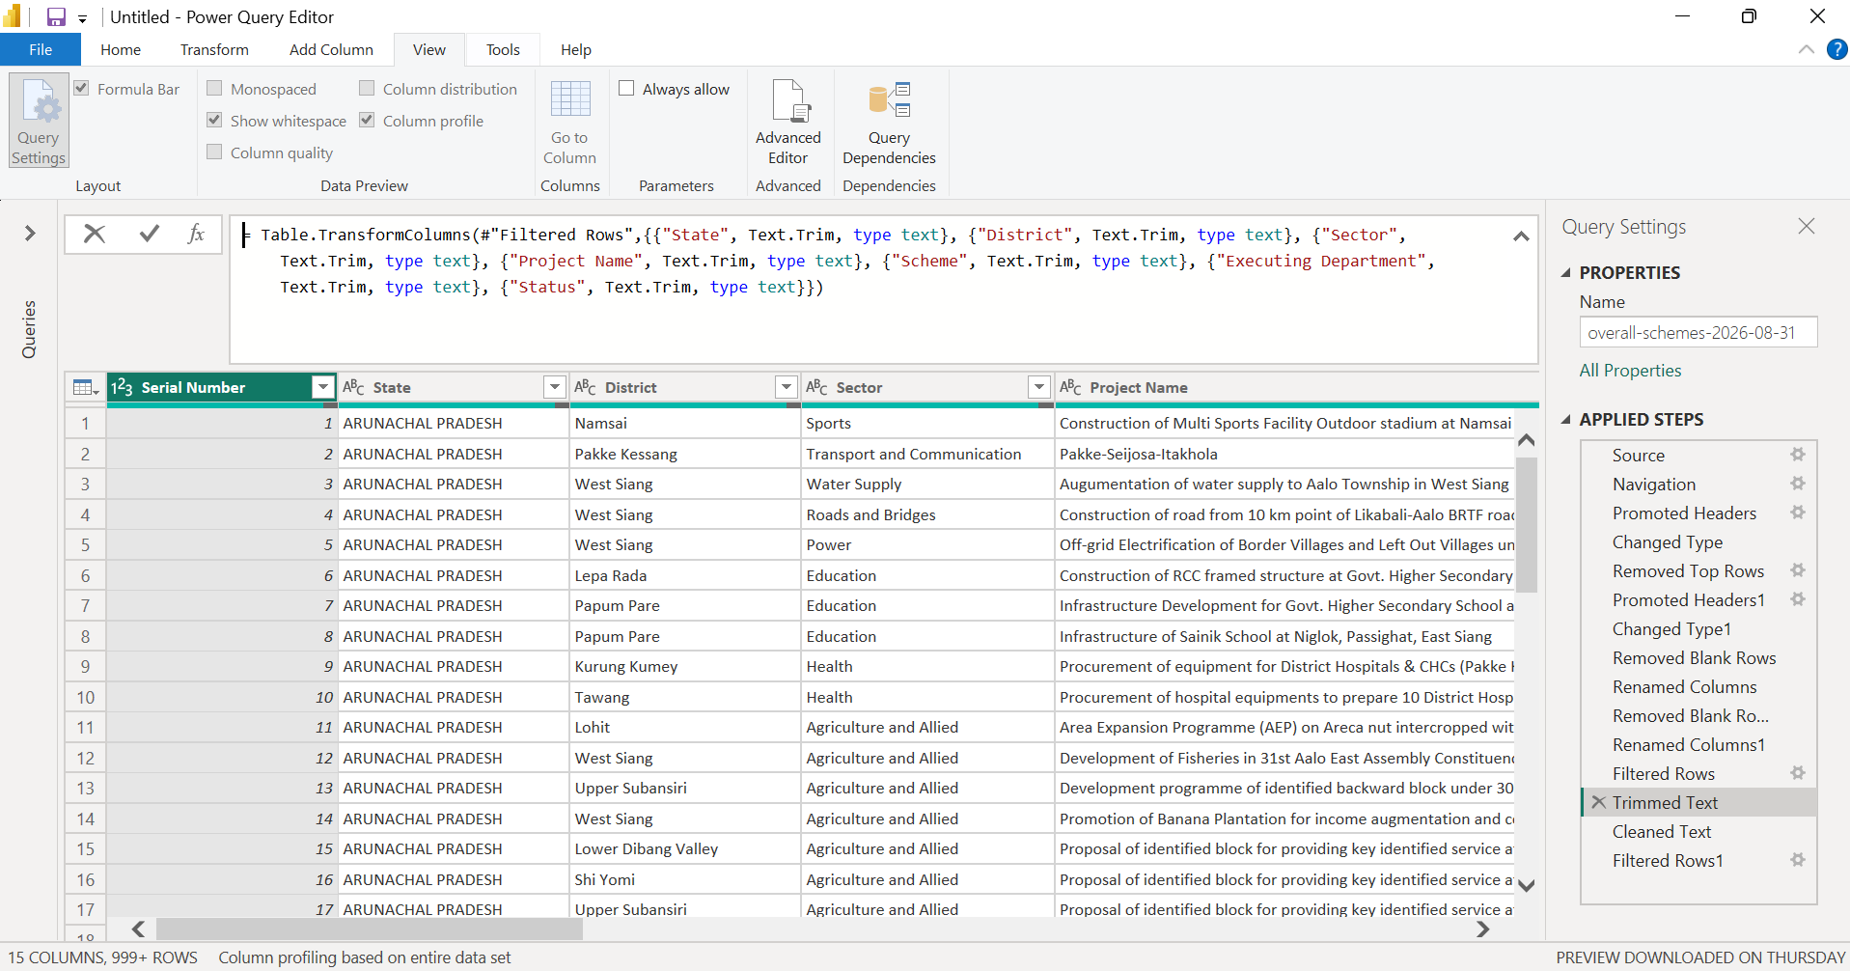
- Tool: Microsoft Power BI Desktop – Power Query Editor
- Applied Step: Trimmed Text
- Transformation: Removed leading and trailing spaces from selected text columns
- Columns affected: [Record the columns selected in this step]
- Visible evidence: [Record the selected columns or formula-bar expression]
- Screenshot purpose: Documents text cleanup intended to reduce inconsistencies caused by unnecessary spaces in text fields.

Screenshot 17 — Text Cleaning
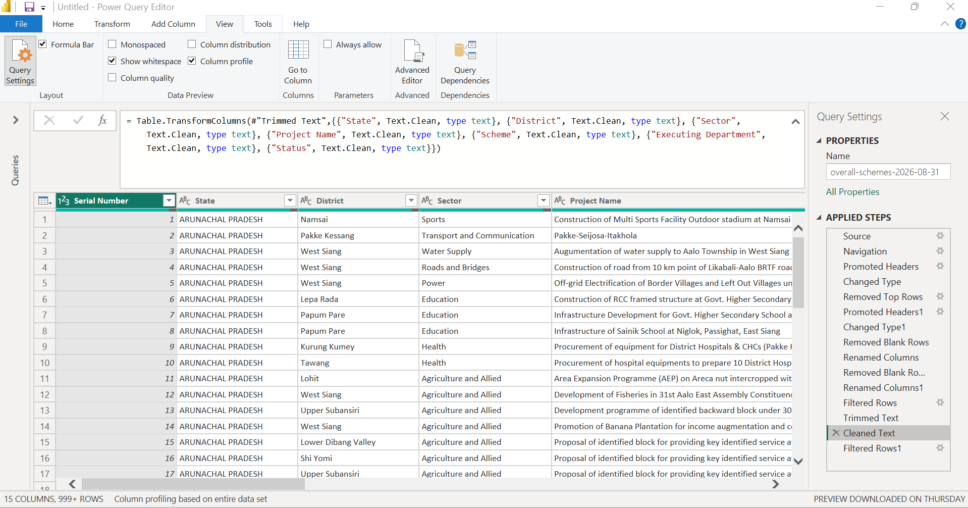
- Tool: Microsoft Power BI Desktop – Power Query Editor
- Applied Step: Cleaned Text
- Transformation: Applied Power Query’s text-cleaning operation to selected text columns
- Columns affected: [Record the columns selected in this step]
- Visible evidence: [Record the selected columns or formula-bar expression]
- Screenshot purpose: Demonstrates the text-cleaning operation applied after trimming.

Screenshot 18 — Serial Number Filter
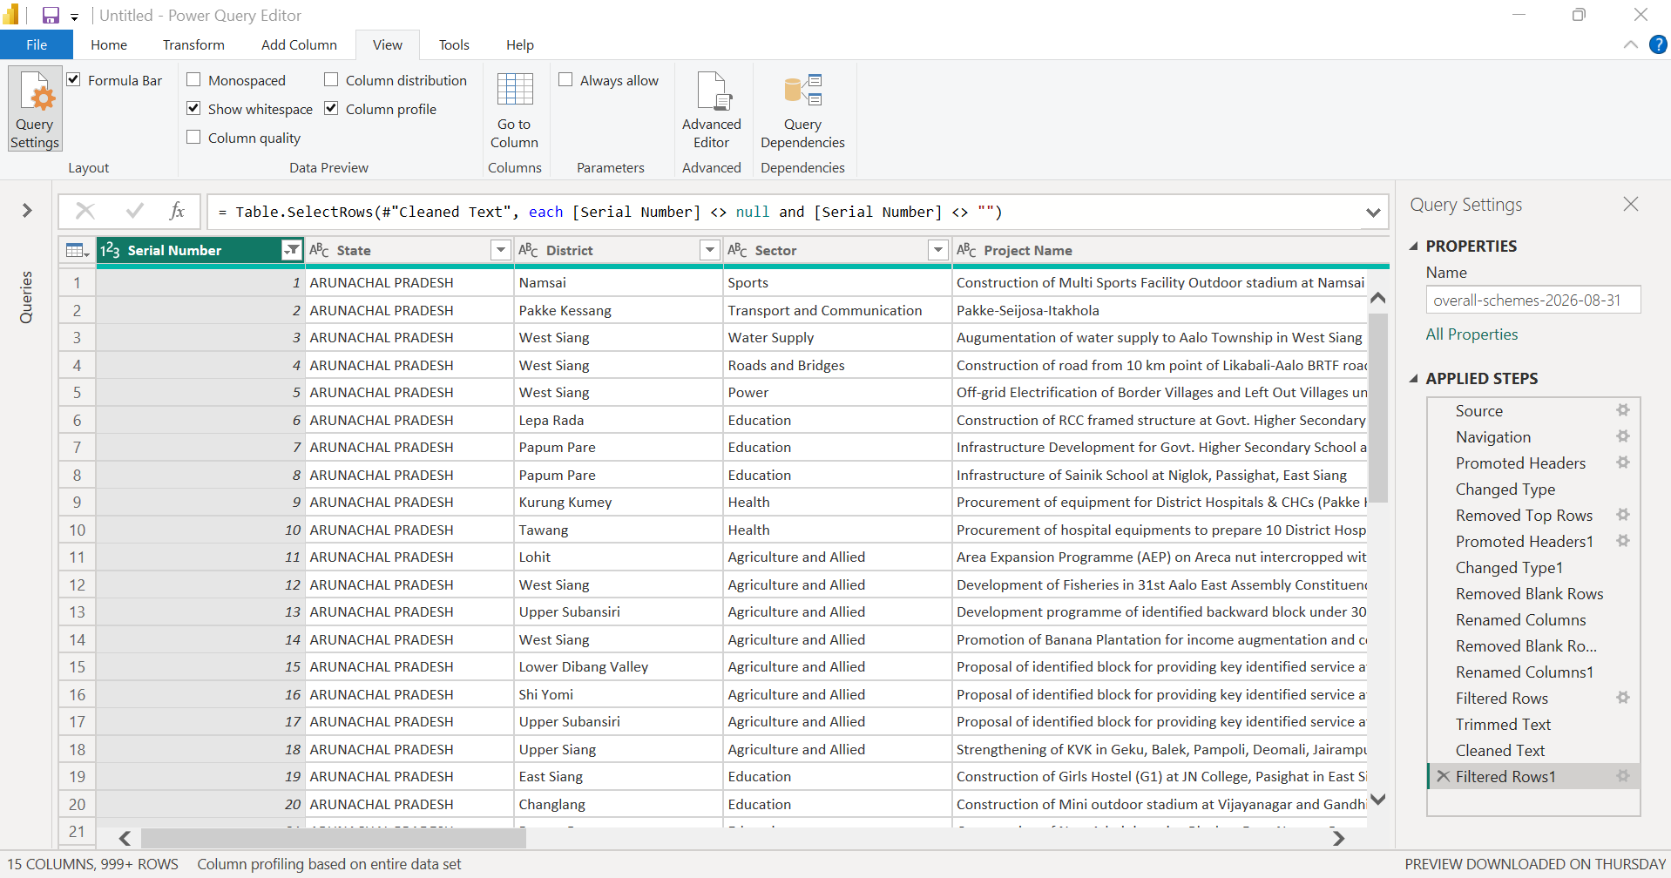
- Tool: Microsoft Power BI Desktop – Power Query Editor
- Applied Step: Filtered Rows1
- Transformation: Retained rows where Serial Number is not null or blank
- Formula: = Table.SelectRows(#"Cleaned Text", each [Serial Number] <> null and [Serial Number] <> "")
- Data handling: Rows without a serial number were excluded at this step.
- Screenshot purpose: Documents the removal of records with missing serial-number values.

Screenshot 19 — Complete Applied Steps
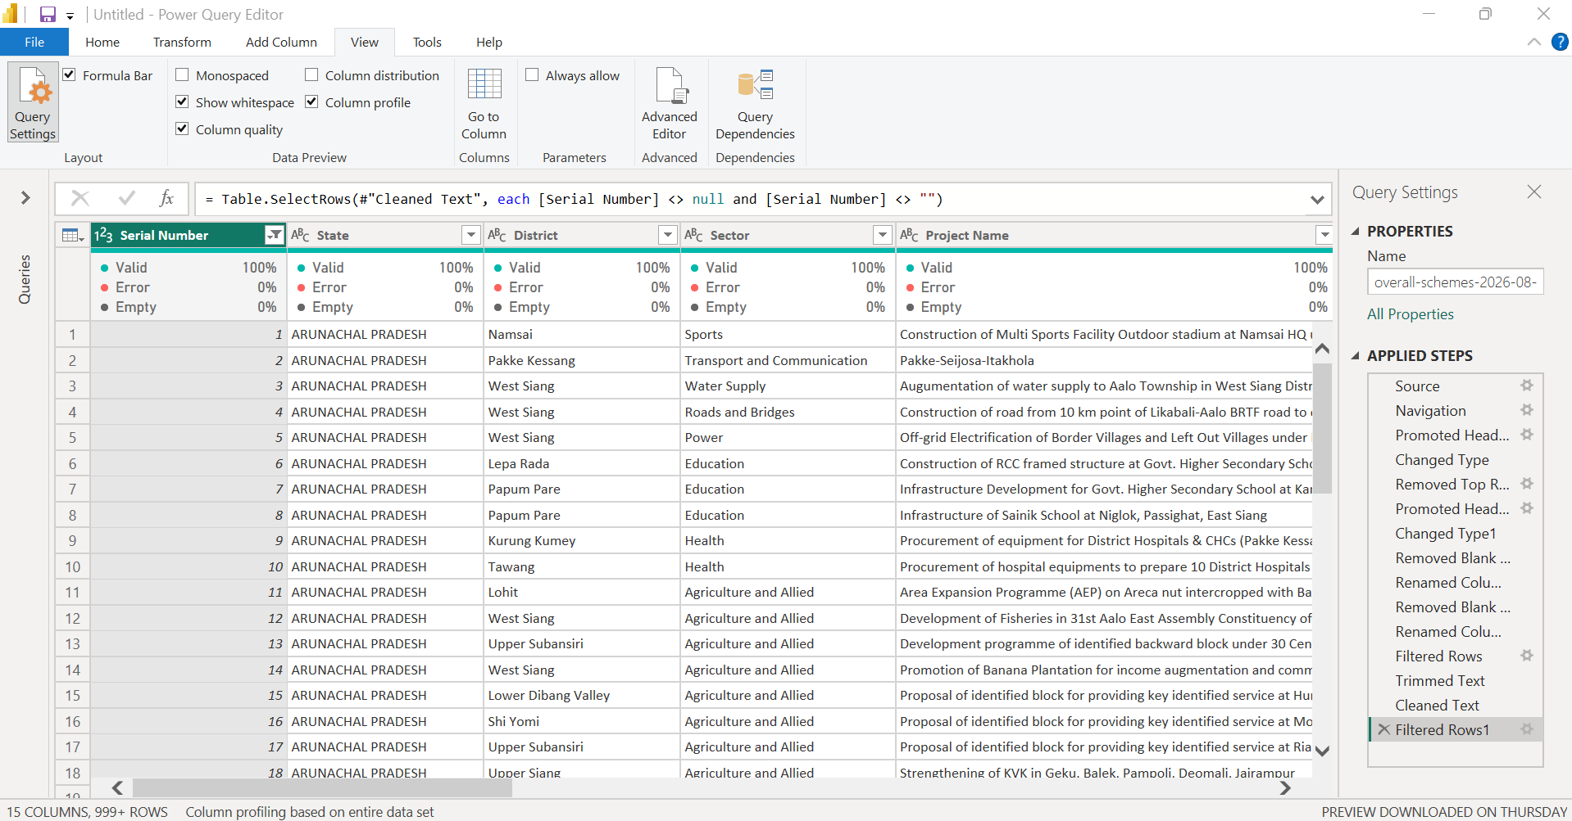
- Tool: Microsoft Power BI Desktop – Power Query Editor
- Evidence type: Query Settings / Applied Steps
- Query: [Record the actual query name]
- Visible steps: Source, Navigation, Promoted Headers, Changed Type, Removed Top Rows, Promoted Headers1, Changed Type1, Removed Blank Rows, Renamed Columns, Removed Blank Rows1, Renamed Columns1, Filtered Rows, Trimmed Text, Cleaned Text, Filtered Rows1
- Current final step: Filtered Rows1
- Screenshot purpose: Provides an overview of the - Transformation sequence applied to the dataset in Power Query.

Screenshot 20 — Final Prepared Dataset Preview
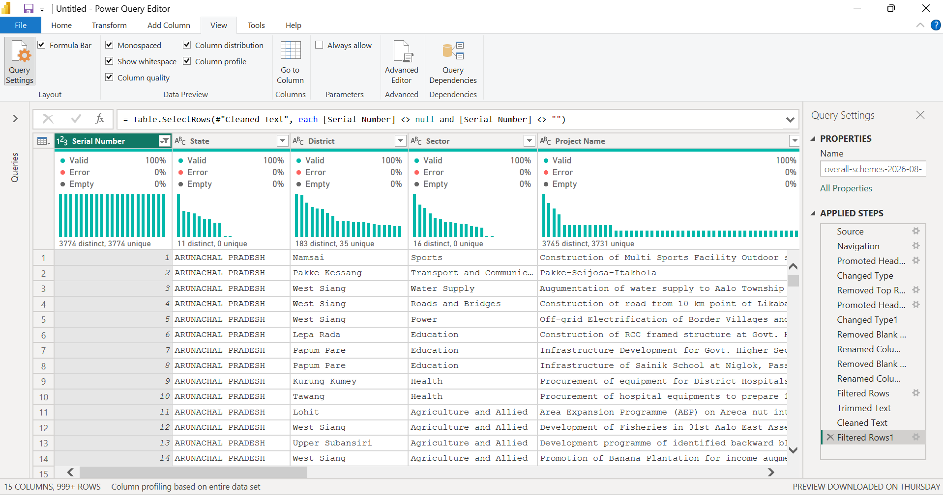
- Tool: Microsoft Power BI Desktop – Power Query Editor
- Evidence type: Column Quality, Column Distribution, Monospaced
- View: Valid / Error / Empty percentages
- Important columns checked: Sanctioned Date, Scheduled Completion Date, Approved Cost, expenditure columns, and U.C. Received
- Observed results:
- Sanctioned Date: approximately 99% valid, less than 1% empty, 0% errors
- Scheduled Completion Date: approximately 99% valid, less than 1% empty, 0% errors
- U.C. Received: 100% valid, based on the displayed column-quality indicator
- Approved Cost and expenditure columns: [Record the exact displayed quality percentages]
- Data handling note: Missing date values were retained rather than removed solely because the date was unavailable.
- Screenshot purpose: Documents the column-quality indicators used to inspect missing values and errors in the prepared dataset.

