WEEK – 5
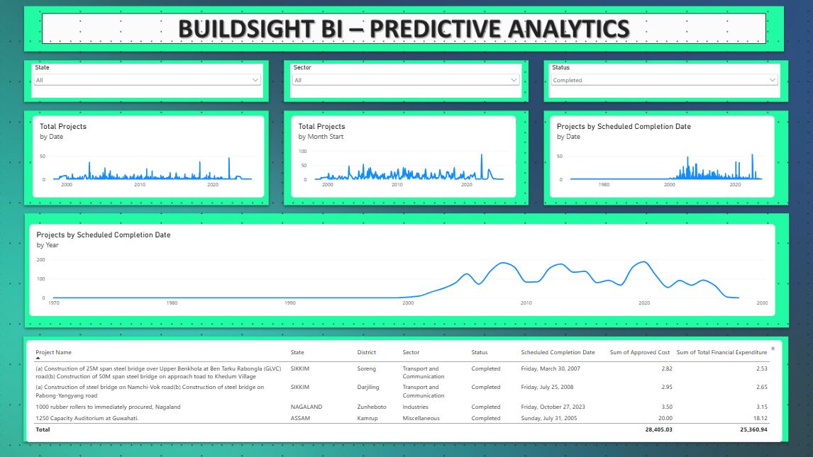
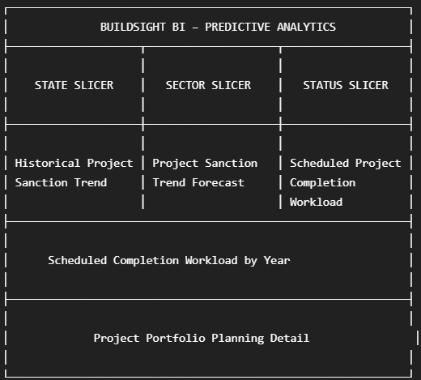

W5-01 — Historical Project Sanction Trend
This line chart presents the historical trend in project records based on their sanctioned dates. The date dimension is plotted along the X-axis, while the Total Projects measure represents the number of project records over time. The visualization establishes the historical time-series pattern used as the basis for the subsequent predictive analysis. It helps identify periods of relatively higher or lower project sanction activity and provides the historical context required for interpreting the forecast.

W5-02 — Project Sanction Trend Forecast
This visualization extends the historical project sanction trend using Power BI's built-in time-series forecasting functionality. The historical Total Projects measure is analyzed against the project date dimension to generate an indicative future trend together with a confidence interval. The forecast is intended to support portfolio-level planning by providing an estimate of future project-record activity based on historical temporal patterns. It should be interpreted as a planning indicator rather than a prediction of physical construction progress, project completion, or actual resource requirements.

W5-03 — Scheduled Project Completion Workload
This line chart shows the distribution of project records according to their scheduled completion dates. The visualization uses the Projects by Scheduled Completion Date measure to activate the scheduled completion date relationship in the analytical model. It provides a forward-looking view of the planned timing of project completion activity and helps identify periods where scheduled project workload may be concentrated. Since the dataset contains scheduled rather than actual completion dates, the visualization represents planned workload and should not be interpreted as evidence of actual project completion performance.

W5-04 — Forecast vs Scheduled Workload
This column chart summarizes the number of project records by their scheduled completion year. It provides a higher-level view of the planned distribution of project completion workload across future periods and complements the detailed scheduled-completion trend shown elsewhere on the dashboard. The visualization can help management identify years with comparatively higher concentrations of scheduled project activity and prioritize monitoring accordingly. The analysis is based on planned completion dates and therefore does not represent actual completion performance or guaranteed future workload.
W5-05 — Project Portfolio Planning Detail
This table provides project-level detail to support portfolio planning and interpretation of the predictive analytics shown in the dashboard. It brings together project identification, geographic, sectoral, status, scheduled completion, approved budget, and recorded expenditure information. Users can apply the State, Sector, and Project Status slicers to narrow the displayed project records and investigate the portfolio underlying the aggregated trends. The table supports detailed review and prioritization but does not independently establish actual project delays or physical construction progress because actual completion and physical-progress information is not available in the source dataset.

