WEEK 4 INTERNSHIP REPORT
BUILDSIGHT BI
A Power BI-Based Business Intelligence Framework for Construction Project Performance
Turning Construction Data into Actionable Intelligence
Designing Interactive Power BI Dashboards for Construction Analytics

Internship | Virtual Construction Business Intelligence Intern
Platform | YuvaIntern
Internship period | 24 August 2026 – 5 October 2026
Assignment | Week 4: Designing Interactive Power BI Dashboards for Construction Analytics
Submitted by | Shalvi Atul Surve
Submitter Organization | Vellore Institute of Technology (VIT), Vellore
Submission date | 5 October 2026
Primary tool | Microsoft Power BI Desktop
Dataset | MDoNER NESetu Projects Dashboard (North Eastern Region of India)
BuildSight BI is a conceptual project and framework created for this internship. It is not an existing commercial organization or an implemented commercial product.

Table of Contents
1. Executive Summary
2. Introduction and Objectives
3. Week 4 Dashboard Requirements and Design Goals
3.1 Week 4 Assignment Context
3.2 Dashboard Objectives
3.3 Construction Analytics Decision Needs
4. Dashboard Design Blueprint
4.1 Overall Layout
4.2 Dashboard Header and Navigation Area
4.3 Interactive Slicers
4.4 KPI Cards
4.5 Time-Based Project Visuals
4.6 Budget and Expenditure Comparison
4.7 Project Detail Table
5. KPI Design and Business Interpretation
5.1 Total Projects
5.2 Total Approved Budget
5.3 Total Expenditure
5.4 Budget Utilization %
6. Interactive Dashboard Functionality
6.1 State Filtering
6.2 Sector Filtering
6.3 Status Filtering
6.4 Cross-Filtering Behaviour
6.5 Filter-Context Behaviour
7. Dashboard Implementation in Power BI
7.1 Connection to the Week 3 Model
7.2 Visual Configuration
7.3 Slicer Configuration
7.4 KPI Implementation
7.5 Chart Implementation
7.6 Detail Table Implementation
8. Dashboard Evidence and Interaction Results
8.1 Overall Dashboard
8.2 State Filter Interaction
8.3 Sector Filter Interaction
8.4 Status Filter Interaction
9. Construction Business Use Cases
9.1 Project Performance Monitoring
9.2 Financial Monitoring
9.3 Geographic Comparison
9.4 Sector-Level Analysis
9.5 Department-Level Comparison
9.6 Workflow and Decision-Support Benefits
10. Dashboard Usability and Design Evaluation
10.1 Strengths
10.2 Implemented Features and Recommended Improvements
11. Limitations and Assumptions
12. Future Enhancements
13. Conclusion
References
Appendix A: Dashboard Visual Inventory
Appendix B: Screenshot Evidence Index

List of Figures
Figure 1 BuildSight BI Performance Dashboard
Figure 2 State Filter Interaction
Figure 3 Sector Filter Interaction
Figure 4 Status Filter Interaction

List of Tables
Table 1 Progression of the BuildSight BI workflow (Weeks 2 to 6)
Table 2 Week 4 Dashboard Design Goals
Table 3 Dashboard layout blueprint (schematic of the implemented layout in Figure 1)
Table 4 Dashboard KPI Definitions
Table 5 Interactive Elements
Table 6 Visual Inventory and Configuration
Table 7 Summary of the Four Dashboard Views
Table 8 Business Use Cases
Table 9 Dashboard Evaluation
Table 10 Future Enhancement Roadmap (proposed)
Table 11 Dashboard Visual Inventory
Table 12 Screenshot Evidence Index

1. Executive Summary
Week 4 of the BuildSight BI project converted the analytical foundation built in Weeks 2 and 3 into an interactive Power BI dashboard titled BUILDSIGHT BI – PERFORMANCE DASHBOARD. Week 2 sourced, imported and prepared the MDoNER NESetu project listing in Power Query. Week 3 built the star-schema data model around the central FactProjects table, together with the DAX measures and financial KPIs. A model and a set of measures are useful to the analyst who built them, but a manager who wants to ask a question needs a single page with controls that can be used without opening the model. Week 4 provides that page.
What was implemented. The dashboard places three dropdown slicers (State, Sector and Status), four KPI cards (Total Projects, Total Approved Budget, Total Expenditure and Budget Utilization %), two column charts that count project records by the year of the sanctioned date and by the year of the scheduled completion date, a chart comparing Total Approved Budget with Total Expenditure by Executing Department, and a project detail table on one page. The slicers are the filtering controls, the KPI cards give the high-level picture, the two timeline charts show how project records are distributed across years, the department chart supports comparison, and the detail table is the layer used to investigate individual project records.
Overall result. In its unfiltered state, the dashboard displays 3,744 project records (the card shows 4K in compact notation), a Total Approved Budget of 51.19K, a Total Expenditure of 37.72K and a Budget Utilization % of 73.68%. These values are quoted as displayed in Power BI. The “K” is Power BI’s compact display notation; the total row of the detail table shows the same sums in full as 51,192.22 and 37,718.69. The source worksheet states that its amounts are in Rs. crore (Week 2), but the KPI cards themselves carry no unit label, so this report quotes them as shown and recommends adding a unit label in Section 12.
Interaction results. Three filter demonstrations are documented. Selecting the state Assam changes the cards to 23 project records, 1.16K approved budget, 529.75 expenditure and 45.64% utilization. Selecting the sector Education gives 464 records, 4.60K, 3.20K and 69.67%. Selecting the status Completed gives 3K records, 28.41K, 25.36K and 89.28%. In each case, the cards, the two timeline charts and the detail table change together, which shows that the slicers work through the Week 3 model’s filter context.
INTERPRETATION BOUNDARY Budget Utilization % is the ratio of recorded expenditure to approved cost within the current filter selection. It is a financial indicator, not a measure of physical progress. The dashboard is descriptive and interactive. It does not measure labour, resources, actual completion or actual delay, and no predictive analytics were implemented in Week 4.
The report is organised as follows. Sections 3 to 5 set out the requirements, the design blueprint and the KPI design. Sections 6 to 8 document the interactive functionality, the Power BI implementation and the screenshot evidence. Sections 9 to 12 cover business use cases, a design evaluation, limitations and future enhancements, and Section 13 concludes and links the work to Week 5.

2. Introduction and Objectives
BuildSight BI is a conceptual project created for this internship; it is a framework for a simulated construction organization and not an existing commercial product. The six weekly assignments build on one another: data sourcing and preparation, then modelling, then a dashboard, then predictive analytics and finally evaluation. Table 1 shows where Week 4 sits in that sequence.
Table 1: Progression of the BuildSight BI workflow (Weeks 2 to 6)
Week | Assignment focus | Contribution to the project | Relationship to Week 4
Week 2 | Data sourcing, import and transformation | MDoNER NESetu project table imported and prepared in Power Query | Supplies the cleaned project fields
Week 3 | Data modelling and DAX | Star-schema model, dimensions, relationships, DAX measures, date-based measures and financial KPIs | Supplies the measures and the filterable dimensions
Week 4 | Interactive dashboard design and implementation | Slicers, KPI cards, charts and a detail table on one page (this report) | Converts the model into a user-facing dashboard
Week 5 | Predictive and trend analytics | Planned | Would build on the dashboard and model; not implemented in Week 4
Week 6 | Comprehensive evaluation | Planned | Would evaluate the framework, including this dashboard

Week 3 created the star-schema model, the dimension tables, the relationships, the DAX measures, the date-based measures and the financial KPIs. These capabilities are reached through the model view or the DAX editor. Week 4 turns them into a user-facing dashboard, so that a user can select a state, a sector or a status and see the portfolio figures change. This report does not repeat the Week 2 or Week 3 work; it gives only the background needed to explain how the dashboard builds on it.

Objectives of Week 4
- Create an accessible construction-performance dashboard.
- Present important project and financial KPIs.
- Enable users to filter by State, Sector and Status.
- Compare sanctioned and scheduled project timelines.
- Compare approved budgets with recorded expenditure by executing department.
- Provide project-level detail for investigation.
- Demonstrate interactive filtering and cross-filtering.
- Establish a dashboard blueprint that can be expanded in later weeks.

3. Week 4 Dashboard Requirements and Design Goals

3.1 Week 4 Assignment Context
The Week 4 task is “Designing Interactive Power BI Dashboards for Construction Analytics”. Its objective is to build a blueprint for interactive dashboards tailored to the virtual construction business, showing how complex construction data can be presented in an accessible and functional way. The expected deliverables are detailed design documentation, a mock-up or storyboard of the layout, and a narrative on how the dashboard serves workflow efficiency, resource management and project performance. The work is judged on the coherence of the design, creativity in interactive elements, the depth of the thought process, the usefulness of the layout and the use of Power BI capabilities.
This report meets those deliverables as follows. The design documentation is Sections 4 to 7. The layout storyboard is the layout blueprint in Section 4.1, drawn from the implemented dashboard, and the actual dashboard screenshots are in Section 8. The business narrative is Section 9. The assignment also mentions maps, gauges, drill-downs and sliders. None of these was implemented in the Week 4 dashboard, and they are discussed in Section 12 as possible future enhancements.

3.2 Dashboard Objectives
The design follows a four-stage philosophy, overview → filter → compare → investigate:
- Overview. The KPI cards give the high-level picture of the selected portfolio.
- Filter. The slicers allow the user to narrow the analysis to a state, sector or status.
- Compare. The charts reveal patterns across years and across executing departments.
- Investigate. The project table enables detailed investigation of individual records.
Five design qualities support this flow: accessibility (a single page, labelled controls, plain KPI names), visual clarity (one purpose per visual), interactivity (every slicer changes the whole page), decision support (comparisons rather than raw lists) and construction-project relevance (cost, schedule and executing-department fields). Table 2 links each goal to a dashboard feature.
Table 2: Week 4 Dashboard Design Goals
Goal | Dashboard Feature | Purpose | Expected User Benefit
Project portfolio monitoring | Total Projects card | Show how many project records are in the selected context | Immediate sense of portfolio size
Financial monitoring | Total Approved Budget, Total Expenditure and Budget Utilization % cards | Compare approved cost with recorded expenditure | Quick view of the financial position of the selection
Geographic filtering | State slicer; State and District columns in the table | Focus the page on one state | State-level view without separate reports
Sector analysis | Sector slicer | Focus the page on one sector | Sector-specific project and financial profile
Status analysis | Status slicer | Focus the page on one recorded status | Comparison of portfolio slices by status label
Department comparison | Approved Budget and Expenditure by Executing Department chart | Compare departments on two financial measures | Identify departments that may need a closer look
Timeline analysis | Projects by Sanctioned Date and by Scheduled Completion Date, by year | Show how project records are distributed over years | Understand the historical and scheduled workload pattern
Project-level investigation | Project detail table | List the records behind the aggregates | Trace a pattern back to individual projects

3.3 Construction Analytics Decision Needs
A construction portfolio manager typically needs to answer questions such as: how large is the portfolio in the area of interest, how does recorded expenditure compare with approved cost, which departments carry the larger amounts, and how are projects spread over time. The dataset supports these questions at the level of project records. It does not support questions about physical progress, labour productivity, resource consumption or actual delay, because the source holds no such information (Section 11). The dashboard is therefore designed around portfolio, financial and timeline questions only.

4. Dashboard Design Blueprint

4.1 Overall Layout
The dashboard is a single report page with a top-to-bottom visual hierarchy of five sections: a header (A), a filter bar (B), a KPI row (C), a row of analytical charts (D) and a detail table (E). The order follows the design philosophy in Section 3.2: the controls sit above the figures they change, the summary numbers come before the charts, and the most granular view, the table, is last. The layout blueprint below is a schematic redrawn from the implemented dashboard in Figure 1 to serve as the storyboard; it is not a Power BI screenshot.
Table 3: Dashboard layout blueprint (schematic of the implemented layout in Figure 1)
A. HEADER
BUILDSIGHT BI – PERFORMANCE DASHBOARD
B. FILTER BAR  State (dropdown) |  |  |  | B. FILTER BAR  Sector (dropdown) |  |  |  | B. FILTER BAR  Status (dropdown)
C. KPI ROW  Total Projects |  |  | C. KPI ROW  Total Approved Budget |  |  | C. KPI ROW  Total Expenditure |  |  | C. KPI ROW  Budget Utilization %
D. ANALYTICAL CHARTS  Projects by Sanctioned Date, by Year |  |  |  | D. ANALYTICAL CHARTS  Projects by Scheduled Completion Date, by Year |  |  |  | D. ANALYTICAL CHARTS  Total Approved Budget and Total Expenditure by Executing Department
E. DETAIL TABLE
State | District | Project Name | Status | Sum of Approved Cost | Sum of Total Financial Expenditure | Sanctioned Date | Scheduled Completion Date

In the screenshots the page uses a dark blue-green background with bright green panel borders around each visual and white visual backgrounds. This high-contrast panel treatment separates the five sections clearly; its effect on readability is assessed in Section 10.

4.2 Dashboard Header and Navigation Area
Section A – Header. The title “BUILDSIGHT BI – PERFORMANCE DASHBOARD” runs across the top of the page. It establishes the dashboard identity and ties the page to the project name used in all four weekly reports. The evidence shows a single report page with no page tabs or navigation buttons, so navigation within the dashboard is done through the slicers and the scroll bars of individual visuals. Multi-page navigation was not implemented.

4.3 Interactive Slicers
Section B – Filter bar. Three dropdown slicers (State, Sector and Status) sit directly under the header. Each shows “All” by default, meaning that no filter is applied. These three dimensions were chosen because they are the categories by which a construction portfolio is most naturally divided: where a project is, what kind of project it is and what its recorded status is.
Dropdown slicers are more compact than long list slicers. A list of every state, sector or status would take up a large part of the page and push the charts down; a dropdown occupies one row, keeps the page uncluttered and leaves the space for the figures. Each dropdown allows the user to focus the whole dashboard on a chosen analytical context in one selection.

4.4 KPI Cards
Section C – KPI row. Four cards give the headline figures: Total Projects, Total Approved Budget, Total Expenditure and Budget Utilization %. They are placed in one row, directly below the filters, so that the effect of a filter selection is seen first in the numbers. Each card has a short plain-language label and one large value, which makes the row quick to read. The cards display large values in compact notation (for example 4K, 51.19K and 37.72K), which is why the detail-table totals are used in this report to confirm the full-precision sums. Section 5 defines each KPI.

4.5 Time-Based Project Visuals
Section D – Analytical charts (1 and 2). Two column charts show project records by year.
Chart 1: Projects by Sanctioned Date, by Year. This chart shows how many project records were sanctioned in each year. It supports historical project-volume analysis and helps identify years with relatively higher or lower numbers of sanctioned project records. In Figure 1 the bars run from roughly the late 1990s to the mid-2020s, with the vertical axis marked at 0 and 200.
Chart 2: Projects by Scheduled Completion Date, by Year. This chart shows project records according to the year in which their completion is scheduled. It helps in understanding the distribution of scheduled completion workload across years. Because the field holds planned dates, the chart does not represent actual completion: a record scheduled for a past year is not thereby shown to have been completed.

4.6 Budget and Expenditure Comparison
Section D – Analytical charts (3). The third chart, Total Approved Budget and Total Expenditure by Executing Department, compares two measures for each executing department, with a legend for the two series. It allows department-level financial comparison, shows where the two measures differ and can help to identify areas that may warrant further investigation. In the supplied screenshots, the chart is compressed: department names are truncated and rotated, a horizontal scroll bar indicates that more departments exist than are shown, and the bars are too small to read. This is an observed limitation of the current layout and is discussed in Section 10.

4.7 Project Detail Table
Section E – Detail table. The table lists project records with the fields State, District, Project Name, Status, Sum of Approved Cost, Sum of Total Financial Expenditure, Sanctioned Date and Scheduled Completion Date, with a total row at the bottom. It is the detailed investigation layer: once a user sees a pattern in the cards or charts, the table shows the individual records behind it. The table follows the same filter selection as the rest of the page. In the screenshots only a few rows are visible at a time, the State column header carries a sort indicator, and the right-hand Scheduled Completion Date column is partly cut off.

5. KPI Design and Business Interpretation
The four KPIs are the Week 3 DAX measures presented as cards. Table 4 summarises each definition, its purpose on the dashboard and the caveat that applies when interpreting it. The definitions are summarised here; the formulae are documented in the Week 3 report. As supporting evidence, the total row of the detail table matches the cards: the sum of approved cost is 51,192.22 against the card’s 51.19K, and the sum of total financial expenditure is 37,718.69 against 37.72K.
Table 4: Dashboard KPI Definitions
KPI | Definition | Dashboard Purpose | Interpretation Caveat
Total Projects | Number of project records in the current filter context | Show the size of the selected portfolio | Counts records in the source listing; says nothing about project size or progress
Total Approved Budget | Sum of Approved Cost for the records in the current filter context | Show the approved financial amount of the selection | Approved cost is a sanctioned figure; source amounts are in Rs. crore, but the card shows no unit
Total Expenditure | Sum of Total Financial Expenditure for the records in the current filter context | Show the expenditure recorded against the selection | It is recorded expenditure, not a measure of work completed on site
Budget Utilization % | Total Expenditure / Total Approved Budget | Show recorded expenditure as a share of approved budget | A financial ratio; not physical progress and not a forecast

5.1 Total Projects
Total Projects counts the project records that pass the active filters. In the unfiltered view it displays 4K on the card, and the evidence record gives the exact value as 3,744. The card is the first check on any filter selection: Assam gives 23 records and Education gives 464 (Section 8), which shows immediately how much of the portfolio is in view.

5.2 Total Approved Budget
Total Approved Budget is the sum of the approved cost of the records in view (51.19K overall). It is the reference amount against which expenditure is compared. It is a sanctioned amount and should not be read as money spent.

5.3 Total Expenditure
Total Expenditure is the sum of the total financial expenditure recorded for the records in view (37.72K overall). The report uses the term “recorded expenditure” deliberately: the figure is what the source listing records, and it does not describe what has been physically built.

5.4 Budget Utilization %
The Week 3 definition is preserved:
Budget Utilization % = Total Expenditure / Total Approved Budget
Overall this is 73.68%. The correct reading is: “73.68% of the approved budget represented in the current dashboard filter context corresponds to recorded financial expenditure.” It does not mean that 73.68% of the construction is complete. The ratio is calculated from the totals in the current selection, so it is recomputed whenever a filter changes. When a user selects a state, sector or status, all four cards update to that context: Assam gives 45.64%, Education gives 69.67% and Completed gives 89.28%.

6. Interactive Dashboard Functionality
Interactivity is the main feature evaluated in Week 4. The mechanism is Power BI filter context: the set of filters that are active when a measure is calculated. A slicer selection adds a filter, and Power BI recalculates every measure on the page using only the records that satisfy it. The user does not edit any formula; choosing “Assam” in the State slicer is enough to change every figure. Table 5 lists the interactive elements and the behaviour documented in the evidence.
Table 5: Interactive Elements
Element | Control or visual | Field | Demonstrated selection | Observed effect
State filtering | Dropdown slicer | State | ASSAM (Figure 2) | Cards change to 23, 1.16K, 529.75 and 45.64%; timeline axes rescale; table lists ASSAM records
Sector filtering | Dropdown slicer | Sector | Education (Figure 3) | Cards change to 464, 4.60K, 3.20K and 69.67%; timeline charts and table change
Status filtering | Dropdown slicer | Status | Completed (Figure 4) | Cards change to 3K, 28.41K, 25.36K and 89.28%; table lists Completed records
Cross-filtering | Slicers acting on cards, charts and table | Via model relationships | All three slicers | Several visuals change from one selection; see Section 6.4 for the department chart
Scrolling | Detail table and department chart | — | Scroll bars visible in all figures | Lets the user move through more rows or departments than fit in the visual

6.1 State Filtering
In Figure 2 the State slicer is set to ASSAM, with Sector and Status left at “All”. The cards show 23 project records, 1.16K approved budget, 529.75 recorded expenditure and 45.64% budget utilization. The detail-table total row confirms the amounts at full precision: 1,160.72 and 529.75. The two timeline charts redraw for Assam, and their vertical axes now run to about 5 instead of 200 as in the unfiltered view, which shows that they are responding to the selection. The table lists ASSAM records, which in the visible rows are in Kamrup Metropolitan (Metro) with the status Ongoing.
OBSERVED RESULT Selecting one state reduced the page from 3,744 records to 23, and Budget Utilization % fell from 73.68% to 45.64%. Using the displayed totals, Assam’s approved budget is about 2.3% of the overall approved budget (author’s calculation).

6.2 Sector Filtering
In Figure 3 the Sector slicer is set to Education. The cards show 464 project records, 4.60K approved budget, 3.20K recorded expenditure and 69.67% utilization, and the table total row gives 4,595.24 and 3,201.58. The charts and table update to show only Education records. Sector selection allows a sector-specific view of the portfolio. Using the displayed figures, Education accounts for about 12.4% of the project records and about 9.0% of the approved budget (author’s calculation), so its average approved cost per record is lower than that of the portfolio overall.

6.3 Status Filtering
In Figure 4 the Status slicer is set to Completed, which is clearly visible in the dropdown, with State and Sector at “All”. The cards show 3K project records, 28.41K approved budget, 25.36K recorded expenditure and 89.28% utilization; the table total row gives 28,405.03 and 25,360.94, and every visible table row has the status Completed. The exact record count behind “3K” is not legible in the screenshot and is not stated here. The status labels are those of the source listing, and “Completed” is the label as recorded, not an independent verification of completion.
OBSERVED RESULT Selecting the status Completed reduced the approved budget in view from 51.19K to 28.41K and raised Budget Utilization % from 73.68% to 89.28%. From the displayed table totals, records not labelled Completed carry about 22,787 of approved cost and 12,358 of recorded expenditure, a ratio of about 54% (author’s calculation from Figures 1 and 4).

6.4 Cross-Filtering Behaviour
By default, a slicer in Power BI filters the other visuals on the page, and this can be changed through edit interactions (Microsoft, n.d.-b). In this dashboard, the slicers act on the cards, the two timeline charts and the detail table through the relationships of the Week 3 model. The evidence for this is that all four cards, both timeline charts and the table change in Figures 2 to 4. The department chart is a partial exception in the evidence: because its bars and department names are compressed, a change in its content cannot be confirmed from the screenshots, although it is built from the same measures and is expected to respond in the same way. Cross-highlighting between visuals (for example, clicking a bar to filter the others) is standard Power BI behaviour but was not demonstrated in the evidence and is not claimed here. Likewise, combined selections, such as a state and a status at once, were not demonstrated.

6.5 Filter-Context Behaviour
A DAX measure is evaluated within the active filter context. Filters can be applied directly to a column or indirectly through model relationships, which pass a filter from one table to another (Microsoft, n.d.-c). In the Week 3 model, the dimension tables DimGeography, DimSector and DimStatus sit around the central FactProjects table, so a slicer selection on a dimension flows into FactProjects and restricts the rows that every measure sees.
The Assam selection illustrates this. The State filter restricts FactProjects to 23 records. Total Projects counts them, Total Approved Budget and Total Expenditure sum their amounts (1,160.72 and 529.75), and Budget Utilization % divides one total by the other: 529.75 / 1,160.72 = 45.64%. The ratio is calculated from the filtered totals; it is not an average of per-project ratios. This is standard filter-context behaviour. The dashboard is interactive in the sense that the user changes the selection and the model is recalculated; no claim of artificial-intelligence features or live data streaming is made.

7. Dashboard Implementation in Power BI
This section describes how the dashboard is built on the Week 3 model. Visual types are identified from their appearance in the screenshots. Exact formatting properties, such as fonts, colours and sizes, cannot be established from the screenshots and are not documented here.

7.1 Connection to the Week 3 Model
The dashboard uses the existing BuildSight BI model rather than a separate dataset. The central table is FactProjects, which is connected to the dimension tables DimDate, DimDepartment, DimGeography, DimSector, DimScheme and DimStatus. Following the Week 3 model design, the dashboard visuals draw on this model in the following way: state and district come from the geography dimension, sector from the sector dimension, status from the status dimension, executing department from the department dimension and the year axes from the date fields. DimScheme is part of the model but no Week 4 visual uses it. Because all visuals read from one model, every figure on the page comes from the same measure definitions, so the cards, charts and table are consistent with each other.

7.2 Visual Configuration
Each analytical visual combines a dimension field, which sets the categories (year or executing department), with a measure, which sets the values. The timeline charts use a project-record count by the year of a date field. The department chart uses two measures, Total Approved Budget and Total Expenditure, against the executing department. The cards use one measure each. The slicers and the detail table use dimension and fact fields directly. Table 6 lists each visual.
Table 6: Visual Inventory and Configuration
Visual | Power BI Visual Type | Fields / Measures | Purpose | Interaction
Title banner | Text element | Static title text | Dashboard identity | None
State slicer | Slicer (dropdown) | State | Select a state | Filters all data visuals
Sector slicer | Slicer (dropdown) | Sector | Select a sector | Filters all data visuals
Status slicer | Slicer (dropdown) | Status | Select a status | Filters all data visuals
Total Projects | Card | Total Projects measure | Portfolio size | Responds to slicers
Total Approved Budget | Card | Total Approved Budget measure | Approved amount | Responds to slicers
Total Expenditure | Card | Total Expenditure measure | Recorded expenditure | Responds to slicers
Budget Utilization % | Card | Budget Utilization % measure | Expenditure / approved budget | Responds to slicers
Projects by Sanctioned Date | Column chart | Sanctioned Date (Year); project-record count | Distribution by sanctioned year | Responds to slicers
Projects by Scheduled Completion Date | Column chart | Scheduled Completion Date (Year); project-record count | Distribution by scheduled year | Responds to slicers
Approved Budget and Expenditure by Executing Department | Clustered column chart (two series) | Executing Department; Total Approved Budget; Total Expenditure | Department comparison | Responds to slicers; horizontal scroll bar
Project detail table | Table | State, District, Project Name, Status, Approved Cost, Total Financial Expenditure, Sanctioned Date, Scheduled Completion Date | Project-level investigation | Responds to slicers; scrolling; total row

7.3 Slicer Configuration
The slicers were configured as dropdowns rather than as long lists. Power BI’s slicer visual supports vertical list, tile, dropdown and date-picker styles (Microsoft, n.d.-b). The dropdown style was chosen to save space and keep the page uncluttered. Each slicer is bound to one dimension field (State, Sector or Status) and defaults to “All”. By default, slicers also filter one another, so the available choices in one dropdown can depend on the selection in another; this was not examined in the evidence.

7.4 KPI Implementation
The four KPIs are card visuals, each bound to one existing Week 3 measure: Total Projects, Total Approved Budget, Total Expenditure and Budget Utilization %. Since the cards use measures, no new calculation was written for Week 4; the dashboard reuses the definitions of Week 3. The cards show large values in compact notation (K), and Budget Utilization % is displayed as a percentage to two decimal places.

7.5 Chart Implementation
The sanctioned-date and scheduled-completion charts are column charts that count project records by the year of the relevant date field. The department chart is a clustered column chart with two series (Total Approved Budget and Total Expenditure) across executing departments. All three are bound to measures and dimension fields from the model and therefore respond to the same slicers. The year axes cover different ranges: the scheduled-completion chart in Figure 1 shows an axis from 1980 to 2040, with bars between roughly 2000 and the late 2020s.

7.6 Detail Table Implementation
The detail table is a table visual with eight fields: State, District, Project Name, Status, Sum of Approved Cost, Sum of Total Financial Expenditure, Sanctioned Date and Scheduled Completion Date. The two monetary columns are summed, as their “Sum of” headings indicate, which allows the table to show a total row that agrees with the cards. The table is the investigation layer of the dashboard: it follows the same filter selection and lists the records that make up the aggregate figures above it.

8. Dashboard Evidence and Interaction Results
This section presents the four Power BI screenshots supplied as Week 4 evidence. Values are read from the screenshots; where a card shows a rounded value, the more precise detail-table total is given alongside it.

8.1 Overall Dashboard
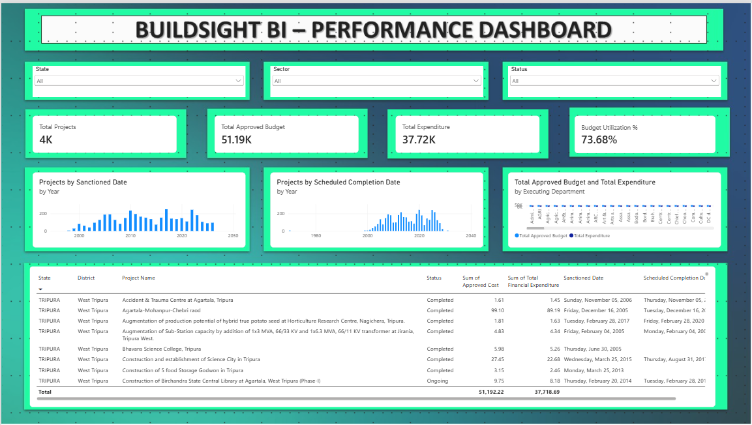
Figure 1: BuildSight BI Performance Dashboard
Source: Prepared by the author. Microsoft Power BI Desktop screenshot of the BuildSight BI dashboard (Week 4 evidence).
Figure 1 shows the dashboard with all three slicers at “All”. The cards show 4K project records (3,744 in the evidence record), 51.19K approved budget, 37.72K recorded expenditure and 73.68% budget utilization. All five sections of the design are visible: the header, the filter bar, the KPI row, the three charts and the detail table. The table total row gives 51,192.22 and 37,718.69. The visible table rows are Tripura projects; because the State slicer shows “All”, this is the order of the table rows and not a filter.

8.2 State Filter Interaction
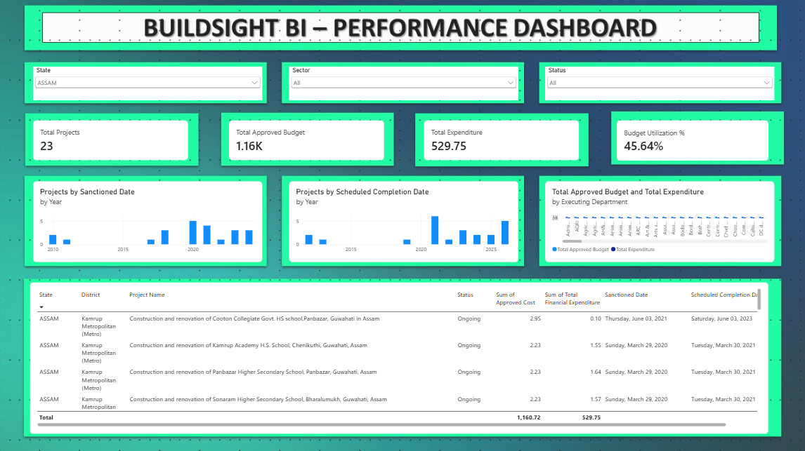
Figure 2: State Filter Interaction
Source: Prepared by the author. Microsoft Power BI Desktop screenshot of the BuildSight BI dashboard (Week 4 evidence).
In Figure 2 the State slicer shows ASSAM. The cards change to 23 records, 1.16K approved budget, 529.75 recorded expenditure and 45.64% utilization. The timeline charts now show small counts per year, and the table lists Assam records in Kamrup Metropolitan (Metro). This demonstrates dynamic filtering: a single selection changes the KPI cards and the context of the visuals together.

8.3 Sector Filter Interaction
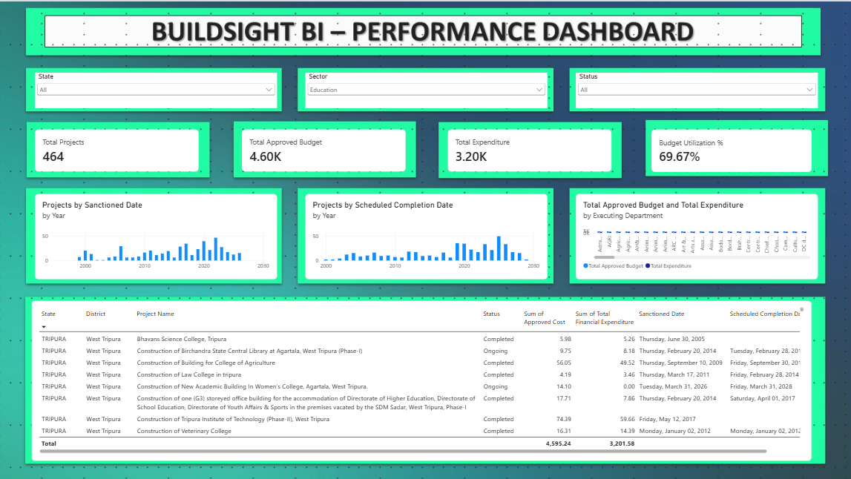
Figure 3: Sector Filter Interaction
Source: Prepared by the author. Microsoft Power BI Desktop screenshot of the BuildSight BI dashboard (Week 4 evidence).
In Figure 3 the Sector slicer shows Education. The cards change to 464 records, 4.60K, 3.20K and 69.67%. The timeline charts redraw on an axis scaled to about 50, and the table lists Education projects (the visible rows include colleges and a library). Selecting a sector gives sector-specific project and financial information on the same page.

8.4 Status Filter Interaction
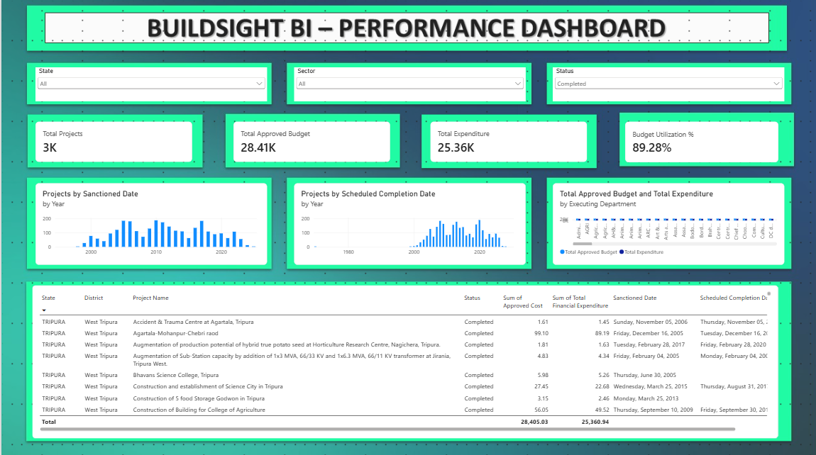
Figure 4: Status Filter Interaction
Source: Prepared by the author. Microsoft Power BI Desktop screenshot of the BuildSight BI dashboard (Week 4 evidence).
In Figure 4 the Status slicer shows Completed. The cards read 3K records, 28.41K approved budget, 25.36K recorded expenditure and 89.28% utilization, and all visible table rows show the status Completed. The sanctioned-date chart now has a different shape from the unfiltered view, with its highest bars in the mid-2000s on an axis marked to 200, while the scheduled-completion chart keeps a broadly similar spread. The result shows that a status selection changes the dashboard context in the same way as a state or sector selection.
Table 7: Summary of the Four Dashboard Views
View | Selection | Total Projects | Total Approved Budget | Total Expenditure | Budget Utilization % | Detail-table totals (approved / expenditure)
Figure 1 | All slicers at “All” | 4K (3,744) | 51.19K | 37.72K | 73.68% | 51,192.22 / 37,718.69
Figure 2 | State: ASSAM | 23 | 1.16K | 529.75 | 45.64% | 1,160.72 / 529.75
Figure 3 | Sector: Education | 464 | 4.60K | 3.20K | 69.67% | 4,595.24 / 3,201.58
Figure 4 | Status: Completed | 3K | 28.41K | 25.36K | 89.28% | 28,405.03 / 25,360.94

INTERPRETATION Across the four views, the ratio shown on the Budget Utilization % card equals the ratio of the detail-table totals, for example 25,360.94 / 28,405.03 = 89.28%. The cards, the table and the Week 3 definition are therefore consistent with each other. Figure 4 shows “3K” as the record count; an exact count was not legible and is not stated.

9. Construction Business Use Cases
The dashboard supports a set of portfolio, financial and timeline questions. Each use case below is tied to a feature that exists on the page and is limited to what the dataset can answer. Table 8 summarises them.
Table 8: Business Use Cases
Use Case | Dashboard Feature | Example Question | Decision Support
1. Project Portfolio Monitoring | Total Projects card | How many project records are currently represented in the selected analytical context? | Sizes the portfolio under review before any detailed analysis
2. Financial Monitoring | Approved Budget, Expenditure and Utilization cards | How does recorded expenditure compare with approved cost? | Flags selections where utilization is low or high compared with the overall 73.68%
3. Geographic Analysis | State slicer; State and District columns | How does the project portfolio differ across states? | Compares states on counts and financial figures (for example Assam: 23 records)
4. Sector Analysis | Sector slicer | How does the financial and project profile change when Education or another sector is selected? | Shows which sectors hold the larger share of records and budget
5. Status-Based Review | Status slicer | How does the project portfolio differ by recorded status? | Separates records by source status label, for example Completed against the rest
6. Department Comparison | Budget and Expenditure by Executing Department chart | Which executing departments have higher approved amounts or recorded expenditure? | Directs attention to departments for review (subject to the readability improvement in Section 10)
7. Timeline Analysis | Sanctioned-date and scheduled-completion charts | How are project records distributed by sanctioned and scheduled completion years? | Shows historical sanctioning volume and the spread of scheduled completion years
8. Project Investigation | Detail table | Which individual project records contribute to an observed aggregate pattern? | Moves from a pattern to the specific records behind it

9.1 Project Performance Monitoring
The Total Projects card and the Budget Utilization % card together give a first view of portfolio performance in financial terms. A user can compare any selection with the overall figures. For instance, Assam’s utilization of 45.64% is well below the overall 73.68%, whereas the Completed status shows 89.28%. This is a descriptive comparison of recorded figures; it does not establish why the values differ.

9.2 Financial Monitoring
The three financial cards compare the approved cost with the recorded expenditure for any selection, and the department chart extends that comparison across executing departments. The report uses the terms “approved budget” and “recorded expenditure” throughout, because the dataset records amounts in the source listing and not the cost of work physically done.

9.3 Geographic Comparison
The State slicer and the State and District columns of the table allow a user to compare states one after another. Selecting Assam brought the page to 23 records, which shows how the portfolio in the source listing differs from state to state. A map visual would present this more directly and is proposed as a future enhancement.

9.4 Sector-Level Analysis
The Sector slicer shows how the profile changes by sector. Education, with 464 records and 69.67% utilization, shows a utilization close to the overall portfolio, with a smaller share of the approved budget than of the project records. Other sectors can be examined in the same way using the same slicer.

9.5 Department-Level Comparison
The department chart is intended to show which executing departments carry larger approved amounts or recorded expenditure. In the current screenshots, the chart is too compressed to read, so department-level conclusions are not drawn in this report. Improving the readability of this visual is the first recommendation in Section 10.

9.6 Workflow and Decision-Support Benefits

Workflow efficiency
Without a dashboard, answering a question such as “how does Education compare with the whole portfolio?” would involve filtering a spreadsheet, recalculating totals by hand and checking ratios. The dashboard reduces this manual, spreadsheet-style inspection by placing KPIs, filters, charts and detail records on one page. A typical user workflow is:
- Open the dashboard.
- Review the KPI cards for the overall picture.
- Select a State, Sector or Status in the filter bar.
- Observe the updated cards and charts.
- Compare approved budget with recorded expenditure and the utilization ratio.
- Inspect department patterns in the department chart.
- Use the detail table for project-level investigation.

Resource management
The dataset holds no labour, material, equipment or other resource-allocation data, so the dashboard does not measure manpower, material inventory, labour productivity or equipment utilization. What it provides is financial and project-portfolio information, such as which departments and sectors carry the larger approved amounts. That information can serve as a foundation for a future resource-management dashboard, but such a dashboard would require additional datasets (Section 12).

10. Dashboard Usability and Design Evaluation
Table 9 evaluates the implemented dashboard against the Week 4 criteria. The assessment is based on the four screenshots and is the author’s own; no formal user testing was carried out.
Table 9: Dashboard Evaluation
Evaluation Criterion | Implementation | Assessment
Coherence | One page; filters above KPIs, KPIs above charts, charts above the table; all visuals from one model | Strong. The flow matches overview, filter, compare, investigate
Visual hierarchy | Title banner, then controls, large KPI values, charts, then the table | Good. The KPI row is the most prominent; the high-contrast panel borders are strong and compete with the data
Accessibility | Dropdown slicers with default “All”; plain labels; no navigation required | Good. Compact KPI notation and missing unit labels reduce clarity
Interactivity | Three slicers; cross-filtering of cards, two charts and table; scrolling | Met. Interactions beyond slicers (drill-down, tooltips, bookmarks) are not implemented
Decision usefulness | Financial ratio, state, sector and status views, department comparison, project table | Good for descriptive review; the department chart is not currently readable
Construction relevance | Cost, expenditure, schedule dates, executing department and status of project records | Relevant to cost and timeline monitoring; no site-level, labour or progress measures
Consistency | Same measures and model as Week 3; same field names across visuals | Good. Card values agree with detail-table totals
Expandability | Built on a star-schema model with unused dimensions (for example DimScheme) | Good. New visuals and pages can reuse the model

10.1 Strengths
The dashboard’s main strength is that every control changes the whole page, which was demonstrated for three different dimensions. Its figures are consistent: each card agrees with the corresponding detail-table total, and the utilization ratio follows from the other two cards. Having the KPIs, filters, charts and records on one page makes the dashboard easy to follow, and the use of the Week 3 model means that no figure is calculated outside it.

10.2 Implemented Features and Recommended Improvements
IMPLEMENTED Three dropdown slicers; four KPI cards; sanctioned-date and scheduled-completion charts; a department budget and expenditure chart; a project detail table with a total row; cross-filtering of the cards, timeline charts and table by the slicers.
RECOMMENDED FUTURE ENHANCEMENT Enlarge the department chart or show a limited number of departments so that bars and names are readable. Add unit labels to the KPI cards. Widen the detail table or reduce columns so that Scheduled Completion Date is not cut off. Add more white space between panels or soften the panel borders. Add drill-through project pages, a map visual, richer tooltip pages, bookmarks for saved views and a more detailed status analysis.
The recommended items are suggestions based on the screenshots. None of them was implemented in Week 4.

11. Limitations and Assumptions
The dashboard is subject to the limitations of its data and of the evidence supplied:
- The dataset is limited to the North Eastern Region project coverage of the source.
- It is a project-level administrative and financial dataset.
- Physical construction progress is not available.
- Actual completion dates are not available.
- Labour and resource allocation data are not available.
- Historical monthly expenditure suitable for forecasting is not available.
- Recorded expenditure should not be interpreted as physical progress.
- Scheduled completion dates are planned dates and are not proof of actual completion.
- Status values are source labels and have not been independently verified.
- Dashboard conclusions depend on the quality and scope of the source data.
Two further points arise from the evidence. First, the KPI cards show values in compact notation without a unit label. The source worksheet states that amounts are in Rs. crore (Week 2), but the dashboard does not display this, so a reader could misread the values. Second, the 3,744 project records in the evidence record were not reconciled in the supplied evidence against the 3,774 distinct Serial Number values seen in the Week 2 profiling; the difference may result from preparation steps in the intervening model, but this was not documented, and a row-count reconciliation across the stages is recommended.
These limitations do not invalidate the dashboard. They define its appropriate use, which is as a descriptive and interactive business intelligence dashboard for project records, approved cost, recorded expenditure and scheduled dates.

12. Future Enhancements
The roadmap below is proposed for later work. None of these items was implemented in Week 4. The Week 4 assignment mentions maps, gauges, drill-downs and sliders; these are included here as possible enhancements, not as existing functionality. Phase 2 and Phase 3 items depend on data that the current source does not contain.
Table 10: Future Enhancement Roadmap (proposed)
Phase | Enhancement | Requirement | Status
Phase 1 | Geographic map visual by state or district | Existing geography fields; map-visual setup | Recommended, not implemented
Phase 1 | Richer tooltip pages | Existing model and measures | Recommended, not implemented
Phase 1 | Drill-through project details; drill-down on year axes | Existing model; report-page design | Recommended, not implemented
Phase 1 | Unit labels on cards; bookmarks; date or numeric range slicers; optional gauge for utilization | Existing model and measures | Recommended, not implemented
Phase 2 | Monthly expenditure history; actual completion dates; physical progress | New data from project monitoring sources | Requires additional data
Phase 2 | Resource utilization; labour data; procurement data | New datasets and model extensions | Requires additional data
Phase 3 | Delay prediction; budget-overrun prediction; resource-demand forecasting; risk scoring | Data from Phase 2 and predictive modelling | Future modelling work

Phase 1 uses the existing model and could be done without new data. Phase 2 depends on additional sources, such as those listed in the Week 2 report, and on extending the model. Phase 3 depends on Phase 2 data and on a modelling approach that has not yet been designed, and it falls within the scope of Week 5 onwards.

13. Conclusion
Week 4 transformed the BuildSight BI analytical model into an interactive Power BI dashboard. Weeks 2 and 3 had produced a prepared dataset, a star-schema model and a set of DAX measures. Week 4 gave those assets a user-facing form: three dropdown slicers, four KPI cards, two timeline charts, a department comparison chart and a project detail table on a single page.
The dashboard follows an overview, filter, compare and investigate flow. The cards give the overall picture, the slicers narrow it, the charts show distributions and comparisons, and the table lists the records behind the aggregates. The unfiltered dashboard displays 3,744 project records, 51.19K approved budget, 37.72K recorded expenditure and 73.68% budget utilization. Three filter demonstrations show the interactivity: Assam gives 23 records and 45.64% utilization, Education gives 464 records and 69.67%, and Completed gives 28.41K approved budget and 89.28%. In every case the figures on the cards agree with the totals in the detail table, and the utilization ratio follows from the Week 3 definition.
The dashboard improves accessibility and reduces the need for manual inspection. A user can reach a state, sector or status view in one selection, without writing formulas or editing a spreadsheet. Its financial and timeline measures support descriptive project-performance analysis, and the project table provides a path to individual records. The dashboard also has clear limits. It reports recorded expenditure and scheduled dates, not physical progress, actual completion, labour productivity or resource use. The evaluation in Section 10 identified specific improvements, mainly the readability of the department chart, the lack of unit labels and the truncated table column, and these are recorded as recommendations.
The dashboard is a foundation for later work, not a finished system. The model and the page layout can be expanded with additional visuals and, when data becomes available, with the measures that Phase 2 and Phase 3 of the roadmap require. The next assignment, Week 5, concerns predictive and trend analytics. It will build on this dashboard and the Week 3 model, but no predictive analytics were implemented in Week 4. Week 6 will then evaluate the framework as a whole.

References
References follow APA 7th edition as far as practical. Only sources used in this report are listed. The dataset values come from the Week 4 screenshot evidence, which is described in Appendix B.
Microsoft. (n.d.-a). Power BI documentation. Microsoft Learn. https://learn.microsoft.com/en-us/power-bi/
Microsoft. (n.d.-b). Slicers in Power BI. Microsoft Learn. https://learn.microsoft.com/en-us/power-bi/visuals/power-bi-visualization-slicers
Microsoft. (n.d.-c). Filter context [Introduction, DAX in Power BI training module]. Microsoft Learn. https://learn.microsoft.com/en-us/training/modules/dax-power-bi-modify-filter/1-introduction
Ministry of Development of North Eastern Region. (n.d.). NESetu projects dashboard: Project list [Data set]. Government of India. https://www.nesetu.mdoner.gov.in/projects/project-list
Surve, S. A. (2026a). BuildSight BI Week 2 internship report: Data sourcing, import, and transformation for construction metrics [Unpublished internship report]. Vellore Institute of Technology.
Surve, S. A. (2026b). BuildSight BI Week 3 internship report: Building advanced data models and DAX calculations [Unpublished internship report]. Vellore Institute of Technology.

Appendix A: Dashboard Visual Inventory
The table lists every visual on the Week 4 dashboard page, as seen in Figure 1. No other visuals or pages were implemented.
Table 11: Dashboard Visual Inventory
ID | Visual | Type | Main Fields / Measures | Purpose
V01 | BUILDSIGHT BI – PERFORMANCE DASHBOARD | Title banner | Static text | Establishes dashboard identity
V02 | State | Dropdown slicer | State | Filters the page by state
V03 | Sector | Dropdown slicer | Sector | Filters the page by sector
V04 | Status | Dropdown slicer | Status | Filters the page by recorded status
V05 | Total Projects | Card | Total Projects measure | Number of project records in context
V06 | Total Approved Budget | Card | Total Approved Budget measure | Approved cost in context
V07 | Total Expenditure | Card | Total Expenditure measure | Recorded expenditure in context
V08 | Budget Utilization % | Card | Budget Utilization % measure (Total Expenditure / Total Approved Budget) | Expenditure as a share of approved budget
V09 | Projects by Sanctioned Date, by Year | Column chart | Sanctioned Date (Year); project-record count | Distribution of records by sanctioned year
V10 | Projects by Scheduled Completion Date, by Year | Column chart | Scheduled Completion Date (Year); project-record count | Distribution of records by scheduled completion year
V11 | Total Approved Budget and Total Expenditure by Executing Department | Clustered column chart | Executing Department; Total Approved Budget; Total Expenditure | Department-level comparison of two measures
V12 | Project detail table | Table | State, District, Project Name, Status, Approved Cost, Total Financial Expenditure, Sanctioned Date, Scheduled Completion Date | Project-level investigation

Appendix B: Screenshot Evidence Index
The four screenshots were taken from Microsoft Power BI Desktop and are reproduced unaltered in Section 8. Where a card shows a rounded value, the values quoted in the report are those displayed on the screenshot.
Table 12: Screenshot Evidence Index
ID | Figure | Description | Evidence Purpose
W4-01 | Figure 1 | Overall Performance Dashboard: all slicers at “All”; cards 4K, 51.19K, 37.72K, 73.68%; three charts; detail table with totals 51,192.22 and 37,718.69 | Shows the complete implemented layout and the unfiltered baseline
W4-02 | Figure 2 | State Filter Interaction – Assam: cards 23, 1.16K, 529.75, 45.64%; table totals 1,160.72 and 529.75 | Demonstrates dynamic filtering by state
W4-03 | Figure 3 | Sector Filter Interaction – Education: cards 464, 4.60K, 3.20K, 69.67%; table totals 4,595.24 and 3,201.58 | Demonstrates dynamic filtering by sector
W4-04 | Figure 4 | Status Filter Interaction – Completed: cards 3K, 28.41K, 25.36K, 89.28%; table totals 28,405.03 and 25,360.94 | Demonstrates dynamic filtering by status

EVIDENCE NOTE The text that accompanied the W4-04 screenshot in the supplied evidence document did not match the screenshot: it named a state as the selected status and repeated the values of the state view. This report therefore uses the slicer selection and the values visible in the screenshot itself (status Completed; cards 3K, 28.41K, 25.36K and 89.28%). The record count behind “3K” is not legible in the screenshot and is not stated. The detail-table totals are read from the screenshots, and the percentages and shares labelled as the author’s calculation are derived from those displayed values.

